**RollNo: 5117060**

**EXPERIMENT 04**

**Aim:** To implement Discrete Fourier Transform.

**Theory:**

The DFT is one of the most powerful tools in digital signal processing which enables us to find the spectrum of a finite-duration signal.

There are many circumstances in which we need to determine the frequency content of a time domain signal. For example, we may have to analyze the spectrum of the output of an LC oscillator  to see how much noise is present in the produced sine wave. This can be achieved by the discrete  Fourier transform (DFT). The DFT is usually considered as one of the two most powerful tools in  digital signal processing (the other one being digital filtering), and though we arrived at this topic  introducing the problem of spectrum estimation, the DFT has several other applications in DSP.

Please note that this article tries to give a basic understanding of the DFT in an intuitive way;  examining a list of its properties, as is usual in textbooks, is not the goal of this article.

**Why the DFT?**

Assume that x (t) x(t), shown in Figure 1, is the continuous-time signal that we need to analyze. 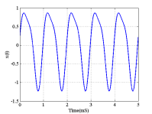

**Figure 1. A continuous-time signal for which we need to determine the frequency content.**

Obviously, a digital computer cannot work with a continuous-time signal and we need to take  some samples of x (t) x(t) and analyze these samples instead of the original signal. Moreover,  while Figure 1 shows only the first 5 5 millisecond of the signal, x (t) x(t) may continue for  hours, years, or more. Since our digital computer can process only a finite number of samples, we  have to make an approximation and use a limited number of samples. Therefore, generally, a finite duration sequence is utilized to represent this analog continuous-time signal which may extend to  positive infinity on the time axis. The reader may wonder how many samples, L L, we need in  order to estimate the frequency content of a given signal. We will discuss this question in a future article of this series. For the time being, assume that we sample x (t) x(t) in Figure 1 with a  sampling rate of 8000 8000 samples/second and take only L = 8 L=8 samples of this signal.  The result is shown in red in Figure 2.

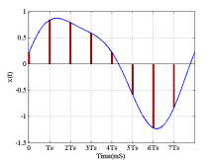

**Figure 2. Sampling allows us to analyze continuous-time signals in a digital computer.**

**Deriving the DFT Equations**

The discussed method for calculating the spectrum of a finite-duration sequence is simple and  intuitive. It clarifies the inherent periodic behavior of DFT representation. However, it is possible  to use the above discussion and derive closed-form DFT equations without the need to calculate  the inverse of a large matrix. To this end, we only need to make a period signal out of  the N N samples of the finite-duration sequence. Then, applying the discrete-time Fourier series  expansion, we can find the frequency domain representation of the periodic signal. The obtained  Fourier series coefficients are the same as the DFT coefficients except for a scaling factor.  Assume that the finite-duration sequence that we need to analyze is as shown in Figure 5 (a). To  calculate the N-point DFT, we need to make a periodic signal, p ( n ) p(n),  from x ( n ) x(n) with period N N, as shown in Figure 5(b).

Considering the fact  that p ( n ) = x ( n ) p(n)=x(n) for n = 0 , 1 ,…, N − 1 n=0,1,…,N−1, we obtain the  discrete-time Fourier series of this periodic signal a k = 1NN − 1 ∑ n = 0 x ( n ) e− j2 π Nk n ak=1N∑n=0N−1x(n)e−j2πNkn

**Equation 6**

where N N denotes the period of the signal. The time-domain signal can be obtained as follows:

x ( n ) = N − 1 ∑ k = 0 a k e j2 π Nk n x(n)=∑k=0N−1akej2πNkn

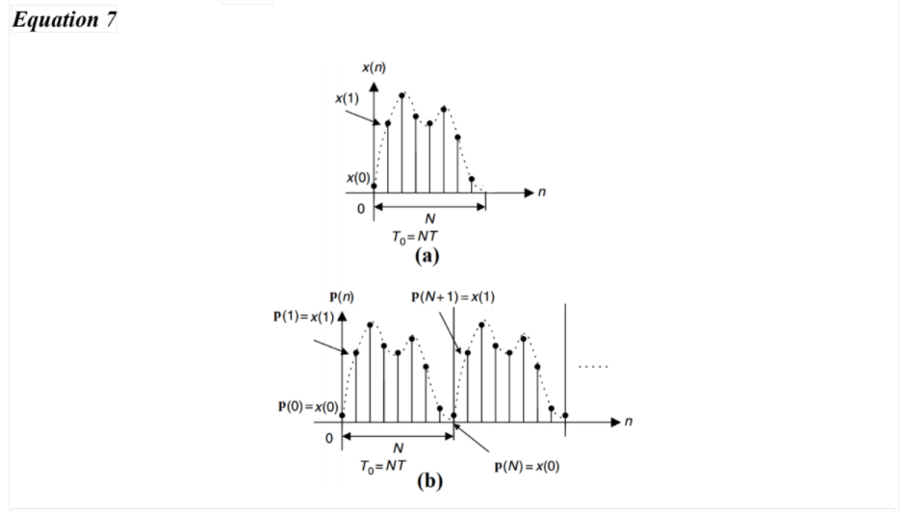

**Figure 5. (a)The finite-duration sequence, x(n), to be analyzed. (b) The periodic signal obtained from x(n). Image courtesy of Digital Signal Processing, Fundamentals, and Applications.**

Multiplying the coefficients given by Equation 6 by N N, we obtain the DFT  coefficients, X(k) X(k), as follows:

X(k) = N − 1 ∑ n = 0 x ( n ) e− j2 π Nk n X(k)=∑n=0N−1x(n)e−j2πNkn **Equation 8**

The inverse DFT will be x ( n ) = 1NN − 1 ∑ k = 0X(k) e j2 π Nk n x(n)=1N∑k=0N−1X(k)ej2πNkn **Equation 9**

Please note that while the discrete-time Fourier series of a signal is periodic, the DFT  coefficients, X(k) X(k), are a finite-duration sequence defined

for 0 ≤ k ≤ N − 1 0≤k≤N−1.

**Summary**

* The DFT is one of the most powerful tools in digital signal processing; it enables us  to find the spectrum of a finite-duration signal x(n).
* Basically, computing the DFT is equivalent to solving a set of linear equations.
* The DFT provides a representation of the finite-duration sequence using a periodic  sequence, where one period of this periodic sequence is the same as the finite-duration  sequence. As a result, we can use the discrete-time Fourier series to derive the DFT  equations.

**Conclusion:**

Thus, we have successfully implemented discrete Fourier Tranform.

**Code:**

clear;

clc ;

close ;

N=4;

n=0:1:N-1;

x=(-1)^n;

//DFT Computation

X = fft (x,-1);

//Display Sequence X[k] in command window

disp(X,"X[k]=");

**Output:**

X[k]= 0. 0. 4. 0.

**Code:**

clc;clear;close;

L=3;A=1/4;

x=A*ones(1,L);

//Calculation of DFT

X=fft(x,-1);

X=clean(X);

disp(x,'Given Sequence is x(n): ');

disp(X,'DFT of the Sequence is X(k): ');

**Output:**

Given Sequence is x(n):

0.25 0.25 0.25

DFT of the Sequence is X(k):

0.75 0. 0.