**Persona**

**Mini Project Topic:** Healthy Life Application

**Following are the personas of the users of the Application:**

1. **Patient:**

There is certain difference between a patient and a normal customer who is using the application. As a patient would be consulting a doctor by using our application, getting medicines prescribed by the doctor, pay his fees online too. A patient can book his/ her appointments and can even do a follow up with the doctor. The following persona has been created of a patient.

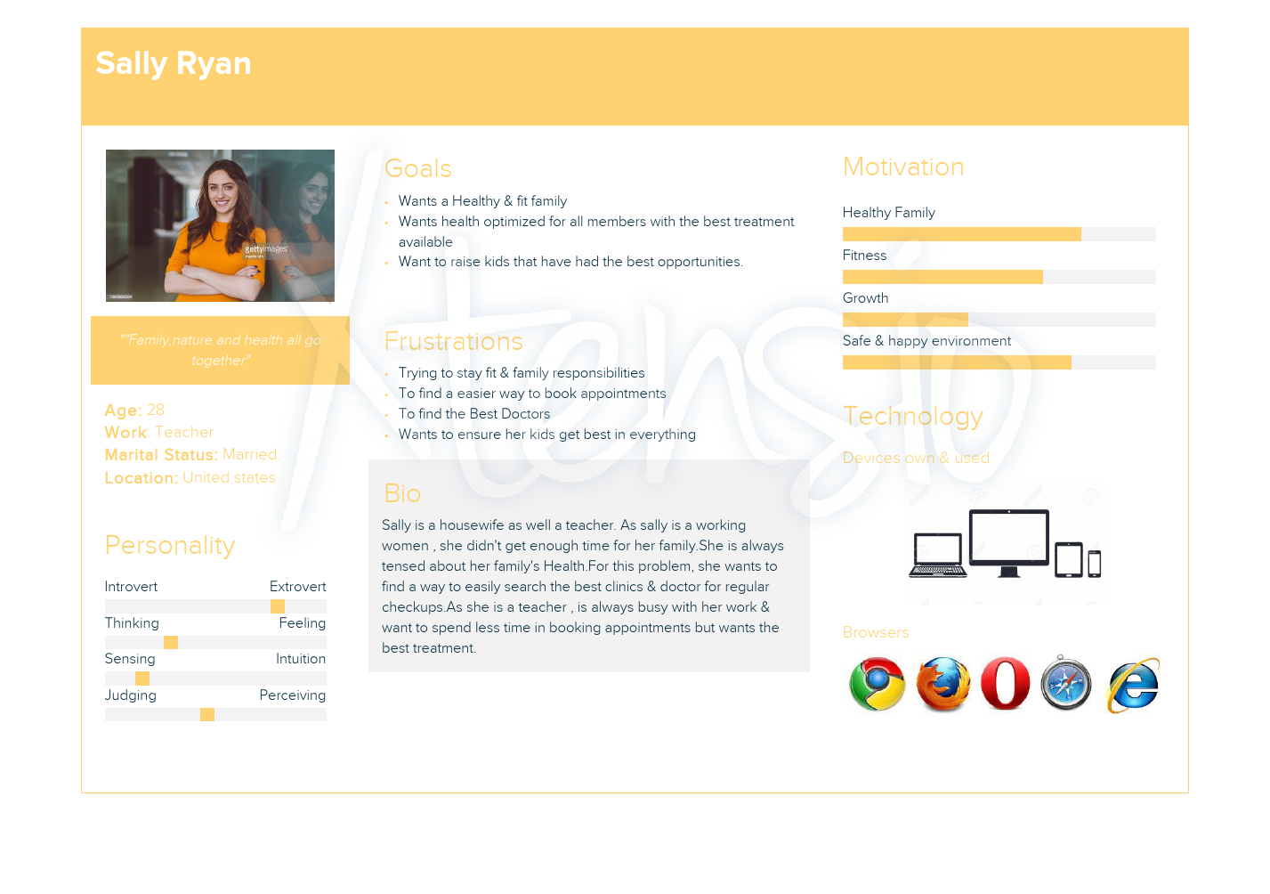

1. **A normal Customer:**

A normal customer could be the one who just uses the services provided by the application for purchasing medicines. He or she does not use the services like booking appointments or consulting a doctor online too. The Customer purchases medicines, gains loyalty points, gets discounts, gets his/ her desired choices delivered to them.

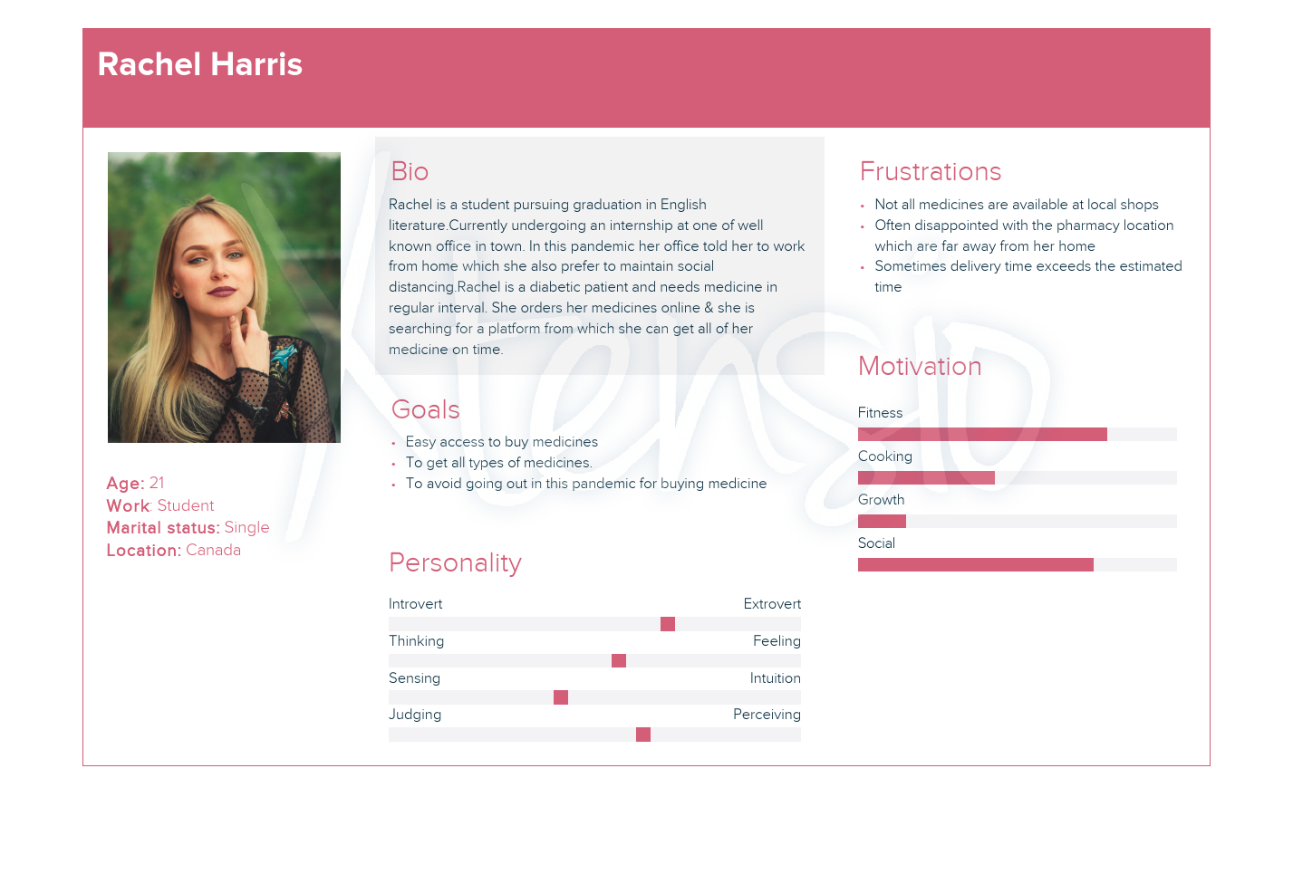

1. **Doctor:**

As the platform serves the purpose of filling the gap between the patient and the doctor, online consultation with doctors is possible. Doctors of specific hospitals that have tied up with the Application can directly interact with the patients online, prescribe medicines to them online, even get their fees paid online by using the unified app.

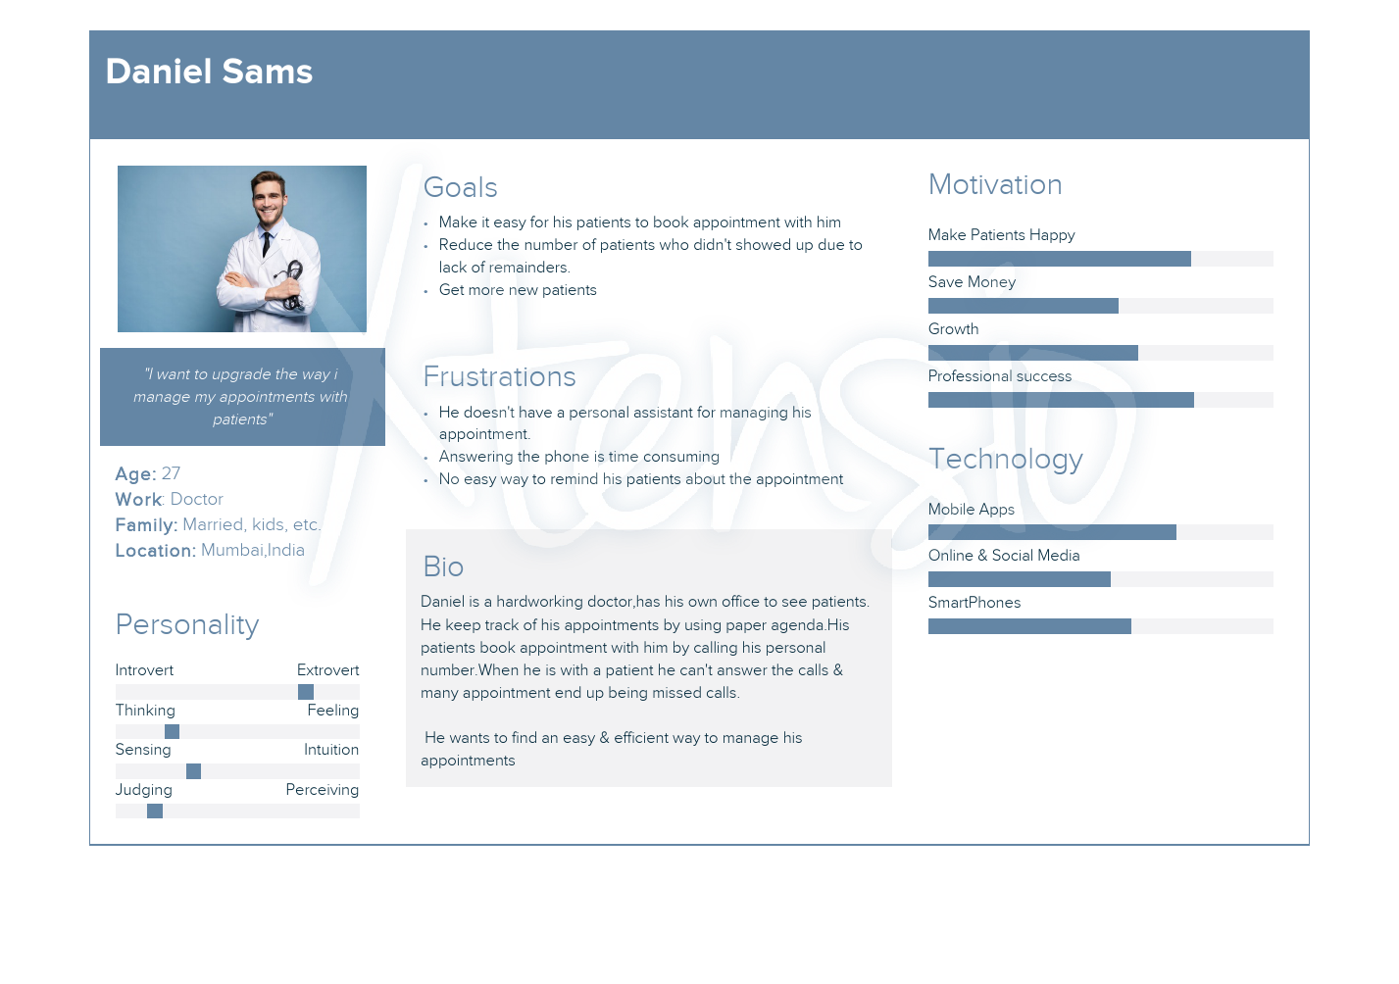

1. **Admin:**

Admin serves as the webmaster as well as the handler of the entire application. He manages the updates, maintenance of the application, solving bugs, changing user privilege levels as well. All in one, the admin is the superuser of the application.

