**Name:** Shivam Tiwari

**Roll No:** 5117060

**Experiment No: 1**

**Aim**: Execution of Simple Hello Word program on MPI platform.

#include "mpi.h"

#include <stdio.h>

int main( int argc, char *argv[] )

{

int rank, size;

MPI_Init( &argc, &argv );

MPI_Comm_rank( MPI_COMM_WORLD, &rank );

MPI_Comm_size( MPI_COMM_WORLD, &size );

printf( "Hello World from process %d of %d\n", rank, size );

MPI_Finalize();

return 0;

}

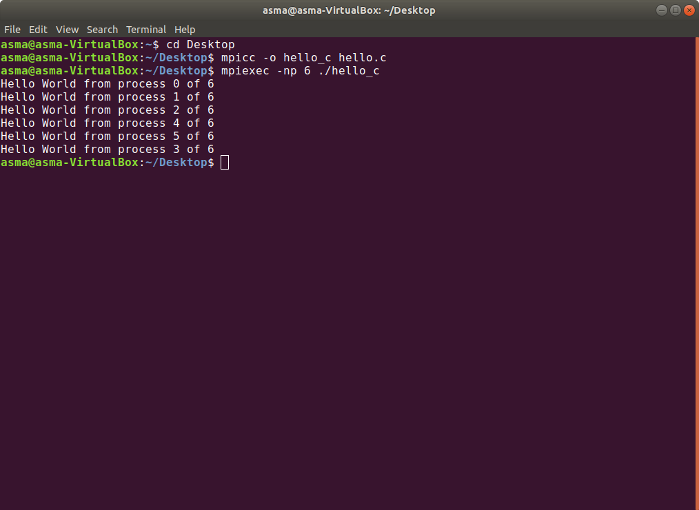

**Name:** Shivam Tiwari

**Roll No:** 5117060

**Experiment No: 2**

**Aim:** a. Program to send and receive data to/from processors using MPI.

b. Program illustrating Broadcast of data using MPI.

#include "mpi.h"

#include<stdio.h>

int main(int argc, char **argv)

{

MPI_Init(NULL, NULL);

// Find out rank, size

int world_rank;

MPI_Comm_rank(MPI_COMM_WORLD, &world_rank);

int world_size;

MPI_Comm_size(MPI_COMM_WORLD, &world_size);

int number;

if (world_rank == 0) {

number = -1;

MPI_Send(&number, 1, MPI_INT, 1, 0, MPI_COMM_WORLD);

MPI_Send(&number, 1, MPI_INT, 2, 0, MPI_COMM_WORLD);

} else if (world_rank == 1) {

MPI_Recv(&number, 1, MPI_INT, 0, 0, MPI_COMM_WORLD,

MPI_STATUS_IGNORE);

printf("Process 1 received number %d from process 0\n",

number);

}

if (world_rank == 2) {

MPI_Recv(&number, 1, MPI_INT, 0, 0, MPI_COMM_WORLD,

MPI_STATUS_IGNORE);

printf("Process 2 received number %d from process 0\n",

number);

}

MPI_Finalize();

return 0;

}

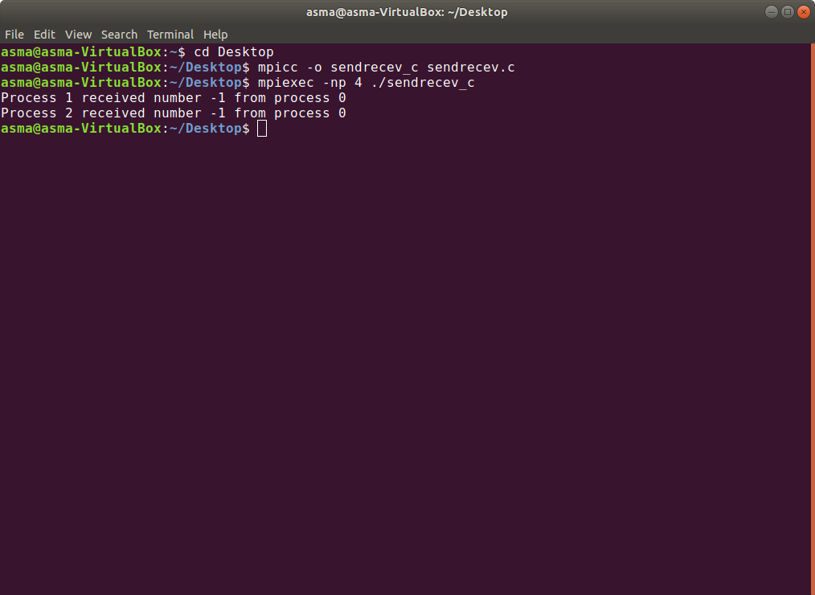

**b. Program illustrating Broadcast of data using MPI.**

#include <stdio.h>

#include <stdlib.h>

#include <mpi.h>

void my_bcast(void* data, int count, MPI_Datatype datatype, int root,

MPI_Comm communicator) {

int world_rank;

MPI_Comm_rank(communicator, &world_rank);

int world_size;

MPI_Comm_size(communicator, &world_size);

if (world_rank == root) {

// If we are the root process, send our data to everyone

int i;

for (i = 0; i < world_size; i++) {

if (i != world_rank) {

MPI_Send(data, count, datatype, i, 0, communicator);

}

}

} else {

// If we are a receiver process, receive the data from the root

MPI_Recv(data, count, datatype, root, 0, communicator, MPI_STATUS_IGNORE);

}

}

int main(int argc, char** argv) {

MPI_Init(NULL, NULL);

int world_rank;

MPI_Comm_rank(MPI_COMM_WORLD, &world_rank);

int data;

if (world_rank == 0) {

data = 100;

printf("Process 0 broadcasting data %d\n", data);

my_bcast(&data, 1, MPI_INT, 0, MPI_COMM_WORLD);

} else {

my_bcast(&data, 1, MPI_INT, 0, MPI_COMM_WORLD);

printf("Process %d received data %d from root process\n", world_rank, data);

}

MPI_Finalize();

}

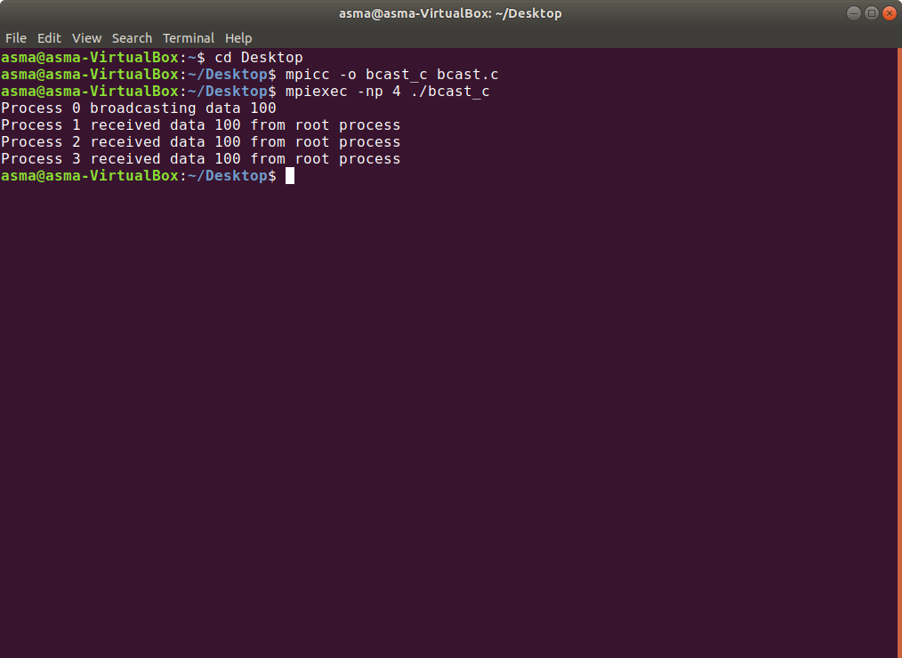

**Name:** Shivam Tiwari

**Roll No:** 5117060

**Experiment No: 3**

**Aim:** To calculate factorial of a number.

#include <stdio.h>

#include <stdlib.h>

#include <unistd.h>

#include <mpi.h>

int main (int argc, char ** argv){

int rank, size,tag=100;

MPI_Init (&argc, &argv); /* starts MPI */

MPI_Comm_rank (MPI_COMM_WORLD, &rank); /* get current process id */

if (rank == 0)

{

int a[10]={1,2,3,4,5,6,7,8,9,10}; // the array with the values to calculate the factorial

int fact[10] = {0}; // the array to store the results

MPI_Send(a, 10, MPI_INT,1,tag, MPI_COMM_WORLD); // the values

MPI_Recv(fact, 10, MPI_INT,1,tag, MPI_COMM_WORLD,MPI_STATUSES_IGNORE); // wait for the result

for(int i = 0; i < 10; i++) // print the results;

printf("Process %d,Result=%d\n",rank, fact[i]);

}

else if (rank == 1)

{

int a[10] = {0};

int fact[10] = {0};

MPI_Recv(a, 10, MPI_INT,0,tag, MPI_COMM_WORLD,MPI_STATUSES_IGNORE);

for(int i = 0; i < 10; i++){

int f = 1;

for (int k = 1; k <= a[i]; ++k) // Calculate the factorials

f *= k;

fact[i] = f;

}

MPI_Send(fact,10, MPI_INT,0,tag, MPI_COMM_WORLD); // send the factorials to process 0

}

MPI_Comm_size (MPI_COMM_WORLD, &size); /* get number of processes */

MPI_Finalize();

return 0;

}

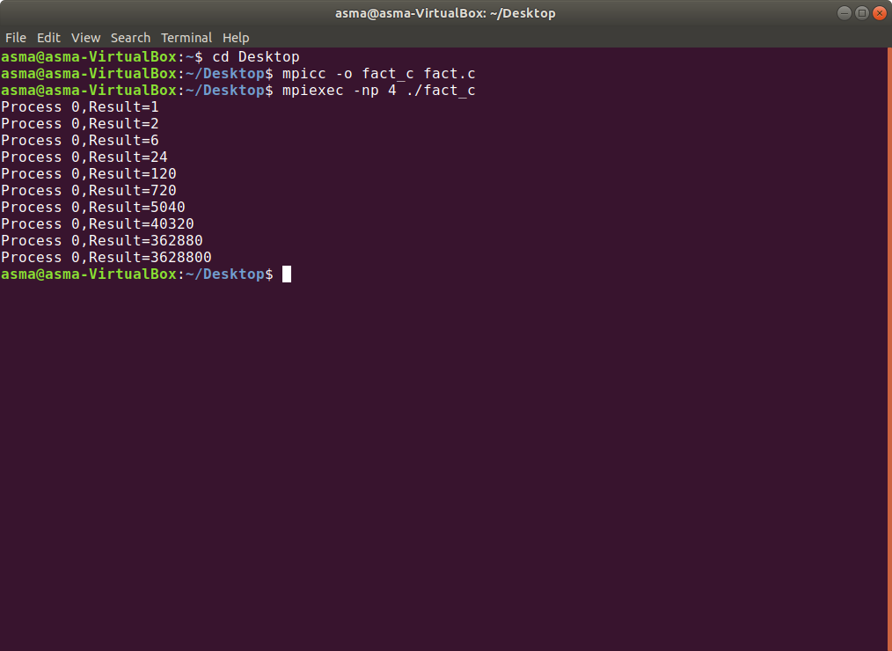

/* simple parallel factorial calculator. Only useful

* to illustrate collective communication :)

*/

#include <stdio.h>

#include "mpi.h"

int main(int argc, char *argv[]){

int myRank;

int size;

int fact;

int lower,upper;

int i;

double local_result = 1.0;

double total;

/* initialize MPI */

MPI_Init(&argc,&argv);

/* get my rank and the size of the communicator */

MPI_Comm_rank(MPI_COMM_WORLD, &myRank);

MPI_Comm_size(MPI_COMM_WORLD, &size);

/* get the input. (only if i have rank 0) */

if(myRank==0){

printf("Enter a number:");

scanf("%d",&fact);

}

/* since only the process with rank 0 has the input,

* we must pass it to all the other processes. */

MPI_Bcast(&fact, /* in/out parameter */

1, /* count */

MPI_INT, /* datatype */

0, /* root */

MPI_COMM_WORLD); /* communicator */

/* calculate the upper and lower boundaries

* for each process

*/

if(myRank==0){

lower = 1;

}else

lower = myRank * (fact / size) + 1;

if(myRank==(size-1))

upper = fact;

else

upper = (myRank + 1) * (fact / size);

/* now that we know upper and lower, do the

* multiplication in our local area

*/

for(i=lower;i<=upper;i++){

local_result = local_result * (double)i;

printf("\nMy upper=%d lower=%d rank=%d val=%lf",upper,lower,myRank,local_result);

}

/* combine all the local results by multiplying them

* together

*/

MPI_Reduce(&local_result, /* operand */

&total, /* result */

1, /* count */

MPI_DOUBLE, /* datatype */

MPI_PROD, /* operator */

0, /* root rank */

MPI_COMM_WORLD); /* communicator */

/* give the output to the user */

if(myRank==0){

printf("The factorial of %d is %lf, and was calculated using %d processes\n",fact,total,size);

}

/* shut down MPI */

MPI_Finalize();

return 0;

}

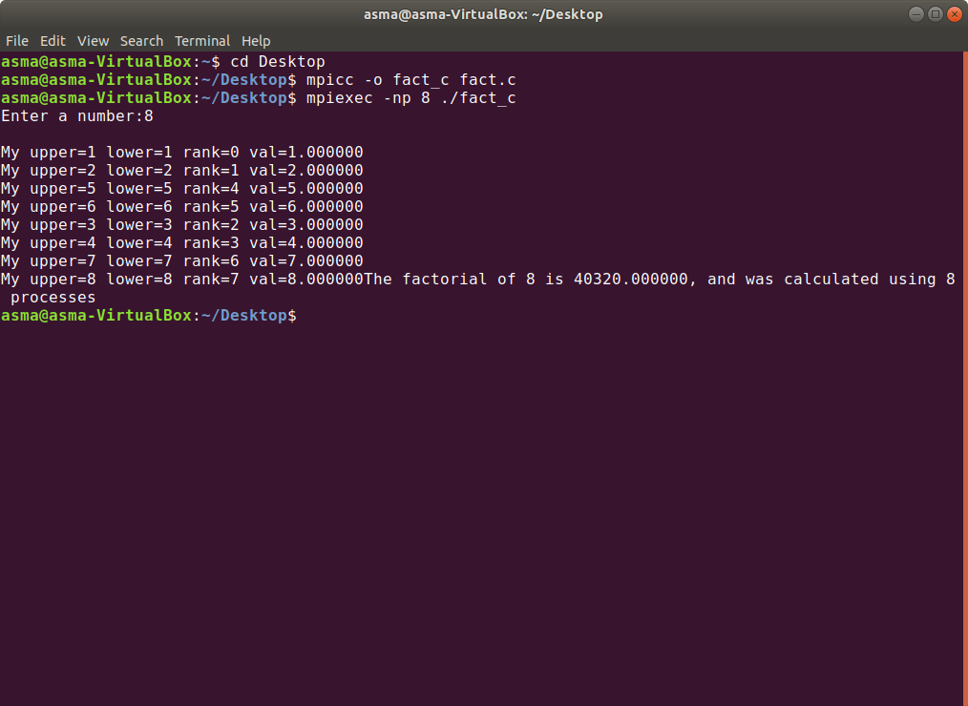

**Name:** Shivam Tiwari

**Roll No:** 5117060

**Experiment No: 4**

**Aim:** a. To implement Average of an array.

b. To implement ring algorithm.

#include <stdio.h>

#include "mpi.h"

int main(int argc, char** argv){

int my_rank;

int total_processes;

int root = 0;

int data[100];

int data_loc[100];

float final_res[100];

MPI_Init(&argc, &argv);

MPI_Comm_rank(MPI_COMM_WORLD, &my_rank);

MPI_Comm_size(MPI_COMM_WORLD, &total_processes);

int input_size = 0;

if (my_rank == 0){

printf("Input how many numbers: ");

scanf("%d", &input_size);

printf("Input the elements of the array: ");

for(int i=0; i<input_size; i++){

scanf("%d", &data[i]);

}

}

MPI_Bcast(&input_size, 1, MPI_INT, root, MPI_COMM_WORLD);

int loc_num = input_size/total_processes;

MPI_Scatter(&data, loc_num, MPI_INT, data_loc, loc_num, MPI_INT, root, MPI_COMM_WORLD);

int loc_sum = 0;

for(int i=0; i< loc_num; i++)

loc_sum += data_loc[i];

float loc_avg = (float) loc_sum / (float) loc_num;

MPI_Gather(&loc_avg, 1, MPI_FLOAT, final_res, 1, MPI_FLOAT, root, MPI_COMM_WORLD);

if(my_rank==0){

float fin = 0;

for(int i=0; i<total_processes; i++)

fin += final_res[i];

float avg = fin / (float) total_processes;

printf("Final average: %f \n", avg);

}

MPI_Finalize();

return 0;

}

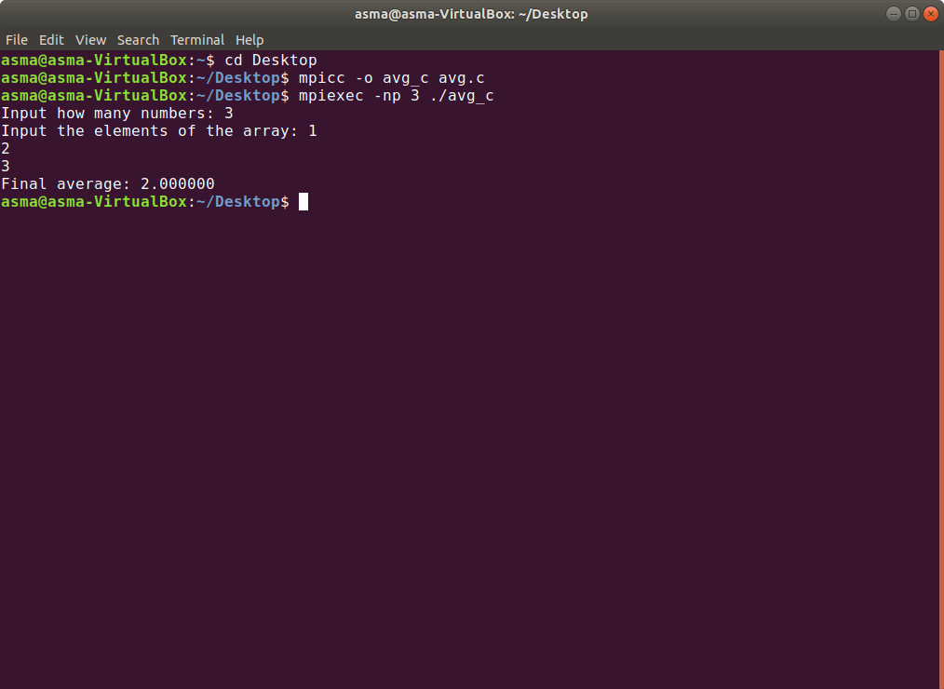

**b. To implement ring algorithm.**

#include "mpi.h"

#include<stdio.h>

int main(int argc, char **argv)

{

MPI_Init(&argc,&argv);

int world_rank;

MPI_Comm_rank(MPI_COMM_WORLD, &world_rank);

int world_size;

MPI_Comm_size(MPI_COMM_WORLD, &world_size);

int token;

if (world_rank != 0) {

MPI_Recv(&token, 1, MPI_INT, world_rank - 1, 0,

MPI_COMM_WORLD, MPI_STATUS_IGNORE);

printf("Process %d received token %d from process %d\n",

world_rank, token, world_rank - 1);

} else {

// Set the token's value if you are process 0

token = -1;

}

MPI_Send(&token, 1, MPI_INT, (world_rank + 1) % world_size,

0, MPI_COMM_WORLD);

// Now process 0 can receive from the last process.

if (world_rank == 0) {

MPI_Recv(&token, 1, MPI_INT, world_size - 1, 0,

MPI_COMM_WORLD, MPI_STATUS_IGNORE);

printf("Process %d received token %d from process %d\n",

world_rank, token, world_size - 1);

}

MPI_Finalize();

return 0;

}

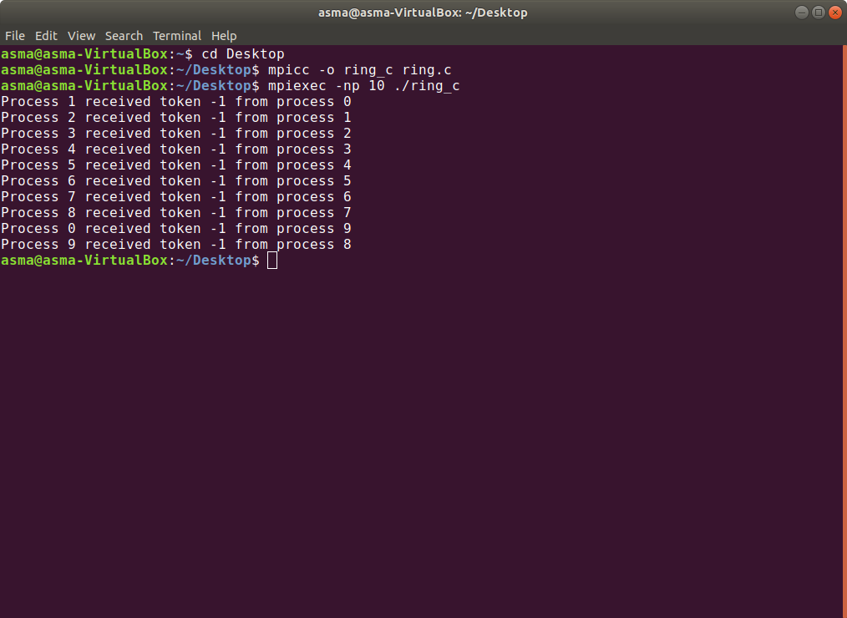

**Name:** Shivam Tiwari

**Roll No:** 5117060

**Experiment No: 5**

**Aim:** To find sum of a one-dimensional Array.

#include <mpi.h>

#include <stdio.h>

#include <stdlib.h>

#include <unistd.h>

// size of array

#define n 10

int a[] = { 1, 2, 3, 4, 5, 6, 7, 8, 9, 10 };

// Temporary array for slave process

int a2[1000];

int main(int argc, char* argv[])

{

int pid, np,

elements_per_process,

n_elements_recieved;

// np -> no. of processes

// pid -> process id

MPI_Status status;

// Creation of parallel processes

MPI_Init(&argc, &argv);

// find out process ID,

// and how many processes were started

MPI_Comm_rank(MPI_COMM_WORLD, &pid);

MPI_Comm_size(MPI_COMM_WORLD, &np);

// master process

if (pid == 0) {

int index, i;

elements_per_process = n / np;

// check if more than 1 processes are run

if (np > 1) {

// distributes the portion of array

// to child processes to calculate

// their partial sums

for (i = 1; i < np - 1; i++) {

index = i * elements_per_process;

MPI_Send(&elements_per_process,

1, MPI_INT, i, 0,

MPI_COMM_WORLD);

MPI_Send(&a[index],

elements_per_process,

MPI_INT, i, 0,

MPI_COMM_WORLD);

}

// last process adds remaining elements

index = i * elements_per_process;

int elements_left = n - index;

MPI_Send(&elements_left,

1, MPI_INT,

i, 0,

MPI_COMM_WORLD);

MPI_Send(&a[index],

elements_left,

MPI_INT, i, 0,

MPI_COMM_WORLD);

}

// master process add its own sub array

int sum = 0;

for (i = 0; i < elements_per_process; i++)

sum += a[i];

// collects partial sums from other processes

int tmp;

for (i = 1; i < np; i++) {

MPI_Recv(&tmp, 1, MPI_INT,

MPI_ANY_SOURCE, 0,

MPI_COMM_WORLD,

&status);

int sender = status.MPI_SOURCE;

sum += tmp;

}

// prints the final sum of array

printf("Sum of array is : %d\n", sum);

}

// slave processes

else {

MPI_Recv(&n_elements_recieved,

1, MPI_INT, 0, 0,

MPI_COMM_WORLD,

&status);

// stores the received array segment

// in local array a2

MPI_Recv(&a2, n_elements_recieved,

MPI_INT, 0, 0,

MPI_COMM_WORLD,

&status);

// calculates its partial sum

int partial_sum = 0;

for (int i = 0; i < n_elements_recieved; i++)

partial_sum += a2[i];

// sends the partial sum to the root process

MPI_Send(&partial_sum, 1, MPI_INT,

0, 0, MPI_COMM_WORLD);

}

// cleans up all MPI state before exit of process

MPI_Finalize();

return 0;

}

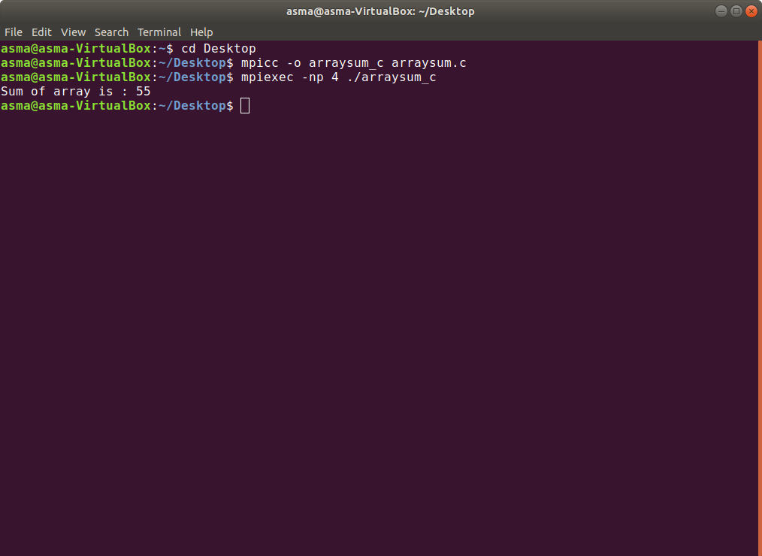

**Name:** Shivam Tiwari

**Roll No:** 5117060

**Experiment No: 6**

**Aim:** Using directives of MPI/OpenMP implement parallel programming for Hello World.

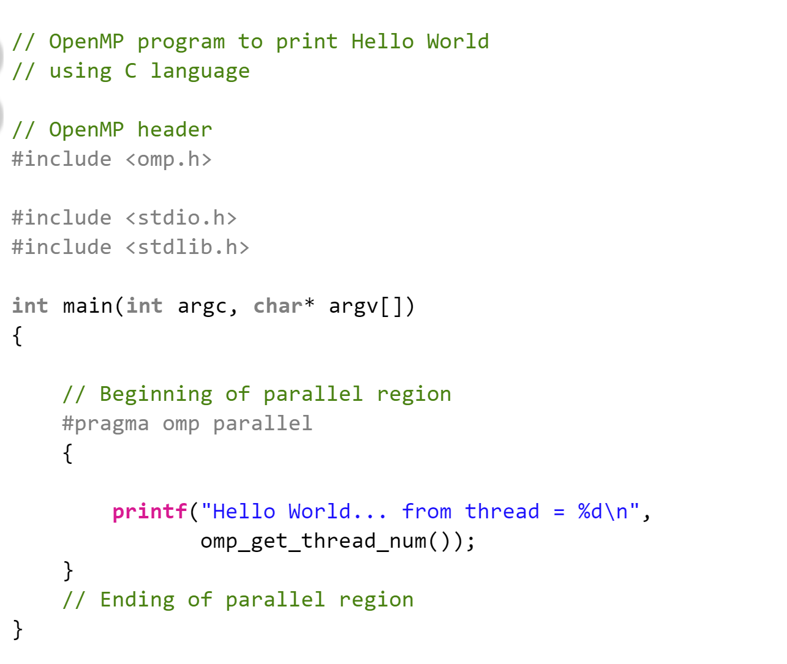

shivam@shivam -VirtualBox:~$ cd Desktop/  
shivam@shivam -VirtualBox:~/Desktop   
shivam@shivam -VirtualBox:~/Desktop$ export OMP_NUM_THREADS=5  
shivam@shivam -VirtualBox:~/Desktop$ gcc -o hello -fopenmp HelloworldOpenMP.c  
shivam@shivam -VirtualBox:~/Desktop $ ./hello  
Hello World... from thread = 2  
Hello World... from thread = 4  
Hello World... from thread = 1  
Hello World... from thread = 0  
Hello World... from thread = 3