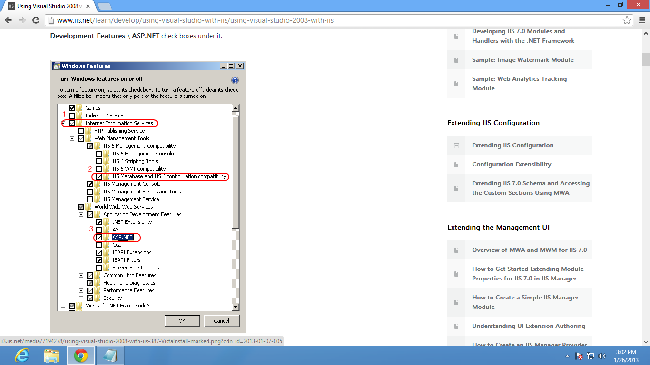

Put published folder in intepub/wwwroot

goto iis
right click folder and convert to application ( convert framework to .net2.0)
enable directory browsing

link for above info :
http://www.iis.net/learn/develop/using-visual-studio-with-iis/using-visual-studio-2008-with-iis

