WEB AUTOMATION

Behaviour Driven Development :
Behaviour Driven Development is enforced through cucumber by creating an extra layer called Feature File that is business user friendly.Each step in the scenarios created under the feature file is linked or glued to methods which are also called step definitions.The step definitions are tagged with Given ,When and Then tags which are cucumber features.

Step 1: Create a feature file
The feature file will comprise the scenarios as below :
Scenario: Validate maximum number selected for perm3 bet type
When Permthree bet type is selected
And select more than twenty numbers for permthree bet
Then popup error message for permthree should display

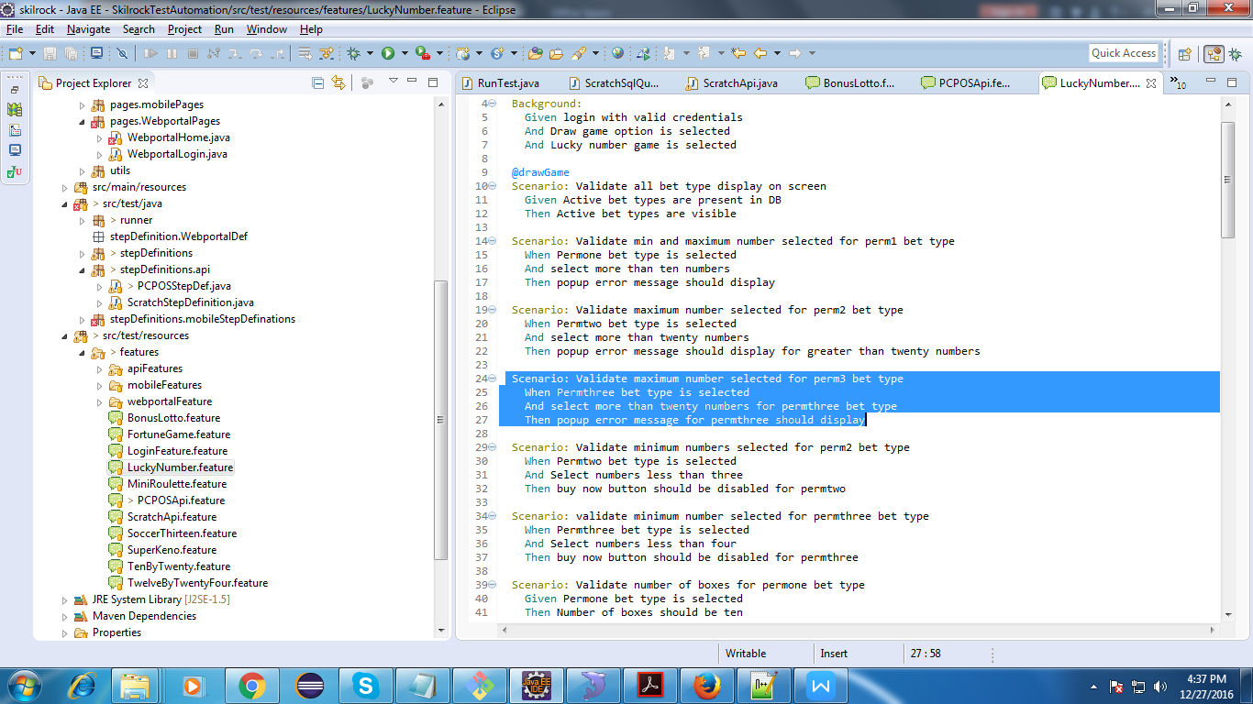

Step 2 : Create step definitions/methods for the steps marked as When And & Then as below :

@When(“^Permthree bet type is selected$”) //this regular expression is matched
public void method_name2() {

}
@When(“^select more than twenty numbers for permthree bet type$”)
public void method_name2() {

}

@Then(“^popup error message for permthree should display$”)
public void method_name3() {

}

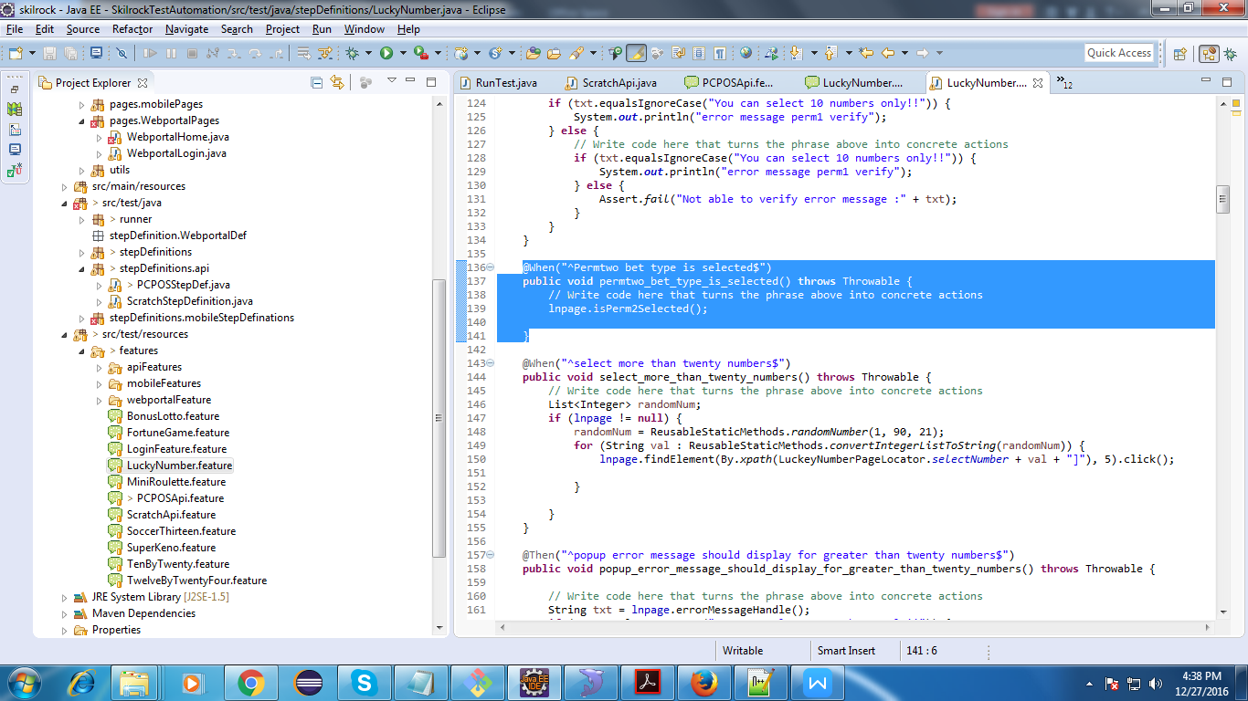

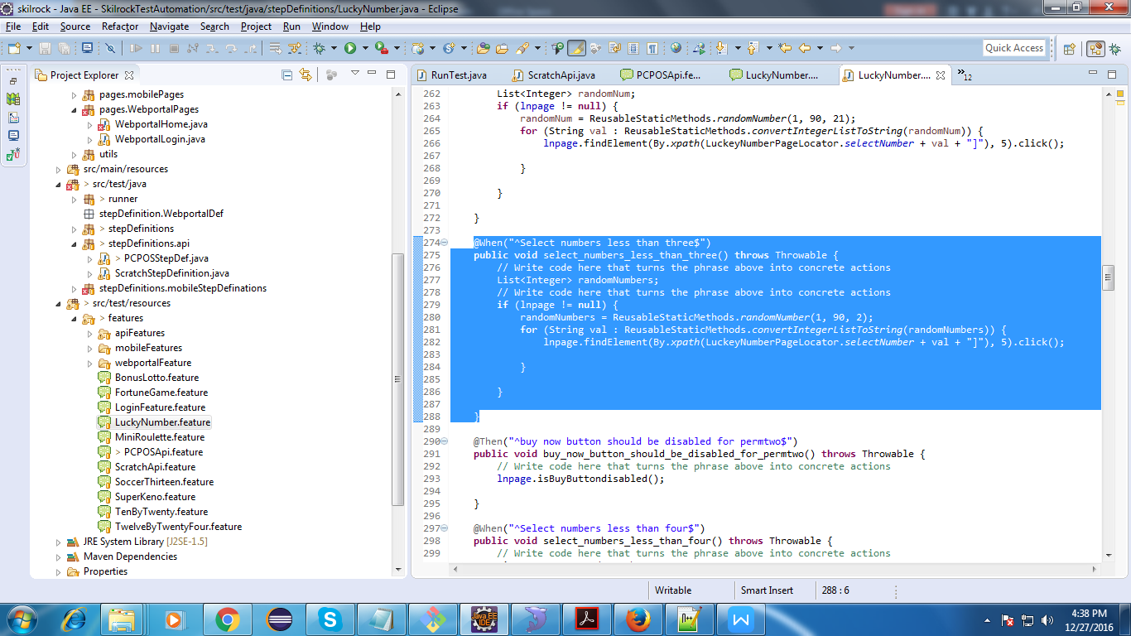

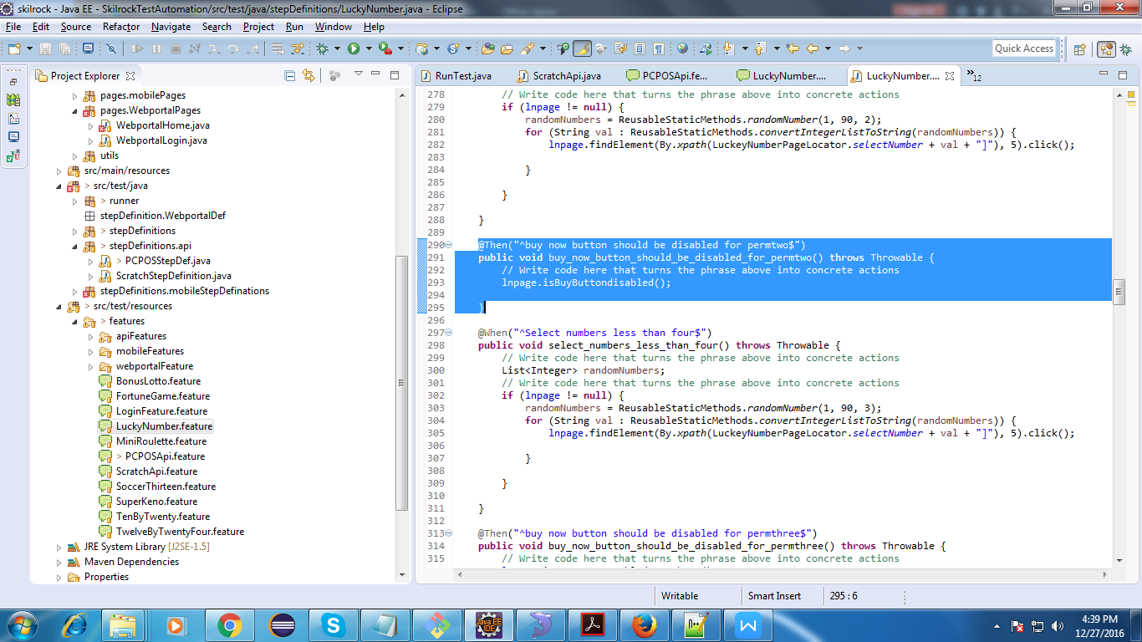

**Please note that the step definition/method that will be called on encountering a particular step in the feature file will depend on the Regular expression(inside the When, Then and Given tags) that matches the step.Method name inside the step definition file has no relevance in resolving method calling in this regard.
**Cucumber Tags Ref

Automation Framework Implemented :
- Common Utility functions are created under src/main/java/utils
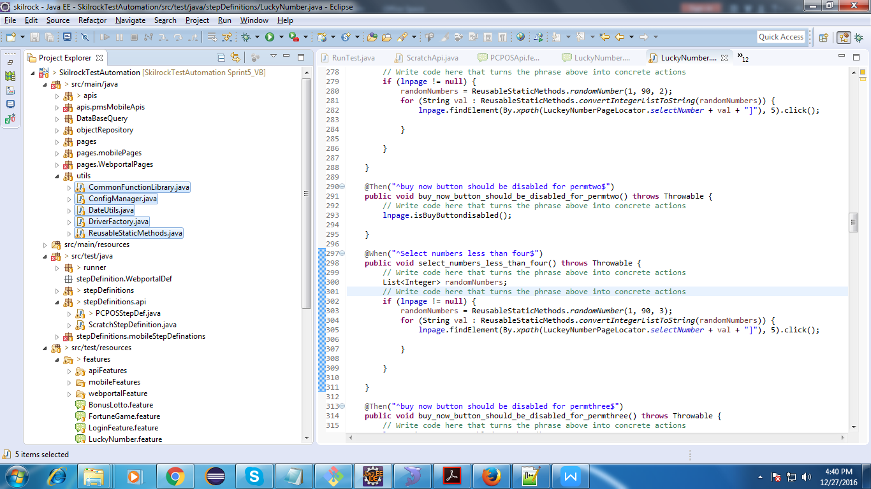

- POM and config file(.properties) are placed under the project
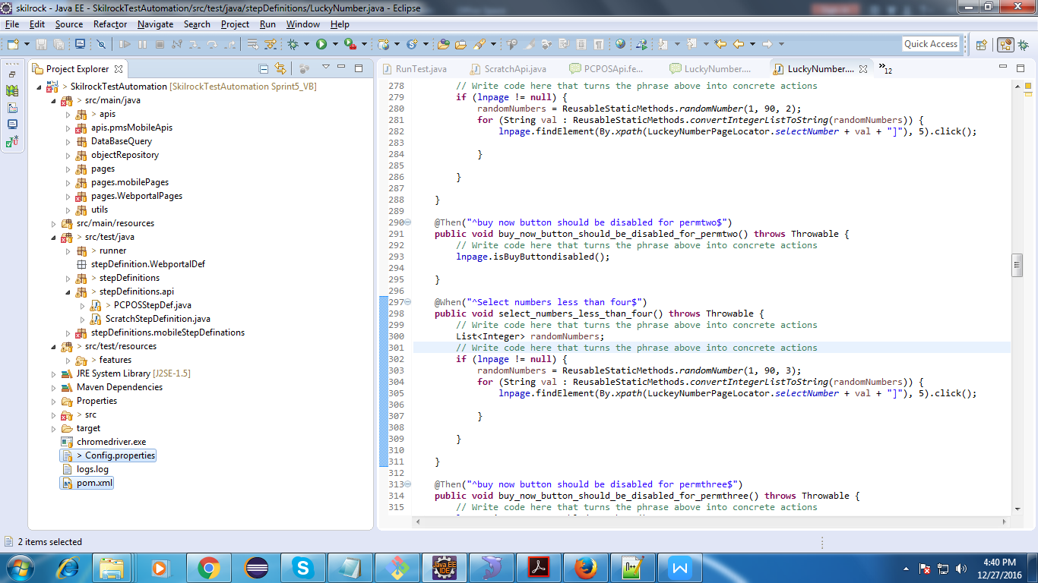

- Feature files(.feature) are placed under src/test/resources/features
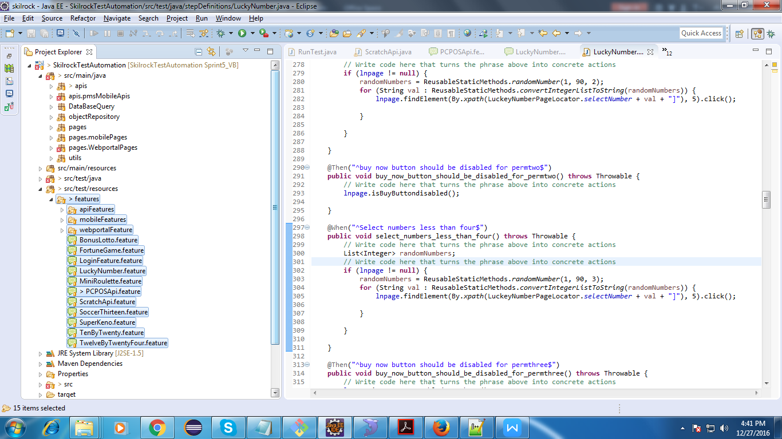
- Step definition files are placed under src/test/java/stepDefinitions
- Page object classes are created under src/main/java/pages
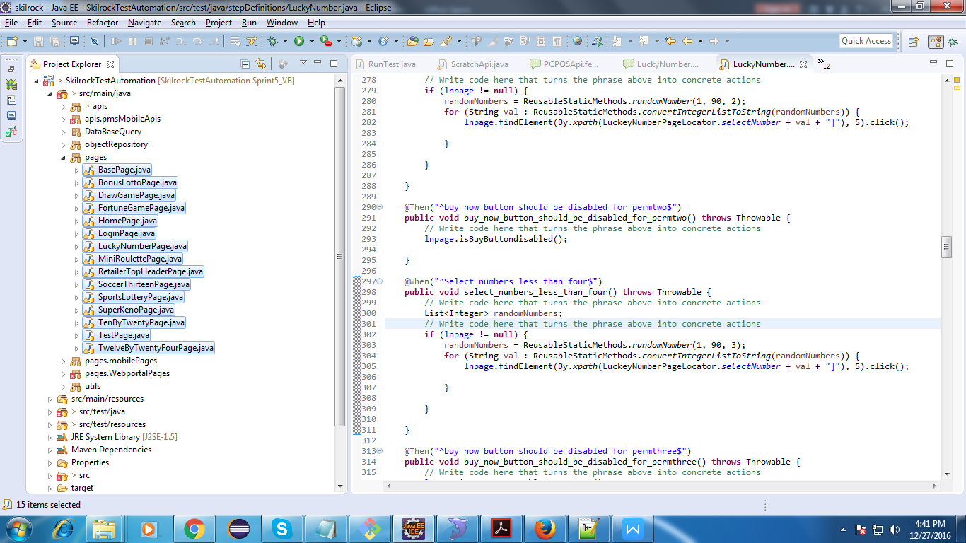

Dependencies to be added to POM for cucumber are as below :

<dependency>
<groupId>info.cukes</groupId>
<artifactId>cucumber-java</artifactId>
<version>1.0.2</version>
<scope>test</scope> </dependency>

<dependency>
<groupId>info.cukes</groupId>
<artifactId>cucumber-junit</artifactId>
<version>1.0.2</version>
<scope>test</scope> </dependency>

Sample POM File :
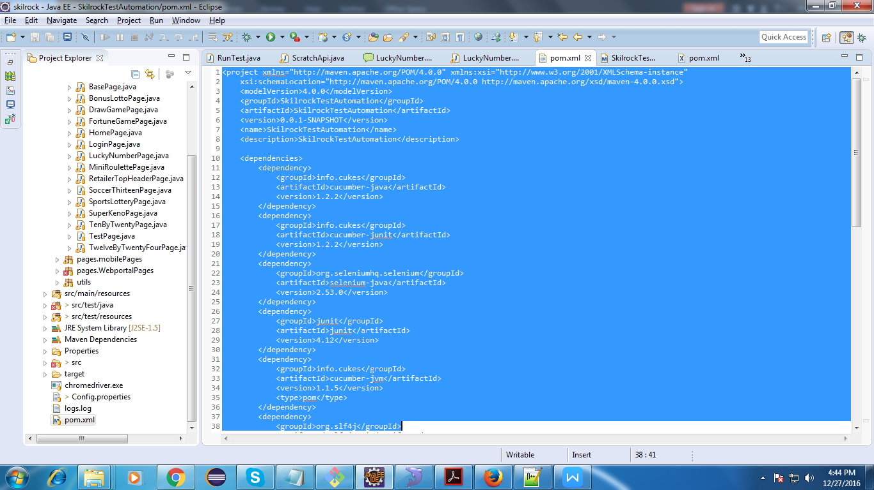

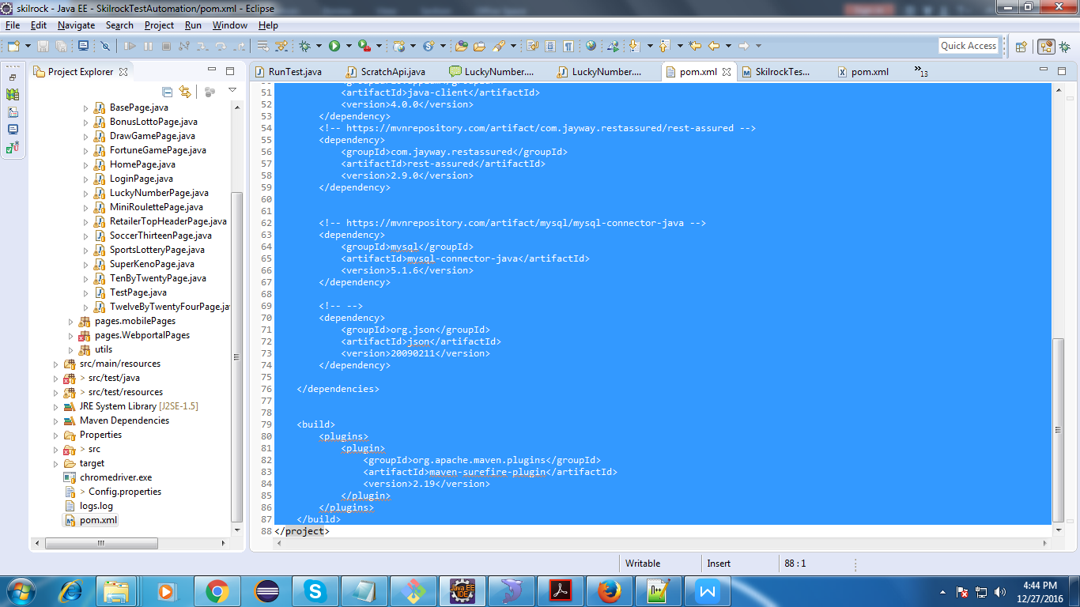

Feature File At a Glance :

Feature: validating various scenarios under mini-roulette

Background:
Given login with valid credentials MiniRoulette
And Draw game option is selected MiniRoulette
And miniRoulette is selected

Scenario Outline:
Given select bet amount<amount>
When select bet types randomly <N> n times
Then validate ticket price

Examples:
| amount | N |
| 20 | 2 |
| 50 | 2 |

Scenario Outline:
Given select bet amount<amount>
When select bet types randomly <N> n times
Then validate price per element

Examples:
| amount | N |
| 50 | 28 |

Scenario Outline:
Given select bet amount<amount>
When select bet types randomly <totalBetTypes> n times
And select <N> advance draw
Then validate ticket price

Examples:
| amount | totalBetTypes | N |
| 50 | 10 | 3 |

Scenario: Validate advance draw info with database
Given Advance draw is selected MiniRoulette
Then draw info should be matched with database MiniRoulette

Scenario Outline: Validate ticket number after sale
When any BetType ticket purchased <N>
And ticket preview display MiniRoulette
Then ticket number in preview should be equal to database value MiniRoulette

Examples:
| N |
| 10 |
Sample Feature File :
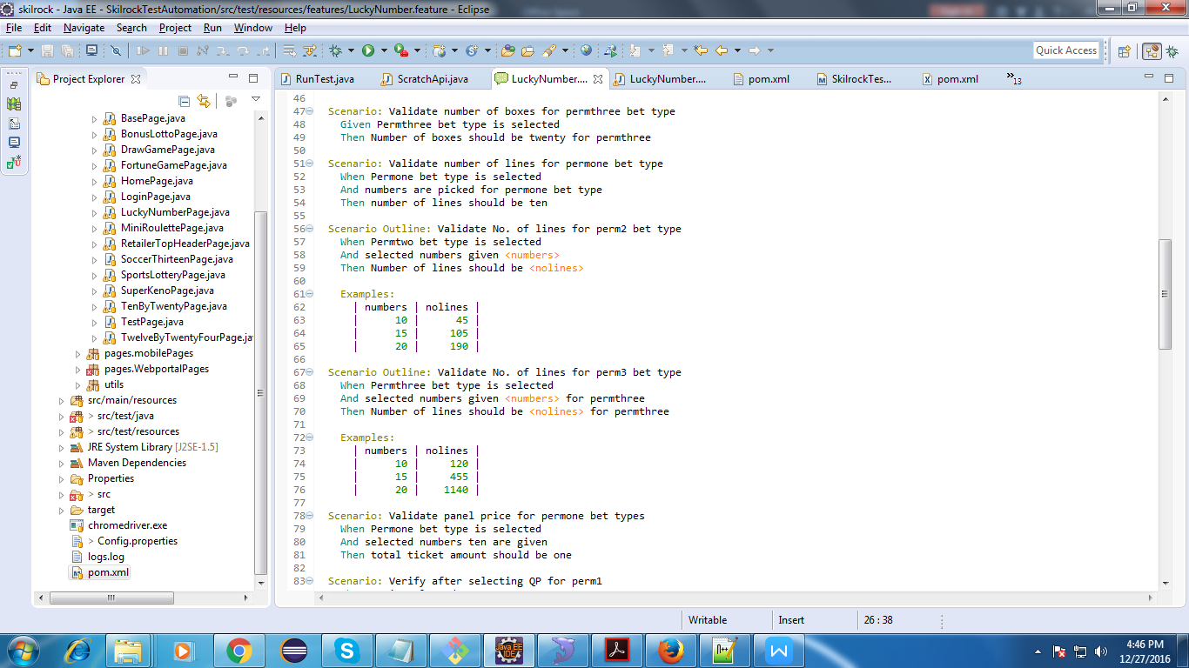

Customizing Scenarios for multiple inputs:
Scenario Outline: The scenarios define placeholders for user inputs which can be placed in the tabular form.
Example of a Scenario Outline is as below:

Scenario Outline:
Given select bet amount<amount>
When select bet types randomly <N> n times
Then validate ticket price

Examples:
| amount | N |
| 20 | 2 |
| 50 | 2 |

Here amounts and N are placeholders.Scenario outline is run for each record in the Examples table.
Background : Is used to specify steps that should be run before each scenario in the feature file.Example of a Background is as below :

Background:
Given login with valid credentials MiniRoulette
And Draw game option is selected MiniRoulette
And miniRoulette is selected

A Maven Project
- It is identified by a POM file which includes minimum information as below:
<project xmlns="http://maven.apache.org/POM/4.0.0" xmlns:xsi="http://www.w3.org/2001/XMLSchema-instance"
xsi:schemaLocation="http://maven.apache.org/POM/4.0.0 http://maven.apache.org/xsd/maven-4.0.0.xsd">
<modelVersion>4.0.0</modelVersion>
<groupId>SkilrockTestAutomation</groupId>
<artifactId>SkilrockTestAutomation</artifactId>
<version>0.0.1-SNAPSHOT</version>
<name>SkilrockTestAutomation</name>
<description>SkilrockTestAutomation</description>
</project>

- Various libraries to be included or used in the project have to be included as dependencies under the POM file
as shown below:
<dependency>
<groupId>io.appium</groupId>
<artifactId>java-client</artifactId>
<version>4.0.0</version>
</dependency>

- Maven accomplishes tasks/goals through plugins. To include plugin dependencies for a particular phase of build cycle use the following:
<build>
<plugins>
<plugin>
<groupId>org.apache.maven.plugins</groupId>
<artifactId>maven-surefire-plugin</artifactId>
<version>2.19</version>
</plugin>
</plugins>
</build>

**Reference For Maven
**Note: In the above we have mentioned maven surefire plugin which is used during test phase of build cycle. You can add other plugins similarly.

