Assignment 1
Introduction to Web Development
Name: Shivam Kumar Roll No: 2315002068 Class Roll no.: 74

Q1. Difference between Frontend, Backend, and Full-Stack Development
Web development is basically split into three parts depending on what side of the website a developer works on.
- Frontend Development – This is everything the user sees and interacts with directly in the browser, like the layout, colors, buttons, and menus. It is built using HTML, CSS, and JavaScript, and frameworks like React or Vue. Example: the news feed, like button, and stories bar on Instagram are all frontend work.
- Backend Development – This is the “hidden” part that runs on the server. It handles things like storing data, checking logins, and sending the right information back to the frontend. Common backend languages are Node.js, Python (Django/Flask), Java, and PHP, along with databases like MySQL or MongoDB. Example: when you log into Instagram, the backend checks your username and password against the database.
- Full-Stack Development – A full-stack developer can work on both the frontend and backend of a project. Example: a freelancer who builds a small business website end-to-end - designing the pages, writing the server code, and connecting it to a database - is doing full-stack work.

Q2. Diagram: How the Client-Server Model Works
The diagram below shows the basic request-response cycle between a client (browser) and a server.
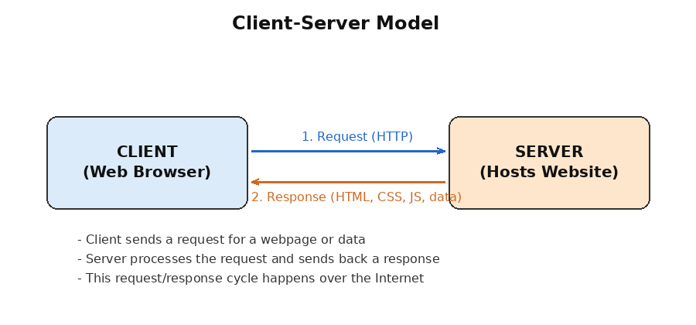

Q3. How a Browser Requests and Displays a Web Page
When we type a URL and hit enter, a whole sequence of steps happens behind the scenes before the page shows up:
- The browser checks the URL and sends a DNS lookup to convert the domain name (e.g. www.example.com) into an IP address.
- The browser opens a connection to the server at that IP address (a TCP connection, secured with TLS if it's HTTPS).
- The browser sends an HTTP request (usually a GET request) asking for the webpage.
- The server receives the request, processes it, and sends back a response - usually an HTML file along with a status code (like 200 OK).
- The browser starts reading the HTML from top to bottom and builds the DOM (Document Object Model).
- While parsing, the browser finds links to CSS and JS files and images, and requests those separately.
- CSS is used to build the CSSOM, which combines with the DOM to form the render tree.
- JavaScript runs and may change the page content or structure.
- Finally, the browser paints everything on the screen, and the page becomes visible to the user.

Q4. Tools Required to Set Up a Web Development Environment
- Code Editor (e.g. VS Code): used to write and edit HTML, CSS, JS and other code, with features like syntax highlighting and extensions.
- Web Browser (Chrome/Firefox): used to view and test the website, and their built-in Developer Tools help debug layout and JS issues.
- Git and GitHub: Git tracks changes made to the code, and GitHub is used to store and share the project online / collaborate with others.
- Node.js and npm: Node.js lets JavaScript run outside the browser, and npm (Node Package Manager) is used to install libraries and tools.
- Terminal / Command Line: used to run commands, start servers, install packages, and use Git.
- Live Server / Local Server: runs the project on localhost so changes can be previewed instantly while developing.
- Database Software (MySQL/MongoDB): needed once the project has a backend, to store and manage data.
- API Testing Tool (Postman): used to test backend APIs by sending requests and checking the responses, without needing a frontend.

Q5. What is a Web Server?
A web server is a combination of software (and sometimes dedicated hardware) that stores the files of a website and responds to requests sent by browsers over HTTP or HTTPS. When a browser asks for a page, the web server is the one that receives that request, finds the correct file/data, and sends it back.
Some commonly used web servers are:
- Apache HTTP Server - one of the oldest and most widely used open-source web servers.
- Nginx - known for being lightweight and handling a large number of requests efficiently.
- Microsoft IIS (Internet Information Services) - commonly used with Windows-based servers and ASP.NET applications.
- Node.js (with Express) - lets developers create a custom web server using JavaScript.
- Apache Tomcat - mainly used for running Java-based web applications.

Q6. Roles in a Project: Frontend, Backend, and Database Administrator
- Frontend Developer: responsible for designing and building the parts of the website that users see and interact with. They focus on layout, responsiveness (making sure the site works on mobile and desktop), and making sure it looks and feels good to use.
- Backend Developer: responsible for the server-side logic - handling requests, authentication, business rules, and connecting the frontend to the database through APIs. They also make sure the application is secure and performs well.
- Database Administrator (DBA): responsible for designing the database structure, keeping the data organized and secure, taking regular backups, and optimizing the database so queries run fast even when there is a lot of data.

Q7. Installing and Configuring VS Code for HTML, CSS and JavaScript
Steps I followed to set up VS Code:
- Downloaded the installer from the official site: code.visualstudio.com, for my operating system.
- Ran the installer and kept the default options selected, including “Add to PATH” so VS Code can be opened from the terminal.
- Opened VS Code and went to the Extensions panel (Ctrl+Shift+X) to install a few helpful extensions:
- Live Server - to run and auto-refresh HTML pages in the browser while editing.
- Prettier - to auto-format code consistently.
- HTML CSS Support - for better autocomplete in HTML/CSS files.
- Auto Rename Tag - automatically renames the matching closing HTML tag.
- Created a new project folder with index.html, style.css and script.js, and opened the folder in VS Code.
- Wrote a basic HTML page and right-clicked to choose “Open with Live Server” to preview it in the browser and confirm everything was working.
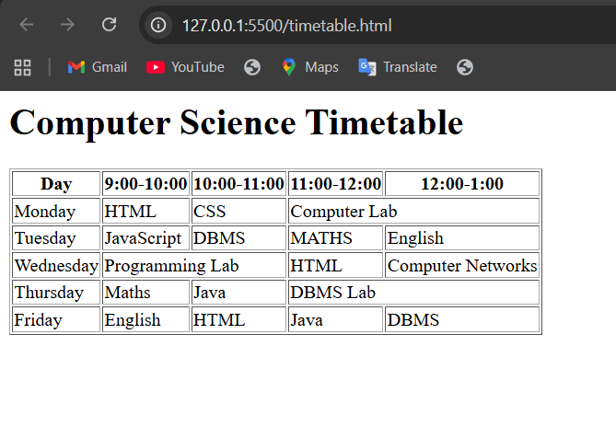

Q8. Static vs Dynamic Websites
- Static Website: the content is fixed and shows the same thing to every visitor. The pages are plain HTML/CSS files that don't change unless someone manually edits the code, and there's no server-side processing involved. Example: a simple personal portfolio or resume website that just shows your projects and contact details.
- Dynamic Website: the content can change based on the user, time, or data stored in a database, and it uses server-side scripting to generate pages on the fly. Example: Amazon.com, where the homepage shows different product recommendations, prices, and your cart contents depending on who is logged in.

Q9. Five Web Browsers and Their Rendering Engines
- Google Chrome - uses the Blink rendering engine.
- Mozilla Firefox - uses the Gecko rendering engine.
- Safari - uses the WebKit rendering engine.
- Microsoft Edge - uses the Blink engine (it switched to Chromium/Blink in 2020, before that it used its own EdgeHTML).
- Opera - also uses the Blink engine, since it is built on Chromium.
The rendering engine is the part of the browser that takes the HTML and CSS and converts it into what we actually see on screen. Because Chrome, Edge and Opera are all Chromium-based, they use the same Blink engine and usually render pages very similarly. Blink itself was originally forked from WebKit (which Safari still uses), so the two are related but have since developed separately. Firefox's Gecko engine was built independently by Mozilla, so it sometimes supports new CSS/JS features on a different timeline and can occasionally render small details - like font rendering or edge-case CSS - slightly differently from the Chromium-based browsers.

Q10. Labeled Diagram: Basic Web Architecture Flow
The diagram below shows how the client, server, database and APIs are all connected in a typical web application.
