**Project : Supply Chain Analysis**

**Table of Contents:**

· Problem Statement

· Data Analysis using MySQL

· Build Dashboard Or a Report using Tableau

· Tools, Software and Libraries

Problem Statement

KPI’s REQUIREMENT

We need to analyse key indicators for our Supply Chain data to gain insights into our business performance. Specifically, we want to calculate the following metrics:

1. Total Revenue generated
2. Total Orders Quantity
3. Total Availability
4. Total Stocks Levels
5. Total Lead Times

**Data Analysis using MySQL**

Utilized MySQL for data extraction and calculation of key metrics such as Total Revenue Generated, Total Orders Quantity, Total Availability, Total Stocks Levels, Total Lead Times.

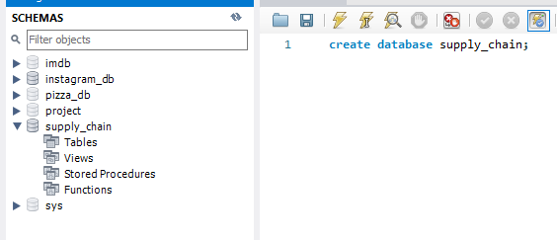

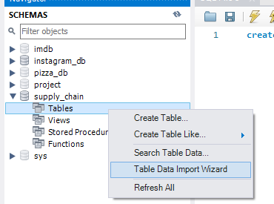

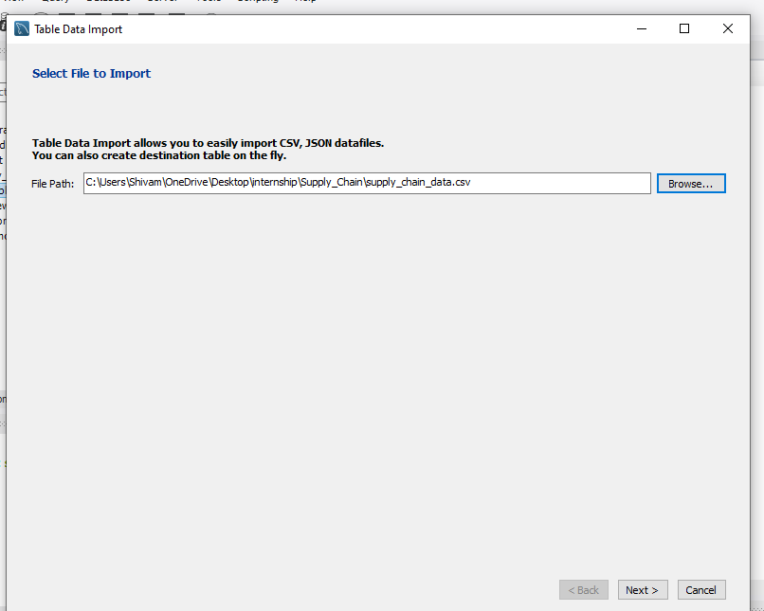

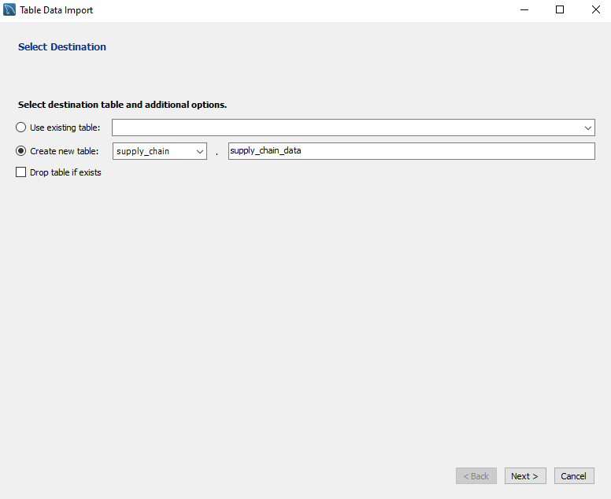

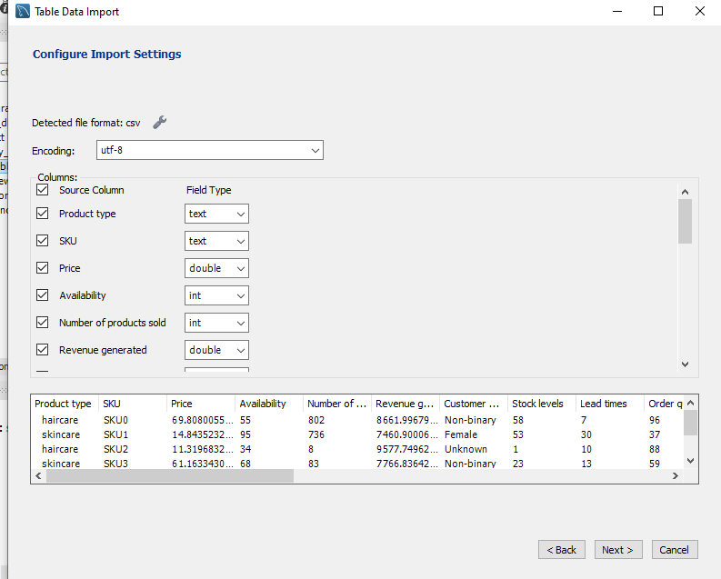

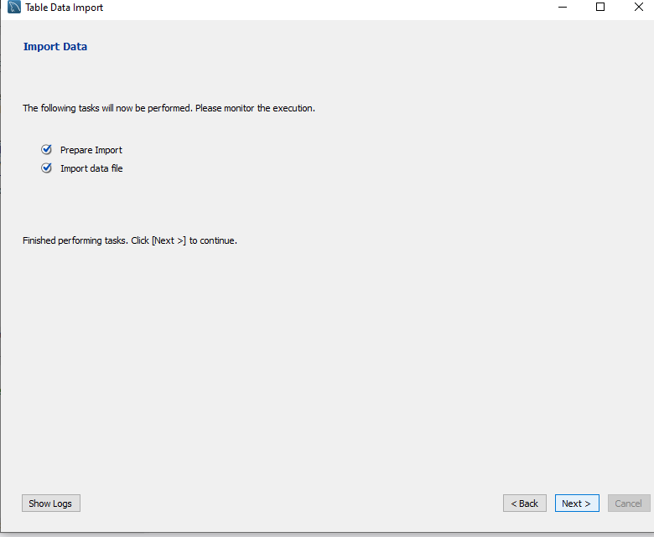

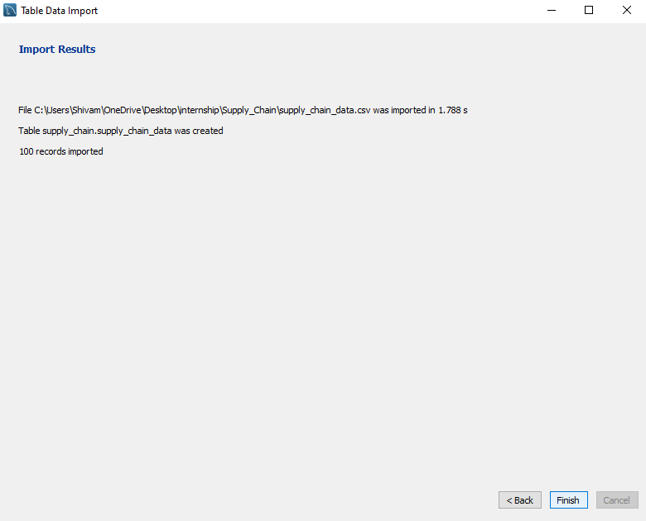

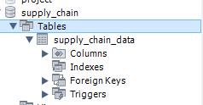

**SUPPLY CHAIN MANAGEMENT SQL QUERIES**

1. KPI’s
2. Total Revenue Generated:

select sum(Revenue_generated) as Total_Revenue_Generated from supply_chain_data;

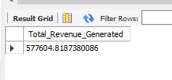

1. Total Orders Quantity:

select sum(Order_quantities) as Total_Orders_Quantity from supply_chain_data;

Output

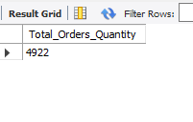

1. Total Availability:

select sum(Availability) as Total_Availability from supply_chain_data;

Output:

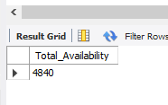

1. Total Stocks Levels :

select sum(Stock_levels) as Total_Stocks_Levels from supply_chain_data;

Output:

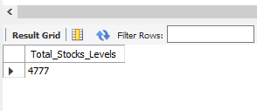

1. Total Lead Times:

select sum(Lead_time) as Total_Lead_Times from supply_chain_data;

Output:

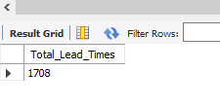

1. Revenue Distribution
2. Revenue Generated by Product Type:

select Product_type, sum(Revenue_generated) as Revenue_generated

from supply_chain_data

group by Product_type;

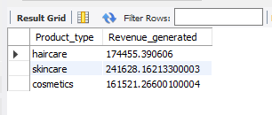

1. Revenue Generated by Location

select Location, cast(sum(Revenue_generated) as decimal(10,2)) as Revenue_generated

from supply_chain_data

group by Location;

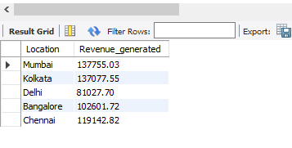

1. Revenue Generated by Price Range

select Price, cast(sum(Revenue_generated) as decimal(10,2)) as Revenue_generated

from supply_chain_data

group by Price

order by Price;

Output

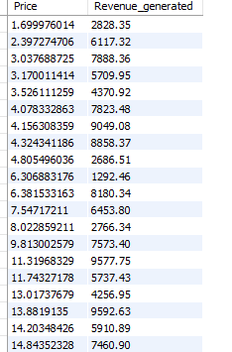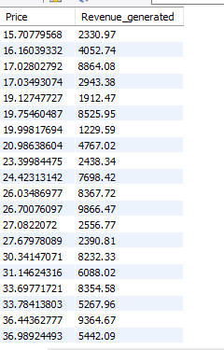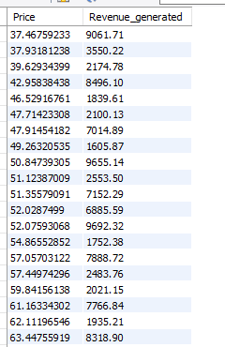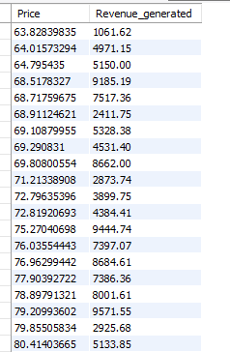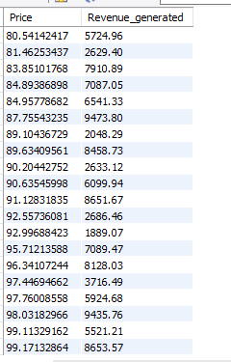

1. Distribution Manufacturing Cost
2. Relationship between Manufacturing Cost and Revenue Generated

select Product_type ,

cast(sum(Manufacturing_costs) as Decimal(10,2)) as Manufacturing_Cost,

cast(sum(Revenue_generated) as decimal(10,2)) as Revenue_generated

from supply_chain_data

group by Product_type

order by Product_type;

Output

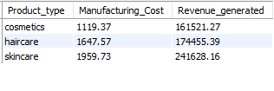

1. Distribution of manufacturing Costs by Supplier Name

select Supplier_name as Suppler_Name, sum(Manufacturing_costs) AS Manufacturing_costs

from supply_chain_data

group by Supplier_Name

order by Supplier_Name;

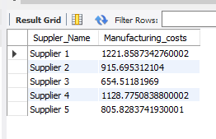

1. Distribution of manufacturing Costs by Production Volumes

select Production_volumes, sum(Manufacturing_costs) AS Manufacturing_costs

from supply_chain_data

group by Production_volumes

order by Production_volumes;

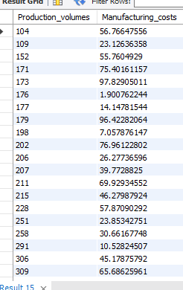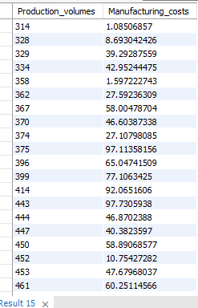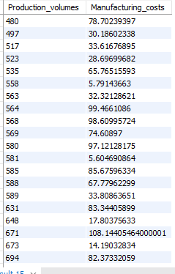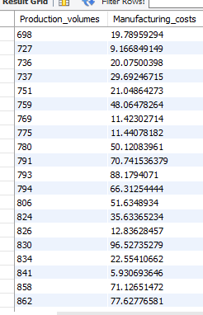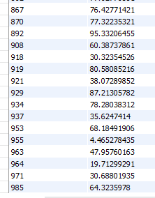

1. Manufacturing Cost by Inspection Results

select Inspection_results, sum(Manufacturing_costs) AS Manufacturing_costs

from supply_chain_data

group by Inspection_results

order by Inspection_results;

Output

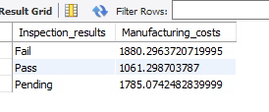

1. Comparison of Manufacturing Costs and Price by Product Type

select Product_type,

cast(sum(Price) as decimal(10,2)) as Price,

cast(sum(Manufacturing_costs) as decimal(10,2)) AS Manufacturing_costs

from supply_chain_data

group by Product_type

order by Product_type;

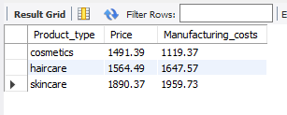

1. Manufacturing Cost by Product Type

select Product_type,

cast(sum(Manufacturing_costs) as decimal(10,2)) AS Manufacturing_costs

from supply_chain_data

group by Product_type

order by Product_type;

Output

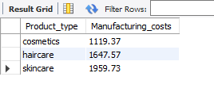

1. Orders & Shipping Cost
2. Order Quantity by Location

select Location, sum(Order_quantities) as Order_Quantity

from supply_chain_data

group by Location

order by Location;

Output

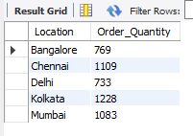

1. Average Order Quantity by Shipping Cost

select Shipping_costs,

avg(Order_quantities) as Avg_Order_Quantity

from supply_chain_data

group by Shipping_costs

order by Shipping_costs;

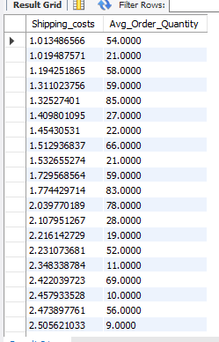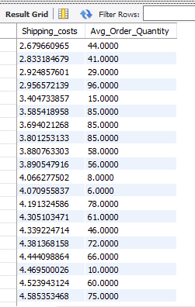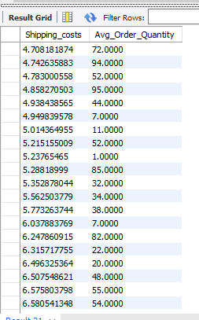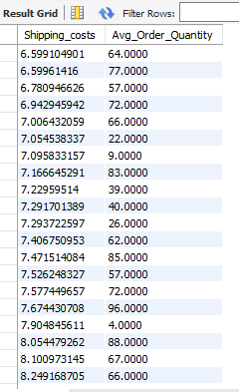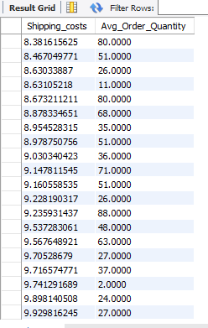

1. Relationship between Total Sipping Costs and Number of Product Sold

select Customer_demographics,

sum(Number_of_products_sold) as Number_of_products_sold,

cast(sum(Shipping_costs) as decimal(10,2)) as Total_Shipping_Cost

from supply_chain_data

group by Customer_demographics

order by Customer_demographics;

Output

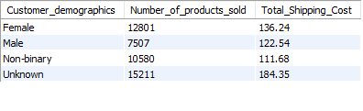

1. Shipping Costs by Shipping Carriers

select Shipping_carriers,

cast(sum(Shipping_costs) as decimal(10,2)) as Total_Shipping_Cost

from supply_chain_data

group by Shipping_carriers

order by Shipping_carriers;

Output

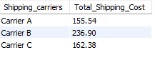

1. Shipping Costs by Transportation Mode

select Transportation_modes,

cast(sum(Shipping_costs) as decimal(10,2)) as Total_Shipping_Cost

from supply_chain_data

group by Transportation_modes

order by Transportation_modes;

Output

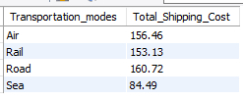

1. Avg. Lead Time by Product Type

select Product_type,

avg(Lead_times) as Avg_Lead_Time

from supply_chain_data

group by Product_type

order by Product_type;

Output

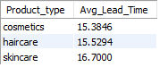

1. Avg. Defect Rate by Product Type

select Product_type,

cast(avg(Defect_rates) as decimal(10,2)) as Avg_Defect_Rate

from supply_chain_data

group by Product_type

order by Product_type;

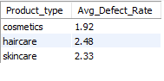

1. Relationship between Production Volumes and Stocks

select Stock_levels, sum(Production_volumes)

from supply_chain_data

group by Stock_levels

order by Stock_levels;

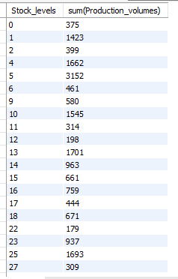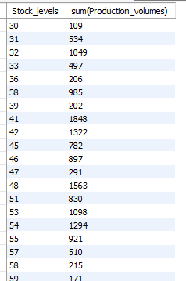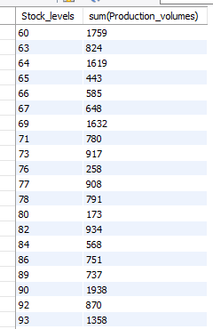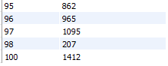

Build Dashboard or a Report using Tableau

Created a comprehensive dashboard in Tableau featuring key metrics and charts,

KPI’S

* Total Revenue generated Sum([Revenue_generated])
* Total Orders Quantity Sum([Orders_quantity])
* Total Availability Sum([Availability])
* Total Stocks Levels Sum([Stocks_levels])
* Total Lead Times Sum([Lead_times])

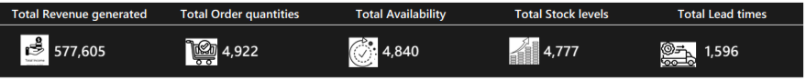

DASHBOARD

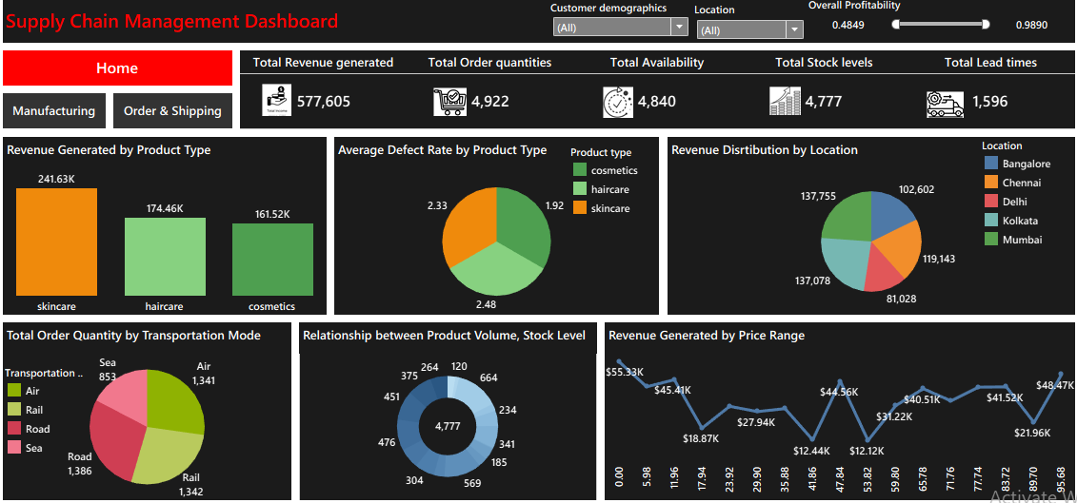

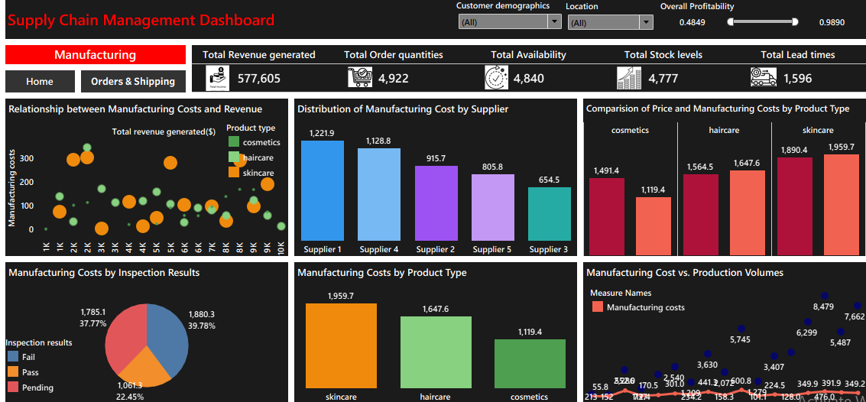

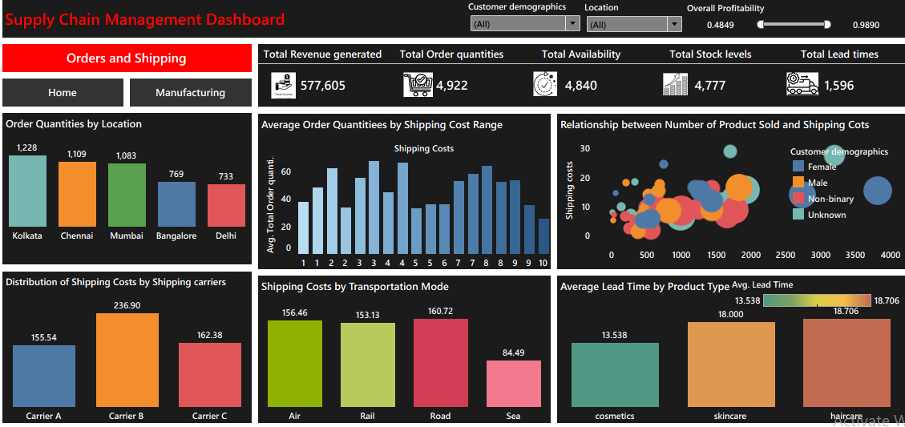

Tools, Software, and Libraries

**· MySQL Workbench 8.0 CE**

for data analysis and storage

**· Tableau Public 2025.2.0**

for dashboard creation and visualization

**· Excel version 2024**

for initial data exploration and manipulation