STRIDE Threat Model – Flipkart E-commerce Platform
Assignment 1 – Secure Software Engineering

1. System Overview
This threat model analyzes Flipkart, India's leading e-commerce marketplace serving 400M+ registered users and 500K+ sellers. The platform follows a microservices architecture deployed on Flipkart Cloud. Key components include:
- API Gateway (Kong/Zuul) – request routing, rate limiting, and authentication.
- User & Auth Service – OTP-based mobile login and email/password authentication.
- Product & Search Service – MySQL catalog with Elasticsearch for full-text search.
- Cart & Checkout Service – handles flash sales (Big Billion Days) with inventory holds.
- Order Management Service – coordinates fulfillment with Ekart logistics.
- Payment Service – integrates Razorpay and PayU gateways within a PCI DSS compliant zone.
- Seller Portal Service – marketplace operations, listing management, and seller KYC.
- Notification Service – SMS, email, and push notifications via external providers.

Scope
In-scope: product browsing and search, user registration and OTP login, cart and checkout, order placement and tracking, seller onboarding and listing management, payment processing, and delivery coordination via Ekart.
Out-of-scope: Flipkart Grocery (separate app), Myntra integration, advertising platform, and internal data analytics pipelines.

2. DFD Level 0 – Context Diagram
The context diagram shows external entities (Customer, Seller, Admin, Payment Gateway, Ekart Logistics, SMS/Email Provider) interacting with the Flipkart Platform and backend databases across a trust boundary.
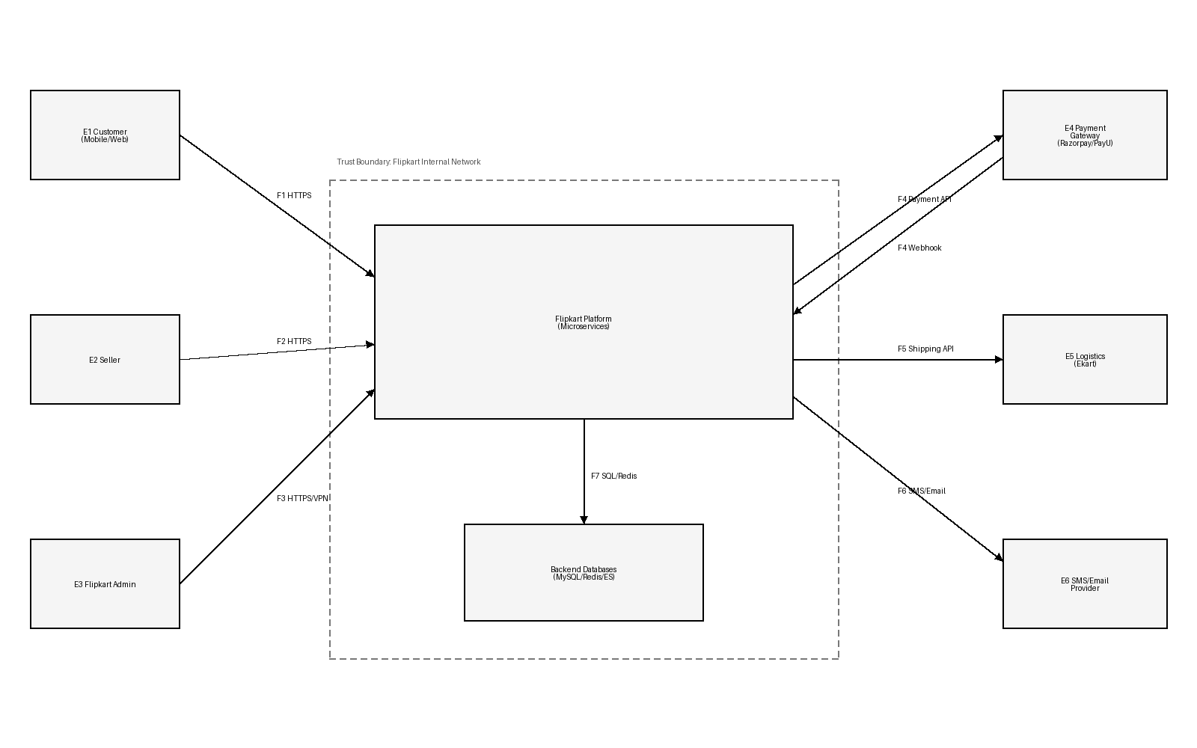

3. DFD Level 1 – Internal Microservices
The Level 1 DFD decomposes the platform into eight processes (P1–P8), six data stores (D1–D6), and data flows between them. The Payment Service (P7) resides in a dedicated PCI compliance zone.
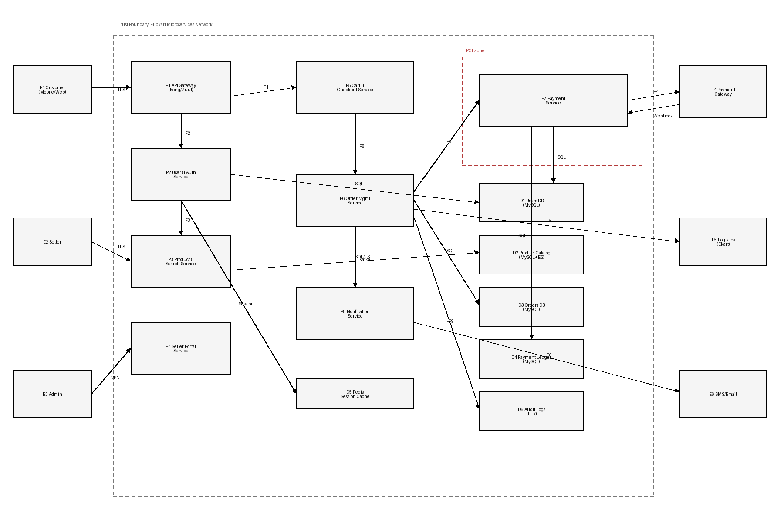

4. STRIDE Mapping Summary
Spoofing: OTP brute-force on mobile login, credential stuffing, fake seller registration, payment webhook forgery, admin phishing, and mobile API key extraction.
Tampering: Price/coupon manipulation at checkout, SQL injection on search filters, stored XSS in reviews, cart bombing during flash sales, seller price manipulation, and API gateway request smuggling.
Repudiation: Delivery disputes without proof, refund fraud, and audit log tampering.
Information Disclosure: Mass PII exposure, payment card data leakage (PCI DSS violation), and mobile app session token extraction.
Denial of Service: Flash sale DDoS (Big Billion Days) and cart inventory hold abuse.
Elevation of Privilege: IDOR on order/address endpoints enabling cross-user data access.

5. STRIDE Threat Table
The table below lists all 20 identified threats with STRIDE classification, attack scenarios, risk ratings, and mitigations.
ElementID | STRIDE | Description | AttackScenario | Likelihood | Impact | Priority | Mitigation
P1 | T | API Gateway request smuggling | Attacker crafts ambiguous HTTP requests to bypass Kong/Zuul gateway routing rules and reach internal microservices directly, potentially accessing admin-only endpoints. | Medium | High | High | Normalize and validate HTTP requests at gateway, disable HTTP/1.0, enforce strict parsing, and run regular smuggling tests.
P2 | S | OTP brute-force on Flipkart login | Flipkart uses OTP-based mobile login. Attacker automates rapid OTP guesses (4-6 digit) against /api/auth/verify-otp to take over accounts without knowing the password. | High | High | High | Rate-limit OTP attempts per phone number, enforce exponential backoff, use CAPTCHA after failed attempts, and expire OTPs within 60 seconds.
P2 | S | Credential stuffing on email/password login | Attacker uses leaked credential databases to automate login attempts against Flipkart accounts that still use email/password. | High | High | High | Breached-password detection, adaptive MFA, device fingerprinting, and account lockout after repeated failures.
P5 | T | Price/coupon tampering during checkout | Attacker intercepts Flipkart checkout API calls and modifies cart total, discount amount, or coupon code in the request body to pay less than the actual price. | Medium | High | High | Server-side price recalculation from catalog DB, signed cart tokens, coupon validation on backend, and re-verify totals before payment.
P6 | E | IDOR on order details and address endpoints | Authenticated customer changes orderId or addressId in /api/orders/{id} or /api/address/{id} to view or modify another user's order details, delivery address, or phone number. | High | High | High | Enforce object-level authorization: verify that the requesting user owns the resource on every API call. Use UUIDs instead of sequential IDs.
E2 | S | Fake seller registration and listing fraud | Attacker registers as a seller with stolen GST/PAN details, lists counterfeit or non-existent products at attractive prices, collects payments, and never ships goods. | Medium | High | High | KYC verification (video, bank account, GST validation), seller escrow with delayed payouts, and automated fraud scoring.
F4 | S | Razorpay/PayU webhook spoofing | Attacker forges a payment success webhook to /api/payment/callback causing Flipkart to mark an unpaid order as paid and ship the product. | Medium | High | High | Verify webhook HMAC signatures using shared secret, validate payment amount matches order total, and perform server-to-server verification with Razorpay Orders API.
D1 | I | Mass user PII exposure (phone, Aadhaar, address) | Database breach or misconfigured backup exposes 400M+ user records including phone numbers, delivery addresses, and saved payment methods to attackers. | Medium | High | High | Encrypt sensitive columns (AES-256), use envelope encryption with AWS KMS, restrict DB access via IAM, encrypt backups, and implement data masking for non-production environments.
P3 | T | SQL injection on product search/filter | Attacker injects SQL via search query, price range filter, or sort parameter on /api/products/search to extract product catalog data, seller information, or pricing strategies. | Medium | High | High | Use parameterized queries for MySQL, validate Elasticsearch query DSL, sanitize all filter inputs, and use ORM (Hibernate) consistently.
P5 | D | Flash sale DDoS (Big Billion Days) | During Flipkart Big Billion Days sale, attackers or scalper bots flood the cart/checkout APIs with millions of requests to exhaust inventory holds and crash the checkout pipeline. | High | High | High | CDN-level DDoS protection (Akamai), rate limiting per user/IP, queue-based checkout (virtual waiting room), bot detection via device fingerprinting, and auto-scaling cart microservice.
P3 | T | Stored XSS in product reviews and Q&A | Attacker posts a product review or Q&A answer containing JavaScript that executes in other customers' browsers, stealing session tokens or redirecting to phishing pages. | Medium | Medium | Medium | Server-side HTML sanitization (OWASP Java HTML Sanitizer), output encoding, strict CSP headers, and review moderation pipeline.
D4 | I | Payment card data exposure (PCI DSS violation) | Saved card details (CVV, full PAN) stored in plaintext in payment ledger or application logs, leading to mass card fraud if breached. | Low | High | High | Tokenize card data via Razorpay vault, never store CVV, truncate PAN to last 4 digits, achieve PCI DSS Level 1 compliance, and scan logs for accidental card data leakage.
E3 | S | Admin account phishing and session hijack | Attacker sends targeted phishing email to Flipkart admin, stealing credentials or admin session cookie to access seller payout controls, catalog management, and user data. | Medium | High | High | Hardware security keys (FIDO2) for admin login, admin-only VPN, session binding to IP/device, privileged access management (PAM), and just-in-time access elevation.
P4 | T | Seller inventory and price manipulation | Compromised seller account or API key is used to bulk-update product prices to 1 INR or inflate stock counts to win Buy Box placement unfairly. | Medium | Medium | Medium | Anomaly detection on price/stock changes (>50% deviation triggers review), seller API rate limits, and mandatory 2FA for bulk updates.
P6 | R | Delivery dispute: customer denies receipt | Customer claims product was not delivered despite successful handoff. Without signed proof of delivery, Flipkart must refund and absorb the loss. | Medium | Medium | Medium | OTP-verified delivery, photo proof of delivery via Ekart app, GPS-stamped delivery events, and centralized dispute audit trail.
D6 | R | Audit log tampering or deletion | Insider or attacker with DB access deletes or modifies audit logs to cover tracks after unauthorized data access or fraudulent refund processing. | Low | Medium | Medium | Write-once append-only log storage, ship logs to centralized SIEM (Splunk/ELK) in real-time, cryptographic log integrity (hash chains), and separate log-admin role.
F1 | I | Session token leakage from mobile app | Flipkart Android/iOS app stores JWT or session token in SharedPreferences/NSUserDefaults without encryption. Malware or rooted device extracts tokens for account takeover. | Medium | High | High | Store tokens in Android Keystore / iOS Keychain, use certificate pinning, detect rooted/jailbroken devices, and bind tokens to device fingerprint.
P5 | T | Cart bombing / inventory hold abuse | Attacker adds limited-stock flash sale items to thousands of carts via automated scripts, holding inventory without purchasing to deny legitimate buyers access. | Medium | Medium | Medium | Short cart reservation timeouts (5 min for flash sales), per-user quantity limits, bot detection (CAPTCHA on add-to-cart during sales), and inventory release on timeout.
P1 | S | Mobile app API key extraction | Attacker reverse-engineers Flipkart APK to extract API keys, client secrets, or hardcoded credentials used for internal service authentication. | Medium | Medium | Medium | Use OAuth2 device flow instead of embedded secrets, obfuscate APK (ProGuard/R8), rotate API keys frequently, and monitor for anomalous API key usage patterns.
P7 | R | Refund fraud with insufficient evidence | Customer or seller disputes a transaction. Without signed receipts, delivery proof, or immutable payment logs, Flipkart cannot prove the transaction occurred, leading to chargebacks. | Medium | Medium | Medium | Store signed payment receipts, maintain immutable transaction ledger, integrate Razorpay dispute evidence API, and implement automated chargeback response.

6. Likelihood and Impact Scale
Likelihood: Low (requires insider access or advanced skill), Medium (feasible with publicly available tools and moderate effort), High (easily automated or frequently observed in the wild).
Impact: Low (limited to individual user inconvenience), Medium (financial loss or data exposure affecting a subset of users), High (platform-wide outage, mass data breach, regulatory penalties under IT Act 2000 or DPDP Act 2023).

7. Top 8 Prioritized Risks and Mitigations

1. OTP brute-force account takeover
Rationale: Flipkart's OTP login (4-6 digits) is vulnerable to automated guessing. Successful attack gives full account access including saved addresses, payment methods, and order history for 400M+ users.
Short-term mitigation: Rate-limit OTP attempts to 3 per phone/10 min, CAPTCHA on retry, 60-second OTP expiry.
Long-term mitigation: Adaptive risk-based authentication, device binding, and behavioral biometrics to detect automated attempts.

2. IDOR on order/address endpoints
Rationale: Sequential or predictable order IDs allow any authenticated user to access other users' orders, addresses, and phone numbers — a direct violation of DPDP Act 2023.
Short-term mitigation: Enforce object-level authorization on every endpoint; use UUIDs.
Long-term mitigation: Centralized authorization policy engine (OPA), automated IDOR scanning in CI/CD, and bug bounty program.

3. Price/coupon tampering at checkout
Rationale: Client-side price manipulation during checkout causes direct financial loss. During Big Billion Days with millions of transactions, even small per-order fraud scales massively.
Short-term mitigation: Server-side price recalculation from catalog DB, signed cart tokens.
Long-term mitigation: Order integrity microservice with real-time fraud scoring and automated anomaly alerting.

4. Razorpay/PayU webhook spoofing
Rationale: Forged payment success webhooks cause Flipkart to ship products without receiving payment. Direct revenue loss per incident.
Short-term mitigation: Verify HMAC signatures on all webhooks, validate amounts, and perform server-to-server payment status verification.
Long-term mitigation: Idempotent payment reconciliation service with automated discrepancy detection and alerting.

5. Flash sale DDoS (Big Billion Days)
Rationale: BBD generates 10x normal traffic. Attackers or scalper bots can amplify this to crash checkout, causing massive revenue loss and reputational damage.
Short-term mitigation: CDN-level DDoS protection, per-user rate limits, virtual waiting room queue for checkout.
Long-term mitigation: Bot detection ML model, auto-scaling microservices, and chaos engineering for flash sale resilience testing.

6. Mass user PII exposure
Rationale: 400M+ user records (phone, address, Aadhaar) make Flipkart a high-value target. Breach triggers DPDP Act penalties and catastrophic trust loss.
Short-term mitigation: Encrypt PII columns with AES-256, AWS KMS key management, and restrict DB access via IAM policies.
Long-term mitigation: Data classification and tokenization, DLP monitoring, and zero-trust database access architecture.

7. Fake seller registration and listing fraud
Rationale: Fraudulent sellers damage marketplace trust, cause financial losses to buyers, and expose Flipkart to regulatory action.
Short-term mitigation: Mandatory KYC with GST/PAN verification, escrow with 7-day payout hold for new sellers.
Long-term mitigation: ML-based seller fraud scoring, automated listing quality checks, and cross-platform fraud intelligence sharing.

8. Admin account compromise
Rationale: Admin access to seller payouts, catalog, and user data makes it a high-value target. Single compromised admin can cause platform-wide damage.
Short-term mitigation: FIDO2 hardware keys for admin auth, VPN-only admin access, and IP-bound sessions.
Long-term mitigation: Privileged access management (PAM), just-in-time access elevation, and continuous admin behavior monitoring.

8. Assumptions
- Flipkart uses a microservices architecture with an API Gateway (Kong/Zuul) as the single entry point.
- User authentication is primarily OTP-based mobile login with email/password as secondary.
- Payment processing is handled by external gateways (Razorpay, PayU) with Flipkart's Payment Service in a PCI DSS compliant zone.
- Ekart is the primary logistics partner with API-based integration.
- Seller Portal is a separate service with its own authentication flow.
- Data stores include MySQL for transactional data, Elasticsearch for product search, and Redis for session caching.
- Inter-service communication uses gRPC and Kafka event streams.

