#### Meteorological Drought

Meteorological drought is defined in terms of degree of dryness and quantity of precipitation deficit (compared to normal or average precipitation) (Wilhite and Glantz, 1985). Since the precipitation patterns and atmospheric conditions are highly region specific, which differs from region to region, meteorological drought must be considered as region specific. Different regions prefer different approaches or scales to define drought such as, for example, regions such as Manaus, Brazil and London identify periods of drought on the basis of the number of days with precipitation less than some specific threshold (Goyal et al., 2017). While some regions like Central United States, Northeast Brazil, West Africa and Northern Australia characterize their climatic regimes by a seasonal rainfall pattern where the definition based on the number of days with precipitation less than some specified threshold is non-viable. Some other regions may identify periods of drought on the basis of monthly, seasonal or annual time scales (Goyal et al., 2017). Various Meteorological drought indices have been developed to monitor and predict the drought events, which are listed in Table 1. Drought indices are calculated by a combination of climatic and meteorological variables, among which precipitation and evapotranspiration as the most important variables in defining the magnitude and intensity of a drought (Alley, 1984; Chang and Kleopa, 1991).

**Table 1.** Meteorological Drought Indices along with description (Svoboda and Fuchs, 2016)

|  |  |  |
| --- | --- | --- |
| **Index** | **Input Parameters** | **Reference** |
| Standardized Precipitation Index (SPI) | P | McKee et al. (1993) |
| Percent of Normal Index (PNI) | P | Willeke et al. (1994) |
| Deciles Index (DI) | P | Salehnia et al. (2017) |
| Effective Drought Index (EDI) | P | Byun and Wilhite (1999) |
| China Z Index (CZI) | P | Ju et al. (1997) and Wu et al. (2001) |
| Rainfall Anomaly Index (RAI) | P | Salehnia et al. (2017) |
| Standardized Precipitation Evapotranspiration Index (SPEI) | P, PET | (Vicente-Serrano et al., 2010) |
| Standardized Precipitation Anomaly Index | P | Kironmala and Maity Rajib, 2015) |

Key to variables: P – precipitation; PET – Potential Evapotranspiration

#### Hydrological Drought

Hydrological Drought is defined in terms of period of precipitation shortfall on surface and subsurface levels (streamflow drought and groundwater drought), which in turn cause the deficit in water in rivers, streams, lakes and wells. A hydrological drought is observed to commence after a meteorological since a deficit in precipitation can cause deficit in streamflow and reservoirs. Drought is observed to follow the above sequence unless there is a human intervention in which case it may alter. For example, though the precipitation is normal in a region, construction of a reservoir/dam upstream of the river and a less/no release of water may cause hydrological drought directly. Catchment control is as important aspect for hydrological drought as climate control Van Lanen et al. (2004); van Vliet et al. (2013). Hydrological droughts are mostly based on below normal streamflow which may be due to the human influenced regulated flows due to diversions, water transfers and abstractions (Lanen et al., 2013). Hydrological drought can be severe in terms of extremely low reservoir and groundwater levels which can cause a restriction in water use for irrigation and domestic use (Aghakouchak et al., 2014; Dettinger and Cayan, 2014). Hydrological drought is an extended period of infrequent low streamflow and groundwater flow unlike low-flow period which is the annual cycle of the streamflow. A low flow may occur once or twice a year depending on the climatic conditions unlike the hydrological drought. The hydrological drought is generally associated with the concept of low flows in rivers, whereas, a single hydrological drought can have multiple low flow events (Zelenhasić and Salvai, 1987). Conventionally hydrological drought assessment was carried out based on hydrological drought indices to capture the occurrence of natural water availability below average (Van Lanen et al., 2004). Geng and Shen (1992) defined Hydrological drought as an eventual and extreme drought and is the continuity and development of meteorological and agricultural droughts. Similar to meteorological drought indices which were developed based on precipitation and evapotranspiration, hydrological droughts were majorly formulated based on streamflow, reservoir flows, snow peak, etc. (Table 2)

**Table 2.** Hydrological Drought Indices along with description (Svoboda and Fuchs, 2016)

|  |  |  |
| --- | --- | --- |
| **Index** | **Input Parameters** | **Reference** |
| Palmer Hydrological Drought  Severity Index (PHDI) | P, T, AWC | Palmer (1965) |
| Standardized Reservoir Supply  Index (SRSI) | RD | Gusyev et al. (2015) |
| Standardized Streamflow Index  (SSFI) | SF | Modarres (2007) |
| Standardized Water-level Index  (SWI) | GW | Bhuiyan (2004) |
| Streamflow Drought Index (SDI) | SF | Nalbantis and Tsakiris (2009) |
| Surface Water Supply Index  (SWSI) | P, RD, SF, S | Shafer and Dezman (1982) |

Key to variables: AWC - available water content; P – precipitation; T – temperature; RD – reservoir; SF – streamflow; S - snowpack; GW – groundwater

## **Data and Methodology**

### **Study area and data**

Tunga-Bhadra river a tropical river system, which is a major tributary of Krishna river, fifth largest river system in central India. The catchment area of the basin is 47,827 km2 and extended from latitudes 130 06’ to 160 16’ N and longitudes of 740 48’ to 770 31’ E. Tunga-Bhadra river is a major source for the drinking, bathing, irrigating crops, fishing and livestock water. The River flows for about 531 km in northeasterly direction, through Mysore, Andhra Pradesh and Telangana and joins the Krishna beyond Kurnool. The length of the river is 786km with total drainage area of the Tunga-Bhadra as 71,417 km2. The mean annual rainfall in the Tunga-Bhadra basin is 884 mm (NIH, 1992).

The catchment area of Tunga-Bhadra sub-basin can be divided into three zones depending on the vegetative growth viz., (i) The Western Ghat belt from Agumbe to Honnali with thick forest and heavy rainfall, (ii) thin vegetative cover from Honnali up to Harihar with moderate rainfall, and (iii) very thin vegetative growth with bare topped hills beyond Harihar and up to Mallapuram with scanty rainfall. The land use in the catchment consists of forest (14.5%), cultivation (59%), pastures (9%), wasteland (12%); the rest (5.5%) is fallow land (KERS, 1985).

Tunga-Bhadra river is one of the most polluted river stretches of India, particularly, Bhadra river stretch with major industrial and municipal effluents (CPCB, 2020). The river location considered for the calculation of hydrological drought are Balehonnur, Hosaritti and Rattihalli stations along the Bhadra river, which confluences with Tunga river to form Tunga-Bhadra river, major tributary of Krishna river basin, India (Figure 2).

The daily discharge, and daily precipitation data from 2005 to 2017 recorded at Balehonnur, Hosaritti and Rattihalli stations were obtained from Advanced Centre for Integrated Water Resources Management (ACIWRM), Bengaluru, Karnataka, India. The water quality data were obtained for three stations namely downstream of Bhadravathi city, New bridge (Kodiyal) and Haralahalli bridge which are near to Balehonnur, Rattihalli and Hosaritti discharge stations respectively for a period of 2005-17 from ACIWRM, India (Table 3).

**Table 3.** Details of selected monitoring stations, Karnataka, India.

|  |  |  |  |
| --- | --- | --- | --- |
| **Station Type** | **Station Name** | **River** | **Time Period** |
| Discharge Station | Balehonnur | Bhadra River | 2005 -17 |
| Discharge Station | Hosaritti | Tunga-Bhadra river | 2005 -17 |
| Discharge Station | Rattihalli | Tunga-Bhadra river | 2005 -17 |
| Water Quality Station | Downstream of  Bhadravathi City | Bhadra river | 2005 -17 |
| Water Quality Station | New Bridge, Kodiyal | Tunga-Bhadra river | 2005 -17 |
| Water Quality Station | Haralahalli Bridge | Tunga-Bhadra river | 2005 -17 |

### **Methodology**

### **Standardized Precipitation Index (SPI)**

Standard Precipitation Index (SPI) (Doesken et al., 1991; Hayes, 2006), an internationally recognized index, developed by McKee et al. (1993) to quantify the precipitation deficit. It was recommended as standard index worldwide by the World Meteorological Organization (WMO) and the Lincoln Declaration on Drought (Hayes, 2006; Loon, 2015; Stagge et al., 2015). It requires a single input which is monthly precipitation data with no gaps and for a longer period of minimum 20 years (Teegavarapu, 2017). The flexibility to calculate for multiple time scales (1, 3, 6, 12, 24 and 48 months) or moving averaging windows gives it a strength. The impacts of drought on different water resources are indicated through these timescales (Bijaber et al., 2018). Since it standardizes the data, all users of the index will have a common basis for both temporal and spatial comparison of index values. SPI is used to study various characteristics of droughts, for example, forecasting, frequency analysis , spatiotemporal analysis and climate impact studies (Mishra and Desai, 2005a, 2005b; Mishra and Singh, 2010, 2011). To calculate the SPI, a long-term precipitation record at the desired station is first fitted to a probability distribution (e.g. gamma distribution) (Doesken et al., 1991; Hayes, 2006), which is then transformed into a normal distribution so that the mean SPI is zero (McKee et al., 1993). Quantify the precipitation deficit in the monsoon and non-monsoon periods based on the equation below:

$SPI= \frac{X_{i,j} -{ X}_{im}}{σ}$ (1)

Where $X_{i,j}$ is the seasonal precipitation at the *ith* rain gauge station and *j*thobservation, $X_{im}$ is the long-term seasonal mean and $σ$ is standard deviation.

### **Streamflow Drought Index (SDI)**

Streamflow Drought Index was developed by Nalbantis and Tsakiris (2009) using the methodology and calculation of SPI as the basis and by considering monthly stream flow value $Q_{i,j}$, where *i* is hydrological year and *j* is months within the hydrological year. With the methods of normalization associated with SPI, SDI was developed using streamflow data. Monthly streamflow values and a historical time series for the streamflow gauge were considered as input parameters. A more accurate results can be obtained with a longer streamflow data available. Whereas, the disadvantage is its consideration of a single input parameter (Nalbantis and Tsakiris, 2009).

Like SPI, for estimating the SDI index the cumulative flow values were estimated individually for each month, then, the SDI values were calculated for various time scales. The cumulative streamﬂow volume $V_{i,k}$, was calculated based on the equation below:

$V_{i,k}= \sum_{j=1}^{3k}{Q_{i,j} k=1, 2, 3, 4}$ (2)

Equation 2 is calculated $V_{i,k}$ values for 3-, 6-, and 12-month periods, respectively. The SDI is described with cumulative streamﬂow volumes $V_{i,k}$ for each reference period *k* of the *i*th hydrological year as follows:

${SDI}_{i,k}= \frac{V_{i,k} -\overline{{ V}_{k}}}{S_{k}} k=1, 2, 3, 4$ (3)

where $\overline{V_{k}}$ and $S_{k}$ are the mean and the standard deviation of cumulative streamﬂow volumes for reference period k, respectively. According to the SDI criterion, wet conditions are deﬁned with values greater than zero, whereas drought conditions are deﬁned with values lower than zero.

The descriptions of SDI and SPI states are provided with the criteria in Table 4.

**Table 4.** Description of hydrological drought based on the stream flow drought index (SDI), Standardized Precipitation Index (SPI) and criterion (Nalbantis and Tsakiris, 2009).

|  |  |
| --- | --- |
| **Description** | **Criterion** |
| Non-drought | SDI, SPI ≥ 0.0 |
| Mild drought | −1.0 ≤ SDI, SPI < 0.0 |
| Moderate drought | −1.5 ≤ SDI, SPI <−1.0 |
| Severe drought | −2.0 ≤ SDI, SPI <−1.5 |
| Extreme drought | SDI, SPI < −2.0 |

**3. Results and Discussion**

**3.1 Hydro-climatology**

The Hydrology of the area was studied by plotting the monthly mean precipitations and monthly mean discharges for the three stations namely Balehonnur, Hosaritti and Rattihalli for the period from 1st June 2005 to 31st May 2017. From Figure 3 (a), it can be observed that discharge and precipitation values for Balehonnur station were decreased from 2010 onwards. The same pattern has been observed at Rattihalli station (Figure 3 (c)). According to Karnataka State Natural Disaster Monitoring Centre (KSNDMC), the state has been experiencing a decline in the rainfall over the past few years along with high fluctuations in the rain patterns. Karnataka receives an annual a rainfall of 1,135 mm in which the south-west monsoon accounts for about 73% of rainfall. But, since 2011, the state has received an average rainfall of 1,033 mm, which is 10% less than the normal rainfall (The Times of India, 2019). Besides, among three stations the discharge is observed to be high at Balehonnur station followed by Hosaritti and Rattihalli. The range of discharge at Balehonnur is very high compared to the other stations while it remains less between them. This is due to the distribution of rainfall over these stations (Figure 3(a), 3(b), 3(c)), the average rainfall of the Balehonnur station is observed to be very high than the other two stations which incur in the variations in the discharge patterns.

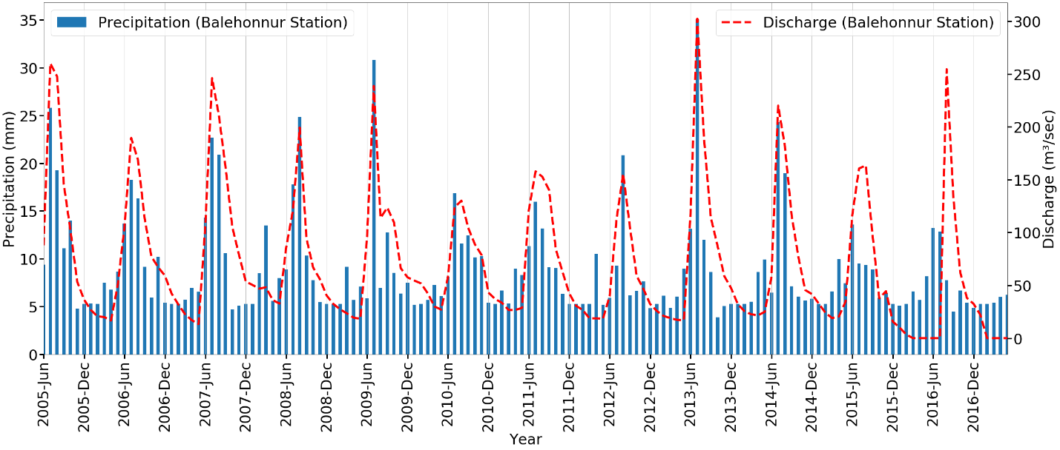

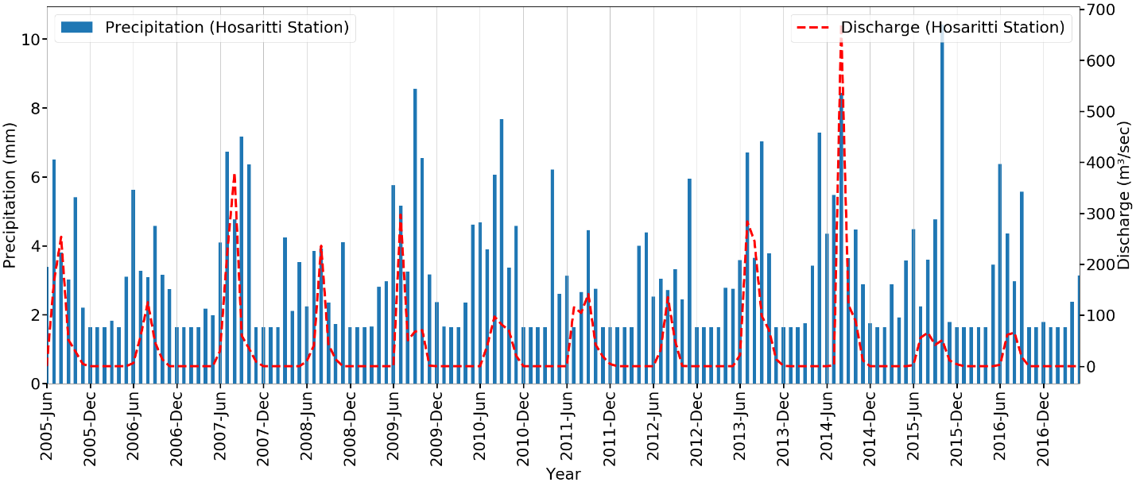

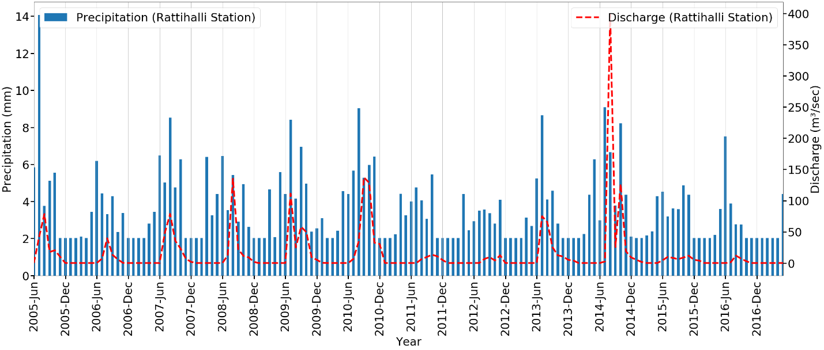

**Figure 3.** Mean monthly precipitation and discharge of Tunga-Bhadra River at a) Balehonnur b) Hosaritti c) Rattihalli station, India [2005–2017].

### **3.2 Hydro-Meteorological Drought Analysis**

To study the drought over the river basin, a meteorological drought index of SPI and hydrological drought index of SDI were studied. The monthly values of SPI and SDI were calculated with 12-month time scale for a period ranging from 1st June 2005 to 31st May 2017 and comparison graphs were being plotted between the two indices for each station respectively as shown in Figure 4. The intensity of the drought was being explained with reference to the thresholds considered in Table 4. In this study, we defined -1.5 as threshold to identify the meteorological and hydrological drought events, represented as rectangular boxes with a, b, c, d as drought years. From the plotted comparison graphs between the SPI and SDI, it was observed that for Balehonnur station a moderate drought occurred in June 2012 and June 2013 (box (a)) and a mild drought was observed between September 2015 and March 2016 (box (b)) as shown in Figure 4(a). While for station Hosaritti, a moderate drought observed during the period between August 2006 and June 2007 (box (a)), September 2012 and June 2013 represented as (box (d)) in Figure 4(b)). For station Rattihalli, a mild drought has been observed during the period between, October 2012 and July 2013 (box (a)) and a moderate drought between October 2015 and November 2016 (box (b) as shown in Figure 4(c). Both meteorological and hydrological droughts have occurred during the same periods for three stations as shown in Fig. 4. The meteorological drought response on hydrological drought has been noted for three stations with a threshold as -1.5 drought intensity. The years, when both meteorological and hydrological drought events have occurred were emphasized. More specifically, hydrological drought events were picked for the possible analysis on river water quality variables. It was observed that based on the SDI values, in Balehonnur station, a mild hydrological drought occurred from June 2012 to August 2012 followed by moderate drought till November 2012 which later worsened to severe drought from December 2012 to May 2013. Another event of severe hydrological drought occurred from October 2015 to May 2017 in Balehonnur station.

For Hosaritti station, a mild hydrological drought was observed during the periods of August 2006 to June 2007 (box, a) and June 2010 to May 2011 (box, c)), September 2012 to June 2013 (box, d) as shown in Figure 4(b)). A moderate hydrological drought event was observed from December 2015 to May 2017 (box, e) as shown in Figure 4(b)). While at Rattihalli station, a mild drought was observed from August 2006 to July 2017, October 2011 to July 2013 (box, a) in Figure 4(c). A moderate hydrological drought event has occurred between July to September 2012 and a moderate drought from October 2015 to November 2016 followed by a mild drought from December 2016 to May 2017 (box, b) as shown in Figure 4(c)) for Rattihalli station. Table 5 describes various meteorological and hydrological drought events occurred for Balehonnur, Hosaritti and Rattihalli locations.

**Table 5**. Drought events occurred over Balehonnur, Hosaritti and Rattihalli locations over Tunga-Bhadra river basin.

|  |  |  |
| --- | --- | --- |
| **Location** | **Meteorological Drought** | **Hydrological Drought** |
| Balehonnur | * June 2010 to March 2011 * November 2011 to June 2013 * June 2015 to May 2017 | * June 2012 to May 2013 * October 2015 to May 2017 |
| Hosaritti | * June 2006 to June 2007 * September 2008 to September 2009 * September 2011 to June 2013 * October 2016 to May 2017 | * August 2006 to June 2007 * June 2010 to May 2011 * September 2012 to June 2013 * August 2015 to May 2017 |
| Rattihalli | * June 2006 to June 2007 * October 2011 to April 2014 * August 2015 to May 2017 | * August 2006 to July 2007 * October 2011 to July 2013 * October 2015 to November 2016 * December 2016 to May 2017 |

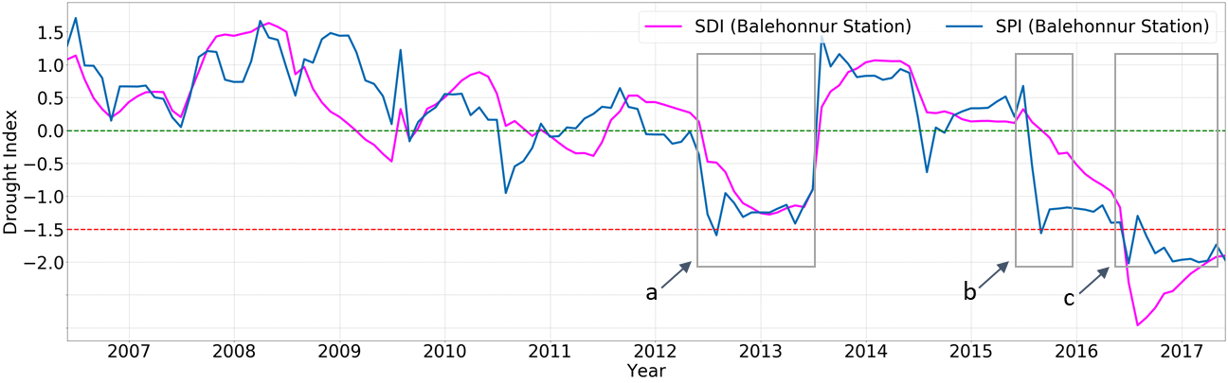

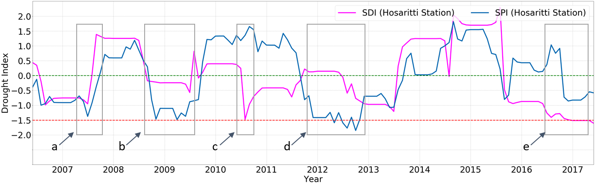

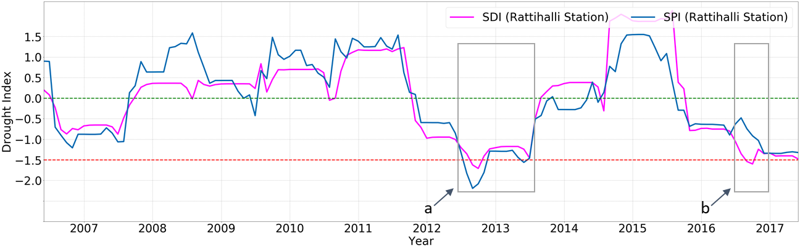

**Figure 4.** Trend of the SDI and SPI indices on a 12-month scale of Tunga-Bhadra River at a) Balehonnur b) Hosaritti c) Rattihalli station, India [2005-2017].

From the Table 5, a common drought period from June 2012 to May 2013 was considered for all three stations. A comparison study for various parameters like precipitation, discharge, air & surface water temperatures and water quality parameters during the drought periods was investigated and compared with the reference periods of two years which are the previous water year (June 2011 to May 2012) and the succeeding water year of drought (June 2013 to May 2014) (van Vliet and Zwolsman, 2008). The study compared the drought year of 2013 with reference wet years of 2012 and 2014 as before and after occurrence of drought year respectively.

The climatology of a drought year and two reference years were compared by comparing the precipitation and temperature for three stations. The annual precipitation and temperatures were compared for the drought year of 2013 with reference years as 2012 and 2014 as given in Table 6. From Table 6, it was observed that the annual precipitations were low during the drought period i.e., 2013 compared to the other two reference periods (2012 and 2014) except for the Hosaritti station where it received a rainfall of 2.6% more than the previous year. While the annual rainfall is decreased, the maximum air temperatures were observed to be increased during the drought year. The drought in the current study is observed to be a combined effect of both precipitation and temperatures. Comparison of annual precipitation sums and mean and maximum air temperatures at the meteorological station of Tunga-Bhadra river for the drought period, with the same parameters for the reference periods also demonstrate the drier and warmer conditions during the droughts. The annual precipitations were substantially lower (2826 mm) during the drought period when compared to the reference periods while the temperatures were incredibly higher (30.9 oC) compared to the post drought period.

**Table 6.** Annual total precipitation and maximum air temperature at the discharge stations for the drought year (2013), reference years, and averaged over the entire period 2005 – 2017

|  |  |  |  |  |  |
| --- | --- | --- | --- | --- | --- |
| Discharge Location | Parameter | Drought | Reference | | Average |
| 2013 | 2012 | 2014 | 2005-2017 |
| Balehonnur | Annual total precipitation (mm) | 2826 | 3102 | 3590 | 3257 |
| Max air temperature (oC) | 30.9 | 30.7 | 26.7 | 28.7 |
| Hosaritti | Annual total precipitation (mm) | 972 | 947 | 1333 | 1168 |
| Max air temperature (oC) | 32.00 | 31.40 | 31.3 | 31.64 |
| Rattihalli | Annual total precipitation (mm) | 1037 | 1168 | 1414 | 1344 |
| Max air temperature (oC) | 31.79 | 31.23 | 31.28 | 31.28 |