Step 1: Setup Data
2a. creating Customers table and inserting data using distinct
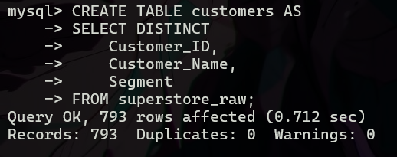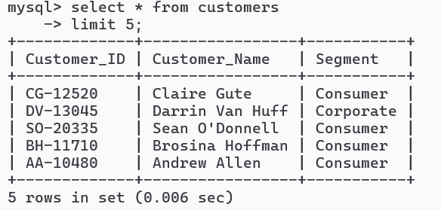

2b. creating orders table and inserting data using distinct
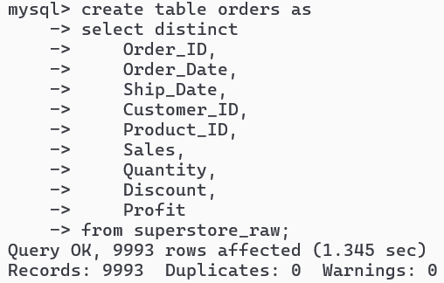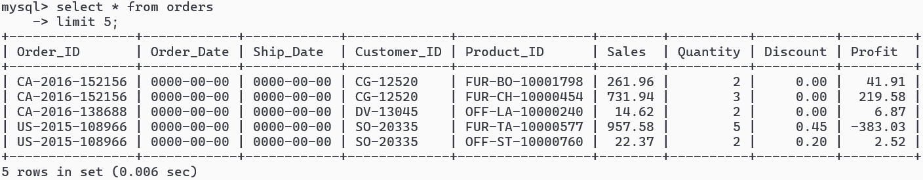

2c. creating products table and inserting data using distinct
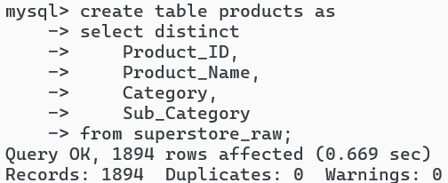

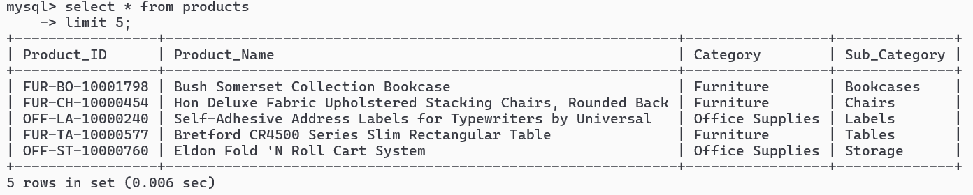

Step 2: Performing Required Queries
- Find all orders where sales are greater than the average sales. (Subquery)
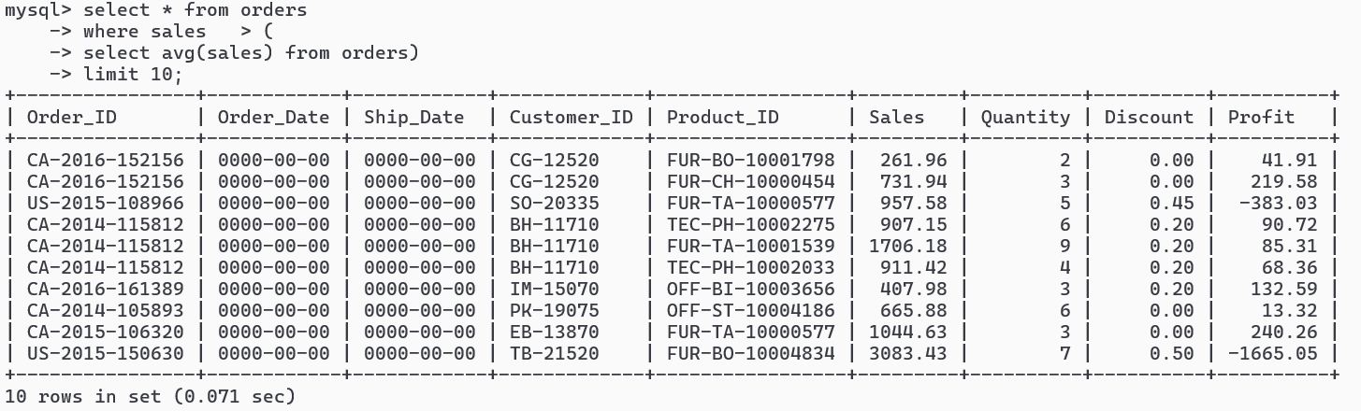
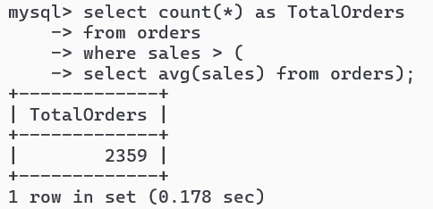

- Find the highest sales order for each customer. (Subquery)
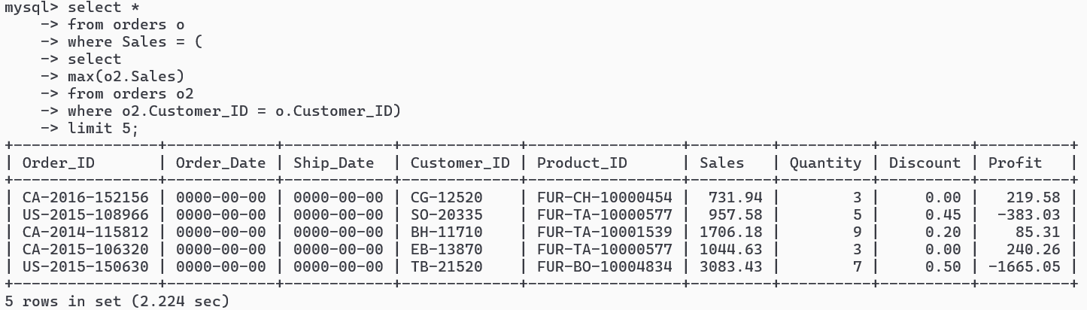
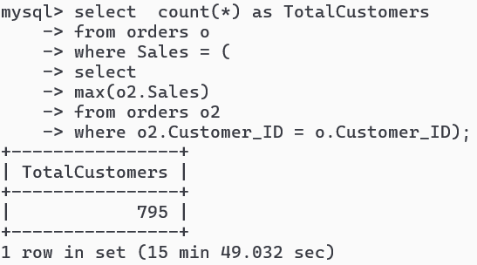
- Calculate total sales for each customer. (CTE)
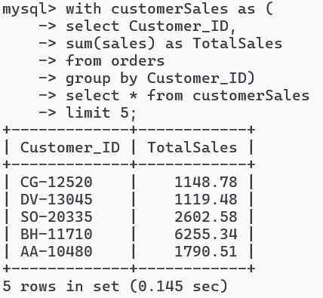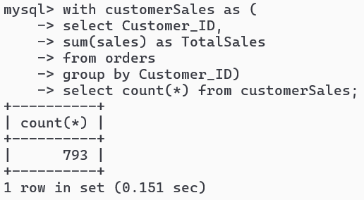

- Find customers whose total sales are above average. (CTE + Subquery)
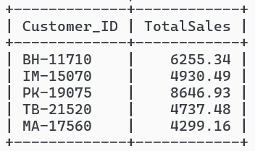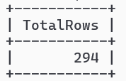

- Rank all customers based on total sales. (Window Function)
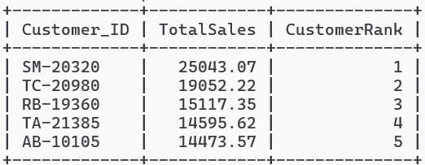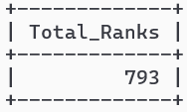

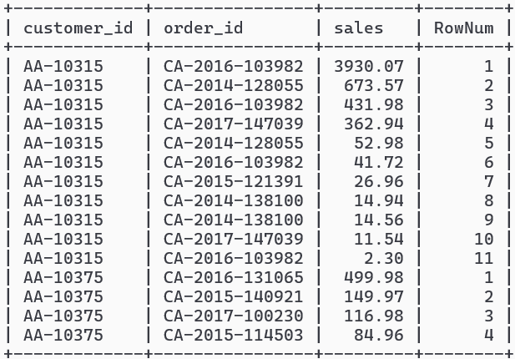
- Assign row numbers to each order within a customer. (Window Function +
PARTITION BY)

- Display top 3 customers based on total sales. (Window Function)
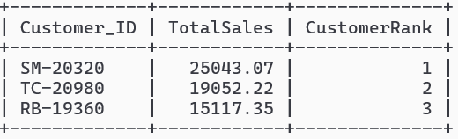

Step 3: Final Combined Query
Write one final query that shows:
- Customer Name
- Total Sales
- Rank
(Use JOIN + CTE + Window Function together)
