Q1: Display all rows and columns from customer’s table
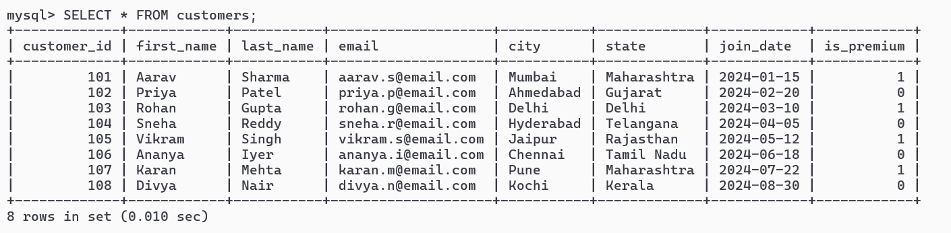

Q2: Retrieve first_name, last_name and city
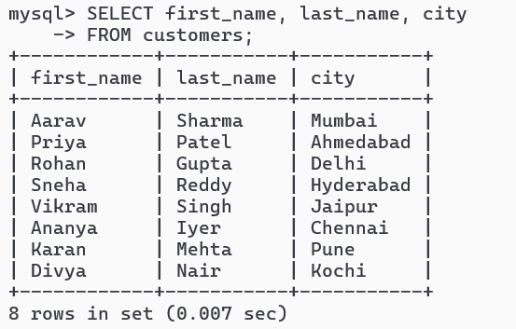

Q3: List all unique categories available in the products table.
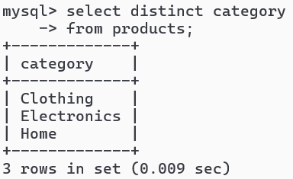

-- Q4. Identify the Primary Key of each table in the schema. Explain why a Primary Key must be unique and NOT NULL.

Primary keys in schema
Table | Primary Key
customers | customer_id
products | product_id
orders | order_id
order_items | item_id

Why Primary Key Must Be UNIQUE
- Because each row must be identifiable individually.
Example:
If two customers both had:
customer_id = 101
database cannot determine:
- which customer an order belongs to
- which row to update/delete
Why NOT NULL
- A primary key cannot be missing.
- NULL means: “unknown”
- But row identity cannot be unknown.

Q5: What constraints are applied to the email column in the customers table? What would happen if you tried to insert a duplicate email?
- email VARCHAR(100) UNIQUE NOT NULL
so, constraints are:
- UNIQUE
- NOT NULL
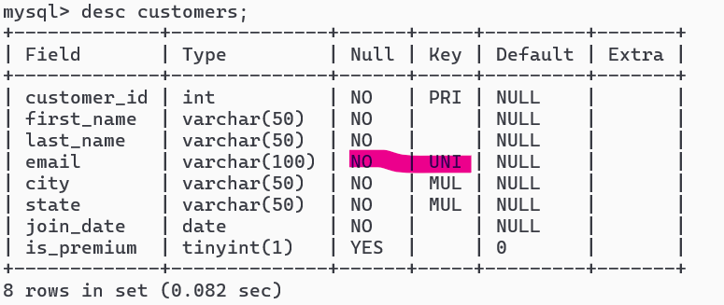
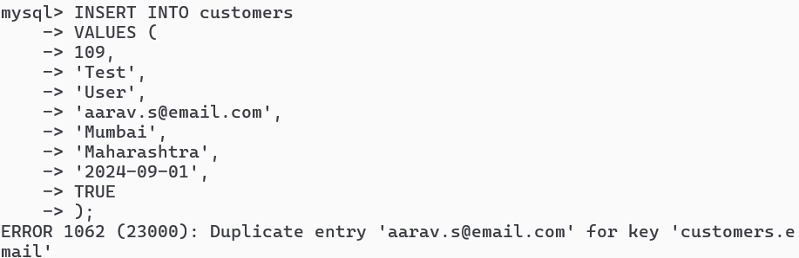
query fails because:
- Duplicate entry for UNIQUE constraint
Reason:
- aarav.s@email.com already exists.

Q6: Try inserting a product with unit_price = -50. What happens and which constraint prevents it? Write both the INSERT statement and explain the error.
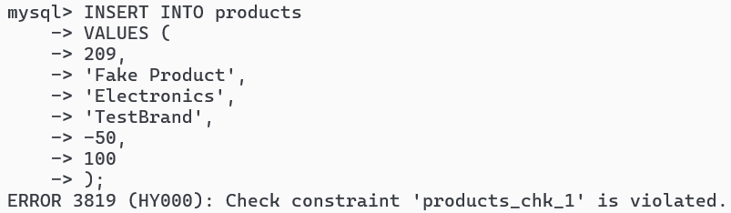
Insertion fails. Because schema contains:
- CHECK (unit_price > 0)
CHECK Constraint Exists to enforce valid business rules. Negative product price makes no logical sense.

Q7. Retrieve all orders with status = 'Delivered'.
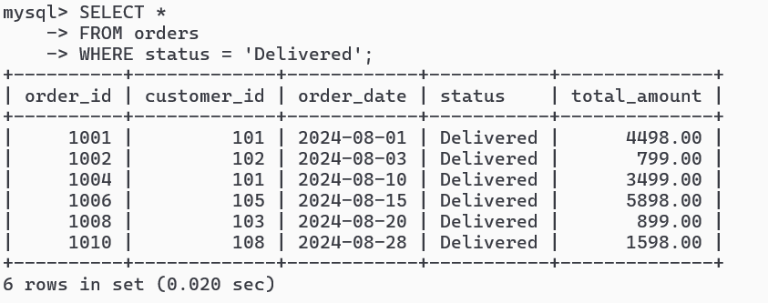

Q8. Find all products in the 'Electronics' category with a unit_price greater than ₹2000.
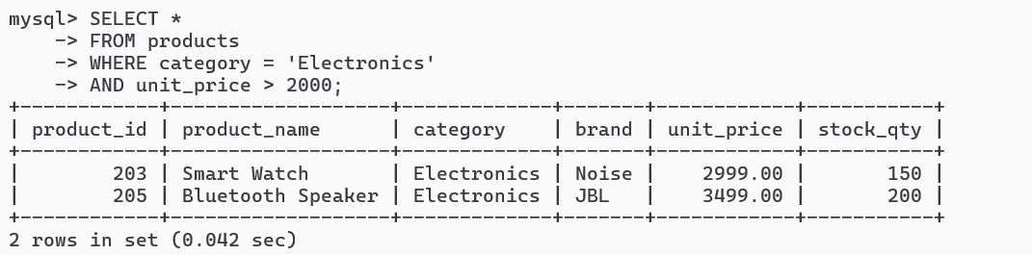
Q9. List all customers who joined in the year 2024 and belong to the state 'Maharashtra'.
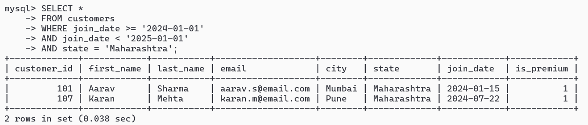
Q10. Find all orders placed between '2024-08-10' and '2024-08-25' (inclusive) that are NOT cancelled.
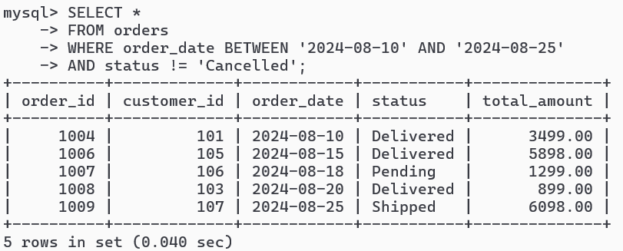
Q11. Explain what the index idx_orders_date does. How would it improve the performance of a query that filters orders by order_date? Write a sample query that would benefit from this index.
From schema:
CREATE INDEX idx_orders_date ON orders(order_date);
idx_orders_date is an index created on the order_date column of the orders table. It helps the database find rows faster when queries filter or sort data using order_date.
Without the index, the database may perform a full table scan by checking every row. With the index, it can directly locate matching dates, improving query performance especially for large datasets.
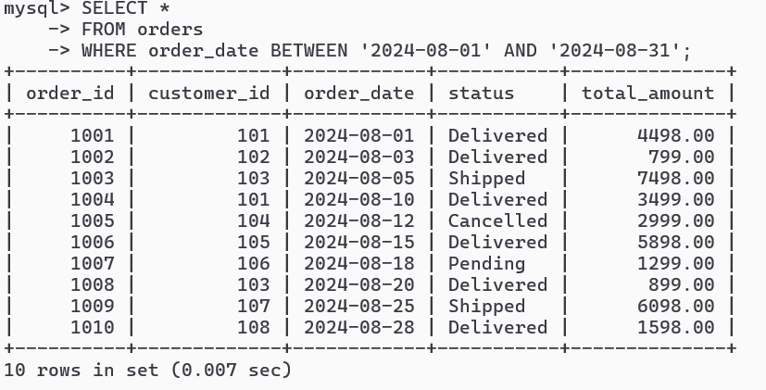
This query benefits from the index because it searches directly on the indexed order_date column.
Q12. If you run: SELECT * FROM customers WHERE YEAR(join_date) = 2024; — would the index on join_date be used? Explain why or why not, and rewrite the query to be index-friendly (SARGable).

Would Index Be Used?
NO (or inefficiently).
Why?
YEAR(join_date)
applies a function to every row. Database cannot efficiently use the index structure directly.
Instead:
it may calculate YEAR() for every row.
This reduces index usefulness.
Update Query:
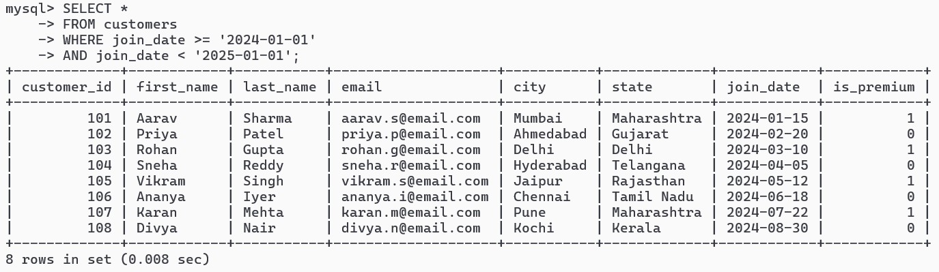
Why This Is Better
Because:
- direct comparison on indexed column
- database can use index range scan efficiently

Q13. Count the total number of orders in the orders table.
COUNT(*) counts all rows in the orders table.
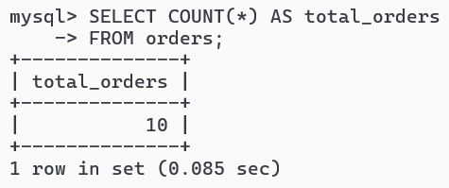

Q14. Find the total revenue (SUM of total_amount) from all 'Delivered' orders.
SUM(total_amount) calculates the total revenue only for orders with status 'Delivered'.
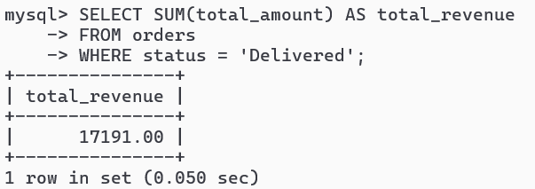

Q15. Calculate the average unit_price of products in each category.
GROUP BY category groups products by category, and AVG(unit_price) calculates the average price for each category.
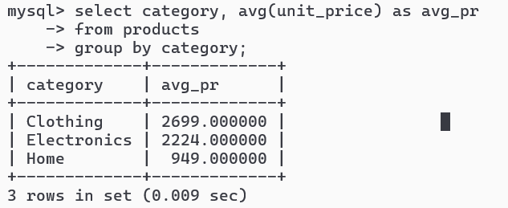
Q16. For each order status, find the count of orders and the total revenue. Sort the result by total revenue in descending order.
This query:
- groups orders by status
- counts orders in each status
- calculates total revenue for each status
- sorts results by revenue in descending order
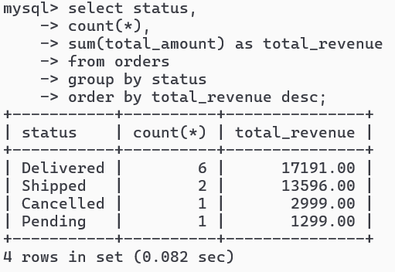

Q17. Find the most expensive (MAX) and cheapest (MIN) product in each category.
Explanation
- MAX(unit_price) finds the highest product price
- MIN(unit_price) finds the lowest product price
within each category.
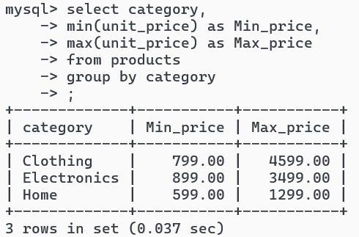

Q18. List all product categories where the average unit_price is greater than ₹2000. (Hint: Use HAVING clause)
HAVING filters grouped results after aggregation.
This query displays only categories whose average product price is greater than ₹2000.
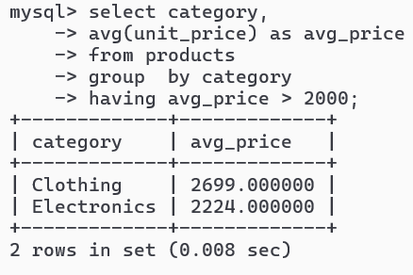

Q19. Write an INNER JOIN query to display each order along with the customer's first_name and last_name. Show: order_id, order_date, first_name, last_name, total_amount.
This query combines:
- orders
- customers
using the matching customer_id.
INNER JOIN returns only records where matching values exist in both tables.

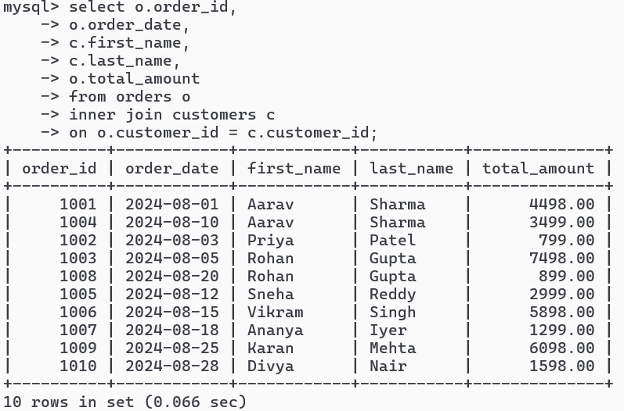
Q20. Using a LEFT JOIN, list ALL customers and their orders (if any). Customers with no orders should still appear with NULL values for order columns.
LEFT JOIN returns:
- all rows from customers
- matching rows from orders
If a customer has no orders:
- order columns become NULL
NOTE: but since all customers placed at least one order, so there is no null value in join table.
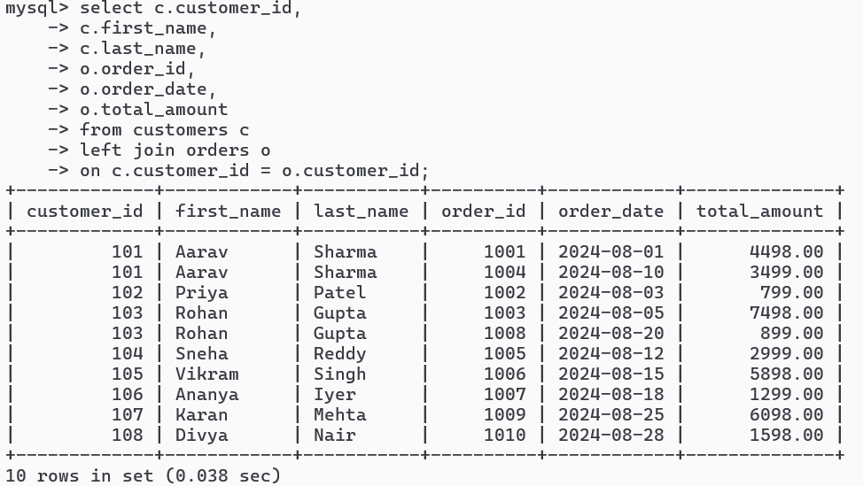

Q21. Write a query using JOINs across three tables (orders → order_items → products) to show: order_id, product_name, quantity, unit_price, and discount_pct for each order item.
This query joins three tables to display:
- order details
- product information
- quantity
- pricing
- discounts
Relationship flow:
orders → order_items → products

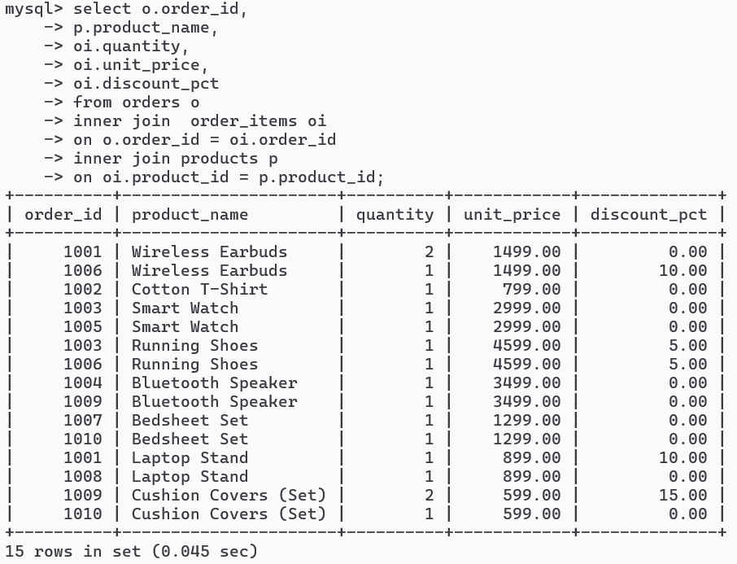

Q22. Explain the difference between LEFT JOIN and RIGHT JOIN with an example from this schema. When would you use a FULL OUTER JOIN?
LEFT JOIN | RIGHT JOIN
preserves left table | preserves right table
all rows from left table | all rows from right table
matching rows from right table | matching rows from left table
Unmatched columns from right become NULL. | Unmatched columns from left become NULL.
Example:  SELECT *  FROM customers c  LEFT JOIN orders o  ON c.customer_id = o.customer_id; | Example:  SELECT *  FROM customers c  RIGHT JOIN orders o  ON c.customer_id = o.customer_id;

Left Join:
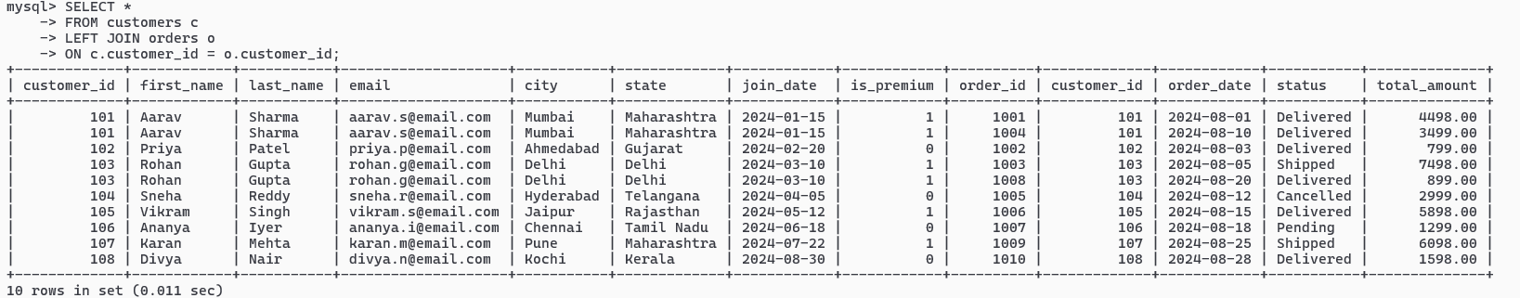
Right join:
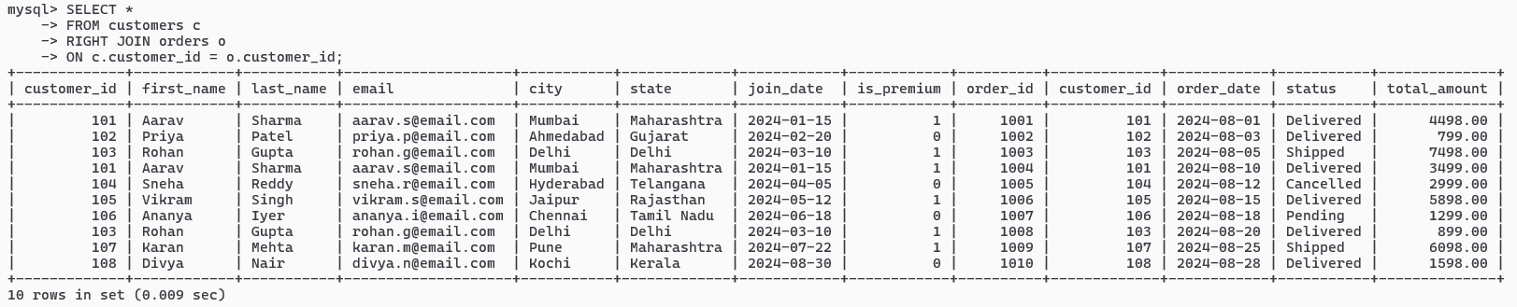
When FULL OUTER JOIN is Used
FULL OUTER JOIN returns:
- all rows from both tables
- matched rows where possible
- NULLs for unmatched rows
Used when you want:
- complete data from both tables
- including unmatched records on both sides

Q23. Identify all Foreign Key relationships in the schema. Explain what would happen if you tried to insert an order with customer_id = 999 (which doesn't exist in customers).
Table | Foreign Key | References
orders | customer_id | customers(customer_id)
order_items | order_id | orders(order_id)
order_items | product_id | Products(product_id)
what would happen if you tried to insert an order with customer_id = 999?
This will fail.
Why?
Because:
- customer_id = 999 does not exist in customers table
- Foreign Key constraint prevents invalid references

Q24. Write a query using CASE to classify products into price tiers:
• 'Budget' → unit_price < 1000
• 'Mid-Range' → unit_price BETWEEN 1000 AND 3000
• 'Premium' → unit_price > 3000
Display: product_name, unit_price, price_tier.
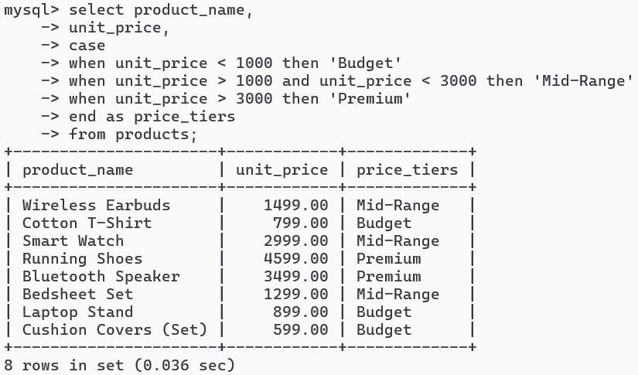

Q25. Using a CASE statement inside an aggregate function, count how many orders are 'Delivered' vs 'Not Delivered' (all other statuses). Display the result in a single row.
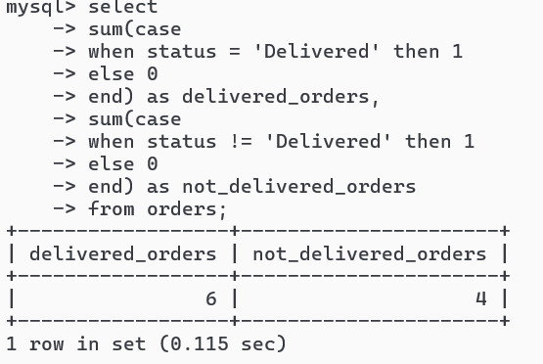

Q26. Explain each letter of ACID:
• A – Atomicity
• C – Consistency
• I – Isolation
• D – Durability
Give a real-world example (e.g., bank transfer) showing why each property is important.
A — Atomicity
Meaning
A transaction must complete fully or not happen at all.
Bank Transfer Example
When ₹5000 is transferred:
- ₹5000 is deducted from Account A
- ₹5000 is added to Account B
If the system crashes after deducting money from Account A but before adding it to Account B, the transaction must be rolled back.
Otherwise, money would disappear.
Atomicity ensures:
- either both operations happen
- or neither happens

C — Consistency
Meaning
The database must remain valid before and after the transaction.
Bank Transfer Example
Suppose:
- Account A has ₹10,000
- Account B has ₹15,000
Total money before transfer:
₹25,000
After transferring ₹5000:
- Account A → ₹5,000
- Account B → ₹20,000
Total money remains:
₹25,000
Consistency ensures:
- no money is created
- no money is lost
- all database rules remain valid

I — Isolation
Meaning
Multiple transactions should not interfere with each other.
Bank Transfer Example
Suppose two ATMs try withdrawing money from the same account simultaneously.
Without isolation:
- both transactions may read the same balance
- both may approve withdrawals
- account could go negative incorrectly
Isolation ensures each transaction behaves independently and safely.

D — Durability
Meaning
Once a transaction is committed, it is permanently saved.
Bank Transfer Example
Suppose transfer completes successfully and bank shows:
Transfer Successful
Immediately after that, the server crashes.
When system restarts:
- transferred money must still exist
- balances must remain updated

Q27. Write a SQL transaction that does the following atomically:
1. Insert a new order (order_id=1011, customer_id=102, today's date, 'Pending', 1598.00)
2. Insert two order items for that order
3. Update the stock_qty of the purchased products
4. If any step fails, ROLLBACK the entire transaction. Otherwise, COMMIT.
Write the complete BEGIN...COMMIT/ROLLBACK block.
Tables after insertion:
