Patel, Shivam 1001707265

**Part 1**

1.a.i) The output given was 57 - 12

1.a.ii) The output given was 45

1.a.iii) The difference between two lines that caused output to be different was use of quotation mark (“ “) in the first sentence. When we use quotation mark and write some operation in it, it displays as it is in the output, without performing the operation. It is used for displaying particular thing in java.

In second sentence we didn’t use quotation mark and wrote the same operation but here the output was the result of the operation. And like in first case it didn’t display the same operation, instead displayed the output of that particular mathematical operation.

1.b.i)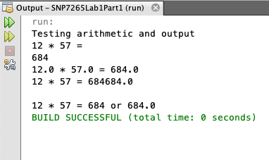

1.b.ii) The two numbers 684 and 684.0 got printed differently because in the input line we wrote two possible outputs for the multiplication of numbers, both meaning same but one is displayed as simple integer value and other is displayed in decimal form.

1.b.iii) The final output number is 684684.0 because, when we gave the input for the line System.out.print("12 * 57 = “); it printed ’12 * 57 =‘ as it is written inside quotation mark. Using ‘print’ here, prints the output in the same line and doesn’t take it to the next line.

And then for the next line, System.out.print(12 * 57); it printed 684, because 12*57 is not in quotation mark, it calculated the problem and displayed its solution. Now this output will be displayed in the same line in which earlier output was displayed because we used print and not println. Using only ‘print’ displays the output in the same line and not in the next line.

The next line is System.out.println(12.0 * 57.0); The output of this line was 684.0, here we used ‘println’, so the next output which will be printed after this line would be printed in the next line and not in the same line. This particular output will be printed with the above two outputs in the same line. That is ’12 * 57 = 684684.0’.

1.b.iv) The difference between two lines is that anything that is written after the sentence in java, which starts with ‘//‘, it does not displays the particular thing in java output. It is use to write comments in java. And anything written in comments is not displayed in output.

It doesn’t affect the output in anyways.

1.b.v) The ‘+’ sign in the following statement is used to print multiple outputs next to one another. That is it would print the value of (12 * 57), and beside it, ‘or’, and than the value of (12.0 * 57.0). It would print all this outputs beside one another in the same line.

1.b.vi) See saved file SNP7265Lab1Part1.java.

**Part 2**

2.a) 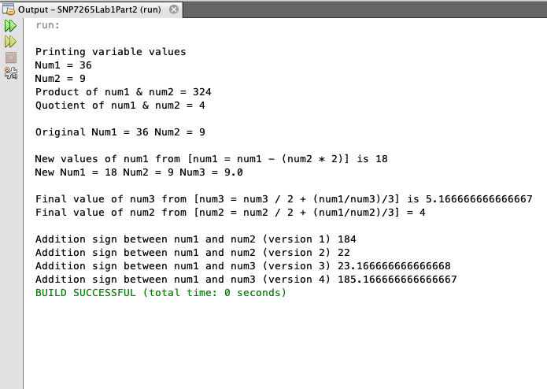

2.b) The name of the operation “ = “ is assignment operator. In java it is used to assign the value of the expression on the right to the variable on the left. It will make left side the value of right side.

2.c) The output of the line (version 3) is 23.166666666666668

2.d) The output of following line (version 4) is 185.166666666666667

2.e) The difference in println statements that causes the output to be different is the use of ‘( )’ parentheses, in the statement version 3, we wrote (num1 + num3) which added two numbers and gave output 23.1.66666666666668, when written inside parentheses.

While in version 4 we didn’t write num1 + num2 in parentheses, which displayed value of num1 and num2 beside each other and not adding them that is 185.166666666666667.

2.f) “System.out.println” is used to print the argument in java. Anything we write in this statement will be printed accordingly in the output. In the following statement, system is a class, out is a variable and println is a method.

2.g) There are three variables declared that are, num1 with datatype int, num2 with datatype int and num3 with datatype double.

2.h) **num 3 = num3 / 2 + (num1/num3) / 3; // statement 1**

(num1/num3) is 18/9.0 which gives 2.0

num3 / 2 is 9.0/2 which gives 4.5

// statement 1 is just comment that is written and it won’t be displayed in the output.

**num 2 = num2 / 2 + (num1/num2) / 3; // statement 2**

(num1/num2) is 18/9 which gives 2

num2/2 is 9/2 which gives 4

// statement is just comment that is written and it won’t be displayed in the output.

2.i) The values of num2 and num3 are different at the end of the program because num2 has datatype int and num3 has datatype double. Both the datatypes work differently. When calculated int does not include decimal, that is while printing output it only prints the number, rounding off to least nearest integer and not the decimal value, whereas double accepts decimal value and prints the output in the form of decimal.

**Part 3**

3.a)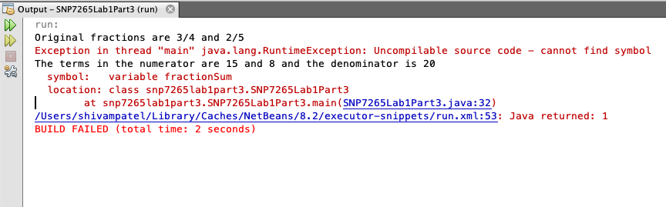

3.b) The line with the error is line number : 32

3.c) The error listed is

cannot find symbol

symbol: variable fraction sum

location: class SNP7265Lab1part3

_ _ _ _

(Alt - Enter show hints)

3.d) Look for Lab1Part3 for this problem.

3.e) The code given above did not work because the variable fractionSum was not initialized with the datatype. Every variable in java needs to be initialized with a datatype.

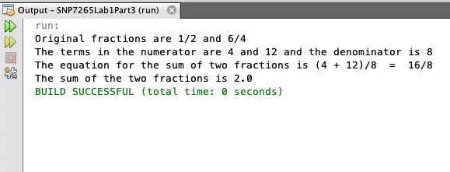

3.f)

