Part 1

1.a)

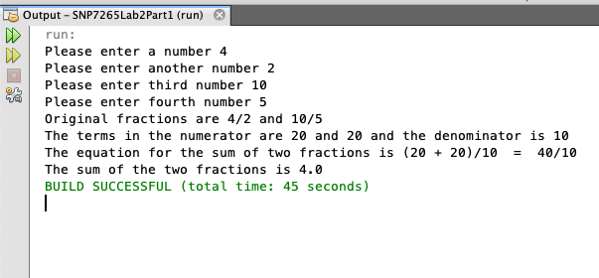

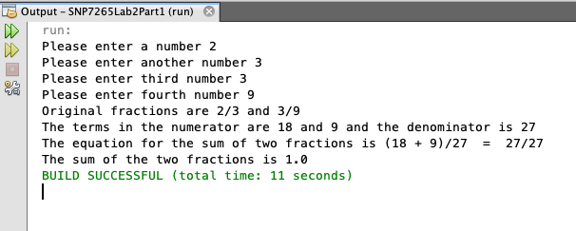

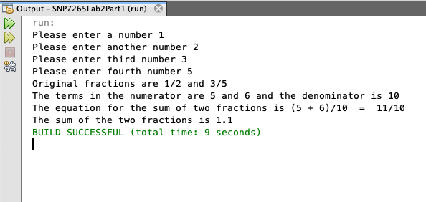

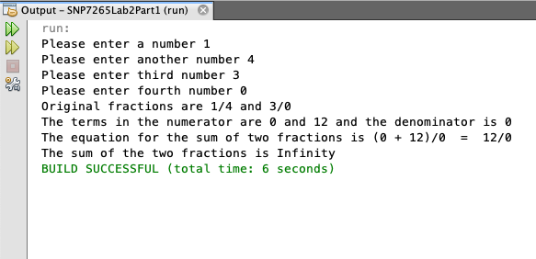

1.b) If we remove double from fraction sum, the output wont be displayed as the value of fraction sum is not initialized.

1.c)

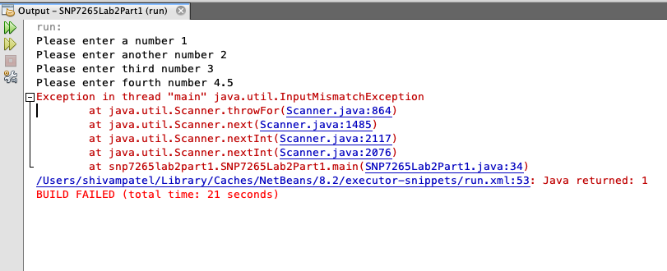

when we enter the decimal value, the program wont work because it only accepts integer values and not decimal values.

1.d) Scanner helps user to input whatever values we want to enter. It is a class in java. It helps to enter values like int, double and strings.

1.e) The line System.out.print(“Please enter a number ”) is before the first call of the scanner because if this line is printed than the user would know which number to print and when to print.

Part 2

2.a) Look for SNP7265Lab2Part2.java for this question.

2.b)

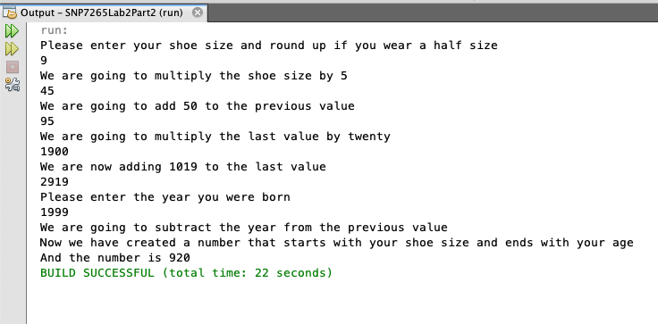

2.c)

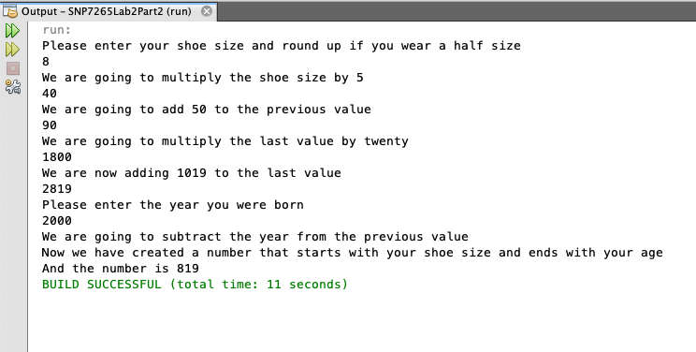

2.d)

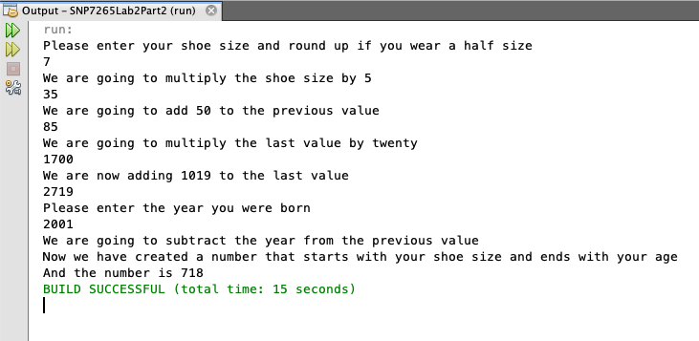

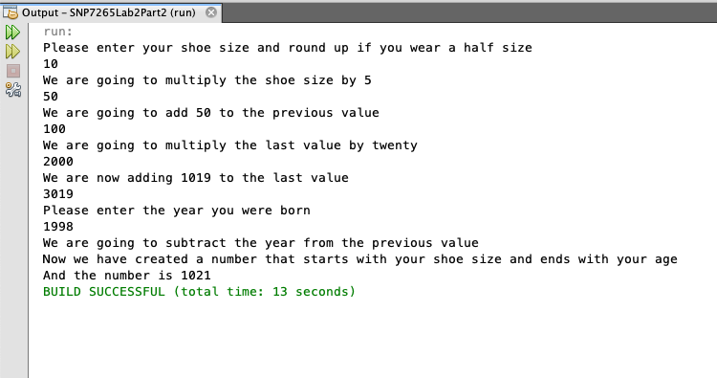

2.e) Look for SNP7265Lab2Part2e.java for this question.

2.f)

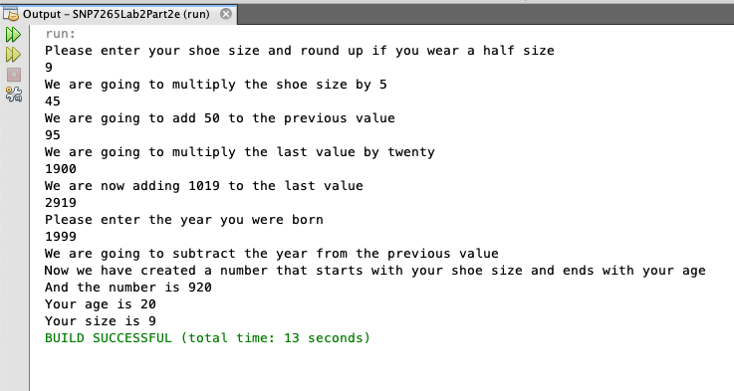

2.g) The code works properly for this puzzle cause the program is carried in different steps. All steps occur one after again. So the program works properly. At first the user enters his/her shoe size and the shoe size is saved is variable shoeSize.

After this the value of shoeSize is multiplied by 5 and saved in mult1st. just like this other steps are carried out as asked and at last it print the value that has your age and shoe size in it. After that we use modulus to find the age and division to find the size.

Part 3

3.a)

Take the input of a,b and c and store it in the variable a,b,c

declare variables a, b, c, denom, numPlus, numMinus, xPlus, xMinus, rad, bSquared

Square the value of b and save it in bSquared

Set denom = 2\*a

If the value of (b\*b- 4ac) < 0, there are not real roots

If (b\*b-4ac) > 0, real roots exist

Use rad operator to find the discriminant, and store it in rad

(discriminant is (b\*b-4ac) )

Find -b+rad and save it to numPlus and find -b-rad and save it in numMinus

After finding numPlus and numMinus divide it with 2a, to find the roots

When you divide numPlus/denom, you get xPlus, the positive root

When you divide numMinus/denom, you get xMinus, the negative root

3.b) Look for SNP7265Part3.java for this question.

3.c)

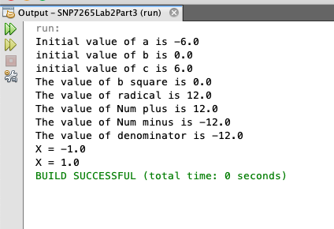

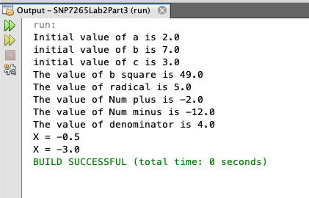

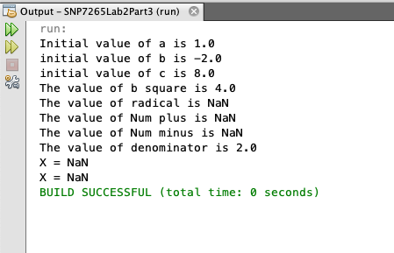

Part 4

4.a) Look for SNP7265Lab2Part4a.java for this following question.

4.b)

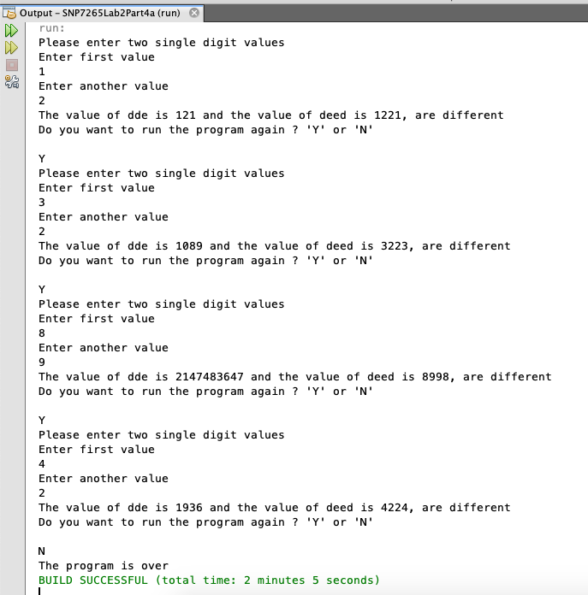

4.c) Look for SNP7265Lab2Part4c.java for this question.

4.d)

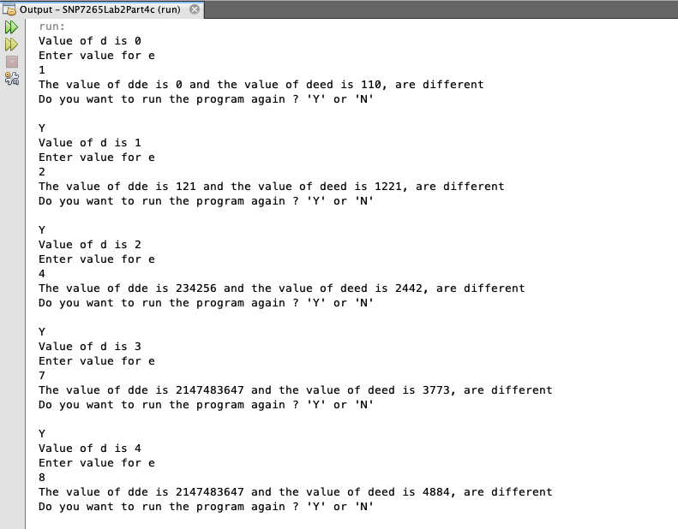

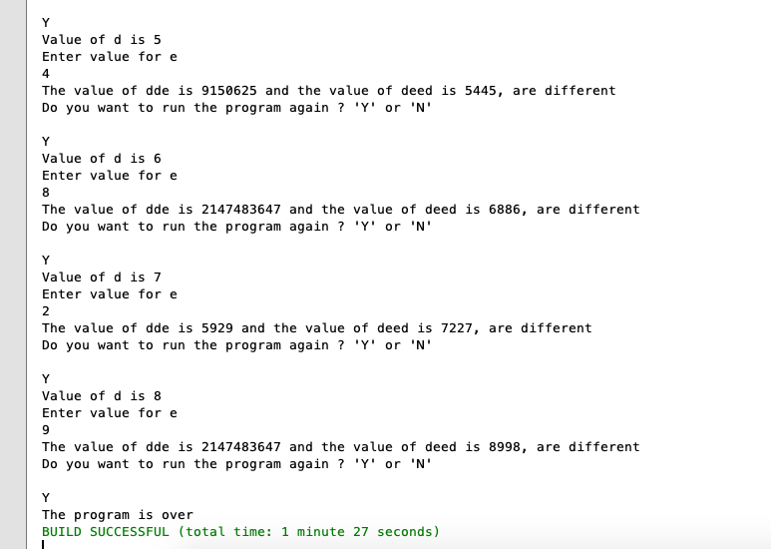

4.e) Look for SNP7265Lab2Part4e.java for this question.

4.f)

