README

1. DOWNLOAD and INSTALL Python( Latest Version) from your favorite Web Browser
2. Launch System Specific Terminal (Windows Displayed)

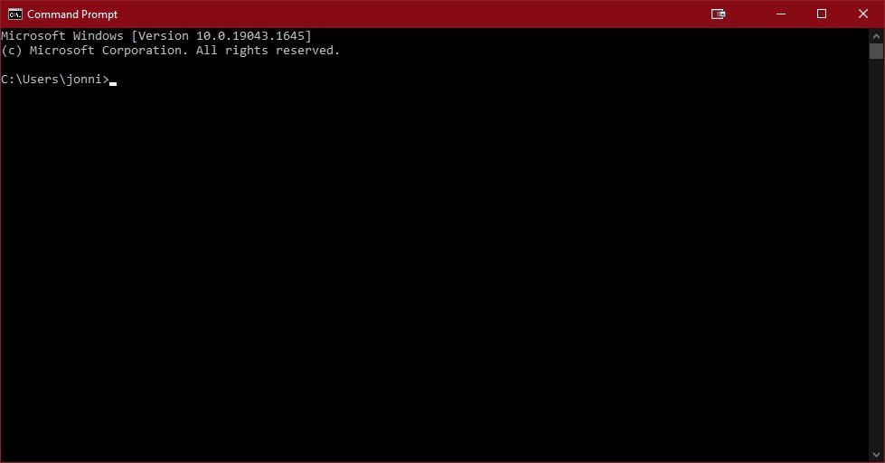

1. Type in the terminal cd and the directory that the folder “Kimeu_Patel_Uresti” is in

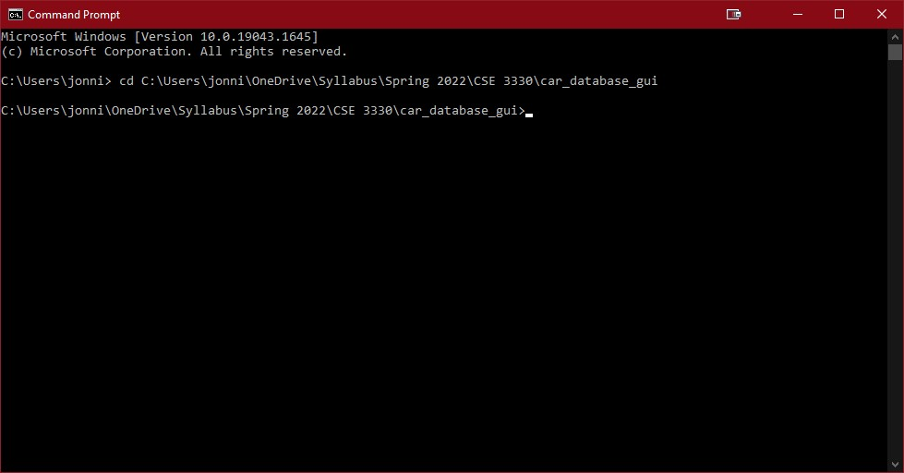

1. Type in the terminal in VSCODE “python main.py”

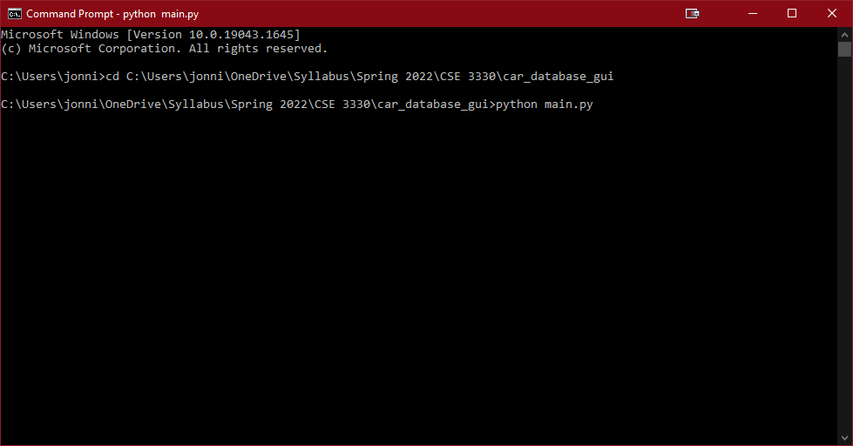

1. This Launches the GUI APP

