CPS LAB -1

Shivam Batra
19BPS1131

1. Single LED blinking

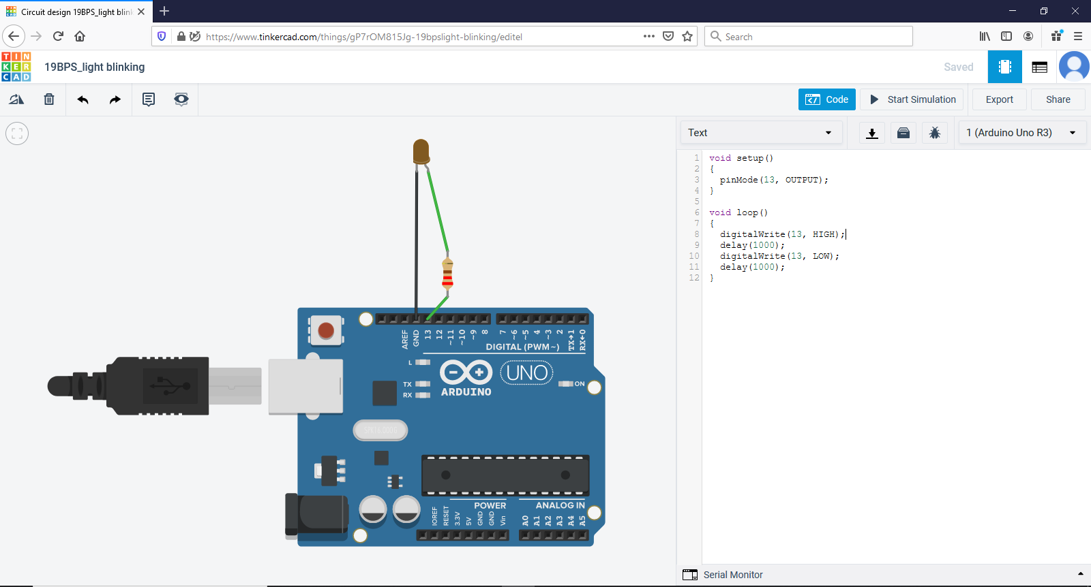
Code:

void setup()
{
pinMode(13, OUTPUT);
}

void loop()
{
digitalWrite(13, HIGH);
delay(1000);
digitalWrite(13, LOW);
delay(1000);
}

Link:

https://www.tinkercad.com/things/gP7rOM815Jg-light-blinking/editel?sharecode=v1P-1i9ATVGkdLHsB6iGbBiZRnjnQI6MAlaOcrNX4z0

2.SINGLE LED BLINKING USING BREADBORD

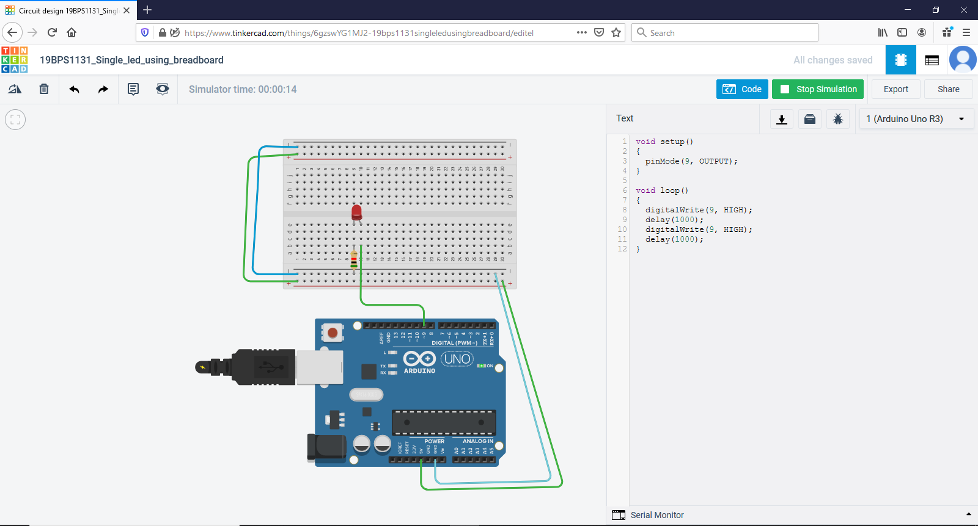
Code

void setup()
{
pinMode(9, OUTPUT);
}

void loop()
{
digitalWrite(9, HIGH);
delay(1000);
digitalWrite(9, HIGH);
delay(1000);
}

LINK:

https://www.tinkercad.com/things/6gzswYG1MJ2-cool-gaaris/editel?sharecode=CezdECJRh0Bgk2uPI_qSgoQZYzkbDCPQop1i4epcsuQ

3. MULTIPLE LED’S WITH RESISTORS AND BREADBOARD

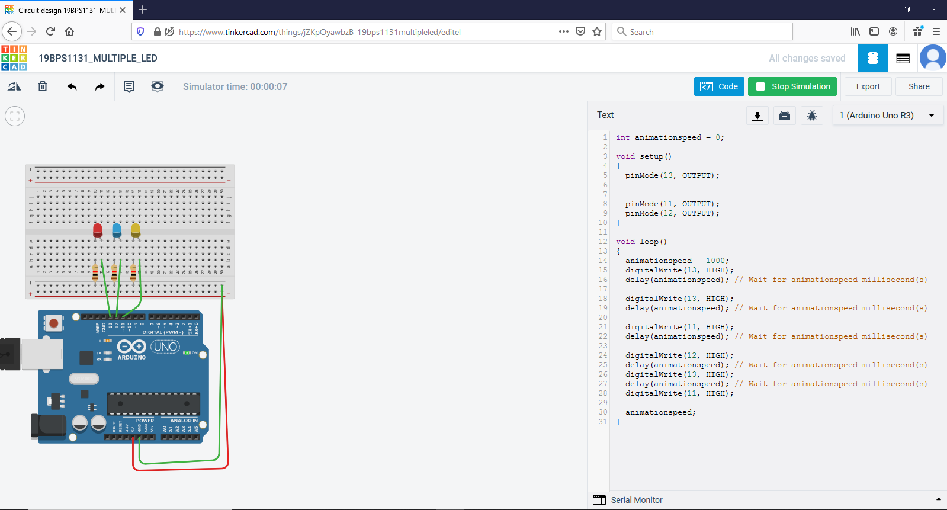
Code:

int animationspeed = 0;

void setup()
{
pinMode(13, OUTPUT);
Serial.begin(9600);

pinMode(11, OUTPUT);
pinMode(12, OUTPUT);
}

void loop()
{
animationspeed = 1000;
digitalWrite(13, HIGH);
delay(animationspeed); // Wait for animationspeed millisecond(s)
Serial.println("led1");
digitalWrite(13, HIGH);
delay(animationspeed); // Wait for animationspeed millisecond(s)
Serial.println("led2");
digitalWrite(11, HIGH);
delay(animationspeed); // Wait for animationspeed millisecond(s)
Serial.println("led3");
digitalWrite(12, HIGH);
delay(animationspeed); // Wait for animationspeed millisecond(s)
digitalWrite(13, HIGH);
delay(animationspeed); // Wait for animationspeed millisecond(s)
digitalWrite(11, HIGH);

animationspeed;
}

Link:

https://www.tinkercad.com/things/jZKpOyawbzB-fabulous-vihelmo/editel?sharecode=T8YtbWOMvGfTRs-fixxPZZ117GOReWsynoE2aO2tHcI

4. DISPLAYING MESSAGE AFTER BLINKING OF EACH LED

HERE (“led1, led2,led3”) is displayed after blinking of each led in serial moniter

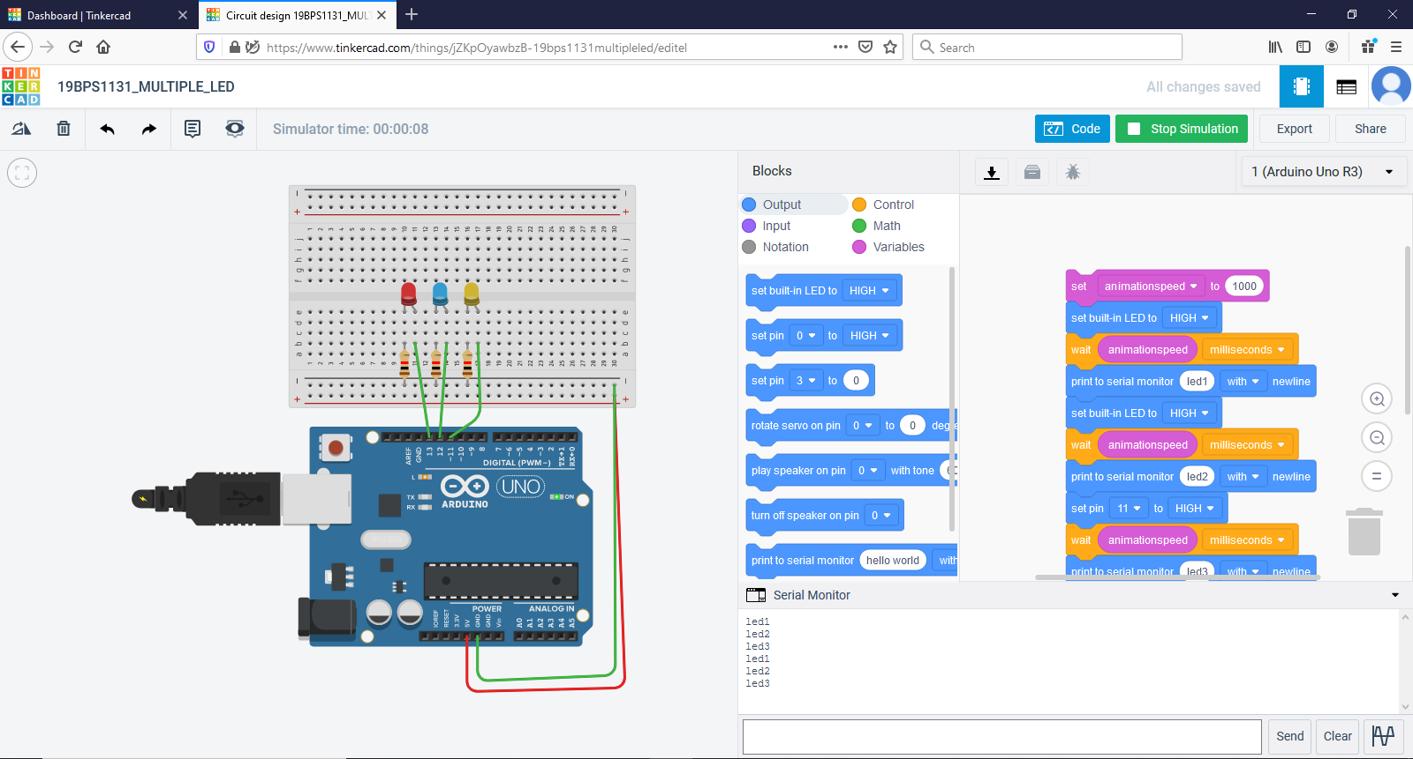
LINK:

https://www.tinkercad.com/things/jZKpOyawbzB-19bps1131multipleled/editel

5. SINGLE LED BLINKING IF BUTTON PRESSED
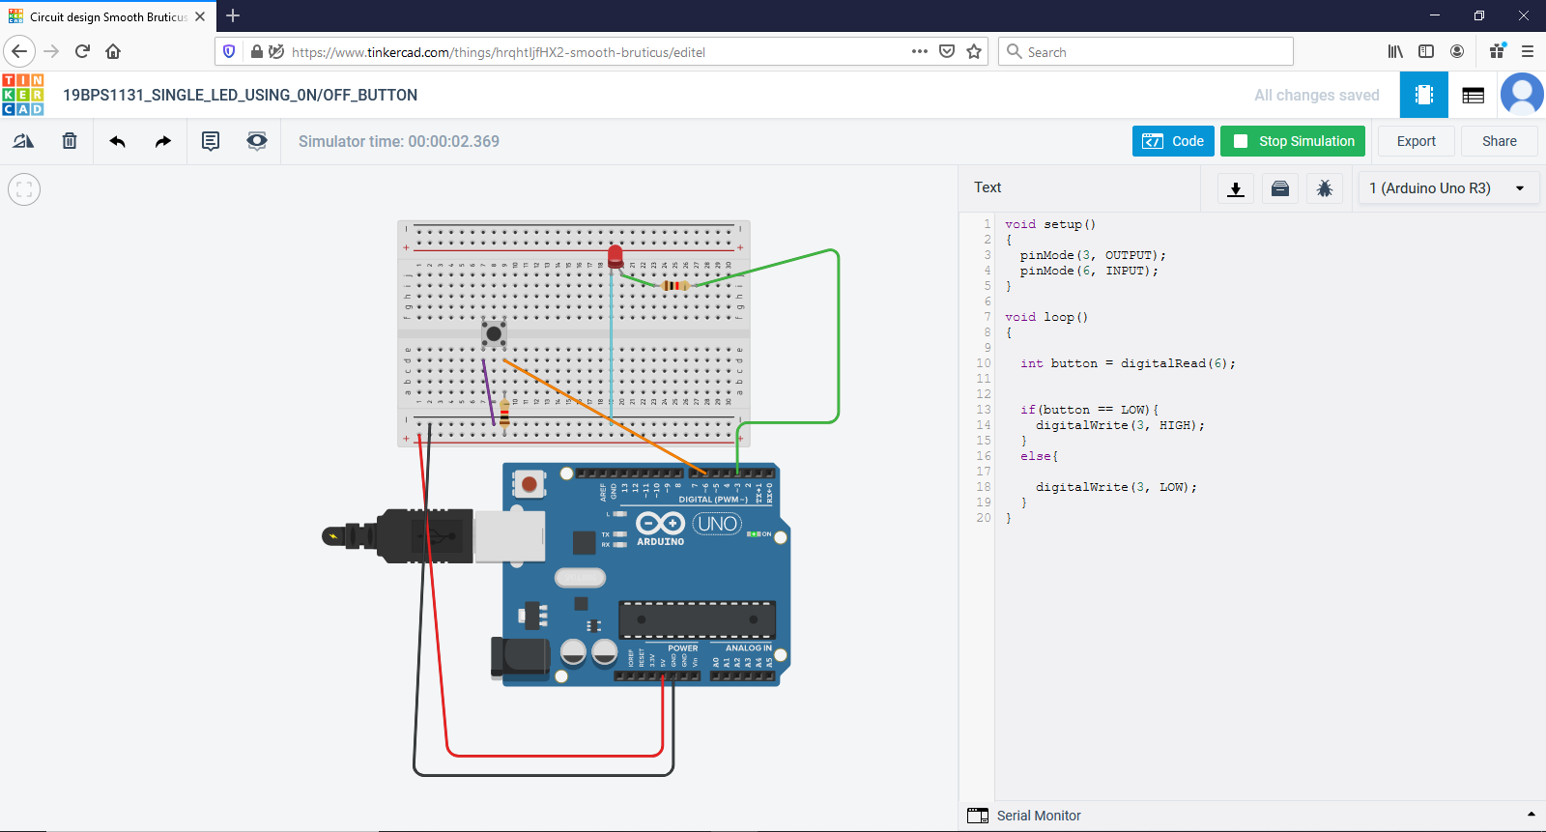
CODE:

void setup()
{
pinMode(3, OUTPUT);
pinMode(6, INPUT);
}

void loop()
{

int button = digitalRead(6);

if(button == LOW){
digitalWrite(3, HIGH);
}
else{

digitalWrite(3, LOW);
}
}
LINK:

https://www.tinkercad.com/things/hrqhtIjfHX2-smooth-bruticus/editel?sharecode=m6deEogFl6eNMNEyhT-HLiVIDKfF0kZeX1vk_pt7oBU

6. MULTIPLE LEDS BLINKING IF BUTTON IS PRESSED

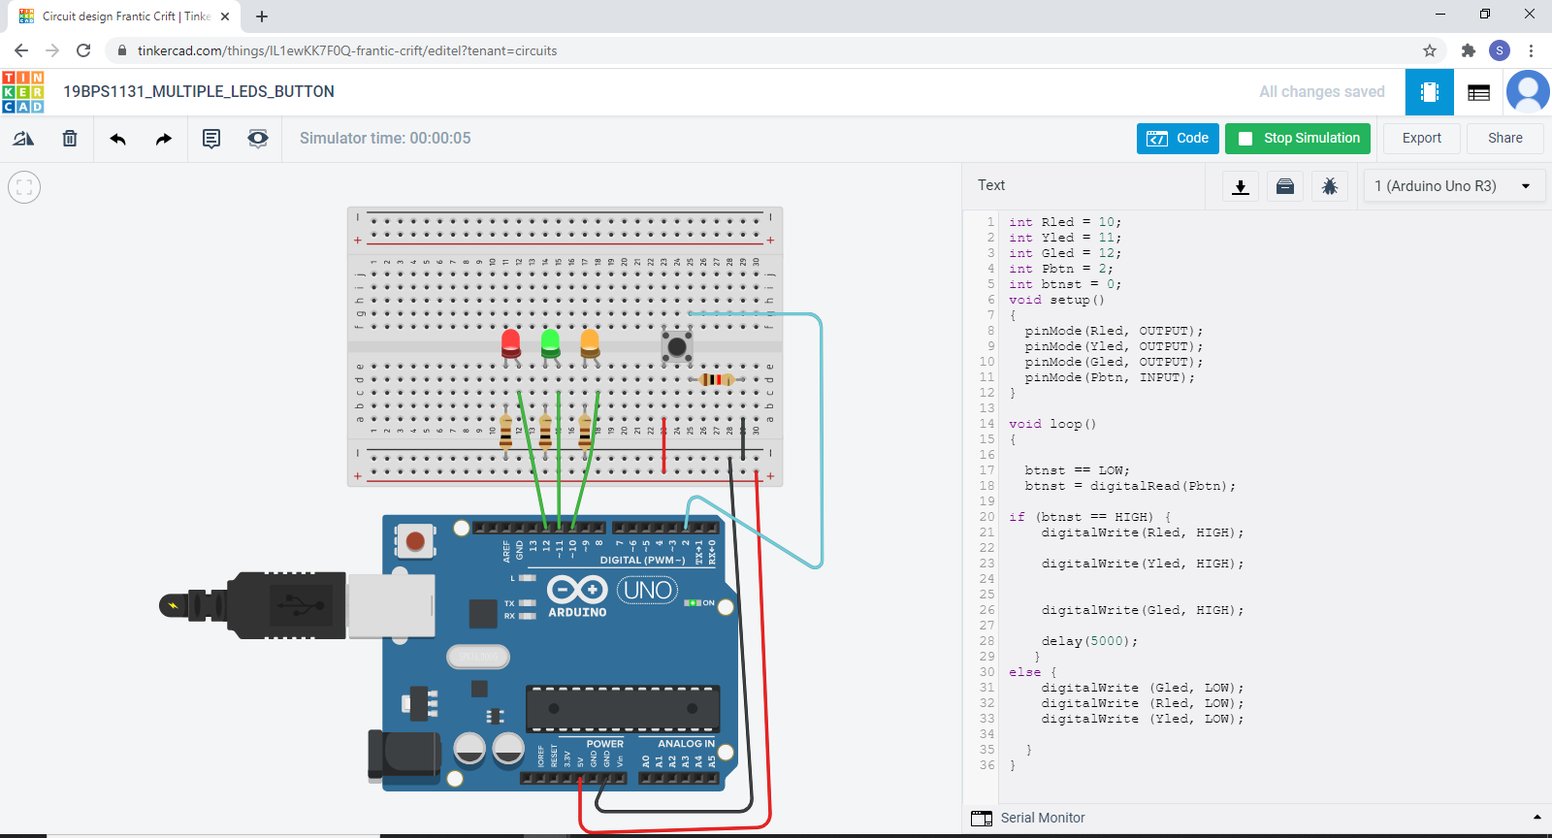
CODE:

int Rled = 10;
int Yled = 11;
int Gled = 12;
int Pbtn = 2;
int btnst = 0;
void setup()
{
pinMode(Rled, OUTPUT);
pinMode(Yled, OUTPUT);
pinMode(Gled, OUTPUT);
pinMode(Pbtn, INPUT);
}

void loop()
{

btnst == LOW;
btnst = digitalRead(Pbtn);

if (btnst == HIGH) {
digitalWrite(Rled, HIGH);

digitalWrite(Yled, HIGH);

digitalWrite(Gled, HIGH);

delay(5000);
}
else {
digitalWrite (Gled, LOW);
digitalWrite (Rled, LOW);
digitalWrite (Yled, LOW);

}
}

LINK:

https://www.tinkercad.com/things/lL1ewKK7F0Q-frantic-crift/editel?sharecode=QH78MByCarvq-nVoYtpYIt5ffP60WOs3ILlzqDxAVEU

