Cyber Physical Systems CSE2020
LAB-3

Shivam Batra
19BPS1131

1. Motion detection using pir sensor, piezo meter and led.

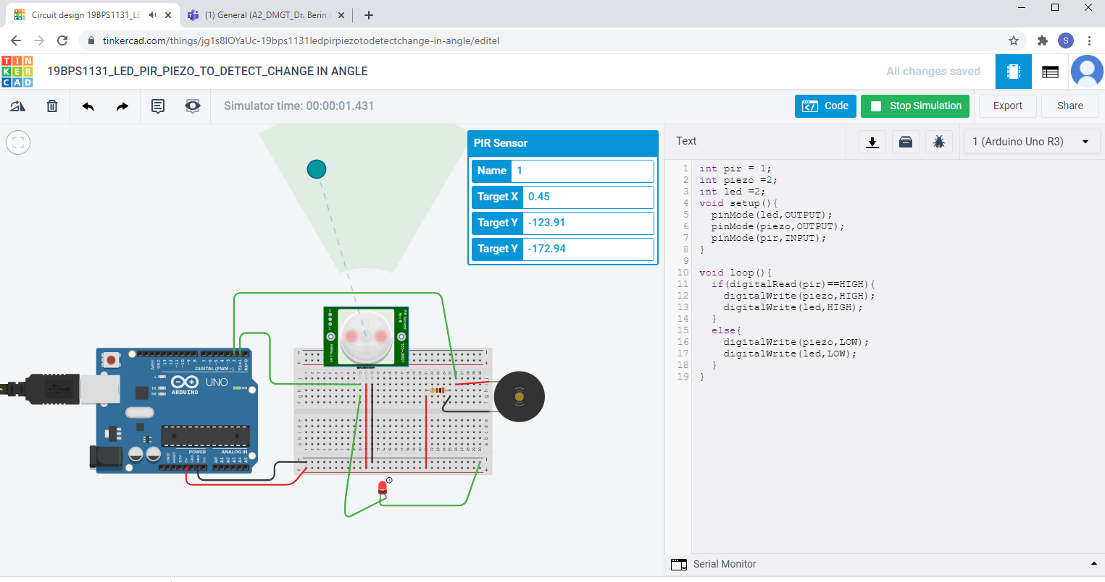

Code:

int pir = 1;
int piezo =2;
int led =2;
void setup(){
pinMode(led,OUTPUT);
pinMode(piezo,OUTPUT);
pinMode(pir,INPUT);
}

void loop(){
if(digitalRead(pir)==HIGH){
digitalWrite(piezo,HIGH);
digitalWrite(led,HIGH);
}
else{
digitalWrite(piezo,LOW);
digitalWrite(led,LOW);
}
}

Link – https://www.tinkercad.com/things/jg1s8lOYaUc-19bps1131ledpirpiezotodetectchange-in-angle/editel?sharecode=9KRsd3HeF4Q5lBuAhVIBsEE8YyMuaBPxInFof4kuoAI

2. Using Rgb light to sense the key pressed in IR remote and displaying corresponding key on serial moniter

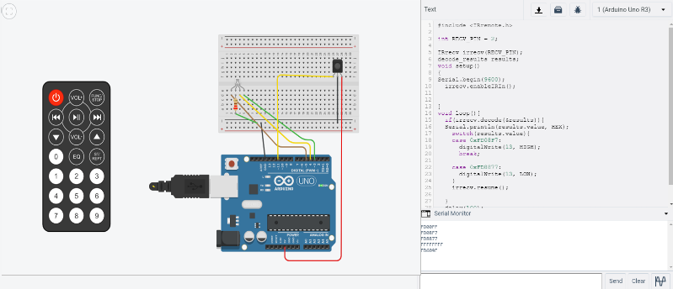

Code:

#include <IRremote.h>
int redLed = 5;
int blueLed = 4;
int greenLed = 3;
int RECV_PIN = 11;

IRrecv irrecv(RECV_PIN);
decode_results results;

void setup()
{

pinMode(redLed, OUTPUT);
pinMode(blueLed, OUTPUT);
pinMode(greenLed, OUTPUT);

Serial.begin(9600);
Serial.println("Enabling IRin");
irrecv.enableIRIn();
Serial.println("Enabled IRin");
}

void loop() {
if (irrecv.decode(&results)) {
unsigned int value = results.value; case
Serial.println(value);
switch (value) {
case 2295:
digitalWrite(redLed, HIGH);
delay(500);
case 10455:
digitalWrite(redLed, LOW);
delay(500);
break;

case 34935:
digitalWrite(blueLed, HIGH);
delay(500);
case 43095:
digitalWrite(blueLed, LOW);
delay(500);
break;

case 18615:
digitalWrite(greenLed, HIGH);
delay(500);
case 26775:
digitalWrite(greenLed, LOW);
delay(500);
break;

}

irrecv.resume();
}
}

Link-- https://www.tinkercad.com/things/3DyEbdsriM1-19bps1131displaytemperatureinlcd/editel?sharecode=XZqvXQPv4D1HGeRuxEOjyvOM8sdxwwdEp64ZnnON7Qo

3. Using piezo sensor and smoke detector to detect smoke and blink red led

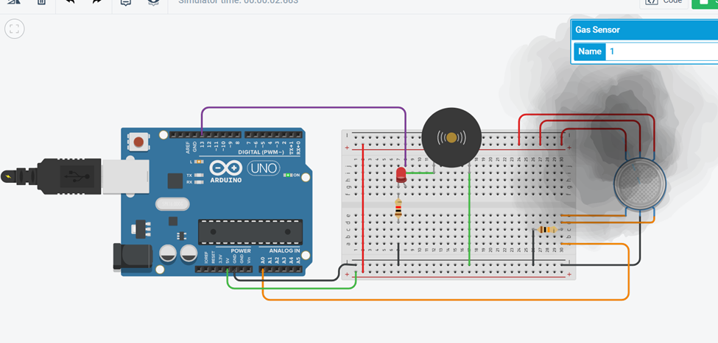

CODE
int sensor=0;

void setup()
{
pinMode(13, OUTPUT);
pinMode(A0, INPUT );
Serial.begin(9600) ;
}
void loop()
{
sensor=analogRead(A0) ;
Serial.println(sensor);
if
(sensor>487)
{
digitalWrite (13, HIGH);
}
else
{
digitalWrite (13, LOW) ;
}
}

Link - CODE
int sensor=0;

void setup()
{
pinMode(13, OUTPUT);
pinMode(A0, INPUT );
Serial.begin(9600) ;
}
void loop()
{
sensor=analogRead(A0) ;
Serial.println(sensor);
if
(sensor>487)
{
digitalWrite (13, HIGH);
}
else
{
digitalWrite (13, LOW) ;
}
}

Link-- https://www.tinkercad.com/things/crSdfh6dGcv-keypaddiplaykeylcd/editel?sharecode=JxMqmHuKC550AEVxc3MBRhgeyBGskHrscAySFhitjIc

4. Using piezo sensor and smoke detector to detect smoke and displaying gas level on lcd

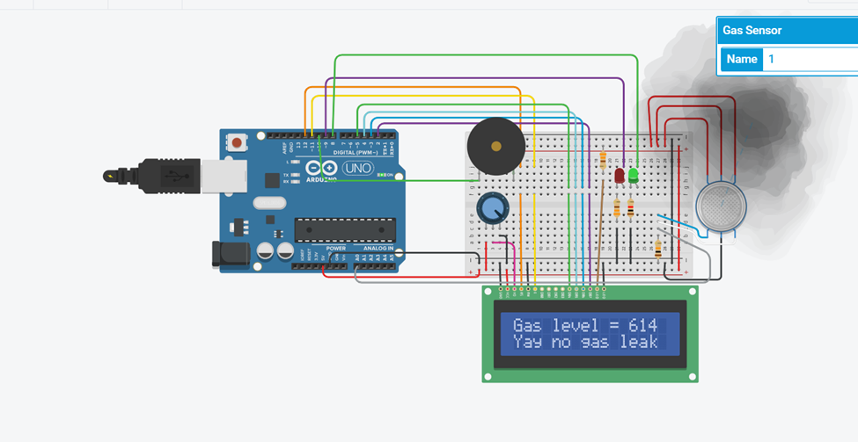

Code:

#include <LiquidCrystal.h>
int gas;
int wait = 100;
LiquidCrystal lcd(12, 11, 5, 4, 3, 2);
void setup() {
lcd.begin(16, 2);
pinMode(9,OUTPUT);
pinMode(8,OUTPUT);
pinMode(A0,INPUT);
pinMode(10,OUTPUT);
}
void loop() {
gas = analogRead(A0);
if(gas>680){
digitalWrite(9,HIGH);
digitalWrite(8,LOW);
digitalWrite(10,HIGH);
lcd.setCursor(0,0);
lcd.print("Gas level = ");
lcd.print(gas);
lcd.setCursor(0,1);
lcd.print("Warning:gas leak");
delay(wait);
}
else {
digitalWrite(9,LOW);
digitalWrite(8,HIGH);
digitalWrite(10,LOW);
lcd.setCursor(0,0);
lcd.print("Gas level = ");
lcd.print(gas);
lcd.setCursor(0,1);
lcd.print(" no gas leak ");
delay(wait);
}
}

Link-- https://www.tinkercad.com/things/crSdfh6dGcv-keypaddiplaykeylcd/editel?sharecode=JxMqmHuKC550AEVxc3MBRhgeyBGskHrscAySFhitjIc

