Client server architecture diagram

client request a service to the server and server processes the data and response according to request

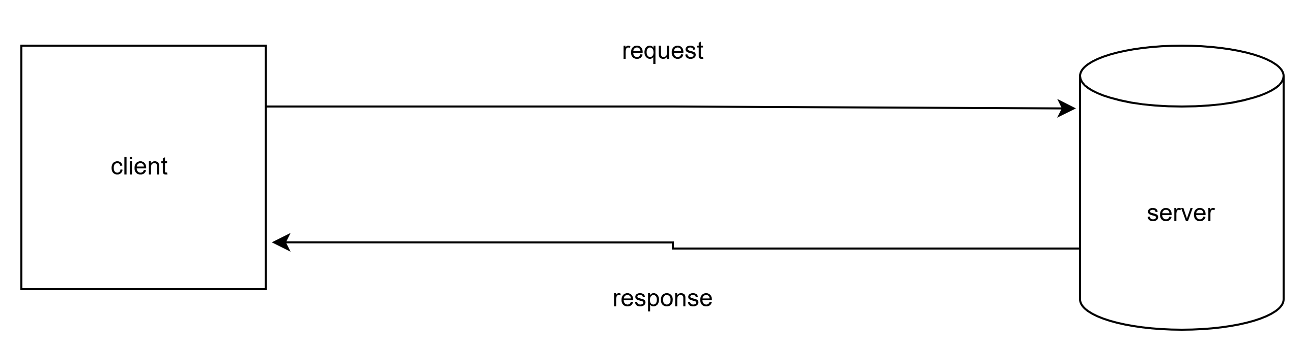

softwere architecture

three tier softwere architecture diagram for web applications

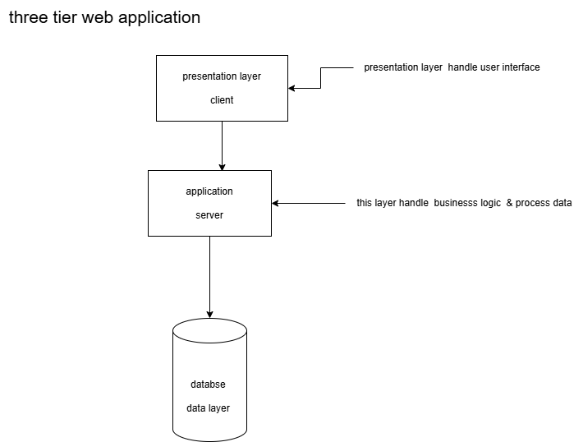

softwere devlopment lifecycle

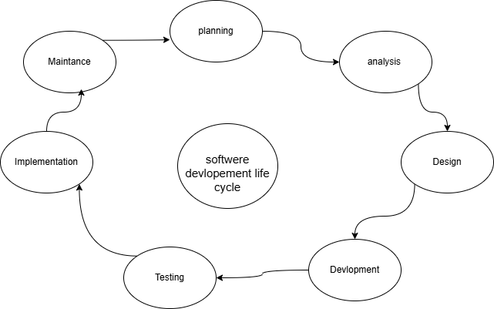

Application Security
- Identify and explain three common application security vulnerabilities. Suggest possible solutions.

1. Injection Attacks (e.g., SQL Injection)
- Description: Injection vulnerabilities occur when untrusted input is sent to an interpreter (like a database), allowing attackers to execute malicious commands or queries. For example, an attacker could bypass authentication by injecting malicious SQL into a login form.
- Solution:
  - Use parameterized queries or prepared statements to prevent malicious input from being interpreted as code.
  - Validate and sanitize all user inputs rigorously.
  - Employ web application firewalls (WAFs) to block suspicious requests.

2. Cross-Site Scripting (XSS)
- Description: XSS vulnerabilities occur when an application allows the injection of malicious scripts into web pages viewed by other users. These scripts can steal sensitive information like cookies or redirect users to malicious sites.
- Solution:
  - Encode output to ensure that any user-provided data displayed on a web page is treated as text and not executable code.
  - Implement a strong Content Security Policy (CSP) to restrict which scripts can run on your website.
  - Validate and sanitize user input to ensure it contains only expected data.

3. Broken Authentication and Session Management
- Description: Weak authentication mechanisms can allow attackers to impersonate other users or hijack sessions, often exploiting poor password policies or insecure session tokens.
- Solution:
  - Use strong, industry-standard authentication methods (e.g., OAuth 2.0, OpenID Connect).
  - Enforce multi-factor authentication (MFA) to add an extra layer of security.
  - Secure session cookies by marking them as Secure and HttpOnly, and implement mechanisms to prevent session fixation attacks.

7. Software Applications and Its Types
- Identify and classify 5 applications you use daily as either system software or application software:
  - System Software:
    - Operating System (e.g., Windows, Linux, macOS).
  - Application Software:
    - Web Browser (e.g., Chrome, Firefox).
    - Word Processor (e.g., Microsoft Word, LibreOffice Writer).
    - Messaging App (e.g., WhatsApp, Slack).
    - Media Player (e.g., VLC Player).

8. Software Architecture
- Design a basic three-tier software architecture diagram for a web application:
  - Presentation Layer (Frontend): Handles user interface (e.g., HTML, CSS, JavaScript).
  - Business Logic Layer (Backend): Manages business rules and logic (e.g., Python, Java).
  - Data Access Layer: Handles database interactions (e.g., MySQL, PostgreSQL).
You can create the diagram using any diagramming tool like Microsoft PowerPoint, draw.io, or a simple pen-and-paper sketch.

9. Layers in Software Architecture
- Create a case study on the functionality of the presentation, business logic, and data access layers of a given software system:
  - Example: For an e-commerce system:
    - Presentation Layer: Displays product catalogs, search options, and user profiles.
    - Business Logic Layer: Handles cart management, checkout processes, and discounts.
    - Data Access Layer: Retrieves product information, processes payments, and updates user data.

10. Software Environments
- Explore different types of software environments (development, testing, production).
  - Development Environment: Set up a basic environment using tools like VirtualBox or Docker. Install an IDE (e.g., Visual Studio Code) and write a "Hello World" program.
  - Testing Environment: Simulate user behavior and test edge cases.
  - Production Environment: Deploy a stable version for end-users.

11. Source Code
- Write and upload your first source code file to GitHub:
  - Create a GitHub account if you don't have one.
  - Initialize a repository.
  - Use a programming language (e.g., Python) to write a basic program:
print("Hello, GitHub!")
  - Upload the file to your repository using Git or the GitHub interface.

12. GitHub and Introductions
- Create a GitHub repository:
  - Go to GitHub and log in.
  - Click "New" to create a repository.
  - Add a README.md file to document how to commit and push code changes:
# My Repository
This repository contains basic programs.
  - Push code using the following commands in the terminal:
git add .
git commit -m "Initial commit"
git push origin main

13. Student Account in GitHub
- Create a student account on GitHub:
  - Visit GitHub Student Developer Pack.
  - Sign up using your student credentials.
  - Collaborate on a small project with a classmate by forking a repository or creating branches.

14. Types of Software
- Create a list of software you use regularly and classify them:
  - System Software:
    - Operating System.
  - Application Software:
    - Web Browsers (Chrome).
    - Messaging Tools (WhatsApp).
  - Utility Software:
    - Antivirus Software.
    - Disk Cleanup Tools.

15. Git and GitHub Training
- Follow a Git tutorial to practice cloning, branching, and merging repositories:
  - Clone:
git clone <repository_url>
  - Branch:
git branch <branch_name>
git checkout <branch_name>
  - Merge:
git merge <branch_name>

16. Application Software
- Write a report on the various types of application software and how they improve productivity:
  - Types:
    - Word Processors (e.g., LibreOffice Writer): Enhance documentation and report creation.
    - Spreadsheets (e.g., Excel): Aid in organizing and analyzing data.
    - Presentation Software (e.g., PowerPoint): Improve communication through visual storytelling.
    - Communication Tools (e.g., Zoom): Facilitate remote collaboration.
    - Database Management Systems (e.g., MySQL): Streamline data storage and retrieval.

17. Software Development Process
- Create a flowchart representing the Software Development Life Cycle (SDLC):
  - Steps:
    - Requirement Analysis: Identify user needs.
    - System Design: Plan the architecture and UI.
    - Development: Write the code.
    - Testing: Check for bugs and errors.
    - Deployment: Release the software to users.
    - Maintenance: Provide updates and fixes.
Use tools like draw.io or pen and paper to create the flowchart.

18. Software Requirement
- Write a requirement specification for a library management system:
  - Functional Requirements:
    - Ability to add and remove books.
    - Search functionality for books by title, author, or category.
    - Track issued and returned books.
  - Non-Functional Requirements:
    - User-friendly interface.
    - Fast response time for searches.

19. Software Analysis
- Perform a functional analysis for an online shopping system:
  - Functions:
    - Browse Products: Users can search and filter items.
    - Add to Cart: Items can be added or removed from the cart.
    - Checkout: Securely process payments and confirm orders.
    - Order Tracking: Real-time updates on delivery status.

20. System Design
- Design a basic system architecture for a food delivery app:
  - Components:
    - Frontend (User Interface): Displays menu, location, and order tracking.
    - Backend (Business Logic): Processes orders, calculates delivery times.
    - Database: Stores user data, menu details, and order history
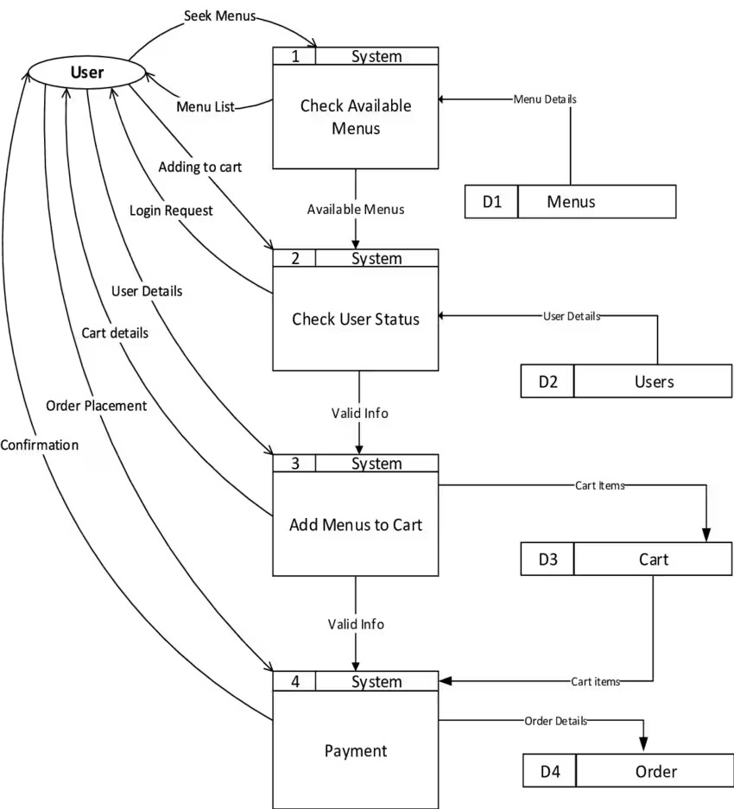

21. Software Testing
- Develop test cases for a simple calculator program:
  - Addition:
    - Input: 2 + 3.
    - Expected Output: 5.
  - Division:
    - Input: 10 ÷ 2.
    - Expected Output: 5.
Expand for other operations like subtraction, multiplication, and handling edge cases (e.g., dividing by zero).

22. Maintenance
- A critical maintenance case occurred with a bank's mobile banking application where a security vulnerability allowed unauthorized access to user accounts. The application's authentication process had a flaw that could be exploited by attackers using a specific sequence of actions, potentially leading to account takeover and financial loss.
Background:
- Application: A popular mobile banking application used by a major bank in Gujarat.
- Problem: A security vulnerability was discovered in the application's authentication process, allowing unauthorized access to user accounts.
- Impact: The vulnerability could be exploited to gain access to user accounts and potentially perform unauthorized financial transactions.
Maintenance Actions:
- Problem Identification: Security researchers and internal testing identified the vulnerability.
- Problem Analysis: Developers analyzed the vulnerability and determined the root cause in the authentication process.
- Design: A fix was designed to address the vulnerability, including strengthening the authentication process and implementing additional security measures.
- Implementation: The fix was implemented in the application's code and tested thoroughly.
- System Testing: Rigorous testing was conducted to ensure the fix worked as intended and didn't introduce any new issues.
- Acceptance Testing: The updated application was tested by users to ensure it met their expectations and that the fix didn't negatively impact functionality.
- Delivery: The updated application with the security fix was deployed to users.
- Communication: The bank communicated with users about the security issue and the measures taken to address it.
Outcome:
- The critical maintenance action successfully resolved the security vulnerability, preventing unauthorized access to user accounts.
- The bank took proactive measures to ensure the safety and security of its users' financial information.
- The incident highlighted the importance of continuous software maintenance and security testing.

23. Data Flow Diagram (DFD)
- Create a DFD for a hospital management system:
  - Entities:
    - Patient, Doctor, Admin.
  - Processes:
    - Appointment Booking.
    - Patient Records Management.

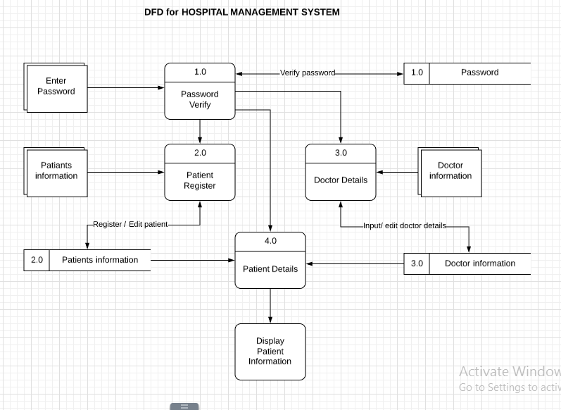

24. Desktop Application
- Build a simple desktop calculator application using a GUI library:
  - Use a language like Python and the Tkinter library to create a calculator that can perform basic operations like addition, subtraction, multiplication, and division.

25. Flow Chart
- Draw a flowchart representing the logic of a basic online registration system:
  - Steps:
    - Start.
    - User inputs details (name, email, password).
    - Validate details.
    - If valid: Save data to the database.
    - If invalid: Display error message.
    - End.

