**Acknowledgment**

We have taken efforts to do this project. However, it would not have been possible without the help and kind support of many individuals and **Infomax College of IT and Management**. We would like to extend our deepest gratitude to all of them who provided us with immense support. We are highly indebted to **Mr. Yuvraj Sharma** for his guidance and constant supervision as well as for providing necessary information and his support in completing the project.

We would like to express our sincere thanks to our parents and friends for their continuous cooperation and encouragement which made this assignment happen.

Our heartily thanks and appreciations also go to our colleagues for helping us in doing this assignment and people who have willingly helped us out with their abilities in the completion of this assignment.

Sincerely,

Kapil Pokhrel (NP000030)

Bikash Baral (NP000021)

Shivam Ranabhat (NP000047)

Table of Contents

1. Datacenter 3

1.1 Introduction to Data Center 3

1.2 Data Center Requirements 3

2.Data Center Design Overview 5

2.1 Site Selection 5

3.IT SPACE 6

3.1 Space Distribution 6

3.2 Entrance room 6

3.3 Main Distribution area 7

3.4 Horizontal Distribution Area 7

4.Data Center Infrastructure Tier 7

4.1 Data Center Tiering Standards 7

4.1.1 Tier 3 Network Architecture Design for Columbia data Center 10

5. Hardware Recommendations 12

5.1 Server 12

5.2 Racks 13

5.3 Networking Devices 14

6. Storages 19

6.1 Comparison of DAS, NAS, and SAN Product Specifications 19

6.2 Characteristics Comparison of DAS, NAS, SAN 20

7. Space Requirement 22

8. Cooling Solutions 23

9. Power 24

9.1 Uninterruptible Power Supply (UPS) 25

9.2 Power Distribution Unit (PDU) 25

10. Energy Management System and Green Computing 26

11. Security 27

11.1 Physical Security 27

11.2 Logical Safety 27

12. Conclusion 29

13. References 30

# 1. Datacenter

## 1.1 Introduction to Data Center

SPIC MALAYSIA is a Malaysian data center consulting company that provides installation and technical services to different companies to build a proper data center. The company has already built several data centers for various companies across the world ranging from small to medium sizes.

Recently the consulting company has signed an agreement with Columbia hospitals which provides health care services to more than 8 million patients. Currently, the hospital is in need to provide CRM (customer relationship management) platform which will allow the practitioners to manage communication with patients, streamline physician relationships, and engage patients in practicing electronic health records (EHR). So, in order and manage the data and provide quality service to the hospital, the Spic company is to build a data center for the hospital and we as the employ of the data center consulting company are assigned to build and implement a new data center that can help offers reliable services to its clients and patients.

Besides that, we are to provide a proper infrastructure design for the data center considering several aspects such as performance, scalability, and flexibility. Such designing requires proper planning, considerations, and justifications to achieve the defined requirements.

## 1.2 Data Center Requirements

To build a proper data center for Columbia hospital, we need to define the requirements or technical goals for the data center. This section will define the basic requirements of a data center. In our project scenario, the data center will have a CRM system with an electronic health record(EHR)

So, after proper planning we have the following requirements for the data center:

* **Security**

Data centers must be protected against physical threats to their components. The proposed data center will have multiple security systems. Cards and biometric systems will be used to enter and exit the building. CCTV system will be installed in every needed corner of the building; both inside and outside. The data center will have a 24/7 monitoring service. The staff working in the building will be restricted to enter inside certain rooms which holds more importance than other rooms. They won’t be allowed to know other things that are outside of their duty field. The security and the monitoring room will be placed in a different section from the main working area so that no passers can view anything going inside.

* **Scalability**

The data center which will be proposed must be able to support the scalability for the Columbia hospitals as the hospital may expand their operations in the future. The proposed data center must be able to co-locate to other places according to the need of the hospital. Scalability is one of the most important needs is to be considered while building a data center since the ability to handle the rising and big volumes of data are needed. We need to propose the data center in such a way that it can handle the incoming hardware and other technical aspects so that it won’t affect the working efficiency of the data center.

* **Manageability**

The data center will be proposed in a way that will be easy to maintain. The data center will be easily accessed for maintenance. Location and security will be taken into consideration as they will affect the manageability of the data center. More ever, data center infrastructure management(DCIM) tools will be used to manage the data in the data center improving the efficiency, uptime, and increasing the productivity of the data center.

* **Flexibility**

The infrastructure in the data center will be flexible that can be moved or replaced according to the needs in the coming years. Inflexible Infrastructure can increase the expense of the data center, so the components that need to be placed inside the building will be chosen to keep it in mind. The flexibility of the data center will be determined by its capacity to handle the incoming infrastructure needs in the future (Dan, 2019).

* **Reliability**

The infrastructure inside the data center will be chosen considering reliability as it is the most needed thing when it comes to running a 24/7 data center. The power supplies will be kept on standby in case the commercial electricity fails. The system must be configured in such a way that it won’t be vulnerable to any threats. The system can multiple standbys by power according to wire configuration in the data center to prevent in case of any malfunctions (Dan, 2019)

* **Network Performance**

The infrastructure inside the data center will be chosen considering network performance as the data center must run optimally all the time providing a good network speed. A data center lacking a proper infrastructure may have a problem with its network performance. So, choosing good equipment to make the network secure and reliable is needed for a data center

# Data Center Design Overview

## 2.1 Site Selection

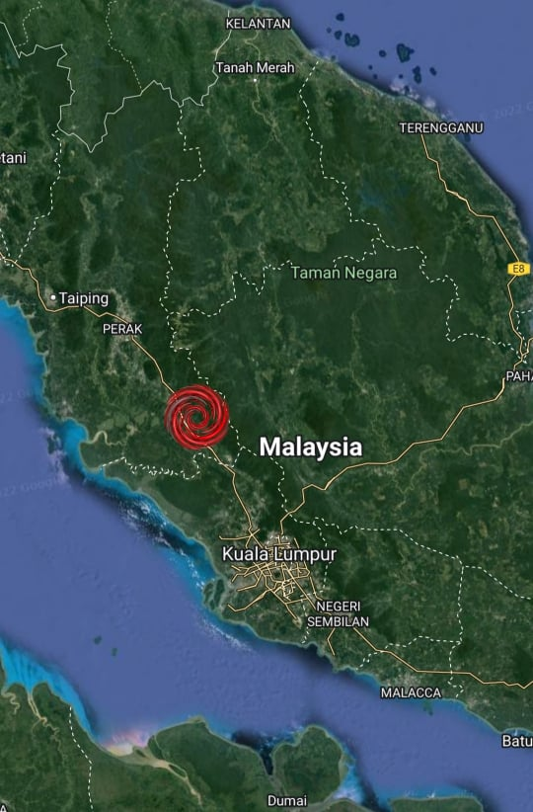

The site for the data center to be built will be selected in such a way that it will get the maximum ideal features. The site selected should be in a safe area where the security will be maximum and there won’t be any kind of environmental disasters like earthquakes and tsunamis. As Malaysia is a country where many parts are prone to tsunamis and earthquakes, the data center will be built in a site where it will be less prone to disasters and the building structure will be hardened accordingly.

# IT SPACE

A data center space is typically divided into 5 sections which are Entrance room, Main Distribution Area (MDA), Horizontal Distribution Areas (HDAs), Zone Distribution Area (ZDA), and Equipment Distribution Area (EDA)

## 3.1 Space Distribution

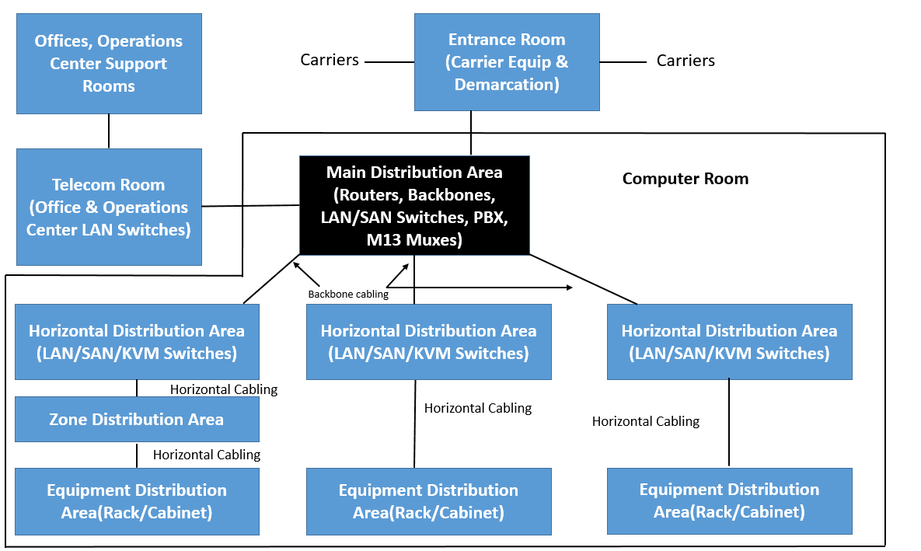

Fig: Space distribution of IT space

## 3**.2 Entrance room**

It is the interface between the data center structured cabling system and inter-building cabling, both access provider and customer owned. The space may be located outside the main computer room if the data center building includes also has other types of general purposes. It may be placed near the computer room considering the security as technicians can easily access and check from time to time. A data center may have multiple entrance rooms as it will help in cable management and provide additional redundancy. Our proposed data center for Columbia hospitals will have the entrance room adjacent or combined with the main distribution area.

## 3.3 Main Distribution area

It is the space that includes the center point of the distribution for the structured cabling system for the data center. It includes the main cross-connect(MC) and may include horizontal cross-connect(HC) when the equipment areas are served directly from MDA. The space is mainly inside the computer room but may be used at a different place for security. Every data center has at least one main distribution area. The computer room which holds the core routers, core LAN switch are often located in this area as it is the hub for cabling infrastructure for the data center. So, our proposed data center MDA will contain the computer room which used the main cross-connect structure cabling. The MDA may serve one or more horizontal distribution areas, equipment distribution areas, telecommunications rooms, and other external support rooms within a data center.

## 3.4 Horizontal Distribution Area

The horizontal distribution area is the space inside the data center where the horizontal cross-connect(HC) resides. It is the point between horizontal and backbone cabling and includes LAN switches, SAN switches, and Keyboard/Video/Mouse (KVM) switches that connect the active equipment like servers, storage devices. The HDA is typically located inside the computer room but may be located at a different place for additional security. A data center may have a computer room located on multiple floors with each one having its HC. Manual data center does not have a horizontal distribution area as the computer room can be supported by the MDA but our proposed data center will have an HDA too keeping the scalability into consideration

# 4.Data Center Infrastructure Tier

## 4.1 Data Center Tiering Standards

A data center tier is a standard ranking system that indicated the reliability of data center infrastructure. The tiering standard has four ranks from 1 to 4 where one is the worst and 4 is the best performing level. A data center receives its international ranking from the Uptime Institute, which determines the tier of the data center based on the Uptime, fault tolerance, and service cost of the data center. The higher the tier is, the higher the availability. Tier description includes information like raised floor heights, watts per square foot, and points of failure. “Need” or “N” indicates the level of redundant components for each tier with N representing only the necessary system need. Construction cost per square foot is also provided varies greatly from tier to tier.

**Tier 1- Basic: 99.671% Availability**

* Susceptible to disruptions from both planned and unplanned activity
* Single path for power and cooling distribution, no redundant components(N)
* May or many not have a raised floor,UPS or generator
* Typically takes 3 months  to implement
* Annual downtime of 28.8 hours
* Must be shut down completely to perform preventive maintenance

**Tier 2- Redundant components: 99.741% Availability**

* Less susceptible to disruption from both planned and unplanned activity
* Single path for power and cooling distribution, includes redundant components (partial (N+1))
* Includes raised floor,UPS and generator
* Typically takes 3 to 6 months to implement
* Annual downtime of 22.0 hours
* Maintenance of power path and other parts of the infrastructure requires a processing shutdown

**Tier 3- Concurrently Maintainable: 99.982% Availability**

* Enables planned activity without disrupting computer hardware operations, but unplanned events will still cause disruption
* Multiple power and cooling distribution paths but with only one path active, includes redundant components (full(N+1)
* Includes raised floor and sufficient capacity and distribution to carry load on one path while performing maintenance on the other
* Typically takes 15 to 20 months to implement
* Annual down time of 1.6 hours

**Tier 4- Fault tolerant: 99.995% Availability**

* Planned activity does not disrupt critical load and data center can sustain at least one worst case unplanned event with no critical load impact
* Multiple active power and cooling distribution paths, includes redundant components (2(N+1)). i.e; 2 ups each with N+1 redundancy
* Typically takes 15 to 20 months to implement
* Annual downtime of 0.4 hours

**Recommendation for our proposed data center**

Tier 4 is more efficient when compared to other tiers. More ever, the tier 4 data center has more reliable redundancy as it has multiple redundant power feeds, diverse paths along with multiple UPS. However, the power source for the tier requires a parallel power source to run the data center.

As a recommendation, we would like to recommend tier 3 certification for our proposed data center for Columbia hospitals. Tier 3 is recommended as it is concurrently maintainable and is qualified to achieve the needed uptime with lower cost and faster implementation time. As our proposed data center is in Malaysia the country has only one known power source utility called Tenaga Nasional Berhad (TNB). The requirement for us to achieve tier 3 for power utility is only one source and the TNB fulfills the gap. Therefore, Tier 3 is qualified and recommended for Columbia hospital’s data center.

## 4.1.1 Tier 3 Network Architecture Design for Columbia data Center

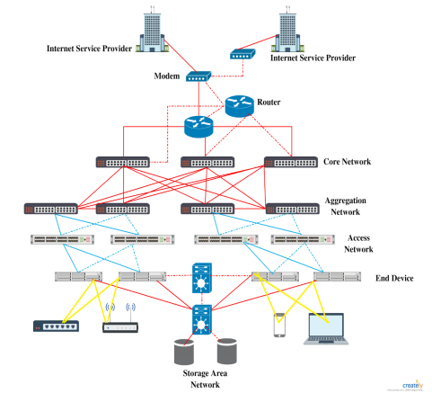

Fig: Tier 3 Architecture Design

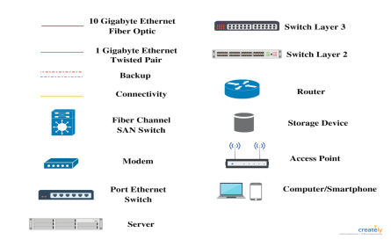

Fig: Legend for Tier 3 diagram

# Hardware Recommendations

## 5.1 Server

|  |  |  |  |
| --- | --- | --- | --- |
| Characteristics | Tower Server | Rack Server | Blade Server |
| Shape and size | Computer intended for use as a server.  Built-in an upright cabinet that stands alone | Rack-mounted server. Designed to be installed in a framework known as a rack. | Server chassis that house several thin, modular electronic circuit boards. |
| Required Space | Large Space | Low Space | Low Space |
| Price | Cheap | Medium | High |
| Density | Low | Low | High |
| Processing power | Low processing (Up to 2 processors) | Medium processing (More than 4 processors) | Highest processing power |

Fig: Comparison table of Tower Server vs Racks Server Vs Blade Server

**Recommendation**

From the above comparison and according to the requirement of Columbia Hospital, the Blade server is found to be more suitable as it is known as the most suitable server for the data center. As Columbia hospital serves more than 8 million patients in Malaysia, Blade server is the most suitable among all. The major reason is to use the blade server is its fast processing speed which supports a large quantity of data. Similarly, it helps to boost system availability as it supports hot-swapping to replace or repair the server. Similarly, it will help to lower the energy usage which results in less carbon footprint for the data center. Furthermore, the physical space will be fully used because the blade server’s architecture fits well in high scalability scenarios without compromising a significant amount of physical space.

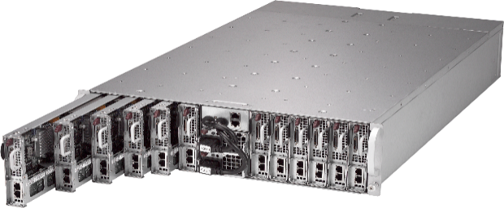

Fig: Blade server

## 5.2 Racks

When choosing the best rack server, it is necessary to choose it according to size, height, width, weight capacity, flexibility, efficiency, and security.

|  |  |  |  |
| --- | --- | --- | --- |
| Rack Name | 4 Post Rack | Server Rack Cabinet | Colocation Cabinets |
| Image | Black &amp; Gray Aluminium 4-Post Open Frame Rack, Rs 14175 /piece Global  Infinity | ID: 20929996433 | 42U door open - Server Cabinet Enclosure | Colocation Server Rack Cabinet Enclosure | RackSolutions |
| Rack Units (U) | 44 | 42 | 42 |
| Width (in.) | 19 | 19 | 19 |
| Door Style | Open | Perforated | Vented |
| Model | AR203A | RSP722020 | SCT-CL84X36-2C-V3 |
| Price | $ 567.48 | $ 1899.00 | $ 2750.00 |

**Recommendation**

When determining which rack to purchase, the in charge of a data center or server must ensure that they have all the relevant information. The most important consideration is to consider not just today’s needs but also future needs. Every person or corporation will have a unique set of priorities that must be evaluated. Cost-cutting can be the main issue in some firms but others are more concerned with ensuring that their investments will satisfy their demands for years to come. From the above comparison table, the 4 post rack is the most affordable according to the price but there is no cage surrounding the rack which results in dust, damage, and other dangerous particles accumulating on the hardware kept inside it. The server rack cabinet is the most affordable closed rack that has been explored. Similarly, the server rack cabinet rack is designed to fit two 21 U cabinets inside a single rack it is found to be adaptable. The individual cabinets can be opened without affecting other cabinets during maintenance. So, the final selection is the server rack cabinet for the data center of Columbia Hospital because it has 42 U racks and has enough room for gear, and offers an additional alternative during maintenance. The price is also reasonable for the rack with the characteristics provided.

## 5.3 Networking Devices

**Router and Switch:**

In a data center switches are used to connect multiple devices on the same network. The switch is used to connect servers to the data center and create a network of shared resources. It serves as a controller allowing devices on the network to share information on the network. Similarly, on the other hand, routers are used to connect multiple networks. So, we can use a router in our proposed data center for Columbia hospitals to connect the internal network servers to the internet. The router will analyze the data being sent over the network and change it accordingly

**Information Flow for our proposed data center for Columbia hospitals:**

**Server > Switch > Router > Internet < Router < Switch < Server**

**Recommended Router**

We have recommended a router from the cisco catalyst 8500 series edge platform for our proposed data center. The router of a specific model number of C8500L-8s4X is chosen due to its high-performance cloud edge platform designed for accelerated service. The router provides multi-layer security, cloud-native agility, and edge intelligence

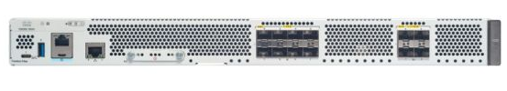

Fig: Router (C8500L-8s4X)

For more details on the router, please visit:

<https://www.cisco.com/c/en/us/products/collateral/routers/catalyst-8500-series-edge-platforms/datasheet-c78-744089.html?oid=dstetr023042>

**Recommended Switch**

We have recommended a fiber optic switch from fiber store.com which is a popular communications equipment company in the world. The switch is proposed as it is more easily available than other switches in the context of Malaysia with a low price and good customer service. The switch model S5850-48S6Q is recommended for the proposed data center due to its performance availability and ease of management.

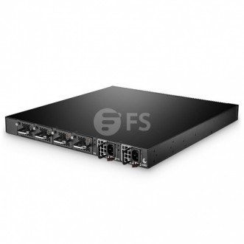

Fig: Switch (S5850-48S6Q)

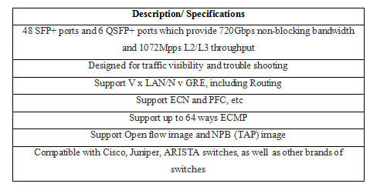

**Cabling**

Cabling in a data center may be structured or unstructured. Structured cabling has predefined standards-based design and predefined points and pathways. It is also categorized further into the backbone and horizontal cabling which is the preferred type of cabling to be used in a data center nowadays. The wiring is structured and is specified according to the bandwidth requirements of the system. Installing this kind of cabling will have lower operational costs when compared to unstructured cabling. Similarly, unstructured (point to point) is the exact opposite of structured cabling. This type of cabling can lead to cooling issues. The managing might be a problem as no prior points are not fixed. We will be using structured cabling for our data center.

Types of Cables:



**Cable Recommendation for proposed data center**

**Fiber optic Cable-Core layer**

As our proposed data center network architecture is divided into three network architectures (Core, distribution, and access layer), we should choose the right cable to implement in the right place. Therefore, we as the network designer would like to recommend fiber optic cable as the connector cable in the core layer of the network architecture. It will be used to connect the core switches used in the core layer. Hence fiber cable would be the best recommendation to implement for the core switch as it offers various benefits such as it is capable of transmitting data up to 100gbps which is suitable for the core switch as the data center requires high packet switching for all incoming and outgoing data. Besides that, the cable also has a bandwidth up to 100 GHz-km which allows the switch in the core layer to smoothly run a routing protocol.

**Twisted pair cable- Access and Distribution layer**

As the network designer for SPIC Malaysia, we would also recommend using a twisted pair cable in the distribution and access layer of the Columbia hospital data center architecture. The reason for using the cable is that it has a data transmission rate of up to 100 Mbps which is good to use on the layer. Also, it is easy to install doesn’t require any professional assistance, thus easing the burden of the network administrator. The cable is also robust and can withstand any kind of pressure. Therefore, it will help the hospital’s data center to gain a long-term benefit using this cable in the following layers.

# Storages

## 6.1 Comparison of DAS, NAS, and SAN Product Specifications

|  |  |  |  |
| --- | --- | --- | --- |
| **Specifications** | **Direct Attached Storage (DAS)** | **Network Attached**  **Storage (NAS)** | **Storage Area Network (SAN)** |
| **Product Name** | JetStor SAS 816S / 816SD | NIMBUSTOR 4 (AS4304T) | Think System DS6200 |
| **Form Factor** | Rackmount / 3U | Mini NAS | Rackmount / 2U |
| **Disk Interface** | 6Gb/sSAS/SATA, 12Gb/s SAS | 4xSATA3 6Gb/s; 3.5"/2.5" HDD/SSD¹ | 12Gb SAS: 7.2K, 10K, and 15K HDDs; MLC SSDs; SED HDDs and SSDs (mixed per chassis) |
| **Host Ports (per controller)** | Two, 4x mini-SAS HD (12Gb/s) (SFF-8644) | Not stated | 4-port SAS, 4-port FC, 4- port iSCSI, hybrid connectivity (FC/iSCSI) |
| **Memory** | Greater than 2 TB | Up to 224 TB  Raw Capacity: 56 TB | Up to 2 PB |
| **Operating**  **Temperature** | 10°C ~ 40°C (50°F ~ 104°F) | 0°C~40°C  (32°F~104°F) | 5 °C to 35 °C (41 °F to 95 °F) |
| **Operating system** | VMWare ESX Server, Windows vSphere, Windows Server 2012 / 2012 R2 | XP, Vista, 7, 8, 10, Server 2003 | Microsoft Windows Server 2019, Red Hat Enterprise Linux 7.5 |

## 6.2 Characteristics Comparison of DAS, NAS, SAN

|  |  |  |  |
| --- | --- | --- | --- |
| **Characteristics** | **DAS** | **NAS** | **SAN** |
| **Storage Type** | Disks that are  physically located in host machine | File-based storage | Block-based  storage |
| **Shared Resources** | No. Can only be used in the attached computers | Resources are  shareable among the computers | Resources are  shareable among the computers |
| **Price** | Low | High | Highest |
| **Remote**  **Management** | No. DAS does not connect to the network | Yes. NAS can be managed remotely | Yes. SAN can be managed remotely |
| **Performances** | Highest  performances as it interfaces directly with the computers | High performance but depends on the network traffic. | High speed data transfer with Fiber Channel (FC)  standards. |
| **Access Mode** | Clients or Servers | Clients or Servers | Difficult |
| **Data Transmission** | IDE/SCSI | TCP/IP, Ethernet | Fiber Channel, IP |

**Data Center Storage Recommendation for Columbia Hospital**

Fig: Architecture of Storage Area Network (SAN)

We'd want to use a Storage Area Network (SAN) for our major storage devices since it's the best fit for mission-critical tasks for our clients. For example, SAN employs a block-based storage system that is capable of storing a wide range of applications at rapid speeds. This is a good fit for Columbia Hospital’s needs, as they run a range of applications such as Customer Relationship Management (CRM) and Electronic Health Records (EHR). Furthermore, in the event of a disaster, SAN has its recovery strategy, with backup SANs that may span a substantial distance while still working on the same network. As a result, as Columbia Hospital seeks cutting-edge security and compliance features, this will aid in increasing data availability. Furthermore, because SAN implements Fiber Channel (FC) standards, it can deliver high-speed, continuous data transfers of massive volumes of data (up to 16 Gbps), resulting in great data availability and storage performance. As Columbia Hospital serves over 8 million patients' records and data, SAN is the best solution.

# Space Requirement



**Recommendation:**

Many reasons encourage the adoption of a raised floor in the data center of Columbia hospital. At first, the raised floor reduces the size of the room and the overall size of the data center. As we suggest using a hot aisle cooling system which also supports green computing with the help of raised floor technique the area needed to be cooled become smaller by adopting raised floor. Raised floor enables the cable management options as it is possible to place the cable under the floor. Using the raised floor, we can maintain an eco-friendly environment, and the maintenance of cabling will be easier.

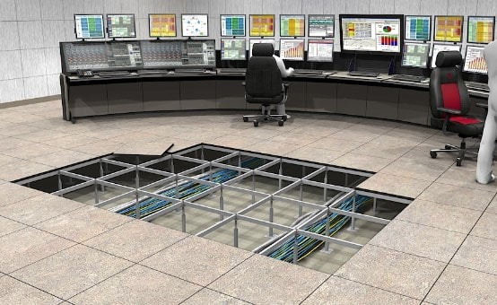

Fig: Raised floor

# Cooling Solutions

An adequate environment is required for equipment running which is provided by the data center cooling system. There are two types of cooling systems i.e., hot aisle and cold aisle containment systems.

|  |  |  |
| --- | --- | --- |
| Cooling System | Hot aisle | Cold aisle |
| Description | In a hot aisle, a physical barrier is used to guide hot exhaust towards the AC return. Just like a drop-ceiling vacuum, the hot air is directed upward into an AC return. | In the cold aisle, the supply airflow is contained by the doors at the end of the aisles and partition on the ceiling which acts as a physical barrier. |
| Pros | Helps to maintain the normal room temperature and create a cold environment in the room. It is used in most data centers and helps the fire detection system to work normally. | It captures less area as it requires space for only doors and partition at the end. Similarly, it is cheaper and enables cold sink areas in case of any failure. |
| Cons | It is expensive and considered as not comfortable to IT technicians. Similarly, it requires a separate confined channel for the airflow from the AC. | It creates a hot spot inside the room that is not considered human-friendly. Similarly, it increases the mix of air which decreases the temperature difference. |

Table: Comparison of hot aisle vs cold aisle

**Recommendation**

From the above comparison table and taking all the factors into account we have chosen a hot aisle containment system as a cooling method. It is a more efficient technique than a cold aisle containment system because it allows for greater workplace temperatures and expanded chilled water temperatures resulting in more economizer hours and significant electrical cost investment funds. It helps to maintain a cold environment and it is the first choice for all the data centers in the case of a cooling system. Similarly, from the perspective of green computing, a hot aisle will be utilized as it will minimize heat by blocking it. It helps to maintain the eco-friendly data center removing heat and distancing it from humans.

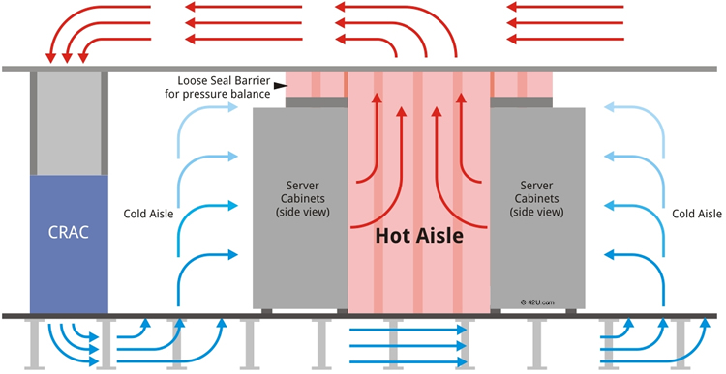

Fig: Hot aisle cooling system

# 9. Power

To keep up the data center running, maintaining a stable and safe power supply for IT equipment is crucial. The power provided to IT equipment must be adjusted because if the power is overloaded in the IT equipment, it would slow down the IT equipment's performance. Customers will be dissatisfied since the server's service is slow as a result of the power outage. DC power distribution was chosen because it features high-efficiency centralized power conversion equipment, resulting in improved efficiency. The transformer will be supplied by the DC power distribution.

## 9.1 Uninterruptible Power Supply (UPS)

This is a backup system that is used to assure that various electrical gadgets receive uninterrupted power. Because it has rechargeable batteries, it provides emergency power whenever the power is out. The primary goal of a UPS is to provide backup power in the case of a power outage, hence preventing transmission errors and data loss. To minimize the potentially severe repercussions of a brief power outage, UPS offers enough battery power to preserve the files and shut down the system in a timely way. It will deliver electricity to the Power Distribution Unit of the Columbia Data Center (PDU).

Figure: Multimode UPS System

## 9.2 Power Distribution Unit (PDU)

The power distribution unit (PDU) is a sort of electrical and power distribution system that manages to give alternating current (AC) power to various I.T equipment items, such as computers, servers, and networking devices, that are located within a rack system. A power distribution unit, which is physically mounted in the rack, can control and distribute enormous amounts of electricity.

As previously stated, the Columbia Hospital Data Center is a modular high-density data center and power distribution system built to current data center standards and requirements. A modular PDU was chosen since it is far more convenient than a standard data center. Furthermore, most things may be added to the Power Distribution Unit over time to meet the challenge with the latest technology, such as transformerless PDUs, power capacity management software, and so on.

Figure: PDU Panel

# 10. Energy Management System and Green Computing

1. Servers, storage, and data centers should be consolidated

The cost of blade servers is expensive but it provides great power efficiency and helps to make it a green option. When opposed to unconsolidated structures such as rack servers, blade servers are designed into a single chassis that contains several servers that all share the power supply, fans, network, and storage device. This not only helps to minimize space but also the multiplication of power sources. Blade servers also aid with drive consolidation by enabling better density computing for power consumption.

1. Perform a Baseline Energy Audit

A baseline energy audit should be the first step in any green data center program. Data centers are made up of many different and interrelated systems, it is necessary to drill down into the individual system to determine where inefficiencies exist within the architecture. The energy audits next analyze the impact of these inefficiencies on the overall use and develop a measurable and trackable remedy plan.

1. Turn off any unused IT devices

In data centers, the devices are not running all the time. But various devices consume 30-40% of maximum power when they are in an idle state. Using power management software and the inbuilt feature of server processors, the issue arising from power consumption will be solved. Or replacing the old servers with newer versions also helps to reduce the power consumption at an idle state.

1. Choose Eco-friendly materials and environmental features

Various factors support less energy consumption such as using low emission materials, waste recycling, usage of alternative energy which lowers the carbon footprint. Updating air compressors, paper shredding, and switching to LED lighting can have a significant impact over time. Furthermore, the organizations can have eco-friendly data centers by using locally sourced renewable resources for power servers and building the data centers in naturally cold locations to gain the benefits of free cooling. In terms of energy efficiency, it is anticipated that these ways of using energy will save 620 billion kWh. (Struckmeier, 2018)

# 11. Security

Multiple types of physical security are integrated with logical security methods for data center security and are applied for further assurance and stability. In addition, the data center must be protected against unwanted access and cyber threats.

## 11.1 Physical Security

Various forms of built-in safety standards must be used to safeguard the data center physically and ecologically. Security guards will be on duty 24 hours a day, seven days a week, and closed-circuit television (CCTV) cameras will be installed to monitor the Data Center. Only authorized staff will be able to access the server room, which will be secured with a card key lock or fingerprint door lock. A fire detection and smoke detection system, as well as a suppression system, will be installed throughout the structure. Because information can be harmed by water, the server room will only have a fire alarm. Azonal dry pipe sprinkling is put to secure the data and information system. To avoid hardware overheating, the servers will run at a steady temperature. Every month, an examination will be performed to ensure that the installed devices are in good working order.

## 11.2 Logical Safety

In a data center, logical security refers to the measures in place to secure access to computer systems and physical places. Cyber threats and human mistakes may both be mitigated using logical security. The majority of downtime errors and IT mishaps are caused by people, either via ignorance or intentional purpose. As a result, we've introduced logical security mechanisms including two-factor authentication and updating user access lists to protect sensitive data. To safeguard the core network servers, we've incorporated multi-level intrusion prevention (IPS/IDS). To prevent our IPs from being stolen or abused, we utilize firewalls, anti-virus, anti-spam, and anti-malware software. All common service ports are also protected by SSL encryption.

## 12. Preventative actions

Data centers are frequently regarded as one of the most important industries in the current digital era. As a result, maintenance is seen as an important part of the data center's operation. The following are some of the inclusive maintenance techniques we've considered:

**Preventive maintenance**

Preventive maintenance refers to actions taken regularly, such as routine measurements, adjustments, part removal, and cleaning, to ensure that systems operate at their best and are as reliable as possible. Filter or oil adjustments, as well as cleaning heat exchangers and electrical systems, are all part of preventative maintenance.

**Corrective maintenance**

Corrective maintenance is performed after a failure has been identified and is designed to return the system to normal operating conditions. This strategy is founded on the obvious assumption that, in the event of an emergency, the cost of downtime and rebuilding will be less than the budget necessary for the repair program.

**Battery maintenance**

Battery maintenance is the largest underlying cause of data center downtime. Batteries are possibly the weakest link in the power chain. A single faulty cell in a string might jeopardize the backup power system as a whole. As a result, establishing a battery maintenance program will aid in the detection of device anomalies while also improving the battery's performance through ongoing device adjustments.

**Re-engineering maintenance**

Modifications to the original specification or facilities to satisfy the anticipated operation.

# 12. Conclusion

We created a data center for a healthcare organization, by the assignment rules. We've suggested a Data Center Design strategy that includes all of the required components and criteria. We were able to meet the necessary issues related to data center design by combining new technologies such as blade servers, which require significantly more power and cooling capacity, demands to consolidate multiple data centers into fewer locations, improvements in operating procedures, and future developments in safety and security laws, all of which merge to force continuous facility changes in the modern data center.

# 13. References

DOYLE, K. (2022). *What is a Tower Server*?. Retrieved 23 February 2022, from <https://www.techbuyer.com/uk/blog/what-is-a-tower-server?fbclid=IwAR3MBVA9q3xChsfY3ymJxzueheQjVnyd2KwdsDmu6xJBXN5LYx5vtxlCGKI#:~:text=Tower%20Servers%20are%20affordable%20IT,midsize%20organisations%20across%20the%20globe.&text=Designed%20to%20be%20installed%20in,similar%20in%20size%20and%20shape>

TAYLOR, C. (2020). *Blade Servers vs Rack Servers vs Tower Servers* | ServerWatch. Retrieved 15 February 2022, from <https://www.serverwatch.com/hardware/blade-servers-vs-rack-servers/?fbclid=IwAR2R9wM7_uw9yiUTf2NYpNof6k9v0GfrmZkWuTBxI1nAn5uO7c0Ad5ncgL8>

Raised Floor vs Non Raised Floor Data Center. (2022). Retrieved 19 February 2022, from <https://www.huiyainc.com/non-raised-floor-data-center.html?fbclid=IwAR1dBGkAjp10jVC7M2QGK4s0u9sHVaSmgbPoKCggC0UyHiNUl3kGhkFdatU>

Struckmeier, J. (2018). 5 Steps to a Green Data Center - *Data Centers Coverage*. Retrieved 16 February 2022, from <https://www.facilitiesnet.com/datacenters/contributed/5-Steps-to-a-Green-Data-Center> 40635?fbclid=IwAR02GpsbExSrE7RhmPNJOgXFRxUhMsdwis7lOhqQkjFIjcyesnnF8dmWDhs

Bell, M., & Dan, J. (2005). Retrieved 22 February 2022, from <https://www.it.northwestern.edu/bin/docs/DesignBestPractices_127434.pdf>

Timb. Retrieved 22 February 2022, from https://blog.siemon.com/standards/tia-942-data-center-spaces

Velimirovic, A. Data Center Tiers Classification Explained: (Tier 1, 2, 3, 4). Retrieved 19 February 2022, from <https://phoenixnap.com/blog/data-center-tiers-classification>

TOMAL, T. (2018). Cisco Three Tier Network Design for Better CCNA Perparation. Retrieved 15 February 2022, from <https://whilenetworking.com/2018/04/15/cisco-three-tier-network-design/>

Tech, R. (2020). Data Center Design: Basic 3 Layers, Core, Aggregation, and Access – Router Switch Blog. Retrieved 23 February 2022, from <https://blog.router-switch.com/2020/11/data-center-design-basic-3-layers-core-aggregation-and-access/>

Data center cabling design fundamentals. Retrieved 23 February 2022, from <https://www.anixter.com/content/dam/Suppliers/CommScope/Documents/CommScope%20HSM/Whitepaper%20-%20Data%20Center%20Cabling%20Design%20Fundamentals.pdf>

Sheldon, R., & Pollack, E. (2020). Storage 101: Data Center Storage Configurations - Simple Talk. Retrieved 25 February 2022, from <https://www.red-gate.com/simple-talk/homepage/storage-101-data-center-storage-configurations/>