**Table of Contents**

**Abstract** 2

**1.** **Introduction** 2

**2.** **Literature Review** 2

**3.** **Problem Statement** 3

**4.** **Aim** 4

**5.** **Objectives** 4

**6.** **Research Questions** 4

**7.** **Significance of the work** 4

**8.** **Methodology** 5

**9.** **Overview of the proposed system** 5

**10.** **Conclusion** 6

**E-Sport Player Recruit System**

Shivam Ranabhat

[shivamranabhat@gmail.com](mailto:shivamranabhat@gmail.com)

# **Abstract**

Electronic sports (eSports) made explosive growth in terms of market value and the number of participants in official tournaments in recent years. The craze of eSports is increasing day by day rather than playing normally for fun purposes only. But in the context of Nepal eSports players are struggling to find perfect teammates and sponsors. In this proposal, I have proposed a solution which is an eSports player recruit system that will help to provide an equal platform for both hiring organizations and all eSports players who have an interest in participating in the official tournament and needs an organization that can support them economically. It has additional features like players can upload their gameplay videos, in-game profile, and contact details. Similarly, an organization can also upload their details and recruit what kind of players they are seeking.

***Key Words***- ESports, recruit, sponsor, tournaments

# **Introduction**

With the growth of technologies, players are showing their interest in electronic games. Due to lockdown in 2020, the number of user in electronic games are increasing in huge amounts, especially in battle royale game. The owner team of such games also thinks from the perspective of the audience and conducts different tournaments with high prize pools so that the competition can be tough, more number of participants can be increases and the desire of every user to become an eSports player will increase. Although this is a market strategy to increase the number of

users, the players who participate in an official tournament get different benefits.

But when it comes to the players of Nepal who have enough potential and wants to participate in official tournaments but due to lack of teammates and sponsors, they are forced to live by adjusting themselves as a viewer only. They still don’t have any platform where they make their official team, seek a good organization. ESports players in Nepal are still struggling to make a career in the gaming field.

The proposed recruit system is especially for the battle royal games in Nepal which have maximum numbers of users and participants in official tournaments. This system will be assistive for eSports players of battleground games, making them easier in their team formation, getting sponsor organization, and chatting with each other. This will help such organizations to recruit better players of their choice. Both players and organizations can apply for each other. This system will bring an adverse change in the sector of eSports so that the competition will be high and the desire of every player for eSports tournaments will be increased.

# **Literature Review**

Three students who had integrated with the same French engineering school (Aix-en-Provence, Robin SOCIE, and Provence-Alpes-Cote d’Azur) proposed a web platform that supports eSports Players and Teams in their evolution. SKILLINKED is a web platform that simply uses a database and allows users to create a professional ESports CV highlighting gaming and eSports experience which adds value to hours of play and brings visibility to an individual’s profile, finds a proper team and players managing all the recruitments i.e., manager, coach, analyst, create and manage team, monitor individual and team performance by accessing game statistics which helps to evaluate player strengths and weakness and discover new ESports training programs.

Ashish Saini, Vedang Mehrotra, and Neeraj Verma are the co-founders of LiveOfficial ESports proposed a web platform in 2018. According to (Saini, 2018) LOE LiveOfficial also uses a database and enables the players to overcome any obstacles to spark outstanding performance in the most prestigious tournaments and leagues. LOE focused on mainly 4 countries i.e., India, Nepal, Bangladesh, Srilanka for seeking out, leveling up, and amplifying gamers and creators where gamers are enabled to apply as to content creators where they will provide the best team managers.

In 2010, brothers Paul and Andrew Bassat and Matthew Rockman proposed a web platform that helps the players to get recruited, seek teammates which help the team to recruit players. It uses a database to store player’s CVs which contains all the gaming experiences on the game of their interest. The entire database of the team’s recruitment offers with advanced filters to match an individual search. Game categories are almost 50 or more than that. Visitors are also allowed to suggest the game if it is missing in the seek-team. It also uses Instant messaging technology which helps the gamers and team managers to chat with the players and if the player suits the manager’s needs then they can recruit that player in just one click. (Rockman, 2010)

Tim Bowen, Yaroslav Kudzyo, and JD Kaplan proposed the largest college recruiting network in 2017 which is a web platform that serves over 2 million high school eSports athletes. BeRecruited is a web platform that helps players to be recruited so that they can play eSports in the college of North America. According to Bowen, Kudzyo, and Kaplan (2017) to enhance athletic skills and get exposure to coaches of college eSports an individual player should record the highlight clips of his/her best plays, compete regularly, create an online recruiting profile, keep the profile up to date and should get good grades (overall GPA of 2.0 out of 4.0 scale in high school) which will be stored in the database of BeRecruitred. Similarly, In BeRecruited the ESports coaches of North American high schools look for other qualities in players like having good grades and being a good team player more than just playing ability which helps to be recruited and get scholarships to eSports players. (Bowen et al., 2017)

Another web platform was developed by the team of Harena Data, Inc in 2021 which is built by gamers for gamers and seeks, to help players with automated coaching advice, stats, analysis, and an introduction to scouts and professional coaches so that they can pursue their dreams, conquer their emerging world. It helps to seek to support gamers and eSports at all levels. It harnesses the power of advanced analytics and data science to help game and eSports enthusiasts of all skills levels. It delivers automatic coaching recommendations based on player data analysis and receives direct introductions to professional eSports scouts all around the world. Similarly, it employs organizational, team management, and scouting technologies to find new players for the recruitment or eSports competitions. It collects league listings from around the world to store in their database and incorporates them into Gyo score to assist players in discovering new opportunities to put their skills to the test in live competitions. (Harena Data Inc et al., 2021)

# **Problem Statement**

Recruitment of eSports players is the burning issue for both sides i.e., player and team organization. According to data collected by Nepal ESports Association (2019), only 10% of eSports players can raise according to their skills and game potential rest of the others are struggling to find better teammates and organization. This data shows still having some platform for the recruitment players are facing serious problems in their gaming carrier. (Nepal ESports Association. int, 2019)

The main problem with eSports Players in Nepal is to find better teammates, team managers or analysts, and team organization. Lack of chat servers in existing recruit system is the biggest problem to connect the players and sponsor organizations. As most of the recruitment platforms are web-based which are hard to find and use for recruitment, and most of the players in that platform are from Europe and North America which is another problem for Nepalese players and organizations to identify where players can find better teammates and can be recruited by any organization.

# **Aim**

The major aim of this project is to provide a system in the form of a mobile application in Nepal that will help players to find teammates of their level, the best team manager, and the team organization to grow the eSports community.

# **Objectives**

The objectives of this project are listed below:

1. To provide a system that uses a database to store gaming CVs and profiles including their gameplay clips of players
2. To provide a system where team managers, casters, and organizations can also build their profiles for recruitment.
3. To use a chat server and a database to connect players, managers, and team organizations.

# **Research Questions**

Research questions are defined as the formal statement which asserts the goal of the study. The research question expresses precisely what the study is investigating and what they aim to suggest. The research question refers to the topic of the study. It is a logical statement that demonstrates the research’s understanding of the topic and what they will learn in that area.

**Domain**

1. What would be the effect of introducing a new system in Nepal for recruiting eSports players?
2. What are the drawbacks of the existing system in the eSports community?
3. How does an eSports player, team manager, and the organization get to benefit from such a system?

**Technical**

1. How does the CV and game clips stored in the database help the players to find teammates, team manager, and organization?
2. Where does the message will be stored when a user sent a message and suddenly goes offline?
3. How will the mechanism in the chat server work when a user sends a message and goes offline?

# **Significance of the work**

Given that approximately 11.7% of normal gamers are becoming eSports players, we can assume that many players face such difficulties who are willing to make their future in eSports. This proposal is about designing a system that helps the eSports players to find better teammates, team coaches, and organization. This system will assist an eSports player to make their profile and CV in that system so that other players, organizations, and team managers can seek out. Players and other users can also stay connected to each other through the chat system of this system. This system is a problem-solving platform for any player dreaming to become an eSports player and willing to have better teammates, proper guidance, and organization. The proposed system will provide a positive impact and help to grow the Nepalese eSports community as it is growing worldwide.

# **Methodology**

Research methodology is the strategy of categorizing, collecting, analyzing, and interpreting information on a certain topic. During the research, a methodology is considered as the most important aspect of research. A better research methodology is essential for better research and better outcome. There are two sorts of research techniques i.e., qualitative and quantitative. To gather more exact data, I have chosen solely qualitative research in this study. Qualitative research is the process of gathering non-numerical data that aids in the understanding of concepts, views, and experiences. The main reason to choose qualitative research is to investigate the related people’s perspectives and thought and analyze them.

Both primary and secondary methods were used to collect data and resources. Online survey preparing some questionnaires for respondents as a primary resource, and research articles, papers, and publications will be referred to as secondary resources. A survey to collect the primary data since it aids in the research of public opinion and attitudes regarding the issue will be carried out. A qualitative online survey will be done to get the opinions and experiences of the players.

To collect the data from more eSports players snowball sampling approach will be used in this study. In this method of sampling approach, few respondents will be called and asked whether they know anyone who possesses that criteria which we needed. I will pal to ask if they have any contact with eSports players. I will choose some of them if they are close to enough to some eSports players which will assist me to gain better outcomes and make more informed judgments. This method of sampling will be best suited for collecting appropriate data for qualitative research as it allows us to find the best match respondents who have enough knowledge and attributes in the field which we are studying.

I will also conduct studies of some case studies of previously created systems as a theoretical perspective to examine what has been already done in that field and what has been remaining to be done to make that field step forward. In social science, case study research has been a widely employed method as it allows the examination of complicated subjects in the context of real-life situations. In this method of gathering data, I will investigate all the features contained in that system and from the feedback of the users of that system limitations and issues can be determined. Avoiding all those limitations and issues, I will make the system focus on the features that the system user wants which lacks on other systems available in markets.

# **Overview of the proposed system**

This proposed system consists of a database system and chat system. After studying the problems faced by the Nepalese eSports player I have designed a system which will be a mobile application that is divided into three main features i.e., Registration, recruiting process, and chatting. The first process is registration where an eSports player and any certified organization can register. To make this system secure I will implement an approval process from admin which uses two databases i.e., temporary and permanent databases. A temporary database will store the registration request which will be displayed in the admin panel and a permanent database that will store the data after the approval of an admin. For registration, a user should provide his/her proper information which includes personal details like name, email, address, contact number, and proof of his/her identity including his/her gaming CV or game clips with the game details which they want to be recruited. After this, the admin will approve their accounts only if they provide proper information. After complete registration, the data of other players will be displayed from the permanent database in the home section. The second feature is recruiting players and organizations which is the same as registration. For this, the user will send recruiting request to any user or organization they like and the request details will be stored in a temporary database. The recruiting request will be retrieved from the temporary database and displayed in the user dashboard. Similarly, after checking the details and ability of the requested player the user can approve the request which will be stored in the permanent database separately so that the details of the same player will not be shown in the home section of other users.

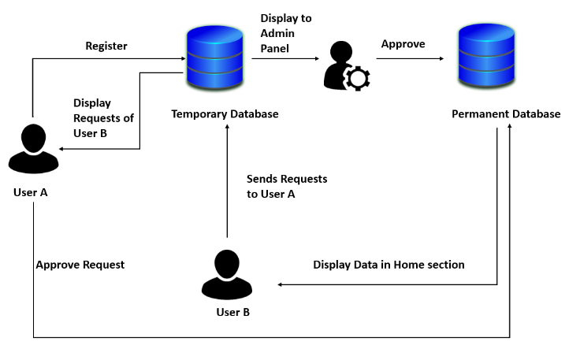

Fig: Mechanism of register and approval

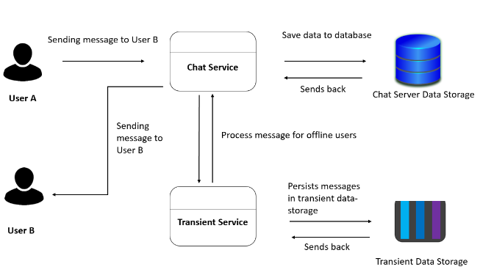

Fig: Chat mechanism for online and offline users

Another feature is chatting between two players or between players and an organization. uses two micro-services i.e., chat service and transient service, and two data storages i.e., chat server data storage and transient data storage. The chat service will handle the online chat messages of active users. This service is responsible to determine whether the user is online or not. If the user is online, then the message from the chat server data storage will be retrieved and sent to him/her immediately. The chat server data storage stores the message of the online users sent by the chat service. Similarly, if the user is offline, the chat service will send the message to the transient service which stores the messages to the transient data storage. When the user comes back online, the chat service will notify the transient service that the user is online then his/her message sent by user A will be retrieved and sent back to the chat service which then delivers the message to user B. These features will help the player and organization to stay connected to each other.

# **Conclusion**

This research helps to propose a mobile application for recruiting eSports players. This system will provide a positive impact on the Nepalese eSports community solving the major problems which Nepalese eSports players and sponsor organizations are facing. This system will be secure preventing fraud cases and chatting feature which enables the users to send texts to each other so, that they can better know each other. This project will require a significant amount of attention, work, and patience. The research will be undertaken in a variety of ways to be accomplished. Once, this project is completed, it will be able to solve the problem of Nepalese eSports players and sponsor organizations for recruitment which they are facing.

1. **References**

*American Journal of Recruit-System for ESports*, 1992. Chapters ESports recruit system 471 new ASHP members in the spring campaign. 49(10), pp.2374-2374.

Bassat, A. & Rockman, M. (2010). Seek-Team For ESports Players. *International Research Journal of ESports Recruit System (IRJERS)*, *07*(05).

Brickell, A., 2017. Addressing Integrity and Regularity Problems in ESports Recruit: THE RESPONSIBILITY OF THE WHOLE ESPORTS COMMUNITY. *Gaming Law Review*, 21(8), pp.603-609.

Cranmer, E., Han, D., van Gisbergen, M. and Jung, T., 2021. ESports Analytics Tools Matrix: Structuring the ESports research agenda. *Computers in Human Behavior*, 117, p.106671.

Deshdeep, N., 2018. *App or Website? 10 Reasons Why Apps Are Better for ESports Players Recruit | VWO*. https://vwo.com/blog/10-reasons-mobile-apps-are-better.

Hong, H., 2022. eSports: the need for a structured support system for players. *European Sport Management Quarterly*, pp.1-24.

Insider Intelligence. (2017). Monthly ESports Viewers. *Insider Intelligence for ESports Viewers in the US*, *19*(3). https://doi.org/10.9790/0661-1903028690

Provence, A., SOCIE, R., and Cote d’Azur, P. (2012). SKILLLINKED A ESports Recruitment System.  *Journal of ESports Athletes Recruitment*, *9*(11).

Saini, A., Mehrotra, V., and Verma, N. (2020). LiveOfficial ESports. *International Research Journal of ESports Recruit System (IRJERS)*, *07*(05).

Thistlethwaite, P., 2016. Problems in ESports Recruit System. *Journal of Library Administration*, 33(1-2), pp.31-44.

‌Permatasari, D. L. B., Natalya, L., & Siaputra, I. B. (2021). Validasi Video Game Addiction Test Player Esport di Indonesia. *Sumber Bukti Berdasarkan Struktur Internal*. *PSIKODIMENSIA*, *20*(2), 243–250.https://doi.org/10.24167/psidim.v20i2.3144.

ChiYoung Ahn. (2011). The Chinese Power ESport Recruit System and Its Characteristics. *아시아문화연구*, *21*(null),1–31. https://doi.org/10.34252/acsri.2011.21..001.

‌

‌