Q1

<!DOCTYPE html>

<head>

  <meta charset="UTF-8" />

  <meta name="viewport" content="width=device-width, initial-scale=1.0" />

  <link rel="stylesheet" href="style.css" />

  <title>Simple webpage</title>

</head>

<body>

  <h1>

    Welcom to web technology

  </h1>

  <p>

    A computer science portal for B.Tech

  </p>

 </body>

</html

<html lang="en">

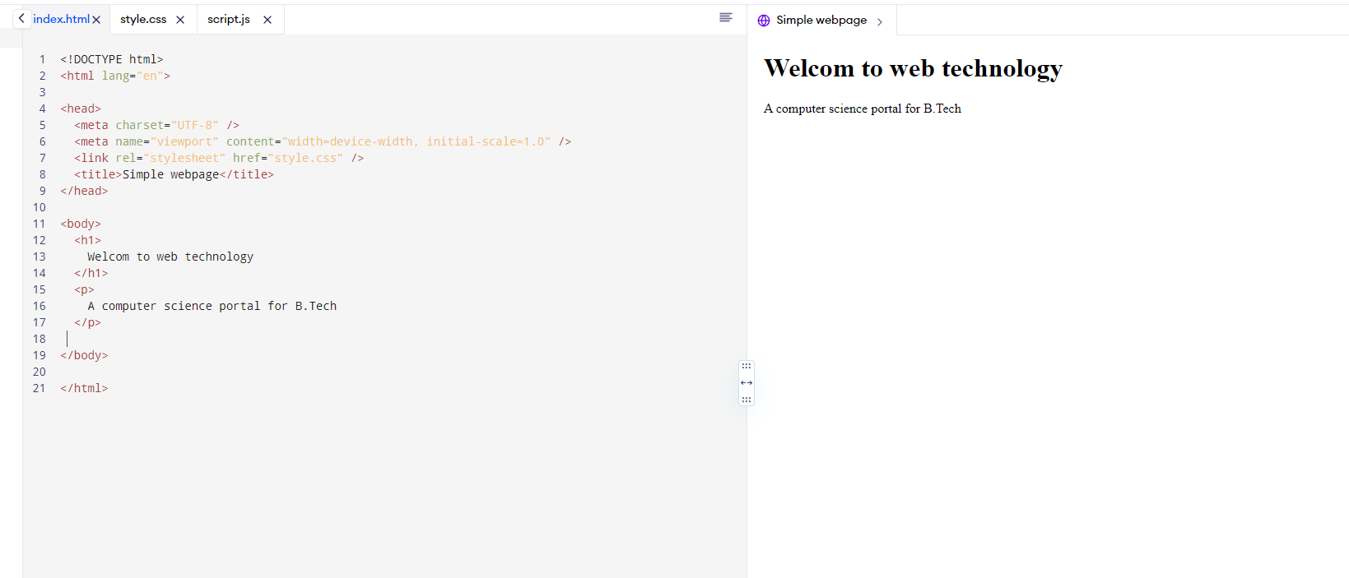

Q2

<!DOCTYPE html>

<html lang="en">

<head>

  <meta charset="UTF-8" />

  <meta name="viewport" content="width=device-width, initial-scale=1.0" />

  <link rel="stylesheet" href="style.css" />

  <title>Simple webpage</title>

</head>

<body>

  <h1>

    Welcome to web technology

  </h1>

  <h2>

    Welcome to web technology

  </h2>

  <h3>

    Welcome to web technology

  </h3>

  <h4>

    Welcome to web technology

  </h4>

  <h5>

    Welcome to web technology

  </h5>

  <h6>

    Welcome to web technology

  </h6>

  <p>

    A computer science portal for B.Tech

  </p>

</body>

</html>

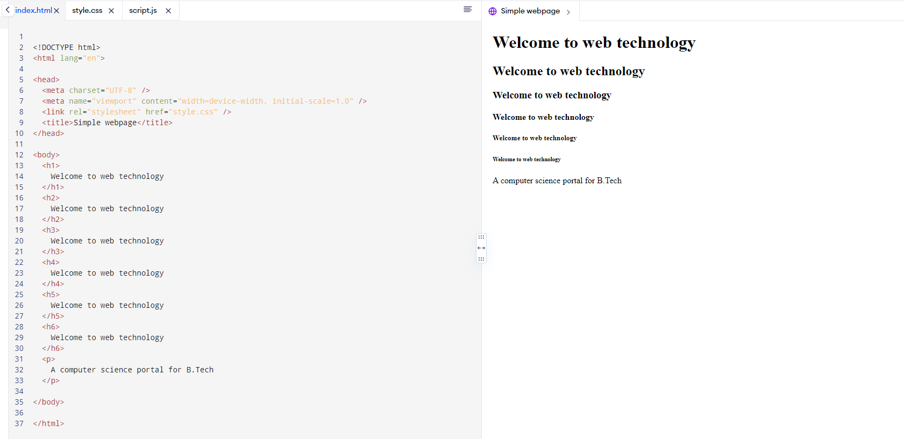Q3

<!DOCTYPE html>

<html lang="en">

<head>

  <meta charset="UTF-8" />

  <meta name="viewport" content="width=device-width, initial-scale=1.0" />

  <link rel="stylesheet" href="style.css" />

  <title>Simple webpage</title>

</head>

<body>

  <h1>

    Welcome to web technology

  </h1>

  <p>

    A computer science portal for B.Tech.asdfvjashfdksabd hfvjsadgvfsbkdfubdsf

Asdfbgjsbdfkgasjdhvbj,sbfjhadvbjsf

  </p>

  <p>

    a new portal

  </p>

</body>

</html>

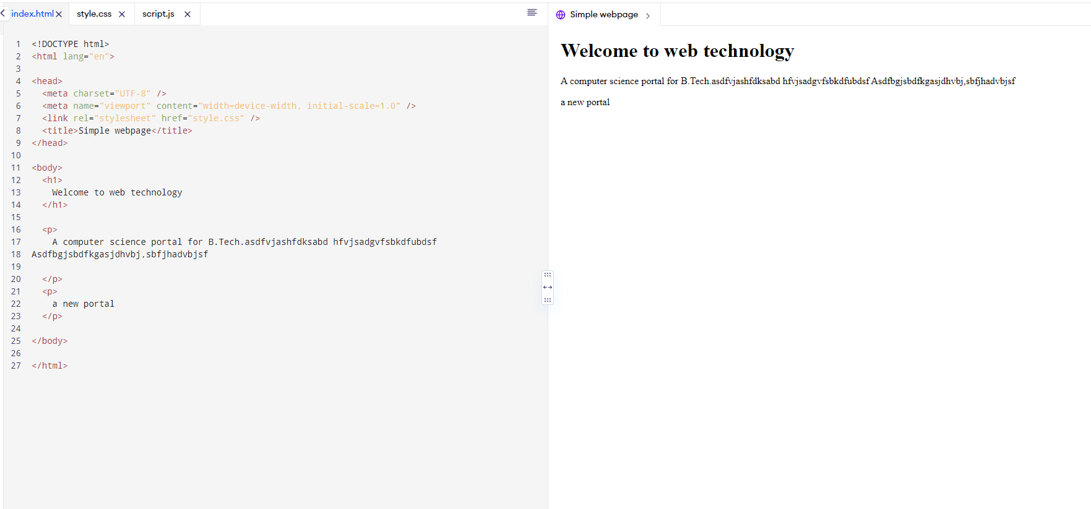

Q5

<!DOCTYPE html>

<html lang="en">

<head>

  <meta charset="UTF-8" />

  <meta name="viewport" content="width=device-width, initial-scale=1.0" />

  <link rel="stylesheet" href="style.css" />

  <title>Simple webpage</title>

</head>

<body>

  <h1>

    Welcome to web technology

  </h1>

  <p>

    A computer science portal for B.Tech

    <p>

        a new portal

      </p>

  </p>

</body>

</html>

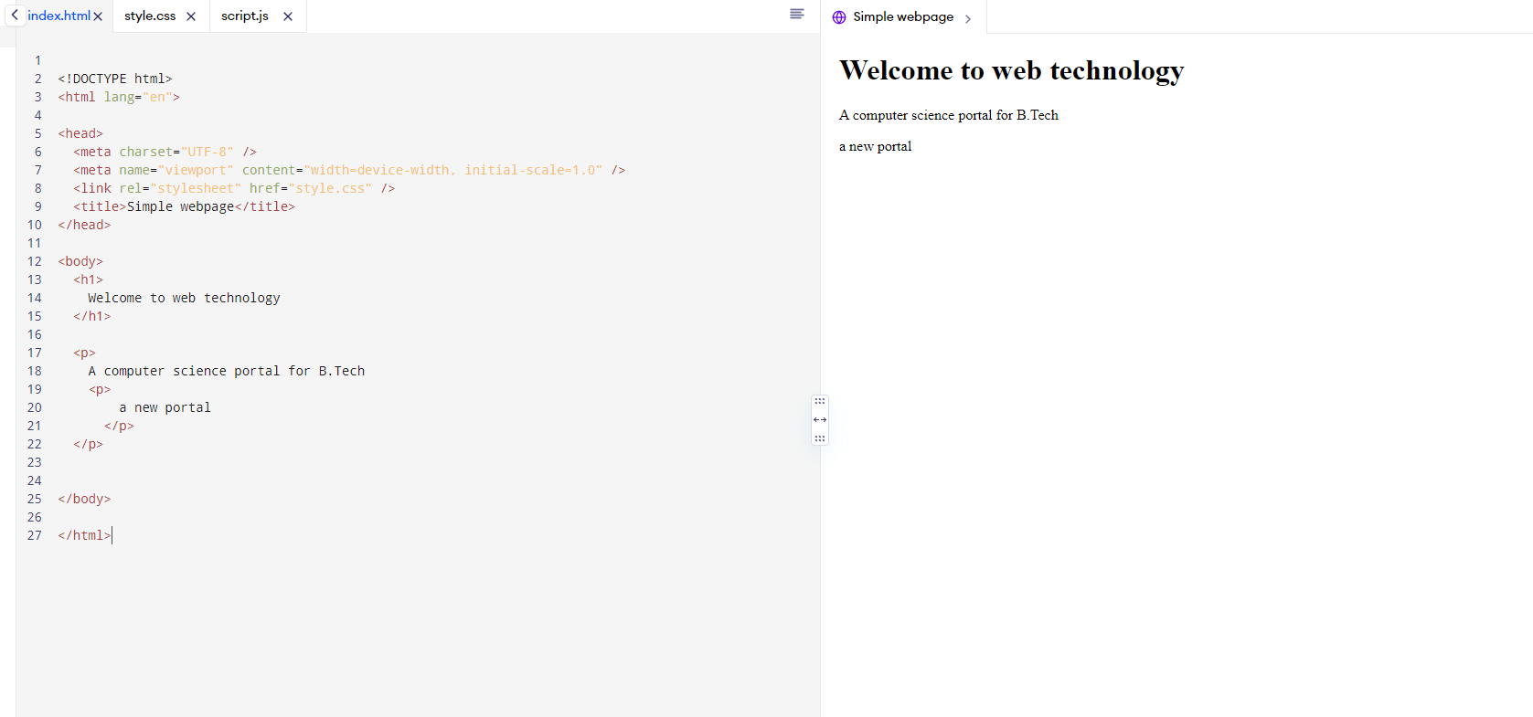Q6

<!DOCTYPE html>

<html lang="en">

<head>

  <meta charset="UTF-8" />

  <meta name="viewport" content="width=device-width, initial-scale=1.0" />

  <link rel="stylesheet" href="style.css" />

  <title>Simple webpage</title>

</head>

<body>

  <p>

    <h1>

            Welcome to web technology

    </h1>

    A computer science portal for B.Tech

  </p>

</body>

</html>

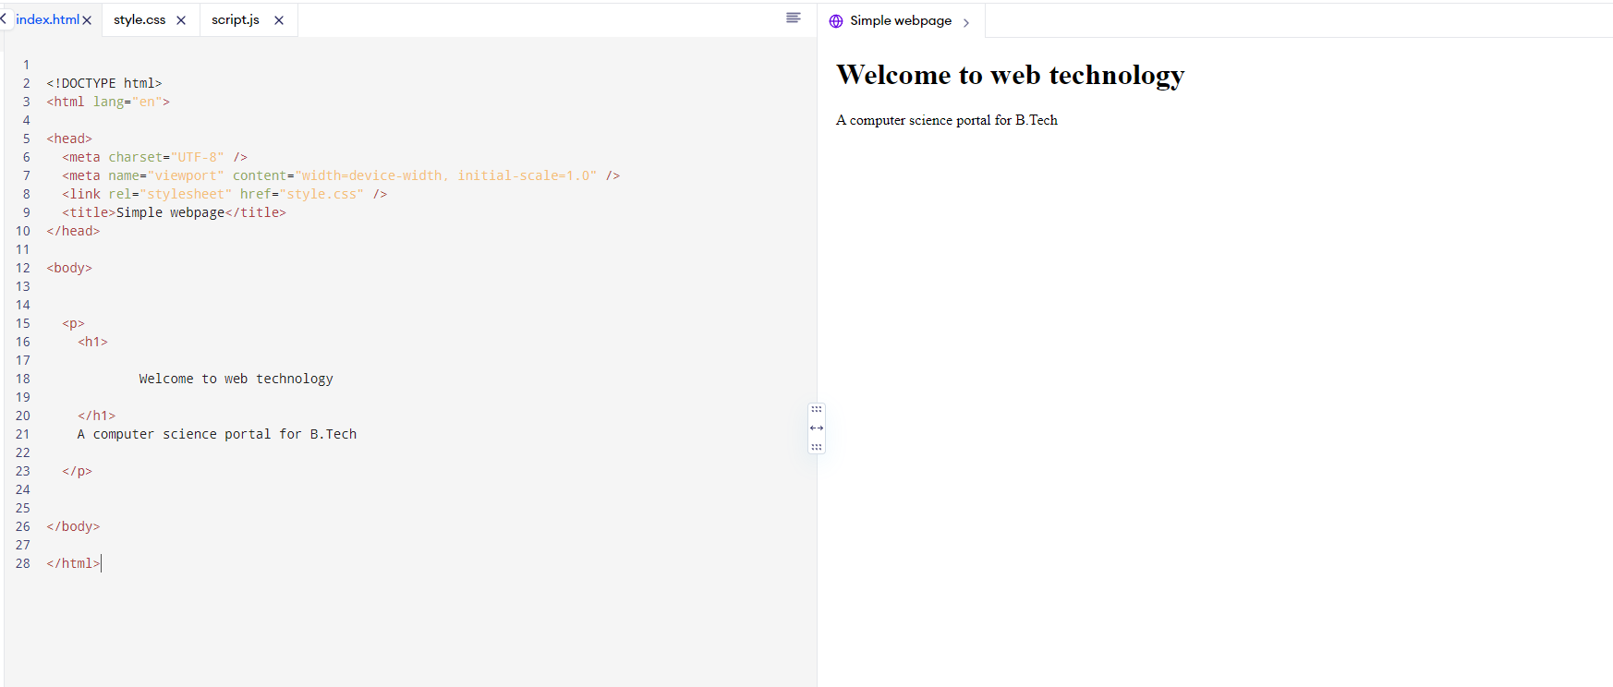Q7

<!DOCTYPE html>

<html lang="en">

<head>

  <meta charset="UTF-8" />

  <meta name="viewport" content="width=device-width, initial-scale=1.0" />

  <link rel="stylesheet" href="style.css" />

  <title>Simple webpage</title>

</head>

<body>

    <h1>

        Welcome to web technology

        <p>

            A computer science portal for B.Tech

          </p>

</h1>

</body>

</html>

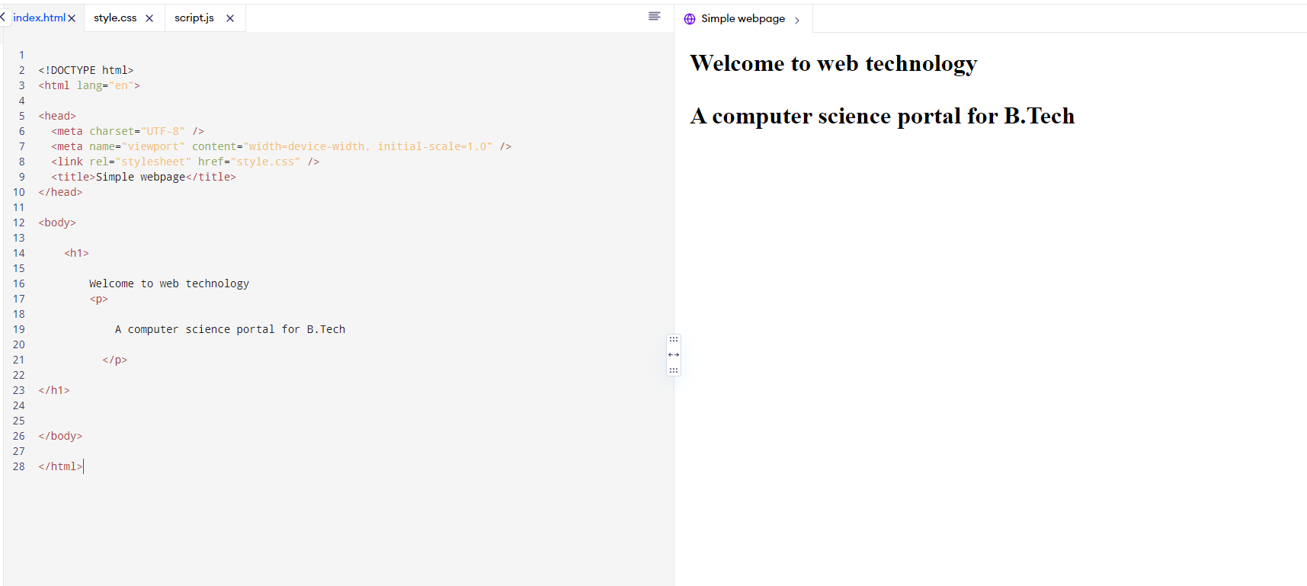

Q8

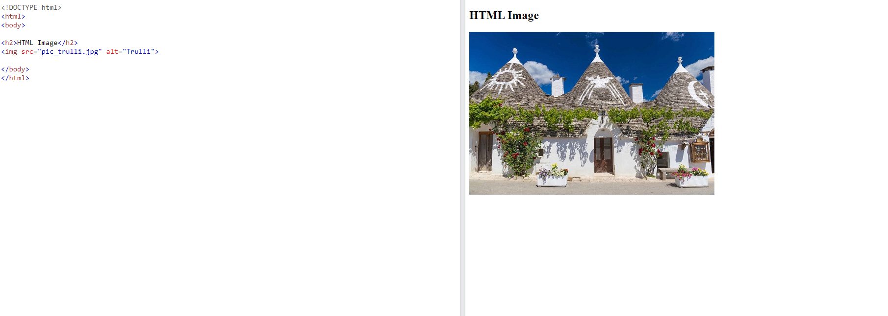

Q9

