Q1.

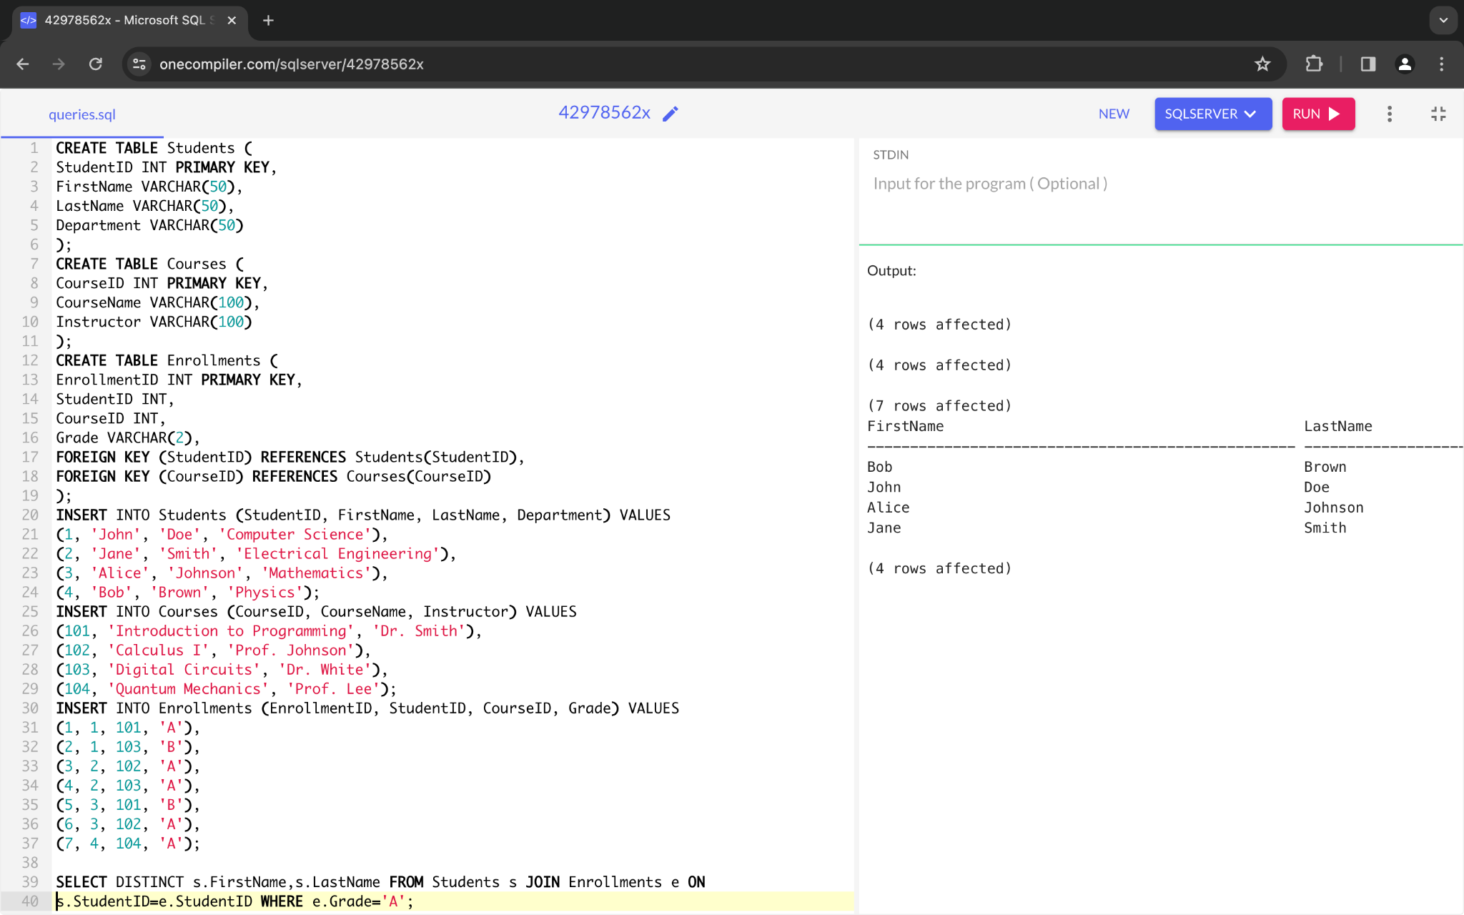

Q2.

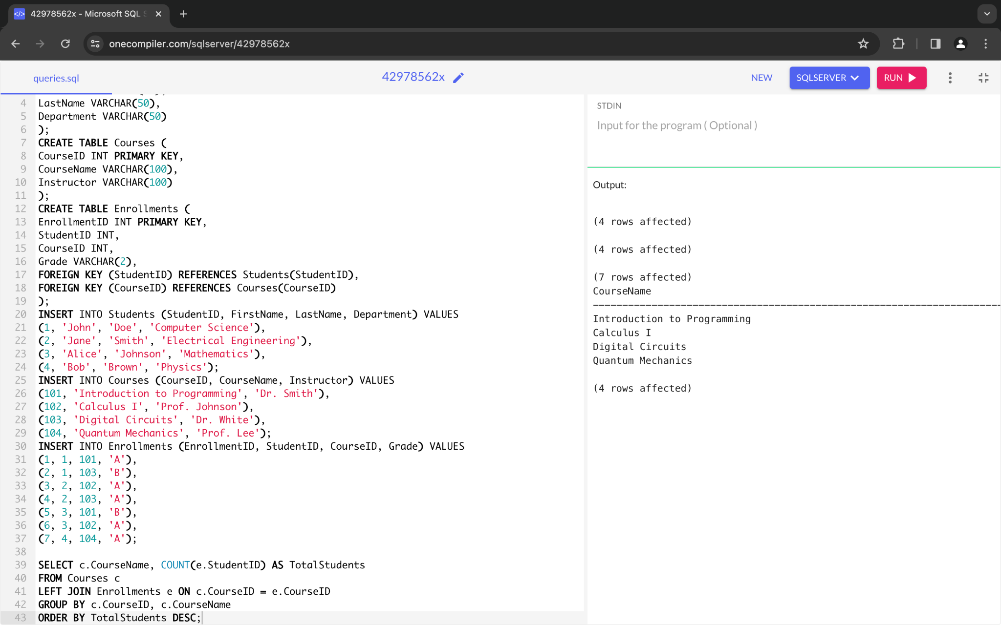

Q3

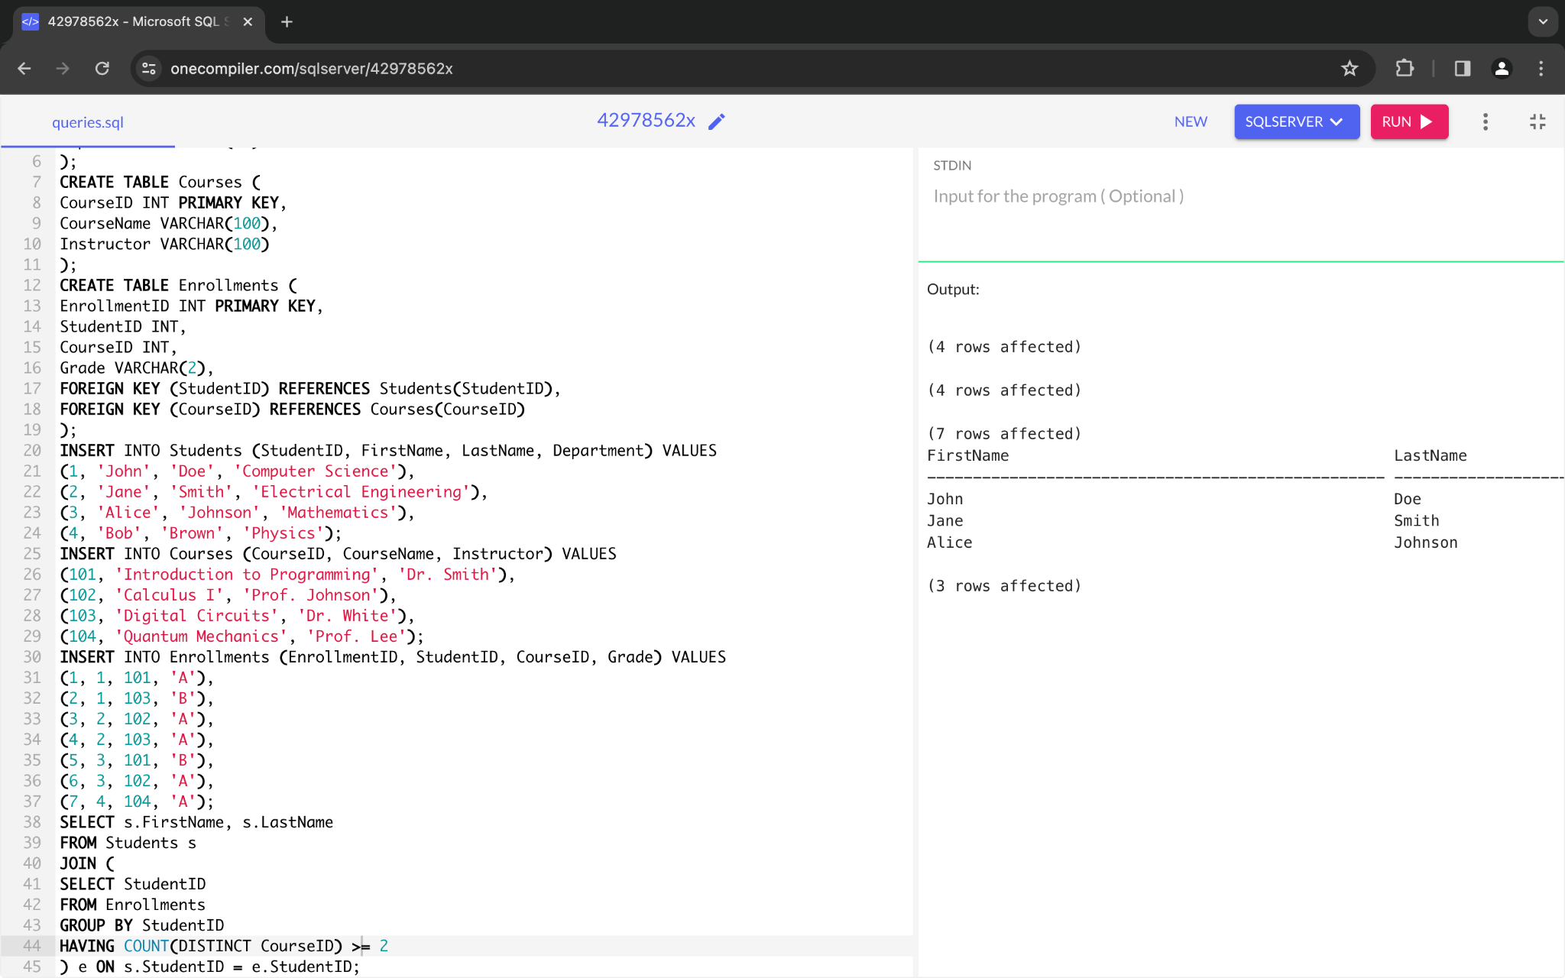

Q4.

SELECT s.FirstName, s.LastName

FROM Students s

JOIN Enrollments e ON s.StudentID = e.StudentID

ORDER BY e.Grade DESC

LIMIT 1;

Output:

FirstName LastName

Jane Smith

Q5.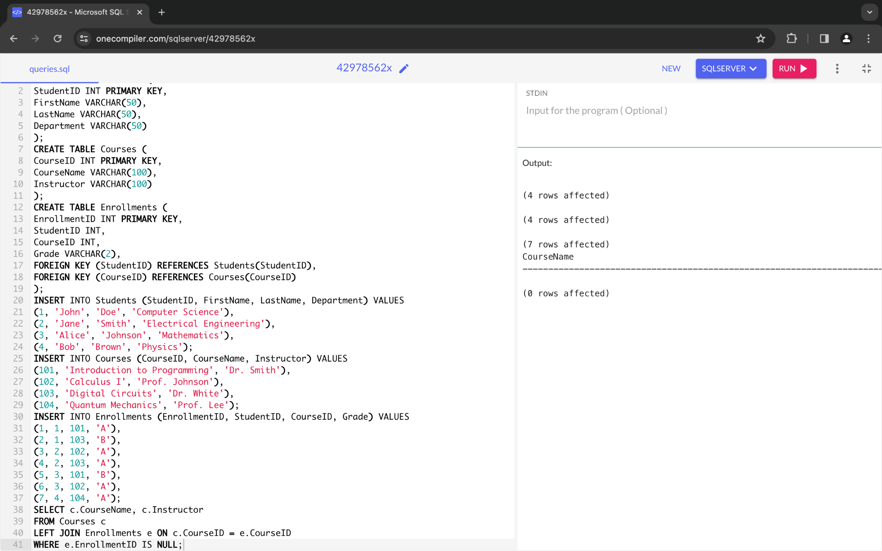Q6.

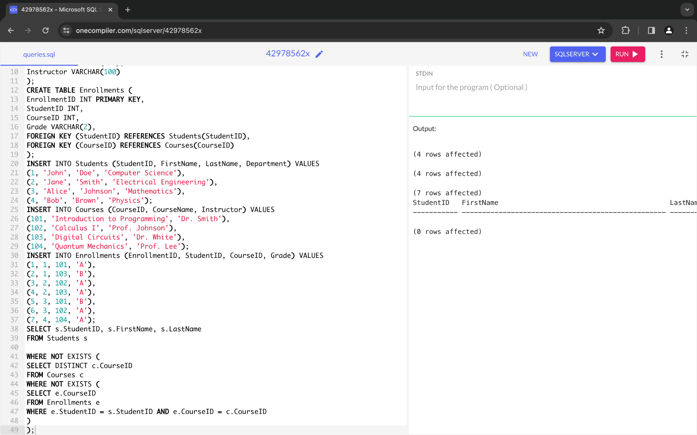

Q7.

SELECT c.CourseName, AVG(e.Grade) AS AvgGrade

FROM Courses c

JOIN Enrollments e ON c.CourseID = e.CourseID

GROUP BY c.CourseName

ORDER BY AvgGrade DESC

LIMIT 1;

Output:

CourseName AvgGrade

Introduction to Programming 1.5

Q8

