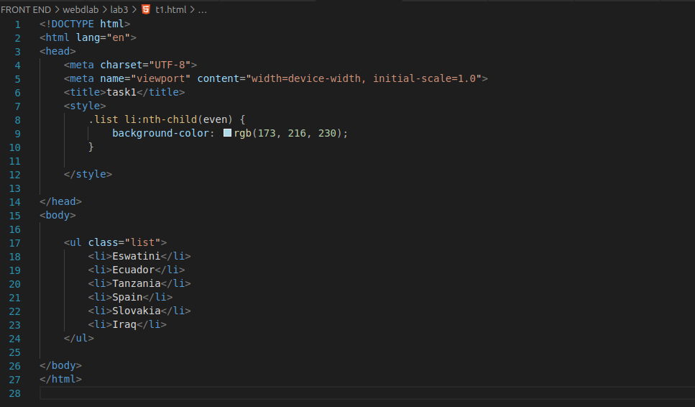

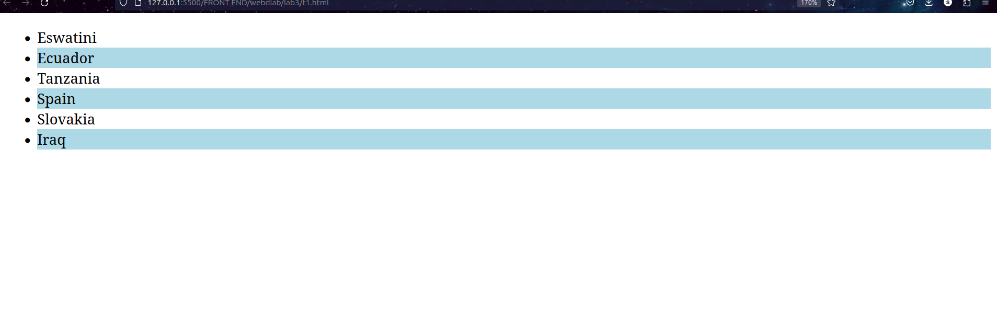

T2. ⇒ 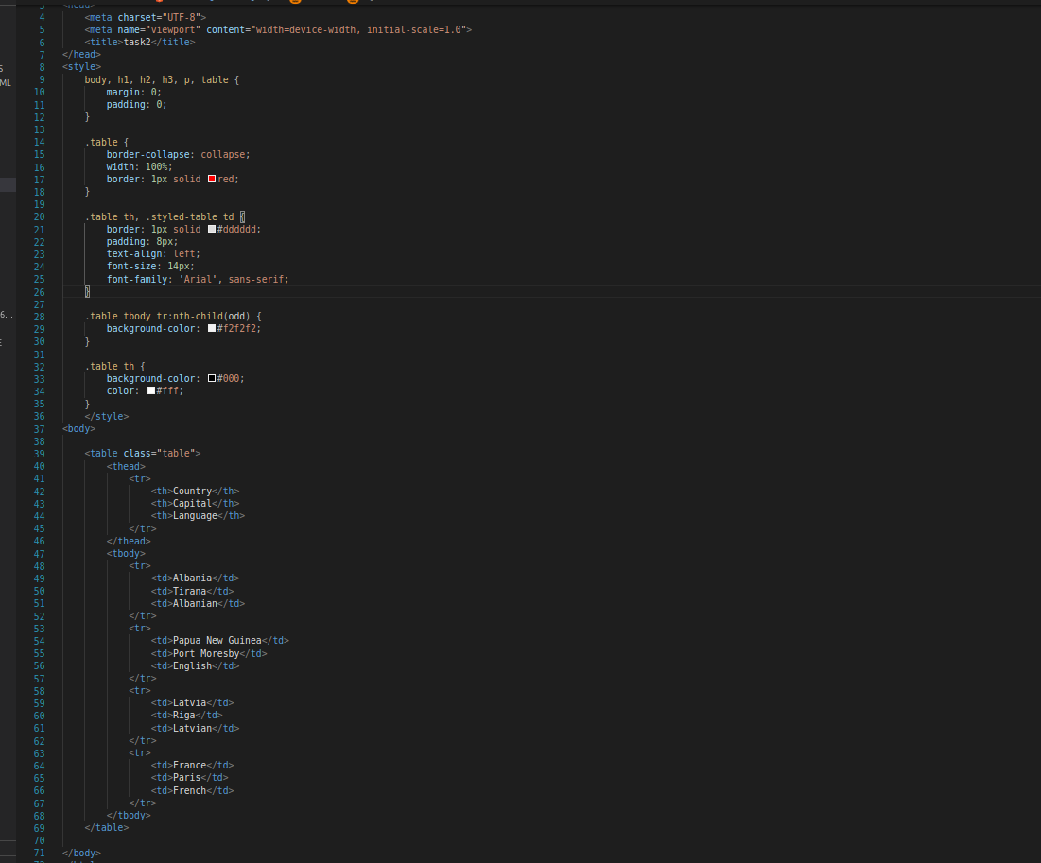

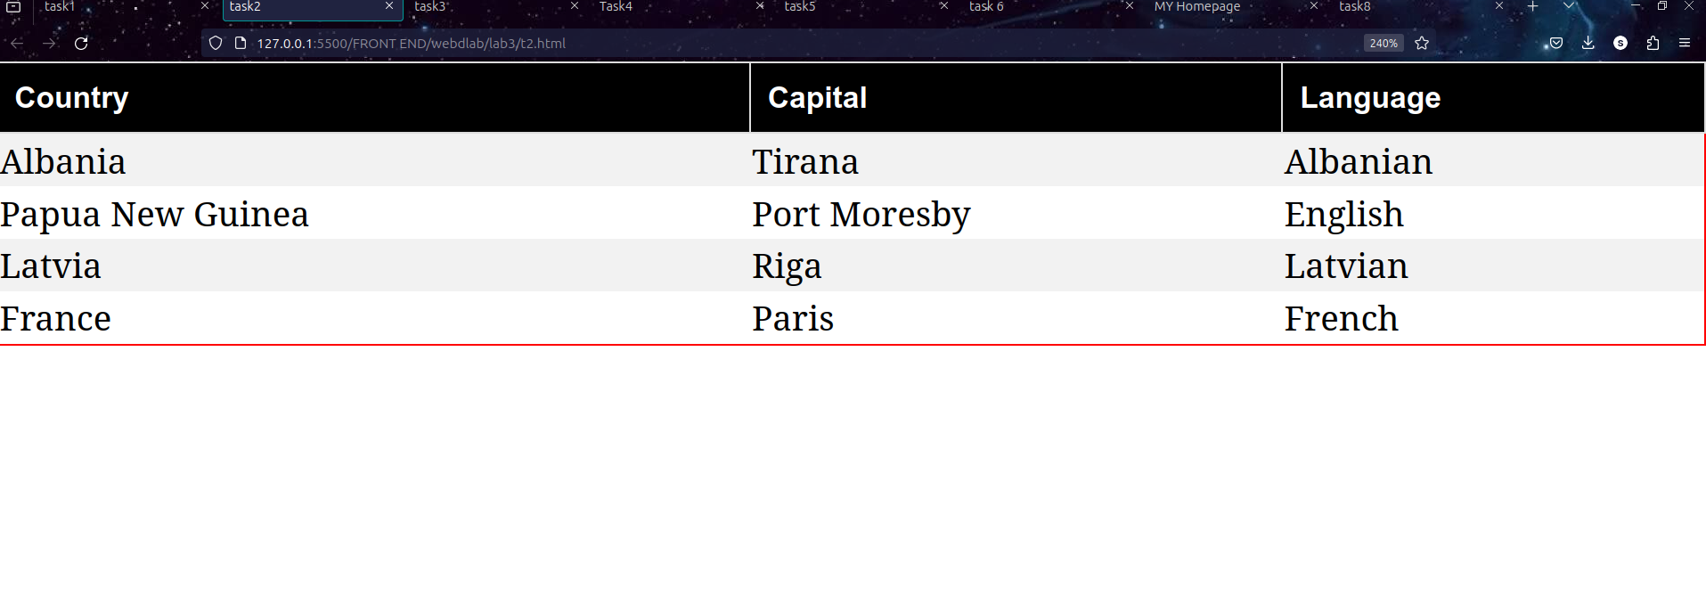

T3.

<!DOCTYPE html>

<html lang="en">

<head>

<meta charset="UTF-8">

<meta name="viewport" content="width=device-width, initial-scale=1.0">

<title>task3</title>

<style>

body {

font-family: 'Arial', sans-serif;

}

h1 {

font-family: 'Helvetica', sans-serif;

}

ul {

list-style: none;

padding: 0;

}

li {

margin-bottom: 8px;

padding: 8px;

font-style: italic;

}

.Bacon {

background-color: #ff9999;

}

.Tomato_slices {

background-color: #99ff99;

}

.dairy {

background-color: #ffff99;

}

</style>

</head>

<body>

<h1>Grilled Cheese Sandwich with Bacon and Tomato</h1>

<h2>Ingredients</h2>

<ul>

<li class="Bacon">Bacon</li>

<li class="dairy">Cheese</li>

<li class="Tomato_slices">Tomato slices</li>

<li class="dairy">Butter</li>

<li class="dairy">Bread slices</li>

</ul>

<h2>Instructions</h2>

<p>Step-1. Heat a non-stick pan over medium heat. Place bacon slices in the pan and cook until crispy. Remove bacon and set aside.</p>

<p>Step-2. Butter one side of each bread slice. On the unbuttered side of half the slices, place a layer of cheese, followed by bacon slices and tomato slices. Top with another bread slice, buttered side facing out.</p>

<p>Step-3. Place the sandwiches in the pan and cook until the bread is golden brown and the cheese is melted. Flip the sandwiches and cook the other side.</p>

<p>Step-4. Serve hot and enjoy your delicious grilled cheese sandwich with bacon and tomato!</p>

</body>

</html>

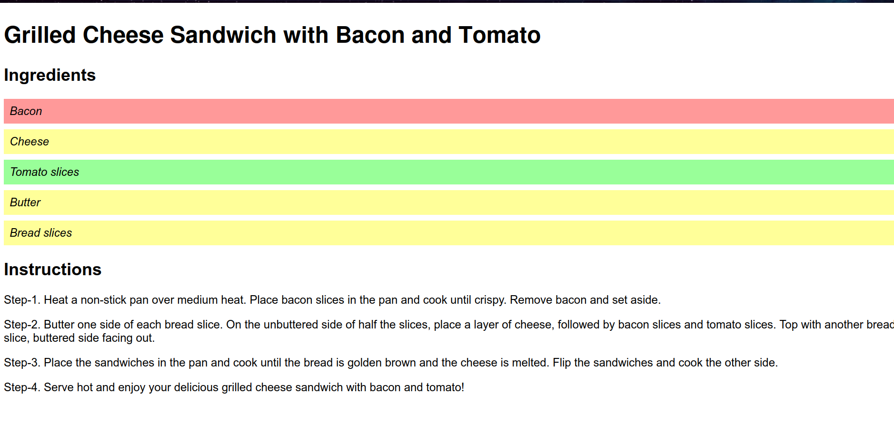

T4. .

⇒ <!DOCTYPE html>

<html lang="en">

<head>

<meta charset="UTF-8">

<meta name="viewport" content="width=device-width, initial-scale=1.0">

<title>Task4</title>

<style>

body {

margin: 0;

padding: 0;

font-family: 'Arial', sans-serif;

}

.container {

display: flex;

width: 100%;

}

.column {

flex: 1;

padding: 20px;

}

._left-column {

background-color: #f0f0f0;

}

._right-column {

background-color: #b3ffb3;

}

ul {

list-style: none;

padding: 0;

margin: 0;

}

li {

margin-bottom: 10px;

}

</style>

</head>

<body>

<div class="container">

<div class="column_left-column">

<h2>Best Selling Books on Amazon Kindle</h2>

<ul>

<li>Book 1</li>

<li>Book 2</li>

<li>Book 3</li>

<li>Book 4</li>

<li>Book 5</li>

</ul>

</div>

<div class="column_right-column">

<h2>My Favorite Celebrities/Athletes</h2>

<ul>

<li>Celebrity/Athlete 1</li>

<li>Celebrity/Athlete 2</li>

<li>Celebrity/Athlete 3</li>

<li>Celebrity/Athlete 4</li>

<li>Celebrity/Athlete 5</li>

</ul>

</div>

</div>

</body>

</html>

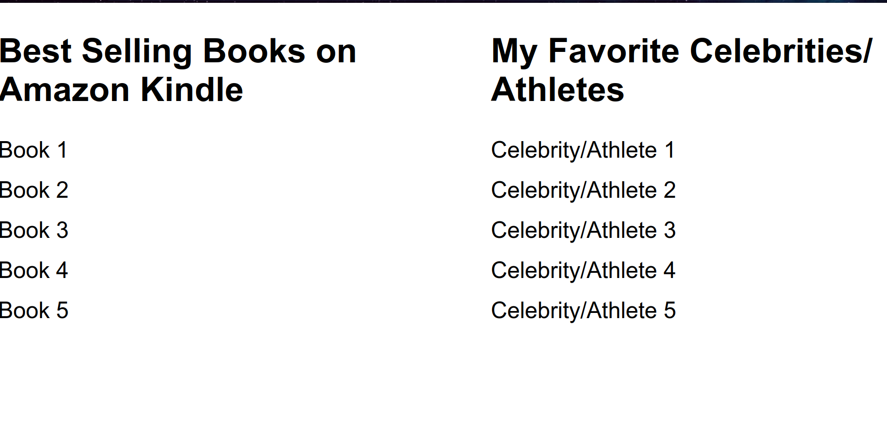

T5.

⇒ <!DOCTYPE html>

<html lang="en">

<head>

<meta charset="UTF-8">

<meta name="viewport" content="width=device-width, initial-scale=1.0">

<title>task5</title>

<style>

body {

margin: 0;

padding: 0;

font-family: 'Arial', sans-serif;

}

nav {

background-color: #add8e6;

padding: 10px;

}

nav ul {

list-style: none;

margin: 0;

padding: 0;

text-align: center;

}

nav li {

display: inline;

margin-right: 20px;

}

nav a {

text-decoration: none;

color: #333;

font-weight: bold;

}

nav h1:hover {

background-color: #0077cc;

transition: background-color 0.3s ease;

}

</style>

</head>

<body>

<nav>

<h1>My portfolio</h1>

<ul>

<li><a href="#">Home</a></li>

<li><a href="#">About</a></li>

<li><a href="#">Contact</a></li>

</ul>

</nav>

</body>

</html>

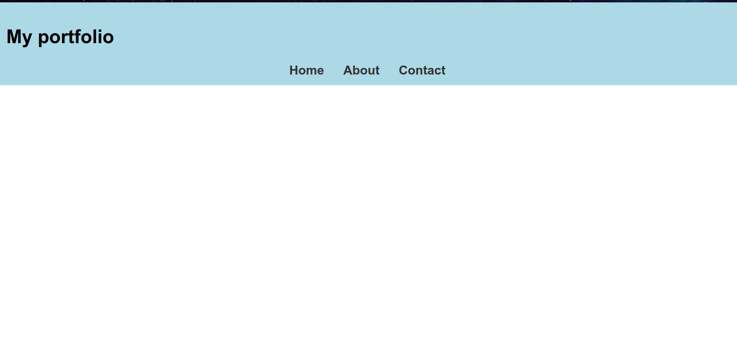

T6. .

⇒ <!DOCTYPE html>

<html lang="en">

<head>

<meta charset="UTF-8">

<meta name="viewport" content="width=device-width, initial-scale=1.0">

<title>task 6</title>

<style>

@keyframes spin {

0% { transform: rotate(0deg); }

100% { transform: rotate(360deg); }

}

.playing-card {

width: 150px;

height: 200px;

margin: 50px auto;

border: 1px solid #ccc;

animation: spin 5s linear infinite;

}

</style>

</head>

<body>

<img class="playing-card" src="https://www.shutterstock.com/image-photo/five-hearts-isolated-on-gray-260nw-2169913703.jpg" alt="Playing Card">

</body>

</html>



T7. .

⇒ index=

<!DOCTYPE html>

<html lang="en">

<head>

<meta charset="UTF-8">

<meta name="viewport" content="width=device-width, initial-scale=1.0">

<link rel="stylesheet" href="style.css">

<title>MY Homepage</title>

</head>

<body>

<header>

<nav>

<ul>

<li><a href="index.html">Home</a></li>

<li><a href="hobbies.html">Hobbies</a></li>

<li><a href="teams.html">Favorite Teams</a></li>

</ul>

</nav>

</header>

<div class="container">

<section class="main-content">

<h1>Welcome to My Homepage</h1>

<p>Lorem ipsum dolor sit amet consectetur adipisicing elit. Debitis a distinctio amet magni repellendus rerum nihil nemo recusandae provident minima blanditiis officiis fugiat, commodi voluptatem non, esse, cum nobis nisi quasi quis. Eum, dolorum. Rerum eius in impedit placeat iste fugiat, repellat pariatur iure exercitationem? Rerum perspiciatis suscipit sunt placeat?

</p>

</section>

<aside class="sidebar">

<h2>About Me</h2>

<p>My name is sunny,i am from bihar.i am currently pursuing my integrated dual degree in computer science and artificial intelligence from rajiv gandhi institute of petroleum technology.i am very much intrested in the field of computer science. </p>

</aside>

</div>

<footer>

<p>&copy; 2024 sunny gupta. All rights reserved.</p>

</footer>

</body>

</html>

Hobbies 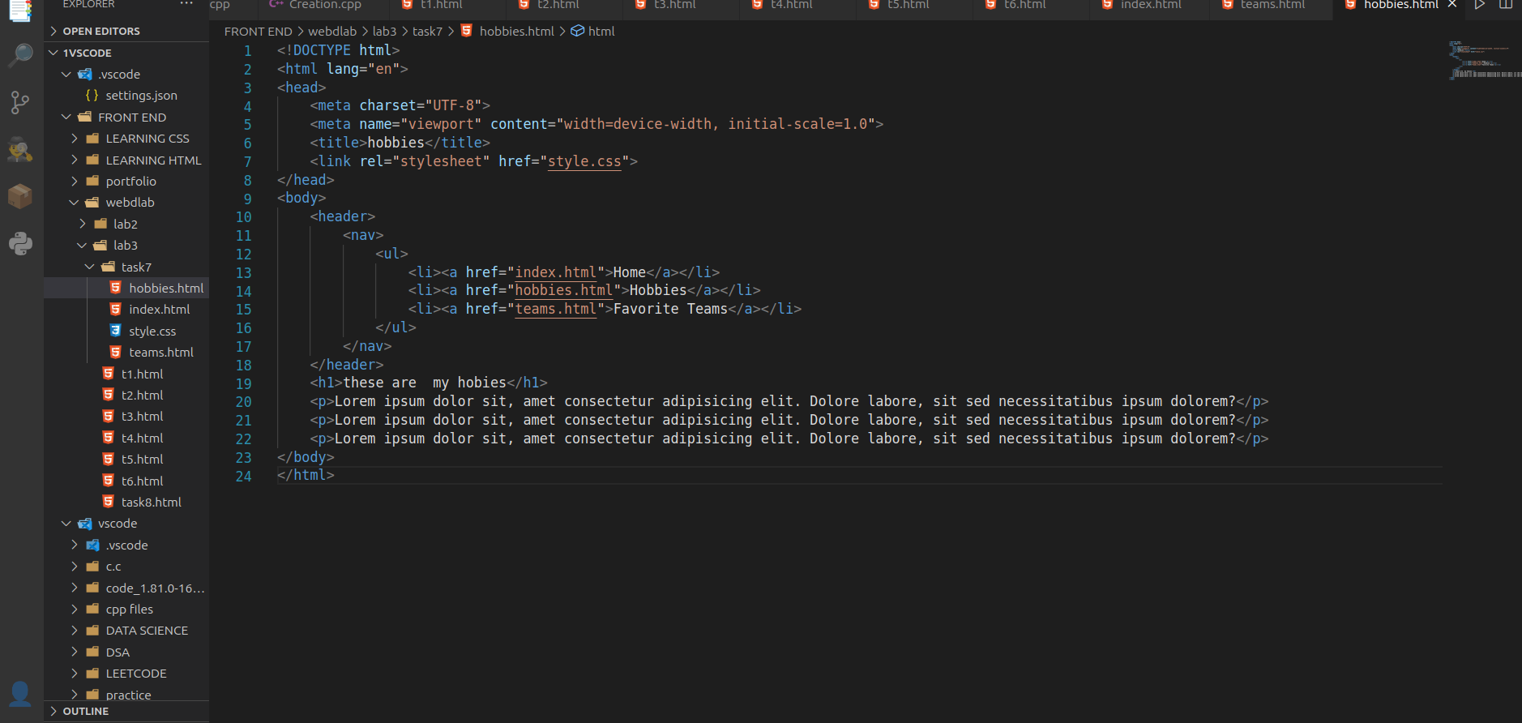

Teams 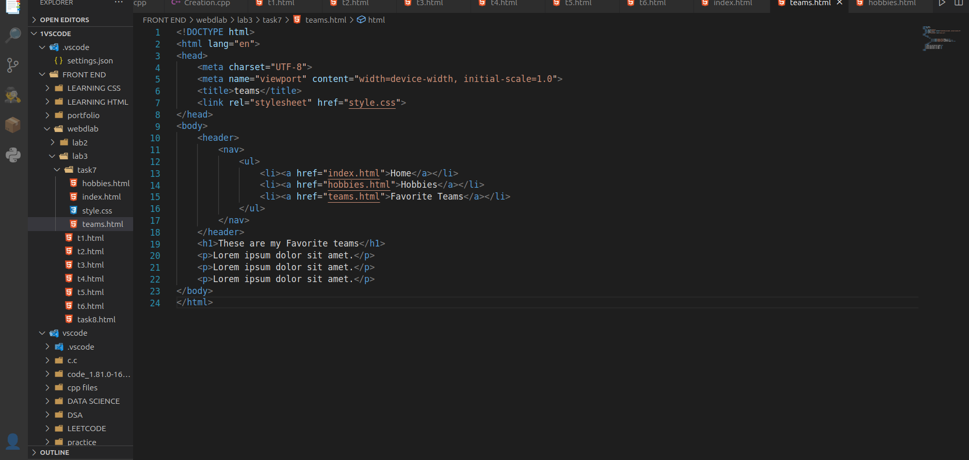

Css file: 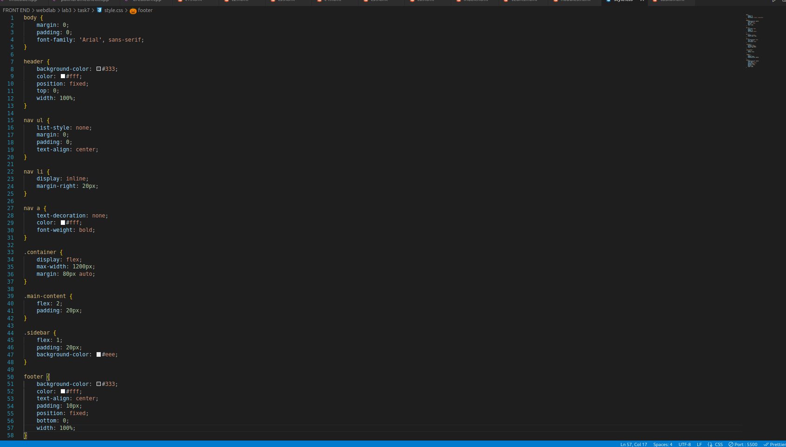

Output: 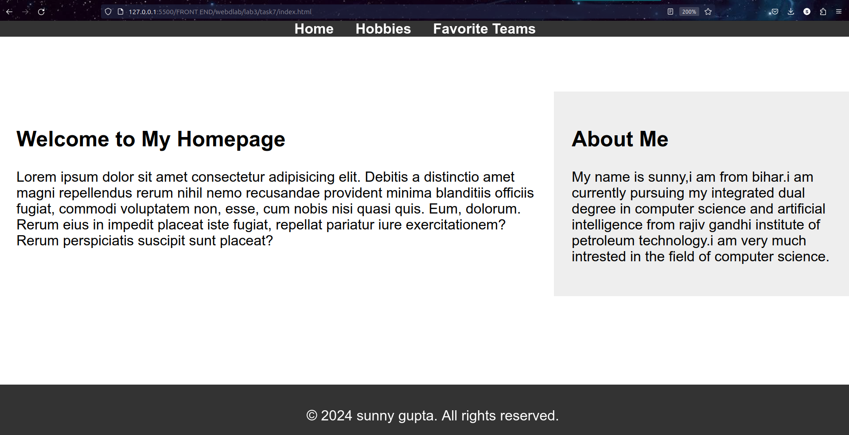

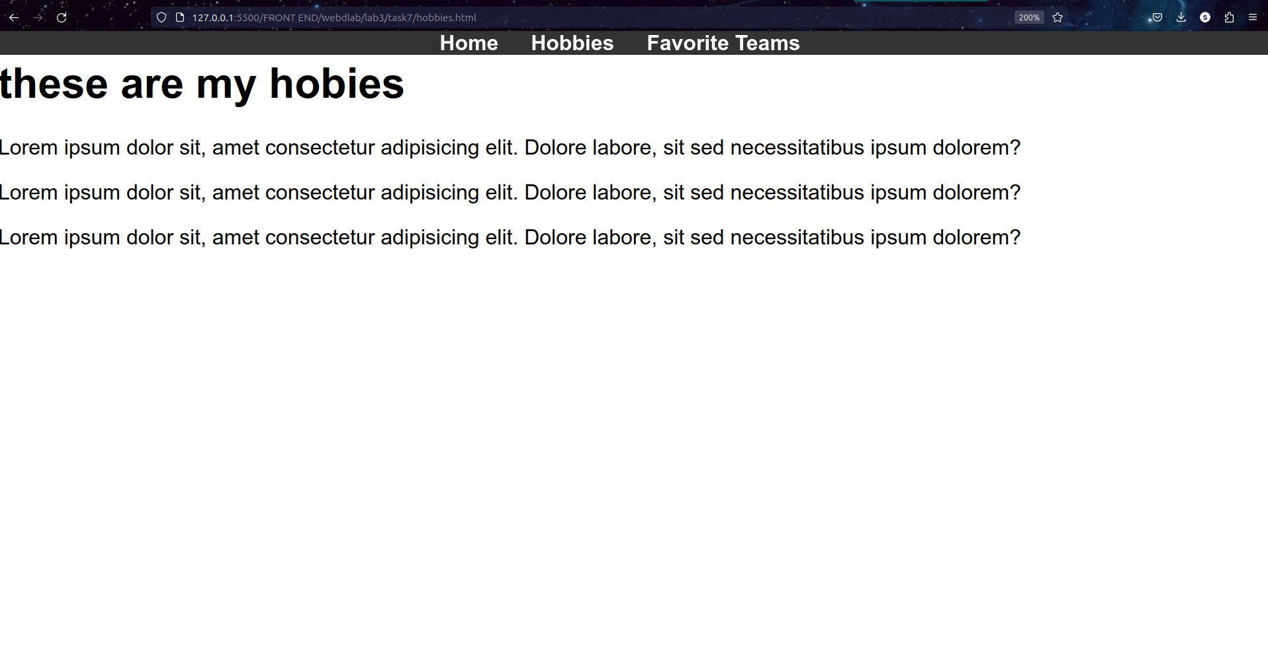

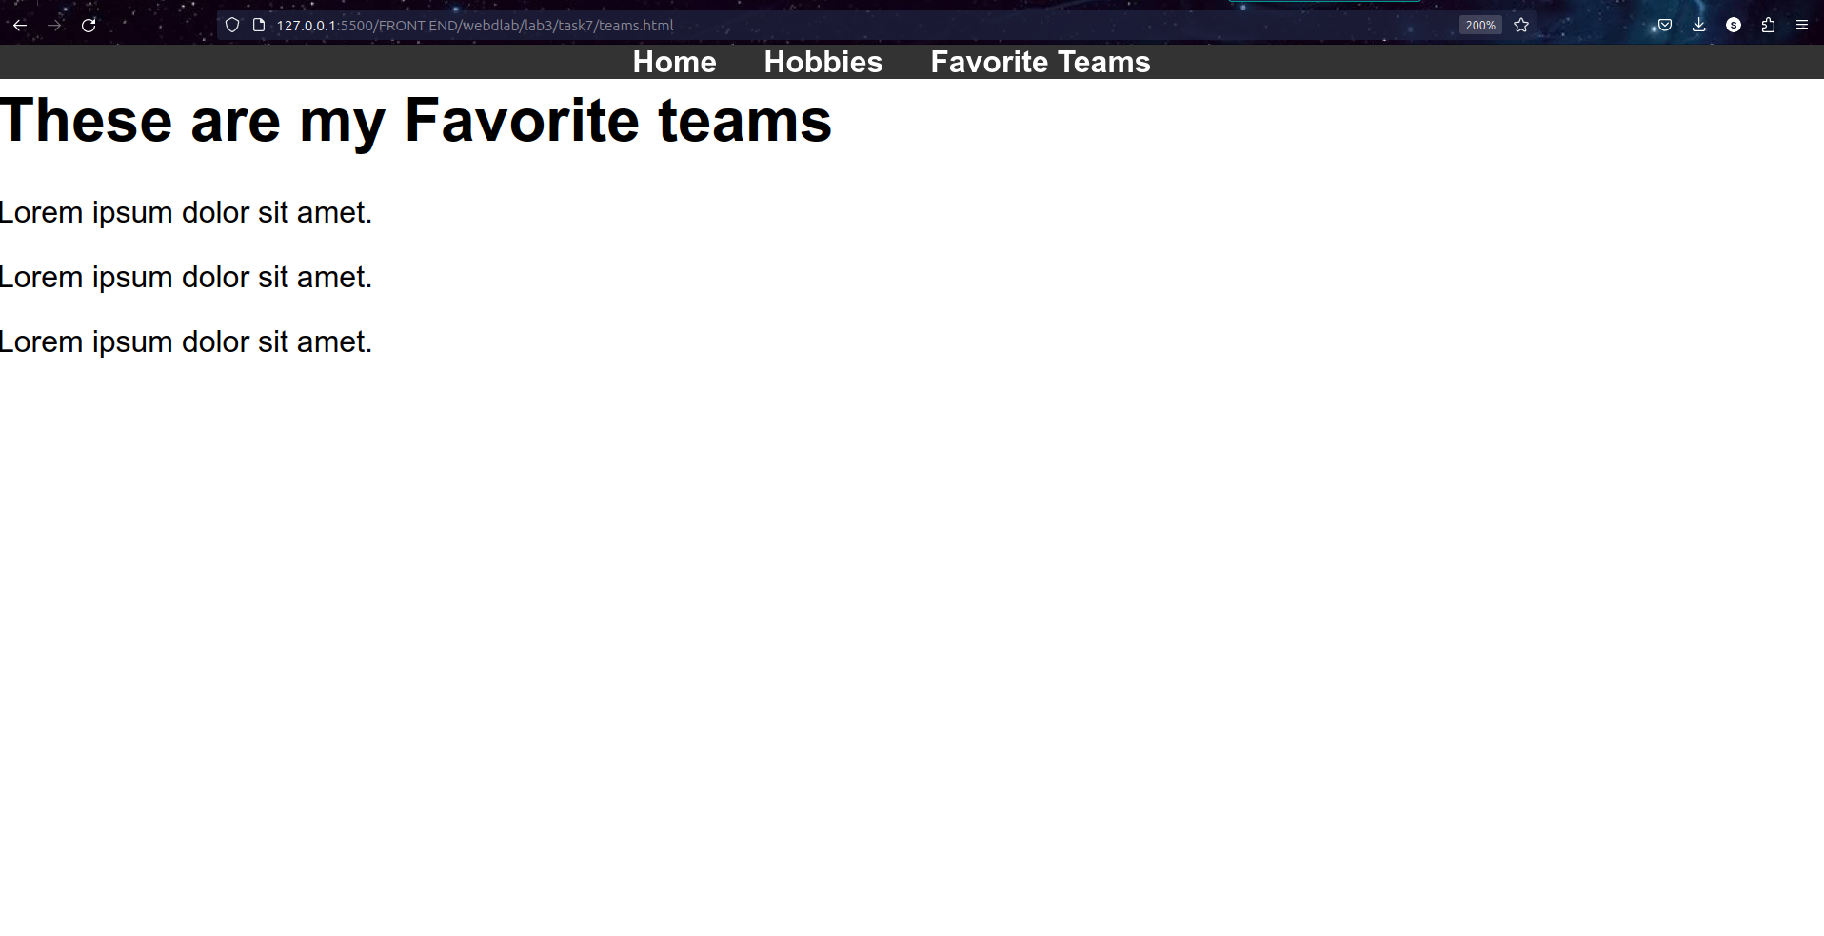

T8. .

⇒<!DOCTYPE html>

<html lang="en">

<head>

<meta charset="UTF-8">

<meta name="viewport" content="width=device-width, initial-scale=1.0">

<title>task8</title>

<style>

body {

font-family: 'Arial', sans-serif;

margin: 0;

padding: 0;

}

header {

background-color: #333;

color: #fff;

padding: 10px;

text-align: center;

}

nav {

background-color: #444;

}

ul {

list-style: none;

padding: 0;

margin: 0;

display: flex;

}

li {

position: relative;

}

a {

display: block;

padding: 15px;

text-decoration: none;

color: #fff;

transition: background-color 0.3s ease;

}

a:hover {

background-color: #555;

}

ul.submenu {

display: none;

position: absolute;

top: 100%;

left: 0;

background-color: #555;

}

li:hover > ul.submenu {

display: block;

}

ul.submenu li {

display: block;

white-space: nowrap;

}

</style>

</head>

<body>

<header>

<h1>Horizontal Dropdown Menu</h1>

</header>

<nav>

<ul>

<li><a href="#">Home</a></li>

<li>

<a href="#">Categories</a>

<ul class="submenu">

<li><a href="#">Category 1</a></li>

<li><a href="#">Category 2</a></li>

<li><a href="#">Category 3</a></li>

</ul>

</li>

<li>

<a href="#">Products</a>

<ul class="submenu">

<li><a href="#">Product 1</a></li>

<li><a href="#">Product 2</a></li>

<li><a href="#">Product 3</a></li>

</ul>

</li>

<li><a href="#">Contact</a></li>

</ul>

</nav>

</body>

</html>

⇒