


A REPORT ON
SUMMER INTERNSHIP AT

KARBIGAHIYA FLYOVER PROJECT
(Flyover connecting Mithapur Flyover to Chiraiyatand Flyover via Karbigahiya,
including approach road, service road and side drains)
Patna, Bihar
Internship Duration: 11 May 2026 to 13 July 2026
Submitted in partial fulfilment of the requirements for the award of the degree of
BACHELOR OF TECHNOLOGY
in
CIVIL ENGINEERING
Submitted by
SHIVAM MODI
2301CE27
Under the guidance of
Ms. Deepti Jha
Project Engineer, Bihar Rajya Pul Nirman Nigam Limited (BRPNNL)
Mr. Nitin Kumar
Assistant Professor, Department of Civil Engineering, IIT Patna
DEPARTMENT OF CIVIL ENGINEERING
INDIAN INSTITUTE OF TECHNOLOGY PATNA

Acknowledgement
I am grateful to Bihar Rajya Pul Nirman Nigam Limited (BRPNNL) for the opportunity to complete my internship on the Karbigahiya Flyover Project, from 11 May 2026 to 13 July 2026, in Patna. Spending time on an active urban flyover site helped me connect several ideas from my coursework with how things are actually decided and built in the field.
My sincere thanks go to my industry supervisor, Ms. Deepti Jha, Project Engineer, BRPNNL, for her guidance throughout the internship and for patiently answering my questions, which allowed me to follow the different stages of construction closely and safely. I am equally thankful to the site engineers, supervisors, and workers at Karbigahiya who explained their work to me and let me observe key activities such as reinforcement checks, girder erection, and deck concreting. In particular, I would like to thank Mr. Gautam, Site Engineer, Rachna Construction Co., and Mr. Vivek, who were both present on site through much of the internship and were generous with their time in explaining the day-to-day work.
I would also like to thank Mr. Nitin Kumar, Assistant Professor, Department of Civil Engineering, IIT Patna, for supervising my internship and for his feedback while this report was being prepared, and the Department of Civil Engineering, IIT Patna, for arranging this internship as part of the academic programme.
Finally, my thanks to everyone at the site, from the engineers to the supervisors and the labour staff, whose willingness to explain everyday decisions on the ground made this a genuinely educational experience.
Shivam Modi

Abstract / Executive Summary
This report describes my internship at the Karbigahiya Flyover Project in Patna, Bihar, completed from 11 May 2026 to 13 July 2026 under the guidance of Ms. Deepti Jha, Project Engineer, Bihar Rajya Pul Nirman Nigam Limited (BRPNNL), and Mr. Nitin Kumar, Assistant Professor, Department of Civil Engineering, IIT Patna. The project, taken up on behalf of BRPNNL, involves building a flyover that links the existing Mithapur flyover to the Chiraiyatand flyover through Karbigahiya, together with the associated approach road, service road, and side drain works. The structure is built as a steel I-girder superstructure with an in-situ reinforced concrete deck slab acting compositely with the girders, carried on RCC piers and pile foundations, a choice made largely to keep the construction footprint small along this crowded, traffic-heavy stretch of Patna.
My exposure during the internship was mainly to the superstructure and deck related activities that happened to be underway at the time: steel girder erection, welding of shear studs, composite deck slab reinforcement, deck concreting, and detailing of bearings and pedestals. This report sets out the project background, the construction methods I observed at each stage, the photographs I took on site, and the technical and professional lessons I took away from the internship, referring to the relevant IS and IRC provisions that govern each stage of work.

Table of Contents
Acknowledgement 1
Abstract / Executive Summary 1
Table of Contents 1
List of Figures and Tables 1
Figures 1
Tables 1
List of Abbreviations 1
1. Introduction 1
1.1 Background 1
1.2 Objective of the Internship 1
1.3 Objective of the Report 1
1.4 Company / Organization Profile 1
1.5 Scope and Limitations 1
2. Project Overview 1
2.1 Project Details 1
2.2 Purpose of the Flyover 1
2.3 Site Layout 1
3. Technical Background 1
3.1 Types of Flyover Construction 1
Why steel girders were chosen for this stretch 1
3.2 Design Considerations 1
3.3 Codes and Standards Referred 1
4. Methodology / Construction Process Observed 1
Key Definitions of Bridge Components 1
4.1 Site Investigation and Survey 1
4.2 Foundation 1
4.3 Pile and Pile Cap 1
4.4 Substructure: Piers and Pier Cap 1
4.5 Pedestals 1
4.6 Superstructure: Steel Composite Girders 1
4.7 Deck Slab 1
4.8 Bearings and Expansion Joints 1
4.9 Wearing Coat and Deck Waterproofing 1
4.10 Approach Road, Service Road, and Side Drains 1
4.11 Formwork and Scaffolding 1
4.12 Quality Control and Testing 1
4.13 Safety Measures on Site 1
5. Observations and Data 1
5.1 Site Photographs 1
5.2 Measurements / Calculations 1
5.3 Challenges Observed on Site 1
6. Your Role and Contribution 1
6.1 Weekly Activity Log 1
6.2 Tools, Software, and Instruments Used 1
6.3 Specific Contributions 1
7. Learning Outcomes 1
7.1 Technical Skills Gained 1
7.2 Theory vs Practice 1
7.3 Soft Skills Developed 1
8. Challenges Faced (Personal) 1
9. Conclusion 1
10. References 1

List of Figures and Tables

Figures
Figure 1: Underside view of the steel I-girder span with temporary erection staging
Figure 2: Close-up of headed shear stud connectors on the girder top flange
Figure 3: Deck slab reinforcement being laid and tied by workers
Figure 4: Close-up of girder web plates with fabrication stencil markings
Figure 5: Underside view of the girder to deck junction near an existing span
Figure 6: Cross bracing and diaphragm connections between adjacent girders
Figure 7: Street level view of the erected steel girder span
Figure 8: Close-up of a bolted cross bracing and diaphragm connection
Figure 9: Pier cap with several girders seated on bearings
Figure 10: Temporary timber packing at the pier cap to girder interface
Figure 11: Mobile crane positioned on top of the flyover deck
Figure 12: Street-level view of the completed flyover span
Figure 13: Completed carriageway on the flyover deck
Figure 14: Close-up of the painted crash barrier along the flyover edge
Figure 15: View along the flyover deck towards the far end
Figure 16: Close-up of reinforcement cages and pier cap detailing at the underside of the flyover near a support location
Figure 17: Another view of the deck parapet wall with the surrounding industrial facility visible beyond the flyover alignment
Figure 18: Workers finishing the deck surface at the flyover approach
Figure 19: Close-up of a cast expansion joint gap left between adjoining deck slab segments

Tables
Table 1: Codes and standards referred
Table 2: Project particulars and dimensions
Table 3: Materials used at various stages of construction
Table 4: Major machinery and equipment observed on site
Table 5: Quality control tests performed at site
Table 6: Weekly activity log
Table 7: Key engineering learnings by construction stage

List of Abbreviations
Abbreviation | Full Form
RCC | Reinforced Cement Concrete
PSC | Prestressed Concrete
IRC | Indian Roads Congress
IS | Indian Standard
NDT | Non-Destructive Testing
RE Wall | Reinforced Earth Wall
BRPNNL | Bihar Rajya Pul Nirman Nigam Limited
ROB | Road Over Bridge
POT/PTFE Bearing | Point / Polytetrafluoroethylene Bearing
BBS | Bar Bending Schedule
SBC | Safe Bearing Capacity
SPT | Standard Penetration Test
DPR | Detailed Project Report
MoRTH | Ministry of Road Transport and Highways
PPE | Personal Protective Equipment
HSFG | High-Strength Friction Grip (bolt)
GSB | Granular Sub-Base
WMM | Wet Mix Macadam
DBM | Dense Bituminous Macadam
BC | Bituminous Concrete

1. Introduction

1.1 Background
Traffic congestion at busy intersections has pushed most Indian cities toward grade separated infrastructure such as flyovers, and Patna is no different. The Mithapur to Karbigahiya to Chiraiyatand corridor is one of the busiest arterial stretches in the city, carrying a mix of through traffic and local commuter traffic across several signalized junctions. BRPNNL took up the Karbigahiya Flyover Project to join the already functional Mithapur flyover to the Chiraiyatand flyover through the Karbigahiya junction, removing an at-grade crossing that has been a long-standing bottleneck on this route. Once finished, this stretch is meant to eventually become part of a larger elevated network linking the Mithapur, Chiraiyatand, New Bypass, and Sipara flyovers, giving the area continuous grade separated movement.

1.2 Objective of the Internship
- To get first-hand, practical exposure to real world flyover construction methods that are hard to fully grasp from textbooks and lecture slides alone
- To see how site planning, execution sequencing, and quality control are actually carried out on a live, congested urban site
- To connect classroom subjects such as RCC design, steel structures, and construction management with the practical decisions engineers make in the field

1.3 Objective of the Report
This report sets out to record the technical processes I observed, the tasks I was involved in during the internship, and the main lessons I took away from my time at the Karbigahiya Flyover Project. It follows the broad sequence of construction, starting with survey and foundation work and moving through to superstructure, deck, and finishing works, although, as noted in Section 1.5, my own period of observation was concentrated on the superstructure and deck stages that happened to be active while I was there.

1.4 Company / Organization Profile
Particular | Details
Name | Bihar Rajya Pul Nirman Nigam Limited (BRPNNL)
Organization type | Government body (Bihar State PSU)
Established | 1975
Head office | 7, Sardar Patel Marg, Veerchand Patel Road Area, Patna, Bihar, 800001
Domain | Bridge and flyover construction, operation, and toll collection
BRPNNL is the Government of Bihar's agency responsible for building, operating, and managing toll collection on bridges and flyovers across the state. It carries out projects through empanelled civil contractors who work under its technical supervision, while BRPNNL's own engineers, including my supervisor Ms. Deepti Jha, handle quality oversight, progress monitoring, and coordination with the contractor at each site. The Karbigahiya Flyover Project is one of several projects currently running under BRPNNL with the aim of decongesting Patna's arterial road network.

1.5 Scope and Limitations
This report draws on the observations and tasks I carried out from 11 May 2026 to 13 July 2026 at the Karbigahiya site. It focuses mainly on the superstructure and deck related works, namely steel girder erection, composite deck slab reinforcement and casting, and bearing and pedestal detailing, since these were the activities I could see directly during my time there. Substructure work such as piling, pile caps, and pier construction at the sections I visited had largely been finished before I joined, so the description of those stages in this report (Sections 4.2 to 4.5) relies on what the site engineers explained to me and on standard practice for this type of structure, along with the relevant IS and IRC provisions, rather than on my own direct observation. Design calculations for the structure were handled by BRPNNL's design consultants and did not form part of my scope.

2. Project Overview

2.1 Project Details
The table below summarises the key particulars of the Karbigahiya Flyover Project.
Particular | Details
Division | Patna-1
Name of work | Construction of flyover connecting Mithapur flyover to Chiraiyatand flyover via Karbigahiya, including approach road, service road and side drain, etc., in Patna town
Executing contractor | Rachna Construction Co., Bharuch, Gujarat
Head / sub-head | Plan
District | Patna
Type and length of bridge | Flyover bridge, 1730.00 m
Length of approach road | 250.00 m
Administrative approval | Rs. 29274.04 lakh, sanction no. 7356(S), dated 21 Aug 2025
Date of scheduled completion | 11 Nov 2018
Revised date of completion | 31 Mar 2022
Likely date of completion | 07 Jul 2026

2.2 Purpose of the Flyover
The project aims to reduce congestion on one of central Patna’s busiest corridors by connecting the Mithapur flyover with the Chiraiyatand flyover through Karbigahiya. Since the Karbigahiya junction currently handles heavy traffic through an at-grade signalized intersection, the elevated corridor is expected to reduce delays and travel time. Approach and service roads will maintain access to nearby properties and side streets.
2.3 Site Layout
The alignment passes through a densely built commercial and residential part of Patna, with shops, multi storey buildings, and overhead utility lines on both sides of the carriageway. The elevated corridor rests on steel I-girders carried by RCC piers placed within the existing road median, which keeps additional land acquisition to a minimum. Service roads run alongside the elevated structure at ground level to keep local access open, with side drains along their outer edges to manage stormwater. The narrow right of way and the continuous traffic passing below were clearly the main factors that shaped both the pier spacing and the decision to use a steel superstructure instead of a bulkier concrete option, discussed further in Section 3.1.

3. Technical Background

3.1 Types of Flyover Construction
- RCC (Reinforced Cement Concrete) construction
- PSC (Prestressed Concrete) box girder or I-girder construction
- Steel girder construction
The Karbigahiya flyover is built using the third of these options, a steel I-girder superstructure. Structural steel to IS 2062 (commonly Grade E250 or E350) is used to fabricate the girders, which is fairly standard for Indian highway over-bridges of this kind. One of the site engineers explained to me during my internship why steel was preferred over a conventional PSC option for this particular stretch, and the reasoning largely matches what is set out below.

Why steel girders were chosen for this stretch
- A smaller footprint in a congested area: Karbigahiya is heavily built up with very limited space, and steel superstructures need fewer, smaller pier footprints than bulky precast concrete alternatives.
- Faster on-site erection: steel I-girders are prefabricated away from site and assembled quickly once delivered, which shortens the time the busy road below stays disrupted.
- Longer spans with less self-weight: because steel has a higher strength to weight ratio than concrete, longer spans across the intersection are possible without needing piers placed close together.
The deck slab is cast in reinforced concrete directly over the steel girders and tied to the top flange through shear stud connectors, so the slab and girder work together as one composite section under load rather than behaving as two separate elements. This composite action shows up on site as a dense grid of welded studs on the top flange before the deck is cast, which I photographed closely during my visit (Figure 2), and it is what lets a shallow steel section carry the full carriageway load efficiently.

3.2 Design Considerations
- Traffic load, following IRC loading standards
- Soil bearing capacity, and the foundation type chosen to suit it
- Seismic zone factors relevant to the region
- Clearance height and geometric design at the crossing

3.3 Codes and Standards Referred
Code | Title
IRC:5 | Standard Specifications and Code of Practice for Road Bridges, Section I: General Features of Design
IRC:6 | Standard Specifications and Code of Practice for Road Bridges, Section II: Loads and Load Combinations
IRC:22 | Standard Specifications and Code of Practice for Road Bridges, Section VI: Composite Construction
IRC:24 | Standard Specifications and Code of Practice for Road Bridges, Section V: Steel Road Bridges
IRC:37 | Guidelines for the Design of Flexible Pavements
IRC:78 | Standard Specifications and Code of Practice for Road Bridges, Section VII: Foundations and Substructure
IRC:83 (Parts I to III) | Standard Specifications and Code of Practice for Road Bridges, Section IX: Bearings
IRC:112 | Code of Practice for Concrete Road Bridges
IRC: SP:102 | Guidelines for Design and Construction of Reinforced Soil (RE) Walls
IS 456:2000 | Plain and Reinforced Concrete, Code of Practice
IS 800:2007 | General Construction in Steel, Code of Practice
IS 1893 | Criteria for Earthquake Resistant Design of Structures
IS 1892 | Code of Practice for Subsurface Investigation for Foundations
IS 2062 | Hot Rolled Medium and High Tensile Structural Steel, Specification
IS 2911 (Parts 1 to 4) | Design and Construction of Pile Foundations, Code of Practice
MoRTH Specifications | Specifications for Road and Bridge Works (Fifth Revision)

4. Methodology / Construction Process Observed
This section walks through the construction sequence for the Karbigahiya flyover, from survey work to the finishing stages. As mentioned in Section 1.5, the parts covering survey, piling, and substructure work (4.2 to 4.5) describe stages that were already finished at the sections of the site I visited, and are based on what the site engineers told me rather than on what I saw myself. From Section 4.6 onward, covering girder erection, the deck slab, bearings, and related finishing work, the descriptions are based on activities I was able to watch directly, several of which are captured in the photographs in Section 5.

Key Definitions of Bridge Components
Before going through the construction sequence, it is useful to define the main structural components referred to in this report.
- Foundation: the part of the structure built below ground level that carries the loads coming from the substructure and superstructure and passes them safely into the soil.
- Pile: a slender, deep foundation element made of concrete or steel that carries structural load down to a stronger stratum, either by end bearing at its tip, by skin friction along its shaft, or by a combination of the two. Piles used for bridges are broadly grouped into driven piles, pre-formed driven cast-in-situ piles, driven cast-in-situ piles, and bored cast-in-situ piles, depending on how they are installed; the Karbigahiya project uses bored cast-in-situ piles, described further in Section 4.3.
- Substructure: everything below the bearings that supports the superstructure and carries its load to the foundation, made up mainly of piers, pier caps, abutments, and wing walls.
- Pier: an intermediate vertical support between two spans that carries load from the superstructure down to the foundation, and works mainly as a compression member.
- Pier cap: the horizontal member on top of the pier that picks up the reaction from the bearings and girders and spreads it into the pier before it continues down to the foundation.
- Abutment: the support at the end of a bridge, which carries vertical load like a pier while also retaining the roadway backfill and giving lateral support to the approach embankment.
- Wing wall: a retaining wall alongside an abutment that holds back the soil of the approach embankment, built either at a right angle to the abutment or splayed at an angle depending on the site.
- Pedestal: a short concrete block cast on the pier cap that gives the bearing a level seating surface and leaves enough vertical clearance beneath the girder for the bearing to be jacked up and serviced later if needed.
- Bearing: the component placed between the pier or pedestal and the superstructure that transfers vertical and horizontal load while allowing the small movements and rotations caused by traffic, temperature change, and other actions.
- Girder: the main horizontal member spanning between two piers, or between a pier and an abutment, that carries the deck slab load down to the substructure; girders may be fabricated steel sections or cast-in-situ RCC beams depending on the span.
- Deck slab: the riding surface of the bridge, cast over the girders, which takes the traffic load directly and passes it on to the girders below.
- Crash barrier: a protective barrier along the edge of the deck that keeps vehicles within the carriageway and reduces the severity of any collision with roadside hazards.

4.1 Site Investigation and Survey
Fixing pier positions, pile cut-off levels, and approach road formation levels all depend on setting up an accurate vertical control network before construction starts. This is done through auto level surveying: the instrument uses a gravity compensated optical system to give a truly horizontal line of sight once it has been roughly levelled, after which elevations are carried between points using the Height of Instrument (HI) method, tied back to a Temporary Benchmark (TBM) referenced to a known GTS datum.
HI = RL(known) + BS RL(target) = HI − FS (or IS)
To keep observation error within limits, backsight and foresight distances are kept roughly equal so that residual instrument collimation error and the effects of earth curvature and refraction largely cancel out. Instrument collimation is checked from time to time using the two-peg test, and the permissible vertical misclosure over a levelling run of total length K, in kilometres, is generally kept within plus or minus 12 root K millimetres.
Beyond levelling work, the site engineers told me that geotechnical investigation had been carried out along the alignment through boreholes at each pier location, with Standard Penetration Tests (SPT) done at regular depth intervals as per IS 1892 to work out the soil's Safe Bearing Capacity (SBC) and identify a suitable founding stratum for the piles. A topographic survey recorded ground levels, existing utilities, and clearances to nearby structures, while a traffic volume survey at the Karbigahiya junction fed into the geometric design of the flyover.

4.2 Foundation
A flyover pier carries large vertical loads, lateral shear from braking, wind, and seismic action, and overturning moments down into the ground. Where the near-surface soil has poor bearing capacity, which is typical of Patna's alluvial strata, deep foundations in the form of bored cast-in-situ piles are used instead of shallow footings.

4.3 Pile and Pile Cap
Load from a pile is carried through a combination of base resistance and shaft skin friction:
Qu = qb × Ab + Σ(fs × As)
where qb is the unit end bearing pressure at the pile base, Ab is the cross-sectional area of the pile toe, fs is the average unit skin friction along the shaft, and As is the shaft surface area for the corresponding soil layer. The pile cap sitting above the pile group is designed as a rigid block that spreads the pier's load evenly across the piles underneath, usually analysed with strut-and-tie models where concrete works as the compression strut and reinforcement acts as the tension tie between pile heads.
Based on what the site engineers explained to me, the stages generally followed for pile construction on this project, in line with IS 2911 (Part 1, Section 2), were as follows:
- Marking out the pile centre and aligning the boring rig over it, checked with a spirit level so the bore stays straight
- Inserting a temporary steel casing to support the top of the borehole before drilling begins
- Drilling the bore with a rotary rig while bentonite slurry is kept circulating to hold the borehole walls in place and stop them from collapsing
- Cleaning out the base of the bore once the design depth is reached, so the concrete bears on sound, undisturbed ground
- Lowering the prefabricated reinforcement cage into the bore carefully, keeping it centred so the design cover is maintained all around
- Placing concrete through a tremie pipe kept embedded below the rising concrete surface, so the bentonite slurry is displaced upward without the mix segregating
- Once the pile has cured, excavating down to cut-off level and chipping away the loose concrete above it until sound material is exposed
- Levelling the exposed surface and casting a thin layer of plain cement concrete as a clean working platform
- Placing the pile cap reinforcement over this layer, followed by marking the centre lines for the pier reinforcement above it
- Casting the pile cap concrete and allowing it to cure before pier construction begins
Foundation integrity was checked through a Pile Integrity Test (PIT), where an accelerometer placed on the pile head records the stress wave reflection from a hammer strike to flag voids or defects along the shaft, along with static load testing on selected piles, following IS 2911 (Part 4).

4.4 Substructure: Piers and Pier Cap
The pier is a vertical element that carries dead load, live load, braking force, wind, and seismic effects down to the pile cap, while the pier cap above it works as a transverse cantilever beam that seats the bearings and takes the shear and negative moment concentrated directly under the girder lines. The sequence generally followed on site was as follows: starter bars projecting from the pile cap are aligned and the pier reinforcement cage tied, using mechanical couplers or lapped splices; steel or plywood-faced formwork is erected and braced and sealed at the joints; concrete of M40 or M50 grade is placed in lifts of no more than about 500 mm, consolidated with internal needle vibrators, and cured for at least 14 days under wet hessian; and finally, once the formwork is stripped, staging is put up for the pier cap, and the pier cap is cast in one continuous pour to avoid cold joints, since it directly seats the bearings.
In large sections such as pier caps, the heat given off during cement hydration can create a temperature difference between the core and the surface that leads to thermal cracking. On this project, this was managed by replacing part of the cement with fly ash (PPC) to slow down hydration, and by using chilled mixing water during pours carried out in hot weather.

4.5 Pedestals
A pedestal is a short concrete plinth cast on top of the pier cap to give the bridge bearing a level, accurately positioned seating surface, adjusting for any deck camber or longitudinal slope. Since the bearing's reaction is concentrated over the pedestal's relatively small footprint before it spreads into the larger area of the pier cap below, the local bearing stress is governed by:
σ(bearing) = 0.45 × fck × √(A2 / A1)
where A1 is the loaded contact area and A2 is the effective supporting area of the pier cap directly beneath it, with the ratio root (A2/A1) capped at 2.0 to prevent local splitting or crushing. Construction involves chipping the pier cap surface to expose sound aggregate for a good bond, tying a dense mesh of reinforcement with anchor bolt sleeves positioned by template to line up with the bearing base plate, setting formwork levelled to within about 2 mm using digital levels, and casting high-strength concrete of M45 or M50 grade, finished flat and cured under wet burlap.

4.6 Superstructure: Steel Composite Girders
The steel I-girders for this project were fabricated in a workshop to the design length using structural steel to IS 2062, with shop welds checked through ultrasonic and radiographic testing before being sent to site. On the top flange, headed shear studs are welded in a grid pattern using a stud welding gun. This is the grid of raised circular studs I photographed closely on site, shown in Figure 2, and it allows the deck slab, once cast over them, to work with the girder as a single composite section instead of two elements flexing independently.
Structurally, this composite action is worked out using the transformed section method, where the concrete deck area is converted into an equivalent steel area using the modular ratio m = Es divided by Ec. This shifts the neutral axis of the combined section upward and increases both the section modulus and moment of inertia compared with the bare steel section alone, letting a comparatively shallow, lighter girder span the intersection efficiently.
On site, I saw girder segments being transported and erected on the piers using cranes, and temporarily supported on timber and steel staging or trestles beneath them, visible in several of the photographs in Section 5, since the bare steel section cannot safely carry wet concrete and construction loads until the deck has cured and composite action starts working. Segments are field spliced using High-Strength Friction Grip (HSFG) bolts tightened to a calibrated torque, as per IRC:24, with cross bracing and diaphragms fixed between adjacent girders to give lateral stability during and after erection. This cross bracing arrangement can be clearly seen in Figures 6 and 8.

4.7 Deck Slab
The deck slab forms the load carrying riding surface and is analysed as a flexural concrete plate under concentrated wheel loads, temperature gradients, and shear, commonly using Pigeaud's method for elastic plate bending or the Westergaard approach for stress distribution under wheel loads. Reinforcement is placed orthogonally, with the primary tensile steel running perpendicular to the girder axis to resist the positive mid-span and negative support moments that build up over each girder line.
On the steel girders at Karbigahiya, corrugated steel decking sheets and temporary shuttering laid across the top flanges acted as formwork for the wet concrete. I was present while reinforcement was being placed over the shear studs on one span, shown in Figure 3, and the site engineer supervising the pour told me that curing, with a minimum of 14 days of moist curing, is critical to control plastic shrinkage cracking, particularly for slabs left exposed to Patna's sun and wind during long, continuous pours.

4.8 Bearings and Expansion Joints
Bridge bearings form the mechanical interface between the girders and the pedestal, allowing the rotations and horizontal movements caused by thermal expansion and contraction, live load deflection, braking, and seismic action without passing damaging lateral force into the piers. Two types are common on Indian flyovers, and both were discussed with me on site:
- Elastomeric bearings, made of alternating layers of vulcanized rubber and steel plates, which allow movement through shear deformation of the rubber and rotation through differential compression, and are cost effective for short to medium spans.
- POT-PTFE bearings, made of a steel piston seated in a pot housing a confined elastomeric pad that behaves like a near incompressible fluid under load, combined with a PTFE on stainless steel sliding interface that allows large longitudinal movement, and are used for longer spans and higher loads.
Installation follows an inspection of the pedestal surface, positioning and aligning the bearing to the girder and pier centrelines using a crane, non-shrink epoxy grouting under the base plate, and, importantly, removing the temporary erection locking plates only once the deck slab has cured, so the bearing's kinematic movement is activated only when it is safe to do so.
At the gap between adjacent spans, expansion joints allow this same movement at deck level without letting water and debris through onto the bearings and pier cap below. Strip seal joints, which use a neoprene gland locked into steel edge rails, are used for movement up to about 80 mm, while modular joints are used where movement exceeds this, as is typical for longer span bridges. Installation is deferred until the deck has substantially cured, with the joint's anchor loops welded to the deck reinforcement and the surrounding recess filled with high-strength, quick-setting micro-concrete.

4.9 Wearing Coat and Deck Waterproofing
Before the final road surfacing layer goes down, the concrete deck is protected against water ingress, which would otherwise corrode the reinforcement and the steel girder underneath, using a waterproofing wearing coat such as mastic asphalt. This is a dense, near voidless bituminous mix applied hot and self-levelling, forming a continuous impermeable membrane. The deck surface is first shot-blasted or wire-brushed to remove laitance and given a bituminous primer coat. The mastic is then poured and spread to the design thickness, commonly around 12 mm, with pre-coated stone chippings rolled into the still hot surface to give a mechanical key for the flexible surfacing layer above.

4.10 Approach Road, Service Road, and Side Drains
The project scope explicitly covers the approach road, service roads, and side drains alongside the elevated structure, since these are what connect the flyover back to the existing ground level road network. Where the approach road rises to meet the flyover deck, a Reinforced Earth (RE) wall is typically used to hold the approach embankment within a compact footprint, which matters in a built-up corridor like this one. An RE wall works by embedding tensile reinforcing elements within compacted frictional backfill. Horizontal earth pressure within the soil mass is transferred to these reinforcing elements by friction, which turns the backfill into a stable, self-supporting composite block, checked for external stability (overturning, sliding, bearing) and internal stability (rupture or pull-out of the reinforcing strips) as per IRC:SP:102.
Above the compacted embankment, the approach and service roads are built as conventional flexible pavements as per IRC:37, spreading wheel loads down to the subgrade through a layered system: a Granular Sub-Base (GSB), a Wet Mix Macadam (WMM) base course, a Dense Bituminous Macadam (DBM) binder course, and a final Bituminous Concrete (BC) wearing course. Between bound layers, a prime coat seals the porous WMM layer and helps the DBM key into it, while a tack coat is applied between the DBM and BC layers to stop slippage under braking traffic. Longitudinal RCC side drains run along the outer edge of the service roads to collect surface runoff and carry it to the municipal stormwater network.

4.11 Formwork and Scaffolding
Conventional formwork, made of plywood sheathing on a timber or steel frame, is used to cast the pile caps, piers, and pier caps. During girder erection and deck slab casting, temporary steel staging or trestles and timber platforms support the girders and give a working platform for placing reinforcement and pouring concrete, since the girders alone cannot safely carry wet concrete and construction loads until composite action takes over. These timber props are clearly visible beneath the girders in several of my photographs, including Figures 1, 7, and 10. Formwork is stripped only once the concrete has gained enough strength, generally 24 to 48 hours for vertical faces and longer for slab soffits, in keeping with IS 456.

4.12 Quality Control and Testing
Test | Purpose / Stage
Concrete slump test | Checked against the target workability for each pour, for example 180 to 220 mm for tremie-placed pile concrete
Concrete cube compressive strength test | At 7 and 28 days, for each concrete grade used
Reinforcement / BBS check | Verified against the approved Bar Bending Schedule before concrete is poured
Pile Integrity Test (PIT) and static load test | On foundations, as per IS 2911 (Part 4)
Field density and material quality checks | On each pavement layer, namely GSB, WMM, DBM, and BC
Torque verification | On HSFG bolted girder splice connections

4.13 Safety Measures on Site
- Personal protective equipment (PPE) enforced for anyone entering the working area
- Barricading of the work zone and phased traffic diversion around active piers and staging
- Daily safety briefings, or toolbox talks, before the shift starts

5. Observations and Data

5.1 Site Photographs
The photographs below were taken by me during site visits at Karbigahiya over the course of the internship.
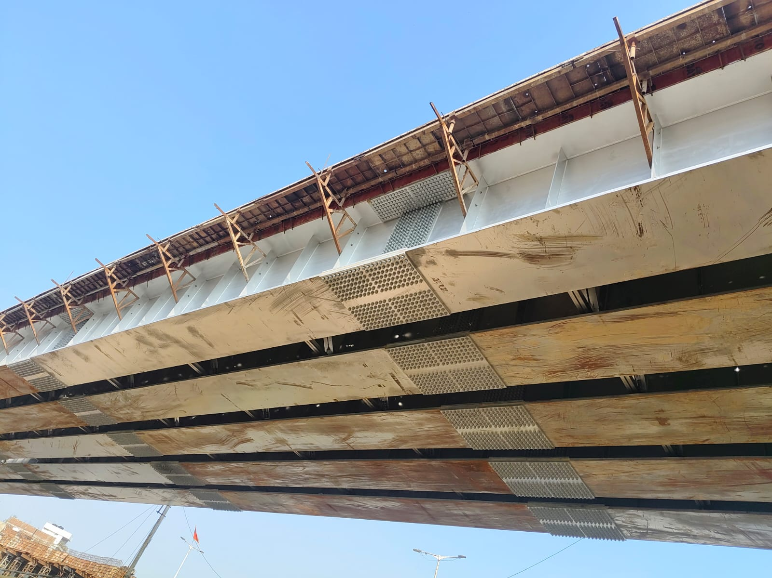
Figure 1: Underside view of the steel I-girder span, showing the corrugated steel soffit and temporary erection staging brackets along its length
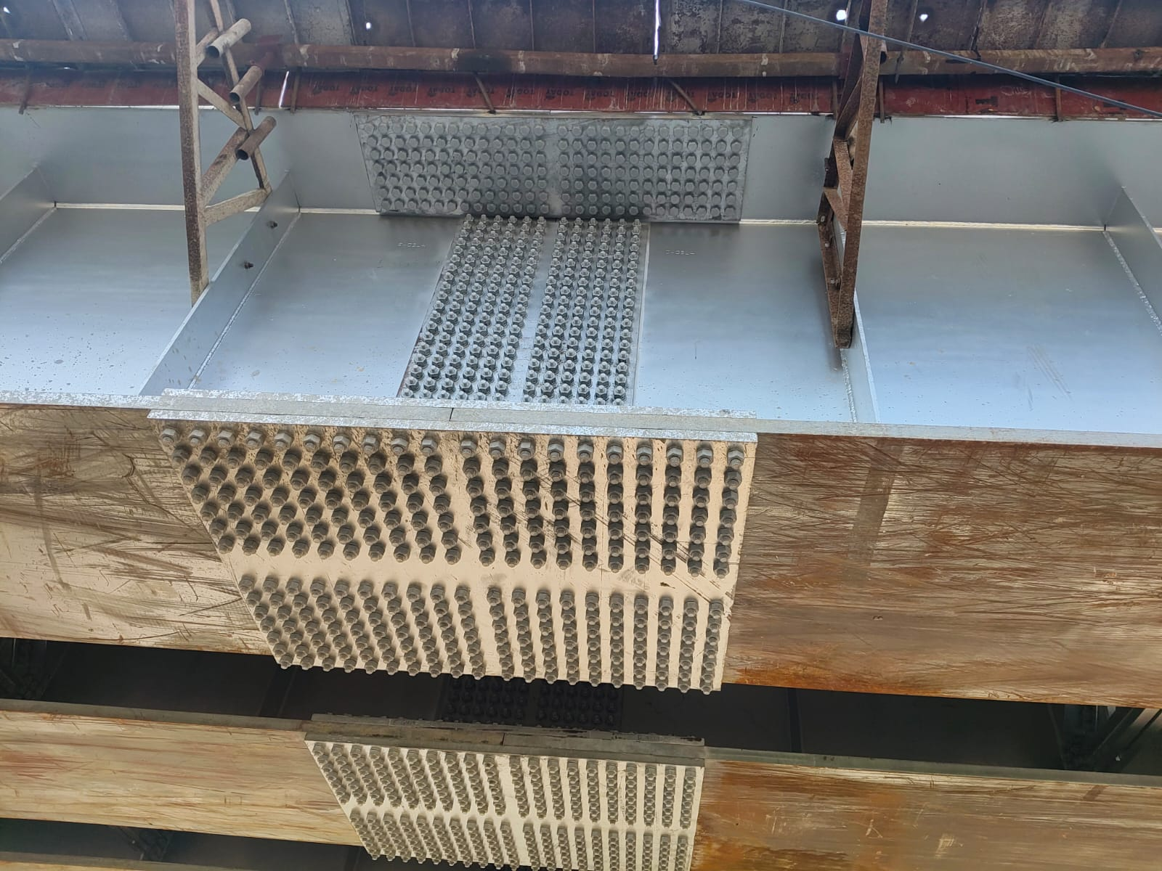
Figure 2: Close-up of headed shear stud connectors welded in a grid pattern on the girder top flange, before deck slab casting
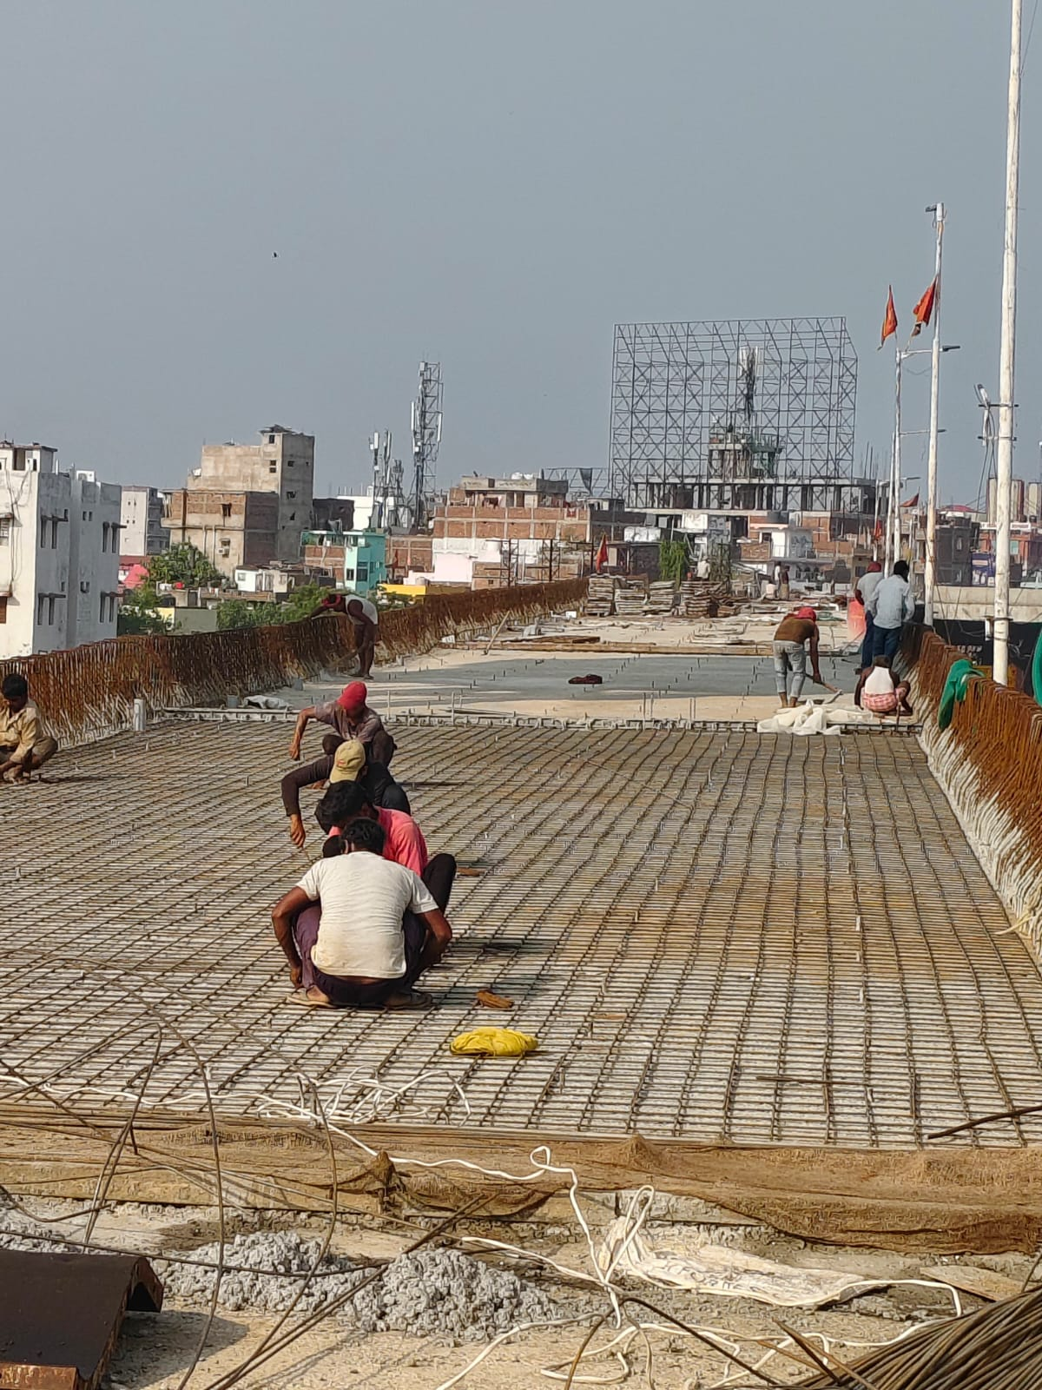
Figure 3: Deck slab reinforcement being laid and tied by workers atop the span, with the Patna city skyline in the background
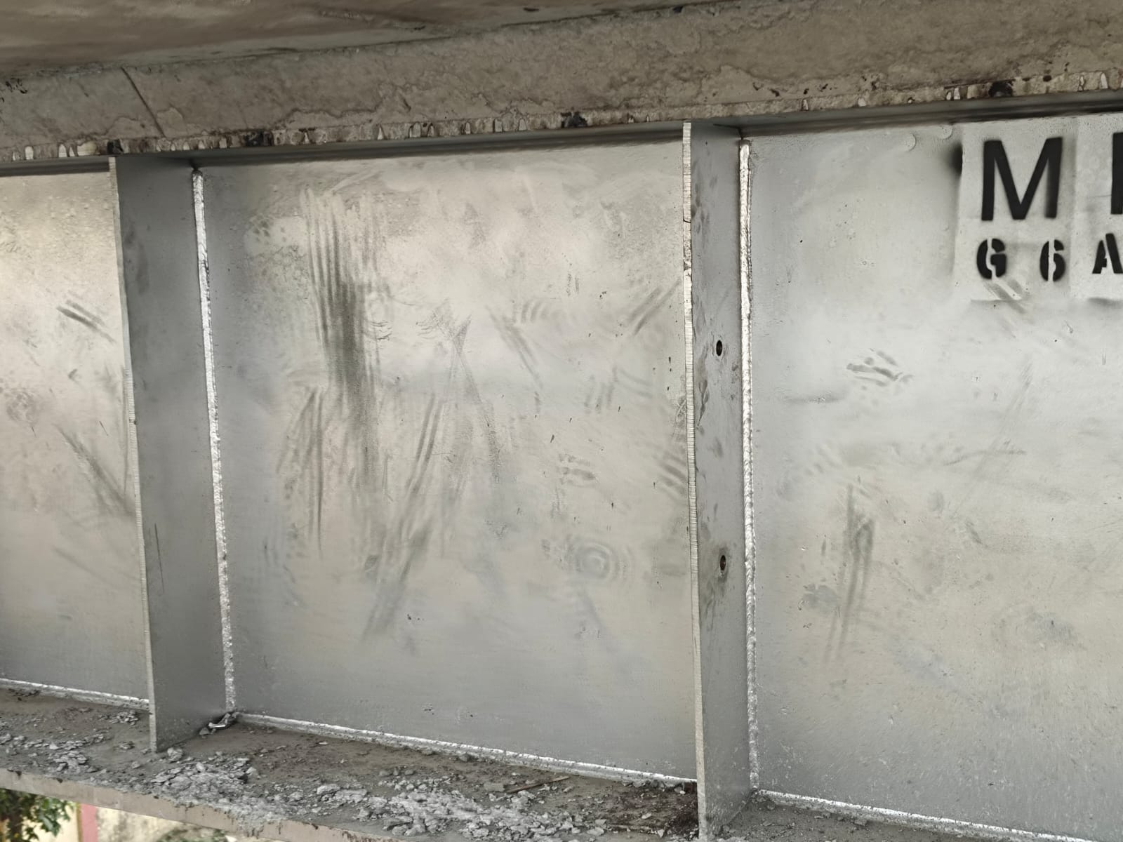
Figure 4: Close-up of girder web plates showing fabrication stencil markings and shop-applied protective coating
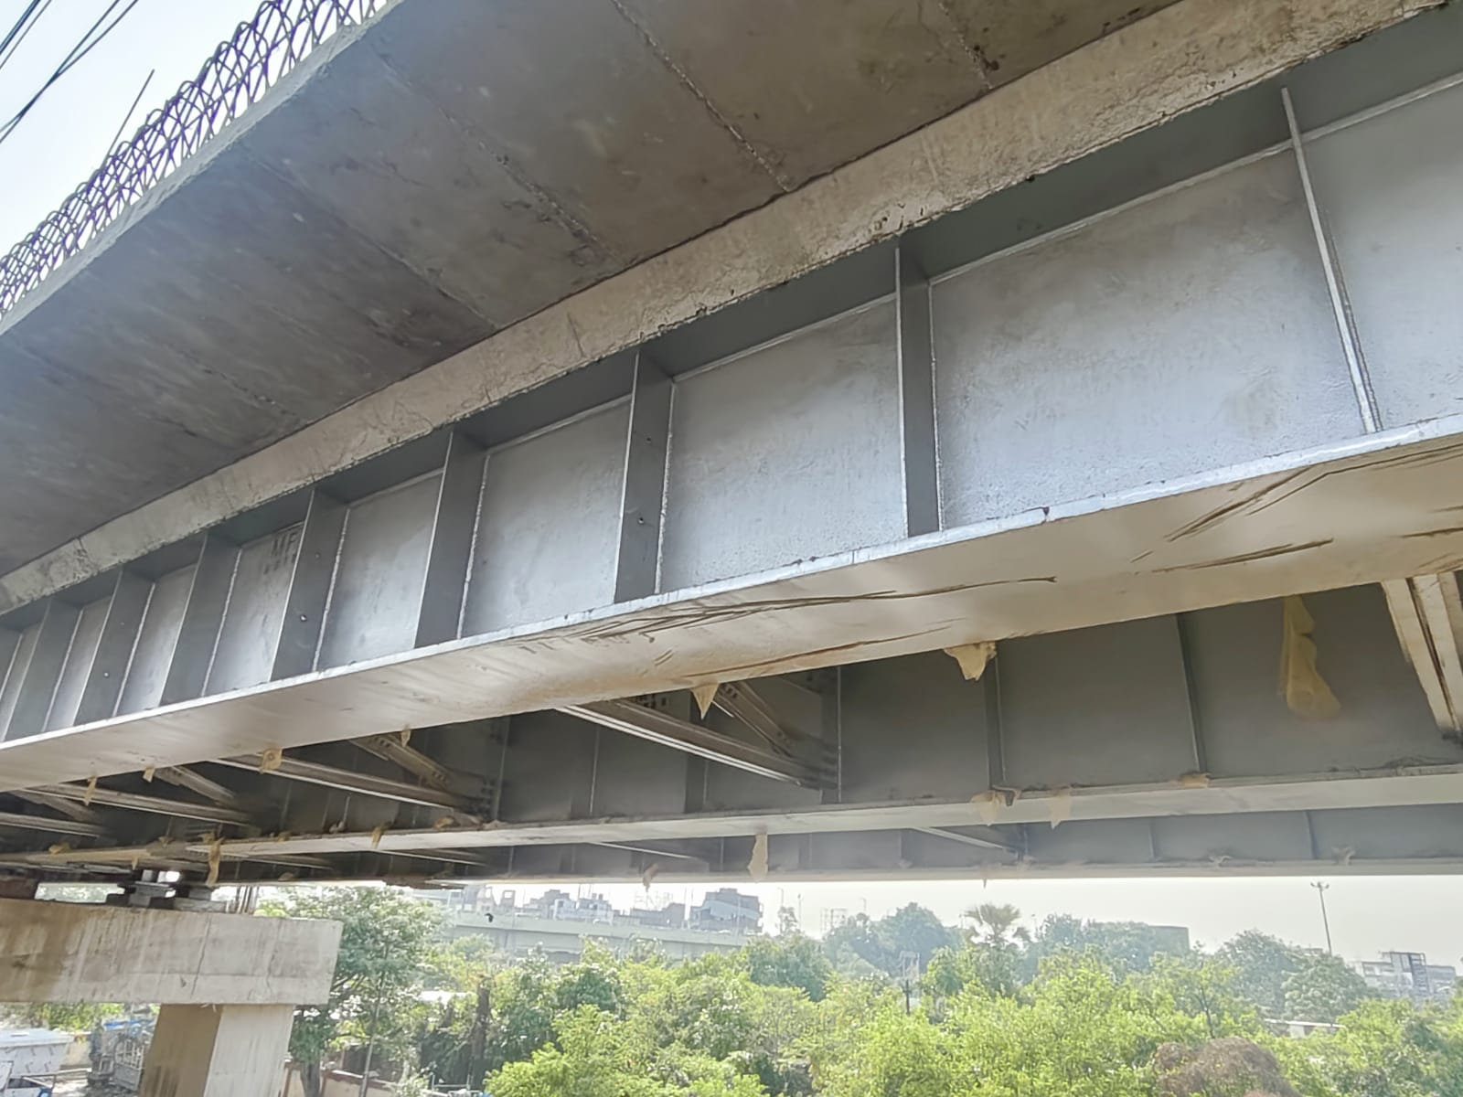
Figure 5: Underside view of the girder to deck junction near an existing span, showing box-section webs, diaphragm plates, and the surrounding built-up area
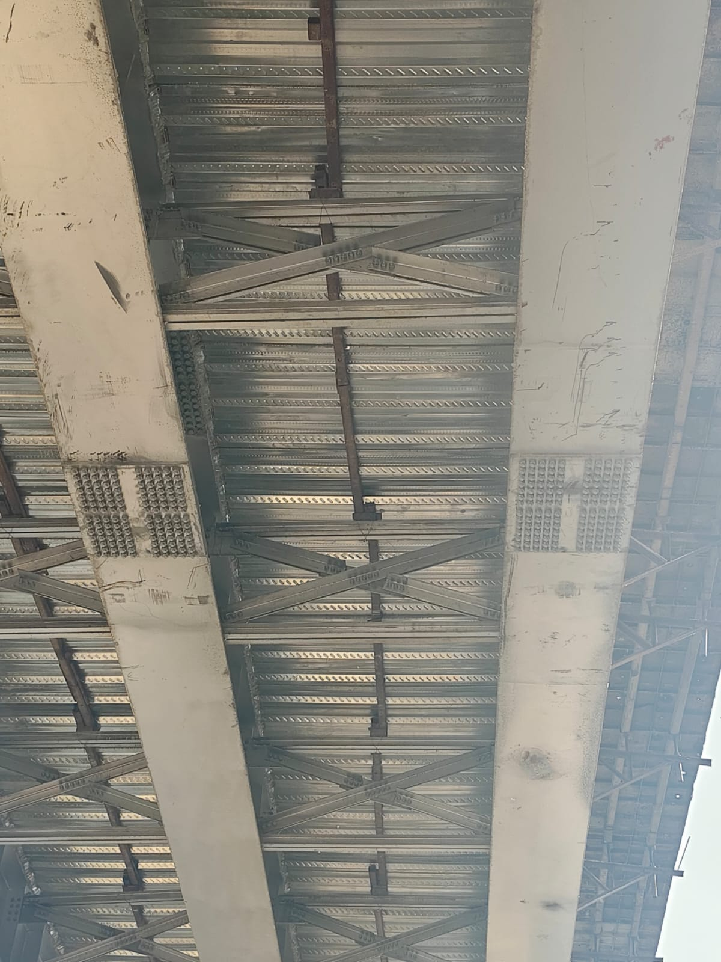
Figure 6: Cross bracing and diaphragm connections between adjacent girders, giving lateral stability to the span during and after erection
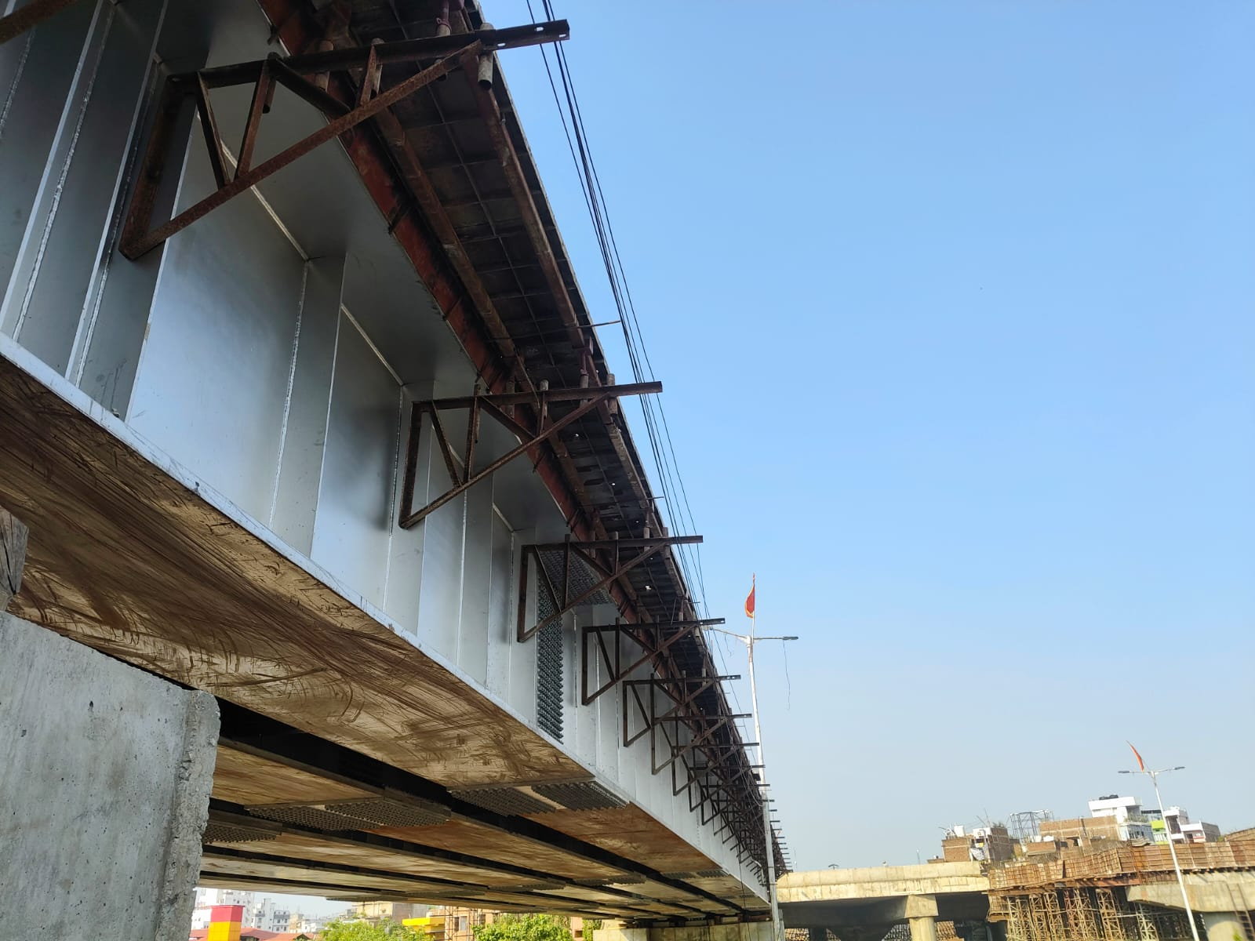
Figure 7: Street level view of the erected steel girder span, with temporary staging brackets and overhead utility lines running alongside
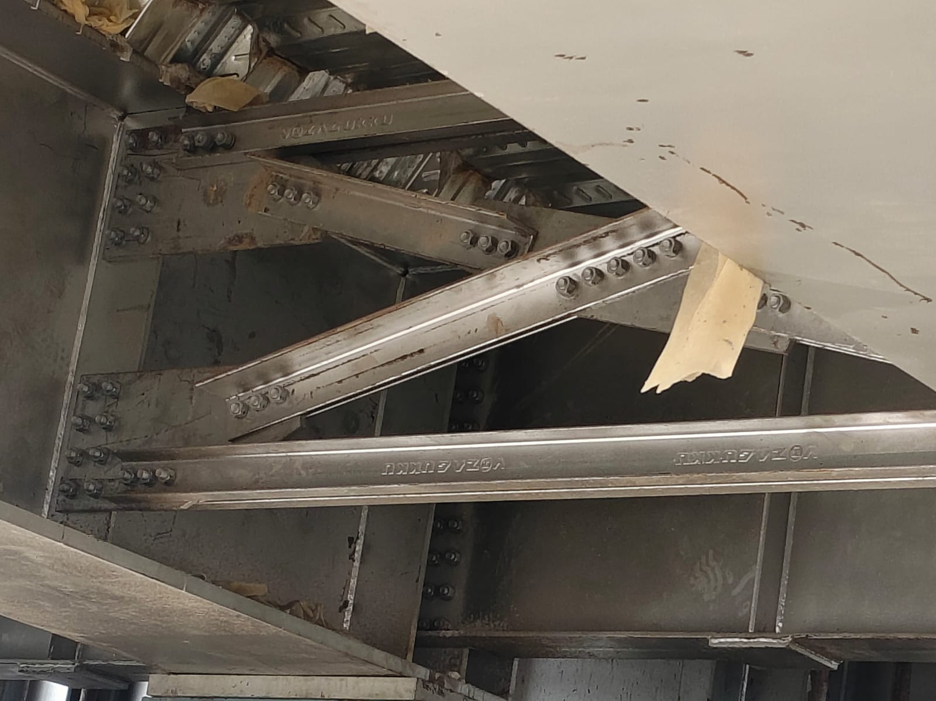
Figure 8: Close-up of a bolted cross bracing and diaphragm connection, showing HSFG bolted splice plates
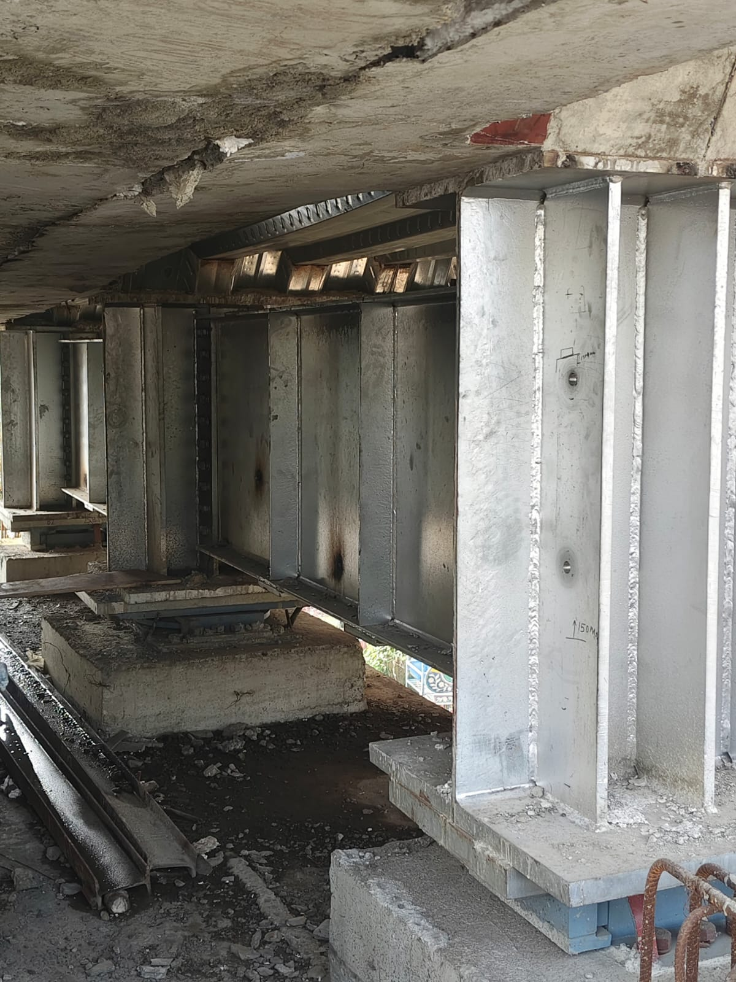
Figure 9: View along the pier cap showing several girders seated in position, with the congested ground level area visible below
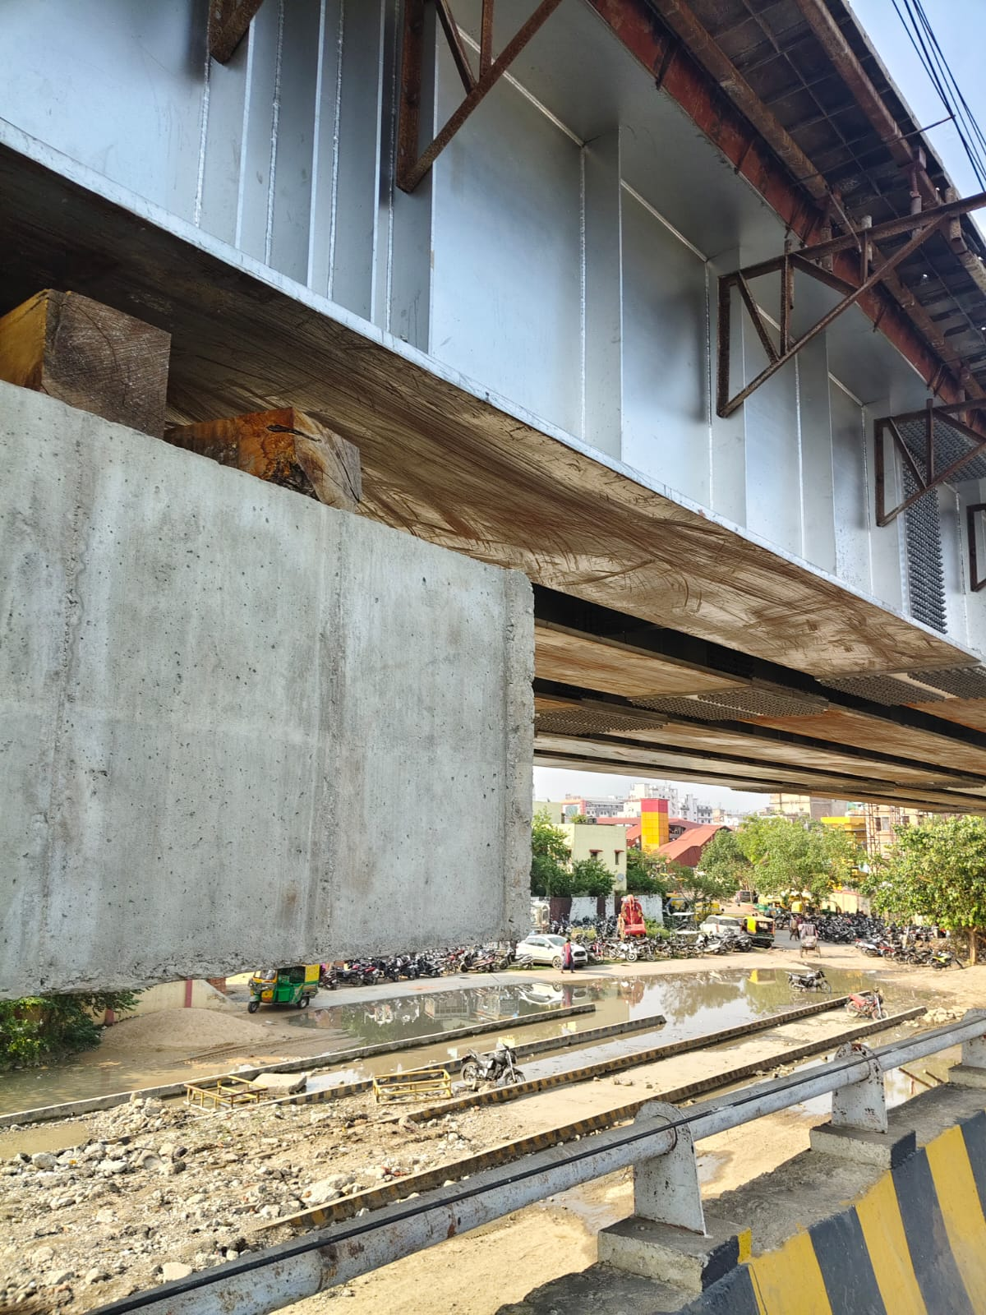
Figure 10: Temporary timber packing at the pier cap to girder interface, with the approach area, parked vehicles, and surrounding buildings visible below
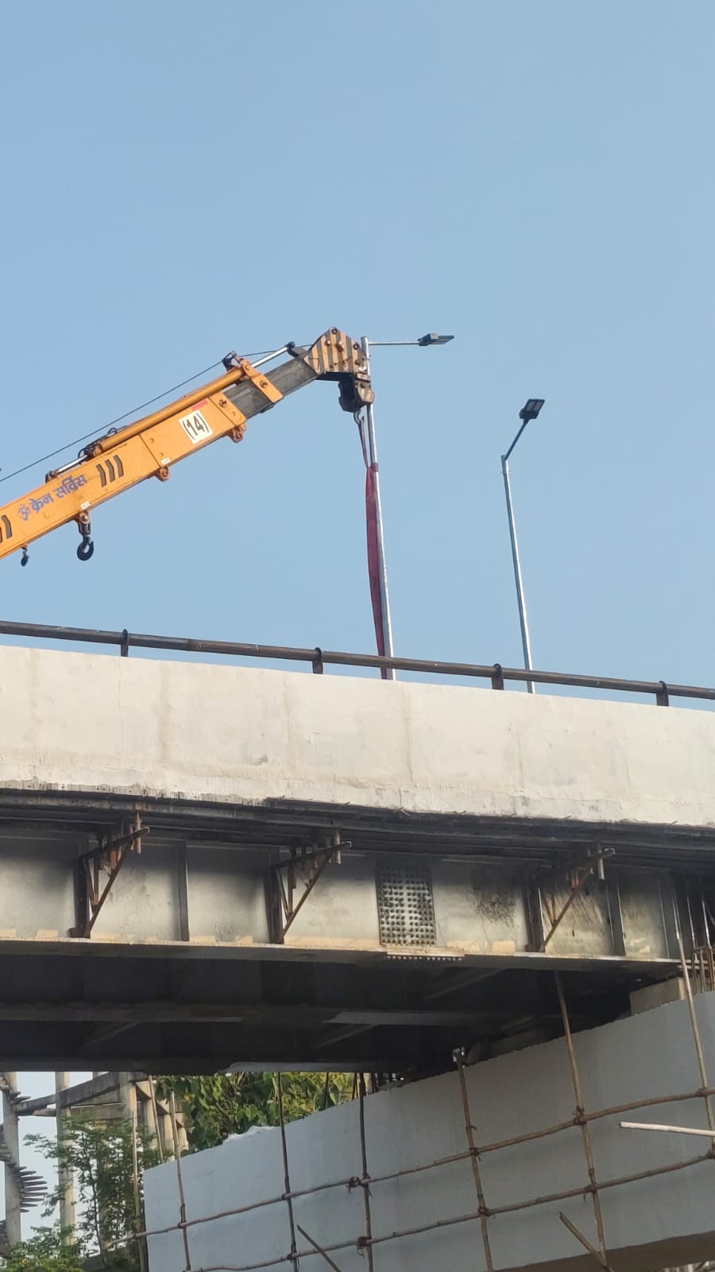
Figure 11: Mobile crane positioned on top of the flyover deck, working alongside a street lighting mast near the girder span.
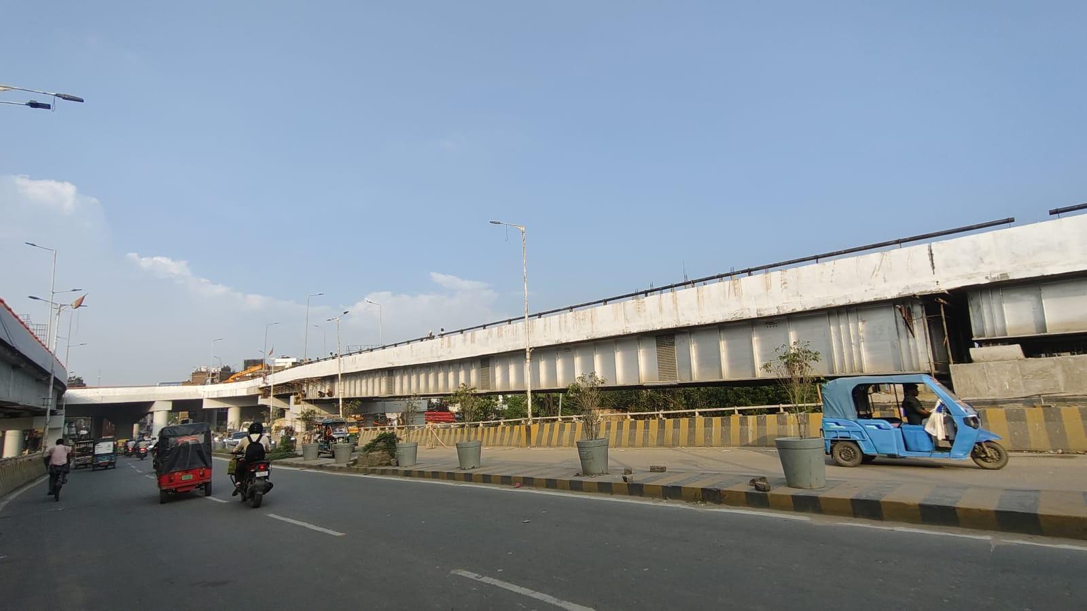
Figure 12: Street-level view of the completed flyover span, showing traffic movement and the approach on the ground below.
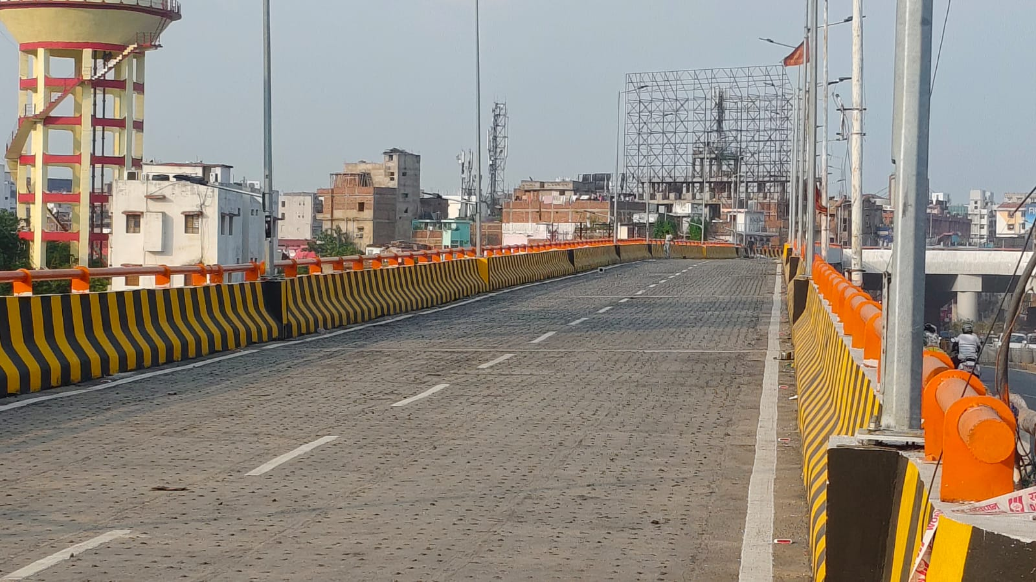
Figure 13: Completed carriageway on the flyover deck, with crash barriers and the approach towards the far end still under construction.
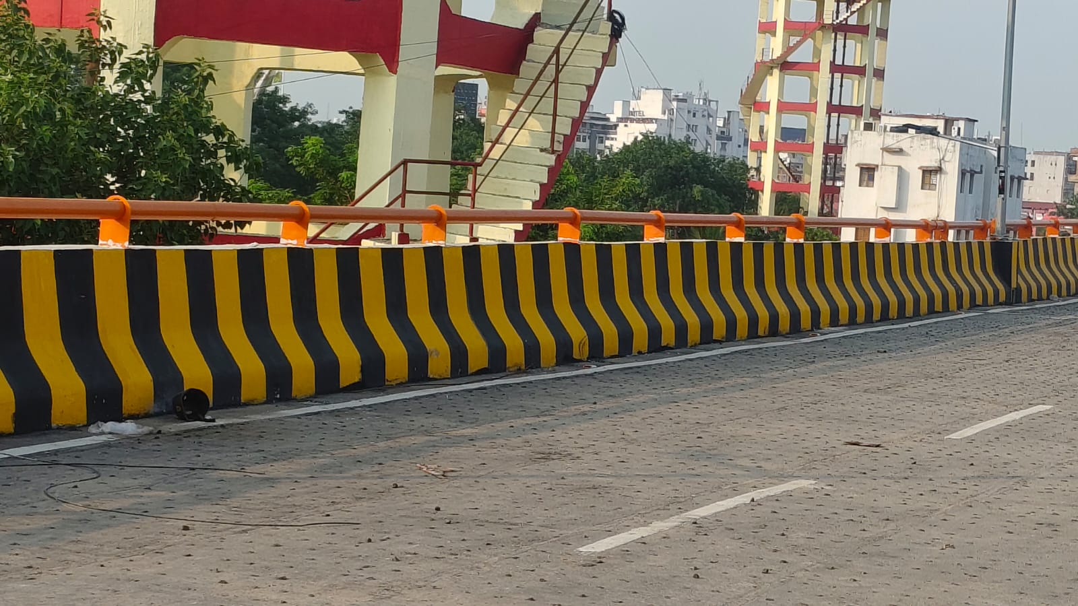
Figure 14: Close-up of the painted crash barrier along the flyover edge, with a water tower and scaffold tower visible in the background.
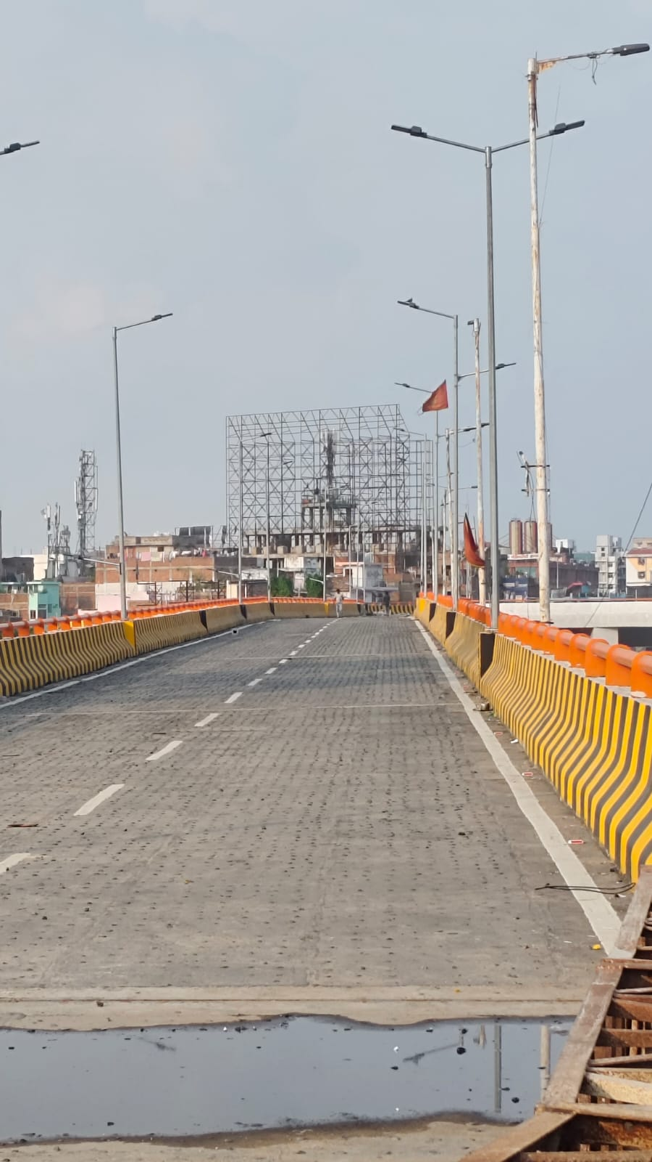
Figure 15: View along the flyover deck towards the far end, showing surface water after curing and the unfinished structure ahead.
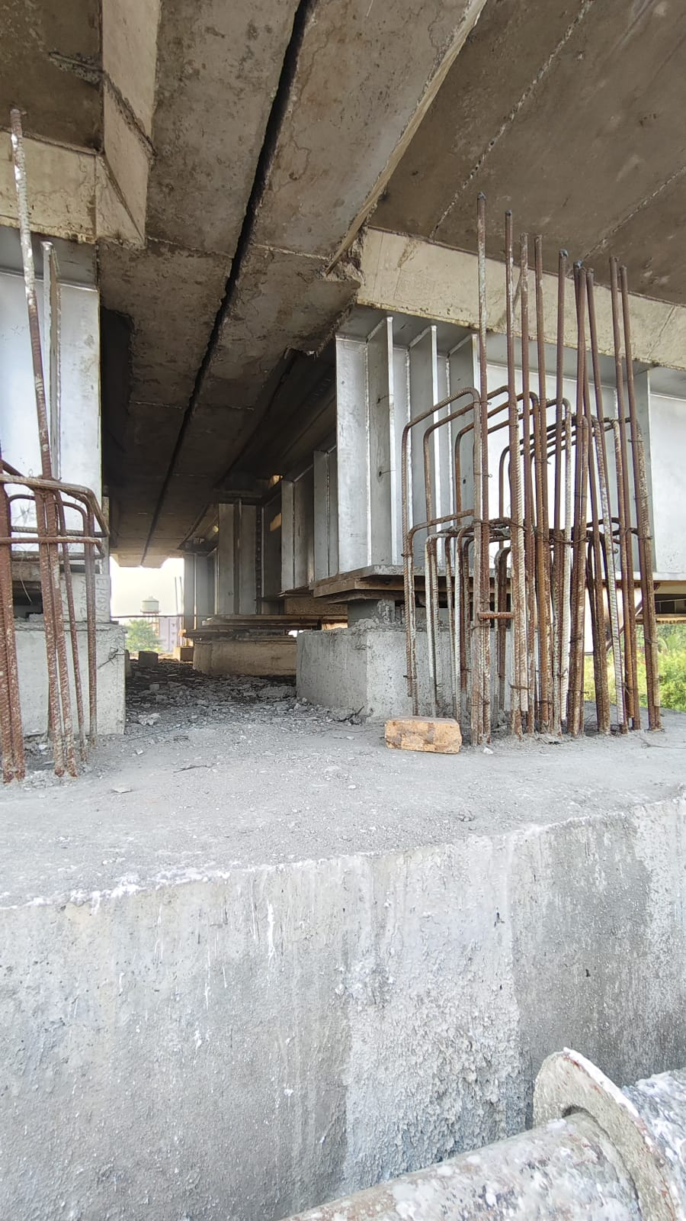
Figure 16: Close-up of reinforcement cages and pier cap detailing at the underside of the flyover near a support location.
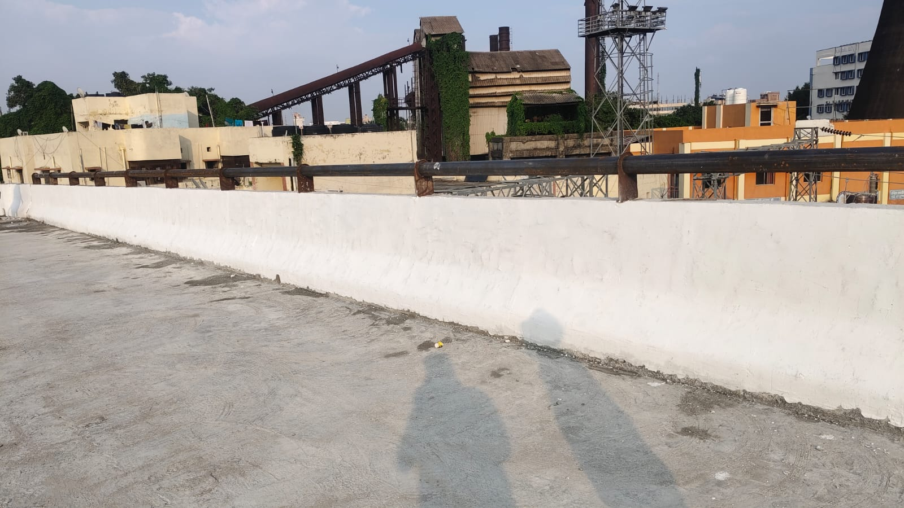
Figure 17: Another view of the deck parapet wall with the surrounding industrial facility visible beyond the flyover alignment.
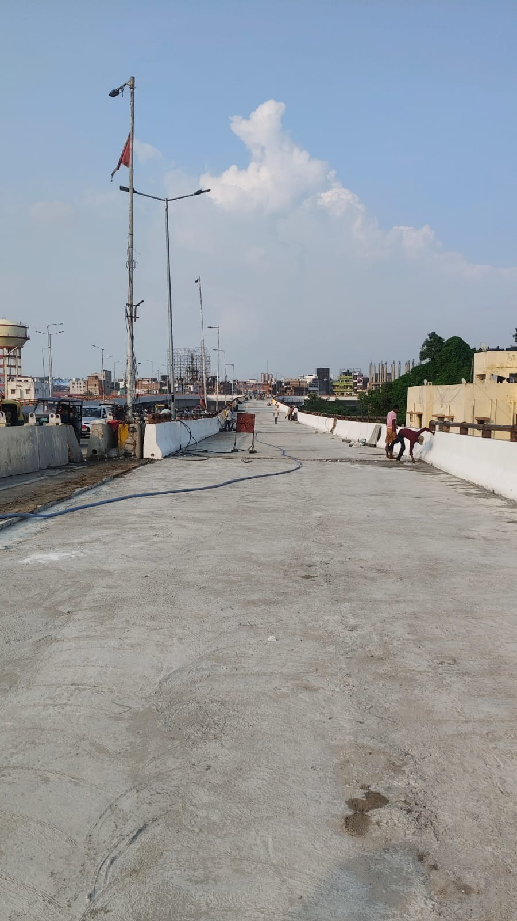
Figure 18: Workers finishing the deck surface at the flyover approach, with an elevated water tower visible in the background.
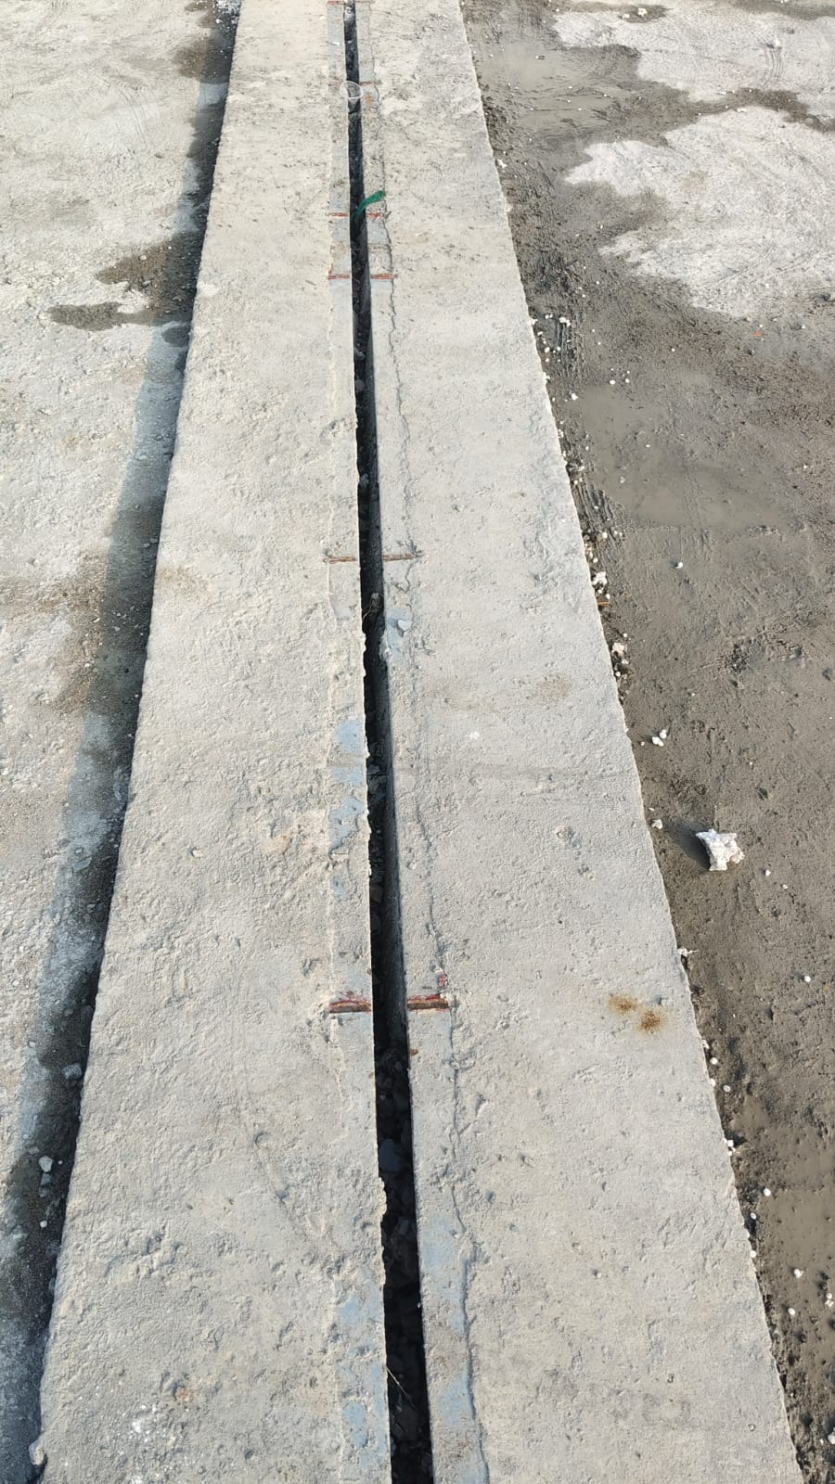
Figure 19: Close-up of a cast expansion joint gap left between adjoining deck slab segments.

5.2 Measurements / Calculations

Recorded site observations during the internship covered verification of reinforcement spacing and concrete cover for pier caps and deck slabs in accordance with the approved Bar Bending Schedule. I also carried out formation level checks at pedestal locations using an auto level. In addition, concrete cube samples were systematically documented along with their respective pour locations and casting dates.

5.3 Challenges Observed on Site
- A congested right of way, with piers and staging having to be positioned around live traffic lanes and existing utility lines
- Utility shifting, such as water lines and electrical or telecom cabling, needed before pier and foundation work could proceed at certain locations
- Traffic diversion and phased lane closures needed to keep the corridor partly open during construction
- Weather-dependent activities such as concreting and curing being affected during periods of rain
- Coordinating crane access and lifting schedules for girder erection within a busy urban street

6. Your Role and Contribution

6.1 Weekly Activity Log
The table below summarises my week-by-week activities on site over the course of the internship.
Week | Activities Performed
Week 1 | Site orientation and safety induction, familiarisation with the overall project layout, alignment, and the different work zones along the flyover
Week 2 | Observed steel girder erection using the mobile crane, and assisted the survey team with level checks along the pier line
Week 3 | Observed deck slab reinforcement placement and spacing checks, and documented daily progress for the site diary
Week 4 | Observed deck slab concreting and curing arrangements, and discussed quality control procedures with the site QC engineer
Week 5 | Monitored bearing and pedestal detailing at the pier caps, and assisted with quality control checks on concrete cube samples
Week 6 | Observed shear stud welding on the girder top flanges, and reviewed composite action checks before deck casting
Week 7 | Reviewed formwork and scaffolding arrangements at the deck edge, and observed routine safety inspections on site
Week 8 | Compiled site photographs and notes for the internship report, and had a wrap-up discussion with the site engineers on the work completed

6.2 Tools, Software, and Instruments Used
- Auto level and total station, used while observing site survey work
- Slump cone and cube testing equipment, used while observing concrete quality checks
- AutoCAD, used to review girder and reinforcement drawings

6.3 Specific Contributions
During my internship, I worked alongside the site engineering team in carrying out pedestal level checks at multiple pier locations. Using an auto level, I verified the formation levels and compared the readings with the approved construction drawings. I also assisted in inspecting deck slab reinforcement by checking bar spacing and concrete cover in accordance with the Bar Bending Schedule prior to concrete placement. In addition, I helped organize daily site photographs and observations into a systematic record for the project engineer. This documentation covered various construction activities, including pedestal preparation, bearing installation, and expansion joint installation, as illustrated in the figures presented throughout this report.

7. Learning Outcomes

7.1 Technical Skills Gained
- A practical understanding of how steel-composite girder erection is sequenced and why temporary staging matters.
- Hands-on exposure to how reinforcement detailing and quality checks are actually verified on site before a pour.
- Familiarity with bearing and pedestal installation procedures and tolerances
- Working knowledge of quality control testing (slump test, cube testing, torque verification)

7.2 Theory vs Practice
Classroom coverage of steel-concrete composite bridges tends to focus on the design side, working out shear connector spacing and checking deflection and stress limits, while treating construction sequencing as something already settled. On site at Karbigahiya, the sequencing itself turned out to be a major engineering decision. Girders must be temporarily propped and stabilized against buckling and lateral-torsional instability before the deck slab is cast, since composite action, and the stiffness that comes with it, does not exist until the concrete has cured. Seeing the timber and steel staging beneath the girders, as in Figures 1, 7, and 10, made this dependency much more concrete to me than a textbook diagram had.
For example, I also noticed that construction sequencing on site, such as the order of girder erection and deck pours, was driven as much by traffic management and site access constraints as by structural logic, an aspect rarely emphasised in coursework.

7.3 Soft Skills Developed
- Teamwork and coordination with site staff across different trades
- Communication with engineers, supervisors, and labour teams, including situations where I had to ask questions in the middle of an ongoing activity
- Time management and adaptability while working in outdoor, weather-dependent site conditions
8. Challenges Faced (Personal)

Adapting to the terminology used on site and interpreting structural drawings within the fast-paced environment of an active construction project was an initial challenge, as working drawings are generally more detailed and use more abbreviations than classroom drawings. Working outdoors in varying weather conditions and planning inspection activities around site safety protocols and access limitations also required some adjustment. With time, these challenges became easier to handle as I became more familiar with the site team, drawings, procedures, and daily work routine.

9. Conclusion
My internship at the Karbigahiya Flyover Project gave me useful, hands-on exposure to the practical side of steel-composite flyover construction in a live, congested urban setting, adding to the theoretical grounding I had built up through coursework at IIT Patna. Watching bare steel girders turn into a fully composite deck section, through shear stud welding, reinforcement placement, and concreting, was for me the most valuable part of the internship, since this sequence is usually only touched on briefly in classroom material. Overall, the internship gave me a much clearer sense of how design decisions translate into day-to-day site practice, and of the coordination required between engineers, contractors, and workers to keep a live urban project moving safely.
This experience has strengthened my interest in structural and bridge engineering and has left me better prepared for future roles in the construction industry.
10. References
1. IRC:5, Standard Specifications and Code of Practice for Road Bridges, Section I: General Features of Design.
2. IRC:6, Standard Specifications and Code of Practice for Road Bridges, Section II: Loads and Load Combinations.
3. IRC:22, Standard Specifications and Code of Practice for Road Bridges, Section VI: Composite Construction.
4. IRC:24, Standard Specifications and Code of Practice for Road Bridges, Section V: Steel Road Bridges.
5. IRC:37, Guidelines for the Design of Flexible Pavements.
6. IRC:78, Standard Specifications and Code of Practice for Road Bridges, Section VII: Foundations and Substructure.
7. IRC:83 (Parts I to III), Standard Specifications and Code of Practice for Road Bridges, Section IX: Bearings.
8. IRC:112, Code of Practice for Concrete Road Bridges.
9. IRC: SP:102, Guidelines for Design and Construction of Reinforced Soil (RE) Walls.
10. IS 456:2000, Plain and Reinforced Concrete, Code of Practice.
11. IS 800:2007, General Construction in Steel, Code of Practice.
12. IS 1893, Criteria for Earthquake Resistant Design of Structures.
13. IS 1892, Code of Practice for Subsurface Investigation for Foundations.
14. IS 2062, Hot Rolled Medium and High Tensile Structural Steel, Specification.
15. IS 2911 (Parts 1 to 4), Design and Construction of Pile Foundations, Code of Practice.
16. MoRTH Specifications for Road and Bridge Works, Ministry of Road Transport and Highways, Government of India (Fifth Revision).
17. BRPNNL Detailed Project Report and site drawings for the Karbigahiya Flyover Project, referred to on site.

