

Design and Development of a Network Congestion Simulator using Runge-Kutta Method with Visualization Dashboard

APROJECTREPORT
Submitted by

ARYAN KUMAR (23BCS10142)

in partialfulfilmentfortheaward of thedegree of

Bachelor of Engineering
In
Computer Science and Engineering



Chandigarh University
APRIL C 2026





BONAFIDE CERTIFICATE

Certified that this project report “Design and Development of a Network Congestion Simulator using Runge-Kutta Method with Visualization Dashboard” is the bonafide work of Aryan Kumar (23BCS10142) who carried out the project work under my supervision.

SIGNATURE
ER. GAGANDEEP SINGH E-Code: E8657

SIGNATURE
DR. RUCHI SHARMA E-Code: E15498

[HEAD OF THE DEPARTMENT]
Computer Science and Engineering

[SUPERVISOR]
Computer Science and Engineering

Submitted for the project viva-voce examination held on

INTERNALEXAMINER EXTERNAL EXAMINER



TABLE OF CONTENTS

CHAPTER – 01

INTRODUCTION

SL.  NO. | TOPIC | PAGE NO.
1 | Introduction | 01-02
2 | Identification of Client/ Need/ Relevant  Contemporary issue | 02-03
3 | Identification of Problem | 03-04
4 | Identification of Tasks | 04-05
5 | Timeline | 05
6 | Organization of the Report | 06

CHAPTER – 02

DESIGN FLOW/PROCESS

SL.  NO. | TOPIC | PAGE  NO.
1 | Evaluation & Selection of Specifications/Features | 07-09
2 | Design Constraints | 09-10
3 | Analysis of Features and finalization subject to  constraints | 10-11
4 | Design Flow | 11-12
5 | Design selection | 12-13
6 | Implementation plan/methodology | 13-14



CHAPTER– 03
RESULTS ANALYSIS AND VALIDATION

SL.  NO. | TOPIC | PAGE  NO.
1 | Implementation of solution | 15-22

CHAPTER– 04

CONCLUSION AND FUTURE WORK

SL.  NO. | TOPIC | PAGE  NO.
1 | Conclusion | 23
2 | Future work | 23-24

MISCELLANEOUS DOCUMENTS

SL.  NO. | TOPIC | PAGE  NO.
1 | REFERENCES | 25
2 | APPENDIX | 26-27



ABSTRCT

Numerical methods play a crucial role in solving complex mathematical problems that cannot be addressed using analytical solutions. In modern computing systems, network congestion is a significant issue that affects data transmission efficiency, latency, and overall system performance. Understanding and analyzing congestion behavior is essential for designing efficient and reliable network systems.
This mini project focuses on the design and development of a Network Congestion Simulator using the Runge-Kutta 4th Order Method (RK4) along with a visualization dashboard. The objective of this project is to model network traffic growth using a logistic differential equation and simulate congestion behavior under varying conditions such as growth rate, initial traffic, and network capacity. In this project, a mathematical model representing network traffic was implemented using an ordinary differential equation. The RK4 numerical method was applied to solve the equation and generate accurate results over discrete time intervals. Additionally, the Euler method was also implemented for comparison to analyze accuracy differences between numerical methods.
A full-stack web-based dashboard was developed using HTML, CSS, JavaScript, and Python (Flask) to provide an interactive interface for users. The dashboard allows users to input parameters such as initial traffic, growth rate, step size, and simulation time. The system dynamically visualizes traffic growth using graphical plots and displays key metrics including maximum traffic, time to congestion, and numerical error.
The simulation results demonstrate how network traffic initially grows rapidly and gradually stabilizes as it approaches the network capacity, reflecting real- world congestion behavior. The comparison between RK4 and Euler methods highlights the improved accuracy and stability of higher-order numerical techniques.
This project provides practical understanding of numerical methods, differential equation modeling, and real-time data visualization. It also enhances knowledge of full-stack development and demonstrates the application of mathematical concepts in solving real-world networking problems.




CHAPTER 01 INTRODUCTION
Numerical methods are essential techniques used to solve mathematical problems that are difficult or impossible to solve analytically. These methods are widely applied in various domains such as engineering, physics, data science, and computer networks. In the field of computer networks, understanding and analyzing traffic behavior is crucial for maintaining system performance and avoiding congestion.
Network congestion occurs when the amount of data transmitted exceeds the network capacity, resulting in delays, packet loss, and reduced efficiency. As modern systems rely heavily on data communication, studying congestion patterns and behavior has become increasingly important. Mathematical modeling provides an effective way to simulate and analyze such real-world problems.
This project focuses on the design and development of a Network Congestion Simulator using the Runge-Kutta Method with a visualization dashboard. The system models network traffic using a logistic differential equation, which represents how traffic grows over time and stabilizes when it approaches the network capacity. This behavior closely resembles real-world congestion scenarios.
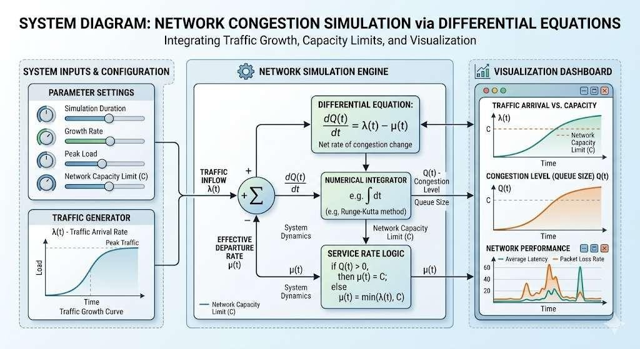

Figure: Network congestion growth and simulation concept diagram
To solve the differential equation, the Runge-Kutta 4th Order Method (RK4) is used due to its high accuracy and stability. Additionally, the Euler method is implemented for comparison purposes to highlight differences in numerical accuracy. The simulation results are visualized through an interactive dashboard that allows users to analyze traffic growth dynamically.


The project integrates both mathematical computation and software development by combining backend numerical processing with frontend visualization. Users can input parameters such as initial traffic, growth rate, step size, and simulation time to observe how network congestion evolves under different conditions.
Overall, this project demonstrates the practical application of numerical methods in solving real-world problems and provides insights into network behavior through simulation and graphical analysis.

Identification of Client/Need/Relevant Contemporary Issue
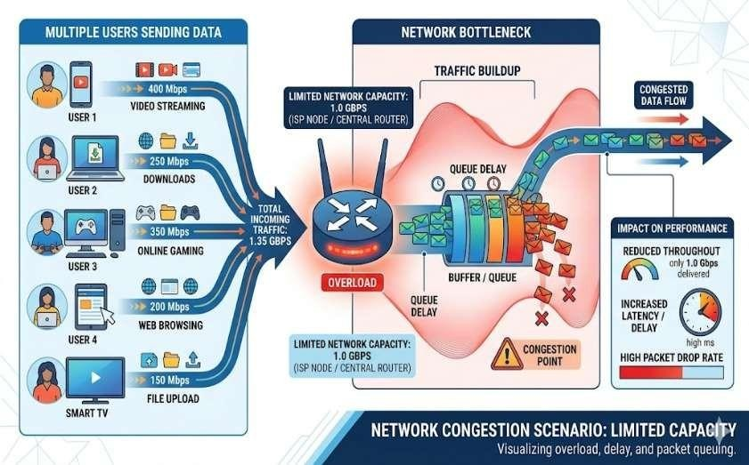
In the modern digital era,
efficient data communication has become a fundamental
requirement for various applications such as online services, cloud computing, video streaming, and real-time communication systems. With

the rapid growth usage and technologies,
of internet data-driven network

congestion has emerged as a significant challenge affecting system performance,
reliability, and user experience.
The identified need for this project arises from the requirement to understand and analyze network traffic behavior under different conditions. In many real-world scenarios, network systems experience congestion when the volume of incoming data exceeds the available bandwidth or capacity. This leads to increased latency, packet loss, and reduced throughput. Therefore, there is a need for a system that can simulate and visualize congestion behavior to help in better understanding and optimization of network performance.
The client in this context can be identified as students, researchers, and professionals in the field of computer science and networking who require an interactive and practical tool to study congestion dynamics. Traditional theoretical approaches often lack visualization and real-time analysis, making it difficult to fully understand the impact of various parameters such as traffic growth rate and network capacity.
The relevant contemporary issue addressed in this project is the increasing demand for efficient network management and performance optimization in modern systems. With the expansion of cloud services, IoT devices, and high-speed internet applications, managing network congestion has become critical. Simulation-based tools provide an effective way to study these problems without requiring real network infrastructure.


This project addresses these needs by developing a Network Congestion Simulator that uses numerical methods to model traffic growth and provides a visualization dashboard for better analysis. It helps bridge the gap between theoretical knowledge and practical understanding by enabling users to interactively explore congestion scenarios.

Identification of Problem
In modern computer networks, efficient data transmission is essential for maintaining performance and ensuring reliable communication. However, one of the major challenges faced by network systems is congestion, which occurs when the incoming traffic exceeds the network’s handling capacity. This leads to delays, packet loss, and degradation in overall system performance.
One of the primary problems identified is the lack of practical tools to simulate and analyze network congestion behavior in an interactive manner. While theoretical concepts of network traffic and congestion are well understood, students and beginners often find it difficult to visualize how traffic grows over time and how congestion develops under different conditions. This creates a gap between theoretical knowledge and practical understanding.
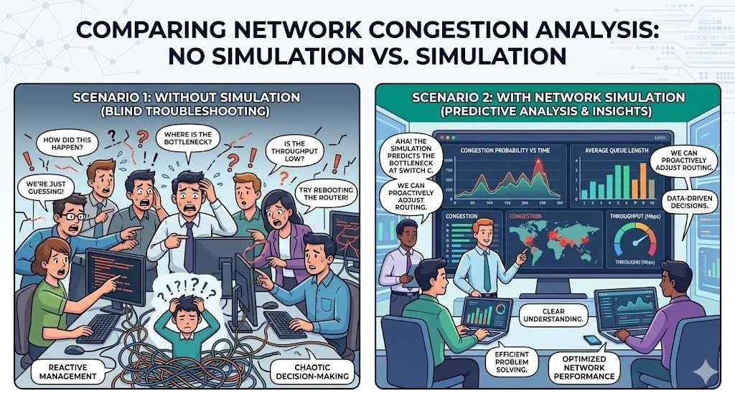

Figure: Problem of lack of congestion visualization tools
Another significant issue is the inability to easily analyze the effect of different parameters such as traffic growth rate, initial traffic, network capacity, and time intervals on congestion behavior. Without simulation tools, it becomes challenging to study how these factors influence network performance and stability.
Additionally, solving differential equations that model network traffic is complex and cannot be done easily using analytical methods. This makes it necessary to use numerical methods such as the Runge-Kutta method to approximate solutions. However, many learners lack practical exposure to implementing these numerical techniques in real-world scenarios.


The absence of visualization tools further complicates the understanding of congestion dynamics. Without graphical representation, it is difficult to interpret how traffic evolves over time and approaches network capacity.
This project addresses these problems by developing a simulation-based system that models network traffic using a differential equation and solves it using the Runge-Kutta method. The system provides an interactive dashboard that allows users to input parameters, visualize results, and analyze congestion behavior effectively. Thus, it bridges the gap between theoretical concepts and practical implementation.

Identification of Tasks
To successfully design and develop the Network Congestion Simulator using the Runge-Kutta Method with a visualization dashboard, a series of well-defined tasks were identified and executed in a structured manner. These tasks ensured proper implementation of mathematical modeling, numerical computation, and system development.
The first task involved understanding the problem domain and defining the mathematical model for network congestion. A logistic differential equation was selected to represent the growth of network traffic over time and its stabilization as it approaches network capacity. This step was crucial for accurately simulating real-world congestion behavior.
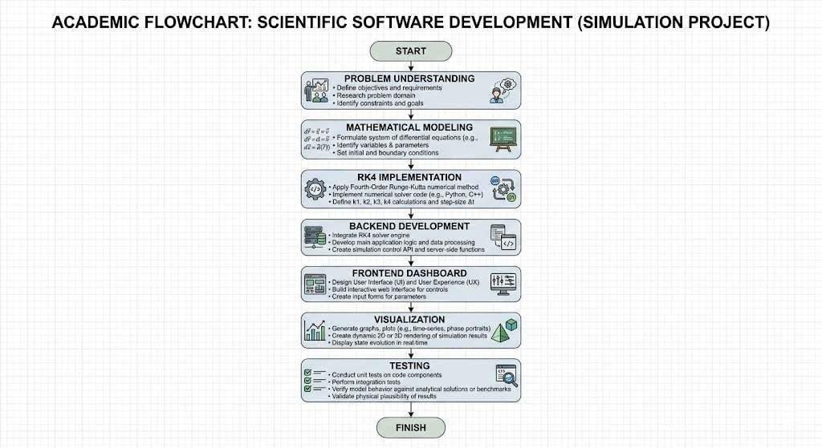

Figure: Stepwise workflow of congestion simulator development
The second task was the implementation of numerical methods. The Runge-Kutta 4th Order
Method (RK4) was implemented to solve the differential equation due to its high accuracy.


Additionally, the Euler method was also implemented to compare results and analyze numerical
errors between different methods.
The third task involved developing the backend system using Python and Flask. The backend was responsible for handling user inputs, performing numerical computations, and generating simulation results. API endpoints were created to process input parameters and return computed data in a structured format.
The fourth task focused on designing and developing the frontend dashboard. HTML, CSS, and JavaScript were used to create a professional and interactive user interface. The dashboard allows users to input parameters such as initial traffic, growth rate, network capacity, step size, and simulation time.
The fifth task involved data visualization. Graphical plots were generated using charting libraries to display traffic growth over time. The visualization includes comparisons between RK4 and Euler methods, along with indicators showing congestion levels.
The sixth task was testing and validation. The system was tested with different input parameters to ensure correct implementation of numerical methods and accurate simulation results. The graphical outputs were verified to match expected behavior of the logistic growth model.
Finally, the last task involved documentation and analysis. The project report was prepared, including explanation of methodology, results, and observations. This ensured proper presentation of the project and its outcomes.
These identified tasks collectively ensured a systematic approach to developing the simulation
system and achieving the project objectives.

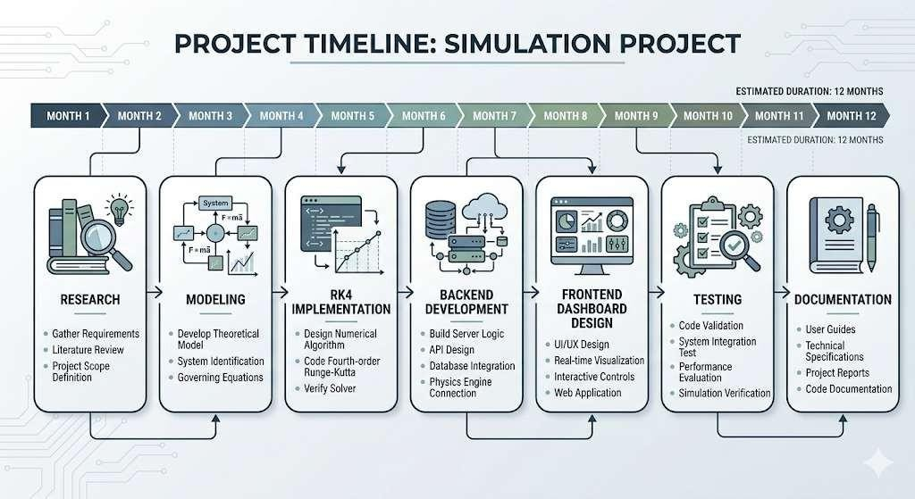
Timeline
Figure: Project development timeline with key implementation phases



Organization of the Report

This report is systematically organized to provide a clear and comprehensive understanding of the project objectives, methodology, implementation process, and results of the Network Congestion Simulator using the Runge-Kutta Method. Each chapter is structured to present specific aspects of the project in a logical and sequential manner.

Chapter 1 introduces the background of the project, identifies the client needs, defines the problem statement, outlines the tasks involved, and presents the project timeline. It establishes the foundation and context for understanding the importance of network congestion analysis and numerical methods.

Chapter 2 describes the design flow and process of the system. It includes evaluation and selection of features, identification of design constraints, analysis of system components, and final design selection. This chapter also explains the implementation methodology used to develop the simulator and visualization dashboard.
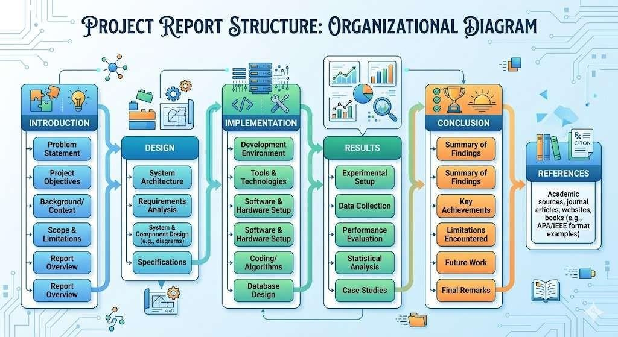

Figure: Structured organization of project report chapters

Chapter 3 focuses on the results, analysis, and validation of the system. It presents the implementation details, graphical outputs, and observations obtained from the simulation. The performance of the Runge-Kutta method is compared with other numerical techniques to validate accuracy and stability.

Chapter 4 concludes the report by summarizing the key findings and learning outcomes of the project. It also discusses possible future enhancements and improvements that can be made to extend the functionality and applicability of the system.

Finally, the report includes references and appendix sections, which provide additional supporting materials, technical details, and resources used during the development of the project. This structured organization ensures clarity, logical flow, and effective presentation of the entire project.



CHAPTER – 02

DESIGN FLOW/PROCESS
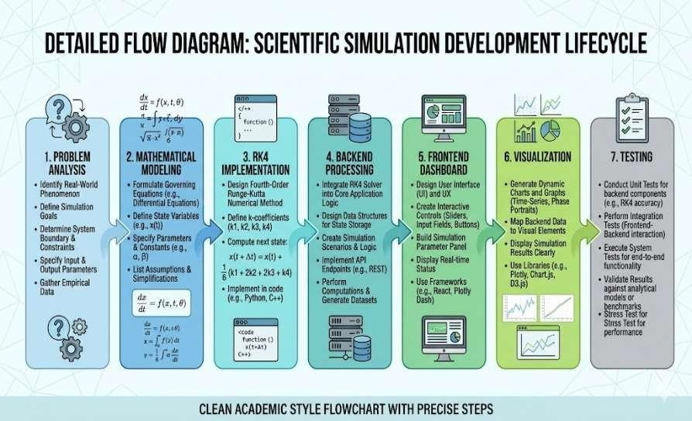

The design flow of this project follows a structured and systematic approach to ensure the successful development of a Network Congestion Simulator using the Runge-Kutta Method with a visualization dashboard. The entire process is divided into multiple stages, beginning from problem understanding and mathematical modeling to implementation and final visualization.

The first phase involves analyzing the problem of network congestion and identifying the appropriate mathematical model. A logistic differential equation is selected to represent the growth of network traffic over time, considering the limitation of network capacity. This model accurately reflects real-world behavior where traffic initially increases rapidly and gradually stabilizes as it approaches capacity.

The second phase focuses on the implementation of numerical methods. The Runge-Kutta 4th Order Method (RK4) is chosen due to its higher accuracy and stability in solving differential equations. Additionally, the Euler method is implemented for comparison purposes to evaluate numerical accuracy and error differences.

The third phase involves backend development, where the numerical computations are handled using Python and Flask. The backend is responsible for receiving user inputs, performing calculations using RK4 and Euler methods, and returning the simulation results in a structured format.

The fourth phase includes frontend development, where an interactive and user-friendly dashboard is designed using HTML, CSS, and JavaScript. The dashboard allows users to input simulation parameters and visualize results in real time.

The fifth phase is data visualization, where graphical representations of traffic growth are generated. Charts are used to display the variation of traffic over time, highlighting congestion behavior and comparison between numerical methods.

The final phase involves testing and validation of the system. The simulation is executed with different input values to ensure accuracy, stability, and correctness of results. The outputs are analyzed to confirm that the model behaves as expected under various conditions. This structured design flow ensures a logical progression from conceptual modeling to practical implementation, resulting in an efficient and reliable simulation system.



Evaluation & Selection of Specifications/Features
The evaluation and selection of appropriate specifications and features play a crucial role in ensuring the effectiveness and reliability of the Network Congestion Simulator. The selected specifications were carefully chosen based on performance requirements, ease of implementation, accuracy of numerical computation, and user interaction capabilities.

Initially, the project required a mathematical model capable of representing real-world network congestion behavior. A logistic differential equation was selected as it effectively models traffic growth with a limiting factor representing network capacity. This choice ensures that the simulation reflects realistic congestion scenarios where traffic stabilizes after reaching capacity.
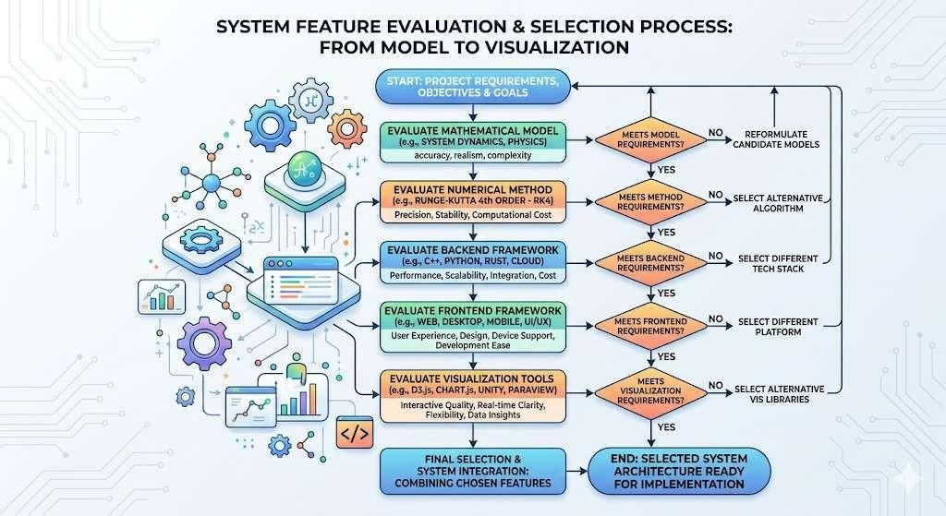

Figure: Selection of features and system specifications

For numerical computation, the Runge-Kutta 4th Order Method (RK4) was selected due to its high accuracy and stability in solving ordinary differential equations. Compared to simpler methods such as Euler’s method, RK4 provides better approximation with reduced numerical error. Additionally, Euler’s method was also included as a feature to enable comparison and analysis of accuracy differences.

The backend technology was selected based on simplicity and efficiency. Python was chosen as the programming language due to its strong support for numerical computation and readability. Flask was selected as the backend framework because it is lightweight, easy to implement, and suitable for developing API-based applications.

For the frontend, HTML, CSS, and JavaScript were selected to create an interactive and visually appealing dashboard. These technologies allow dynamic user input handling and real-


time data visualization. Charting libraries such as Chart.js were used to generate graphical plots for better understanding of traffic growth and congestion patterns.

Visualization features were also carefully selected to enhance user experience. The system includes graphical representation of traffic over time, comparison between RK4 and Euler methods, and indicators showing congestion levels. These features make the system more informative and user-friendly.

Additionally, simplicity and maintainability were considered important factors. The system was designed to be lightweight and easy to understand, ensuring that users can easily interact with the simulator without requiring advanced technical knowledge.

Overall, the selected specifications and features provide a balance between accuracy, usability, performance, and simplicity, making the system effective for both learning and practical demonstration purposes.

Design Constraints
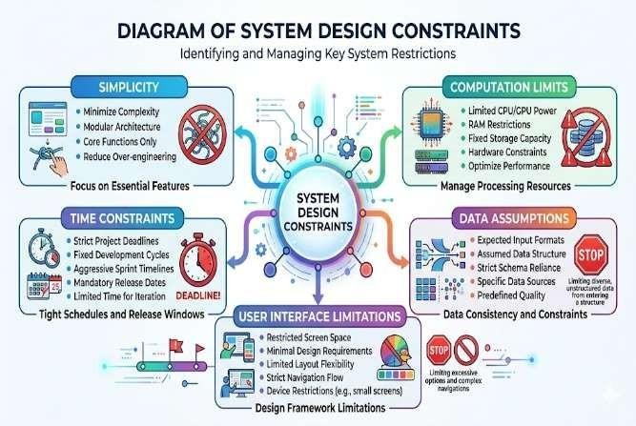
The design and development of the Network Congestion Simulator were carried out by considering several technical and operational constraints. These constraints influenced the selection of tools, system architecture, and implementation approach to ensure an efficient, simple, and reliable solution within the academic scope.

One of the primary constraints was simplicity and ease of implementation. Since the project is
intended for educational purposes, it was important to design the system in a way that is easy to
understand and implement. Therefore, lightweight technologies such as Python (Flask) for backend and HTML, CSS, and JavaScript for frontend were selected to avoid unnecessary complexity.

Another constraint was computational efficiency. Numerical methods such as the Runge-Kutta method require multiple calculations at each step. Hence, the implementation needed to be optimized to ensure smooth execution without excessive computational overhead, especially for larger simulation time intervals.

The limitation of real-world data was also considered as a constraint. The simulation is based on a mathematical model rather than real-time network data. Therefore, assumptions such as constant growth rate and fixed network capacity were made to simplify the model while still maintaining realistic behavior.

User interaction and visualization posed another design constraint. The system needed to provide
clear and understandable graphical outputs without overwhelming the user. Hence, a simple and


clean dashboard design was adopted with essential features such as input fields, graphs, and status indicators.

Browser compatibility and system accessibility were also taken into account. The application was designed to run on standard web browsers without requiring specialized software or high- end hardware, ensuring accessibility for all users.

Finally, time and resource constraints influenced the scope of the project. Advanced features such as real-time network integration or large-scale simulations were avoided to keep the project manageable within the given timeline.

By addressing these constraints, the project achieves a balance between functionality, simplicity, performance, and usability while successfully demonstrating the concept of network congestion simulation using numerical methods.

Analysis of Features and finalization subject to constraints
After identifying the design constraints, a detailed analysis of the system features was carried out to ensure that the final implementation remains efficient, accurate, and user-friendly. Each feature was evaluated based on its feasibility, performance, and compatibility with the overall system design.

One of the primary features analyzed was the mathematical modeling of network congestion. The logistic differential equation was selected as it effectively represents traffic growth with a limiting factor. This feature was finalized because it provides realistic simulation behavior while keeping the model simple and computationally efficient.
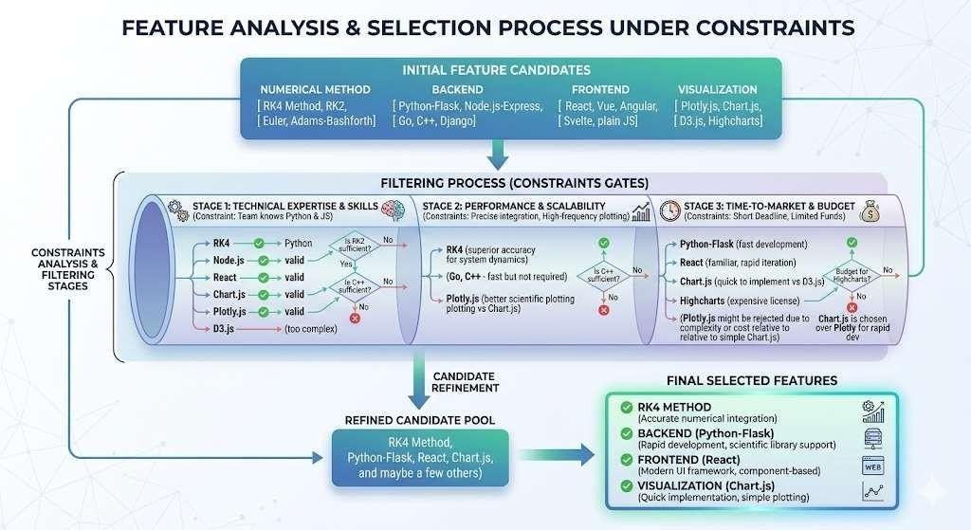

Figure: Feature analysis and final system selection process

The numerical method selection was another important aspect of analysis. While several numerical techniques are available, the Runge-Kutta 4th Order Method (RK4) was finalized due to its superior accuracy and stability compared to simpler methods such as Euler’s method.


However, Euler’s method was also retained as a feature for comparison purposes, allowing users to observe differences in numerical accuracy and error.

The backend system was analyzed for simplicity and performance. Python with Flask was finalized as it provides a lightweight framework for handling user inputs and performing numerical computations efficiently. This choice ensures easy implementation and maintainability within the project scope.

The frontend dashboard design was evaluated based on usability and visualization capabilities. HTML, CSS, and JavaScript were finalized as they allow creation of an interactive and responsive interface. The inclusion of graphical visualization using charting libraries was considered essential to help users better understand congestion behavior.

Visualization features such as traffic growth graphs, method comparison plots, and congestion indicators were finalized after analysis. These features enhance the interpretability of results and provide a clear understanding of system behavior.

Additionally, simplicity and clarity were prioritized while finalizing features. Advanced functionalities that could increase complexity without significant benefit were avoided to maintain a balance between functionality and usability.

Through systematic analysis and careful selection, the final set of features ensures that the system is accurate, efficient, and easy to use while meeting all project objectives within the defined constraints.

Design Flow
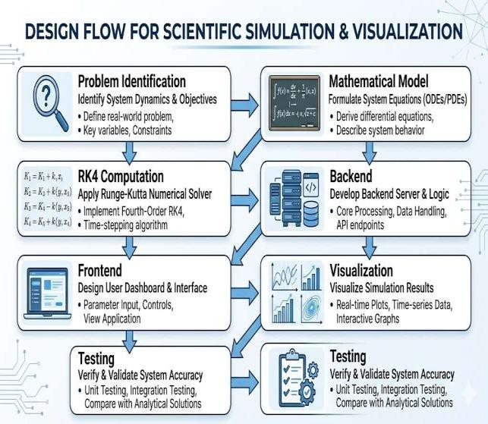
The design flow of the Network Congestion Simulator follows a structured sequence of steps to ensure systematic development and successful implementation of the system. Each stage in the design flow is logically connected, allowing smooth progression from problem analysis to final output visualization.

The process begins with problem identification and understanding of network congestion behavior. This is followed by selecting an appropriate mathematical model, where a logistic
differential equation is used to represent traffic growth and capacity limitation.

The next step involves implementing numerical methods to solve the differential equation. The
Runge-Kutta 4th Order Method (RK4) is applied for accurate computation, while the Euler method


is also implemented for comparison. This stage forms the core computational component of the system.

Following numerical implementation, the backend system is developed using Python and Flask. The backend processes user inputs, performs calculations, and generates simulation results. API endpoints are used to facilitate communication between the frontend and backend.

The frontend development stage focuses on creating an interactive dashboard using HTML, CSS, and JavaScript. Users can input parameters such as initial traffic, growth rate, network capacity, step size, and simulation time. The interface is designed to be user-friendly and visually appealing.

The next stage involves data visualization, where simulation results are presented through graphs and charts. These visual elements help users understand traffic growth patterns and congestion behavior effectively. Comparisons between RK4 and Euler methods are also displayed for analysis.

Finally, testing and validation are performed to ensure the accuracy and reliability of the system. Different input values are used to verify the correctness of results and the stability of numerical methods.

This structured design flow ensures that the system is developed in an organized and efficient
manner, resulting in a reliable and interactive network congestion simulation tool.

Design selection
The design selection for this project was carried out after evaluating different possible approaches for implementing a network congestion simulation system. The final design was chosen based on simplicity, efficiency, ease of implementation, and suitability for academic purposes.

A single-tier client-server architecture was selected for this project. In this design, the user interacts with the frontend dashboard through a web browser, while the backend system processes the input parameters and performs numerical computations. The backend communicates with the frontend using API requests and responses, ensuring smooth data flow within the system.
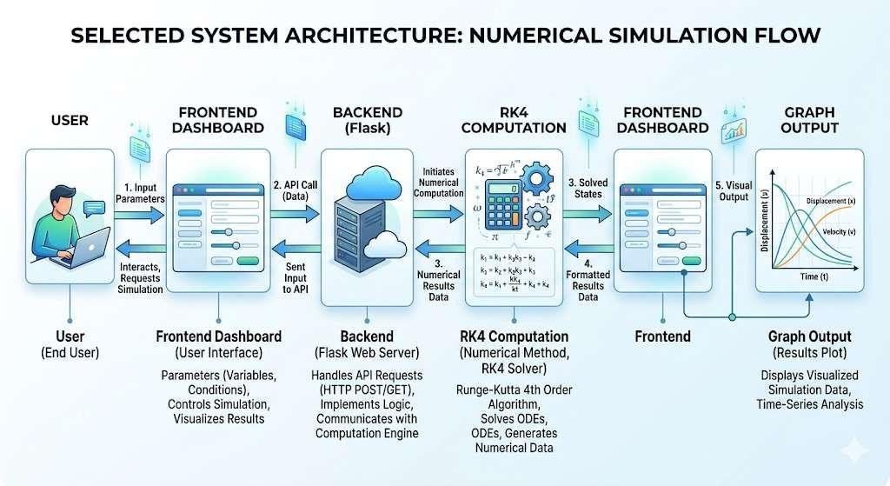

Figure: Selected system architecture with frontend and backend


The mathematical model selected for the system is a logistic differential equation, which effectively represents the growth of network traffic under capacity constraints. This model was chosen because it provides realistic simulation behavior while remaining simple and computationally efficient.

For numerical computation, the Runge-Kutta 4th Order Method (RK4) was selected as the primary method due to its high accuracy and stability. The Euler method was also included in the design to allow comparison and analysis of numerical errors, enhancing the educational value of the project.

Python with Flask was selected as the backend technology due to its simplicity, readability, and strong support for numerical computations. It allows easy implementation of API-based communication and efficient handling of simulation logic.

On the frontend side, HTML, CSS, and JavaScript were selected to create an interactive and visually appealing dashboard. These technologies enable dynamic user input, real-time data updates, and graphical visualization of results.

Charting libraries were incorporated to display traffic growth and comparison graphs. These visual components improve understanding of congestion behavior and make the system more user-friendly.

The final design ensures a balance between functionality, simplicity, and performance. It provides an effective solution for simulating and analyzing network congestion while maintaining ease of use and clarity for educational purposes.

Implementation plan/methodology
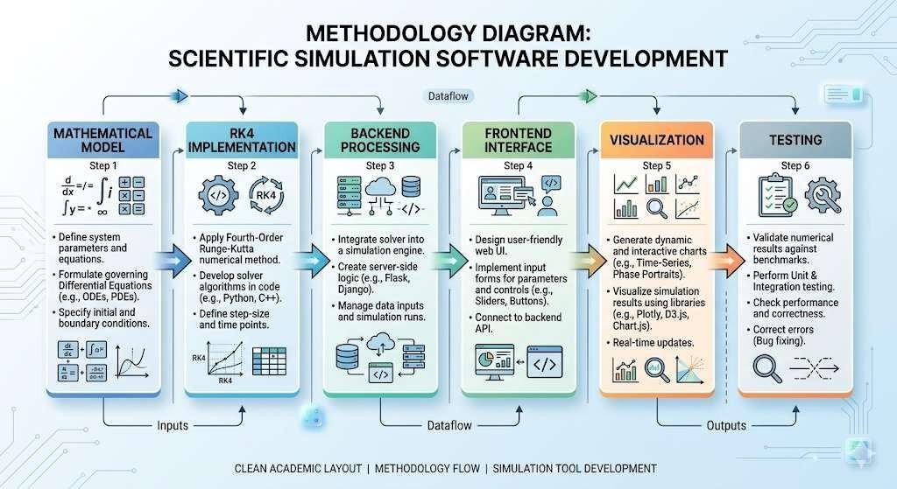

Figure: Implementation methodology of congestion simulation system


The implementation of the Network Congestion Simulator was carried out in a structured and systematic manner to ensure accurate numerical computation and efficient visualization of results. The methodology followed a step-by-step approach, integrating mathematical modeling, backend processing, and frontend visualization.

The first step involved defining the mathematical model for network congestion. A logistic differential equation was selected to represent traffic growth with a limiting factor based on network capacity. This model forms the foundation of the simulation.

The second step focused on implementing numerical methods. The Runge-Kutta 4th Order Method (RK4) was developed to solve the differential equation due to its high accuracy and stability. Additionally, the Euler method was implemented to provide a comparative analysis of numerical accuracy and error.

The third step involved backend development using Python and Flask. The backend system was designed to accept input parameters such as initial traffic, growth rate, network capacity, step size, and simulation time. These inputs are processed to compute traffic values over discrete time intervals using numerical methods.

The fourth step included frontend development. An interactive dashboard was created using HTML, CSS, and JavaScript to allow users to input parameters and visualize results. The interface was designed to be simple, user-friendly, and visually appealing.

The fifth step focused on data visualization. Graphs were generated to display traffic growth over time, along with comparisons between RK4 and Euler methods. Additional indicators such as congestion level and error analysis were included to enhance understanding.

The sixth step involved integration of frontend and backend components. API endpoints were used to transfer data between the user interface and the computation engine, ensuring smooth interaction and real-time updates.

Finally, testing and validation were performed to verify the correctness of the implementation. Various input values were tested to ensure accurate results and proper functioning of the system.

This structured implementation plan ensured that the project was developed efficiently while maintaining accuracy, usability, and clarity.



CHAPTER – 03
RESULTS ANALYSIS AND VALIDATION

Implementation of solution
The implementation phase focuses on the practical execution of the Network Congestion Simulator using the Runge-Kutta Method along with a visualization dashboard. In this stage, the mathematical model was successfully integrated with backend computation and frontend visualization to create a complete functional system.

The backend system was developed using Python and Flask, where the numerical methods were implemented. The Runge-Kutta 4th Order Method (RK4) was used to solve the logistic differential equation, and the Euler method was also implemented for comparison. The backend processes user inputs such as initial traffic, growth rate, network capacity, step size, and simulation time, and generates traffic values over time.

The frontend dashboard was designed using HTML, CSS, and JavaScript to provide an interactive user interface. Users can input simulation parameters and visualize results dynamically. The interface includes graphical representation of traffic growth, comparison between RK4 and Euler methods, and indicators showing congestion levels.
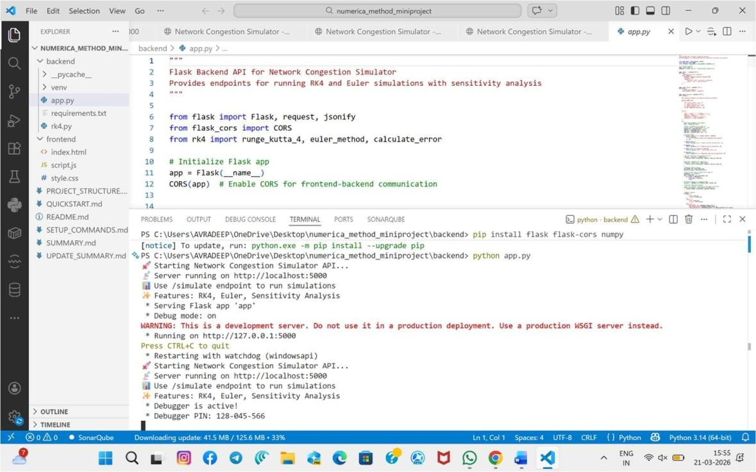

Figure: Backend server running successfully in VS Code terminal


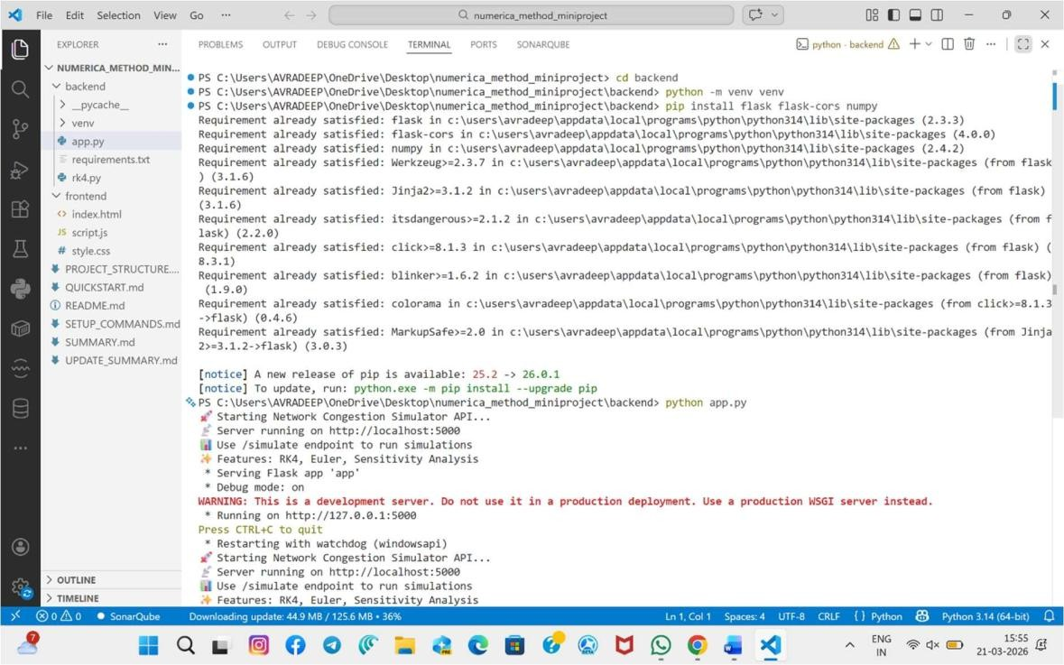

Figure: Flask server execution with dependencies installed successfully
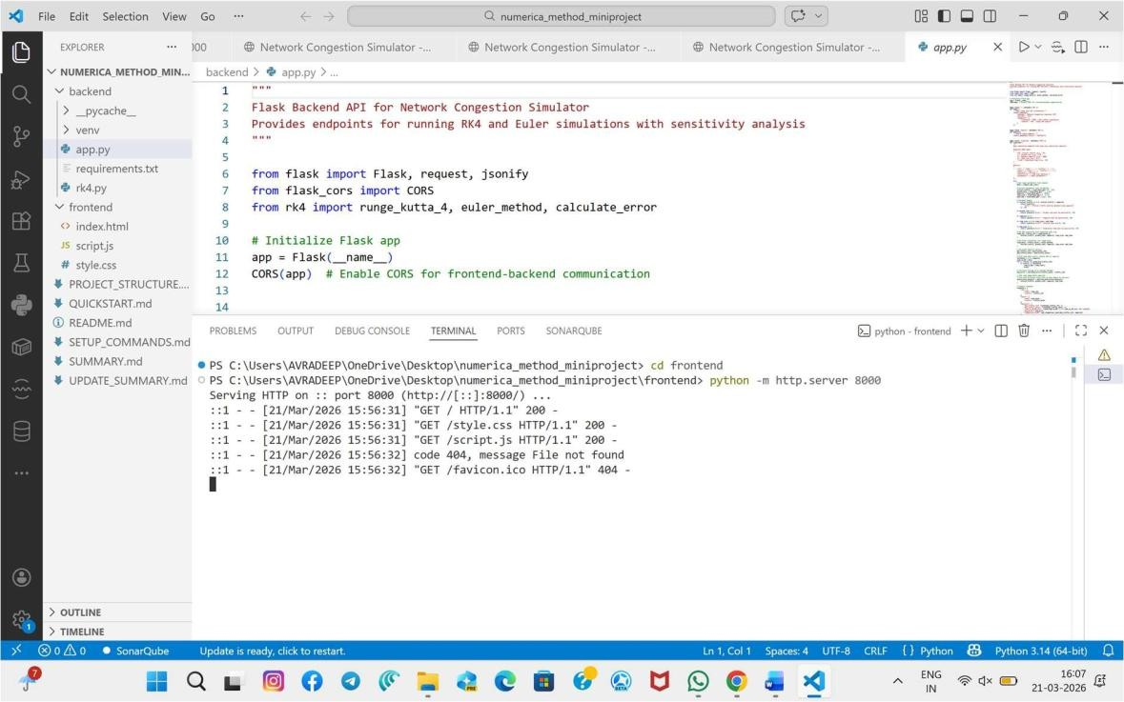

Figure: Frontend server running and serving project files locally


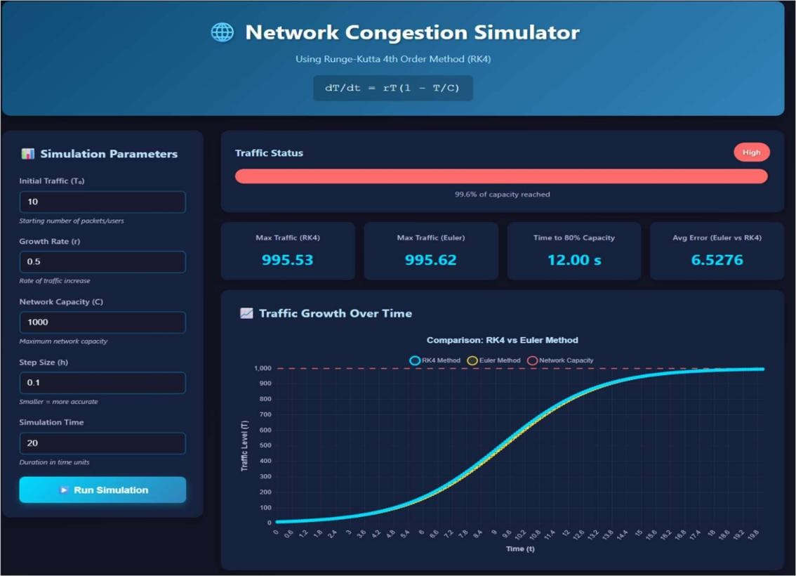

Figure: Network congestion simulator dashboard initial interface display
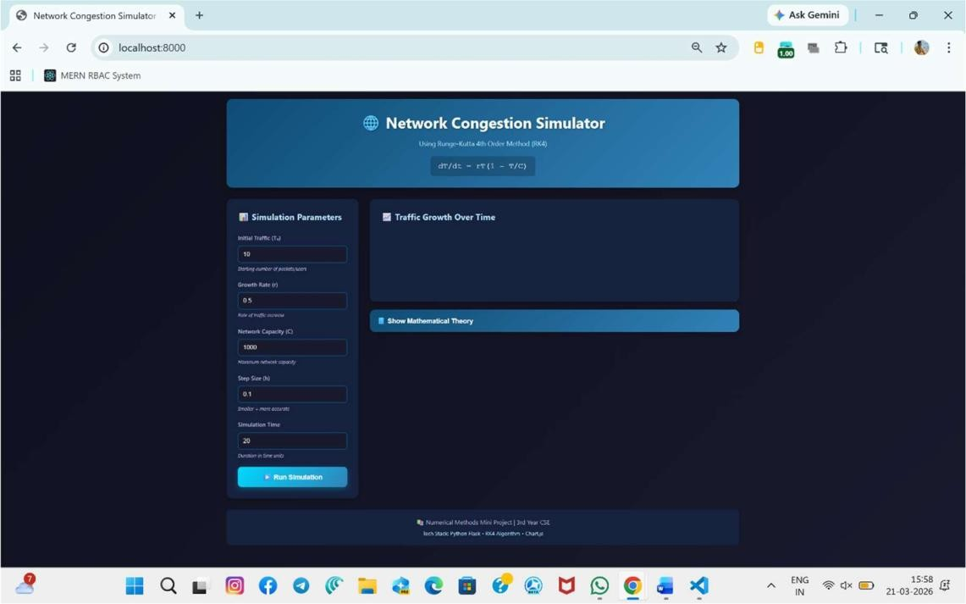

Figure: High congestion simulation with RK4 and Euler graph


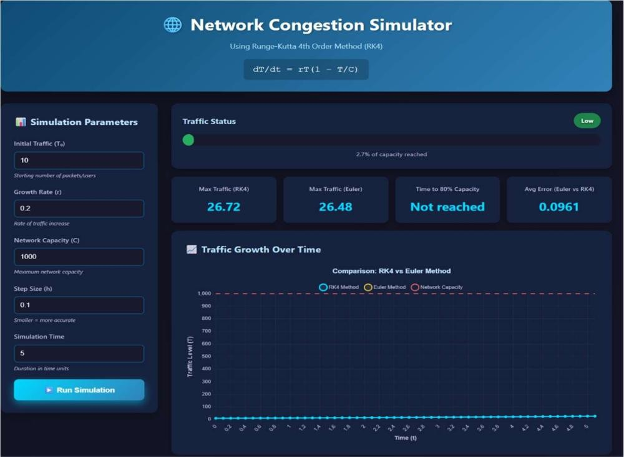

Figure: Low traffic simulation with minimal congestion growth
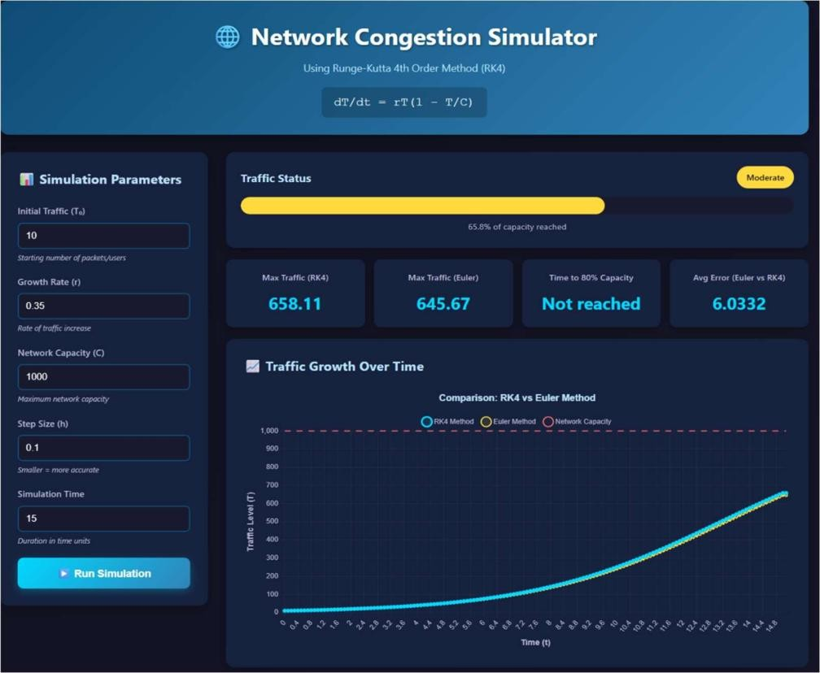

Figure: Moderate traffic simulation with balanced congestion growth


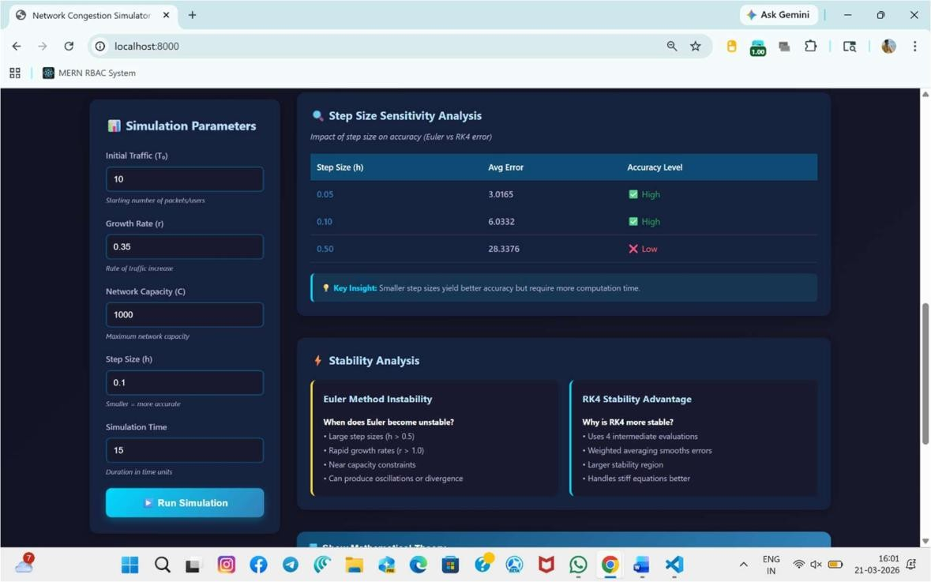

Figure: Step size sensitivity and stability analysis results displayed
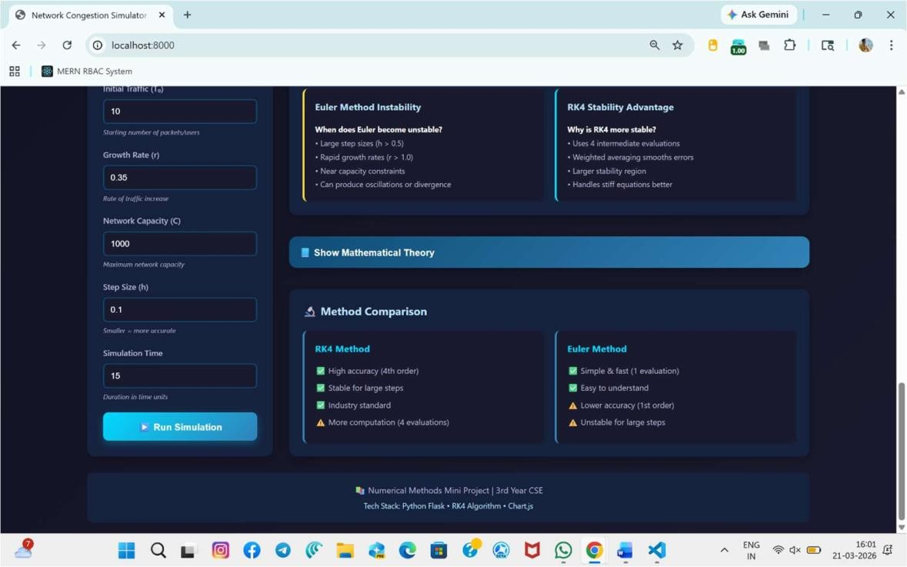

Figure: RK4 and Euler method comparison with features


The system successfully integrates frontend and backend through API communication. When the user runs the simulation, input data is sent to the backend, processed using numerical methods, and the results are returned to the frontend for visualization.

Graphical outputs clearly demonstrate the behavior of network traffic over time. The results show that traffic initially grows rapidly and gradually stabilizes as it approaches the network capacity, which represents congestion. The comparison between RK4 and Euler methods highlights the improved accuracy of RK4, as it produces smoother and more precise results.

The implementation confirms that the system works efficiently and provides accurate simulation of network congestion behavior. The integration of numerical methods with visualization enhances understanding and allows users to analyze different scenarios effectively.

Error Analysis and Mathematical Interpretation:

The results obtained from the implementation of the Network Congestion Simulator were analyzed in terms of numerical accuracy, convergence behavior, and stability of the applied methods. The system is based on solving the logistic differential equation:
𝑑𝑇 = 𝑟𝑇 ( 1 − 𝑇)
𝑑𝑡 𝐶

which represents bounded growth with saturation at network capacity.

The numerical solution obtained using the Runge-Kutta 4th Order Method (RK4) shows high accuracy due to its higher-order approximation. The RK4 method evaluates intermediate slopes at each step, leading to reduced truncation error and improved convergence toward the true solution.

In contrast, the Euler method, being a first-order method, introduces larger truncation errors. This is evident from the deviation between RK4 and Euler results observed in the graphical outputs. The average error between the two methods increases as the step size increases, confirming that Euler method is less accurate for larger step intervals.
The error analysis shows that:

- For smaller step size (h = 0.05), the error is minimal, indicating high accuracy
- For moderate step size (h = 0.1), the error remains acceptable
- For larger step size (h ≥ 0.5), the error increases significantly

This demonstrates the direct relationship between step size and numerical error, where smaller step sizes lead to better approximation of the exact solution.


The stability of the methods was also analyzed. The RK4 method remains stable even for relatively larger step sizes due to its multi-stage evaluation process. On the other hand, the Euler method exhibits instability under large step sizes and higher growth rates, which may lead to divergence or inaccurate results.

From a mathematical perspective, the system exhibits convergence towards the equilibrium point 𝑇 = 𝐶, where the growth rate becomes zero. This confirms that the numerical solution correctly follows the theoretical behavior of the logistic model.

Thus, the error analysis validates that the RK4 method provides a more accurate, stable, and reliable solution compared to the Euler method, making it suitable for modeling network congestion problems.

Validation of Results:

The validation of results is performed to ensure that the numerical solution obtained from the
simulation is consistent with the theoretical behavior of the mathematical model.

The given differential equation:
𝑑𝑇 𝑇
= 𝑟𝑇 ( 1 − )
𝑑𝑡 𝐶

represents a logistic growth model, which has a known analytical behavior. According to theory, the solution should exhibit the following characteristics:

- Initial exponential growth when 𝑇 ≪ 𝐶
- Gradual reduction in growth rate as 𝑇approaches 𝐶
- Saturation at 𝑇 = 𝐶, where growth becomes zero

The simulation results obtained using the Runge-Kutta 4th Order Method (RK4) closely follow this expected behavior. The graphical outputs clearly show an S-shaped (sigmoid) curve, which is a characteristic feature of logistic growth. This confirms that the numerical implementation is correct.

Further validation is performed by comparing the RK4 method with the Euler method. It is observed that both methods follow the same general trend, but RK4 produces smoother and more accurate results. The deviation between the two methods is within acceptable limits for smaller step sizes, which validates the correctness of the implementation.

The equilibrium point of the system is observed at 𝑇 = 𝐶, where the rate of change becomes zero:
𝑑𝑇 = 0 ⇒ 𝑇 = 𝐶
𝑑𝑡


The simulation results confirm that the traffic stabilizes near the network capacity, which matches the theoretical prediction.
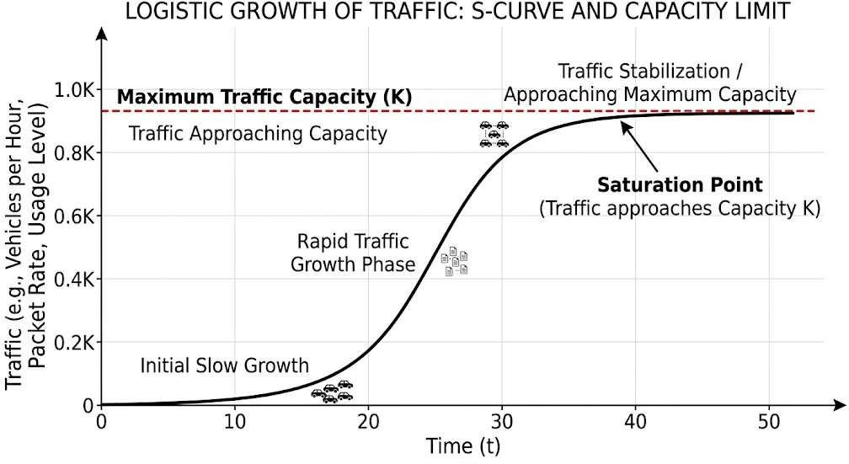

Figure: Logistic growth curve showing traffic saturation behavior
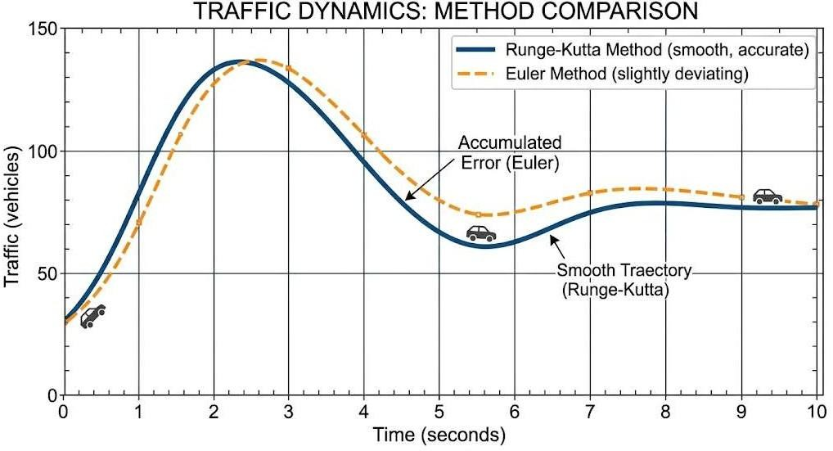

Figure: Comparison between RK4 and Euler methods accuracy

Additionally, the effect of step size on accuracy further validates the model. Smaller step sizes produce results closer to the expected theoretical solution, while larger step sizes introduce noticeable deviation. This aligns with standard numerical analysis principles.

The stability analysis also supports validation. The RK4 method remains stable under different parameter values, whereas the Euler method shows instability for larger step sizes. This behavior is consistent with theoretical expectations of first-order and higher-order numerical methods.

Thus, the simulation results are validated both qualitatively (through graphical behavior) and quantitatively (through error comparison), confirming that the implemented model is mathematically correct and reliable.



CHAPTER – 04 CONCLUSION AND FUTURE WORK

Conclusion

The design and development of the Network Congestion Simulator using the Runge-Kutta Method with a visualization dashboard successfully demonstrate the practical application of numerical methods in analyzing real-world problems. This project integrates mathematical modeling, numerical computation, and software development to simulate network congestion behavior effectively.

The logistic differential equation used in this project provides a realistic representation of traffic growth under capacity constraints. The implementation of the Runge-Kutta 4th Order Method (RK4) ensures high accuracy and stability in solving the differential equation, while the Euler method serves as a comparative approach to highlight differences in numerical precision.

The developed system includes a user-friendly dashboard that allows dynamic input of parameters such as initial traffic, growth rate, network capacity, and simulation time. The graphical outputs clearly illustrate how traffic grows over time and stabilizes as it approaches network capacity, reflecting real-world congestion scenarios.

The results obtained from the simulation confirm that RK4 produces more accurate and stable solutions compared to the Euler method. The error analysis and step size sensitivity further validate the importance of selecting appropriate numerical methods and parameters for reliable results.

Overall, the project enhances understanding of numerical methods, differential equations, and their applications in network systems. It successfully bridges the gap between theoretical concepts and practical implementation, making it a valuable academic and technical contribution.

Future Work

Although the Network Congestion Simulator has been successfully developed using the Runge-Kutta Method with a visualization dashboard, there are several potential enhancements and improvements that can be implemented in the future to increase the functionality, accuracy, and applicability of the system.

One of the major improvements can be the integration of real-time network data into the simulation. Currently, the model is based on a mathematical approximation using a logistic


differential equation. In future, the system can be extended to incorporate real-time traffic data collected from network monitoring tools. This would allow the simulator to reflect actual network conditions and provide more realistic analysis.

Another important enhancement would be the implementation of advanced numerical methods. While the Runge-Kutta 4th Order Method provides high accuracy, other methods such as adaptive step-size Runge-Kutta, predictor-corrector methods, or implicit methods can be introduced to improve efficiency and handle more complex systems. These methods can further reduce numerical error and improve computational performance.

The current system assumes constant parameters such as growth rate and network capacity. In future, the model can be extended to support dynamic parameters, where growth rate and capacity vary with time. This would better represent real-world scenarios where network conditions change dynamically due to varying user demand and bandwidth availability.

Another significant improvement can be the expansion of the mathematical model. Instead of using a single differential equation, multi-variable systems or partial differential equations can be incorporated to simulate more complex network environments. This would allow modeling of multiple nodes, traffic routing, and congestion control mechanisms.

The visualization dashboard can also be enhanced further. Advanced data visualization techniques such as interactive graphs, real-time updates, and 3D visualization can be implemented to improve user experience. Features like zooming, filtering, and dynamic parameter adjustment can make the system more interactive and informative.

In terms of system architecture, the project can be upgraded to a scalable web application. Integration with cloud platforms such as AWS or Google Cloud can allow deployment of the simulator as an online service. This would enable multiple users to access the system simultaneously and perform simulations remotely.

Another future enhancement is the incorporation of machine learning techniques. Predictive models can be developed to forecast network congestion based on historical data. This would transform the system from a simulation tool into a predictive analytics system, which can be useful for network planning and optimization.

Security and performance optimization can also be improved in future versions. Implementing authentication mechanisms, optimizing backend computations, and improving response time can make the system more robust and production-ready.

Additionally, the project can be extended for educational purposes by adding tutorial modules, step-by-step explanations, and interactive learning components. This would make the system useful as a teaching tool for understanding numerical methods and network behavior.

Finally, mobile compatibility and cross-platform support can be introduced to make the application accessible on different devices. This would enhance usability and allow users to perform simulations conveniently from anywhere.



REFERENCES
- E. Kreyszig, Advanced Engineering Mathematics, 10th ed., Wiley, 2011.
- S. C. Chapra and R. P. Canale, Numerical Methods for Engineers, 7th ed., McGraw-Hill, 2015.
- R. L. Burden and J. D. Faires, Numerical Analysis, 10th ed., Cengage Learning, 2016.
- K. E. Atkinson, An Introduction to Numerical Analysis, 2nd ed., Wiley, 1989.
- J. D. Lambert, Numerical Methods for Ordinary Differential Systems, Wiley, 1991.
- G. D. Smith, Numerical Solution of Partial Differential Equations, Oxford University Press, 1985.
- W. H. Press et al., Numerical Recipes in C, Cambridge University Press, 2007.
- J. C. Butcher, Numerical Methods for Ordinary Differential Equations, 2nd ed., Wiley, 2008.
- MIT OpenCourseWare, Numerical Methods for Differential Equations, 2024. Available: https://ocw.mit.edu
- NPTEL, Numerical Methods and Programming, IIT Lectures, 2024. Available: https://nptel.ac.in
- Khan Academy, Differential Equations Course, 2024. Available:
https://www.khanacademy.org
- MathWorks, Runge-Kutta Methods Documentation, 2024. Available:
https://www.mathworks.com
- Wolfram MathWorld, Runge-Kutta Method, 2024. Available: https://mathworld.wolfram.com
- Wolfram MathWorld, Logistic Equation, 2024. Available: https://mathworld.wolfram.com
- GeeksforGeeks, Runge-Kutta Method Implementation, 2024. Available: https://www.geeksforgeeks.org
- GeeksforGeeks, Euler Method for Differential Equations, 2024. Available: https://www.geeksforgeeks.org

- Python Software https://docs.python.org
Foundation, Python Documentation, 2024. Available:

- Flask Documentation, Flask Web Framework, 2024. Available:
https://flask.palletsprojects.com
- NumPy Documentation, Numerical Computing in Python, 2024. Available: https://numpy.org
- Matplotlib Documentation, Data Visualization in Python, 2024. Available: https://matplotlib.org
- Chart.js Documentation, JavaScript Charting Library, 2024. Available: https://www.chartjs.org
- MDN Web Docs, HTML: HyperText Markup Language, 2024. Available: https://developer.mozilla.org
- MDN Web Docs, CSS: Cascading Style Sheets, 2024. Available: https://developer.mozilla.org
- MDN Web Docs, JavaScript Guide, 2024. Available: https://developer.mozilla.org
- W3Schools, HTML, CSS, and JavaScript Tutorials, 2024. Available:
https://www.w3schools.com
- T. H. Cormen et al., Introduction to Algorithms, MIT Press, 2009.



APPENDIX
The appendix section contains supporting materials and additional technical details related to the implementation of the Network Congestion Simulator. These details provide supplementary information about the tools, commands, and system structure used during the development of the project.

Appendix A: Key Commands Used During Implementation
Below are the important commands used for setting up and running the project:

# Create virtual environment python -m venv venv
# Activate virtual environment venv\Scripts\activate
# Install required packages
pip install flask flask-cors numpy

# Run backend server python app.py

# Run frontend server python -m http.server 8000

Appendix B: System Configuration

- Backend Technology: Python (Flask)
- Frontend Technology: HTML, CSS, JavaScript
- Numerical Methods: Runge-Kutta 4th Order Method, Euler Method
- Visualization Tool: Chart.js
- Development Environment: Visual Studio Code

Appendix C: Project File Structure

Network_Congestion_Simulator/
│
├── backend/
│ ├── app.py
│ ├── rk4.py
│
├── frontend/
│ ├── index.html
│ ├── style.css
│ ├── script.js
│
└── README.md



Appendix D: Sample Input Parameters

Example values used during simulation:

- Initial Traffic (T0): 10
- Growth Rate (r): 0.35
- Network Capacity (C): 1000
- Step Size (h): 0.1
- Simulation Time: 10

Appendix E: Output Description

The output of the system includes:

- Graph showing traffic growth over time
- Comparison between RK4 and Euler methods
- Congestion status (Low, Medium, High)
- Error analysis and step size sensitivity






