*  This command will show all the necessary command needed.
* This hello World directory is already present in the hub repository (online), simply we have to pull and we have to run it. This command will download hello-word directory to your pc(if not available), and run it , basically this hello-world is the docker image and we are fetching this image and by running it we means to say we are making container of it.

***Build, Run and Push in Docker***

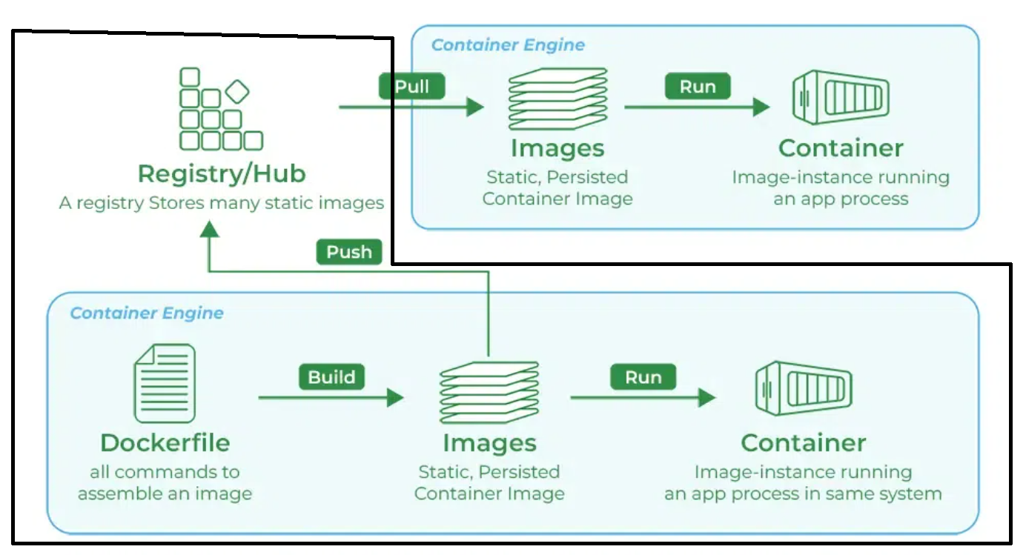

1. **Building docker image**: Before building docker image we have to make a dockerfile and that app or website that we want to convert into image,
   1. First step is make one requirement.txt file in that we have to mention all the python library that we are using in our app/website. 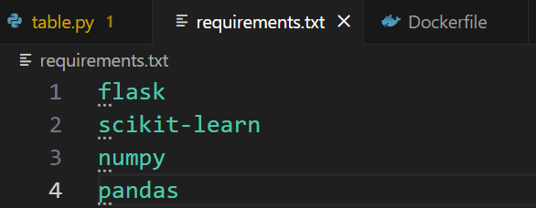
   2. Now the second step is make the docker file, so in dockerfile we have to give/write few attributes such as base image, directory, copy files, run, port and commands. I will tell you in short what are all these: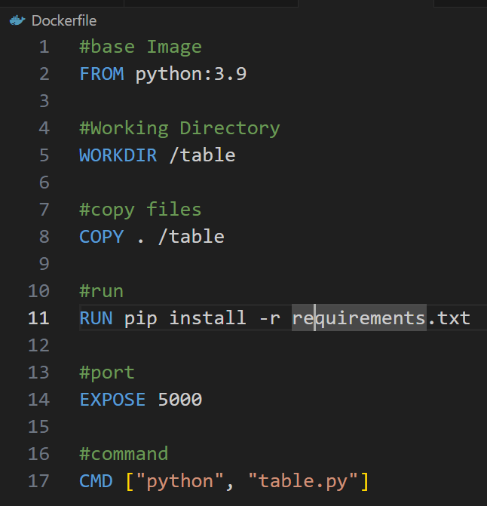
      1. In base image we have to give the language that we are using and along with that image one small linux os will also be downloaded.
      2. In working directory we have to give the path name to our docker image, basically all the layers of image will be stored inside that name.
      3. Copy commands takes two attributes one is how my data we have to copy (. Means all) and another attribute is where we have to copy (i.e. which directory).
      4. Run commands will download all the dependencies that is mentioned in the requirement.txt file.
      5. Port number we have to mention separately, some by default port is for FLASK : port number is 5000.
      6. And in command we have to mention the language and of which file we are making the docker image.
   3.  After making the dockerfile we have to run the build command, -t is tag, . means for all.
   4. By running this command one docker image will be generated and you can verify it in docker desktop application> docker image section.
2. **Running a Container:** Now to run that generated docker image file (basically making container), command is , here –p is port addressing, 8000 is our local port address of machine and 5000 is the docker hub port address and : means we are making it equivalent ,
3. **Pushing Image to Docker hub:** For pushing the docker image to the docker hub website 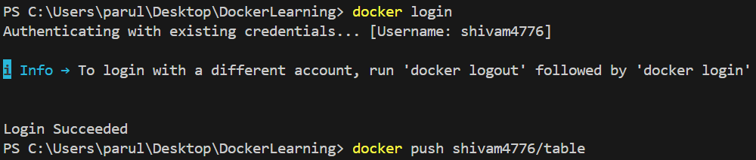this is the command, like first we have to login into the docker account, “docker login” command will simply logged u in to the docker account, secondly use the simple push command to push the docker image to the docker hub ( here shivam4776 is my account username).