FINAL PROJECT REPORT
EasyRTG
An Intelligent No-Code Platform for Training Robots
Shivam Chavan
Student ID: 3053682
Supervisor: Shraddha Naik
MSc in Artificial Intelligence and Computer Science
School of Computer Science
University of Birmingham Dubai
August 2026

Declaration and Honour Code
I certify that the work presented in this report is my own. The concept, architecture, feature set, design decisions, experimental work, interpretation of results and conclusions describe the EasyRTG system contained in the GitLab repository submitted with this document. Parts of the implementation, particularly the Flutter desktop frontend, were produced with generative-AI assistance from specifications that I defined. The following page describes this involvement by component. Ideas, software and published findings from other authors are acknowledged through numbered citations and corresponding bibliography entries.
I understand that the submission must comply with the University's academic-integrity requirements, including the prescribed honour-code wording and disclosure of supporting tools. My use of generative AI is declared on the following page.
Name: Shivam Chavan
Student ID: 3053682

Use of Generative AI
Generative AI, principally Anthropic's Claude, supported implementation, debugging, review and language work during this project. The platform concept, backend architecture, feature set and agent-layer design are my work. Its involvement differed across components and is described below.
- Desktop user interface. I specified each screen, its state flow and intended behaviour. Claude generated most of the Dart code from these specifications. I reviewed, executed and corrected it, and the submitted interface contains substantial revisions. The frontend is therefore largely AI-generated under my direction.
- Backend and agent implementation. I designed the two simulation lanes, morphology layer, expression compiler and audit, assistant toolbox and approval gates described in Chapter 4. The assistant drafted parts of the implementation beyond boilerplate and docstrings. I defined the required structure, interfaces and behaviour and verified the result against the running system and test suite.
- Debugging. The assistant was used to interpret stack traces and identify candidate causes when simulator configurations failed or policies converged on unintended behaviour. Every retained fix was verified against the running system.
- Implementation options. The assistant compared approaches that I was considering, including whether Isaac Sim should be embedded or launched as a subprocess. I made the final decisions and developed the reasoning recorded in Chapter 5.
- Language and documentation. The assistant was used to draft docstrings, improve wording and support preparation of this report. The argument, technical claims and final interpretation remain my responsibility.
The assistant did not determine the objectives or conduct the evaluation. I configured, launched and interpreted every experiment in Chapter 6; every reported value is derived from recorded telemetry. Suggestions were checked against source code, repository history, telemetry or cited literature, and observed system behaviour took precedence. Responsibility for the submitted software and technical content is mine.

Acknowledgements
I am sincerely grateful to my supervisor, Shraddha Naik, for her patience, guidance and constructive feedback throughout this project. She encouraged me to examine the relevant literature more carefully and to connect the implementation to established research rather than treating it only as a software project. Her broader knowledge of software development, academic writing and the qualities expected of a complete application helped me improve both the system and this report.
I would also like to thank the School of Computer Science and its teaching staff for the knowledge, guidance and learning opportunities they provided throughout my degree. The principles and skills developed during the programme formed an important foundation for this project.
Finally, I am grateful to my friends and colleagues for their encouragement during the less visible and more difficult parts of the project. Their support helped me persist through unsuccessful simulator configurations, policies that did not learn the intended behaviour and long-running experiments. These setbacks ultimately contributed to several of the design decisions documented in this report.

Abstract
Training a robot with reinforcement learning requires the integration of a physics simulator, an environment, a reward function, a learning algorithm, experiment monitoring and policy evaluation. Although existing frameworks provide these capabilities, configuring them normally requires simulator-specific knowledge and programming experience. EasyRTG addresses this barrier through a no-code desktop workflow in which a user imports a robot in Universal Robot Description Format (URDF), describes the required behaviour, reviews an assistant-generated configuration and reward, validates the reward, trains a policy and evaluates the result.
The system combines a Flutter desktop interface, a FastAPI orchestration backend, PyBullet inspection and reward testing, and NVIDIA Isaac Sim training and playback. EasyRTG derives control-relevant morphology directly from the URDF and represents rewards as audited mathematical expressions over a shared state vocabulary. This removes fixed joint-name rules and predefined reward terms, allowing one application pipeline to support quadruped and humanoid robots.
The platform was evaluated using 40 Isaac run directories covering the Unitree A1, ANYmal, Unitree Go1 and NASA Valkyrie under PPO, SAC and TD3. Thirty-four runs contained usable reward telemetry and six failed before producing telemetry. Twelve analysable runs reached at least 95% of the 1,000-step episode limit, while peak throughput reached 32,056.8 environment steps per second on a single RTX 5000. On Go1, PPO, SAC and TD3 reached 96.3%, 100% and 99.1% of the episode limit respectively. On Valkyrie, SAC reached 82.1%, while PPO and TD3 remained near 20%, indicating that learner choice affected the more difficult humanoid task.
The evaluation also shows that a high reward does not necessarily represent the intended behaviour: on the galloping task, TD3 produced a fast trot without a true flight phase. EasyRTG demonstrates a working integration of language-assisted configuration, general robot inspection and accelerated learning, but does not yet establish a measured reduction in user effort or transfer to physical hardware.

Table of Contents
1 Introduction 1
1.1 Project motivation 1
1.2 Problem statement 1
1.3 Aim and objectives 2
1.4 Research questions 2
1.5 Scope and contributions 3
1.6 Organisation of this report 3
2 Background and Literature Survey 4
2.1 Reinforcement learning for robot control 4
2.2 The three learners: PPO, SAC and TD3 4
2.3 From single environments to massively parallel simulation 5
2.4 Isaac Gym and the GPU-native turn 5
2.5 Orbit and Isaac Lab 5
2.6 Learning to walk in minutes 5
2.7 Reward design as the real bottleneck 6
2.8 Eureka: language models writing rewards 6
2.9 DrEureka: pushing language-assisted design toward hardware 6
2.10 General-purpose simulators: Gazebo and Unity ML-Agents 7
2.11 Unity RL Playground: the closest accessibility claim 7
2.12 Where EasyRTG sits 7
3 Research Methodology and Requirements 8
3.1 Design-science approach 8
3.2 Evidence sources 8
3.3 Functional and non-functional requirements 9
3.4 Experimental protocol and metrics 9
3.5 Software verification 10
4 System Design and Architecture 10
4.1 Architectural overview 10
4.2 URDF inspection and morphology 11
4.3 Expression rewards and the shared state vocabulary 11
4.4 Assistant and human oversight 12
4.5 Training, monitoring and evaluation 13
5 Implementation and Iterative Development 14
5.1 From proposal to working system 14
5.2 Milestone history 14
5.3 Key engineering decisions 16
5.4 Security and reliability improvements 16
6 Experiments, Results and Findings 16
6.1 Run coverage and failure history 16
6.2 Fleet-level results 17
6.3 What the reward actually paid for 18
6.4 Throughput and the GPU lane 19
6.5 How long learning took 19
6.6 Go1: three learners, one solved robot 20
6.7 Go1 walking and galloping 20
6.8 Valkyrie: a controlled algorithm comparison 21
6.9 Functional verification 23
7 Discussion 23
7.1 Answering the research questions 23
7.2 What the project learned about abstraction 24
7.3 Limitations and threats to validity 25
7.4 Practical and academic significance 25
8 Conclusion and Future Work 26
8.1 Conclusion 26
8.2 Future work 26
Bibliography 27
Appendix A GitLab Repository and Running the Project 28
A.1 Repository 28
A.2 Minimum setup 29
A.3 Verification commands 29
Appendix B Experiment Coverage 29
Appendix C Supplementary Figures 30
Appendix D Full Run Index 32
Appendix E Compute Environment and Reproduction Notes 34

List of Figures
Figure 1. The EasyRTG workflow, from robot import to policy evaluation. 1
Figure 2. EasyRTG architecture, and the separation between the inspection and GPU training lanes. 11
Figure 3. The EasyRTG desktop assistant, showing a generated training configuration and the changes offered for review. 13
Figure 4. Major implementation and experiment milestones, reconstructed from Git dates and the run archive. 14
Figure 5. Episode survival for the best observed run in each robot and algorithm pairing. 17
Figure 6. Term-by-term decomposition of the reward at the peak-reward step of the best Go1 run. 18
Figure 7. Peak simulation throughput against the number of parallel environments, coloured by robot. 19
Figure 8. Reward for the best Go1 run under each learner, at 4,096 environments with the same reward expression. 20
Figure 9. The Unitree Go1 during recorded policy evaluation. 21
Figure 10. Reward for Valkyrie under SAC and TD3, same reward expression and same 40M-step budget. 22
Figure 11. Episode length reveals that SAC's advantage came from staying upright, not from scoring faster. 22
Figure 12. The NASA Valkyrie during recorded SAC policy evaluation. 23
Figure 13. Best mean episode length for every analysable Isaac run, in chronological order. 30
Figure 14. Reward against environment steps for the best run of each robot family. 31
Figure 15. Environment steps before each run's smoothed mean episode length first holds above 900. 32
Figure 16. Episode length for the best Go1 run under each learner. 32

List of Tables
Table 1. Research questions used to organise the implementation and evaluation. 3
Table 2. Algorithm rationale and its observed role in EasyRTG. 4
Table 3. Positioning EasyRTG against representative robot-simulation and learning platforms. 8
Table 4. Traceable project requirements. 9
Table 5. Engineering decisions that emerged through iteration. 16
Table 6. Best observed run for each robot and algorithm pairing. 17
Table 7. Coverage of the 34 analysable Isaac runs by robot and algorithm. 29
Table 8. All 34 analysable Isaac runs, 13 July to 18 August 2026. 33
Table 9. Compute and software environment used for all experiments. 34

Abbreviations
Term | Meaning
API | Application Programming Interface
AST | Abstract Syntax Tree
DRL | Deep Reinforcement Learning
GPU | Graphics Processing Unit
LLM | Large Language Model
PPO | Proximal Policy Optimisation
REST | Representational State Transfer
RL | Reinforcement Learning
SAC | Soft Actor-Critic
TD3 | Twin Delayed Deep Deterministic Policy Gradient
UI | User Interface
URDF | Universal Robot Description Format
USD | Universal Scene Description

1 Introduction

1.1 Project motivation
Reinforcement learning is commonly described as a cycle in which an agent observes the state of an environment, selects an action and receives a reward [1]. Applying this cycle to robot control requires considerably more supporting work. The user must configure a simulator, interpret the robot model, define observations and actions, design a reward function, select training parameters, monitor the experiment and evaluate the resulting policy.
Mature reinforcement-learning libraries reduce the amount of algorithm code that must be written, but they generally assume that the user can already construct a valid environment [2]. This requirement creates a barrier for newcomers because each part of the workflow depends on knowledge of the others. A reward cannot be designed correctly without understanding the available state, and the state cannot be interpreted correctly without understanding the robot and simulator.
The motivation for EasyRTG arose from an earlier robotics project in which the robot learned the intended behaviour, but only after substantial manual integration of the simulator, environment code, reward function, training scripts and visualisation. The final demonstration did not represent this underlying effort. EasyRTG was therefore developed to make environment creation and experiment management part of the application itself rather than an undocumented prerequisite.
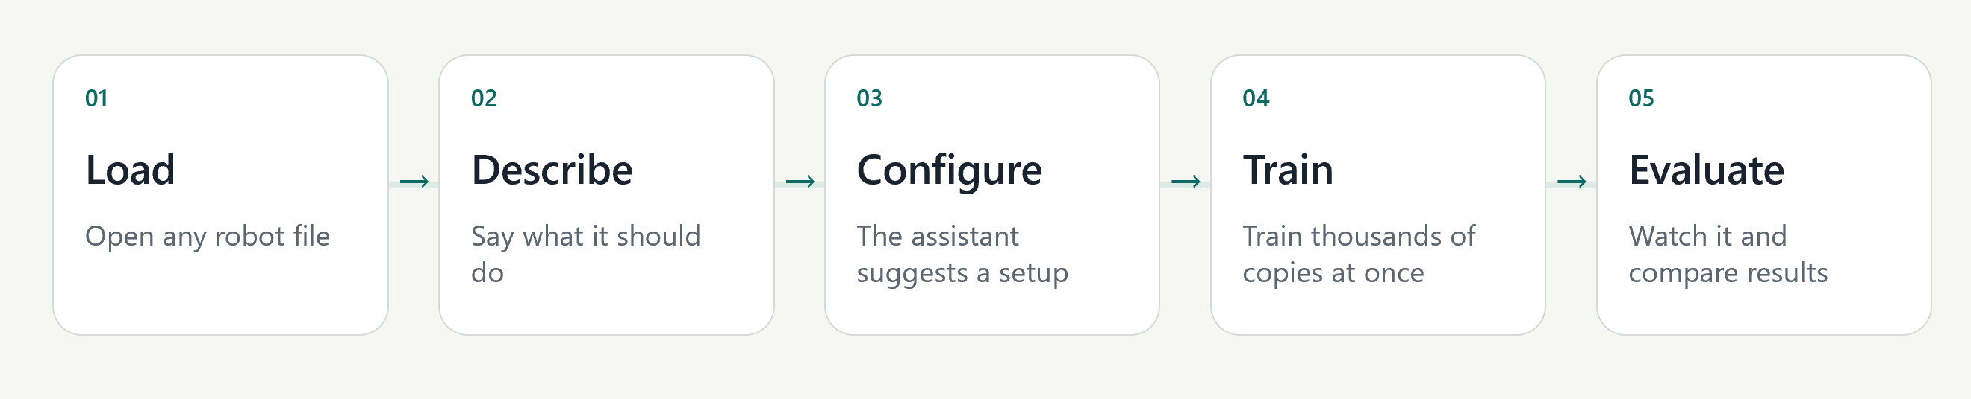
Figure 1. The EasyRTG workflow, from robot import to policy evaluation.

1.2 Problem statement
The problem addressed by this project is the fragmented expertise required to convert a robot description and a behavioural objective into a valid reinforcement-learning experiment. Existing frameworks provide capable simulation and learning tools, but expose them through source code, configuration files and simulator-specific conventions. A URDF describes the structure of a robot, but does not specify which joints should be controlled, which contacts are permitted, how the robot should be initialised or how the desired behaviour should be rewarded.
Consequently, a user must translate both the robot structure and the intended behaviour into an environment that is technically valid and produces meaningful evidence. This project investigates whether that process can be organised as an integrated desktop workflow that remains inspectable and repeatable while reducing the need for simulator-specific programming.

1.3 Aim and objectives
The aim of this project was to develop a desktop platform that takes a user from a URDF robot and a natural-language objective to a trained and evaluated policy without requiring simulator or reinforcement-learning code. The objectives were to:
- Provide a single desktop workflow for robot inspection, configuration, monitoring, training and evaluation.
- Derive the morphology required for control directly from the URDF without relying on robot-specific joint-name rules.
- Allow an LLM assistant to propose reward expressions and configuration changes while keeping consequential actions reviewable and subject to user approval.
- Use GPU-parallel simulation to make repeated robot-learning experiments practical on a single workstation.
- Evaluate the platform across multiple robot bodies, tasks and learning algorithms using saved telemetry and recorded behaviour.

1.4 Research questions
The implementation and evaluation were guided by the following four research questions.
Table 1. Research questions used to organise the implementation and evaluation.
ID | Research question
RQ1 | How can a no-code interface translate a URDF and a natural-language goal into a valid RL configuration while retaining human oversight?
RQ2 | To what extent can morphology-derived configuration and expression rewards support different robot bodies without robot-specific application logic?
RQ3 | How do PPO, SAC and TD3 differ across quadruped and humanoid locomotion experiments?
RQ4 | How do parallel environment count and robot complexity affect GPU simulation throughput?

1.5 Scope and contributions
EasyRTG is a single-user desktop application for simulated robots described in URDF. Its contributions are an integrated workflow, morphology-derived configuration, expression-based rewards, configuration auditing, controlled assistant tool use and retained run provenance. The project does not propose a new reinforcement-learning algorithm.
The implemented scope excludes physical deployment, terrain curricula, camera observations, ROS integration and multi-agent learning. The evaluation therefore provides evidence that the platform can configure and train several simulated legged robots. It does not provide evidence of transfer to physical hardware or establish that the workflow is accessible to all users, which would require a separate user study.

1.6 Organisation of this report
Chapter 2 reviews the reinforcement-learning algorithms, GPU-native simulation methods, reward-design research and related accessibility platforms on which this work builds. Chapter 3 describes the design-science methodology, evidence sources, requirements and experimental protocol. Chapter 4 presents the system architecture and its main technical mechanisms, while Chapter 5 explains the implementation and iterative development process. Chapter 6 reports the experiments and results from the run archive. Chapter 7 answers the research questions and discusses the limitations of the study. Chapter 8 presents the conclusion and future work.

2 Background and Literature Survey

2.1 Reinforcement learning for robot control
In reinforcement learning, a policy selects actions from observations and is improved using rewards collected through interaction with an environment [1]. This formulation is suitable for robotics because the desired behaviour can be specified without providing a labelled action for every possible state. However, continuous action spaces, contact dynamics and long training horizons increase both learning instability and the cost of reward-design errors [2]. Robot policies are therefore normally trained in simulation before they are considered for physical deployment. All experiments in this report were conducted in simulation.

2.2 The three learners: PPO, SAC and TD3
Three algorithms were selected for the evaluation. Proximal Policy Optimisation (PPO) is an on-policy method that limits destructive policy updates through a clipped surrogate objective [3]. Its simplicity and reliable implementations have made it a common baseline for locomotion. Soft Actor-Critic (SAC) is an off-policy method that maximises expected return together with policy entropy [4], thereby maintaining exploration in continuous-control tasks. Twin Delayed Deep Deterministic Policy Gradient (TD3) addresses value overestimation through twin critics, delayed policy updates and target-policy smoothing [5].
EasyRTG initially supported PPO only. SAC and TD3 were added after the pipeline had demonstrated that a robot could learn, allowing the evaluation to examine whether different learners produced different outcomes under the same task configuration.
Table 2. Algorithm rationale and its observed role in EasyRTG.
Algorithm | Learning style | Reason for inclusion | Observed project role
PPO | On-policy, stochastic | Common locomotion baseline; stable implementation | Strong quadruped results; weak Valkyrie survival
SAC | Off-policy, maximum entropy | Exploration and sample reuse in continuous control | Best Go1 and Valkyrie policies
TD3 | Off-policy, deterministic | Tests whether twin critics reduce overestimation | Strong Go1 result; Valkyrie later diverged

2.3 From single environments to massively parallel simulation
Gym standardised the interface between an agent and an environment [6], while Gymnasium and Stable-Baselines3 provided maintained APIs and implementations on which the first EasyRTG CPU training lane was built [7, 8]. PyBullet provided a lightweight method for loading URDF models, inspecting joints and validating state calculations [9]. These tools were suitable for checking individual robot instances, but could not provide the volume of experience required by the final locomotion experiments. This limitation motivated the GPU training architecture described in Chapter 4.

2.4 Isaac Gym and the GPU-native turn
Makoviychuk et al. demonstrated that physics simulation and policy learning can remain on the GPU, removing the CPU transfer bottleneck and increasing throughput by orders of magnitude [10]. For EasyRTG, this approach enabled thousands of robot environments to run in parallel rather than one environment at a few hundred steps per second. The resulting throughput made repeated locomotion experiments feasible on a single workstation; the measured performance is reported in Section 6.4.

2.5 Orbit and Isaac Lab
Mittal et al. introduced Orbit, a modular framework for robot-learning environments based on Isaac Sim that was later developed into Isaac Lab [11]. Orbit demonstrates the structure that a well-designed environment framework can provide, but its Python environment definitions are intended for developers. EasyRTG uses Isaac Lab as its training substrate [25] while placing its configuration behind the desktop workflow. The underlying capability is retained without requiring the user to author an Isaac Lab environment directly.

2.6 Learning to walk in minutes
Rudin et al. trained thousands of simulated ANYmal robots to walk within minutes on a single GPU [12]. Their result established an important performance reference and motivated the initial use of ANYmal in this project. However, the reported speed relied on an environment, reward and curriculum designed specifically for that robot. EasyRTG required ten ANYmal attempts before one run reached 95% of the episode limit (Appendix D). This difference illustrates the current cost of supporting a general no-code workflow rather than a specialist robot implementation.

2.7 Reward design as the real bottleneck
A reward is an optimisation target rather than a neutral description of a task. An agent may therefore exploit any difference between the intended behaviour and the quantity that is measured. Potential-based shaping preserves an optimal policy under specific conditions [13], but practical locomotion rewards combine objectives and penalties for which this guarantee does not generally hold. Henderson et al. and Engstrom et al. further show that implementation details and evaluation choices can materially affect deep-reinforcement-learning results [14, 15].
This literature supports treating reward authoring as a correctness problem, not only as a configuration task. EasyRTG therefore compiles and audits reward expressions before GPU training begins. The evaluation also reports episode length and behavioural measures alongside reward. Section 6.7 provides a direct example of the underlying risk: a policy achieved a high galloping reward without performing a true gallop.

2.8 Eureka: language models writing rewards
Ma et al. demonstrated through Eureka that a large language model can generate reward code and refine it using training feedback, achieving human-competitive reward design across several tasks [16]. Eureka is the closest published precedent for the EasyRTG assistant, but the two systems make different safety trade-offs. Eureka generates executable reward code and searches over it evolutionarily. EasyRTG generates expressions over an approved state vocabulary; these expressions are compiled through an AST whitelist and audited on synthetic state ranges before they can be saved. EasyRTG therefore accepts less expressive freedom in exchange for inspectability and controlled tool use.

2.9 DrEureka: pushing language-assisted design toward hardware
DrEureka extended language-assisted reward design towards sim-to-real transfer by using a language model to generate both reward and domain-randomisation configurations [17]. This work also identifies an important boundary of EasyRTG. The present system stops at a recorded policy in simulation and does not implement domain randomisation or hardware deployment. These capabilities are therefore included in the future-work requirements in Section 8.2.

2.10 General-purpose simulators: Gazebo and Unity ML-Agents
Gazebo provides a general robot simulator with programmatic interfaces and extensive ROS integration [18], while Unity ML-Agents turns game-engine scenes into learning environments [19]. Gazebo offers broad robotics support but requires substantial setup. Unity ML-Agents provides flexible visual environments but requires engine-specific authoring. Both platforms are more capable than EasyRTG within their intended domains; however, the path from a robot model to a trained policy still requires code and framework-specific knowledge.

2.11 Unity RL Playground: the closest accessibility claim
The Unity RL Playground presented by Ye et al. is the closest published system to the accessibility objective of EasyRTG, providing one-click locomotion training for imported mobile robots [20]. EasyRTG differs by exposing a shared state vocabulary for reward authoring, performing a reward audit before training, and retaining a run archive for later examination. The published description of Unity RL Playground does not report reward authoring at the same level of detail, although its stated scope is narrower.

2.12 Where EasyRTG sits
The literature provides established learning algorithms, high-throughput simulators and methods for language-assisted reward generation. The remaining accessibility problem is their integration into a coherent workflow. EasyRTG addresses this gap by making robot structure, reward semantics, training controls and supporting evidence visible within one application. Its contribution is therefore the design and evaluation of this integration, including an account of where the abstraction succeeds and where expert judgement remains necessary.
Table 3. Positioning EasyRTG against representative robot-simulation and learning platforms.
Platform | Robot import | Training interface | Reward authoring | Primary trade-off
Gazebo/ROS | Rich model ecosystem | Programmatic | Controller/environment code | Broad robotics integration; substantial setup
Unity ML-Agents | Scene/component based | Unity + Python | Agent scripts and trainer config | Flexible visuals; engine-specific authoring
Isaac Lab | USD/URDF workflows | Python/configuration | Environment/reward code | High throughput; expert-oriented
Unity RL Playground | Imported mobile robots | One-click task workflow | Task framework | Closest accessibility goal; narrower reported scope
EasyRTG | URDF with inferred morphology | Desktop no-code flow | Audited expressions from user or assistant | Accessible integration; currently simulation-only

3 Research Methodology and Requirements

3.1 Design-science approach
A design-science approach was adopted because the research questions concern both the design of an integrated tool and its behaviour when applied [21]. Knowledge was developed by building and evaluating the EasyRTG artefact rather than through observation alone. The process was iterative: a barrier was identified, a mechanism was implemented, its behaviour was evaluated, and the design was refined. This process follows the stages proposed by Peffers et al.: problem identification, definition of objectives, design and development, demonstration, evaluation and communication [22]. Chapter 5 records how these stages were repeated during development.

3.2 Evidence sources
The evaluation used four evidence sources. First, 50 Git commits between 11 June and 14 August 2026 record the sequence of architectural changes. Second, the source code and automated tests establish which functions were implemented. Third, each Isaac run retains its configuration and telemetry, allowing the numerical results in Chapter 6 to be recomputed from the archive. Finally, recorded policy videos provide behavioural evidence that cannot be obtained from reward and episode statistics alone.
One inclusion rule was applied throughout the analysis: timestamped directories containing numeric reward telemetry were included as analysable runs, while directories without telemetry were retained as pre-telemetry failures. This rule explains why the run count in this report is higher than the count presented in the earlier project presentation.

3.3 Functional and non-functional requirements
The implementation was assessed against eight requirements. Each requirement is linked to evidence that can be inspected in the repository.
Table 4. Traceable project requirements.
ID | Requirement | Verification evidence
FR1 | Load and inspect an arbitrary URDF robot | Robot panel, morphology tests, A1/ANYmal/Go1/Valkyrie
FR2 | Create observations, actions, rewards and terminations without editing code | Config panels and expression editor
FR3 | Let an assistant propose and apply configuration through tools | Agent toolbox and confirmation gates
FR4 | Launch and monitor GPU-parallel training | Isaac worker and telemetry charts
FR5 | Replay and compare completed policies | Evaluation worker, videos and run archive
NFR1 | Reject invalid or unsafe reward expressions before launch | Compiler, audit and configuration tests
NFR2 | Keep the desktop responsive during long-running work | Subprocess workers and polling/streaming
NFR3 | Preserve run provenance | Saved config, telemetry, checkpoints and video

3.4 Experimental protocol and metrics
The run archive contains experiments conducted between 13 July and 18 August 2026 on a single RTX 5000. The analysable set contains 34 runs: eight A1 PPO, ten ANYmal PPO, four Go1 PPO, three Go1 SAC, two Go1 TD3, three Valkyrie PPO, three Valkyrie SAC and one Valkyrie TD3. This distribution is unbalanced. The comparisons in Chapter 6 are therefore reported as observed project results rather than as a statistically complete benchmark.
The primary measures were mean episode reward, mean episode length and environment steps per second. Task-specific measures included forward velocity, uprightness, lateral drift and flight phase. Episode length is reported as a fraction of the 1,000-step limit because it indicates whether the robot remained stable for the episode. Fleet summaries select the run with the highest observed reward for each robot-algorithm pairing. This improves readability but introduces best-run selection bias, which is addressed in Section 7.3.

3.5 Software verification
Software verification was performed by running the backend test suite in a new temporary directory with third-party pytest plugin autoloading disabled. The result was 256 passing tests, one skipped test and no failures. The tests cover configuration phases, expression compilation, morphology, contact state, episode timing, Isaac bridge calculations, action authoring, spawn height and smoke behaviour. The Flutter command-line tool did not return in the available environment; consequently, no current claim is made about frontend analysis or test status. This limitation is recorded in Section 7.3.

4 System Design and Architecture

4.1 Architectural overview
The architecture must support thousands of parallel GPU environments while keeping the desktop responsive. EasyRTG separates the user interface from local orchestration to satisfy both requirements. Flutter provides the desktop interface [26]. FastAPI manages application state, exposes REST and streaming endpoints, supervises workers and records project state [27]. The LLM assistant has no privileged access and calls the same bounded tools used by the application. Simulation is divided into a lightweight inspection lane and a GPU training lane, preventing simple checks from consuming a training session.
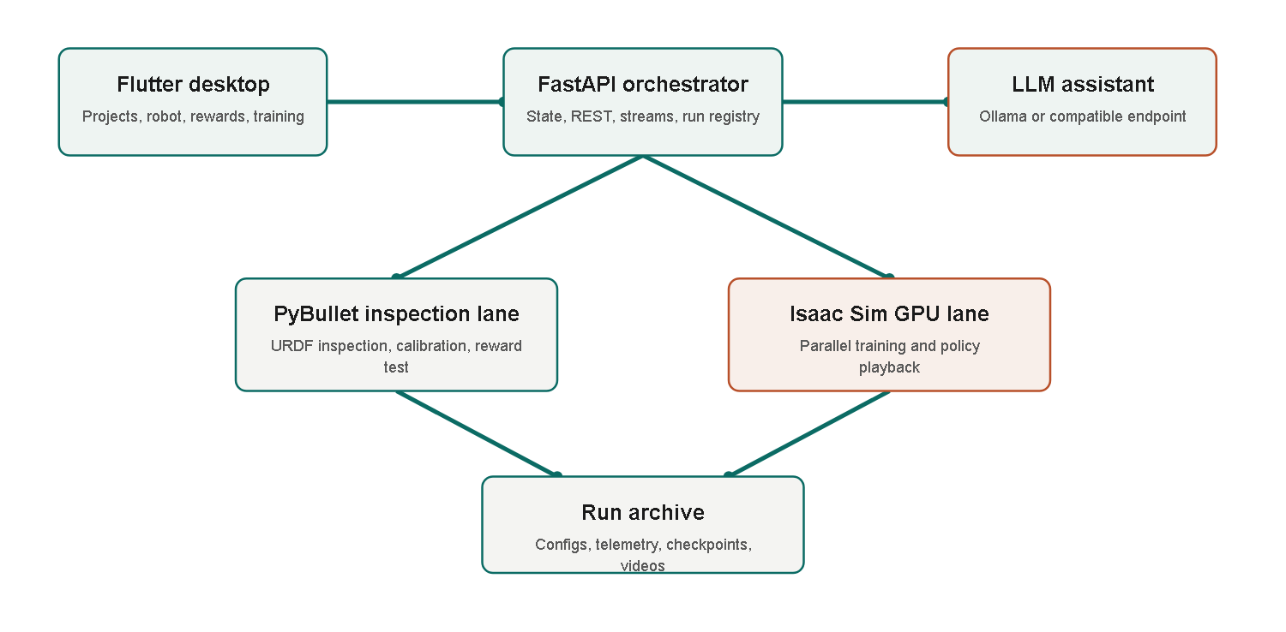
Figure 2. EasyRTG architecture, and the separation between the inspection and GPU training lanes.
The principal mechanisms follow the order of the workflow: the robot structure is inspected, a reward is defined against that structure, and the assistant then supports configuration and execution. This ordering ensures that assistant proposals are grounded in the inspected robot and the available state vocabulary.

4.2 URDF inspection and morphology
The first prototype inferred robot roles from link and joint names such as 'hip', 'foot' and 'ankle'. This approach failed when naming conventions changed. The resulting morphology layer instead treats the URDF as a kinematic tree. It identifies the base link, movable joints, leaf structures, candidate limbs and contact links from connectivity and joint properties. Standing height and spawn height are measured relative to the robot rather than copied from a sample model. Dimensionless signals such as `height_ratio` and `upright` can therefore retain the same meaning for quadruped and humanoid robots.
Morphology inference does not make every URDF automatically trainable. Poor inertial values, unrealistic joint limits and ambiguous contact geometry may still require calibration. Its contribution is narrower: a new robot is configured from structural evidence rather than from naming rules written for a previous model.

4.3 Expression rewards and the shared state vocabulary
After the robot structure has been derived, the required behaviour must be expressed as a reward. An early fixed catalogue allowed users to select only predefined components. Although simple, this approach restricted the range of behaviours and required application changes for every new task. EasyRTG instead represents each reward term as a mathematical expression over a shared state vocabulary, including `forward_velocity`, `upright`, `height_ratio`, `mean(contact)`, `flight_phase` and `episode_progress`. Vector widths are supplied by the morphology layer, so `mean(contact)` has the same interpretation whether the robot has two, four or six contact limbs.
Safety is provided through compilation rather than a restricted catalogue. Expressions are parsed into an abstract syntax tree and accepted only when every node is whitelisted. Attribute access and subscripting are excluded, preventing arbitrary Python execution. Configuration patches compile every enabled expression before saving. A separate audit evaluates reward scale over synthetic state ranges and flags non-finite values, dominant penalties, all-penalty designs and sums that depend on the number of degrees of freedom. These checks cannot guarantee successful learning, but they detect several expensive failure classes before a GPU run begins.

4.4 Assistant and human oversight
The assistant makes expression-based configuration accessible to users who would not write the expressions directly. It can inspect robot details, calibrate a goal, patch a configuration, test a reward, start or stop training and inspect previous runs. Basic requests can be routed to a local Ollama model, while more complex goal interpretation can use an OpenAI-compatible endpoint. The system prompt provides the robot-specific vocabulary and available reward priors.
Tools that change configuration or control runs remain subject to explicit user approval. This design follows human-AI interaction guidance that recommends communicating system capabilities, making changes visible and preserving correction or undo [23]. The approval step introduces friction, but ensures that consequential actions remain reviewable and recoverable.
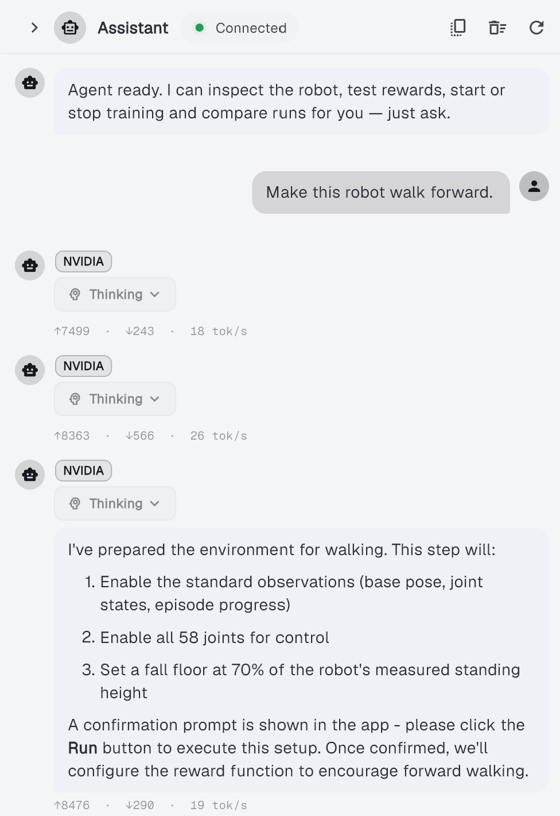
Figure 3. The EasyRTG desktop assistant, showing a generated training configuration and the changes offered for review.

4.5 Training, monitoring and evaluation
After a configuration is approved, Isaac training runs in a separate subprocess under Isaac Sim's Python environment and follows the installed Isaac Lab workflow [25]. The worker writes telemetry to a file, which the backend follows and streams to the Flutter charts. Every run retains its environment configuration, observation and action contracts, checkpoints, log and evaluation video. Live evaluation can launch NVIDIA's WebRTC client, while recorded evaluation runs headlessly and produces an MP4 file that can be replayed inside the desktop application.
Retained evidence is required because a reward curve cannot show whether a humanoid is walking forward, drifting sideways or merely remaining upright. The interpretation of several experiments in Chapter 6 depends on the saved configuration, term-level telemetry and recorded video. Run provenance is therefore part of the evaluation mechanism rather than only a storage feature.

5 Implementation and Iterative Development

5.1 From proposal to working system
The original proposal described a six-week, CPU-first application based on PyBullet, Gymnasium and PPO from Stable-Baselines3. It was intended to run on an average laptop and to use predefined reward components with optional custom Python. The completed system differs from this plan in each area that introduced significant technical risk. Training moved to NVIDIA Isaac Sim on a GPU, custom Python rewards were removed, predefined reward components became audited expressions, and joint-name rules were replaced by morphology inference. The evaluation also expanded from PPO on sample robots to three algorithms across four robot families.
These changes do not indicate that the proposal failed. Instead, the prototype exposed requirements that could not have been established from the initial design alone. The following development history identifies the failures and observations that produced each major revision.

5.2 Milestone history
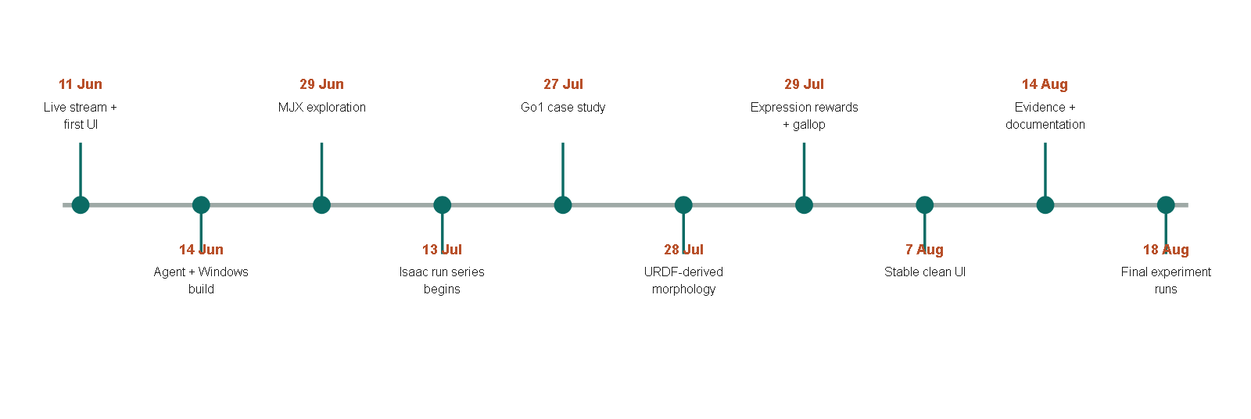
Figure 4. Major implementation and experiment milestones, reconstructed from Git dates and the run archive.
The commits dated 11 June, 'initial 300x300 30fps stream' and 'most of the app is working and is stable', established the first visible prototype. On 14 June, 'most of the agent is working' and 'Make Windows build/run work; stream JPEG sim frames' connected the assistant to a desktop build. Although the commit messages are informal, this phase established one complete user interaction before the underlying components were refined.
The commit 'Add MJX backend, config revisions, and agent routing' on 29 June introduced an alternative high-performance backend. The following day's commit, 'switching to linux as mujoco isnt working good on win', records the operating-system difficulty that prevented this branch from becoming the final training lane. The attempt demonstrated that simulator and operating-system constraints remain present even when hidden by a desktop interface. EasyRTG subsequently adopted Isaac Sim as a separate GPU subprocess, allowing the main application to remain cross-platform while the training lane retained its required platform-specific runtime.
The locomotion case study began on 27 July with 'added unitree go1 robot as casestudy'. The first walking reward produced a low crawling behaviour because this was an easier way to gain forward velocity. The commit 'fix: reject crawling in walk goals' introduced robot-relative height termination to prevent this outcome. On 28 July, 'Derive robot structure from URDF, not joint names; add expression layer' removed a second source of robot-specific assumptions.
The most substantial redesign occurred on 29 July through four commits: 'Evaluate rewards as expressions on the Isaac lane', 'Give the Isaac lane real contact state, so a flight phase is expressible', 'Let the agent author the reward; delete the 4-keyword goal enum', and 'Delete the reward catalogue: expressions are the only reward path'. The final commit that day, 'Record the gallop result; gait is no longer inexpressible', captured the significance of these changes. Galloping cannot be defined by forward velocity alone because it requires a flight phase in which all four feet leave the ground. The task therefore required both Isaac contact state and a reward language capable of expressing that state. Before these mechanisms existed, the behaviour could not be specified by the application.
Later work focused on interface refinement and error handling. The 30 July commit 'Stop expressions written against observation names from being saved' followed an authoring error and added a further validation boundary. Interface refinement continued until the 7 August commit 'most stable and clean ui'. Commits on 14 August reorganised the architecture notes and updated the presentation and README. Additional run directories created on 18 August expanded the analysable dataset beyond the values reported in the earlier presentation.

5.3 Key engineering decisions
Six engineering decisions emerged from this sequence. Table 5 lists each retained decision, the alternative that was attempted and the reason for the final choice.
Table 5. Engineering decisions that emerged through iteration.
Decision | Alternative encountered | Reason retained
Two simulation lanes | Use PyBullet for everything | Fast inspection stays lightweight; Isaac provides training throughput
Expression rewards | Fixed catalogue or arbitrary Python | More behaviours than a catalogue; safer and more portable than exec
URDF-derived morphology | Joint-name heuristics | Supports unfamiliar naming and robot-relative measurements
Subprocess Isaac worker | Embed Isaac in FastAPI | Isaac uses its own Python and runtime, and can fail without taking the UI down
Human approval gates | Fully autonomous tool execution | Makes consequential changes visible and recoverable
Saved run directories | Ephemeral charts | Enables later recomputation, comparison and failure diagnosis

5.4 Security and reliability improvements
A no-code interface increases the user's dependence on application-level safeguards. Security and reliability are therefore part of the system design. An internal assessment identified unsafe pickle loading, arbitrary custom reward execution, ungated assistant changes and permissive CORS settings. The highest-priority issues were addressed during July. In particular, the custom-Python reward path was removed rather than protected through an expanding denylist; the expression compiler now excludes dangerous syntax by construction. Training, tuning and evaluation workers also check for conflicting jobs, and the desktop launcher will terminate only the backend process that it started.

6 Experiments, Results and Findings

6.1 Run coverage and failure history
The earlier project presentation summarised 30 runs up to 3 August 2026, while the README later reported 32. A final scan for this report identified 40 timestamped run directories. Thirty-four contained numeric reward telemetry and six contained none. The difference reflects experiments added during the final fortnight, including most of the SAC and TD3 coverage. All fleet-level results in this chapter are based on the 34 analysable runs, which are listed individually in Appendix D.
Twelve runs maintained at least 95% of the episode limit. Several achieved only partial stability, and one Valkyrie TD3 run produced usable telemetry before a numerical failure. The chronological view in Appendix C shows that successful policies appeared only after repeated failures involving spawning, termination, reward scale and learned behaviour. Final evaluation videos therefore represent only part of the development evidence.

6.2 Fleet-level results
Table 6. Best observed run for each robot and algorithm pairing.
Robot | Algorithm | Best reward | Episode length | % of cap | Peak steps/s
A1 | PPO | 4,767.0 | 967.5 | 96.8% | 32,056.8
ANYmal | PPO | 769.8 | 954.6 | 95.5% | 21,055.5
Go1 | PPO | 2,073.9 | 962.7 | 96.3% | 27,500.0
Go1 | SAC | 2,250.1 | 1000.0 | 100.0% | 27,840.3
Go1 | TD3 | 2,112.7 | 990.9 | 99.1% | 28,975.6
Valkyrie | PPO | 276.1 | 204.2 | 20.4% | 14,280.0
Valkyrie | SAC | 1,283.8 | 821.0 | 82.1% | 11,171.6
Valkyrie | TD3 | 287.0 | 206.2 | 20.6% | 14,388.8

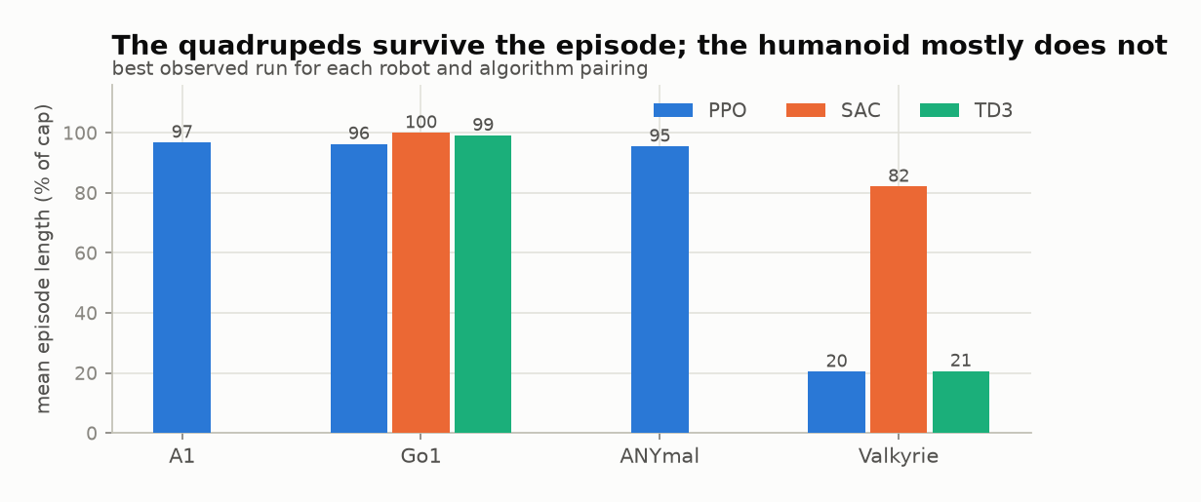
Figure 5. Episode survival for the best observed run in each robot and algorithm pairing.
The quadruped policies achieved the highest episode survival. A1 under PPO reached 967.5 steps and produced the highest reward in the archive, 4,767.0. ANYmal under PPO reached 954.6 steps. Go1 reached 962.7 steps under PPO, the full 1,000 under SAC and 990.9 under TD3. The Valkyrie results were lower and differed by learner: PPO reached 204.2 steps, SAC reached 821.0 and TD3 reached 206.2.
Interpretation. Reward functions differ between robots and tasks, so reward totals are not comparable across rows. A1's reward of 4,767.0 does not establish that it learned better than Go1; its reward expression assigns a different value per step. The `% of cap` column provides the directly comparable measure of episode survival.

6.3 What the reward actually paid for
Because reward totals are not comparable across robots, the more informative question is which terms produced a policy's score. EasyRTG logs every reward term separately, allowing the total to be decomposed at the point of highest observed performance.
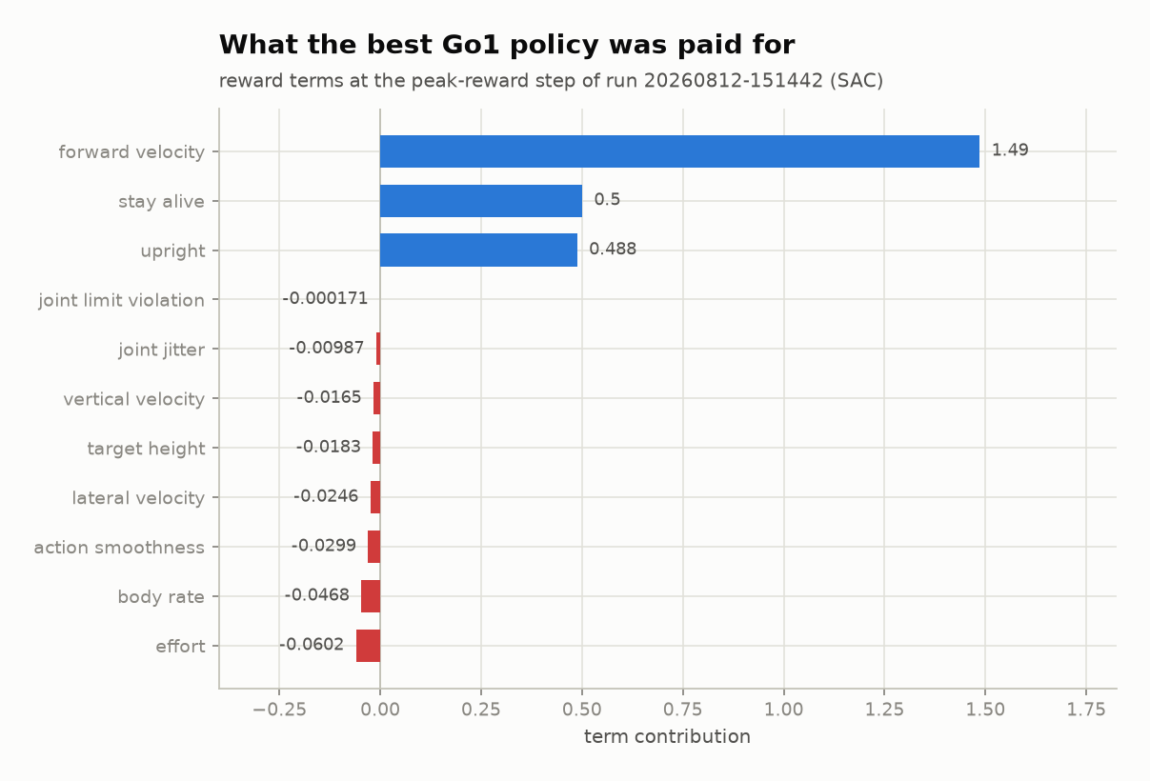
Figure 6. Term-by-term decomposition of the reward at the peak-reward step of the best Go1 run.
Three positive terms dominate the decomposition: forward velocity at 1.49, staying alive at 0.50 and uprightness at 0.49. The penalties are between one and four orders of magnitude smaller. Effort is the largest penalty at -0.060, while joint-limit violation is effectively zero at -0.00017, indicating that the policy was not operating against its joint limits.
Interpretation. The decomposition confirms that the policy earned its score primarily by moving forward while upright. It also shows that the penalties provided little constraint. A reward dominated by positive terms remains vulnerable to the type of misspecification demonstrated in Section 6.7, supporting the audit mechanism described in Section 4.3.

6.4 Throughput and the GPU lane
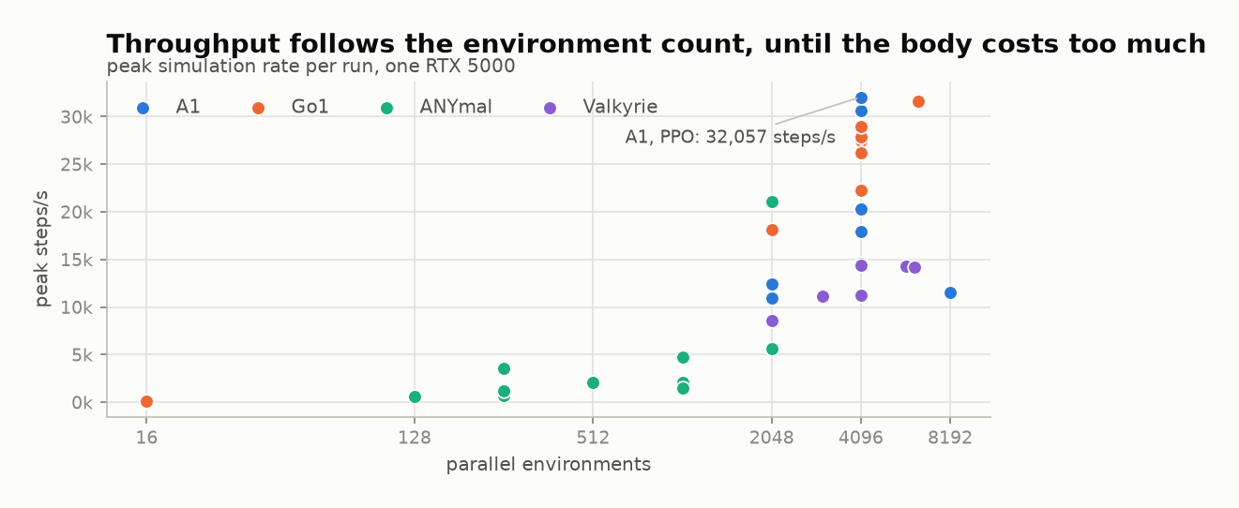
Figure 7. Peak simulation throughput against the number of parallel environments, coloured by robot.
The highest measured throughput was 32,056.8 environment steps per second, achieved by A1 at 4,096 environments. Go1 also exceeded 30,000 steps per second in recorded runs, while Valkyrie remained below approximately 14,600 steps per second at every tested batch size.
Increasing the number of environments provides more parallel work, but robot morphology determines the cost of each simulated step. A humanoid with more joints and bodies is therefore not directly comparable with a quadruped. RQ4 is explained by the interaction of two factors: parallelism determines the available workload, while robot complexity sets the practical throughput ceiling. The two diagnostic runs at 16 environments both remained below 100 steps per second, approximately three hundred times slower than the same robots at 4,096 environments.

6.5 How long learning took
Experiment cost depends on both simulation throughput and the number of steps required for learning. Learning time was measured as the number of environment steps before the smoothed mean episode length first remained above 900. This threshold indicates sustained stability rather than a single favourable logging interval.
Exactly twelve runs crossed this threshold, matching the twelve runs that reached 95% of the episode limit through a separately calculated measure. Appendix C provides the complete ordering. The best ANYmal run crossed after 2.51M steps, while the slowest successful Go1 run required 17.60M steps. Faster stabilisation did not imply a higher final reward. The highest-reward A1 run (20260728-202311; reward 4,767.0) required 16.42M steps to stabilise, whereas an earlier A1 run stabilised after 4.03M steps and achieved less than half that reward. Learning speed and final score must therefore be reported separately.

6.6 Go1: three learners, one solved robot
Go1 was the only robot evaluated with all three learners at the same environment count, making it the most suitable three-algorithm comparison.
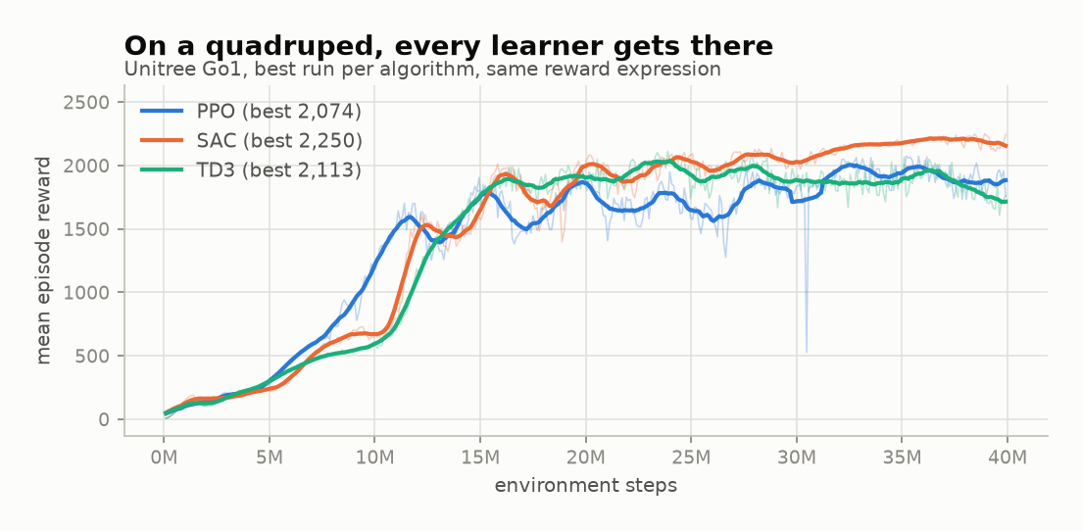
Figure 8. Reward for the best Go1 run under each learner, at 4,096 environments with the same reward expression.
All three Go1 policies converged to within 8% on reward: SAC reached 2,250.1, TD3 reached 2,112.7 and PPO reached 2,073.9. Episode survival was also similar at 100%, 99.1% and 96.3% of the limit respectively. The traces differ mainly in shape. SAC improves in distinct stages, PPO improves more smoothly, and TD3 rises fastest initially before flattening.
Interpretation. These results do not establish that the algorithms are equivalent. They show that the Go1 task was sufficiently tractable for all three learners to approach saturation. The comparison provides a baseline in which the pipeline does not visibly favour one learner. The more difficult Valkyrie task in Section 6.8 provides the separating case.

6.7 Go1 walking and galloping
The Go1 experiments demonstrate how reward semantics define learned behaviour. The walking reward encouraged forward motion, uprightness and sustained ground contact. The galloping reward additionally required a flight phase in which all four feet left the ground. In the presentation experiments, the walking policy travelled at 0.98 m/s, achieved an uprightness of 0.99 and survived 963 steps. The galloping policy reached 1.38 m/s, survived the full episode and was airborne for 43% of the stride. The robot and training budget were unchanged; only the reward semantics differed.
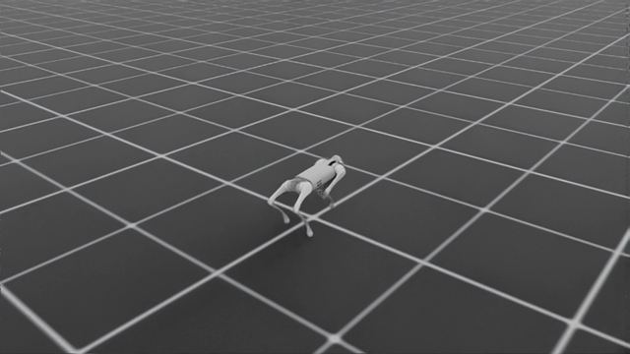
Figure 9. The Unitree Go1 during recorded policy evaluation.
The three-algorithm comparison exposed a limitation in the galloping reward. TD3 achieved the highest velocity, approximately 1.65 m/s, but had the lowest flight fraction at 29%. SAC was slower at 1.52 m/s but achieved a 52% flight fraction. TD3 had therefore learned a fast trot that scored well without producing the intended gallop.
Interpretation. This outcome is the reward-misspecification failure predicted by the literature [13, 14]. It demonstrates why contact-state measurements and video inspection must accompany reward. A high reward alone is insufficient evidence that the intended task has been learned.

6.8 Valkyrie: a controlled algorithm comparison
The strongest controlled comparison in the archive is between SAC and TD3 on Valkyrie. Both runs use the same reward expression and a 40M-step budget, holding the tested configuration constant except for the learner.
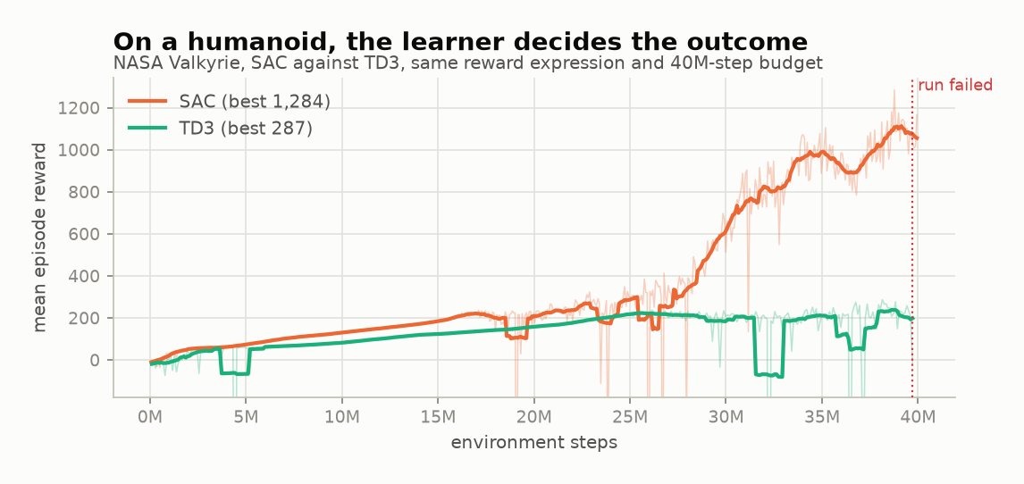
Figure 10. Reward for Valkyrie under SAC and TD3, same reward expression and same 40M-step budget.
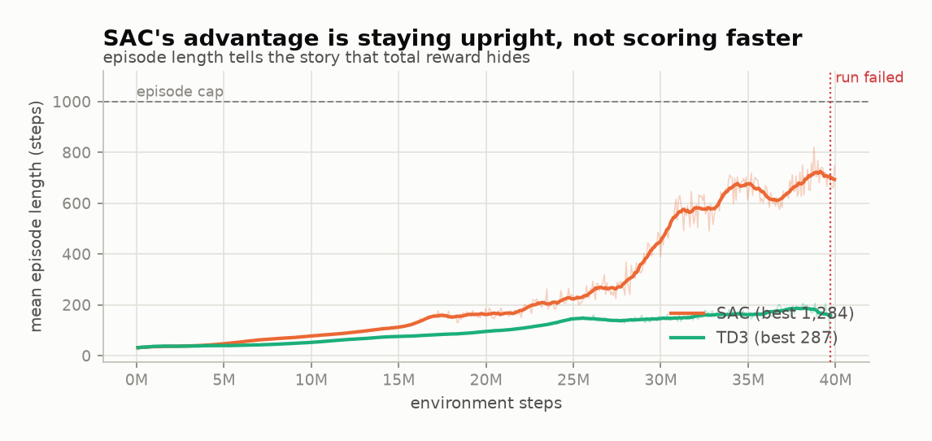
Figure 11. Episode length reveals that SAC's advantage came from staying upright, not from scoring faster.
Both learners initially improved and remained similar for approximately 20 million steps. Their behaviour then diverged. SAC reached a best mean reward of 1,283.8 with a mean episode length of 821.0 steps. TD3 remained near 200 steps of survival, reached a best reward of 287.0 and later stopped after producing NaN observations. The dotted line in the figures marks the point of failure.
At their best checkpoints, the policies received broadly similar reward per step. SAC achieved a larger total because it accumulated these terms for approximately four times as many steps before falling. Its advantage was therefore episode survival rather than a higher scoring rate. TD3 telemetry also showed several reward terms increasing by orders of magnitude before failure, indicating critic or numerical instability rather than only a failure to move forward.
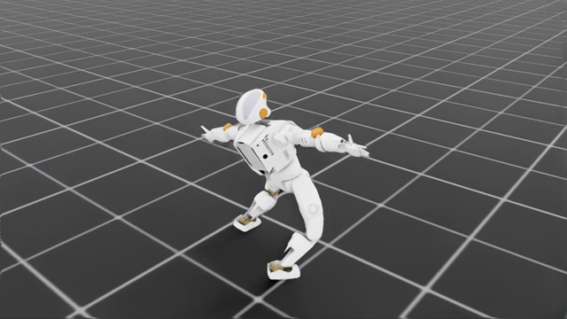
Figure 12. The NASA Valkyrie during recorded SAC policy evaluation.
Interpretation. Learner choice materially affected the Valkyrie outcome under the tested configuration, with SAC producing substantially longer survival than TD3. This is a result for one task and configuration, not evidence that SAC is generally superior. The limits of the comparison are discussed in Section 7.3.

6.9 Functional verification
The 256 passing backend tests provide a second form of evidence. They do not demonstrate learned robot behaviour. Instead, they verify the mechanisms required to interpret the training results: morphology, action mapping, the state vocabulary, expression guards, episode clocks, contact signals, Isaac bridge calculations, configuration phases and failure handling.
Neither evidence source is sufficient alone. A visually convincing gait cannot establish configuration safety, while a passing unit test cannot establish useful behaviour. The galloping result in Section 6.7 passed the software checks but produced the wrong gait, demonstrating the need for both software verification and behavioural evaluation.

7 Discussion

7.1 Answering the research questions
RQ1: configuration with human oversight. EasyRTG implements a staged workflow consisting of structural inspection, robot-relative calibration, reward authoring over an approved shared vocabulary, compile-and-audit checks, and explicit confirmation for consequential tools. The application completes this workflow without requiring the user to edit environment source code. However, the reduction in required expertise or completion time was not measured because no comparative user study was conducted.
RQ2: applicability across robot bodies. The same core pipeline produced analysable runs for the A1, ANYmal and Go1 quadrupeds and the Valkyrie humanoid. Structural morphology and dimensionless state terms removed several robot-specific assumptions. The evidence therefore supports applicability across the tested legged URDF models, but does not extend to manipulators, wheeled robots or closed-chain mechanisms.
RQ3: differences between learners. On Go1, all three learners approached saturation and learner choice had little effect on the final outcome. On Valkyrie, SAC was the only learner to produce sustained walking under the compared configuration. The evidence therefore indicates an interaction between learner and task difficulty rather than a general algorithm ranking. The conclusion is limited by unbalanced algorithm coverage, incomplete hyperparameter tuning and best-run selection.
RQ4: simulation throughput. Throughput increased with the number of parallel environments but was bounded by robot complexity. A1 reached 32,056.8 steps per second at 4,096 environments, while Valkyrie remained substantially below this value. The result is consistent with GPU-native simulation research [10, 12] and supports the architectural change to Isaac described in Section 5.2.

7.2 What the project learned about abstraction
The central abstraction problem was deciding which complexity should remain visible. Hiding simulator installation does not remove hardware or operating-system constraints, as the MJX attempt demonstrated. A fixed reward catalogue produces a simple but inflexible interface, while arbitrary Python provides flexibility without adequate safety. EasyRTG therefore exposes the decisions that directly influence learning - observations, actions, reward expressions, terminations and algorithm choice - while hiding the boilerplate required to execute them.
The appropriate boundary for the assistant remains less certain. The assistant is an authoring and orchestration layer within a system of validation and human review, not an independent authority. The six pre-telemetry failures and the many short-lived policies are part of the evaluation evidence. Language assistance can reduce configuration effort, but it does not replace measurable checks or expert diagnosis, as demonstrated by the manual investigation of the Valkyrie TD3 failure.

7.3 Limitations and threats to validity
- The experiment matrix is unbalanced. SAC and TD3 were concentrated on Go1 and Valkyrie, while A1 and ANYmal were run with PPO only, so no cross-robot algorithm claim is available.
- Fleet summaries select the highest-reward run for each pairing. They represent best observed performance rather than an expected mean across random seeds.
- All throughput values were measured on one RTX 5000 and should not be generalised to other GPUs without further measurement.
- Every policy was evaluated in simulation. Domain randomisation and transfer to a physical robot were not attempted.
- The no-code claim is architectural rather than empirical. No participant study measured task completion time, error rate, learning curve or perceived usability.
- Training quality depends on the URDF dynamics, and automatic morphology inference cannot repair unrealistic mass, inertia, collision or joint-limit data.
- Observations remain a fixed seven-key catalogue, even though rewards are expressions. Camera observations, terrain, velocity commands, ROS and multi-agent RL are not implemented.
- The fresh verification covered the backend only. The Flutter command-line tool did not return in the available environment, so current frontend lint and test status remains unconfirmed.

7.4 Practical and academic significance
The practical contribution of EasyRTG is an integrated path from a robot file to a recorded policy, combining configuration, training and supporting evidence within one application. Its academic contribution is a case study of language-assisted reward design without unrestricted code execution. The heterogeneous run archive also demonstrates why reward, episode survival and task-specific behaviour must be evaluated together.
The project does not demonstrate that robot learning has become effortless. Its more defensible contribution is that important configuration decisions are made visible, reviewable and repeatable. When a decision is incorrect, as in the galloping reward, the retained evidence makes the error identifiable.

8 Conclusion and Future Work

8.1 Conclusion
EasyRTG was developed to provide a single understandable process for loading a robot, defining a goal, training a policy and evaluating the result. The completed implementation is a working desktop platform with URDF inspection, morphology-derived configuration, assistant-authored reward expressions, GPU-parallel training, live telemetry and retained policy evaluation.
The evaluation contains 34 analysable Isaac runs across four robot families and three algorithms. It records a peak throughput of 32,056.8 environment steps per second, stable quadruped locomotion and a substantial SAC advantage on the tested Valkyrie task. Development failures also produced important design changes: crawling motivated robot-relative termination; joint-name failures motivated structural morphology; the galloping task motivated contact state and expression rewards; and the risk of arbitrary Python motivated a restricted expression compiler. The fast-trotting gallop policy further demonstrated why episode length, contact measurements and video must be considered alongside reward.
The project is therefore best understood as an iterative refinement of its proposal rather than a direct implementation of the original plan. The initial six-week CPU design developed into a platform whose central claim is supported by working software and a reproducible run archive: robot structure, reward semantics and training evidence can be made visible within one workflow for a non-expert user.

8.2 Future work
The first priority is a controlled usability study. A comparison between the EasyRTG workflow and a documented code-based baseline should measure task completion time, configuration errors, requests for assistance and a validated usability scale. This study is required to evaluate the no-code claim empirically rather than infer it from the architecture.
Observation expressions and per-episode velocity commands should also be introduced together, allowing one policy to respond to changing instructions rather than a fixed goal. A campaign worker could then propose, audit and test reward revisions automatically while retaining the user-approval mechanism described in Section 4.4.
Further work should add terrain and sensor observations, improve automatic dynamics checks, evaluate more robots with balanced seeds and algorithm budgets, and measure throughput on additional GPUs. Hyperparameters should be studied through a reproducible optimisation framework such as Optuna [24] rather than through individual experiments alone. Finally, domain randomisation and hardware export are required before EasyRTG can claim a complete route from simulation to physical robot behaviour. DrEureka provides a relevant model for this stage [17].

Bibliography
[1] R. S. Sutton and A. G. Barto, Reinforcement Learning: An Introduction, 2nd ed. Cambridge, MA: MIT Press, 2018.
[2] J. Kober, J. A. Bagnell, and J. Peters, "Reinforcement learning in robotics: A survey," International Journal of Robotics Research, vol. 32, no. 11, pp. 1238-1274, 2013.
[3] J. Schulman, F. Wolski, P. Dhariwal, A. Radford, and O. Klimov, "Proximal policy optimization algorithms," arXiv:1707.06347, 2017.
[4] T. Haarnoja, A. Zhou, P. Abbeel, and S. Levine, "Soft actor-critic: Off-policy maximum entropy deep reinforcement learning with a stochastic actor," in Proceedings of ICML, pp. 1861-1870, 2018.
[5] S. Fujimoto, H. van Hoof, and D. Meger, "Addressing function approximation error in actor-critic methods," in Proceedings of ICML, pp. 1587-1596, 2018.
[6] G. Brockman et al., "OpenAI Gym," arXiv:1606.01540, 2016.
[7] M. Towers et al., "Gymnasium: A standard interface for reinforcement learning environments," arXiv:2407.17032, 2024.
[8] A. Raffin et al., "Stable-Baselines3: Reliable reinforcement learning implementations," Journal of Machine Learning Research, vol. 22, no. 268, pp. 1-8, 2021.
[9] E. Coumans and Y. Bai, "PyBullet, a Python module for physics simulation for games, robotics and machine learning," 2016-2021. Available: https://pybullet.org/.
[10] V. Makoviychuk et al., "Isaac Gym: High performance GPU-based physics simulation for robot learning," arXiv:2108.10470, 2021.
[11] M. Mittal et al., "Orbit: A unified simulation framework for interactive robot learning environments," IEEE Robotics and Automation Letters, vol. 8, no. 6, pp. 3740-3747, 2023.
[12] N. Rudin, D. Hoeller, P. Reist, and M. Hutter, "Learning to walk in minutes using massively parallel deep reinforcement learning," in Proceedings of CoRL, PMLR vol. 164, pp. 91-100, 2022.
[13] A. Y. Ng, D. Harada, and S. Russell, "Policy invariance under reward transformations: Theory and application to reward shaping," in Proceedings of ICML, pp. 278-287, 1999.
[14] P. Henderson et al., "Deep reinforcement learning that matters," in Proceedings of AAAI, vol. 32, no. 1, 2018.
[15] L. Engstrom et al., "Implementation matters in deep policy gradients: A case study on PPO and TRPO," in Proceedings of ICLR, 2020.
[16] Y. J. Ma et al., "Eureka: Human-level reward design via coding large language models," arXiv:2310.12931, 2023.
[17] Y. J. Ma et al., "DrEureka: Language model guided sim-to-real transfer," in Proceedings of Robotics: Science and Systems, 2024.
[18] N. Koenig and A. Howard, "Design and use paradigms for Gazebo, an open-source multi-robot simulator," in Proceedings of IEEE/RSJ IROS, pp. 2149-2154, 2004.
[19] A. Juliani et al., "Unity: A general platform for intelligent agents," arXiv:1809.02627, 2020.
[20] L. Ye et al., "Unity RL Playground: A versatile reinforcement learning framework for mobile robots," arXiv:2503.05146, 2025.
[21] A. R. Hevner, S. T. March, J. Park, and S. Ram, "Design science in information systems research," MIS Quarterly, vol. 28, no. 1, pp. 75-105, 2004.
[22] K. Peffers, T. Tuunanen, M. A. Rothenberger, and S. Chatterjee, "A design science research methodology for information systems research," Journal of Management Information Systems, vol. 24, no. 3, pp. 45-77, 2007.
[23] S. Amershi et al., "Guidelines for human-AI interaction," in Proceedings of CHI, paper 3, pp. 1-13, 2019.
[24] T. Akiba, S. Sano, T. Yanase, T. Ohta, and M. Koyama, "Optuna: A next-generation hyperparameter optimization framework," in Proceedings of KDD, pp. 2623-2631, 2019.
[25] NVIDIA, "Isaac Lab documentation," 2026. Available: https://isaac-sim.github.io/IsaacLab/.
[26] Flutter, "Flutter desktop documentation," 2026. Available: https://docs.flutter.dev/platform-integration/desktop.
[27] FastAPI, "FastAPI documentation," 2026. Available: https://fastapi.tiangolo.com/.

Appendix A GitLab Repository and Running the Project

A.1 Repository
GitLab project URL: https://git.cs.bham.ac.uk/projects-2025-26/sxc1742
The `backend` directory contains the FastAPI orchestration service, robot inspection, configuration services, reinforcement-learning logic, Isaac subprocess workers and assistant tools. The Flutter desktop application is located in `frontend/rtg-flutter-app`. Architecture notes, setup records and design plans are stored in `docs`, while `scripts` contains the Windows and Linux launchers, build tools and media generators. The `backend/runs` directory stores each experiment's configuration, telemetry, checkpoints and evaluation video and is the source of every numerical result in Chapter 6.

A.2 Minimum setup
- Install Python 3.12, the Flutter desktop tooling and the backend packages listed in `backend/requirements.txt`.
- For GPU training, install NVIDIA Isaac Sim 6.0.1 and Isaac Lab 3.0 as described in `docs/isaac_setup.md`.
- Create the Python environment using `uv` and install the backend requirements into it.
- Start both services with `scripts/dev_run.ps1` on Windows or `scripts/dev_run.sh` on Linux.
- Load a URDF, configure the goal and reward, run Test reward, then launch Isaac training from the desktop application.

A.3 Verification commands
Backend tests: `$env:PYTEST_DISABLE_PLUGIN_AUTOLOAD=1; .\.venv\Scripts\python.exe -m pytest backend\tests\ -q --basetemp=.pytest_tmp`
Frontend: `cd frontend\rtg-flutter-app; flutter analyze; flutter test`
Report figures: `py -m uv run --python 3.12 --with matplotlib --with numpy python scripts/make_report_figures.py`
Report document: `.venv\Scripts\python.exe scripts\write_report.py`

Appendix B Experiment Coverage
Table 7. Coverage of the 34 analysable Isaac runs by robot and algorithm.
Robot | PPO | SAC | TD3 | Total analysable
A1 | 8 | 0 | 0 | 8
ANYmal | 10 | 0 | 0 | 10
Go1 | 4 | 3 | 2 | 9
Valkyrie | 3 | 3 | 1 | 7

Six timestamped run directories contained no numeric reward telemetry and are retained as pre-telemetry failures. The additional `p3gallop` directory does not follow the timestamped `*-isaac` naming convention and is excluded from fleet-level calculations. Figures are generated from the run archive by `scripts/make_report_figures.py`; the run directories remain the authoritative data source.

Appendix C Supplementary Figures
The following figures support the analysis in Chapter 6 and were placed in the appendix to keep the main body within the page limit. Each figure is generated from the same run archive as the figures in the main text.
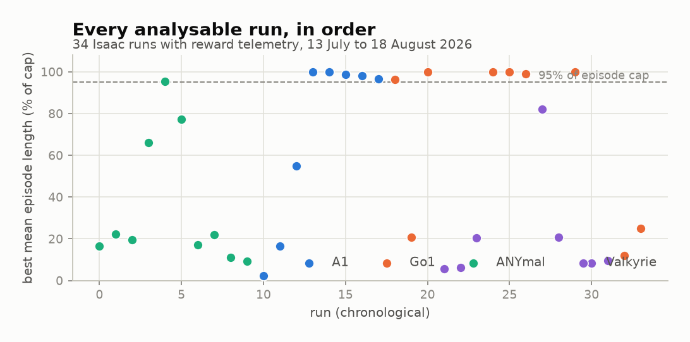
Figure 13. Best mean episode length for every analysable Isaac run, in chronological order.
The chronological view describes the development history rather than a single experimental outcome. Early ANYmal runs cluster at low episode lengths, while A1 and Go1 runs from late July onwards cluster near the episode limit. The two runs at 16 environments were added on 18 August as diagnostic experiments and establish the lower end of the throughput relationship discussed in Section 6.4.
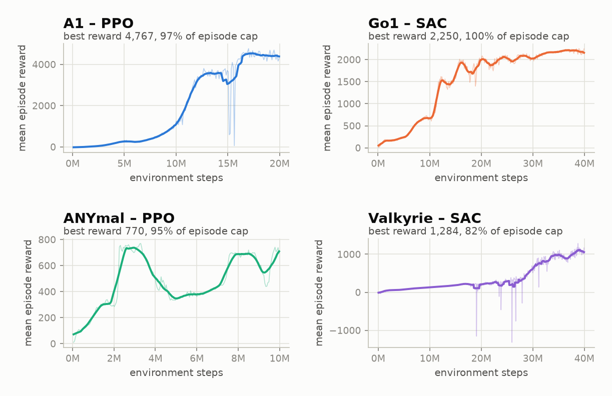
Figure 14. Reward against environment steps for the best run of each robot family.
The best run for each robot is plotted using the same scale within its panel. A1 improves rapidly and increases again near 16M steps, while Go1 improves in visible stages. ANYmal remains unstable and decreases by approximately half between 3M and 5M steps before recovering, illustrating why ten attempts were required. Valkyrie improves slowly for 25M steps before accelerating; a shorter training budget would therefore have produced a different conclusion about humanoid learning.
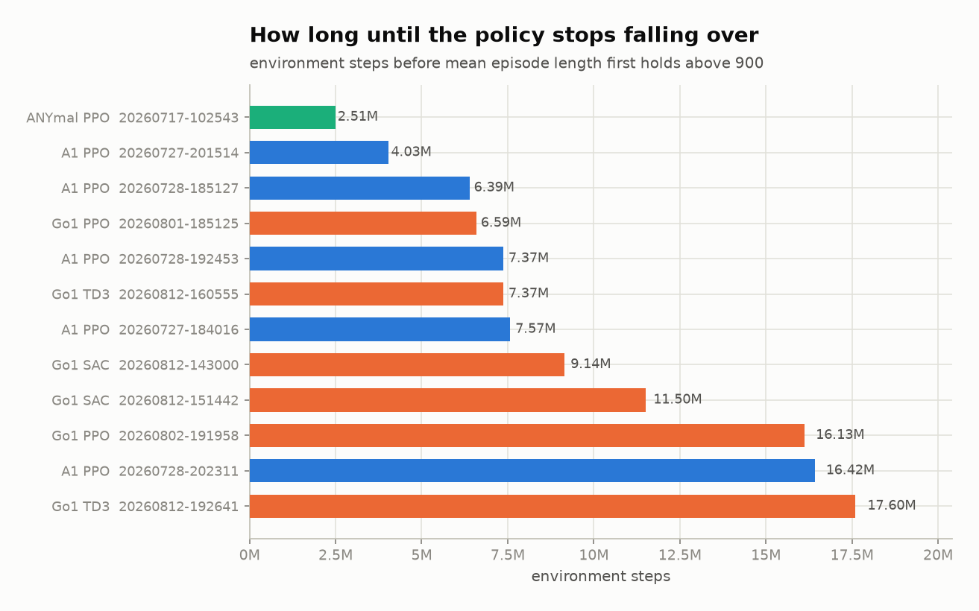
Figure 15. Environment steps before each run's smoothed mean episode length first holds above 900.
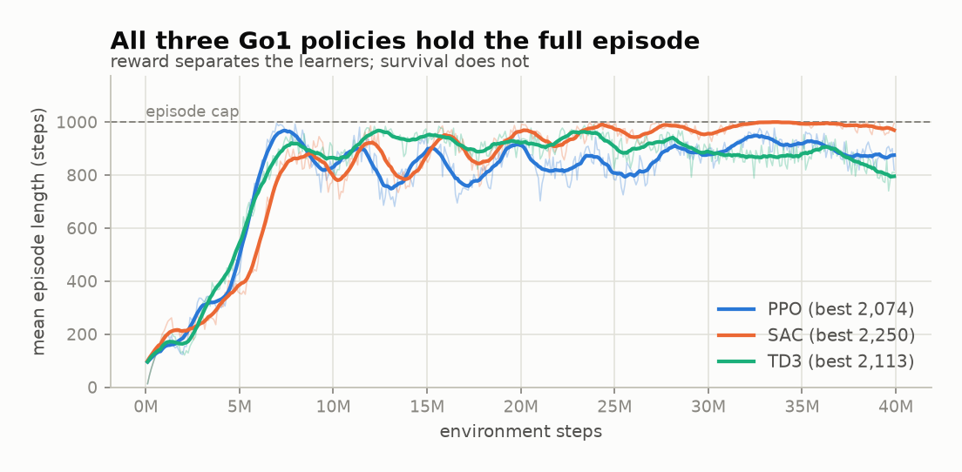
Figure 16. Episode length for the best Go1 run under each learner.
All three Go1 learners reach and maintain the episode limit, so episode survival does not distinguish them on this robot. In contrast, the Valkyrie comparison in Section 6.8 is separated primarily by survival.

Appendix D Full Run Index
Table D.1 lists every analysable run in the archive. Best reward is the highest observed mean episode reward. Episode length is the mean episode length at the same step, and peak steps per second is the highest recorded throughput. The fleet-level values in Chapter 6 are derived from this table.
Table 8. All 34 analysable Isaac runs, 13 July to 18 August 2026.
Run | Robot | Algorithm | Envs | Best reward | Episode length | % of cap | Peak steps/s
20260713-083121 | ANYmal | PPO | 512 | 137.0 | 165.9 | 16.6% | 2,095
20260713-084227 | ANYmal | PPO | 256 | 193.4 | 222.2 | 22.2% | 738
20260717-093639 | ANYmal | PPO | 256 | 159.1 | 195.4 | 19.5% | 1,207
20260717-093932 | ANYmal | PPO | 256 | 518.0 | 659.4 | 65.9% | 3,572
20260717-102543 | ANYmal | PPO | 2048 | 769.8 | 954.6 | 95.5% | 21,056
20260717-110526 | ANYmal | PPO | 128 | 738.2 | 771.6 | 77.2% | 591
20260722-133515 | ANYmal | PPO | 2048 | 144.0 | 170.5 | 17.0% | 5,582
20260722-140347 | ANYmal | PPO | 1024 | 174.6 | 219.7 | 22.0% | 2,047
20260722-141517 | ANYmal | PPO | 1024 | 93.1 | 112.0 | 11.2% | 4,745
20260722-141803 | ANYmal | PPO | 1024 | 76.7 | 93.0 | 9.3% | 1,525
20260727-173801 | A1 | PPO | 2048 | 12.3 | 22.5 | 2.2% | 12,420
20260727-180733 | A1 | PPO | 2048 | 152.0 | 164.2 | 16.4% | 10,966
20260727-182222 | A1 | PPO | 8192 | 506.5 | 547.6 | 54.8% | 11,493
20260727-184016 | A1 | PPO | 4096 | 2,146.8 | 1000.0 | 100.0% | 17,925
20260727-201514 | A1 | PPO | 4096 | 2,338.3 | 1000.0 | 100.0% | 20,285
20260728-185127 | A1 | PPO | 4096 | 1,865.3 | 988.3 | 98.8% | 30,599
20260728-192453 | A1 | PPO | 4096 | 1,900.9 | 979.9 | 98.0% | 28,462
20260728-202311 | A1 | PPO | 4096 | 4,767.0 | 967.5 | 96.8% | 32,057
20260801-185125 | Go1 | PPO | 4096 | 2,073.9 | 962.7 | 96.3% | 27,500
20260801-215400 | Go1 | PPO | 2048 | 147.7 | 208.8 | 20.9% | 18,081
20260802-191958 | Go1 | PPO | 6400 | 1,600.6 | 1000.0 | 100.0% | 31,631
20260803-211052 | Valkyrie | PPO | 4096 | 88.3 | 55.9 | 5.6% | 14,556
20260803-230732 | Valkyrie | PPO | 4096 | 96.1 | 62.4 | 6.2% | 11,230
20260803-233317 | Valkyrie | PPO | 5800 | 276.1 | 204.2 | 20.4% | 14,280
20260812-143000 | Go1 | SAC | 4096 | 1,952.9 | 1000.0 | 100.0% | 26,180
20260812-151442 | Go1 | SAC | 4096 | 2,250.1 | 1000.0 | 100.0% | 27,840
20260812-160555 | Go1 | TD3 | 4096 | 2,112.7 | 990.9 | 99.1% | 28,976
20260812-165024 | Valkyrie | SAC | 3048 | 1,283.8 | 821.0 | 82.1% | 11,172
20260812-181127 | Valkyrie | TD3 | 4096 | 287.0 | 206.2 | 20.6% | 14,389
20260812-192641 | Go1 | TD3 | 4096 | 1,905.0 | 1000.0 | 100.0% | 22,239
20260813-175701 | Valkyrie | SAC | 6200 | 251.3 | 82.8 | 8.3% | 14,182
20260813-190946 | Valkyrie | SAC | 2048 | 140.0 | 94.1 | 9.4% | 8,540
20260818-084821 | Go1 | SAC | 16 | 97.5 | 121.1 | 12.1% | 96
20260818-145041 | Go1 | PPO | 16 | 147.2 | 250.4 | 25.0% | 80

Twelve runs maintain at least 95% of the episode limit: five A1 PPO runs from 27 and 28 July, one ANYmal PPO run from 17 July at 2,048 environments, and all six Go1 runs at 4,096 environments or more. No Valkyrie run reaches this threshold.

Appendix E Compute Environment and Reproduction Notes
All training and evaluation results were produced on one workstation. The pre-release status of the simulator stack must be considered when reproducing the experiments.
Table 9. Compute and software environment used for all experiments.
Component | Version or specification
GPU | One NVIDIA RTX 5000
Isaac Sim | 6.0.1-rc.7
Isaac Lab | 3.0.0-beta2 (`v3.0.0-beta2.patch1`)
Physics backend | Newton (replaces `omni.physics.tensors` from Isaac Sim 6.0)
Isaac Sim Python | 3.12, bundled with Isaac Sim
Application Python | 3.12, project virtual environment
Inspection simulator | PyBullet, headless
Backend | FastAPI
Desktop client | Flutter
Episode cap | 1,000 steps

Isaac Sim is a release candidate and Isaac Lab is a beta. Isaac Sim 6.0 also replaces the earlier `omni.physics.tensors` implementation with the Newton physics backend. Results from an earlier build should therefore not be expected to match those reported here. Isaac Sim uses its own bundled Python and cannot run inside the application virtual environment, which is the practical reason for the subprocess architecture described in Section 4.5.
Three additional conditions apply to reproduction. First, throughput values are peak observations rather than sustained averages and vary with environment count. Second, the two 16-environment runs are diagnostic experiments rather than failed training attempts. Third, every figure is regenerated from `backend/runs` by `scripts/make_report_figures.py`; adding a run and executing the figure and document scripts updates the reported evidence without manual editing.

