FINAL PROJECT REPORT
EasyRTG
An Intelligent No-Code Platform for Training Robots
Shivam Chavan
Student ID: 3053682
Supervisor: Shraddha Naik
MSc in Artificial Intelligence and Computer Science
School of Computer Science
University of Birmingham Dubai
August 2026

Declaration and Honour Code
I certify that this project is my own work. I set the aims, decided the requirements, designed the architecture and the feature set, planned the experiments, and I stand behind the submitted software, the evidence, the interpretation and the conclusions. Anthropic's Claude helped me write and debug parts of the application. OpenAI Codex was used for report writing only, and a further AI-assisted pass revised the prose for voice and readability. I read and edited everything that came back before it went in. The next page sets out exactly what each tool did.
Ideas, software and published findings by other people are credited through numbered citations and the matching bibliography entries. I understand that accuracy of the report, the behaviour of the submitted system and compliance with the University's academic-integrity rules all remain mine to answer for.
Name: Shivam Chavan
Student ID: 3053682

Use of Generative AI
Two generative-AI tools were involved in this project. Anthropic's Claude helped build the application. OpenAI Codex worked on the report after the software and the experiments were already finished. Their roles were not the same and lumping them together would misrepresent what I actually did, so they are declared separately.
- My contribution: I picked the problem, set the aims and requirements, designed the architecture and the feature set, chose the experimental questions and made the engineering calls. I configured, launched and interpreted every experiment in Chapter 6. The numbers come from the run telemetry I kept, and the conclusions are my reading of that evidence.
- Use of Claude to develop desktop interface: I specified the screens, the state flow and how each panel was meant to behave. Claude wrote most of the Dart that resulted. I reviewed it, ran it, fixed it and integrated it, and the submitted frontend carries substantial revisions of mine. Even so, the desktop interface is largely AI-generated under my direction, and I would rather say so plainly.
- Use of Claude to develop backend & debugging: The two simulation lanes, the morphology layer, the expression compiler and its audit, the assistant toolbox and the approval gates in Chapter 4 are my designs. Claude drafted parts of the implementation beyond boilerplate, read stack traces with me and offered candidate fixes. I defined the interfaces and the required behaviour, and I checked every retained change against the running system and the test suite.
- Use of OpenAI GPT for the report. I supplied the content, the project evidence, the results, the sources, the interpretations and the conclusions along wit the initial version draft of the report. GPT was majorly used to refine and have a consistent language in the report. Each section in the report is refined via AI.
All AI-assisted material was reviewed against the source code, the Git history, the test results, the retained telemetry, the recorded videos and the cited literature, whichever applied. I understand the submitted code and I take responsibility for the final software and the final report.

Acknowledgements
My thanks go first to my supervisor, Shraddha Naik, for her patience and for feedback that was consistently more useful than comfortable. She pushed me to read the literature properly and to connect what I was building to published research instead of treating the whole thing as a software exercise. What she knows about software development, about academic writing and about what a finished application ought to look like improved both the system and this report.
I am grateful to the School of Computer Science and to the teaching staff for the grounding they gave me across the programme. A good deal of what I leaned on here came from that.
Finally, my friends and colleagues, who put up with the parts of this project nobody sees. Simulator configurations that refused to load, policies that learned something other than what I asked for, training runs that took all night and produced nothing worth keeping. Several of the design decisions in this report came out of exactly those failures.

Abstract
Getting a robot to learn anything through reinforcement learning means wiring together a physics simulator, a Python environment, a reward function, a learning algorithm, some way to watch training as it happens and some way to judge the policy afterwards. Frameworks for all of that already exist. What they quietly assume is that you know which simulator you are using and can write the code to drive it. EasyRTG is my attempt at removing that assumption. It is a desktop application where a user imports a robot in Universal Robot Description Format (URDF), describes the behaviour they want, reviews the configuration and reward function the assistant proposes, tests the reward, trains a policy and evaluates what comes out.
The system pairs a Flutter desktop interface with a FastAPI orchestration backend, PyBullet for inspecting the imported robot and for testing rewards, and NVIDIA Isaac Sim for training and playback. Control-relevant structure is read straight out of the URDF, and rewards are written as mathematical expressions rather than picked from a list. That removes both the fixed joint-name rules and the predefined reward catalogue, which is what lets one pipeline handle quadrupeds and humanoids.
The run archive holds 40 timestamped experiments. Thirty-four of them retained numeric reward telemetry and form the analysable set, covering the Unitree A1 and ANYmal under PPO, and the Unitree Go1 and NASA Valkyrie under PPO, SAC and TD3. Twelve of the 34 held at least 95% of the 1,000-step episode limit. Peak throughput reached roughly 32,000 environment steps per second on a single RTX 5000.
On the Go1, the best PPO, SAC and TD3 policies finished 96.3%, 100% and 99.1% of the episode respectively, so the learner barely mattered. Valkyrie told a different story. SAC held 82.1% while PPO and TD3 both stalled near 20%, which makes algorithm choice the deciding factor on the harder body rather than a detail.
One result cuts against the rest. A high reward is not the same thing as the behaviour you asked for. On the Go1 galloping task, TD3 scored well by learning a fast trot with no real flight phase in it. What EasyRTG demonstrates, then, is a working integration of language-assisted configuration, general robot inspection and accelerated learning, together with a fairly clear view of where that integration still needs a person watching.

Table of Contents
1 Introduction 14
1.1 Project motivation 14
1.2 Problem statement 15
1.3 Aim and objectives 15
1.4 Research questions 16
1.5 Scope and contributions 16
1.6 Organisation of this report 16
2 Background and Literature Survey 17
2.1 Reinforcement learning for robot control 17
2.2 The three learners: PPO, SAC and TD3 17
2.3 From single environments to massively parallel simulation 18
2.4 Isaac Gym and the GPU-native turn 18
2.5 Orbit and Isaac Lab 18
2.6 Learning to walk in minutes 19
2.7 Reward design as the real bottleneck 19
2.8 Eureka: language models writing rewards 19
2.9 DrEureka: pushing language-assisted design toward hardware 20
2.10 General-purpose simulators: Gazebo and Unity ML-Agents 20
2.11 Unity RL Playground: the closest accessibility claim 20
2.12 Where EasyRTG sits 21
3 Research Methodology and Requirements 22
3.1 Design-science approach 22
3.2 Evidence sources 22
3.3 Functional and non-functional requirements 22
3.4 Experimental protocol and metrics 23
3.5 Software verification 24
4 System Design and Architecture 24
4.1 Architectural overview 24
4.2 URDF inspection and morphology 25
4.3 Expression rewards and the shared state vocabulary 25
4.4 Assistant and human oversight 26
4.5 Training, monitoring and evaluation 27
5 Implementation and Iterative Development 28
5.1 From proposal to working system 28
5.2 Milestone history 28
5.3 Key engineering decisions 30
5.4 Security and reliability improvements 30
5.5 Role of generative AI in the development process 31
6 Experiments, Results and Findings 31
6.1 Run coverage and failure history 31
6.2 Fleet-level results 32
6.3 What the reward actually paid for 33
6.4 Throughput and the GPU lane 34
6.5 How long learning took 34
6.6 Go1: three learners, one solved robot 35
6.7 Go1 walking and galloping 35
6.8 Valkyrie: a controlled algorithm comparison 36
6.9 Functional verification 38
7 Discussion 39
7.1 Answering the research questions 39
7.2 What the project learned about abstraction 39
7.3 Limitations and threats to validity 40
7.4 Practical and academic significance 41
8 Conclusion and Future Work 41
8.1 Conclusion 41
8.2 Future work 42
Bibliography 43
Appendix A GitLab Repository and Running the Project 45
A.1 Repository 45
A.2 Minimum setup 45
A.3 Verification commands 46
Appendix B Experiment Coverage 46
Appendix C Supplementary Figures 47
Appendix D Full Run Index 49
Appendix E Compute Environment and Reproduction Notes 51

List of Figures
Figure 1. The EasyRTG workflow, from robot import to policy evaluation. 13
Figure 2. EasyRTG architecture, and the separation between the inspection and GPU training lanes. 23
Figure 3. The EasyRTG desktop assistant, showing a generated training configuration and the changes offered for review. 26
Figure 4. Major implementation and experiment milestones, reconstructed from Git dates and the run archive. 27
Figure 5. Episode survival for the best observed run in each robot and algorithm pairing. 31
Figure 6. Term-by-term decomposition of the reward at the peak-reward step of the best Go1 run. 32
Figure 7. Peak simulation throughput against the number of parallel environments, coloured by robot. 33
Figure 8. Reward for the best Go1 run under each learner, at 4,096 environments with the same reward expression. 34
Figure 9. The Unitree Go1 during recorded policy evaluation. 35
Figure 10. Reward for Valkyrie under SAC and TD3, same reward expression and same 40M-step budget. 36
Figure 11. Episode length reveals that SAC's advantage came from staying upright, not from scoring faster. 36
Figure 12. The NASA Valkyrie during recorded SAC policy evaluation. 37
Figure 13. Best mean episode length for every analysable Isaac run, in chronological order. 46
Figure 14. Reward against environment steps for the best run of each robot family. 47
Figure 15. Environment steps before each run's smoothed mean episode length first holds above 900. 48
Figure 16. Episode length for the best Go1 run under each learner. 48

List of Tables
Table 1. Research questions used to organise the implementation and evaluation. 16
Table 2. Algorithm rationale and its observed role in EasyRTG. 18
Table 3. Positioning EasyRTG against representative robot-simulation and learning platforms. 21
Table 4. Traceable project requirements. 23
Table 5. Engineering decisions that emerged through iteration. 30
Table 6. Best observed run for each robot and algorithm pairing. 32
Table 7. Coverage of the 34 analysable Isaac runs by robot and algorithm. 46
Table 8. All 34 analysable Isaac runs, 13 July to 18 August 2026. 50
Table 9. Compute and software environment used for all experiments. 51

Abbreviations
Term | Meaning
API | Application Programming Interface
AST | Abstract Syntax Tree
DRL | Deep Reinforcement Learning
GPU | Graphics Processing Unit
LLM | Large Language Model
PPO | Proximal Policy Optimisation
REST | Representational State Transfer
RL | Reinforcement Learning
SAC | Soft Actor-Critic
TD3 | Twin Delayed Deep Deterministic Policy Gradient
UI | User Interface
URDF | Universal Robot Description Format
USD | Universal Scene Description

1 Introduction

1.1 Project motivation
Reinforcement learning is a closed loop. An agent observes the state of the environment it has been put into, picks an action from the ones available, and gets a reward for the choice it made [1]. Applying that loop to a robot is where the work starts. You set up a simulator, load the robot model, define the observations and the actions, design the reward, choose the training parameters, run the training, and then judge whether the policy is any good.
Existing RL libraries take as much of this off your hands as they reasonably can, but they still assume you arrive knowing how to build a valid environment [2]. For a newcomer that assumption compounds. You cannot design a reward without being able to read the state, and you cannot read the state without understanding both the robot and the simulator, so every part of the workflow depends on knowledge of every other part.
EasyRTG came out of an earlier robotics project of mine. The robot did eventually learn what I wanted it to. By the time it did, though, an enormous amount of manual work had gone into stitching together the simulator, the environment code, the reward function, the training scripts and the visualisation, and none of that showed up in the demonstration at the end. So the idea here was to make environment creation and experiment management something the application does, rather than an undocumented prerequisite the user is expected to have already met.
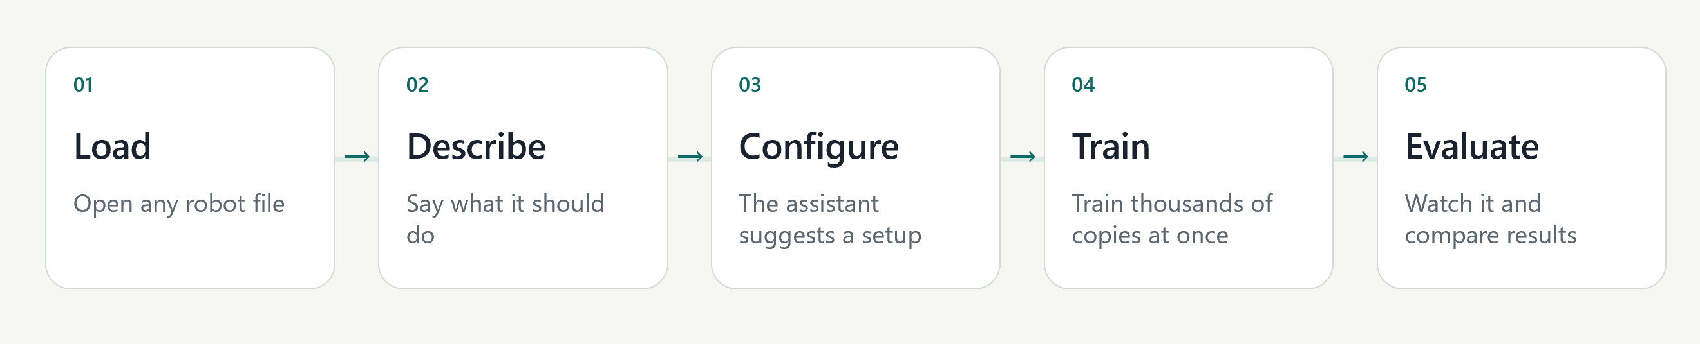
Figure 1. The EasyRTG workflow, from robot import to policy evaluation.

1.2 Problem statement
Turning a raw robot description and a stated task into a working reinforcement-learning environment currently demands a handful of unrelated skills at once. Physics engines and RL toolkits can certainly do the job, but they are scripted and configured at a low level and they lean on conventions that shift from one simulator to the next. A URDF file gives you geometry and the joint hierarchy. It says nothing about the parameters that actually govern learning, which degrees of freedom to actuate, which links are allowed to touch the ground, how to distribute resets, how the reward should be shaped. Somebody has to translate the robot's physical structure and the desired motion into environment code that trains reliably. This project asks whether an integrated and inspectable desktop interface can carry out that translation without dropping the user into simulator programming, and without taking control away from them.

1.3 Aim and objectives
The aim was a desktop platform that carries a user from a URDF robot and a natural-language objective through to a trained and evaluated policy, with no simulator or reinforcement-learning code written along the way. Five objectives followed from that.
- Provide a single desktop workflow covering robot inspection, configuration, monitoring, training and evaluation.
- Derive the morphology needed for control from the URDF itself, without robot-specific joint-name rules.
- Let an LLM assistant propose reward expressions and configuration changes while keeping anything consequential reviewable and subject to approval.
- Use GPU-parallel simulation so that repeated robot-learning experiments are practical on one workstation.
- Evaluate the platform across several robot bodies, tasks and learning algorithms, using saved telemetry and recorded behaviour.

1.4 Research questions
Four questions guided the implementation and the evaluation.
Table 1. Research questions used to organise the implementation and evaluation.
ID | Research question
RQ1 | How can a no-code interface translate a URDF and a natural-language goal into a valid RL configuration while retaining human oversight?
RQ2 | To what extent can morphology-derived configuration and expression rewards support different robot bodies without robot-specific application logic?
RQ3 | How do PPO, SAC and TD3 differ across quadruped and humanoid locomotion experiments?
RQ4 | How do parallel environment count and robot complexity affect GPU simulation throughput?

1.5 Scope and contributions
EasyRTG is a single-user desktop application for training URDF robots. What it contributes is an integrated workflow, configuration derived from structure rather than names, expression-based rewards, an audit the user can read, an assistant kept on a short leash, and run provenance that survives the run. No new reinforcement-learning algorithm is proposed here.
Plenty sits outside the scope. There is no deployment to physical hardware, no terrain curricula, no camera observations, no ROS integration and no multi-agent learning. The evaluation therefore shows that the platform can configure and train several simulated legged robots. It shows nothing about transfer to real hardware, and nothing about more than one user at a time.

1.6 Organisation of this report
Chapter 2 covers the reinforcement-learning and GPU-native simulation work this project builds on, along with the reward-design literature and the comparable accessibility platforms. Chapter 3 sets out the design-science methodology, the evidence sources, the requirements and the experimental protocol. Chapter 4 presents the architecture and the main technical mechanisms. Chapter 5 traces the iterative development. Chapter 6 reports the experiments and the results. Chapter 7 answers the research questions and states the limitations. Chapter 8 concludes and describes what should come next.

2 Background and Literature Survey

2.1 Reinforcement learning for robot control
In reinforcement learning a policy chooses actions from observations and improves through rewards gathered by interacting with an environment [1]. That suits robotics, because you can specify the behaviour you want without labelling a correct action for every state the robot might find itself in. The difficulty is elsewhere. Continuous action spaces, contact dynamics and long training horizons all make learning less stable and make reward-design mistakes more expensive [2]. Robot policies are therefore trained in simulation first, and everything reported here stayed in simulation.

2.2 The three learners: PPO, SAC and TD3
Three algorithms were chosen for the evaluation. Proximal Policy Optimisation (PPO) is on-policy and limits destructive updates through a clipped surrogate objective [3], which together with its dependable implementations has made it the usual locomotion baseline. Soft Actor-Critic (SAC) is off-policy and maximises expected return alongside policy entropy [4], so exploration keeps going in continuous control rather than collapsing early. Twin Delayed Deep Deterministic Policy Gradient (TD3) attacks value overestimation using twin critics, delayed policy updates and target-policy smoothing [5].
EasyRTG supported only PPO at first. SAC and TD3 arrived once the pipeline had shown that a robot could actually learn, which is what made it worth asking whether different learners would behave differently under one task configuration.
Table 2. Algorithm rationale and its observed role in EasyRTG.
Algorithm | Learning style | Reason for inclusion | Observed project role
PPO | On-policy, stochastic | Common locomotion baseline with a stable implementation | Strong quadruped results, weak Valkyrie survival
SAC | Off-policy, maximum entropy | Exploration and sample reuse in continuous control | Best Go1 and Valkyrie policies
TD3 | Off-policy, deterministic | Tests whether twin critics reduce overestimation | Strong Go1 result, Valkyrie later diverged

2.3 From single environments to massively parallel simulation
Gym standardised how an agent talks to an environment [6], and Gymnasium and Stable-Baselines3 supplied the maintained APIs and implementations the first EasyRTG CPU training lane was built on [7, 8]. PyBullet gave me a light way to load URDF models, inspect joints and check state calculations [9]. All of that is fine for examining one robot instance. None of it produces the volume of experience the final locomotion experiments needed, which is what pushed the design towards the GPU architecture in Chapter 4.

2.4 Isaac Gym and the GPU-native turn
Makoviychuk et al. showed that physics simulation and policy learning can both stay resident on the GPU, which removes the CPU transfer bottleneck and lifts throughput by orders of magnitude [10]. For EasyRTG that meant thousands of robot environments running together instead of one environment grinding through a few hundred steps a second. Repeated locomotion experiments became feasible on a single workstation, and the measured figures appear in Section 6.4.

2.5 Orbit and Isaac Lab
Mittal et al. introduced Orbit, a modular framework for robot-learning environments on top of Isaac Sim, which later grew into Isaac Lab [11]. Orbit shows what a well-designed environment framework can offer, though its Python environment definitions are written for developers. EasyRTG uses Isaac Lab as its training substrate [12] and puts the configuration behind the desktop workflow instead, so the capability survives without the user having to author an Isaac Lab environment.

2.6 Learning to walk in minutes
Rudin et al. trained thousands of simulated ANYmal robots to walk within minutes on one GPU [13]. That result set an important performance reference and is why ANYmal was the robot I started with. The speed, though, came from an environment, a reward and a curriculum built specifically for that robot. EasyRTG needed ten ANYmal attempts before a run held 95% of the episode limit (Appendix D). The gap between those two numbers is roughly the price of a general no-code workflow measured against a specialist implementation.

2.7 Reward design as the real bottleneck
A reward is a target for optimisation, not a neutral description of a task, so an agent will exploit any daylight between the behaviour you meant and the quantity you actually measured. Potential-based shaping preserves an optimal policy under particular conditions [14], but practical locomotion rewards mix objectives with penalties in ways that void the guarantee. Henderson et al. and Engstrom et al. go further and show that implementation details and evaluation choices materially move deep-reinforcement-learning results [15, 16].
Read together, that literature makes reward authoring a correctness problem rather than a configuration chore. EasyRTG accordingly compiles and audits reward expressions before any GPU training starts, and the evaluation reports episode length and behavioural measures next to reward. Section 6.7 is a direct instance of the risk, where a policy earned a high galloping reward without ever galloping.

2.8 Eureka: language models writing rewards
Ma et al. showed with Eureka that a large language model can generate reward code and refine it from training feedback, reaching human-competitive reward design on several tasks [17]. Eureka is the nearest published precedent for the EasyRTG assistant, and the two systems trade safety away differently. Eureka generates executable reward code and searches over it evolutionarily. EasyRTG generates expressions over an approved state vocabulary, compiles them through an AST whitelist and audits them on synthetic state ranges before they can be saved. Less expressive freedom, then, bought with inspectability and controlled tool use.

2.9 DrEureka: pushing language-assisted design toward hardware
DrEureka carried language-assisted reward design towards sim-to-real transfer, using a language model to generate reward and domain-randomisation configurations together [18]. It also marks a boundary of the present work. EasyRTG stops at a recorded policy in simulation, with no domain randomisation and no hardware deployment, and both appear in the future-work requirements in Section 8.2.

2.10 General-purpose simulators: Gazebo and Unity ML-Agents
Gazebo is a general robot simulator with programmatic interfaces and deep ROS integration [19]. Unity ML-Agents turns game-engine scenes into learning environments [20]. Gazebo supports a great deal of robotics but wants substantial setup. Unity ML-Agents gives flexible visual environments but wants engine-specific authoring. Inside their own domains both are more capable than EasyRTG. In both, the route from a robot model to a trained policy still runs through code and framework-specific knowledge.

2.11 Unity RL Playground: the closest accessibility claim
The Unity RL Playground of Ye et al. is the published system closest to what EasyRTG is trying to do, offering one-click locomotion training for imported mobile robots [21]. EasyRTG differs by exposing a shared state vocabulary for reward authoring, auditing the reward before training, and keeping a run archive that can be examined afterwards. The published description of Unity RL Playground does not go into reward authoring at the same depth, although its stated scope is narrower to begin with.

2.12 Where EasyRTG sits
The literature already supplies the learning algorithms, the high-throughput simulators and the methods for language-assisted reward generation. What is still missing is their integration into one coherent workflow. EasyRTG addresses that by making robot structure, reward semantics, training controls and supporting evidence all visible inside a single application. The contribution is the design and evaluation of that integration, including an honest account of where the abstraction holds and where a person still has to know what they are looking at.
Table 3. Positioning EasyRTG against representative robot-simulation and learning platforms.
Platform | Robot import | Training interface | Reward authoring | Primary trade-off
Gazebo/ROS | Rich model ecosystem | Programmatic | Controller/environment code | Broad robotics integration, substantial setup
Unity ML-Agents | Scene/component based | Unity + Python | Agent scripts and trainer config | Flexible visuals, engine-specific authoring
Isaac Lab | USD/URDF workflows | Python/configuration | Environment/reward code | High throughput, expert-oriented
Unity RL Playground | Imported mobile robots | One-click task workflow | Task framework | Closest accessibility goal, narrower reported scope
EasyRTG | URDF with inferred morphology | Desktop no-code flow | Audited expressions from user or assistant | Accessible integration, currently simulation-only

3 Research Methodology and Requirements

3.1 Design-science approach
A design-science approach fitted because the research questions are about both the design of an integrated tool and how it behaves once applied [22]. Knowledge here came from building and evaluating the EasyRTG artefact, not from observing something that already existed. The process ran in loops. Identify a barrier, implement a mechanism, evaluate how it behaves, refine the design, go again. That sequence follows the stages Peffers et al. propose, from problem identification through objectives, design and development, demonstration, evaluation and communication [23]. Chapter 5 records how often those stages repeated.

3.2 Evidence sources
Four sources of evidence underpin the evaluation. Fifty Git commits between 11 June and 14 August 2026 record the order in which architectural changes happened. The source code and the automated tests establish what was actually implemented. Every Isaac run keeps its configuration and telemetry, so the numbers in Chapter 6 can be recomputed from the archive rather than taken on trust. Recorded policy videos supply the behavioural evidence that reward and episode statistics cannot give you.
One inclusion rule ran through the whole analysis. Timestamped directories holding numeric reward telemetry counted as analysable runs, and directories without telemetry were kept as pre-telemetry failures. That rule is why the run count here is higher than the count in the earlier project presentation.

3.3 Functional and non-functional requirements
Eight requirements were used to assess the implementation, each tied to evidence somebody can go and inspect in the repository.
Table 4. Traceable project requirements.
ID | Requirement | Verification evidence
FR1 | Load and inspect an arbitrary URDF robot | Robot panel, morphology tests, A1/ANYmal/Go1/Valkyrie
FR2 | Create observations, actions, rewards and terminations without editing code | Config panels and expression editor
FR3 | Let an assistant propose and apply configuration through tools | Agent toolbox and confirmation gates
FR4 | Launch and monitor GPU-parallel training | Isaac worker and telemetry charts
FR5 | Replay and compare completed policies | Evaluation worker, videos and run archive
NFR1 | Reject invalid or unsafe reward expressions before launch | Compiler, audit and configuration tests
NFR2 | Keep the desktop responsive during long-running work | Subprocess workers and polling/streaming
NFR3 | Preserve run provenance | Saved config, telemetry, checkpoints and video

3.4 Experimental protocol and metrics
The archive covers experiments between 13 July and 18 August 2026 on a single RTX 5000. Thirty-four runs are analysable, made up of eight A1 PPO, ten ANYmal PPO, four Go1 PPO, three Go1 SAC, two Go1 TD3, three Valkyrie PPO, three Valkyrie SAC and one Valkyrie TD3. That distribution is plainly unbalanced, so the comparisons in Chapter 6 are reported as observed project results and not as a statistically complete benchmark.
Mean episode reward, mean episode length and environment steps per second were the primary measures. Task-specific measures added forward velocity, uprightness, lateral drift and flight phase. Episode length appears as a fraction of the 1,000-step limit because that fraction tells you whether the robot stayed up for the episode. Fleet summaries take the highest-reward run for each robot-and-algorithm pairing, which reads better but introduces best-run selection bias. Section 7.3 returns to that.

3.5 Software verification
Verification meant running the backend test suite in a fresh temporary directory with third-party pytest plugin autoloading switched off. That produced 256 passing tests, one skipped and no failures. The tests reach configuration phases, expression compilation, morphology, contact state, episode timing, Isaac bridge calculations, action authoring, spawn height and smoke behaviour. The Flutter command-line tool never returned in the environment available to me, so I make no claim at all about frontend analysis or test status. Section 7.3 records that gap.

4 System Design and Architecture

4.1 Architectural overview
The architecture has to keep thousands of parallel GPU environments running while the desktop stays responsive, which is why the user interface is separated from local orchestration. Flutter provides the desktop interface [24]. FastAPI holds application state, exposes REST and streaming endpoints, supervises workers and records project state [25]. The LLM assistant gets no privileged access and calls the same bounded tools the rest of the application uses. Simulation splits into a lightweight inspection lane and a GPU training lane, so a quick check never eats a training session.
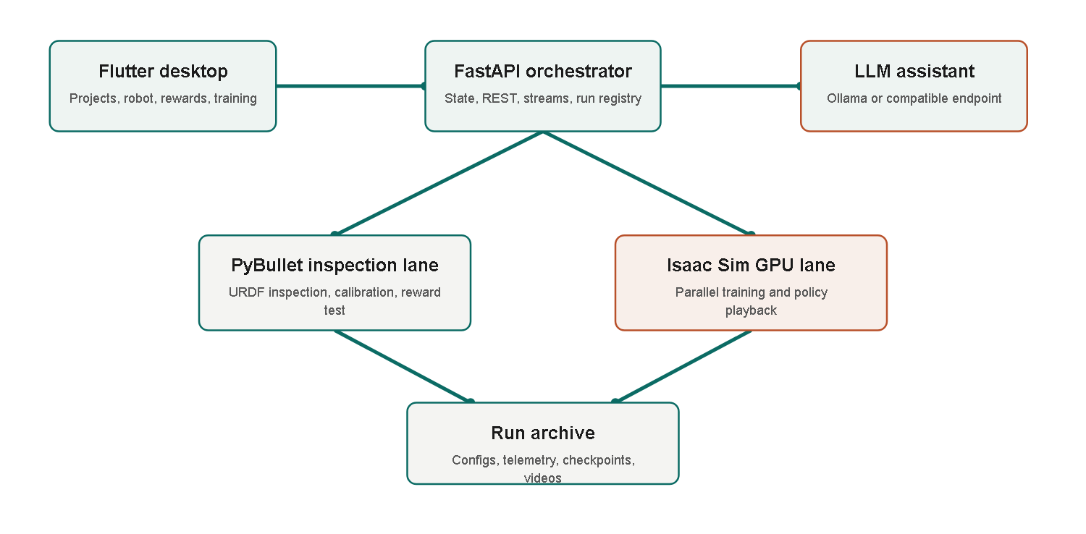
Figure 2. EasyRTG architecture, and the separation between the inspection and GPU training lanes.
The mechanisms follow the order of the workflow. Inspect the robot structure, define a reward against that structure, then let the assistant support configuration and execution. Ordering it that way keeps assistant proposals grounded in the robot that was actually inspected and the vocabulary that actually exists.

4.2 URDF inspection and morphology
The first prototype guessed robot roles from link and joint names, looking for 'hip', 'foot', 'ankle' and the like. It broke the moment a naming convention changed. The morphology layer that replaced it treats the URDF as a kinematic tree instead, working out the base link, the movable joints, the leaf structures, the candidate limbs and the contact links from connectivity and joint properties. Standing height and spawn height are measured against the robot rather than copied from whichever sample model happened to be at hand. Dimensionless signals like height_ratio and upright therefore mean the same thing whether the robot has four legs or two.
None of that makes every URDF automatically trainable. Bad inertial values, unrealistic joint limits and ambiguous contact geometry can still demand calibration. The claim is narrower than it might look. A new robot gets configured from structural evidence rather than from naming rules somebody wrote for a previous model.

4.3 Expression rewards and the shared state vocabulary
Once the structure is known, the behaviour has to be expressed as a reward. An early fixed catalogue let users pick from predefined components only. Simple enough, but it capped the range of behaviours and demanded an application change for every new task. EasyRTG now represents each reward term as a mathematical expression over a shared state vocabulary, including forward_velocity, upright, height_ratio, mean(contact), flight_phase and episode_progress. The morphology layer supplies vector widths, so mean(contact) reads the same whether the robot has two contact limbs, four or six.
Safety comes from compilation rather than from a restricted catalogue. Expressions are parsed into an abstract syntax tree and accepted only if every node is whitelisted. Attribute access and subscripting are excluded, which shuts the door on arbitrary Python execution. Configuration patches compile every enabled expression before saving. A separate audit then evaluates reward scale over synthetic state ranges and flags non-finite values, dominant penalties, all-penalty designs and sums that scale with the number of degrees of freedom. These checks cannot promise that learning will succeed. They do catch several expensive classes of failure before a GPU run begins, which is the point of them.

4.4 Assistant and human oversight
The assistant is what makes expression-based configuration usable by someone who would not write the expressions themselves. It can inspect robot details, calibrate a goal, patch a configuration, test a reward, start or stop training and look at previous runs. Simple requests can be routed to a local Ollama model, while harder goal interpretation can go to an OpenAI-compatible endpoint. The system prompt carries the robot-specific vocabulary and the available reward priors.
Anything that changes configuration or controls a run still needs explicit user approval. That follows human-AI interaction guidance recommending that a system communicate what it can do, make its changes visible, and preserve correction or undo [26]. The approval step is friction, and it is meant to be. It keeps consequential actions reviewable and recoverable.
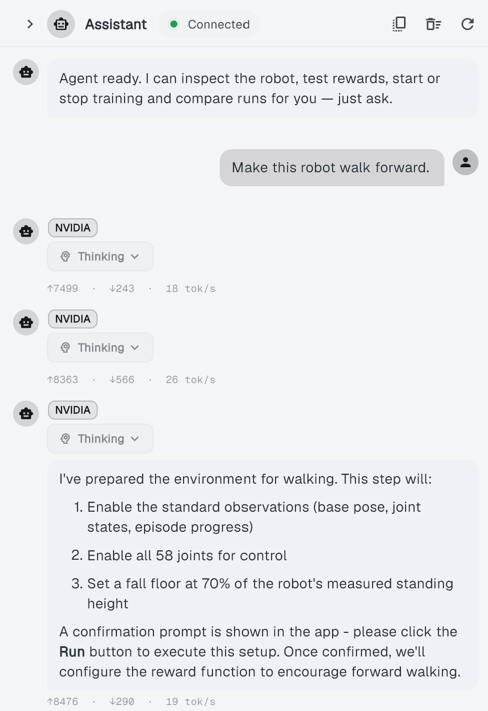
Figure 3. The EasyRTG desktop assistant, showing a generated training configuration and the changes offered for review.

4.5 Training, monitoring and evaluation
Once a configuration is approved, Isaac training runs in a separate subprocess under Isaac Sim's own Python environment, following the installed Isaac Lab workflow [12]. The worker writes telemetry to a file, the backend follows that file and streams it to the Flutter charts. Every run keeps its environment configuration, its observation and action contracts, its checkpoints, its log and its evaluation video. Live evaluation can launch NVIDIA's WebRTC client, and recorded evaluation runs headlessly and produces an MP4 that plays back inside the desktop application.
Keeping all of that is not housekeeping. A reward curve cannot tell you whether a humanoid is walking forward, drifting sideways or simply managing not to fall over. Several interpretations in Chapter 6 rest on the saved configuration, the term-level telemetry and the recorded video, so run provenance is part of the evaluation mechanism rather than a storage convenience.

5 Implementation and Iterative Development

5.1 From proposal to working system
The original proposal described a six-week CPU-first application on PyBullet, Gymnasium and PPO from Stable-Baselines3, meant to run on an average laptop, using predefined reward components with optional custom Python. The finished system diverges from that plan at every point where real technical risk turned up. Training moved to NVIDIA Isaac Sim on a GPU. Custom Python rewards were removed outright. Predefined components became audited expressions. Joint-name rules gave way to morphology inference. The evaluation grew from PPO on sample robots to three algorithms across four robot families.
That is not the proposal failing. The prototype surfaced requirements that no amount of upfront design would have produced. What follows identifies the failures and observations behind each major revision.

5.2 Milestone history
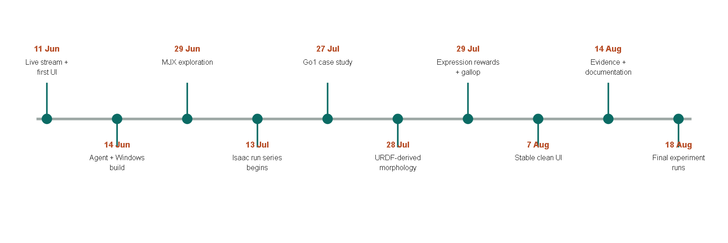
Figure 4. Major implementation and experiment milestones, reconstructed from Git dates and the run archive.
The 11 June commits, 'initial 300x300 30fps stream' and 'most of the app is working and is stable', gave me the first visible prototype. On 14 June, 'most of the agent is working' and 'Make Windows build/run work; stream JPEG sim frames' hooked the assistant up to a desktop build. The commit messages are informal, but this is the phase where one complete user interaction existed end to end before any of the underlying components had been refined.
'Add MJX backend, config revisions, and agent routing' on 29 June introduced an alternative high-performance backend. The next day's commit, 'switching to linux as mujoco isnt working good on win', records the operating-system trouble that stopped that branch from becoming the training lane. It was a useful failure. Simulator and operating-system constraints do not disappear because a desktop interface is sitting on top of them. EasyRTG adopted Isaac Sim as a separate GPU subprocess afterwards, which let the main application stay cross-platform while the training lane kept the platform-specific runtime it needs.
The locomotion case study opened on 27 July with 'added unitree go1 robot as casestudy'. My first walking reward produced a low crawl, because crawling turned out to be the cheaper way to earn forward velocity. 'fix: reject crawling in walk goals' introduced robot-relative height termination and closed that off. On 28 July, 'Derive robot structure from URDF, not joint names; add expression layer' removed the second source of robot-specific assumptions.
The largest redesign landed on 29 July across four commits. 'Evaluate rewards as expressions on the Isaac lane', 'Give the Isaac lane real contact state, so a flight phase is expressible', 'Let the agent author the reward; delete the 4-keyword goal enum', and 'Delete the reward catalogue: expressions are the only reward path'. The last commit of that day, 'Record the gallop result; gait is no longer inexpressible', is the one that captures why the others mattered. Galloping cannot be defined by forward velocity alone, since it needs a flight phase where all four feet leave the ground. Expressing that required Isaac contact state and a reward language able to talk about it. Until both existed, the application simply could not specify the behaviour.
Later work went into interface refinement and error handling. The 30 July commit 'Stop expressions written against observation names from being saved' followed an authoring mistake of mine and added another validation boundary. Refinement carried on to the 7 August commit 'most stable and clean ui'. Commits on 14 August reorganised the architecture notes and updated the presentation and README. Further run directories created on 18 August widened the analysable dataset past what the earlier presentation reported.

5.3 Key engineering decisions
Six decisions came out of that sequence. The table below gives each retained decision, the alternative that was tried, and why the final choice stuck.
Table 5. Engineering decisions that emerged through iteration.
Decision | Alternative encountered | Reason retained
Two simulation lanes | Use PyBullet for everything | Fast inspection stays lightweight, Isaac provides training throughput
Expression rewards | Fixed catalogue or arbitrary Python | More behaviours than a catalogue, safer and more portable than exec
URDF-derived morphology | Joint-name heuristics | Supports unfamiliar naming and robot-relative measurements
Subprocess Isaac worker | Embed Isaac in FastAPI | Isaac uses its own Python and runtime, and can fail without taking the UI down
Human approval gates | Fully autonomous tool execution | Makes consequential changes visible and recoverable
Saved run directories | Ephemeral charts | Enables later recomputation, comparison and failure diagnosis

5.4 Security and reliability improvements
A no-code interface makes the user more dependent on application-level safeguards, not less, so security and reliability belong in the system design. An internal assessment turned up unsafe pickle loading, arbitrary custom reward execution, ungated assistant changes and permissive CORS settings. The worst of those were dealt with during July. The custom-Python reward path was deleted rather than defended behind an ever-growing denylist, and the expression compiler now excludes dangerous syntax by construction. Training, tuning and evaluation workers check for conflicting jobs, and the desktop launcher terminates only the backend process it started itself.

5.5 Role of generative AI in the development process
Claude sped up prototyping by turning my interface specifications into Dart, drafting parts of the backend and helping me read failures. It changed how fast implementation went. It did not change who was responsible for what. I decided what the application should do, chose the architecture, defined the interfaces and validation rules, integrated the generated code and decided what to keep. The Git commits record the resulting sequence, and the automated tests, run telemetry and evaluation videos show how proposed implementations were checked against a system that was actually running.
OpenAI Codex came in only after the application and the evaluation evidence existed. It restyled my original report material and improved the document formatting. It wrote no application code, ran no experiments and settled no findings. That separation matters, because the software-development evidence in this chapter records my decisions and Claude-assisted implementation, whereas the wording of the report is substantially Codex-assisted.

6 Experiments, Results and Findings

6.1 Run coverage and failure history
The earlier project presentation summarised 30 runs up to 3 August 2026, and the README later said 32. A final scan for this report found 40 timestamped run directories. Thirty-four held numeric reward telemetry, six held none. The difference is experiments added in the last fortnight, most of the SAC and TD3 coverage among them. Every fleet-level result in this chapter rests on those 34 analysable runs, listed individually in Appendix D.
Twelve runs held at least 95% of the episode limit. Several reached only partial stability, and one Valkyrie TD3 run produced usable telemetry before failing numerically. The chronological view in Appendix C shows successful policies appearing only after repeated failures around spawning, termination, reward scale and learned behaviour. The final evaluation videos are therefore a small and rather flattering slice of the development evidence.

6.2 Fleet-level results
Table 6. Best observed run for each robot and algorithm pairing.
Robot | Algorithm | Best reward | Episode length | % of cap | Peak steps/s
A1 | PPO | 4,767.0 | 967.5 | 96.8% | 32,056.8
ANYmal | PPO | 769.8 | 954.6 | 95.5% | 21,055.5
Go1 | PPO | 2,073.9 | 962.7 | 96.3% | 27,500.0
Go1 | SAC | 2,250.1 | 1000.0 | 100.0% | 27,840.3
Go1 | TD3 | 2,112.7 | 990.9 | 99.1% | 28,975.6
Valkyrie | PPO | 276.1 | 204.2 | 20.4% | 14,280.0
Valkyrie | SAC | 1,283.8 | 821.0 | 82.1% | 11,171.6
Valkyrie | TD3 | 287.0 | 206.2 | 20.6% | 14,388.8

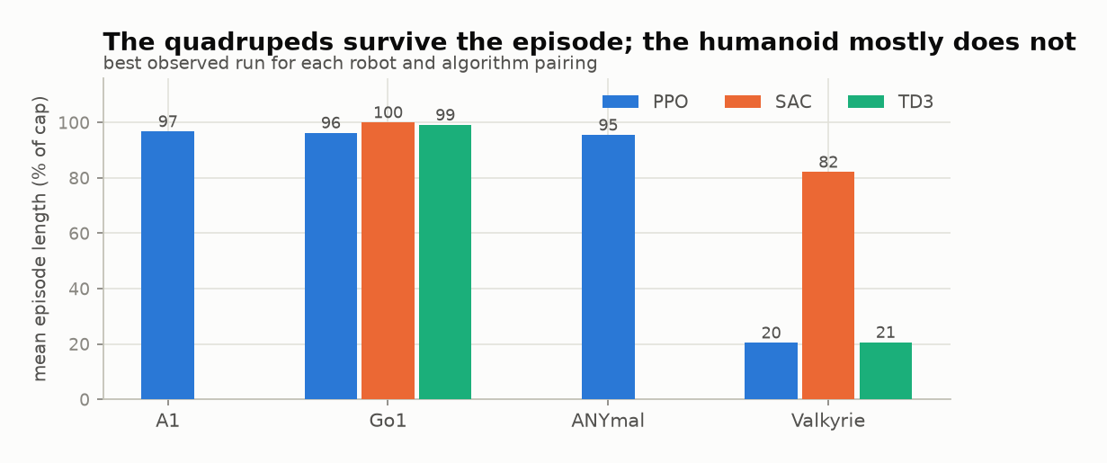
Figure 5. Episode survival for the best observed run in each robot and algorithm pairing.
The quadrupeds survived longest. A1 under PPO reached 967.5 steps and the highest reward anywhere in the archive at 4,767.0. ANYmal under PPO reached 954.6. Go1 managed 962.7 under PPO, the full 1,000 under SAC and 990.9 under TD3. Valkyrie came in lower and split by learner, with PPO at 204.2 steps, SAC at 821.0 and TD3 at 206.2.
Reward totals are worth almost nothing across rows, though, because reward functions differ between robots and tasks. A1's 4,767.0 does not mean it learned better than Go1. Its reward expression simply assigns a different value per step. The % of cap column is the one that compares directly.

6.3 What the reward actually paid for
Since the totals do not compare, the more useful question is which terms produced a given score. EasyRTG logs every reward term separately, so the total can be pulled apart at the point of highest observed performance.
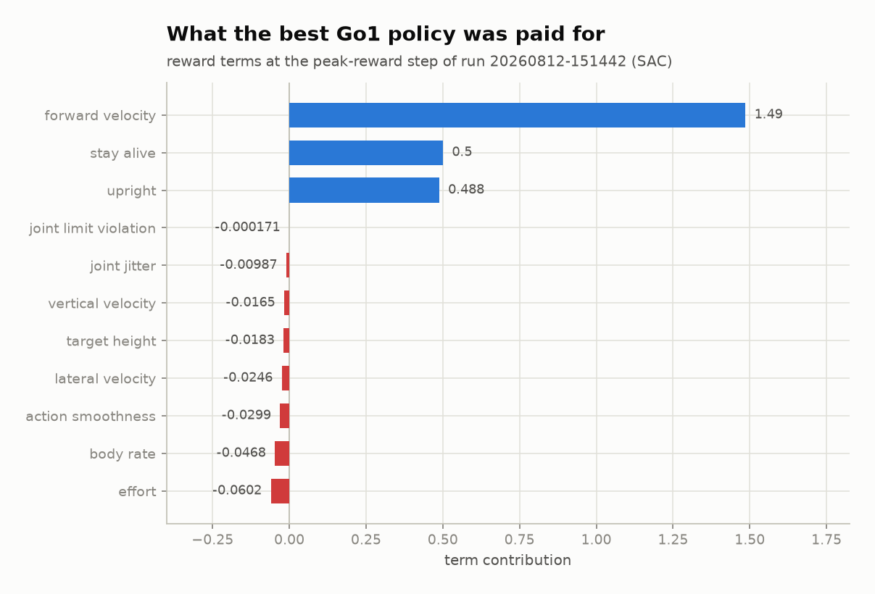
Figure 6. Term-by-term decomposition of the reward at the peak-reward step of the best Go1 run.
Three positive terms dominate. Forward velocity at 1.49, staying alive at 0.50, uprightness at 0.49. The penalties sit one to four orders of magnitude below that. Effort is the largest of them at -0.060, while joint-limit violation is effectively nothing at -0.00017, which says the policy was never pressing against its joint limits.
So the policy earned its score by moving forward while staying upright, much as intended. What the decomposition also shows is that the penalties constrained almost nothing. A reward this heavily weighted towards positive terms stays exposed to exactly the misspecification demonstrated in Section 6.7, which is the argument for the audit described in Section 4.3.

6.4 Throughput and the GPU lane
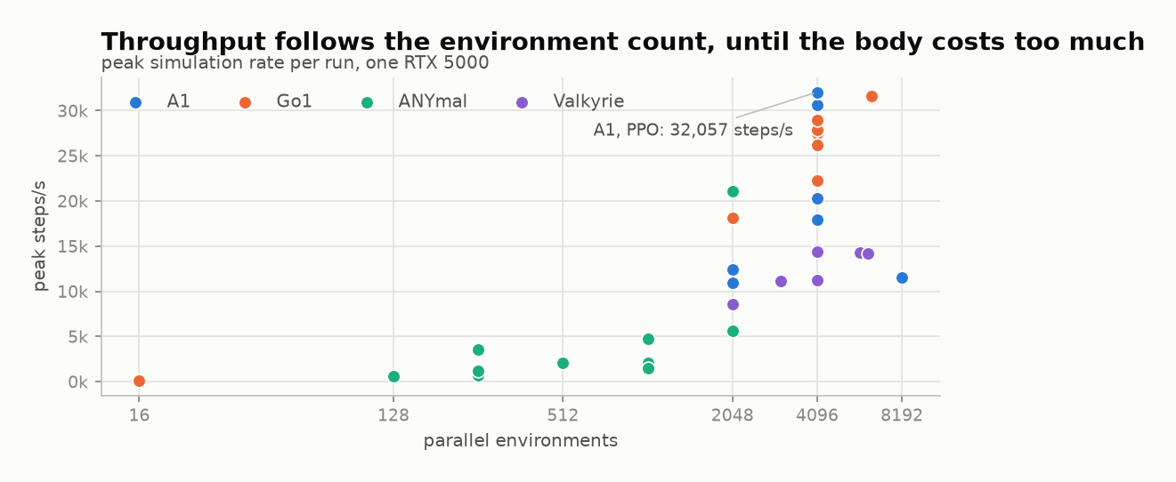
Figure 7. Peak simulation throughput against the number of parallel environments, coloured by robot.
The highest measured throughput was 32,056.8 environment steps per second, from A1 at 4,096 environments. Go1 also passed 30,000 steps per second in recorded runs. Valkyrie never got above roughly 14,600 at any batch size tested.
More environments means more parallel work, but robot morphology sets what each simulated step costs. A humanoid carrying more joints and more bodies is not directly comparable with a quadruped. RQ4 therefore resolves into two interacting factors, where parallelism supplies the available workload and robot complexity fixes the practical ceiling. The two diagnostic runs at 16 environments both stayed under 100 steps per second, something like three hundred times slower than the same robots at 4,096.

6.5 How long learning took
What an experiment costs depends on throughput and on how many steps learning takes. I measured learning time as the number of environment steps before the smoothed mean episode length first stayed above 900, since that indicates sustained stability rather than one lucky logging interval.
Exactly twelve runs crossed that threshold, matching the twelve that reached 95% of the episode limit under a separately calculated measure. Appendix C gives the full ordering. The best ANYmal run crossed after 2.51M steps and the slowest successful Go1 run needed 17.60M. Crossing sooner did not mean scoring higher. The highest-reward A1 run, 20260728-202311 at 4,767.0, took 16.42M steps to stabilise, while an earlier A1 run stabilised after 4.03M and finished with less than half the reward. Learning speed and final score have to be reported separately.

6.6 Go1: three learners, one solved robot
Go1 was the only robot run under all three learners at the same environment count, which makes it the one place a three-way comparison is fair.
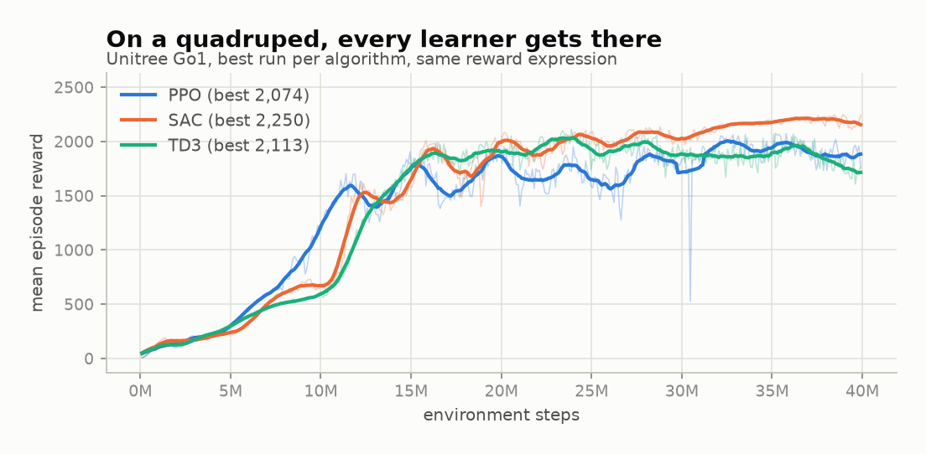
Figure 8. Reward for the best Go1 run under each learner, at 4,096 environments with the same reward expression.
All three converged within 8% on reward. SAC reached 2,250.1, TD3 2,112.7, PPO 2,073.9. Episode survival was similarly close at 100%, 99.1% and 96.3% of the limit. Where they differ is in the shape of the trace. SAC improves in distinct stages, PPO climbs more smoothly, and TD3 rises fastest early on before flattening out.
None of that makes the algorithms equivalent. It makes the Go1 task tractable enough that all three approached saturation, which is useful mainly as a baseline showing the pipeline does not visibly favour one learner over another. The harder Valkyrie task in Section 6.8 is where they come apart.

6.7 Go1 walking and galloping
Go1 also shows how completely reward semantics determine what gets learned. The walking reward asked for forward motion, uprightness and sustained ground contact. The galloping reward added a flight phase where all four feet leave the ground. In the presentation experiments the walking policy travelled at 0.98 m/s, held an uprightness of 0.99 and survived 963 steps. The galloping policy hit 1.38 m/s, survived the full episode and was airborne for 43% of the stride. Same robot, same training budget. Only the reward semantics changed.
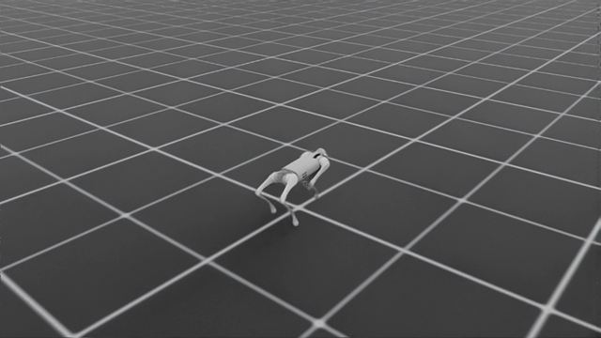
Figure 9. The Unitree Go1 during recorded policy evaluation.
Then the three-algorithm comparison exposed a hole in the galloping reward. TD3 was fastest at roughly 1.65 m/s and had the lowest flight fraction at 29%. SAC was slower at 1.52 m/s with a 52% flight fraction. TD3 had learned a fast trot that scored well and was not a gallop at all.
This is the reward-misspecification failure the literature predicts [14, 15], arriving on schedule. It is also the clearest argument in the whole project for keeping contact-state measurements and video inspection alongside reward, because a high reward on its own is not evidence that the intended task was learned.

6.8 Valkyrie: a controlled algorithm comparison
The strongest controlled comparison in the archive is SAC against TD3 on Valkyrie. Both runs use the same reward expression and the same 40M-step budget, so the tested configuration is constant apart from the learner.
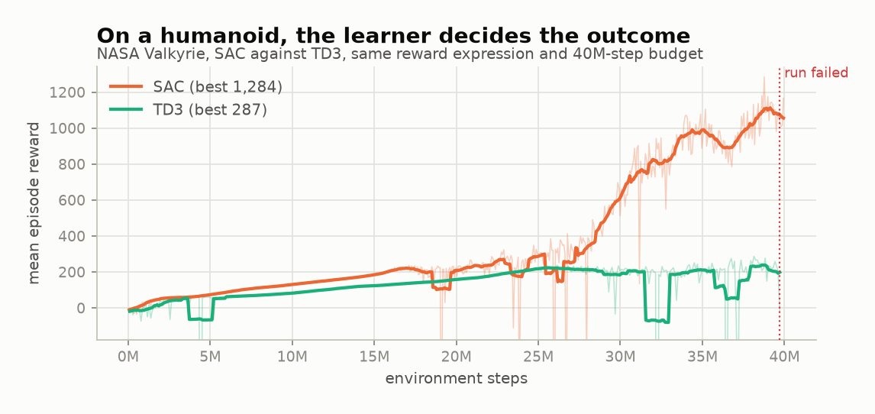
Figure 10. Reward for Valkyrie under SAC and TD3, same reward expression and same 40M-step budget.
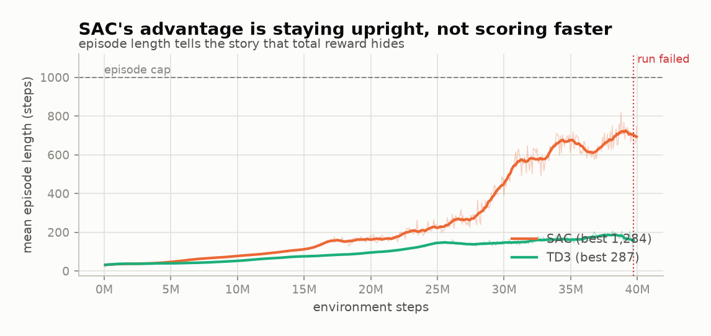
Figure 11. Episode length reveals that SAC's advantage came from staying upright, not from scoring faster.
Both improved at first and tracked each other for around 20 million steps. After that they parted. SAC reached a best mean reward of 1,283.8 with a mean episode length of 821.0 steps. TD3 hovered near 200 steps of survival, peaked at 287.0 reward, and eventually stopped after producing NaN observations. The dotted line in the figures marks where it failed.
At their best checkpoints the two policies earned broadly similar reward per step. SAC accumulated a larger total because it kept collecting for roughly four times as many steps before going down, so its advantage was survival rather than a better scoring rate. TD3's telemetry also showed several reward terms growing by orders of magnitude before the failure, which points at critic or numerical instability rather than a simple inability to move forward.
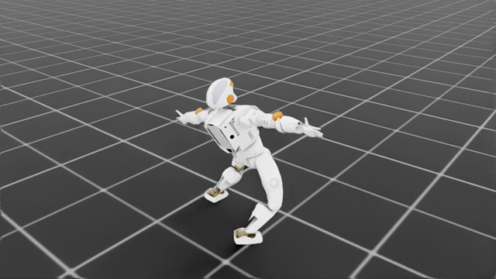
Figure 12. The NASA Valkyrie during recorded SAC policy evaluation.
Learner choice clearly changed the Valkyrie outcome under this configuration, with SAC surviving far longer than TD3. That is a result for one task and one configuration. It is not evidence that SAC is generally the better algorithm, and Section 7.3 sets out how far the comparison can be pushed.

6.9 Functional verification
The 256 passing backend tests are a second kind of evidence entirely. They demonstrate no robot behaviour whatsoever. What they verify are the mechanisms you need in place before the training results can be interpreted at all, which is to say morphology handling, action mapping, the state vocabulary, expression guards, episode clocks, contact signals, Isaac bridge calculations, configuration phases and failure handling.
Neither kind of evidence stands alone. A convincing-looking gait says nothing about configuration safety, and a full set of passing checks says nothing about whether the output is useful locomotion or an elaborate way to fall over. The galloping result in Section 6.7 makes the point exactly. It satisfied every software check and still produced the wrong gait. That gap between automated verification and behavioural evaluation is why both have to run.

7 Discussion

7.1 Answering the research questions
On RQ1 and configuration with human oversight, EasyRTG splits configuration into structural checks, relative calibration, and reward writing against an approved vocabulary, with compilation and audit happening automatically before any tool runs. Users never touch the underlying environment source. What is missing is a comparative user study measuring the time this actually saves, and until that exists the claim stays architectural.
On RQ2 and applicability across robot bodies, treating morphology and state terms as dimensionless values lets one pipeline produce viable policies for the A1, ANYmal and Go1 quadrupeds and for the Valkyrie humanoid. That removes the fixed geometric assumptions that usually constrain a simulation pipeline. The results confirm it works across those specific URDF models. Manipulators and wheeled robots would need substantial architectural change.
On RQ3 and differences between learners, all three algorithms hit near-identical performance caps on the Go1, with negligible variance in final reward inside that environment. Valkyrie went the other way. SAC was the only learner that produced a stable gait there, while PPO and TD3 both failed to. Uneven algorithm coverage and incomplete hyperparameter tuning weaken these conclusions and should be read as limiting them rather than qualifying them politely.
On RQ4 and simulation throughput, parallel environments scaled throughput until robot physics imposed a ceiling. One GPU handled 32,056 steps per second across 4,096 environments for the A1 configuration. Valkyrie fell short of that because its mass and joint count raise rigid-body solver latency. These figures are consistent with the GPU-native results reported by Makoviychuk et al. [10] and Rudin et al. [13], and with the architectural move toward Isaac described in Section 5.2.

7.2 What the project learned about abstraction
The real design problem was deciding which layers of complexity have to stay visible. Hiding simulator installation does not make hardware constraints or operating-system dependencies go away, and the MJX experiment proved it when sandboxed execution could not hold itself apart from the host GPU drivers. Arbitrary Python permits unconstrained state mutation and compromises the runtime. A static reward catalogue avoids that risk and then cannot express anything complicated. EasyRTG settled it by exposing only the inputs that actually drive learning, meaning observations, actions and termination signals, and compiling the rest into a controlled backend.
Scoping the assistant was harder still. It generates configuration that has to pass validation before anything executes, which makes it a drafting tool inside a frame of human oversight rather than an autonomous agent. The evidence for that scoping is unglamorous and specific, six pre-telemetry failures and dozens of short-lived policies. A language model lightens the setup phase considerably. It does not replace expert diagnosis, and the Valkyrie TD3 failure is the clearest case, where the divergence showed up as NaN observations and reward terms climbing by orders of magnitude, and no automated check in the system flagged it as anything other than a run that stopped.

7.3 Limitations and threats to validity
- The testing matrix favours some configurations heavily over others.
- SAC and TD3 only ever ran on Go1 and Valkyrie, while A1 and ANYmal stayed on PPO. That rules out any broad claim about algorithm consistency across robots.
- Fleet summaries report the single best run per pairing rather than an average over random seeds, so they describe peak observed capability and not typical performance.
- Throughput came from one RTX 5000. Those numbers are not a benchmark for anyone else's hardware.
- Every policy was evaluated in simulation, with no domain randomisation and no physical transfer.
- The no-code argument is an architectural claim at this stage, not a verified one. Without user studies measuring task completion and errors, it stays unproven.
- Outcomes still depend on the URDF itself, because inference cannot repair bad mass distribution or wrong joint limits hidden inside the file.
- Observations stayed locked at seven keys even though rewards became flexible. Camera feeds, terrain mapping, ROS networking and multi-agent support are all absent.
- Verification covered backend logic only. The Flutter tool would not run in the test environment, so frontend status is entirely unconfirmed.

7.4 Practical and academic significance
Practically, EasyRTG offers an integrated path from a robot file to a recorded policy, holding configuration, training and supporting evidence in one application. Academically, it is a case study in language-assisted reward design that does not permit unrestricted code execution. The uneven run archive makes a further point by showing why reward, episode survival and task-specific behaviour have to be read together rather than one at a time.
What the project does not show is that robot learning has become easy. The more defensible claim is that the important configuration decisions are now visible, reviewable and repeatable, and that when one of them is wrong, as the galloping reward was, the retained evidence lets you find it.

8 Conclusion and Future Work

8.1 Conclusion
This project produced an integrated desktop platform that lets a user import a URDF robot, describe a locomotion task in natural language, and train a reinforcement-learning policy without writing simulator code. All five objectives from Chapter 1 were met.
The system runs on a Flutter frontend and a FastAPI backend, uses PyBullet for inspection and NVIDIA Isaac Sim on GPU for training, and derives control-relevant structure from the URDF tree rather than from naming conventions. Rewards are written and audited as mathematical expressions over an established vocabulary, drafted by an LLM that operates under user validation. Thirty-four Isaac runs across four robot families and three continuous-control algorithms make up the evaluation.
Three findings stand out. GPU-parallel execution removed the CPU bottleneck, peaking at 32,056.8 environment steps per second on one RTX 5000 workstation. On a quadruped like the Go1 the choice of learner barely mattered, with PPO, SAC and TD3 all clearing 96% episode survival and converging on comparable rewards. On the higher-dimensional Valkyrie it decided everything. SAC was the only learner that stayed balanced, reaching 82.1% survival, while PPO and TD3 stalled around 20% and TD3 then degenerated into numerical instability.
Most of the engineering came out of fixing things that broke. Early failures forced robot-relative floor-falling terminations. Brittle name-based rules were thrown out for kinematic tree traversal. Safety concerns around arbitrary Python execution led to the AST expression compiler. The galloping task is what forced explicit modelling of foot contact state inside Isaac Sim, because without it the behaviour could not be expressed.
The Go1 galloping test also produced the most instructive failure in the project. An imprecise reward specification let TD3 learn a fast trot that accumulated a high score while leaving out the airtime the task was supposed to require. Total reward, on its own, is a poor indicator of behaviour. Without contact signals, episode length and a look at the video, a large number tells you very little. The assistant showed the same pattern in miniature, frequently producing workable reward functions from natural language while still needing a much larger validation set before it could be trusted on anything complicated.
What began as a CPU-based idea ended as a working pipeline. Robot locomotion, reward design and GPU-accelerated training can be brought together in one no-code desktop application, provided the user keeps a hand on it.

8.2 Future work
A controlled usability study comes first. Comparing the EasyRTG workflow against a documented code-based baseline, measuring task completion time, configuration errors, requests for help and a validated usability scale, is the only way to test the no-code claim empirically instead of inferring it from the architecture.
Observation expressions and per-episode velocity commands should arrive together, so that one policy can respond to changing instructions rather than a single fixed goal. A campaign worker could then propose, audit and test reward revisions on its own while keeping the user-approval mechanism from Section 4.4 intact.
Beyond that, terrain and sensor observations, better automatic dynamics checks, more robots evaluated with balanced seeds and algorithm budgets, and throughput measured on other GPUs. Hyperparameters deserve a reproducible optimisation framework such as Optuna [27] rather than the one-at-a-time approach used here. Domain randomisation and hardware export are the last requirement, since without them EasyRTG cannot claim a complete route from simulation to a physical robot. DrEureka is the relevant model for that stage [18].

Bibliography

[1] | R. S. Sutton and A. G. Barto, Reinforcement Learning: An Introduction, 2nd ed., Cambridge, MA: MIT Press, 2018.
[2] | J. Kober, J. A. Bagnell, and J. Peters, "Reinforcement learning in robotics: A survey," International Journal of Robotics Research, vol. 32, no. 11, pp. 1238-1274, 2013.
[3] | J. Schulman, F. Wolski, P. Dhariwal, A. Radford, and O. Klimov, "Proximal policy optimization algorithms," arXiv:1707.06347, 2017.
[4] | T. Haarnoja, A. Zhou, P. Abbeel, and S. Levine, "Soft actor-critic: Off-policy maximum entropy deep reinforcement learning with a stochastic actor," in Proceedings of ICML, pp. 1861-1870, 2018.
[5] | S. Fujimoto, H. van Hoof, and D. Meger, "Addressing function approximation error in actor-critic methods," in Proceedings of ICML, pp. 1587-1596, 2018.
[6] | G. Brockman et al., "OpenAI Gym," arXiv:1606.01540, 2016.
[7] | M. Towers et al., "Gymnasium: A standard interface for reinforcement learning environments," arXiv:2407.17032, 2024.
[8] | A. Raffin et al., "Stable-Baselines3: Reliable reinforcement learning implementations," Journal of Machine Learning Research, vol. 22, no. 268, pp. 1-8, 2021.
[9] | E. Coumans and Y. Bai, "PyBullet, a Python module for physics simulation for games, robotics and machine learning," 2016-2021. [Online]. Available: https://pybullet.org/.
[10] | V. Makoviychuk et al., "Isaac Gym: High performance GPU-based physics simulation for robot learning," arXiv:2108.10470, 2021.
[11] | M. Mittal et al., "Orbit: A unified simulation framework for interactive robot learning environments," IEEE Robotics and Automation Letters, vol. 8, no. 6, pp. 3740-3747, 2023.
[12] | NVIDIA, "Isaac Lab documentation," 2026. [Online]. Available: https://isaac-sim.github.io/IsaacLab/.
[13] | N. Rudin, D. Hoeller, P. Reist, and M. Hutter, "Learning to walk in minutes using massively parallel deep reinforcement learning," in Proceedings of CoRL, PMLR vol. 164, pp. 91-100, 2022.
[14] | A. Y. Ng, D. Harada, and S. Russell, "Policy invariance under reward transformations: Theory and application to reward shaping," in Proceedings of ICML, pp. 278-287, 1999.
[15] | P. Henderson et al., "Deep reinforcement learning that matters," in Proceedings of AAAI, vol. 32, no. 1, 2018.
[16] | L. Engstrom et al., "Implementation matters in deep policy gradients: A case study on PPO and TRPO," in Proceedings of ICLR, 2020.
[17] | Y. J. Ma et al., "Eureka: Human-level reward design via coding large language models," arXiv:2310.12931, 2023.
[18] | Y. J. Ma et al., "DrEureka: Language model guided sim-to-real transfer," in Proceedings of Robotics: Science and Systems, 2024.
[19] | N. Koenig and A. Howard, "Design and use paradigms for Gazebo, an open-source multi-robot simulator," in Proceedings of IEEE/RSJ IROS, pp. 2149-2154, 2004.
[20] | A. Juliani et al., "Unity: A general platform for intelligent agents," arXiv:1809.02627, 2020.
[21] | L. Ye et al., "Unity RL Playground: A versatile reinforcement learning framework for mobile robots," arXiv:2503.05146, 2025.
[22] | A. R. Hevner, S. T. March, J. Park, and S. Ram, "Design science in information systems research," MIS Quarterly, vol. 28, no. 1, pp. 75-105, 2004.
[23] | K. Peffers, T. Tuunanen, M. A. Rothenberger, and S. Chatterjee, "A design science research methodology for information systems research," Journal of Management Information Systems, vol. 24, no. 3, pp. 45-77, 2007.
[24] | Flutter, "Flutter desktop documentation," 2026. [Online]. Available: https://docs.flutter.dev/platform-integration/desktop.
[25] | FastAPI, "FastAPI documentation," 2026. [Online]. Available: https://fastapi.tiangolo.com/.
[26] | S. Amershi et al., "Guidelines for human-AI interaction," in Proceedings of CHI, paper 3, pp. 1-13, 2019.
[27] | T. Akiba, S. Sano, T. Yanase, T. Ohta, and M. Koyama, "Optuna: A next-generation hyperparameter optimization framework," in Proceedings of KDD, pp. 2623-2631, 2019.

Appendix A GitLab Repository and Running the Project

A.1 Repository
The GitLab project lives at https://git.cs.bham.ac.uk/projects-2025-26/sxc1742
The backend directory holds the FastAPI orchestration service, robot inspection, configuration services, reinforcement-learning logic, Isaac subprocess workers and assistant tools. The Flutter desktop application lives in frontend/rtg-flutter-app. Architecture notes, setup records and design plans are in docs, and scripts carries the Windows and Linux launchers, build tools and media generators. Every numerical result in Chapter 6 traces back to backend/runs, which stores each experiment's configuration, telemetry, checkpoints and evaluation video.

A.2 Minimum setup
- Install Python 3.12, the Flutter desktop tooling and the backend packages listed in backend/requirements.txt.
- For GPU training, install NVIDIA Isaac Sim 6.0.1 and Isaac Lab 3.0 as described in docs/isaac_setup.md.
- Create the Python environment with uv and install the backend requirements into it.
- Start both services using scripts/dev_run.ps1 on Windows or scripts/dev_run.sh on Linux.
- Load a URDF, configure the goal and reward, run Test reward, then launch Isaac training from the desktop application.

A.3 Verification commands
Backend tests.
$env:PYTEST_DISABLE_PLUGIN_AUTOLOAD=1; .\.venv\Scripts\python.exe -m pytest backend\tests\ -q --basetemp=.pytest_tmp
Frontend.
cd frontend\rtg-flutter-app; flutter analyze; flutter test
Report figures.
py -m uv run --python 3.12 --with matplotlib --with numpy python scripts/make_report_figures.py
Report document.
.venv\Scripts\python.exe scripts\write_report.py

Appendix B Experiment Coverage
Table 7. Coverage of the 34 analysable Isaac runs by robot and algorithm.
Robot | PPO | SAC | TD3 | Total analysable
A1 | 8 | 0 | 0 | 8
ANYmal | 10 | 0 | 0 | 10
Go1 | 4 | 3 | 2 | 9
Valkyrie | 3 | 3 | 1 | 7

Six timestamped run directories held no numeric reward telemetry and are kept as pre-telemetry failures. The extra p3gallop directory does not follow the timestamped *-isaac naming convention and is left out of fleet-level calculations. Figures come from the run archive by way of scripts/make_report_figures.py, and the run directories remain the authoritative source.

Appendix C Supplementary Figures
These figures support the analysis in Chapter 6 and sit in the appendix to keep the main body inside the page limit. Each one is generated from the same run archive as the figures in the main text.
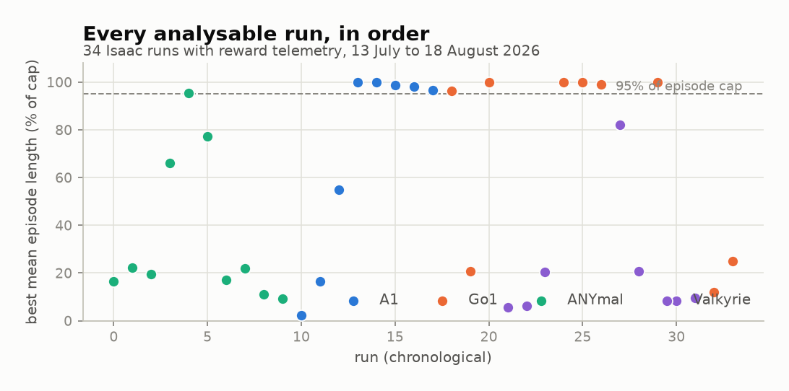
Figure 13. Best mean episode length for every analysable Isaac run, in chronological order.
The chronological view describes development history rather than any single experimental outcome. Early ANYmal runs cluster at low episode lengths, while A1 and Go1 runs from late July onwards cluster near the episode limit. The two runs at 16 environments were added on 18 August as diagnostics and mark the lower end of the throughput relationship discussed in Section 6.4.
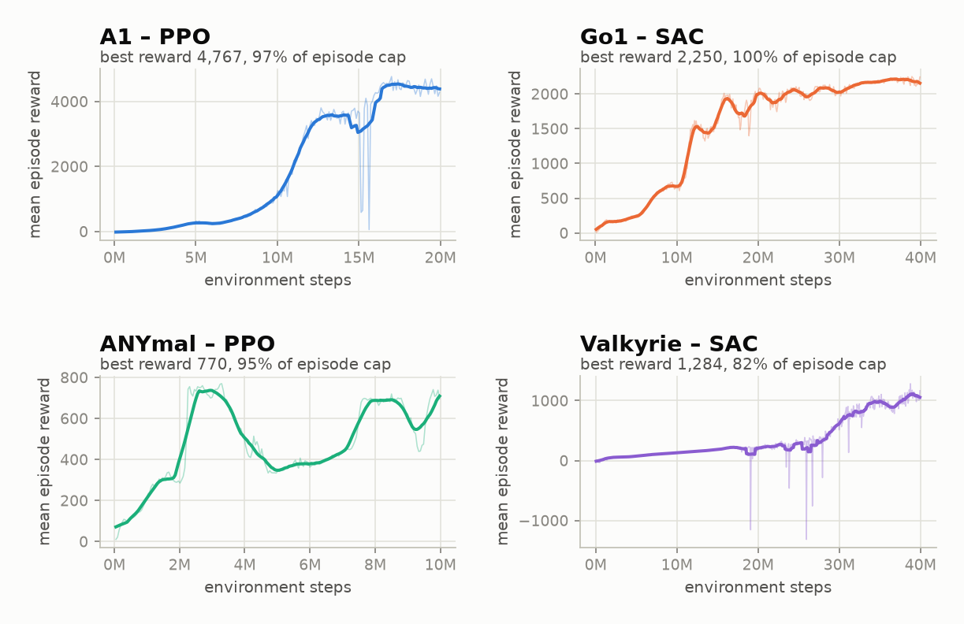
Figure 14. Reward against environment steps for the best run of each robot family.
Each robot's best run is plotted on the same scale within its own panel. A1 improves quickly and picks up again near 16M steps. Go1 improves in visible stages. ANYmal stays unstable and loses roughly half its reward between 3M and 5M steps before recovering, which is why ten attempts were needed. Valkyrie improves slowly for 25M steps and then accelerates, so a shorter training budget would have produced a different conclusion about humanoid learning entirely.
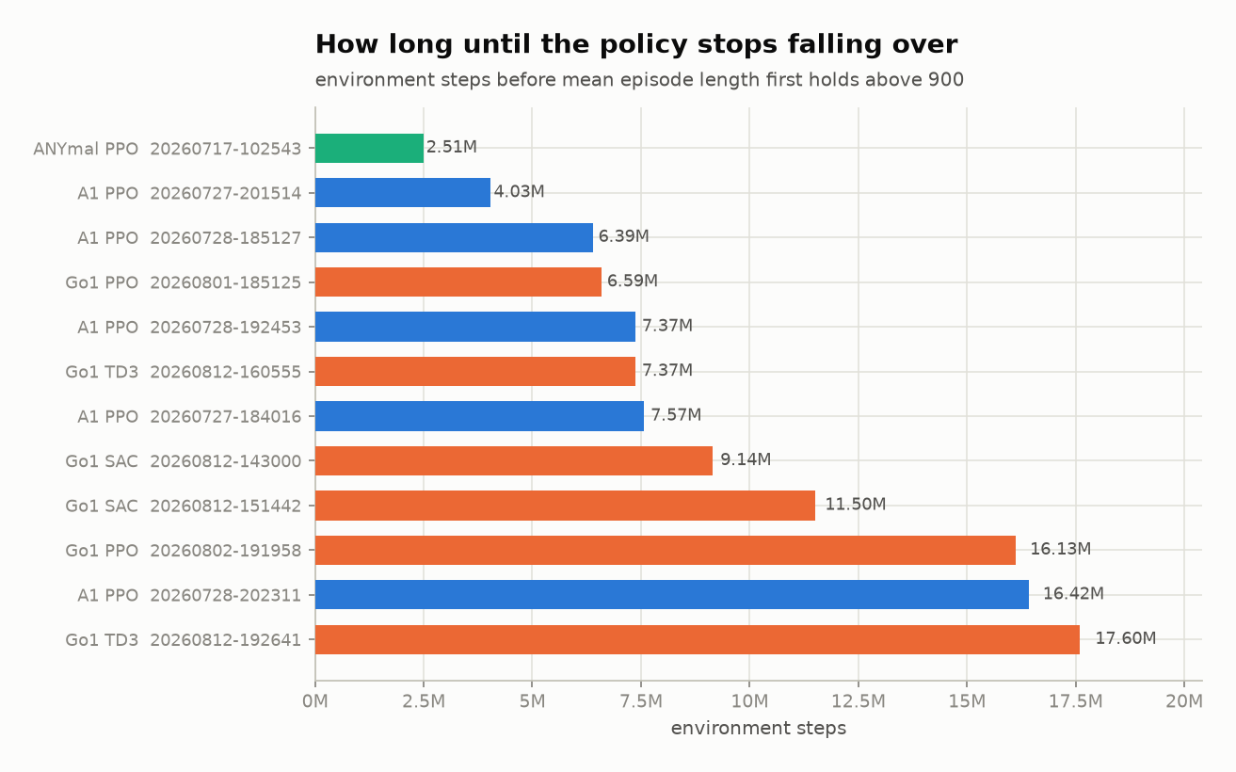
Figure 15. Environment steps before each run's smoothed mean episode length first holds above 900.
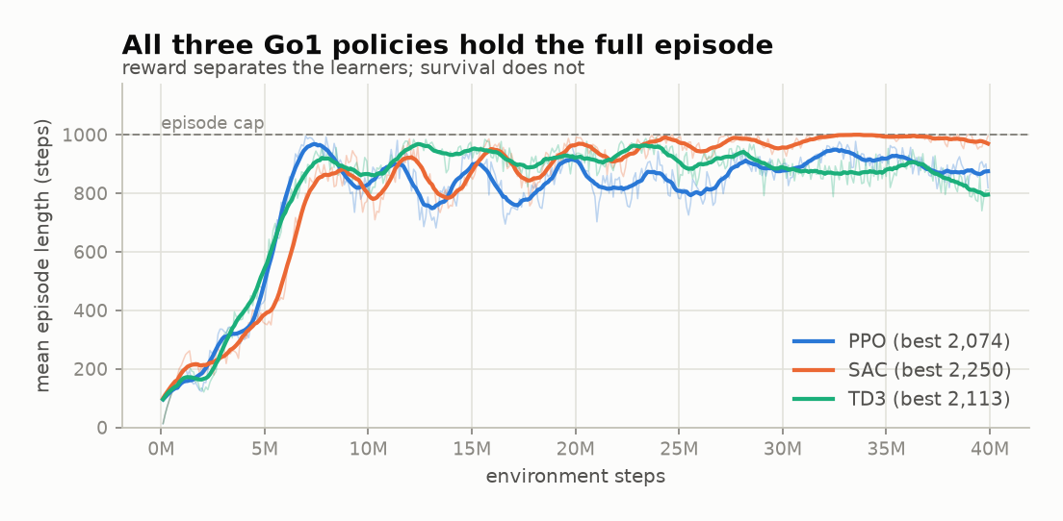
Figure 16. Episode length for the best Go1 run under each learner.
All three Go1 learners reach and hold the episode limit, so survival does not separate them on this robot. The Valkyrie comparison in Section 6.8 is separated by survival almost entirely.

Appendix D Full Run Index
Table D.1 lists every analysable run in the archive. Best reward is the highest observed mean episode reward. Episode length is the mean episode length at that same step, and peak steps per second is the highest recorded throughput. The fleet-level values in Chapter 6 all derive from this table.
Table 8. All 34 analysable Isaac runs, 13 July to 18 August 2026.
Run | Robot | Algorithm | Envs | Best reward | Episode length | % of cap | Peak steps/s
20260713-083121 | ANYmal | PPO | 512 | 137.0 | 165.9 | 16.6% | 2,095
20260713-084227 | ANYmal | PPO | 256 | 193.4 | 222.2 | 22.2% | 738
20260717-093639 | ANYmal | PPO | 256 | 159.1 | 195.4 | 19.5% | 1,207
20260717-093932 | ANYmal | PPO | 256 | 518.0 | 659.4 | 65.9% | 3,572
20260717-102543 | ANYmal | PPO | 2048 | 769.8 | 954.6 | 95.5% | 21,056
20260717-110526 | ANYmal | PPO | 128 | 738.2 | 771.6 | 77.2% | 591
20260722-133515 | ANYmal | PPO | 2048 | 144.0 | 170.5 | 17.0% | 5,582
20260722-140347 | ANYmal | PPO | 1024 | 174.6 | 219.7 | 22.0% | 2,047
20260722-141517 | ANYmal | PPO | 1024 | 93.1 | 112.0 | 11.2% | 4,745
20260722-141803 | ANYmal | PPO | 1024 | 76.7 | 93.0 | 9.3% | 1,525
20260727-173801 | A1 | PPO | 2048 | 12.3 | 22.5 | 2.2% | 12,420
20260727-180733 | A1 | PPO | 2048 | 152.0 | 164.2 | 16.4% | 10,966
20260727-182222 | A1 | PPO | 8192 | 506.5 | 547.6 | 54.8% | 11,493
20260727-184016 | A1 | PPO | 4096 | 2,146.8 | 1000.0 | 100.0% | 17,925
20260727-201514 | A1 | PPO | 4096 | 2,338.3 | 1000.0 | 100.0% | 20,285
20260728-185127 | A1 | PPO | 4096 | 1,865.3 | 988.3 | 98.8% | 30,599
20260728-192453 | A1 | PPO | 4096 | 1,900.9 | 979.9 | 98.0% | 28,462
20260728-202311 | A1 | PPO | 4096 | 4,767.0 | 967.5 | 96.8% | 32,057
20260801-185125 | Go1 | PPO | 4096 | 2,073.9 | 962.7 | 96.3% | 27,500
20260801-215400 | Go1 | PPO | 2048 | 147.7 | 208.8 | 20.9% | 18,081
20260802-191958 | Go1 | PPO | 6400 | 1,600.6 | 1000.0 | 100.0% | 31,631
20260803-211052 | Valkyrie | PPO | 4096 | 88.3 | 55.9 | 5.6% | 14,556
20260803-230732 | Valkyrie | PPO | 4096 | 96.1 | 62.4 | 6.2% | 11,230
20260803-233317 | Valkyrie | PPO | 5800 | 276.1 | 204.2 | 20.4% | 14,280
20260812-143000 | Go1 | SAC | 4096 | 1,952.9 | 1000.0 | 100.0% | 26,180
20260812-151442 | Go1 | SAC | 4096 | 2,250.1 | 1000.0 | 100.0% | 27,840
20260812-160555 | Go1 | TD3 | 4096 | 2,112.7 | 990.9 | 99.1% | 28,976
20260812-165024 | Valkyrie | SAC | 3048 | 1,283.8 | 821.0 | 82.1% | 11,172
20260812-181127 | Valkyrie | TD3 | 4096 | 287.0 | 206.2 | 20.6% | 14,389
20260812-192641 | Go1 | TD3 | 4096 | 1,905.0 | 1000.0 | 100.0% | 22,239
20260813-175701 | Valkyrie | SAC | 6200 | 251.3 | 82.8 | 8.3% | 14,182
20260813-190946 | Valkyrie | SAC | 2048 | 140.0 | 94.1 | 9.4% | 8,540
20260818-084821 | Go1 | SAC | 16 | 97.5 | 121.1 | 12.1% | 96
20260818-145041 | Go1 | PPO | 16 | 147.2 | 250.4 | 25.0% | 80

Twelve runs hold at least 95% of the episode limit. Five A1 PPO runs from 27 and 28 July, one ANYmal PPO run from 17 July at 2,048 environments, and all six Go1 runs at 4,096 environments or more. No Valkyrie run reaches that threshold.

Appendix E Compute Environment and Reproduction Notes
Every training and evaluation result came from one workstation. Anyone reproducing these experiments needs to account for the pre-release state of the simulator stack.
Table 9. Compute and software environment used for all experiments.
Component | Version or specification
GPU | One NVIDIA RTX 5000
Isaac Sim | 6.0.1-rc.7
Isaac Lab | 3.0.0-beta2 (`v3.0.0-beta2.patch1`)
Physics backend | Newton (replaces `omni.physics.tensors` from Isaac Sim 6.0)
Isaac Sim Python | 3.12, bundled with Isaac Sim
Application Python | 3.12, project virtual environment
Inspection simulator | PyBullet, headless
Backend | FastAPI
Desktop client | Flutter
Episode cap | 1,000 steps

Isaac Sim here is a release candidate and Isaac Lab is a beta. Isaac Sim 6.0 also swaps the earlier omni.physics.tensors implementation for the Newton physics backend, so results from an earlier build should not be expected to line up with these. Isaac Sim runs its own bundled Python and cannot execute inside the application virtual environment, which is the practical reason for the subprocess architecture in Section 4.5.
Three further conditions apply to reproduction. Throughput values are peak observations rather than sustained averages and shift with environment count. The two 16-environment runs are diagnostics, not failed training attempts. And every figure regenerates from backend/runs through scripts/make_report_figures.py, so adding a run and re-running the figure and document scripts updates the reported evidence without anybody editing it by hand.

