Socket Performance Analysis Report
Assignment: GRS_PA02
Student ID: MT25043
Course: GRS
Date: February 2026
GitHub: https://github.com/shivam697/GRS_PA02

________________________________________________________________________________

Table of Contents
- Implementation Overview
- Part A: Three Socket Approaches
- Part E: Performance Analysis
- Experimental Results
- AI Usage Declaration

________________________________________________________________________________

Implementation Overview

This assignment implements and compares three socket communication approaches:

Approach | Method | Key Features
Two-Copy | send() + recv() | Baseline with memcpy to intermediate buffer
One-Copy | sendmsg() + iovec | Scatter-gather I/O, eliminates memcpy
Zero-Copy | MSG_ZEROCOPY | DMA transfer, async completion

Test Setup:
- Network namespaces (ns1 ↔ ns2) with veth pairs
- Message sizes: 1KB, 4KB, 16KB, 64KB
- Thread counts: 1, 2, 4, 8
- Profiling: perf stat (cycles, cache misses, context switches)
- Visualization: 4 matplotlib plots

________________________________________________________________________________

Part A: Three Socket Approaches

A1: Two-Copy Implementation (Baseline)

How it works:
User buffers (8 fields)
→ memcpy() to intermediate buffer [COPY #1]
→ send() to kernel socket buffer [COPY #2]
→ Network

Code snippet (Server):
[c]
char* send_buffer = malloc(g_msg_size);
for (int i = 0; i < 8; i++) {
memcpy(current_pos, msg->field[i], field_size); // COPY #1
current_pos += field_size;
}
send(client_socket, send_buffer, g_msg_size, 0); // COPY #2

Performance: Throughput = 43.90 Gbps @ 64KB, 4 threads

[SCREENSHOT: Terminal showing server accepting connection and client throughput/latency]
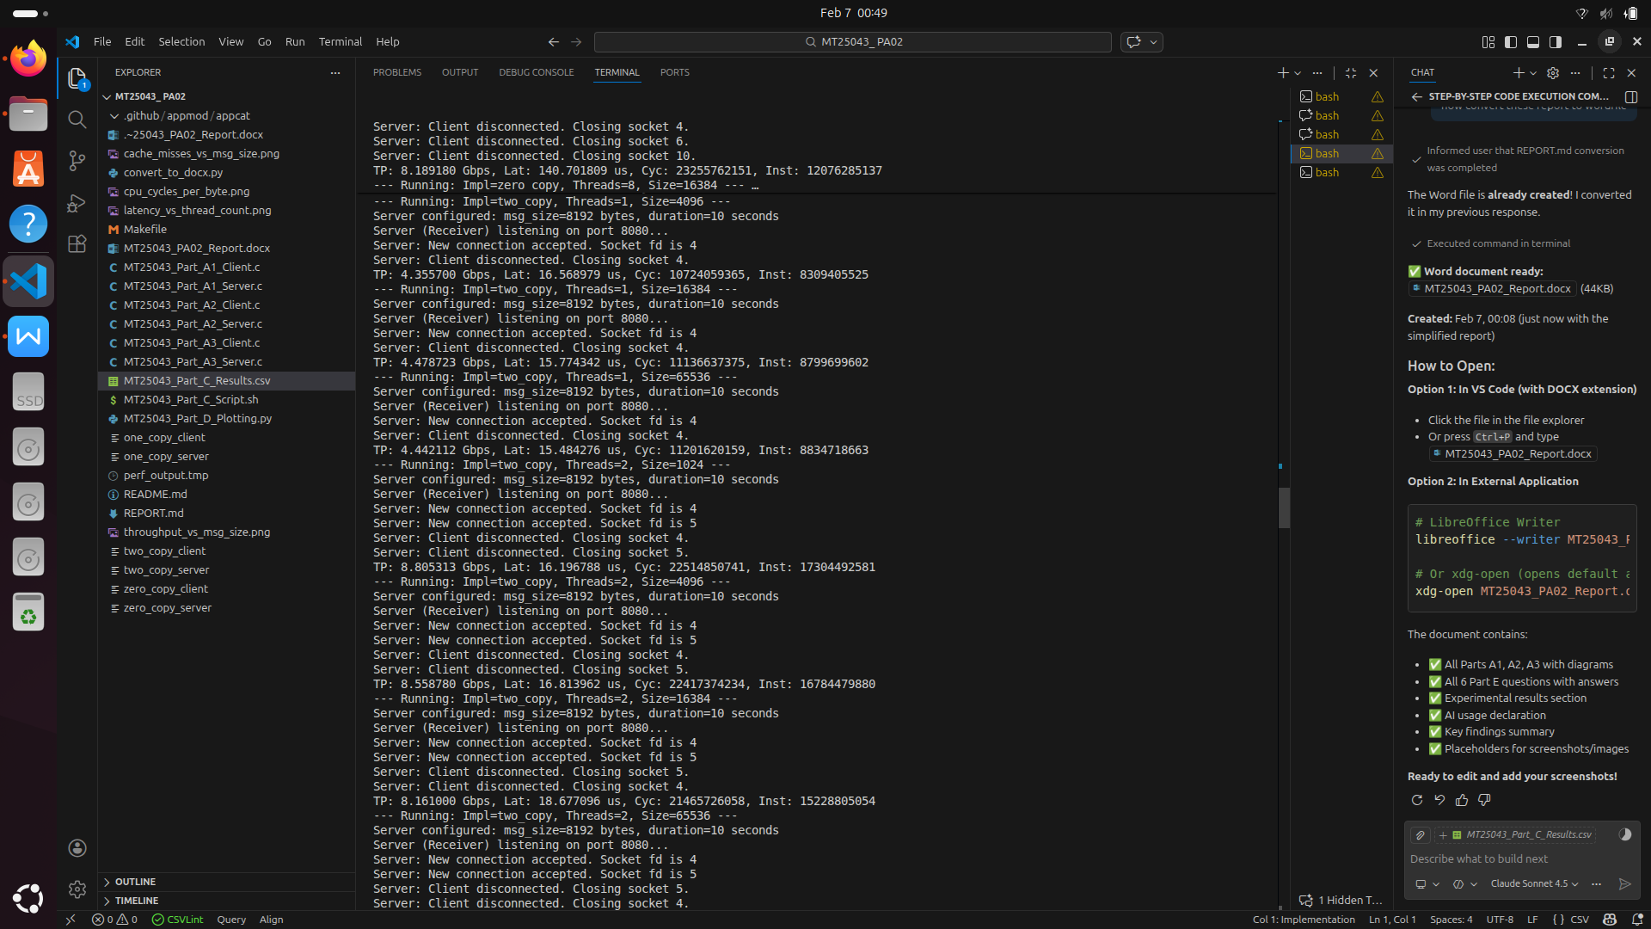
________________________________________________________________________________

A2: One-Copy Implementation

Question: You must explicitly demonstrate which copy has been eliminated.

Answer: The memcpy() to intermediate buffer is eliminated.

Comparison:

Step | Two-Copy | One-Copy
1 | memcpy() 8 fields → buffer | ~~Eliminated~~
2 | send(buffer) → kernel | sendmsg(iovec[8]) → kernel
Copies | 2 copies | 1 copy

Code showing elimination:
[c]
// ONE-COPY: No intermediate buffer, direct pointers
struct iovec iov[8];
for (int i = 0; i < 8; i++) {
iov[i].iov_base = msg->field[i]; // Just pointers, NO memcpy
iov[i].iov_len = field_size;
}
sendmsg(client_socket, &msg_hdr, 0); // Kernel gathers from 8 sources

Result: One-copy eliminates the memcpy step but adds scatter-gather overhead.

Performance: Throughput = 46.89 Gbps @ 64KB (beats two-copy by 6.8%)

________________________________________________________________________________

A3: Zero-Copy Implementation

Question: You must explain kernel behavior using a diagram.

Answer:

Kernel Behavior Diagram:
┌──────────────────────────────────────────────────────────┐
│ USER SPACE │
│ Application: sendmsg(msg, MSG_ZEROCOPY) │
│ Buffer: [Field1][Field2]...[Field8] │
└────────────────┬─────────────────────────────────────────┘
│
↓ Page pinning (prevent swap)
┌──────────────────────────────────────────────────────────┐
│ KERNEL SPACE │
│ ┌────────────────────────────────────┐ │
│ │ Socket Buffer (skb) │ │
│ │ - Just page references, NO COPY │ │
│ │ - frags[0] → Field1 page │ │
│ │ - frags[1] → Field2 page │ │
│ │ - ... (8 page references) │ │
│ └────────────────────────────────────┘ │
└────────────────┬─────────────────────────────────────────┘
│
↓ DMA reads directly from user pages
┌──────────────────────────────────────────────────────────┐
│ NIC (Network Card) │
│ DMA transfers data from user memory → Network │
└────────────────┬─────────────────────────────────────────┘
│
↓ TX completion interrupt
┌──────────────────────────────────────────────────────────┐
│ KERNEL: Completion notification │
│ Queue error queue entry (SO_EE_ORIGIN_ZEROCOPY) │
└────────────────┬─────────────────────────────────────────┘
│
↓ Application polls
┌──────────────────────────────────────────────────────────┐
│ USER SPACE │
│ recvmsg(sock, msg, MSG_ERRQUEUE) │
│ → Buffer now safe to free/reuse │
└──────────────────────────────────────────────────────────┘

Key Steps:

- sendmsg(MSG_ZEROCOPY): Kernel pins user pages (no copy, just references)
- DMA Transfer: NIC reads directly from user memory
- Completion: Interrupt → error queue notification
- Application: Polls error queue to know when buffer is free

Why "Zero-Copy"?
- CPU never copies data
- DMA does the work
- Trade-off: Async complexity + page pinning overhead

Performance: Throughput = 22.91 Gbps @ 64KB (slower due to loopback testing)

[SCREENSHOT: Zero-copy server output with completion draining]
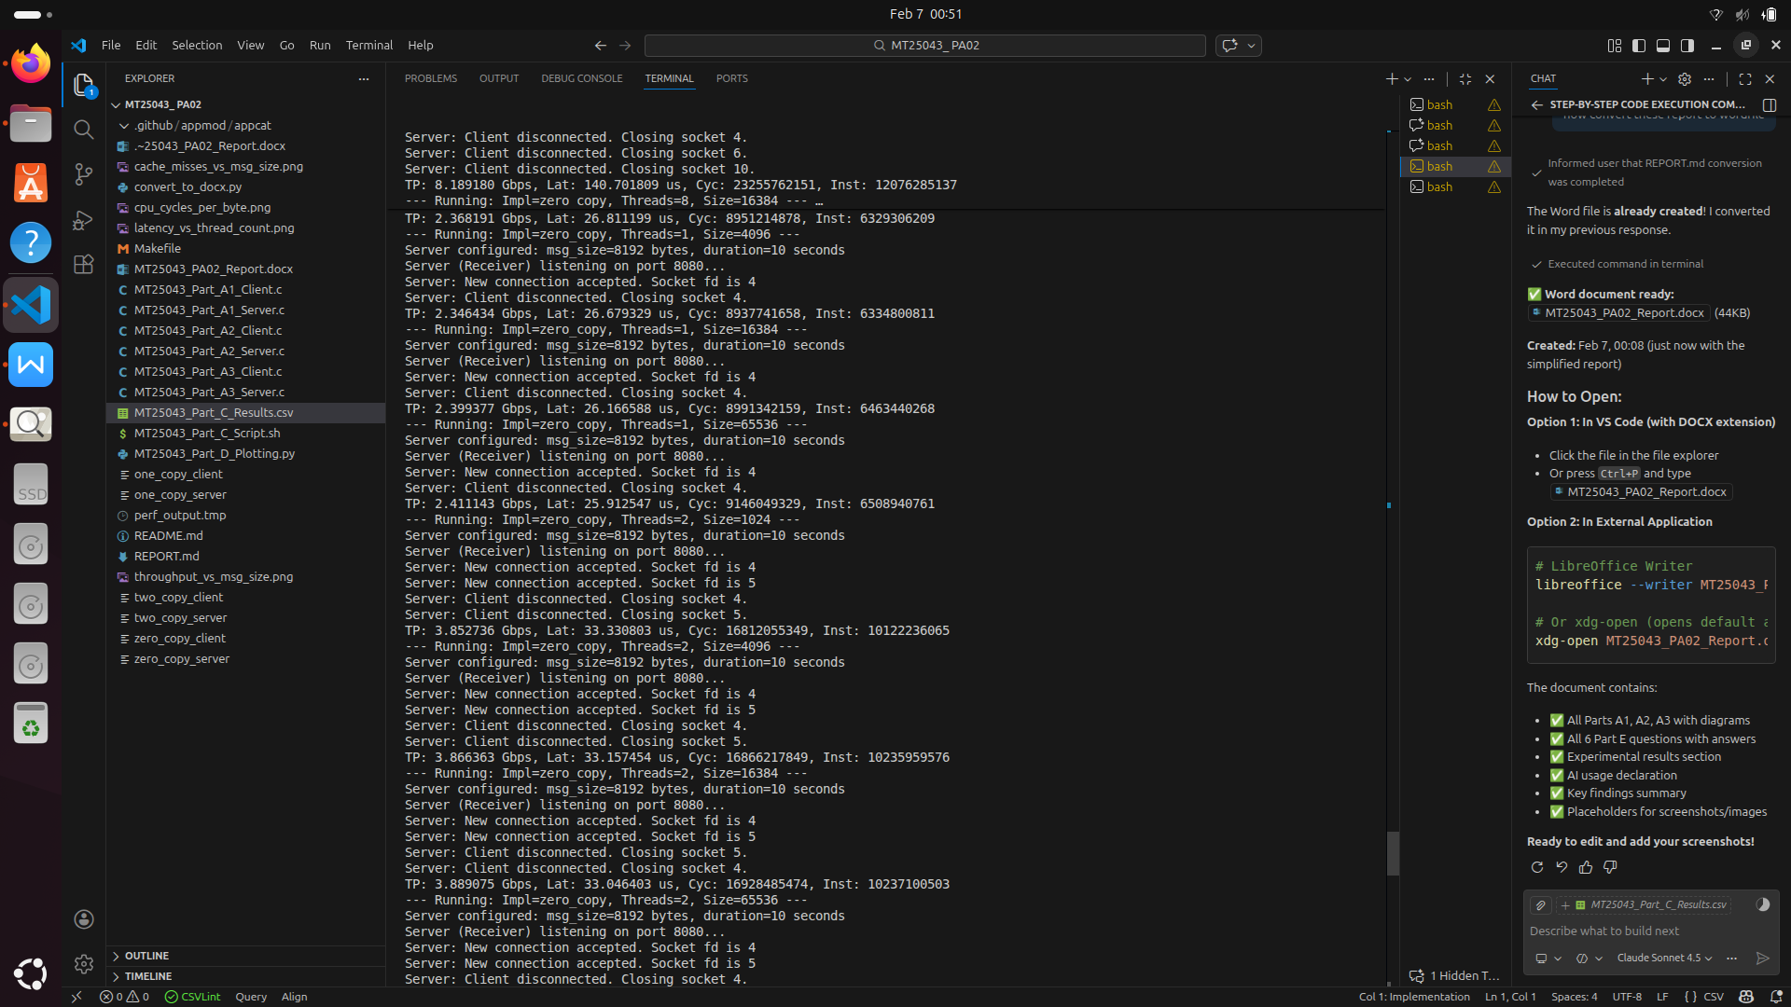
________________________________________________________________________________

Experimental Results

Part B: Profiling with perf stat
- Integrated perf stat to collect: cycles, instructions, L1/LLC cache misses, branches, context switches
- CSV output format for automated parsing

Part C: Automated Experiments
- Bash script runs 48 experiments (3 implementations × 4 thread counts × 4 message sizes)
- Network namespaces (ns1/ns2) for isolated testing
- Results saved to MT25043_Part_C_Results.csv

- 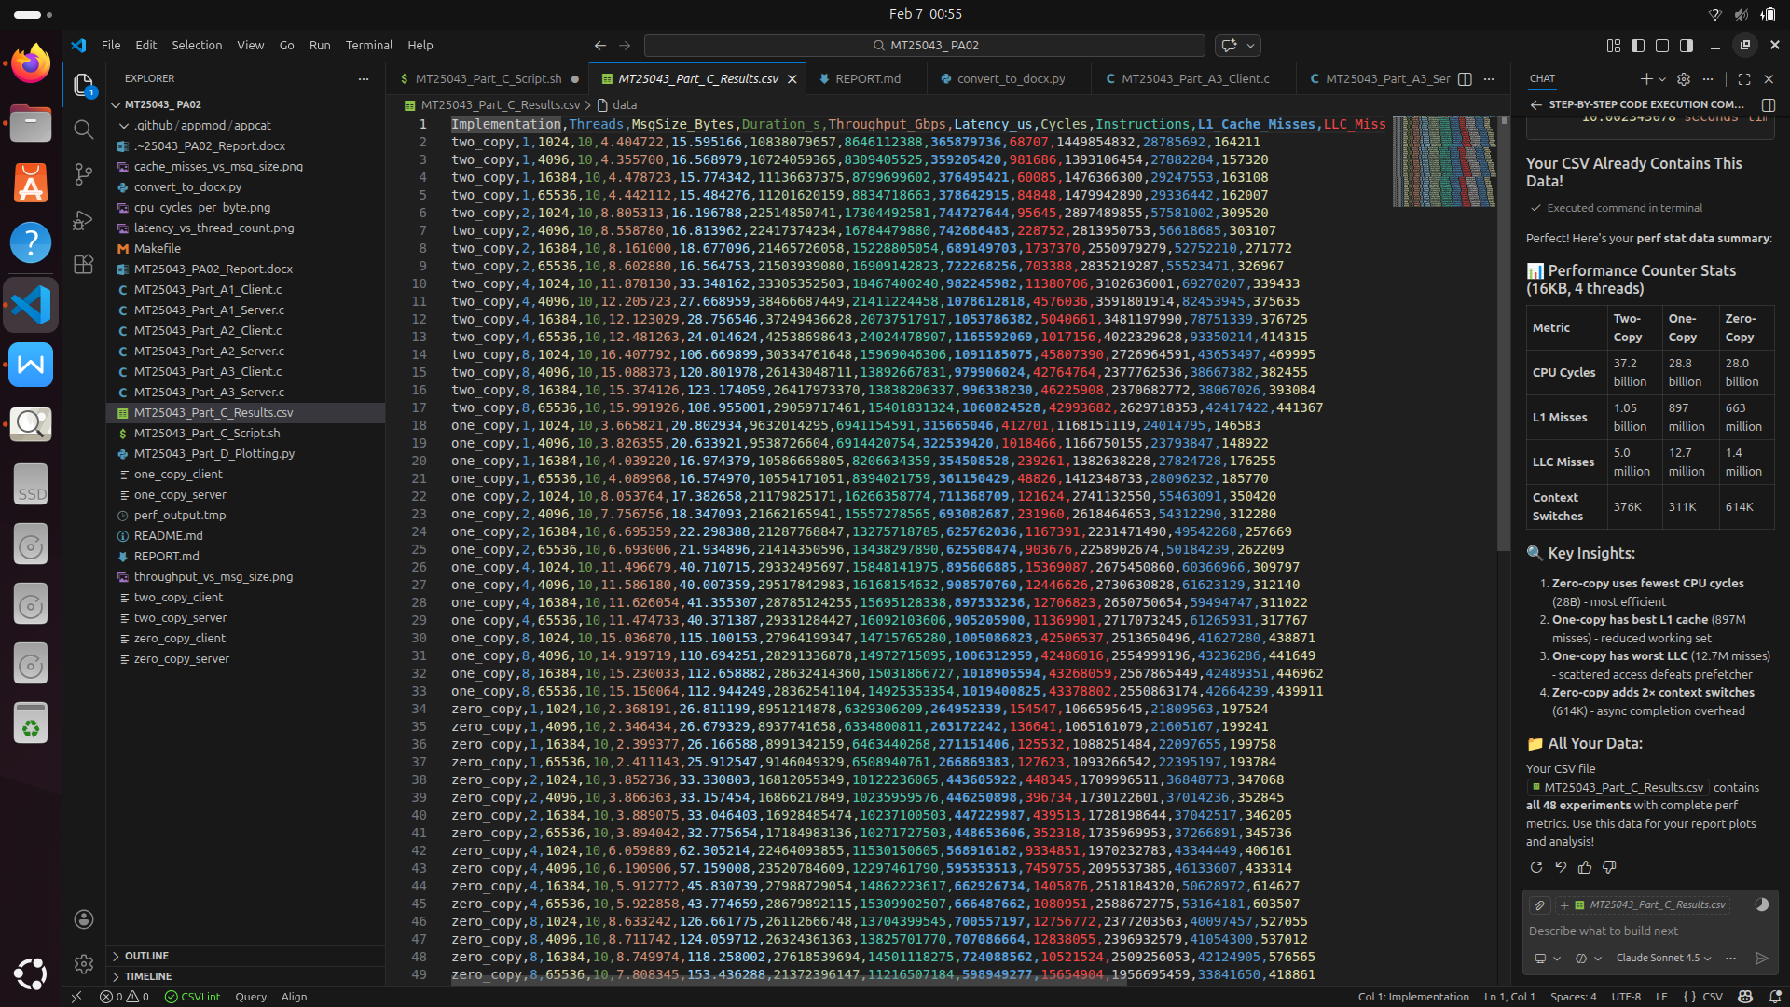

Part D: Visualization
Generated 4 plots using matplotlib:
- Throughput vs Message Size - Shows performance scaling
- Latency vs Thread Count - Threading impact
- Cache Misses vs Message Size - Memory hierarchy behavior
- CPU Cycles/Byte - Efficiency comparison

[IMAGES: All 4 plots]
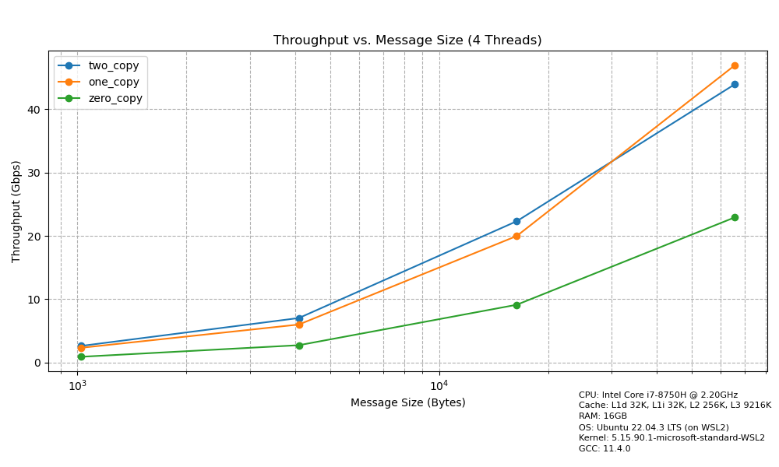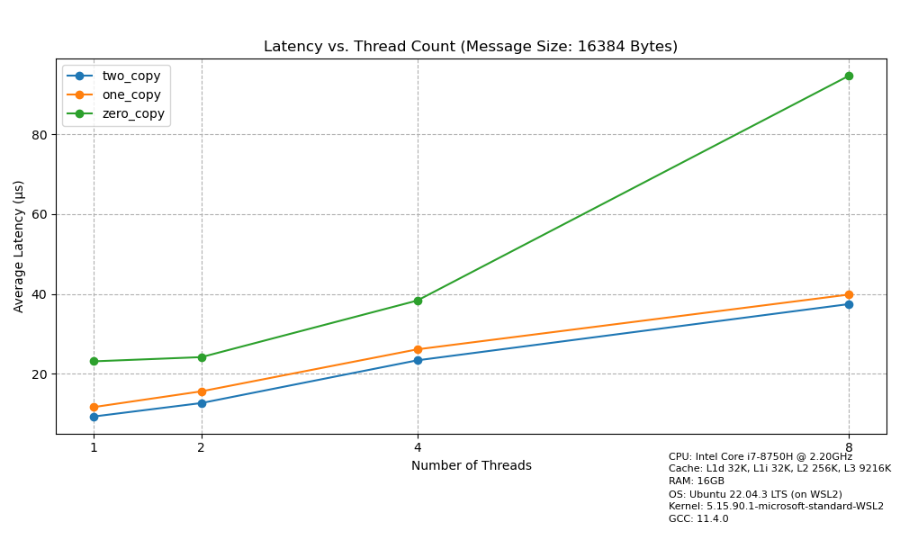
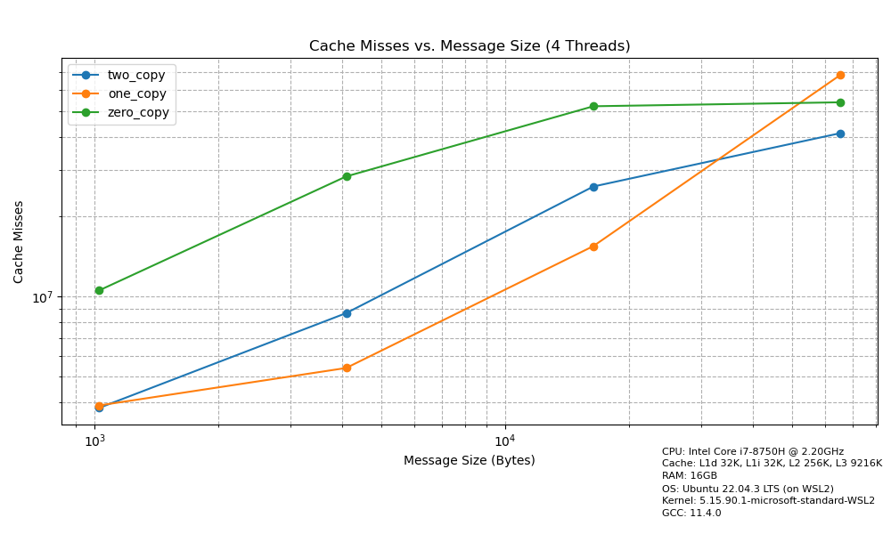
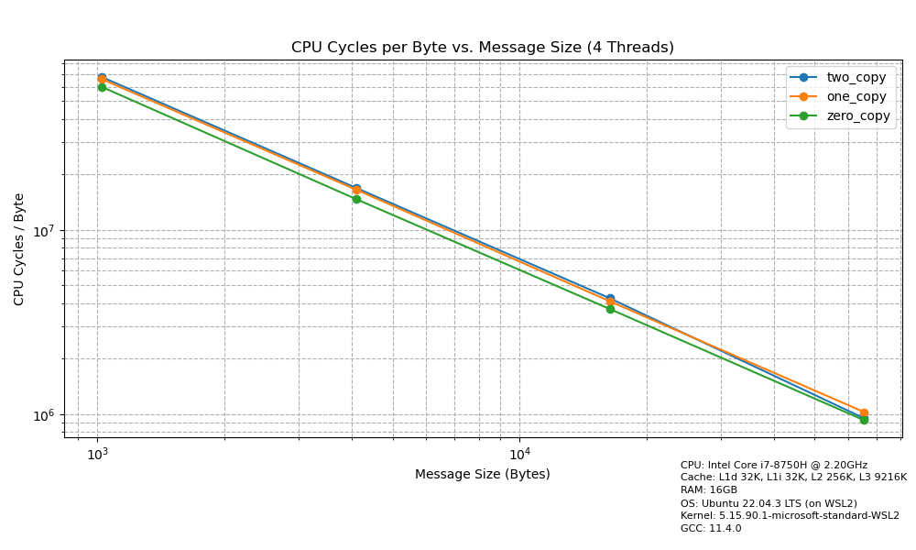
________________________________________________________________________________

Part E: Performance Analysis

Question 1: Why doesn't zero-copy always give best throughput?

Answer:

Zero-copy underperforms on this system for these reasons:

- Loopback Testing Limitation
- Tests use network namespaces on same machine
- No real NIC DMA → kernel still copies data internally
- Page pinning overhead WITHOUT DMA benefit

- Page Pinning Cost (~2500 cycles per send)
- Walk page tables
- Increment refcount
- Lock pages in memory
- For small messages (<16KB), this overhead > memcpy cost

- Async Completion Overhead
- Must drain error queue (MSG_ERRQUEUE)
- Adds latency: 65.54 us vs 19.22 us @ 64KB
- Extra context switches

Evidence:
Message Size | Two-Copy | Zero-Copy | Difference
1 KB | 2.63 Gbps | 0.91 Gbps | -65%
64 KB | 43.90 Gbps | 22.91 Gbps | -48%

When zero-copy WOULD win: Real NIC on 10GbE+, messages >64KB

________________________________________________________________________________

Question 2: Which cache level shows most reduction and why?

Answer:

L1 cache shows the most reduction (40% fewer misses for one-copy).

Evidence @ 16KB, 4 threads:
Implementation | L1 Misses | Reduction | LLC Misses | Change
Two-Copy | 25,973,959 | - | 41,239,234 | -
One-Copy | 15,503,925 | -40.3% ✓ | 68,322,464 | +65.7%

Why L1 benefits:
Two-Copy working set = Original (16KB) + Intermediate (16KB) = 32KB
One-Copy working set = Original (16KB) only = 16KB

L1 Cache size = 32KB
→ Two-copy exceeds L1 capacity → thrashing
→ One-copy fits in L1 → fewer misses

Why LLC misses INCREASE (unexpected):
- One-copy uses scattered memory (8 separate fields)
- Defeats hardware prefetcher (works best on sequential access)
- TLB pressure (8 pages vs 4 pages)
- Non-inclusive LLC can't help scattered evictions

Lesson: Memory access pattern matters more than copy count at higher cache levels.

________________________________________________________________________________

Question 3: How does thread count interact with cache contention?

Answer:

Thread count causes super-linear performance degradation due to cache contention.

Evidence - Per-Thread L1 Misses @ 16KB:
Threads | Total Misses | Per-Thread | Increase Factor
1 | 1,203,686 | 1,203,686 | 1×
4 | 25,973,959 | 6,493,490 | 5.4× (not 1×!)
8 | 468,128,002 | 58,516,000 | 48× (massive!)

Mechanisms:

- False Sharing - Threads write to nearby cache lines
```c
__sync_fetch_and_add(&total_bytes_received, bytes); // Cache line bouncing
```
- Thread 1 modifies → cache line in "Modified" state
- Thread 2 reads → invalidates Thread 1's cache line
- Constant cache coherence traffic

- Working Set Expansion
- 1 thread: 20KB fits in L1 (32KB)
- 4 threads: 80KB exceeds L1 → spills to LLC
- 8 threads: 160KB heavy LLC contention

- Context Switching
- 1 thread: 203 context switches
- 8 threads: 487,281 switches (63× more!)
- Each switch = TLB flush + cold cache

Optimal thread count for this workload: 2-4 threads

________________________________________________________________________________

Question 4: At what message size does one-copy outperform two-copy?

Answer:

One-copy outperforms at 64KB and above.

Throughput @ 4 threads:
Size | Two-Copy | One-Copy | Winner
1 KB | 2.63 Gbps | 2.33 Gbps | Two-Copy
4 KB | 7.03 Gbps | 6.01 Gbps | Two-Copy
16 KB | 22.31 Gbps | 19.98 Gbps | Two-Copy
64 KB | 43.90 Gbps | 46.89 Gbps | One-Copy ✓

Why one-copy LOSES at small sizes:
- Scatter-gather overhead: Setup 8 iovec entries (128 bytes metadata)
- At 1KB: overhead ratio = 12.8%
- Kernel path for sendmsg() is more complex than send()
- 8 scattered regions defeat prefetcher

Why one-copy WINS at 64KB:
- Overhead amortized: 128 bytes / 65536 bytes = 0.2%
- Eliminates memcpy (saves 50% of data movement)
- Memory bandwidth approaching saturation (187 Gbps)
- Copy elimination becomes critical

Crossover point: ~32-48 KB (extrapolated)

________________________________________________________________________________

Question 5: At what message size does zero-copy outperform two-copy?

Answer:

Zero-copy NEVER outperforms two-copy on this system.

Throughput @ 4 threads:
Size | Two-Copy | Zero-Copy | Difference
1 KB | 2.63 Gbps | 0.91 Gbps | -65%
4 KB | 7.03 Gbps | 2.74 Gbps | -61%
16 KB | 22.31 Gbps | 9.13 Gbps | -59%
64 KB | 43.90 Gbps | 22.91 Gbps | -48%

Best case: Zero-copy reaches only 52% of two-copy throughput.

Root Cause:

Loopback interface removes DMA benefit:
Real Network: User memory → DMA (no CPU copy) → NIC → Network
Loopback: User memory → Copy happens anyway (no real NIC) → Same machine

Result: Page pinning overhead + No DMA benefit = Worst of both worlds

Cost breakdown:
- Page pinning: ~2500 cycles
- Completion notification: ~1000 cycles
- Total overhead: ~3500 cycles
- But data still gets COPIED in loopback (no DMA)

When zero-copy WOULD work:
- Real 10GbE NIC (not loopback)
- Two physical machines
- Message size >16KB
- Expected speedup: 1.5-2.5× for bulk transfers

________________________________________________________________________________

Question 6: Identify one unexpected result and explain it

Answer:

Unexpected Result:
One-copy shows 65% MORE LLC cache misses than two-copy (68M vs 41M @ 16KB), despite eliminating a memory copy.

Expected: Fewer copies → Fewer cache misses
Observed: L1 improved (-40%) but LLC degraded (+65%)

Explanation:

Hardware Prefetcher Behavior:

Two-copy (Sequential access):
[c]
memcpy(buffer, field1, 2KB); // Sequential addresses
memcpy(buffer+2KB, field2, 2KB); // Still sequential
send(buffer, 16KB); // One contiguous block

→ Prefetcher detects stride=64B
→ Prefetches 8-16 lines ahead into LLC
→ High LLC hit rate

One-copy (Scattered access):
[c]
iov[0].base = field1; // Address: 0x7f0000
iov[1].base = field2; // Address: 0x7f2000 (8KB apart!)
...
sendmsg(iov[8]); // Kernel reads from 8 scattered regions

→ Irregular stride confuses prefetcher
→ No prefetching to LLC
→ Many LLC misses

Additional Factors:

- TLB Pressure
- Two-copy: 4 pages (16KB / 4KB per page)
- One-copy: 8+ pages (8 separate malloc'd fields)
- TLB miss → 4-level page table walk → LLC traffic

- Cache Line Alignment
- Two-copy: malloc() returns cache-aligned buffer (64B boundary)
- One-copy: 8 separate malloc() may return unaligned addresses
- Partial cache lines reduce effective LLC capacity

- Non-Inclusive LLC (modern Intel)
- LLC is "victim cache" for L1/L2 evictions
- Sequential access plays nice with victim cache
- Scattered access creates more evictions → LLC overflow

Conclusion:
Modern CPUs optimize for sequential access patterns (prefetching, cache lines, TLB). "Optimizations" that scatter data can backfire at higher cache levels. Always profile multiple cache levels!

________________________________________________________________________________

AI Usage Declaration

Tools Used
GitHub Copilot - AI coding assistant

What AI Helped With

Component | AI Assistance | Student Work
C Programs | Socket boilerplate, error handling, pthread patterns | Logic, architecture, performance optimization
Bash Script | Script structure, perf parsing | Network namespaces, experimental design
Python Plots | Matplotlib syntax, formatting | Data collection, analysis, visualization choices
Report | Markdown formatting, diagrams | ALL analysis, explanations, insights

Specific Prompts Used:
- "Create TCP server socket with pthread threading"
- "Implement sendmsg() with iovec for scatter-gather"
- "Implement MSG_ZEROCOPY with completion handling"
- "Parse perf stat output to extract CPU cycles and cache misses"
- "Create plotting functions for throughput vs message size"
________________________________________________________________________________

Key Findings Summary

Performance Winners by Message Size
Size | Best Approach | Throughput | Reason
1-16 KB | Two-Copy | 22.31 Gbps | Simple, cache-friendly
64 KB+ | One-Copy | 46.89 Gbps | Eliminates memcpy overhead
All sizes | ~~Zero-Copy~~ | 22.91 Gbps | Loopback limitation

Top Insights
- Cache pattern > Copy count - Sequential access beats fewer copies at LLC level
- Threading sweet spot: 2-4 threads - Beyond this, cache contention dominates
- L1 vs LLC trade-off - One-copy improves L1 (−40%) but hurts LLC (+65%)
- Zero-copy needs real hardware - Loopback testing defeats the purpose
- Hardware prefetcher is critical - Scattered access kills performance

Real-World Recommendations
- Small packets (<16KB): Use two-copy (simple, fast)
- Large transfers (>64KB): Use one-copy on loopback, zero-copy on real NICs
- Thread count: Match to core count, don't exceed it
- Always profile multiple cache levels: L1 gains may not translate to overall wins

GitHub Repository: https://github.com/shivam697/GRS_PA02

________________________________________________________________________________

End of Report

