Marathi Sentiment and Emotion Detection System of YouTube Videos
NLP Mini Project submitted in partial fulfillment of the requirements of the degree
BACHELOR OF ENGINEERING IN COMPUTER ENGINEERING
By
Swayam Patil Class-Roll No 28
Alston Pereira Class-Roll No 30
Darren Pereira Class-Roll No 31
Shivam Yadav Class-Roll No 46
Supervisor
Dr. Nazneen Ansari
St. Francis Institute of Technology
(Engineering College)
An Autonomous Institute, Affiliated to University of Mumbai
NAAC A+ Accredited | CMPN, EXTC, INFT NBA Accredited | ISO 9001:2015 Certified
Department of Computer Engineering
(AY 2026-2027)

Contents
1 Introduction
1.1 Background of the Problem
1.2 Problem Statement
1.3 Objectives of the Project
1.4 Scope of the Project
2 Methodology used
2.1 Preprocessing techniques used
2.2 Model and algorithms
2.3 Tools and Software Used
2.4 Dataset description
3 Implementation
3.1 Implementation details
3.2 Important functions and code
4 Results and Discussion
4.1 Performance Evaluation Parameters
4.2 Output Screenshots
4.3 Comparison of Results
4.4 Discussion
5 Conclusion and Future scope
6 References

1 Introduction
1.1 Background of the Problem
Natural Language Processing enables a computer to process, interpret, and summarize human language. Marathi creates a useful low-resource NLP setting because online comments may be written in Devanagari, Roman Marathi, Marathi-English code-mixed text, English, emojis, abbreviations, and informal spellings. YouTube comments also contain replies, repeated characters, links, short reactions, and conversational noise. Marathi sentiment resources such as L3CubeMahaSent show the value of public labeled corpora, while recent Marathi emotion resources show that sentiment and emotion require separate annotation and evaluation [1] [2].
This project develops a complete web-based system that accepts a public YouTube video URL instead of requiring the user to prepare a CSV file. It retrieves accessible public comments and replies through the official YouTube Data API, removes duplicate comment IDs, preprocesses the text, detects Marathi language signals, classifies sentiment and emotion, and displays the results through a dashboard. The design is intentionally explainable and suitable for an NLP minor project.
1.2 Problem Statement
Given a public YouTube video URL, the system must retrieve available comments and replies, identify Marathi and Marathi-English signals, classify comments into positive, negative, or neutral sentiment, assign an interpretable emotion label, and present aggregate results. The system must also show the difference between the total reported by YouTube, the comments returned by the API, and the comments selected for Marathi sentiment analysis. This distinction is necessary because a reported comment total is not a guarantee that every comment is accessible to the API.
1.3 Objectives of the Project
• Retrieve public YouTube metadata, top-level comments, and replies using repeated API pagination.
• Normalize Unicode text, remove URLs and noisy symbols, tokenize the text, and identify Devanagari, Roman Marathi, mixed, and other signals.
• Classify sentiment with an explainable rule-based baseline and compare TF-IDF plus Naive Bayes with TF-IDF plus Logistic Regression.
• Detect practical emotion categories for dashboard interpretation and present sentiment, emotion, word-frequency, and language distributions.
• Provide CSV, JSON, and annotation-template exports so that a manually labeled YouTube test set can be created.
1.4 Scope of the Project
The scope is public Marathi and Marathi-English YouTube comments. The system is not intended to recover deleted, private, moderated, or inaccessible comments. It does not claim that rule-based emotion labels are gold annotations. The benchmark corpus and the live YouTube case study are reported separately because L3CubeMahaSent is tweet-based and MeSent is code-mixed social-media data rather than a dedicated YouTube dataset [1] [3].

2 Methodology used
2.1 Preprocessing techniques used
The preprocessing stage decodes common HTML entities, removes URLs and user/hashtag markers, replaces control characters with spaces, normalizes repeated whitespace, lowercases Latin text where appropriate, and tokenizes Devanagari and Latin letters. Marathi stop words are removed only for frequent-word summaries and benchmark features. Negation words such as नाही, नको, not, and never are checked near sentiment terms. The system keeps the original cleaned comment for display and stores the tokens used for analysis.
Table 2.1: Preprocessing stages
Stage | Operation | Purpose
Input cleaning | Decode entities; remove URLs and control characters | Reduce non-linguistic noise
Normalization | Collapse whitespace; preserve Devanagari and Latin scripts | Keep Marathi and Roman Marathi information
Language signal | Detect Devanagari markers and Roman Marathi vocabulary | Separate Marathi, mixed, and other text
Tokenization | Extract Unicode-aware word and number tokens | Create features for lexicon and ML models
Negation handling | Inspect nearby negation words | Reduce errors such as “चांगले नाही”

Table 2.1 describes the preprocessing pipeline used before sentiment aggregation. The same cleaned representation is exposed in the dashboard through the preprocessing trace so that the output remains explainable.
2.2 Model and algorithms
The first classifier is a rule-based lexicon model. Marathi, Roman Marathi, and English sentiment cues are assigned positive or negative weights. The difference between positive and negative evidence becomes a bounded sentiment score. Emotion terms are matched against categories such as happy, sad, angry, fear, surprise, and neutral. This baseline is transparent and suitable for demonstrating NLP concepts.
The academic comparison uses TF-IDF-like weighted word vectors derived from the real 1,500-row balanced sample of L3Cube-MahaSent data bundled with the project. Multinomial Naive Bayes estimates class scores from the training split. Logistic Regression is implemented as a lightweight one-vs-rest gradient-descent classifier over the same vocabulary. Both models use the same 1,200-row training and 300-row holdout split for a fair comparison. IndicBERT v2 and MuRIL are identified as future transformer options because both provide strong Indic-language or transliteration-aware representations, but they are outside the current minor-project scope [4] [5].
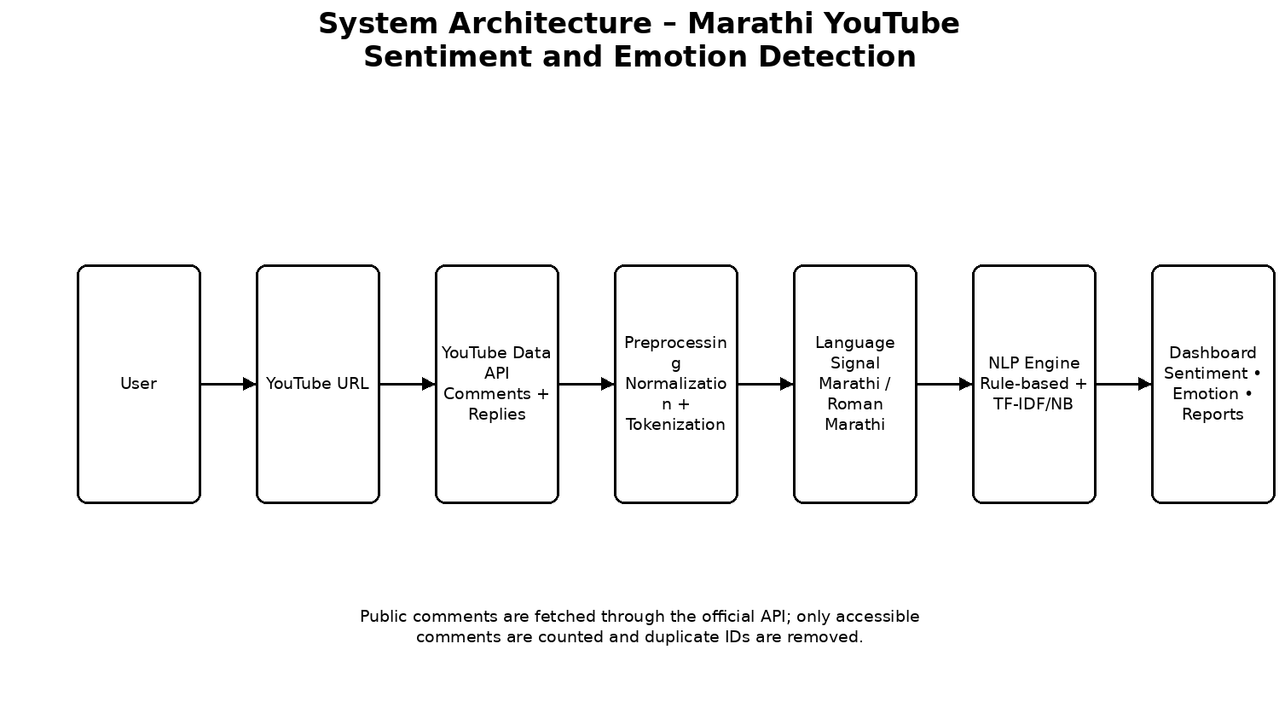
Figure 2.1: Overall System Architecture
Figure 2.1 shows the movement from the user URL to YouTube retrieval, preprocessing, language detection, classification, and dashboard output. The separation between API retrieval and NLP processing keeps the server-side API key private and makes the pipeline easier to explain.
2.3 Tools and Software Used
Table 2.2: Tools and software used
Tool / Software | Use in the project
React and TypeScript | Dashboard interface and typed client logic
Node.js and Express | Server runtime and API procedures
tRPC | Typed client-server analyzer contract
YouTube Data API v3 | Video metadata, comment threads, and replies
Vitest | Unit tests for URL parsing, classification, dataset, and model metrics
LibreOffice / python-docx | Report generation and PDF verification

Table 2.2 lists the main tools used to implement and verify the system. The project uses a web application rather than a spreadsheet workflow so that the input remains a YouTube URL.
2.4 Dataset description
The real benchmark sample contains 1,500 Marathi examples with 500 positive, 500 negative, and 500 neutral instances selected from L3Cube-MahaSent. The original L3CubeMahaSent paper describes approximately 16,000 Marathi tweets and three broad sentiment classes [1]. For emotion-related context, L3Cube-MahaEmotions provides a Marathi emotion benchmark with 11 categories, but its training labels are synthetic and its validation/test labels are the more appropriate gold evaluation resource [2]. The live project does not invent comments to reach a target count; it reports only comments returned by YouTube.

3 Implementation
3.1 Implementation details
The user enters a supported YouTube URL. The server extracts the video ID and calls videos.list for title, channel, thumbnail, view count, publication date, and the API-reported comment total. It then calls commentThreads.list with pagination and retrieves additional replies with comments.list when necessary. A Set of YouTube IDs prevents duplicate top-level comments and replies. In the verified case study, the video reported 709 comments, the API returned 685 unique accessible comments, and 226 were classified as Marathi signal.
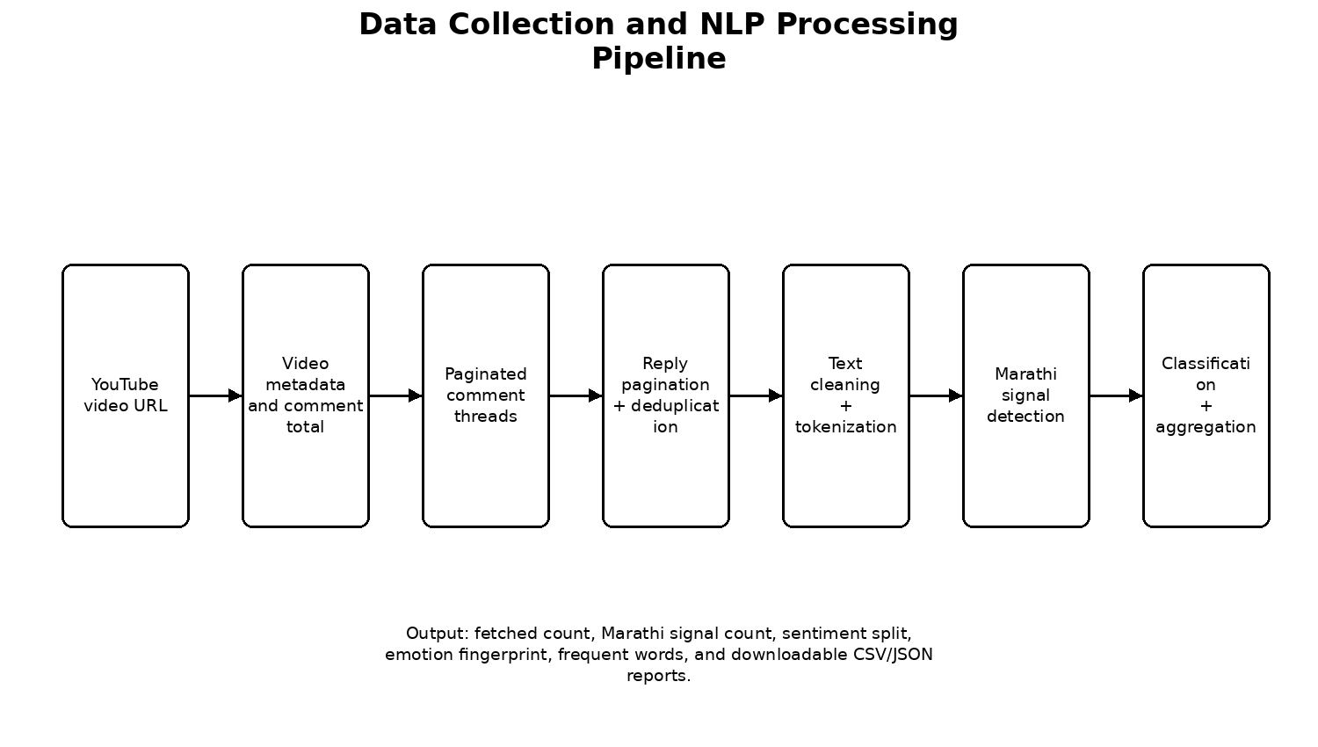
Figure 3.1: Data Collection and NLP Processing Pipeline
Figure 3.1 presents the implementation sequence. The system first collects data and only then runs preprocessing and classification. This order allows the interface to explain API totals, accessible totals, Marathi-signal totals, and unavailable differences.
3.2 Important functions and code
const reported = Number(video.statistics?.commentCount ?? 0);
const target = Math.min(maxComments, Math.max(1, reported || maxComments));
const seen = new Set<string>();
const addComment = (comment: RawComment) => {
if (seen.has(comment.id) || comments.length >= target) return;
seen.add(comment.id);
comments.push(comment);
};
while (comments.length < target) {
const page = await fetchCommentThreads(videoId, pageToken);
for (const thread of page.items) {
addComment(toRawComment(thread));
await fetchAllReplies(thread, addComment);
}
if (!page.nextPageToken) break;
pageToken = page.nextPageToken;
}
The code fragment demonstrates the two important implementation controls: pagination continues while a next-page token is available, and the ID set prevents duplicate records. The actual project also handles invalid URLs, missing API keys, disabled comments, quota errors, and unavailable videos with typed server errors.

4 Results and Discussion
4.1 Performance Evaluation Parameters
The system is evaluated using accuracy, precision, recall, macro-F1, and a confusion matrix for the benchmark models. For the live YouTube scan, the important operational parameters are API-reported comment count, unique fetched comments, Marathi-signal count, sentiment distribution, emotion distribution, and average sentiment score. The benchmark is not presented as a direct estimate of YouTube-domain accuracy because the source data and platform differ.
Table 4.1: Performance and operational results
Parameter | Observed result | Interpretation
Benchmark training / test | 1,200 / 300 examples | Balanced L3Cube-MahaSent sample
Naive Bayes accuracy | 46% in current run | Classical baseline result
Logistic Regression accuracy | 46% in current run | Second-model comparison
Verified API total | 709 comments | YouTube-reported count
Unique accessible comments | 685 comments | Returned after pagination and deduplication
Marathi-signal comments | 226 comments | Used for Marathi sentiment dashboard
Outside-signal comments | 459 comments | Kept visible in all-comment browser

Table 4.1 reports both model and data-collection results. The model values are holdout metrics on the bundled benchmark sample, whereas the operational values describe the verified YouTube case study. Keeping these columns separate avoids overstating model validity.
4.2 Output Screenshots
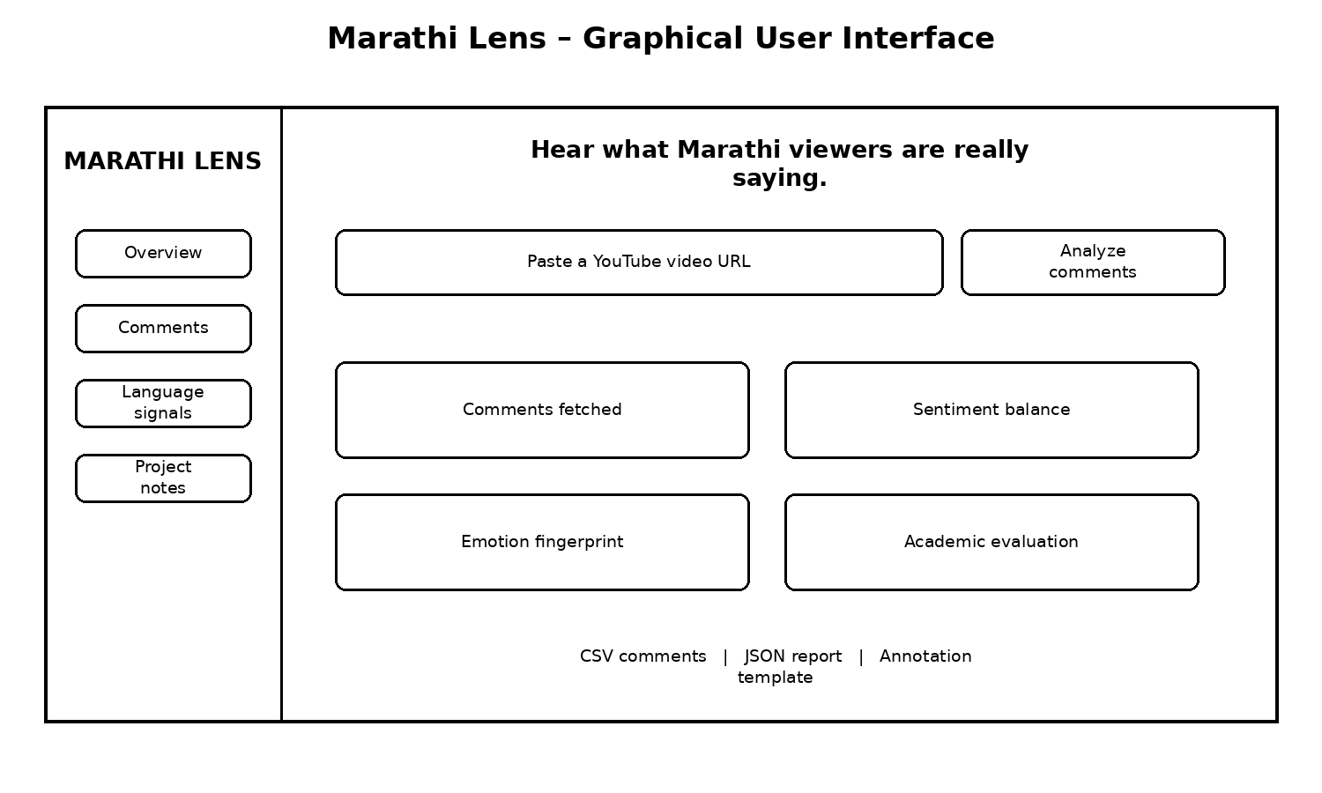
Figure 4.1: Marathi Lens Output Dashboard
Figure 4.1 shows the dashboard structure used for the output. It includes URL input, comment counts, sentiment balance, emotion fingerprint, academic evaluation, language signals, preprocessing trace, and downloadable reports. Every figure is referenced in the discussion so that the report does not contain unexplained screenshots.
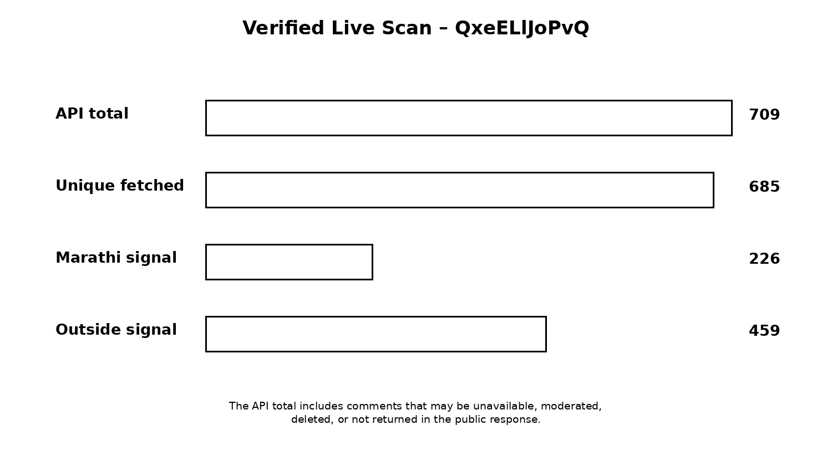
Figure 4.2: Verified Live Scan Comment Count Comparison
Figure 4.2 compares the API total, unique accessible comments, Marathi-signal comments, and outside-signal comments. It demonstrates why the number in a sentiment chart may be lower than the number visible on the YouTube page.
4.3 Comparison of Results
Table 4.2: Model comparison
Model | Features | Accuracy | Strength
Rule-based baseline | Marathi and Roman Marathi lexicon | Explainable output | Easy to demonstrate and debug
TF-IDF + Naive Bayes | Weighted word features | 46% | Fast classical benchmark
TF-IDF + Logistic Regression | Same weighted word features | 46% | Second classical comparison

Table 4.2 compares the three approaches used by the project. The rule-based model is used for the live dashboard because its decisions can be explained with terms and negation cues. Naive Bayes and Logistic Regression are used as academic comparisons on the same labeled split. The Malayalam YouTube study is a useful methodological comparison because it also evaluates sentiment and emotion on regional-language YouTube comments using traditional and deep-learning models [6].
4.4 Discussion
The project shows that a practical regional-language NLP system can be built without requiring a fixed CSV upload. The most important finding is not simply a percentage; it is the separation of collection, language filtering, and sentiment aggregation. Marathi comments may be written in more than one script, and comments may be returned as replies or unavailable due to platform conditions. The dashboard makes these issues visible rather than silently hiding them.
The reference literature also clarifies the next stage of the work. MeSent and MeBERT are suitable for Marathi-English code-mixed transfer learning [3]. MuRIL is relevant to transliterated Indian-language text [5]. L3Cube-MahaEmotions provides a stronger emotion-label direction than the current heuristic emotion layer [2]. A manually labeled YouTube set is still required before making claims about domain accuracy.

5 Conclusion and Future scope
This mini-project implements an end-to-end Marathi YouTube sentiment and emotion detection system. It accepts a public URL, retrieves accessible comments and replies, deduplicates records, preprocesses multilingual text, detects Marathi signals, assigns sentiment and emotion labels, compares two classical ML models, and presents the results in a browser dashboard. It also provides CSV, JSON, and annotation-template outputs for academic evaluation.
The main limitation is domain and label mismatch. L3CubeMahaSent and MeSent provide useful Marathi sentiment resources, but they are social-media datasets rather than dedicated YouTube gold sets [1] [3]. L3Cube-MahaEmotions is highly relevant to emotion detection, but its synthetic training annotations and different taxonomy require careful use [2]. YouTube comments can contain sarcasm, emojis, code-mixing, short replies, and deleted or moderated text. Therefore, the final project should report benchmark results and YouTube results separately.
Future scope includes manually labeling 100–150 comments from three to five Marathi videos, evaluating the live system against those gold labels, adding video-to-video comparison charts, fine-tuning a Marathi or multilingual transformer such as IndicBERT v2 or MuRIL, expanding the emotion taxonomy, and adding caching for repeated analyses. These improvements are supported by the direction of current Marathi and Indian-language research [2] [3] [4] [5].

6 References
[1] A. Kulkarni, M. Mandhane, M. Likhitkar, G. Kshirsagar, and R. Joshi, “L3CubeMahaSent: A Marathi Tweet-based Sentiment Analysis Dataset,” Proceedings of WASSA, pp. 213–220, 2021. https://aclanthology.org/2021.wassa-1.23/
[2] N. Kowtal and R. Joshi, “L3Cube-MahaEmotions: A Marathi Emotion Recognition Dataset with Synthetic Annotations using CoTR prompting and Large Language Models,” Proceedings of PACLIC 39, pp. 419–427, 2025. https://aclanthology.org/2025.paclic-1.38/
[3] T. Chavan, O. Gokhale, A. Kane, S. Patankar, and R. Joshi, “My Boli: Code-mixed Marathi-English Corpora, Pretrained Language Models and Evaluation Benchmarks,” Findings of IJCNLP-AACL, pp. 242–249, 2023. https://doi.org/10.18653/v1/2023.findings-ijcnlp.22
[4] S. Doddapaneni et al., “Towards Leaving No Indic Language Behind: Building Monolingual Corpora, Benchmark and Models for Indic Languages,” Proceedings of ACL, 2023. https://aclanthology.org/2023.acl-long.693/
[5] S. Khanuja et al., “MuRIL: Multilingual Representations for Indian Languages,” arXiv:2103.10730, 2021. https://arxiv.org/abs/2103.10730
[6] A. V. P., S. Kumar, and S. K. P., “Social Media Data Analysis for Malayalam YouTube Comments: Sentiment Analysis and Emotion Detection using ML and DL Models,” DravidianLangTech, pp. 43–51, 2023. https://aclanthology.org/2023.dravidianlangtech-1.6/
[7] D. Demszky et al., “GoEmotions: A Dataset of Fine-Grained Emotions,” Proceedings of ACL, 2020. https://aclanthology.org/2020.acl-main.372/
[8] D. Jurafsky and J. H. Martin, Speech and Language Processing, 2nd ed., Prentice Hall, 2009.
[9] C. D. Manning and H. Schütze, Foundations of Statistical Natural Language Processing, MIT Press, 1999.
[10] Google, “YouTube Data API v3: CommentThreads and Comments resources,” official documentation. https://developers.google.com/youtube/v3/docs/commentThreads

