Question 1. How are inline and block elements different from each other?
Answer 1. Block Elements :- A block-level element always starts on a new line and takes up the full width available (stretches out to the left and right as far as it can).
Ex:-<div>
Inline Elements:- An inline element does not start on a new line and only takes up as much width as necessary.
Ex:-<span>

Question 2. Explain the difference between visibility:hidden and display:none
Answer 2. Visibility Hidden :-
It hides an element, but it will still take up the same space as before. The element will be hidden, but still, affect the layout. Visibility: hidden preserve the space,
display:none :-
while display:none doesn’t preserve the space.

Question 3. Explain the clear and float properties.
Answer 3. Float :-The float property is used for positioning and formatting content.
Float can be of following values:
left :The element floats to the left of its container.
Right :The element floats to the right of its container.
None :The element does not float.This is default
Inherit :The elements the float value of its parent.

Clear :- The Clear property specifies what elements can float beside the cleared element and on which side.
Clear can be following values:
none - Allows floating elements on both sides. This is default
left – no floating elements allow on the left side
right – no floating elements allow on the right side.
Both - no floating elements allow on either the left side or right side.
Inherit – The elements inherit the clear value of its parent.

Question 4 :explain difference between absolute, relative,fixed and static.
Answer 4 :
These all are the position property.
absolute : An element with position : absolute; is positioned relative to the nearest positioned ancestor.
relative :An element with position: relative; is positioned relative to its normal position.
Fixed : An element with position: fixed; is positioned relative to the viewport, which means it always stays in the same place even if the page is scrolled
static : An element with position: static; is not positioned in any special way; it is always positioned according to the normal flow of the page.

Question 5: Write the HTML code to create a table in which there are 4 columns( ID , Employee Name, Designation, Department) and at least 6 rows. Also do some styling to it.
Answer 5: <!DOCTYPE html>
<html>
<head>
<title>Table form</title>
</head
<body>
<table border=”1” style=”color:red”>
<tr>
<td>ID</td>
<td>Employee Name</td>
<td>Designation</td>
<td>Department</td>
</tr>
<tr>
<td>100</td>
<td>shivam</td>
<td>engineer</td>
<td>CS</td>
</tr>
<tr>
<td>101</td>
<td>shivani</td>
<td>engineer</td>
<td>CS</td>
</tr>
<tr>
<td>102</td>
<td>shivangi</td>
<td>engineer</td>
<td>CS</td>
</tr>
<tr>
<td>103</td>
<td>shiva</td>
<td>engineer</td>
<td>IT</td>
</tr>
<tr>
<td>104</td>
<td>satyam</td>
<td>engineer</td>
<td>IT</td>
</tr>
<tr>
<td>105</td>
<td>vishal</td>
<td>engineer</td>
<td>CS & IT</td>
</tr>
</table>
</body>
</html>
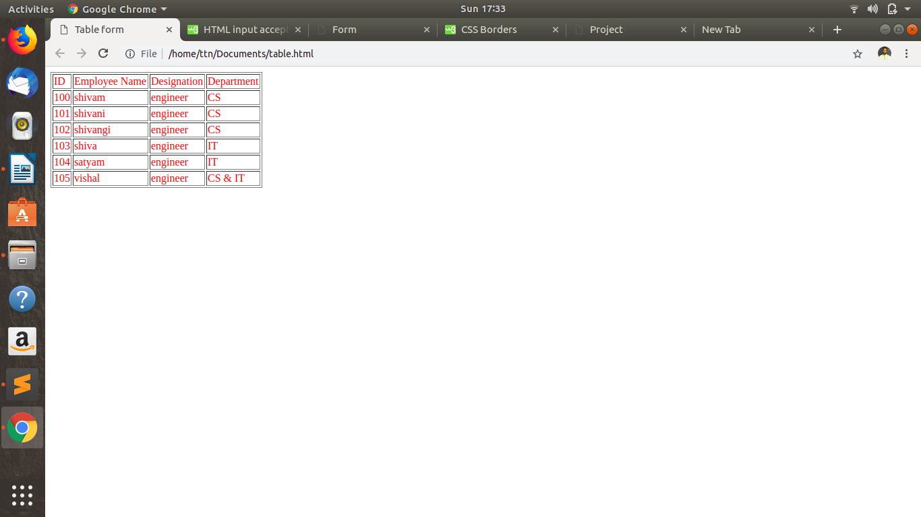
Question 6: Why do we use meta tags?
Answer 6: The <meta> tag provides metadata about the HTML document. Metadata will not be displayed on the page,but will be machine parsable.
It helps to improve the SEO(Search Engine Optimization)of a web page.
It always go inside the <head> element.

Question 7: Explain box model.
Answer 7: Box Model is nothing but it contains 4 basics elements i.e.
padding : Clears an area around the content.padding is transparent
margin : clears an area outside the border. Margin is transparent
border : borders that goes around the padding and content.
content : The Content of the box, where text and images appear.

Question 8: What are the different types of CSS Selectors?
Answer 8: In CSS, selectors are patterns used to select the element(s)

You want to style.

selector { property: value }

body {background: #eeeeee; font-family: Georgia, sans-serif;}

h1 {font-family: Georgia, sans-serif;}

h1, h2 {color: #009900;font-family: Georgia, sans-serif;}

Question 9: Define Doctype.
Answer 9: Doctype is basically used for HTML 5. It easily identifies the properties of html that html 5.0 support.

Question 10: Explain 5 HTML5 semantic tags.
Answer 10:
<article> - Defines an article in the document.
<aside> - Defines content aside from the page content like sidebar.
<footer> - Defines a footer for the document or a section.
<header> - Defines a header for the document or a section.
<nav> - Defines navigation links in the document.

