Question 1 : Console "Hello Word" in document.ready function
Answer 1:
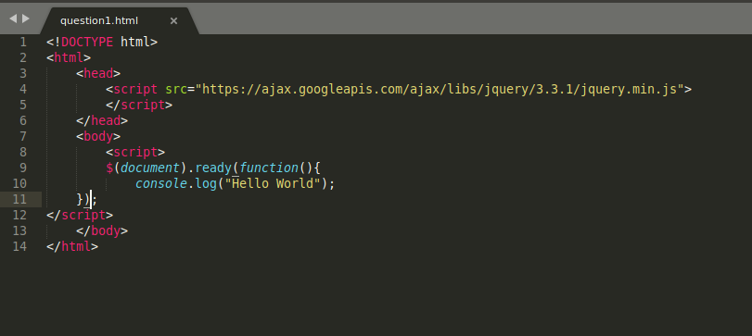

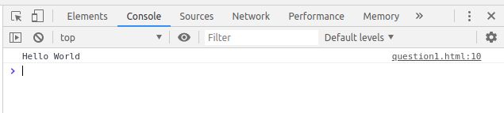

Question 2:Select a ID name "#test" and add class "load" when DOM is loaded.
Answer 2 :

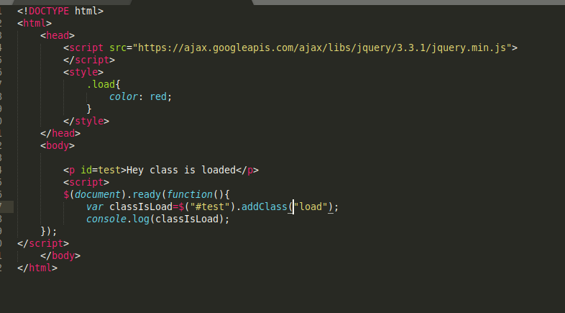
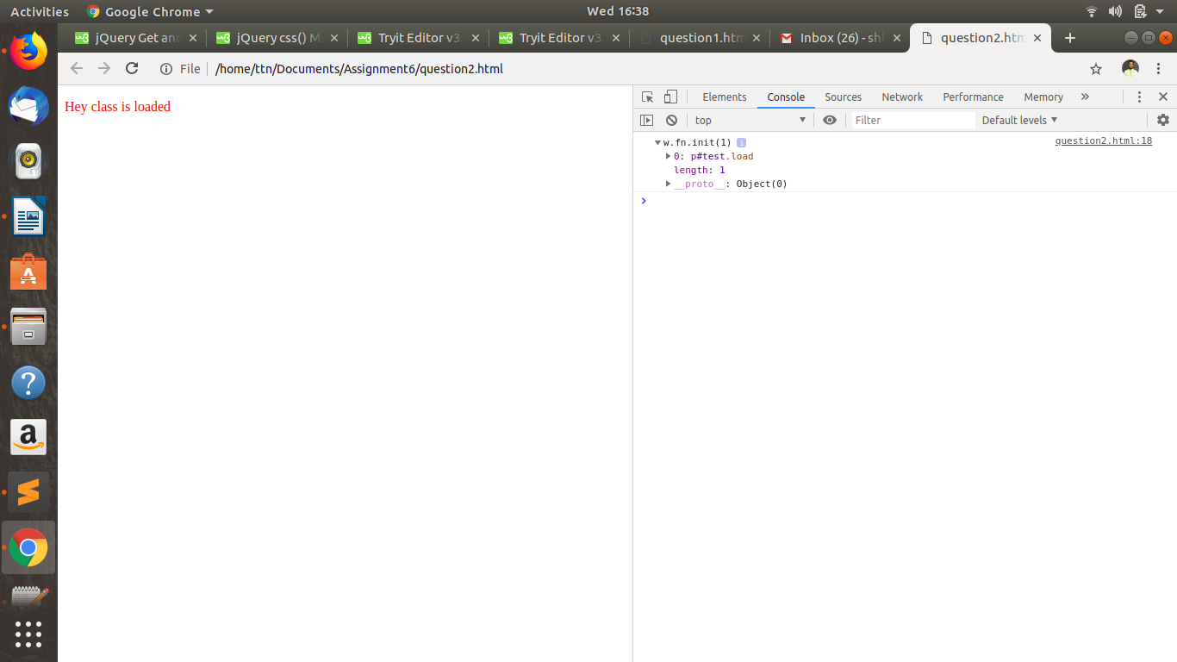

Question 3 : Change the color of element which class name end with "-new".
Answer 3 :

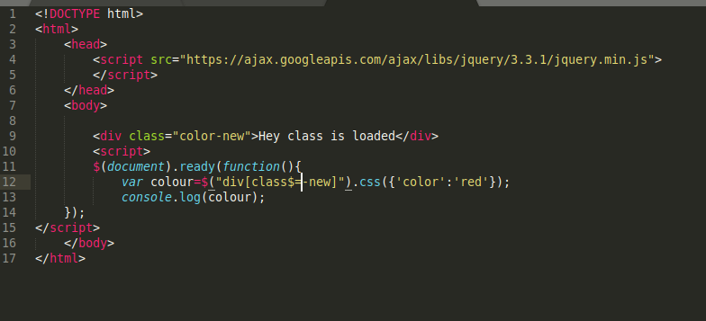
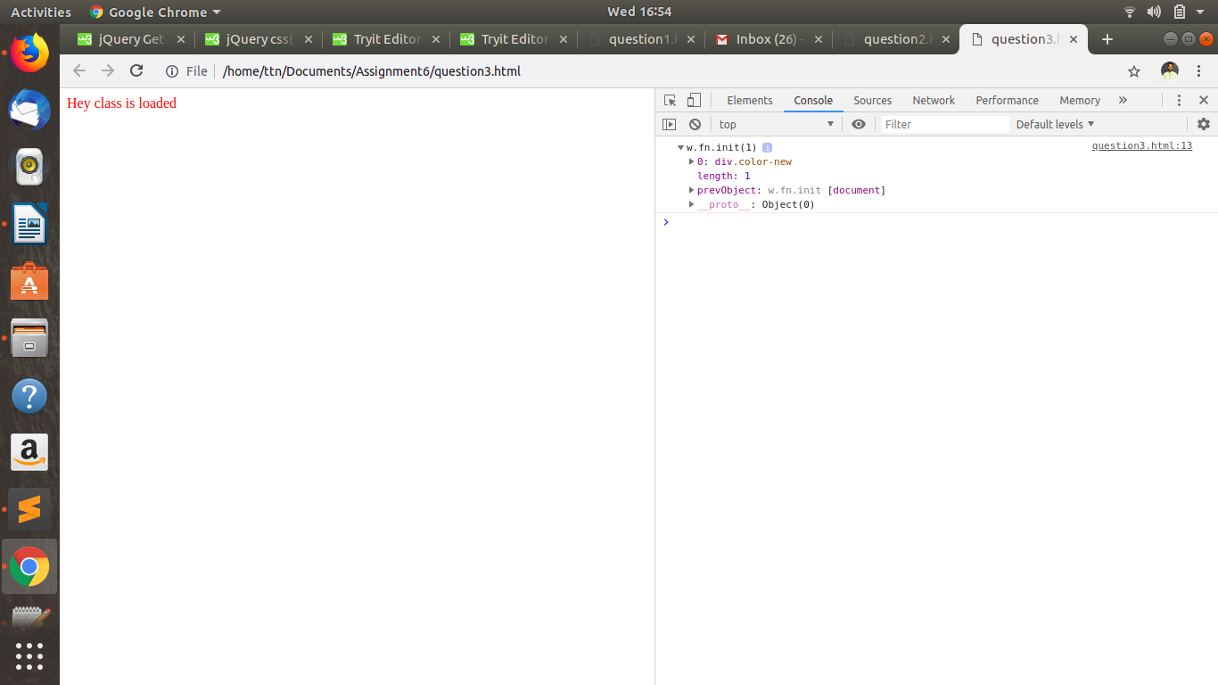

Question 4 : Disable submit button using jquery attr method
Answer 4 :

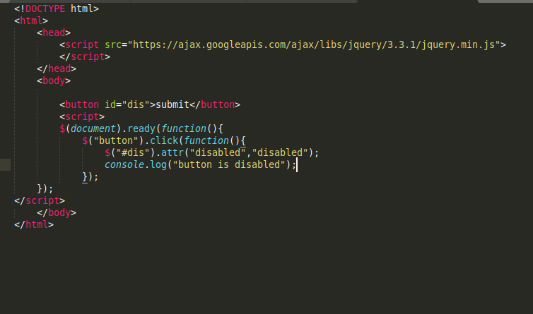
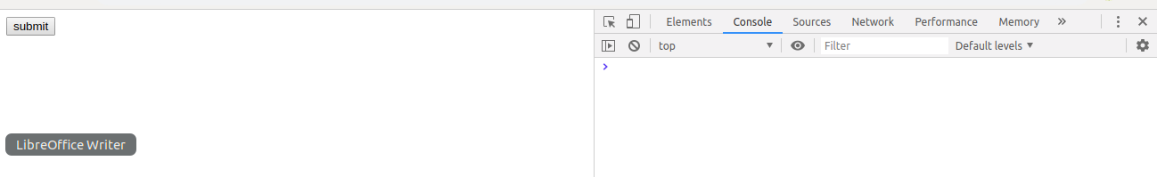
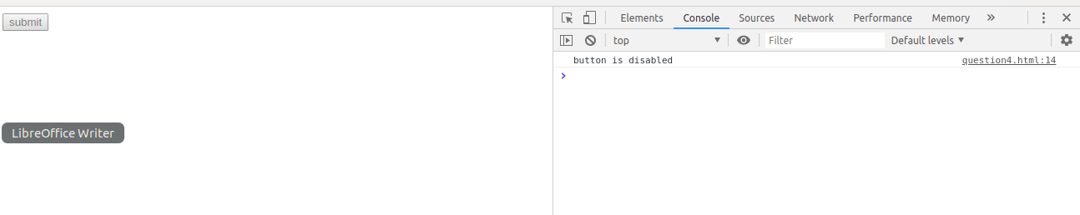

Question 5: Change the font size of ".target" which has parent element with id name "#main".
Answer 5 :

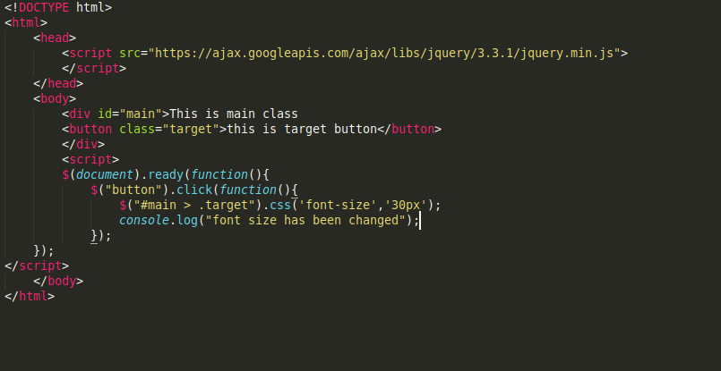

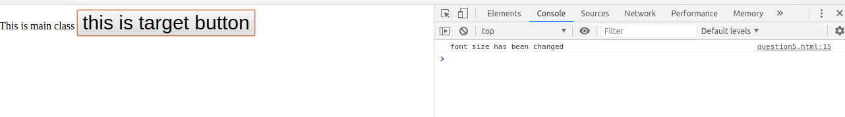

Question 6: After page load change the HTML of div element with "p" element.
Answer 6 :
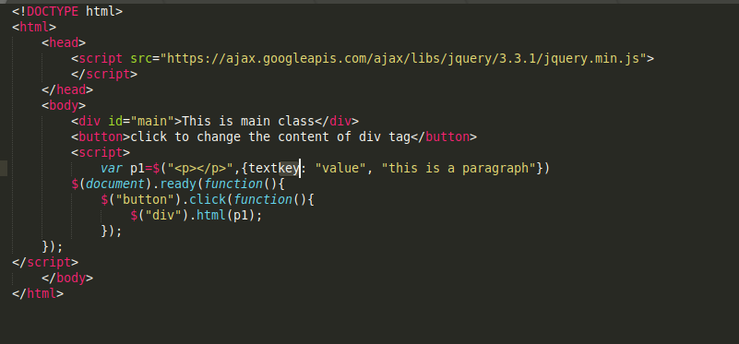

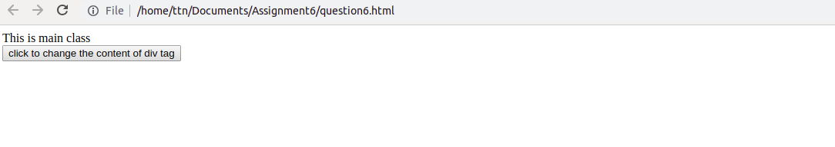

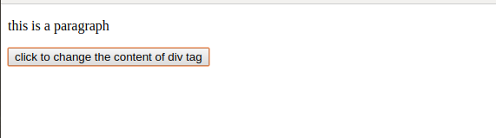

Question 7 : Bind a click function to an "click" element and append next "click" next to it.
Answer 7 :
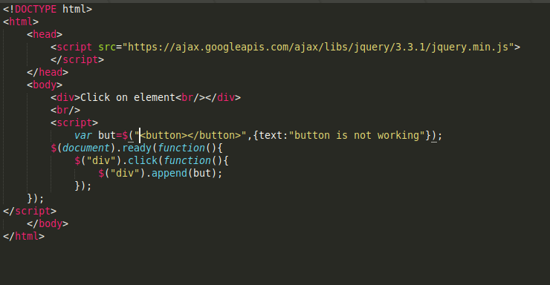
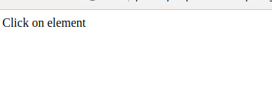

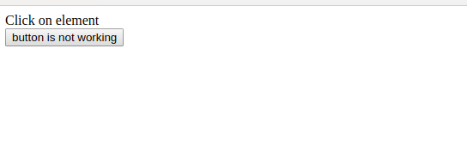

Question 8: Click event not working on element which added dynamicly or via script, make it work using .on method
Answer 8:

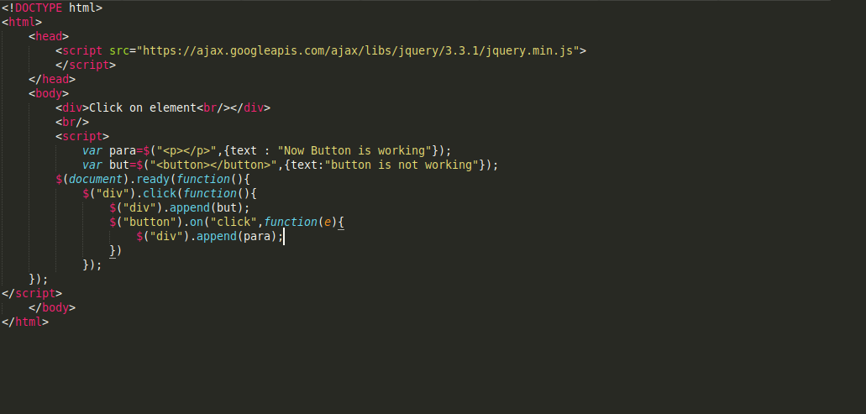
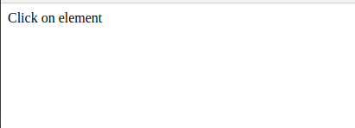

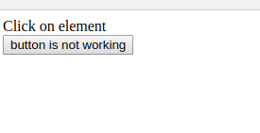

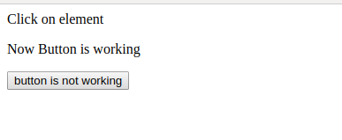

Question 9: Get dropdown selected value on onchanage event and append in div container
Answer 9:
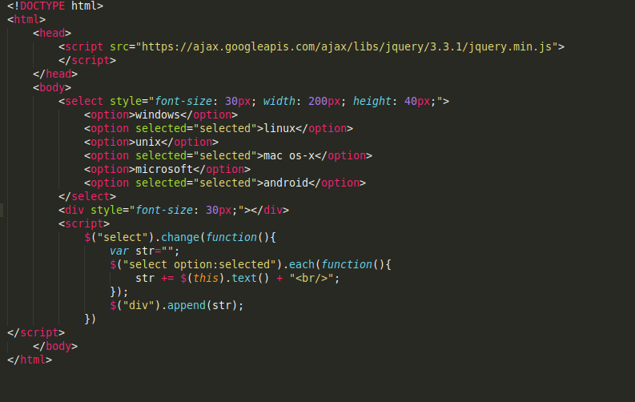
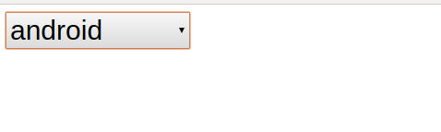

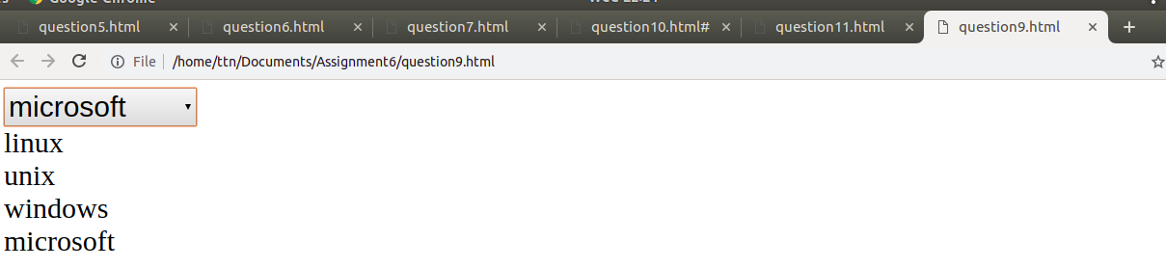

Question 10: Create a dropdown menu using hover method in jquery
Answer 10:
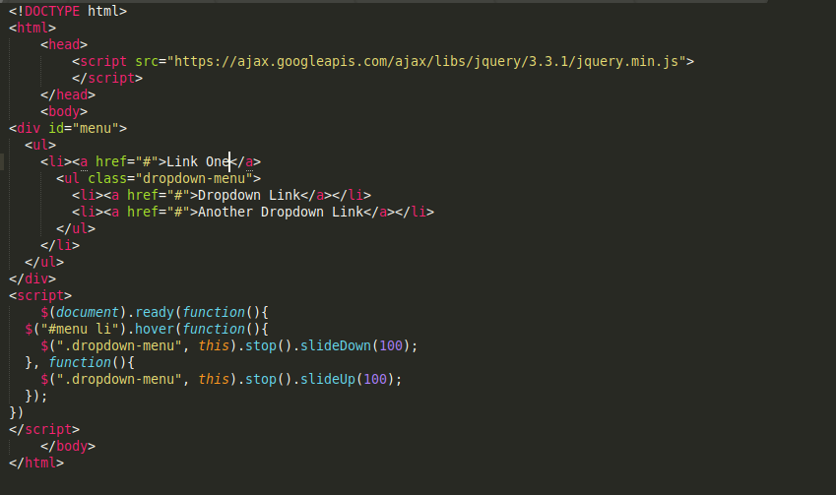
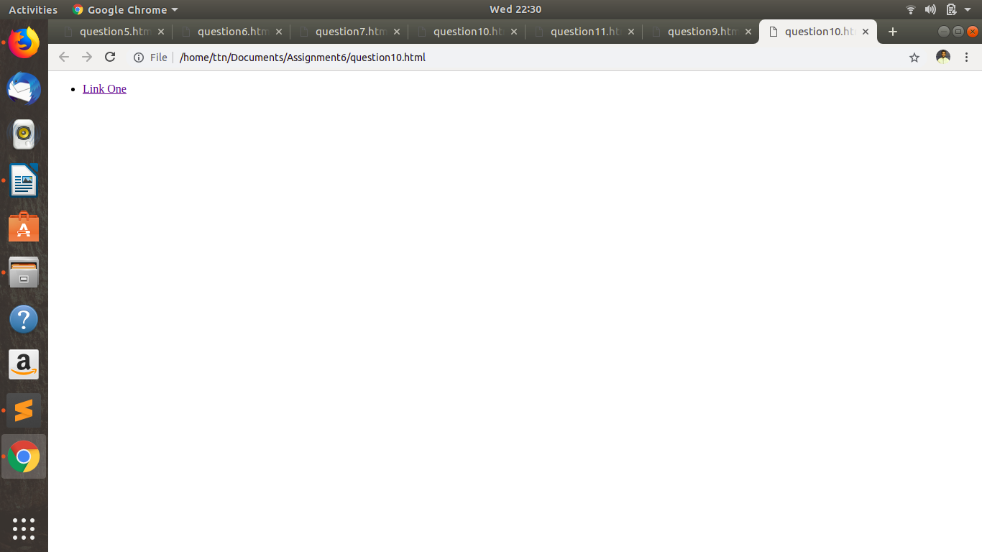
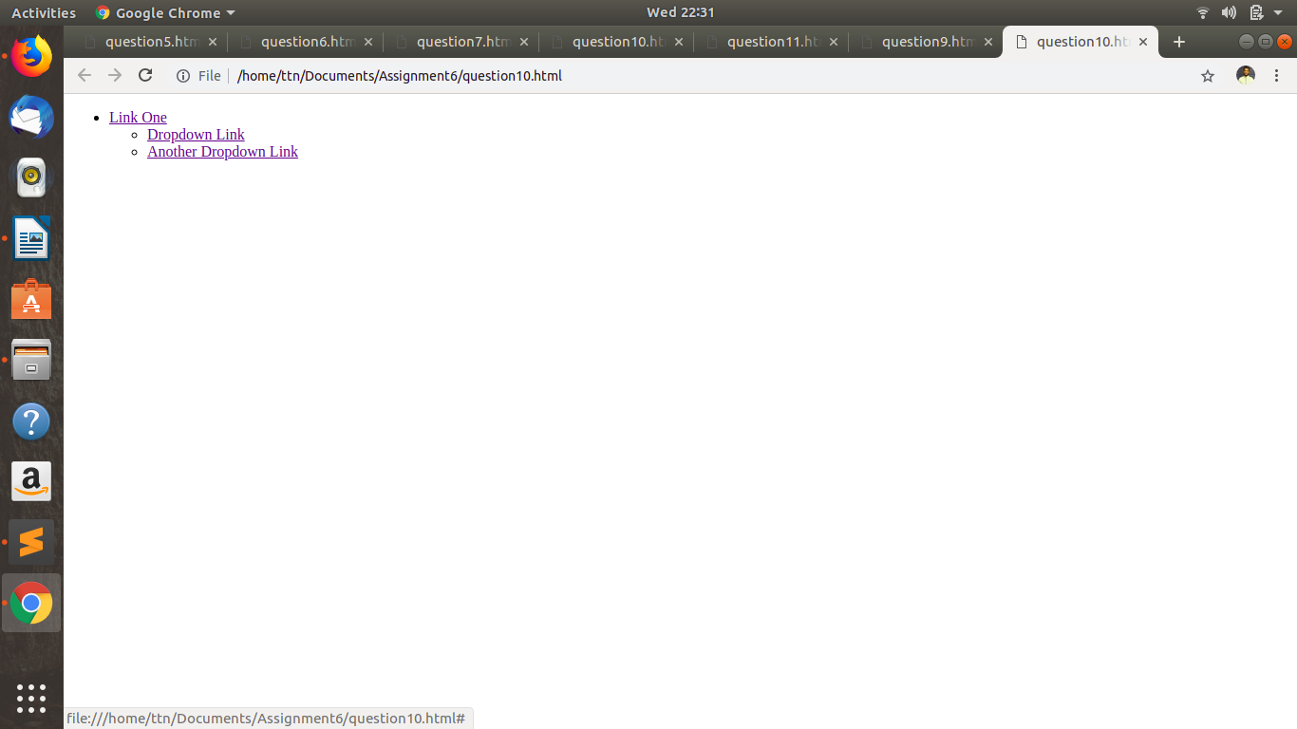

Question 11 : On clicking on “google” tag. It is taking us to google home page. Stop it from happening.
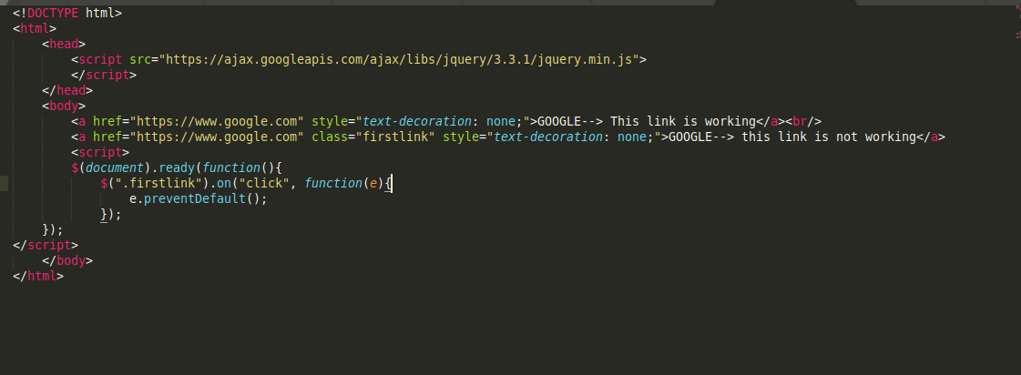
Answer 11 :

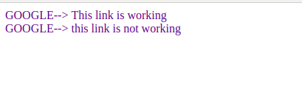

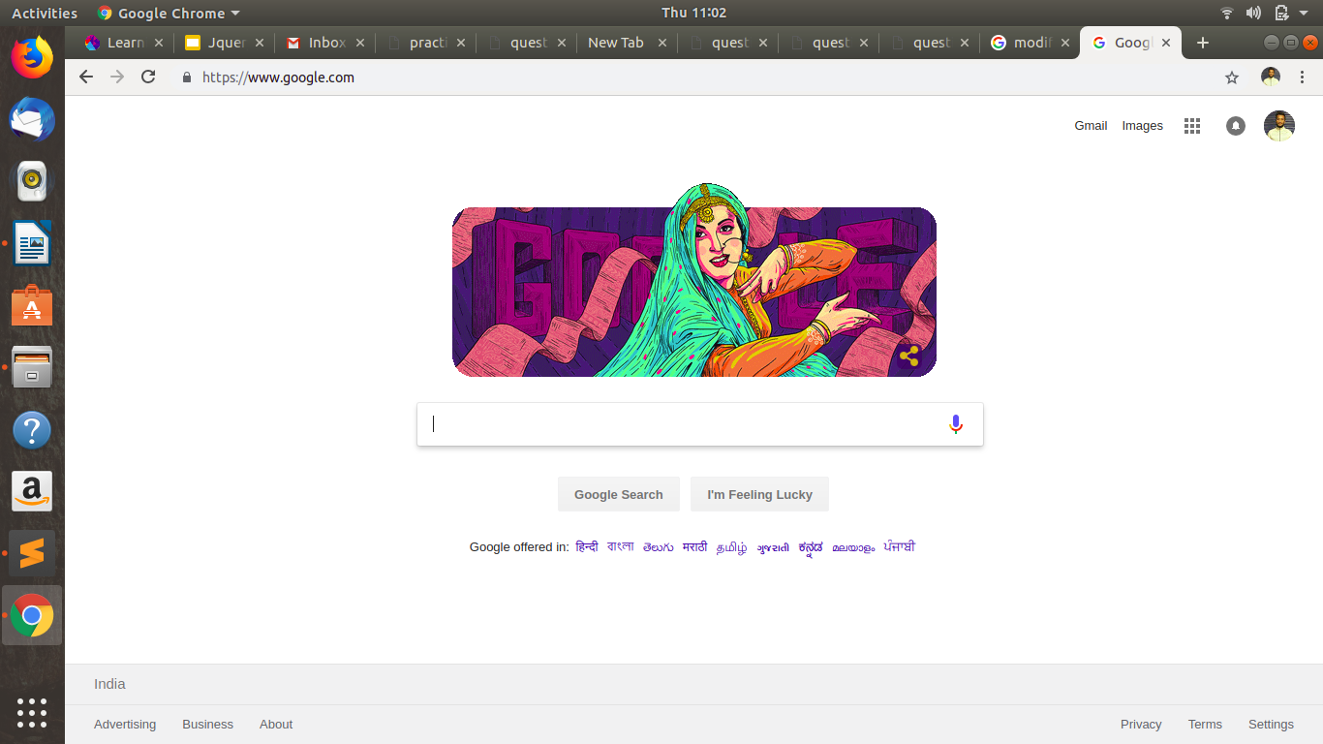

Question 12: We have bind a click funtion to parent div but we want stop it from performing when user clicks on its child li
Anwer 12 :
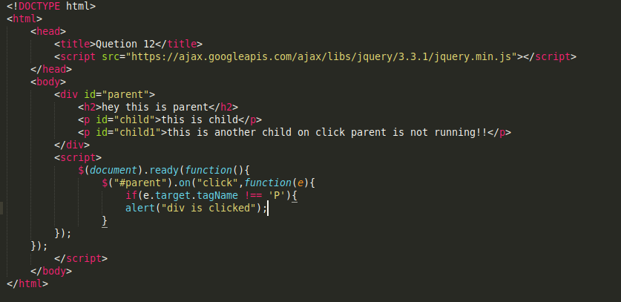

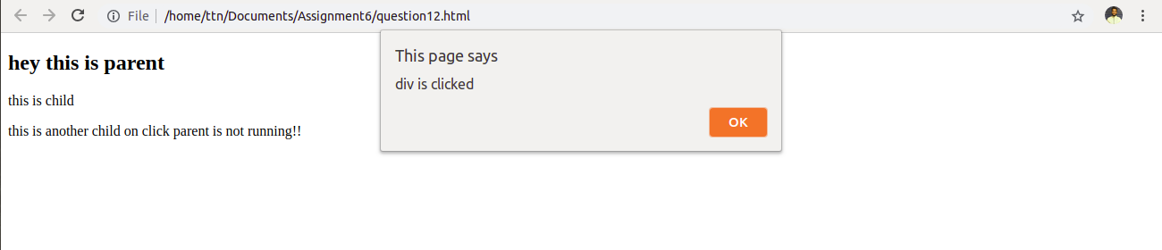

Question 13: Get the max height of elements using jquery each method
Answer 13 :
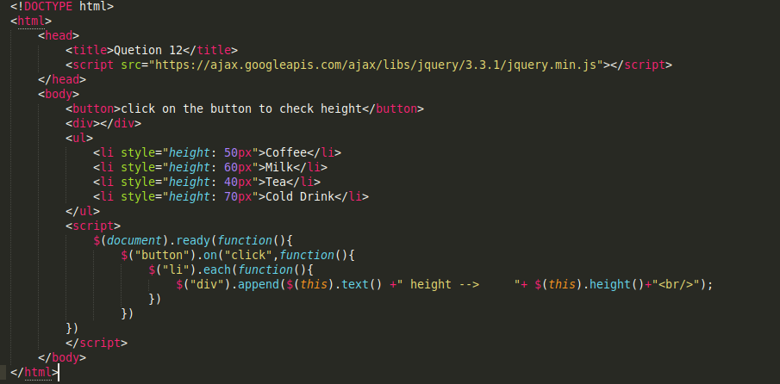
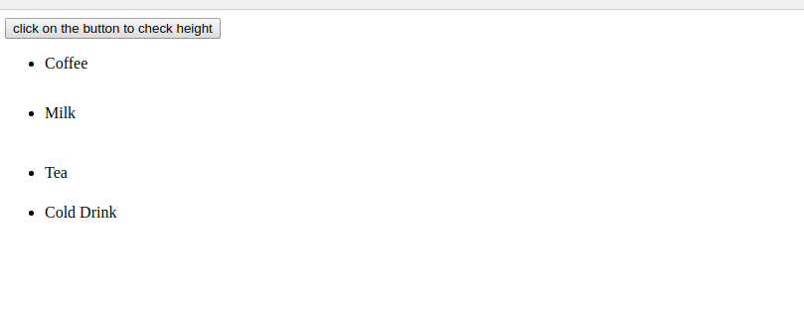
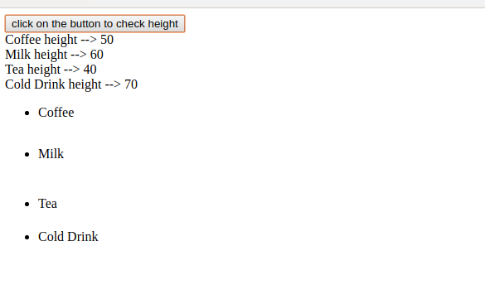
Question 14 : Chagne color of every cell which has numberl larger than 10.
Answer 14 :
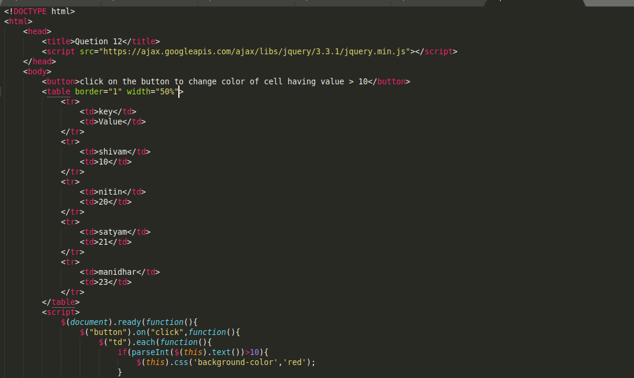
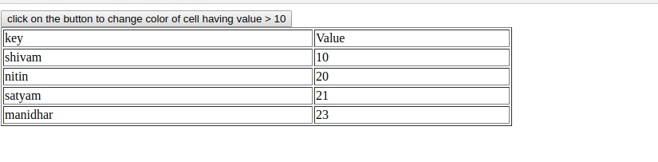
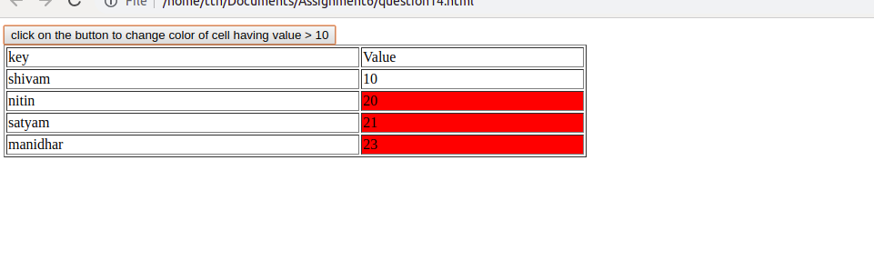

Question 15 : Retrive the data from server using ajax get call
Answer 15 :

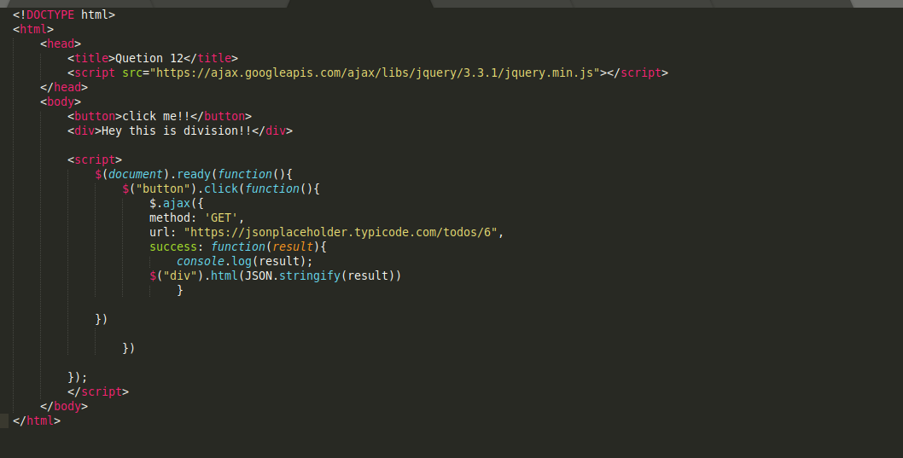
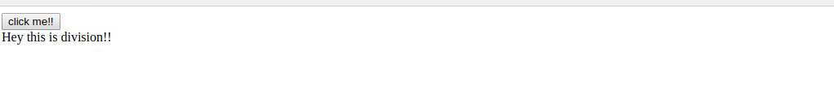
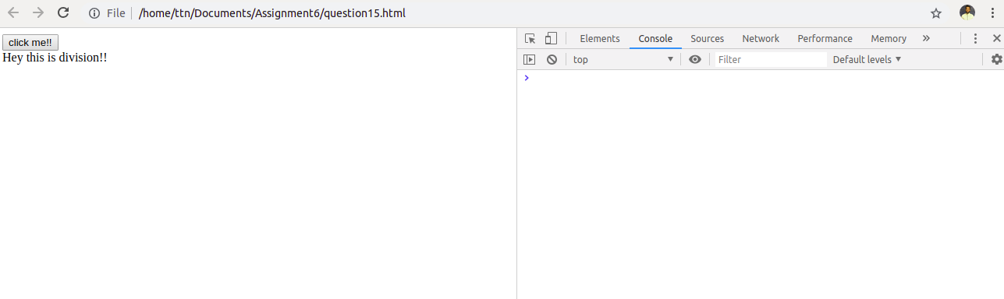
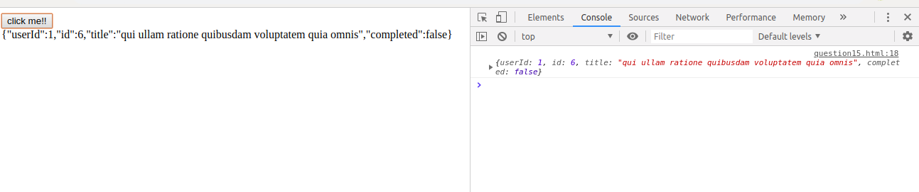

Question 17: Create a image array and in div create a slide show to animate images of delay of 500ms.
Answer 17:

