Question 1.Write Java code to define List . Insert 5 floating point numbers in List, and using an iterator, find the sum of the numbers in List.
Answer 1.
package Question.question1;
import java.util.ArrayList;
import java.util.Iterator;
import java.util.List;
public class SumListExample {
public static void main(String[] args) {
float sum = 0.0f;
List<Float> list = new ArrayList();
list.add(10.7f);
list.add(10.5f);
list.add(14.23f);
list.add(11.1f);
list.add(20.7f);
Iterator<Float> iterator = list.iterator();
while(iterator.hasNext()){
sum+=iterator.next();
}
System.out.println(sum);
}
}
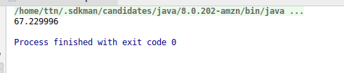

Question 2: Write a method that takes a string and returns the number of unique characters in the string.
Answer 2 : package Question.question2;
import java.util.HashSet;
import java.util.Iterator;
import java.util.Set;
public class FindUniqueCharacterOfStringExample {
public Set<String> stringUnique(String string){
Set set=new HashSet();
for(int i=0;i<string.length();i++){
set.add(string.charAt(i));
}
return set;
}
public static void main(String[] args) {
FindUniqueCharacterOfStringExample findUniqueCharacterOfStringExample=new FindUniqueCharacterOfStringExample();
Set<String> strings=findUniqueCharacterOfStringExample.stringUnique("nitin");
Iterator iterator=strings.iterator();
while (iterator.hasNext()){
System.out.println(iterator.next());
}
}
}
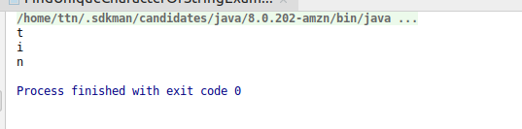

Question 3 : Write a method that takes a string and print the number of occurrence of each character characters in the string.
Answer 3 : package Question.question3;
import java.util.HashMap;
import java.util.Map;
public class OccurenceOfCharacterExample {
static void charOccurence(String string){
HashMap<Character,Integer> charCountMap=new HashMap<Character, Integer>();
char[] strArray=string.toCharArray();
for(char c:strArray){
if(charCountMap.containsKey(c)){
charCountMap.put(c,charCountMap.get(c)+1);
}else{
charCountMap.put(c,1);
}
}
for(Map.Entry entry:charCountMap.entrySet()){
System.out.println(entry.getKey()+"-->"+entry.getValue());
}
}
public static void main(String[] args) {
OccurenceOfCharacterExample.charOccurence("sshhaac");
}
}
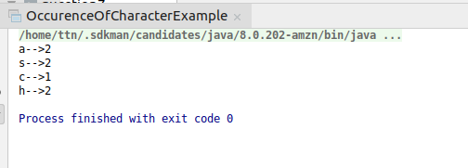

Question 4 :Write a program to sort Employee objects based on highest salary using Comparator. Employee class{ Double Age; Double Salary; String Name
Answer 4 :package Question.question4;
import java.util.ArrayList;
import java.util.Collections;
import java.util.Comparator;
public class Employee {
String name;
Double age;
Double Salary;
public Employee(String name,Double age,Double salary){
this.name=name;
this.age=age;
this.Salary=salary;
}
public String toString(){
return this.name+" "+this.age+" "+this.Salary;
}
}
class sortByAddress implements Comparator<Employee> {
@Override
public int compare(Employee o1, Employee o2) {
return (o1.Salary).compareTo(o2.Salary);
}
}
class Main{
public static void main(String[] args) {
ArrayList<Employee> arrayList=new ArrayList<>();
arrayList.add(new Employee("shivam",21D,5000.1D));
arrayList.add(new Employee("pulkit",21D,5000.2D));
arrayList.add(new Employee("manidhar",21D,41000.34D));
arrayList.add(new Employee("chotu",21D,11000.34D));
Collections.sort(arrayList,new sortByAddress());
for(int i=arrayList.size()-1;i>=0;i--){
System.out.println(arrayList.get(i));
}
}
}
//Another method for calculate Maximum salary
/*if((o1.Salary).intValue()>(o2.Salary).intValue()) {
return -1;
}if((o1.Salary).intValue()==(o2.Salary).intValue()){
return 0;
}else
return +1;
*/
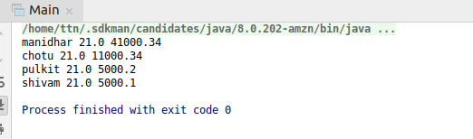
Question 5 :Write a program to sort the Student objects based on Score , if the score are same then sort on First Name . Class Student{ String Name; Double Score; Double Age,
Answer 5 :
package Question.question5;
import java.util.ArrayList;
import java.util.Collections;
import java.util.Comparator;
public class Student {
String Name;
Double Score;
Double Age;
public Student(String name, Double score, Double age) {
this.Name = name;
this.Score = score;
this.Age = age;
}
public double getScore(){
return this.Score;
}
public String toString() {
return this.Name + " " + this.Score + " " + this.Age;
}
}
class SortOnScore implements Comparator<Student> {
@Override
public int compare(Student o1, Student o2) {
if ((o1.Score) == (o2.Score)) {
return (o1.Name).compareTo(o2.Name);
} else
return (o1.Score).compareTo(o2.Score);
}
}
class Main {
public static void main(String[] args) {
ArrayList<Student> arrayList = new ArrayList<>();
arrayList.add(new Student("shivam", 321.2D, 23D));
arrayList.add(new Student("sa", 321.2D, 23D));
arrayList.add(new Student("manidhar", 321.2D, 23D));
arrayList.add(new Student("ansal", 321.2D, 21D));
arrayList.add(new Student("vishal", 231.2D, 22D));
arrayList.add(new Student("chotu", 231.2D, 22D));
Collections.sort(arrayList, new SortOnScore());
for (int i = arrayList.size() - 1; i >= 0; i--) {
System.out.println(arrayList.get(i));
}
}
}
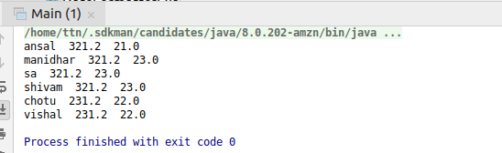

Question 6: Print the elements of an array in the decreasing frequency if 2 numbers have same frequency then print the one which came first.
Answer 6 :
package Question.question6;
import sun.nio.ch.sctp.SctpNet;
import java.util.*;
public class FreqExample {
public static void main(String[] args) {
Scanner sc=new Scanner(System.in);
System.out.println("enter the length of array");
int n=sc.nextInt();
int arr[]=new int[n];
Set<Integer> hset=new LinkedHashSet<>();
for(int i=0;i<n;i++){
arr[i]=sc.nextInt();
hset.add(arr[i]);
}
List<ArrayList<Integer>> freq=new ArrayList<>();
for(int i:hset){
int count=0;
for(int j=0;j<n;j++){
if(i == arr[j]){
count++;
}
}
freq.add(new ArrayList(Arrays.asList(i,count)));
}
freq.sort(new Comparator<ArrayList<Integer>>() {
@Override
public int compare(ArrayList<Integer> o1, ArrayList<Integer> o2) {
return o2.get(1)-o1.get(1);
}
});
System.out.println("Elemnts in decresing frequency is");
for(ArrayList<Integer> list:freq){
System.out.println(list.get(0) +" : "+list.get(1));
}
}
}
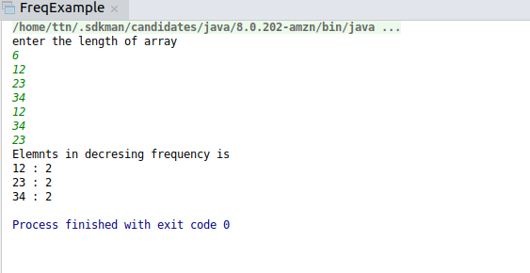
Question 7 :Design a Data Structure SpecialStack that supports all the stack operations like push(), pop(), isEmpty(), isFull() and an additional operation getMin() which should return minimum element from the SpecialStack. (Expected complexity -O(1))
Answer 7 :package Question.question7;
import java.util.Stack;
public class StackDemo {
Stack<Integer> stack;
int minimumElement;
public StackDemo(){
stack=new Stack<Integer>();
}
void push(int value){
if(stack.isEmpty()){
minimumElement=value;
stack.push(value);
System.out.println("Value Inserted : "+value);
return;
}
if(value<minimumElement){
stack.push(2*value - minimumElement);
minimumElement=value;
}else{
stack.push(value);
}
System.out.println("value inserted is : "+value);
}
void pop(){
if(stack.isEmpty()){
System.out.println("stack is empty");
return;
}
System.out.println("\nTop Element popped : ");
int removedvalue=stack.pop();
if(removedvalue < minimumElement){
System.out.println(minimumElement);
minimumElement=2*minimumElement-removedvalue;
}else{
System.out.println(removedvalue);
}
}
void peek(){
if(stack.isEmpty()){
System.out.println("stack is empty");
return;
}
int topelement=stack.peek();
System.out.println("Top Element is :");
if(topelement<minimumElement){
System.out.println(minimumElement);
}else
System.out.println(topelement);
}
void getMin(){
if(stack.isEmpty()){
System.out.println("stack is empty");
}else{
System.out.println(minimumElement);
}
}
}
class Main{
public static void main(String[] args) {
StackDemo stackDemo = new StackDemo();
stackDemo.push(34);
stackDemo.push(323);
stackDemo.push(141);
stackDemo.push(54);
stackDemo.push(4);
System.out.println("\nFetching minimum Element");
stackDemo.getMin();
stackDemo.pop();
stackDemo.pop();
System.out.println("\nFetching minimum Element");
stackDemo.getMin();
}
}
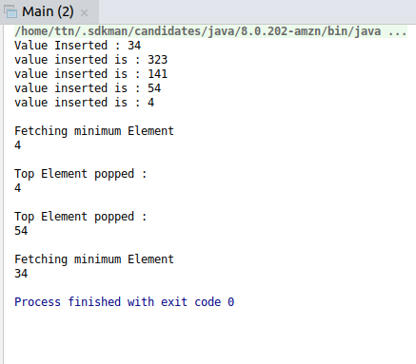

Question 8 :Write a program to format date as example "21-March-2016"
Answer 8 :
package Question.question8;
import java.text.SimpleDateFormat;
import java.util.Calendar;
import java.util.GregorianCalendar;
public class DateFormatterExample {
public static void main(String[] args) {
SimpleDateFormat simpleDateFormat=new SimpleDateFormat("dd-MMMM-yyyy");
Calendar calendar=new GregorianCalendar(2016,Calendar.MARCH,21);
System.out.println("Date is "+simpleDateFormat.format(calendar.getTime()));
}
}
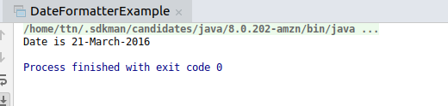

Question 9 :Write a program to display times in different country format.
Answer 9 : package Question.question9;
import java.text.DateFormat;
import java.util.Date;
import java.util.Locale;
public class LocaleExample {
public static void main(String[] args) {
Date date = new Date();
System.out.println("today Date is :"+date.toString());
Locale locale=new Locale("fr","FR");;
DateFormat dateFormat=DateFormat.getDateInstance(DateFormat.FULL,locale);
System.out.println("today in france is :"+dateFormat.format(date));
}
}
