Question 1 :Implement Singleton Design Pattern on a dummy class.
Answer 1 :
package Questions.question1;
public class SingletonExample {
static SingletonExample singletonExample;
String x,y;
private SingletonExample(){
this.x="shivam";
this.y="saxena";
}
@Override
public String toString() {
return "SingletonExample{" +
"x='" + x + '\'' +
", y='" + y + '\'' +
'}';
}
static SingletonExample getInstance(){
if(singletonExample ==null){
singletonExample=new SingletonExample();
}
return singletonExample;
}
}
class Main{
public static void main(String[] args) {
System.out.println(SingletonExample.getInstance());
System.out.println(SingletonExample.getInstance());
}
}
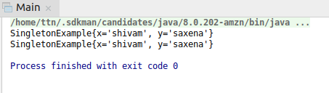

Question 2 :Implement Factory Pattern to get the Polygon of differnt type.
Answer 2 :
package Questions.question2;
interface Types {
void isType();
}
class Triangle implements Types {
@Override
public void isType() {
System.out.println("This is a Triangle");
}
}
class Quadilateral implements Types {
@Override
public void isType() {
System.out.println("This is a quadilateral");
}
}
class Pentagon implements Types {
@Override
public void isType() {
System.out.println("This is a pentagon");
}
}
class Hexagon implements Types {
@Override
public void isType() {
System.out.println("This is a Hexagon");
}
}
class Polygon{
Types types;
public Types getTypes() {
return types;
}
public void setTypes(Types types) {
this.types = types;
}
}
class FactoryObject{
static Polygon getPolygonObject(int sides){
Polygon polygon=new Polygon();
switch (sides) {
case 3: polygon.setTypes(new Triangle());
break;
case 4: polygon.setTypes(new Quadilateral());
break;
case 5: polygon.setTypes(new Pentagon());
break;
case 6: polygon.setTypes(new Hexagon());
break;
}
return polygon;
}
}
public class FactoryPatternDesign {
public static void main(String[] args) {
Polygon triangle=FactoryObject.getPolygonObject(3);
triangle.getTypes().isType();
Polygon quadilateral=FactoryObject.getPolygonObject(4);
quadilateral.getTypes().isType();
Polygon pentagon=FactoryObject.getPolygonObject(5);
pentagon.getTypes().isType();
Polygon Heaxagon=FactoryObject.getPolygonObject(6);
Heaxagon.getTypes().isType();
}
}
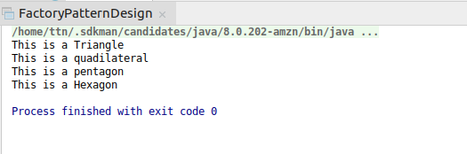

Question 3 :Implement Abstract Factory Pattern to create cars of different categories from different countries.
Answer 3 :
package Questions.question3.AbstactFactoryDesign;
enum CarType{
MINI,MICRO,LUXURY;
}
enum Location{
INDIA,USA,JAPAN;
}
abstract class Car{
CarType carType;
Location location;
public Car(CarType carType, Location location) {
this.carType = carType;
this.location = location;
}
abstract void construct();
@Override
public String toString() {
return "Car{" +
"carType=" + carType +
", location=" + location +
'}';
}
}
class LuxuryCar extends Car{
public LuxuryCar(Location location) {
super(CarType.LUXURY,location);
}
@Override
void construct() {
System.out.println("Connecting to Luxury Car");
}
}
class MiniCar extends Car{
public MiniCar(Location location) {
super(CarType.MINI, location);
}
@Override
void construct() {
System.out.println("Connecting to Mini Car");
}
}
class Micro extends Car{
public Micro(Location location) {
super(CarType.MICRO, location);
}
@Override
void construct() {
System.out.println("Connecting to Micro Car");
}
}
class IndiaCarFactory{
static Car buildCar(CarType carType){
Car car=null;
switch (carType){
case MINI:
car=new MiniCar(Location.INDIA);
break;
case MICRO:
car=new Micro(Location.INDIA);
break;
case LUXURY:
car=new LuxuryCar(Location.INDIA);
break;
}
return car;
}
}
class USACarFactory{
static Car buildCar(CarType carType){
Car car=null;
switch (carType){
case LUXURY:
car=new LuxuryCar(Location.USA);
break;
case MICRO:
car=new Micro(Location.USA);
break;
case MINI:
car=new MiniCar(Location.USA);
break;
}
return car;
}
}
class JapanCarFactory{
static Car buildCar(CarType carType){
Car car=null;
switch (carType){
case MINI:
car=new MiniCar(Location.JAPAN);
break;
case MICRO:
car=new Micro(Location.JAPAN);
break;
case LUXURY:
car=new LuxuryCar(Location.JAPAN);
break;
}
return car;
}
}
class CarFactory{
static Car buildCar(CarType carType,Location location){
Car car= null;
switch (location){
case INDIA:
car =IndiaCarFactory.buildCar(carType);
break;
case USA:
car=USACarFactory.buildCar(carType);
break;
case JAPAN:
car=JapanCarFactory.buildCar(carType);
break;
}
return car;
}
}
public class AbstractFactory {
public static void main(String[] args) {
MiniCar miniCar=new MiniCar(Location.INDIA);
miniCar.construct();
System.out.println(CarFactory.buildCar(CarType.MINI,Location.INDIA));
LuxuryCar luxuryCar=new LuxuryCar(Location.INDIA);
luxuryCar.construct();
System.out.println(CarFactory.buildCar(CarType.LUXURY,Location.INDIA));
}
}
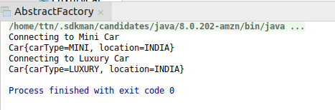

Question 4 :Implement Builder pattern to create a student object with more than 6 fields.
Answer 4 :
package Questions.question4;
class Student{
private String name;
private int rollno;
private int age;
private int phonenumber;
private String city;
private String address;
public Student(StudentBuilder studentBuilder){
this.name=studentBuilder.getName();
this.rollno=studentBuilder.getRollno();
this.age=studentBuilder.getAge();
this.phonenumber=studentBuilder.getPhonenumber();
this.city=studentBuilder.getCity();
this.address=studentBuilder.getAddress();
}
public String getName() {
return name;
}
public void setName(String name) {
this.name = name;
}
public int getRollno() {
return rollno;
}
public void setRollno(int rollno) {
this.rollno = rollno;
}
public int getAge() {
return age;
}
public void setAge(int age) {
this.age = age;
}
public int getPhonenumber() {
return phonenumber;
}
public void setPhonenumber(int phonenumber) {
this.phonenumber = phonenumber;
}
public String getCity() {
return city;
}
public void setCity(String city) {
this.city = city;
}
public String getAddress() {
return address;
}
public void setAddress(String address) {
this.address = address;
}
@Override
public String toString() {
return "Student{" +
"name='" + name + '\'' +
", rollno=" + rollno +
", age=" + age +
", phonenumber=" + phonenumber +
", city='" + city + '\'' +
", address='" + address + '\'' +
'}';
}
}
class StudentBuilder{
private String name;
private int rollno;
private int age;
private int phonenumber;
private String city;
private String address;
public String getName() {
return name;
}
public StudentBuilder setName(String name) {
this.name = name;
return this;
}
public int getRollno() {
return rollno;
}
public StudentBuilder setRollno(int rollno) {
this.rollno = rollno;
return this;
}
public int getAge() {
return age;
}
public StudentBuilder setAge(int age) {
this.age = age;
return this;
}
public int getPhonenumber() {
return phonenumber;
}
public StudentBuilder setPhonenumber(int phonenumber) {
this.phonenumber = phonenumber;
return this;
}
public String getCity() {
return city;
}
public StudentBuilder setCity(String city) {
this.city = city;
return this;
}
public String getAddress() {
return address;
}
public StudentBuilder setAddress(String address) {
this.address = address;
return this;
}
public Student build(){
return new Student(this);
}
}
public class BuilderPatternExample {
public static void main(String[] args) {
Student student=new StudentBuilder()
.setName("Shivam")
.setRollno(1)
.setAge(12)
.setCity("agra")
.setPhonenumber(123456789)
.setAddress("xyz")
.build();
System.out.println(student);
Student student1=new StudentBuilder()
.setName("Satyam")
.setRollno(2)
.setAge(34)
.setCity("lucknow")
.setPhonenumber(987654321)
.setAddress("abc")
.build();
System.out.println(student1);
}
}
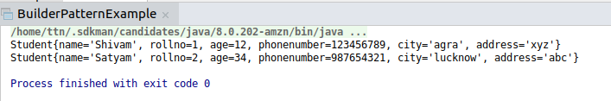

Question 5 :Implement Bridge Design Pattern for Color and Shape such that Shape and Color can be combined together e.g BlueSquare, RedSquare, PinkTriangle etc.
Answer 5 :
package Questions.question5;
interface Color {
String getColorType();
}
class Red implements Color{
@Override
public String getColorType() {
return "Red";
}
}
class Blue implements Color{
@Override
public String getColorType() {
return "Blue";
}
}
class Pink implements Color{
@Override
public String getColorType() {
return "Pink";
}
}
abstract class Polygon{
String type;
Color color;
public Polygon(String type,Color color){
this.type=type;
this.color=color;
}
}
class Shape extends Polygon{
String specification;
public Shape(String type, Color color, String specification) {
super(type, color);
this.specification=specification;
}
@Override
public String toString() {
return specification +" is: "+color.getColorType()+type;
}
}
public class BridgeDesignPattern {
public static void main(String[] args) {
Shape shape=new Shape("Square",new Blue(),"Polygon");
System.out.println(shape);
Shape shape1=new Shape("Square",new Red(),"polygon");
System.out.println(shape1);
Shape shape2=new Shape("Triangle",new Pink(),"Polygon");
System.out.println(shape2);
}
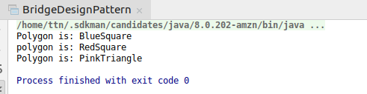
}

Question 6 :Implement Decorator pattern to decorate the Pizza with topings.
Answer 6 :
package Questions.question6;
interface Pizza {
String info();
}
class Onion implements Pizza {
int onion_quantity;
public Onion(int onion_quantity) {
this.onion_quantity = onion_quantity;
}
public int getOnion_quantity() {
return onion_quantity;
}
public void setOnion_quantity(int onion_quantity) {
this.onion_quantity = onion_quantity;
}
@Override
public String info() {
return "A pizza is ready with " + onion_quantity + "g quatity of onion";
}
}
class Tomato implements Pizza {
int tomato_quatity;
public Tomato(int tomato_quatity) {
this.tomato_quatity = tomato_quatity;
}
public int getTomato_quatity() {
return tomato_quatity;
}
public void setTomato_quatity(int tomato_quatity) {
this.tomato_quatity = tomato_quatity;
}
@Override
public String info() {
return "A pizza is ready with " + tomato_quatity + "g quantity of tomato";
}
}
class Toppings implements Pizza {
private Pizza pizza;
private String Toppings_types;
public Toppings(Pizza pizza, String cheese_types) {
this.pizza = pizza;
this.Toppings_types = cheese_types;
}
public Pizza getPizza() {
return pizza;
}
public void setPizza(Pizza pizza) {
this.pizza = pizza;
}
public String getToppings_types() {
return Toppings_types;
}
public void setToppings_types(String toppings_types) {
this.Toppings_types = toppings_types;
}
@Override
public String info() {
return pizza.info() + " and toppings of " + Toppings_types;
}
}
class CheeseQuantity implements Pizza {
Pizza pizza;
int cheese_quantity;
public CheeseQuantity(Pizza pizza, int cheese_quantity) {
this.cheese_quantity = cheese_quantity;
this.pizza = pizza;
}
public Pizza getPizza() {
return pizza;
}
public void setPizza(Pizza pizza) {
this.pizza = pizza;
}
public int getCheese_quantity() {
return cheese_quantity;
}
public void setCheese_quantity(int cheese_quantity) {
this.cheese_quantity = cheese_quantity;
}
@Override
public String info() {
return pizza.info() + " and having Toppings quantity " + cheese_quantity + "g";
}
}
public class DecoratePatternExample {
public static void main(String[] args) {
Onion onion = new Onion(23);
System.out.println(onion.info());
Toppings toppings = new Toppings(new Tomato(40), "Mozrilla");
System.out.println(toppings.info());
CheeseQuantity cheeseQuantity = new CheeseQuantity(new Onion(21), 23);
System.out.println(cheeseQuantity.info());
}
}
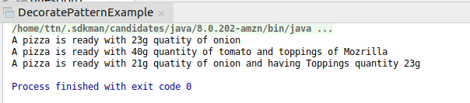

Question 7 :Implement Composite Design Pattern to maintaing the directories of employees on the basis of departments.
Answer 7 :
package Questions.question7;
import java.util.ArrayList;
import java.util.List;
interface Employees{
void showEmployeesDetails();
}
class Developer implements Employees{
private String name;
private String KnownLangauge;
public Developer(String name, String knownLangauge) {
this.name = name;
KnownLangauge = knownLangauge;
}
public String getName() {
return name;
}
public void setName(String name) {
this.name = name;
}
public String getKnownLangauge() {
return KnownLangauge;
}
public void setKnownLangauge(String knownLangauge) {
KnownLangauge = knownLangauge;
}
@Override
public void showEmployeesDetails() {
System.out.println("Developer{" +
"name='" + name + '\'' +
", KnownLangauge='" + KnownLangauge + '\'' +
'}');
}
@Override
public String toString() {
return "Developer{" +
"name='" + name + '\'' +
", KnownLangauge='" + KnownLangauge + '\'' +
'}';
}
}
class Manager implements Employees{Developer developer1=new Developer("Shivam","java");
Developer developer2=new Developer("Sanjeev","python");
DeveloperEmployee developerEmployee=new DeveloperEmployee();
private String name;
private String type;
public Manager(String name, String type) {
this.name = name;
this.type = type;
}
public String getName() {
return name;
}
public void setName(String name) {
this.name = name;
}
public String getType() {
return type;
}
public void setType(String type) {
this.type = type;
}
@Override
public String toString() {
return "Manager{" +
"name='" + name + '\'' +
", type='" + type + '\'' +
'}';
}
@Override
public void showEmployeesDetails() {
System.out.println("Manager{" +
"name='" + name + '\'' +
", type='" + type + '\'' +
'}');
}
}
class DeveloperEmployee implements Employees{
List<Employees> employeesdeveloper=new ArrayList<>();
@Override
public void showEmployeesDetails() {
System.out.println("Developers Details");
employeesdeveloper.forEach((e)->e.showEmployeesDetails());
}
}
class ManagerEmployee implements Employees{
List<Employees> employeesmanager=new ArrayList<>();
@Override
public void showEmployeesDetails() {
System.out.println("Manager Details");
employeesmanager.forEach((e)->e.showEmployeesDetails());
}
}
public class CompositeDesignPattern {
public static void main(String[] args) {
Developer developer1=new Developer("Shivam","java");
Developer developer2=new Developer("Sanjeev","python");
Manager manager1=new Manager("Arzoo","H.R");
Manager manager2=new Manager("Raghav","Senior Manager");
DeveloperEmployee developerEmployee=new DeveloperEmployee();
developerEmployee.employeesdeveloper.add(developer1);
developerEmployee.employeesdeveloper.add(developer2);
developerEmployee.showEmployeesDetails();
ManagerEmployee managerEmployee=new ManagerEmployee();
managerEmployee.employeesmanager.add(manager1);
managerEmployee.employeesmanager.add(manager2);
managerEmployee.showEmployeesDetails();
}
}
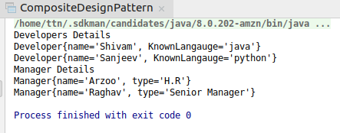

Question 8 :Implement proxy design for accessing Record of a student and allow the access only to Admin.
Answer 8 :
package Questions.question8;
import java.util.Scanner;
class Admin{
private String password;
public Admin(String password) {
this.password = password;
}
public String getPassword() {
return password;
}
public void setPassword(String password) {
this.password = password;
}
}
interface AdminAccessing{
void getAccess();
}
class Student implements AdminAccessing{
String name;
Admin admin;
public Student(String name, Admin admin) {
this.name = name;
this.admin = admin;
}
@Override
public void getAccess() {
System.out.println("student name is : "+name);
}
}
class StudentProxy extends Student{
public StudentProxy(String name, Admin admin) {
super(name, admin);
}
public void getAccess() {
System.out.println("Admin Enter Password");
Scanner scanner=new Scanner(System.in);
String password=scanner.next();
if(!admin.getPassword().equals(password)){
System.out.println("you can not access to Student");
}else{
System.out.println("you can access to Student");
super.getAccess();
}
}
}
public class ProxyDesignPattern {
public static void main(String[] args) {
Student student=new Student("shivam",new Admin("Shivam"));
StudentProxy studentProxy=new StudentProxy("Shivam",new Admin("shivam"));
studentProxy.getAccess();
}
}

For Incorrect Admin Access.
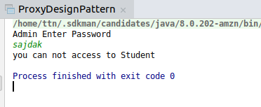

For correct Admin Access.

