Q1. Write a program to replace a substring inside a string with other string ?
package Questions.question1;
public class Main1 {
public static void main(String[] args) {
Logic1 lg=new Logic1();
lg.ques1();
}
}
package Questions.question1;
public class Logic1 {
public void ques1(){
CharSequence str="shivam";
CharSequence str2="IV";
CharSequence charSequence=str.subSequence(2,4);
System.out.println("replace " +charSequence+" with "+str2);
CharSequence str3=((String) str).replace(charSequence,str2);
System.out.println(str3);
}
}
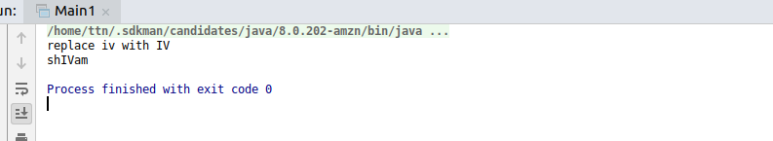

Q2. Write a program to find the number of occurrences of the duplicate words in a string and print them ?
package Questions.question2;
public class Main2 {
public static void main(String[] args) {
logic2 lg=new logic2();
lg.que2();
}
}
package Questions.question2;
import java.util.Scanner;
public class logic2 {
public void que2(){
System.out.println("Enter the string to check Duplicacy");
Scanner sc=new Scanner(System.in);
String str=sc.nextLine();
System.out.println("String is : "+str);
String[] str1=str.split(" ");
int wc=1;
for(int i=0;i<str1.length;i++){
for(int j=i+1;j<str1.length;j++) {
if (str1[i].equals(str1[j])) {
wc = wc + 1;
str1[j] = "0";
}
}
if(str1[i]!="0"){
System.out.println(str1[i] + "---->" + wc);
wc=1;
}
}
}
}
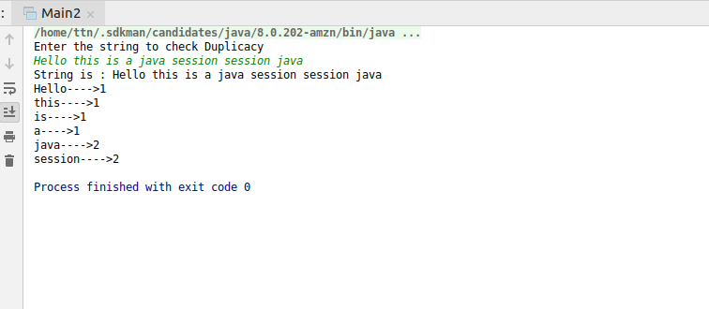

Q3. Write a program to find the number of occurrences of a character in a string without using loop?

package Questions.question3;
public class logic3 {
int count(String[] s, String c){
int count=0;
for(int i=0;i<s.length;i++){
if(s[i].equals(c))
count++;
}
return count;
}
}
package Questions.question3;
import java.util.Scanner;
public class CharacterOccurence {
public static void main(String[] args) {
System.out.println("Enter the String :");
Scanner sc=new Scanner(System.in);
String s=sc.nextLine();
String[] str=s.split("");
System.out.println("Enter the words to check the occurences");
String c=sc.next();
logic3 lg=new logic3();
int occurence=lg.count(str,c);
System.out.println("Occurence of word (" + c + ") in "+ s +" is :" +occurence);
}
}
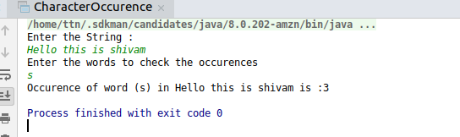

Q4. Calculate the number & Percentage Of Lowercase Letters,Uppercase Letters, Digits And Other Special Characters In A String
package Questions.question4;
import java.util.Calendar;
public class logic4 {
public void charPercent(String s) {
int lowerchar=0;
int upperchar=0;
int digit=0;
int specialchar=0;
int len=s.length();
for(int i=0;i<len;i++){
char ch=s.charAt(i);
if(Character.isLowerCase(ch)){
lowerchar++;
}else if(Character.isUpperCase(ch)){
upperchar++;
}else if(Character.isDigit(ch)){
digit++;
}else {
specialchar++;
}
}
float lower_char_perc=(lowerchar*100)/len;
float upper_char_perc=(upperchar*100)/len;
float digit_perc=(digit*100)/len;
float special_char_perc=(specialchar*100)/len;
System.out.println("Number of lower case letter :"+lowerchar);
System.out.println("Number of percentage of lower case letter :"+lower_char_perc);
System.out.println("Number of Upper case letter :"+upperchar);
System.out.println("Number of percentage of upper case letter :"+upper_char_perc);
System.out.println("Number of digit in String : " +digit);
System.out.println("Number of percentage of Digit :"+digit_perc);
System.out.println("Number of Special case letter :"+specialchar);
System.out.println("Number of percentage of lower case letter :"+special_char_perc);
}
}
package Questions.question4;
import java.util.Scanner;
public class Character_Percentage {
public static void main(String[] args) {
System.out.println("Enter String to check");
Scanner sc=new Scanner(System.in);
String str=sc.nextLine();
logic4 lg=new logic4();
lg.charPercent(str);
}
}
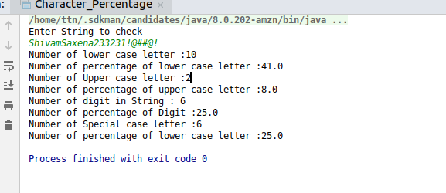

Q5. Find common elements between two arrays.
package Questions.question5;
public class logic5 {
public static void main(String[] args) {
int[] arr=new int[]{1,2,3,4,5,6,7,8};
int[] arr1=new int[]{2,21,23,3,5,4,123,231};
int[] arr_withoutduplicacy=new int[]{};
for(int i=0;i<arr.length;i++){
for(int j=0;j<arr1.length;j++){
if(arr[i]==arr1[j]){
System.out.println(arr[i]);
}
}
}
}
}
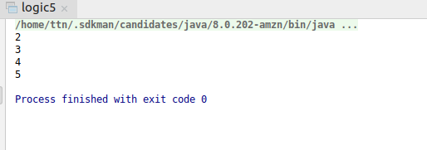

Q6. There is an array with every element repeated twice except one. Find that element
package Questions.question6;
public class Logic6 {
public int searchElement(int arr[],int arr_size){
int res=arr[0];
for(int i=1;i<arr_size;i++){
res=res^arr[i];
}
return res;
}

}
package Questions.question6;
public class CheckElement {
public static void main(String[] args) {
int[] arr=new int[]{1,2,2,1,3,5,5};
int arr_size=arr.length;
Logic6 lg=new Logic6();
int res=lg.searchElement(arr,arr_size);
System.out.println(res);
}
}
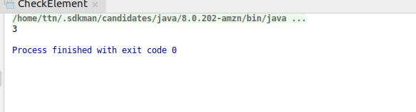

Q7. Write a program to print your Firstname,LastName & age using static block,static method & static variable respectively
package Questions.question7;
public class StaticExample {
static String First_name;
static String Last_name;
static int Age;
public static void main(String[] args) {
System.out.println("FirstName : "+First_name);
System.out.println("LastName :"+Last_name);
System.out.println("Age :"+Age);
}
static{
System.out.println("This is a static block");
First_name="Shivam";
Last_name="Saxena";
Age=20;
}
}
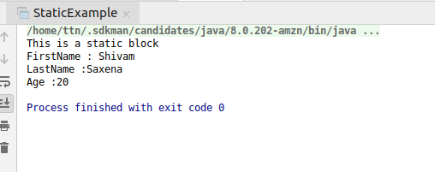
package Questions.question7;
public class StaticMethodEx {
static private String FirstName;
static private String LastName;
static private int Age;
public static void main(String[] args) {
StaticMethodEx.My_info("shivam","saxena",20);
System.out.println(FirstName);
System.out.println(LastName);
System.out.println(Age);
}
public static void My_info(String f,String l,int a){
FirstName=f;
LastName=l;
Age=a;
}
}
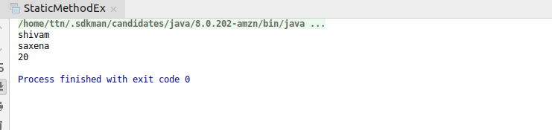

Q8. Write a program to reverse a string and remove character from index 4 to index 9 from the reversed string using String Buffer
package Questions.question8;
public class StringReverseEx {
public static void main(String[] args) {
StringBuffer stringBuffer=new StringBuffer("Successfully");
stringBuffer.reverse().replace(4,9,"");
System.out.println(stringBuffer);
}
}
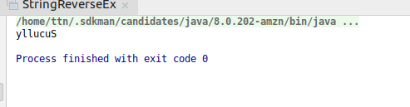

Q9.Write a program to display values of enums using a constructor & getPrice() method (Example display house & their prices)
package Questions.question9;
public enum Houses {
HOUSES_2BHK(100000L),
HOUSES_3BHK(200000L),
HOUSES_4BHK(300000L);
Long price;
Houses(Long p){
this.price=p;
System.out.println("fetching through Constructor --> "+this.toString()+" and price is --> "+p);
}
Long getPrice(){
return price;
}
}
class DisplayHouses{
public static void main(String[] args) {
for(Houses i: Houses.values()) {
System.out.println("this is through getPriceMethod() --> "+i+" cost price is --> "+i.getPrice());
}
}
}
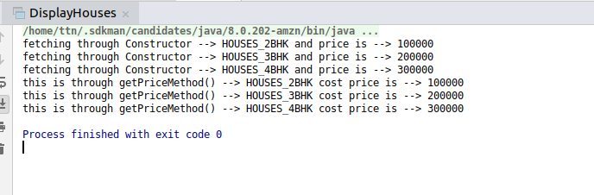

Q10.Write a single program for following operation using overloading
A) Adding 2 integer number
B) Adding 2 double
C) multiplying 2 float
D) multiplying 2 int
E) concate 2 string
F) Concate 3 String
package Questions.question10;
public class MethodOverloading {
public static void main(String[] args) {
MethodOverloading methodOverloading=new MethodOverloading();
int sum_int=methodOverloading.add(10,12);
System.out.println("Two Integer Sum : "+sum_int);
double sum_double=methodOverloading.add(11.07,12.03);
System.out.println("Two Double Sum : " +sum_double);
float mul_float=methodOverloading.multiply(11.02f,12.02f);
System.out.println("Two Float Multiplication : "+mul_float);
int mul_int=methodOverloading.multiply(12,11);
System.out.println("Two Integer Multiply : " +mul_int);
String str=methodOverloading.concatString("Shivam"," Saxena");
System.out.println("Two Concat String : "+str);
String str1=methodOverloading.concatString("Nitin"," Kumar"," Singh");
System.out.println("Three concat String : "+str1);
}
public int add(int a,int b){
int c=a+b;
return c;
}
public double add(double a,double b){
double c=a+b;
return c;
}
public float multiply(float a,float b){
float c=a*b;
return c;
}
public int multiply(int a,int b){
int c=a*b;
return c;
}
public String concatString(String str1,String str2){
String str3=str1.concat(str2);
return str3;
}
public String concatString(String str1,String str2,String str3){
String str4=(str1.concat(str2)).concat(str3);
return str4;
}
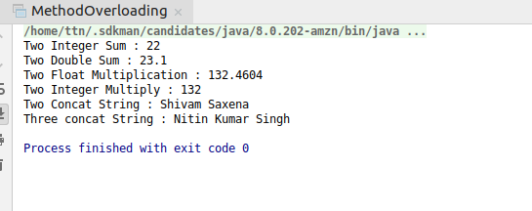
}

Q11.Create 3 sub class of bank SBI,BOI,ICICI all 4 should have method called getDetails which provide there specific details like rateofinterest etc,print details of every banks
package Questions.question11;
public class BankDetails {
public static void main(String[] args) {
Banks obj=new Banks();
obj.getDetails();
Banks obj1=new SBI();
obj1.getDetails();
Banks obj2=new PNB();
obj2.getDetails();
Banks obj3=new OBI();
obj3.getDetails();
}
}
class Banks{
public void getDetails(){
System.out.println("Bank Information\n");
}
}
class SBI extends Banks{
public void getDetails(){
System.out.println("State Bank Of India\nRate of Interest is : 10\n");
}
}
class PNB extends Banks{
public void getDetails(){
System.out.println("Punjab National Bank\nRate of Interest is : 14\n");
}
}
class OBI extends Banks{
public void getDetails(){
System.out.println("Oriental Bank Of India\nRate of Interest is : 12\n");
}
}
