Question 1:- Create and Run a Thread using Runnable Interface and Thread class.
Answer 1:- Using Runnable
package Question.question1;
public class ThreadEx implements Runnable {
@Override
public void run() {
System.out.println("This is through Runnable");
}
}
class ThreadEx1 implements Runnable {
@Override
public void run() {
System.out.println("This is through Runnable2");
}
}
class Main{
public static void main(String[] args) {
ThreadEx threadEx=new ThreadEx();
ThreadEx1 threadEx1=new ThreadEx1();
Thread t=new Thread(threadEx);
Thread t1=new Thread(threadEx1);
t.start();
t1.start();
}
}
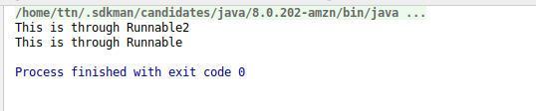

Using Thread:
package Question.question1;
public class ThreadExample extends Thread{
public void run(){
System.out.println("this is thread Example");
}
public static void main(String[] args) {
ThreadExample threadExample=new ThreadExample();
threadExample.start();
}
}
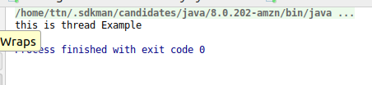
Question 2 : Use sleep and join methods with thread.
package Question.question2;
public class SleepAndJoinsExample {
public static void main(String[] args) throws InterruptedException {
Thread thread = new Thread(new Runnable() {
@Override
public void run() {
try {
Thread.sleep(1000L);
System.out.println("Running 1st thread");
} catch (InterruptedException ex) {
ex.printStackTrace();
}
}
});
Thread thread1 = new Thread(new Runnable() {
@Override
public void run() {
try {
Thread.sleep(1000L);
System.out.println("Running 2nd thread");
} catch (InterruptedException ex) {
ex.printStackTrace();
}
}
});
thread.start();
thread.join();
thread1.start();
thread1.join();
}
}
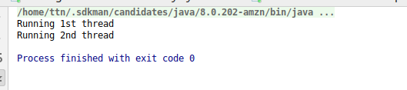

Question 3: Use a singleThreadExecutor to submit multiple threads.
Answer 3 : package Question.question3;
import java.util.concurrent.ExecutorService;
import java.util.concurrent.Executors;
public class SingleThreadExecuterExample {
public static void main(String[] args) {
ExecutorService executorService= Executors.newSingleThreadExecutor();
try{
executorService.submit(new Runnable() {
@Override
public void run() {
System.out.println("Thread 1");
}
});
executorService.submit(new Runnable() {
@Override
public void run() {
System.out.println("Thread 2");
}
});
executorService.submit(new Runnable() {
@Override
public void run() {
try {
Thread.sleep(1000L);
System.out.println("Thread 3");
} catch (InterruptedException e) {
e.printStackTrace();
}
}
});
}finally {
System.out.println("End");
}
}
}
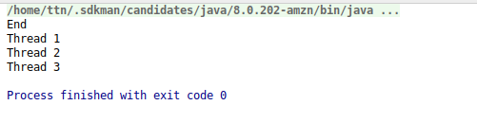

Question 4 : Try shutdown() and shutdownNow() and observe the difference.
Answer 4 : shutdown():-
package Question.question4;
import java.util.concurrent.ExecutorService;
import java.util.concurrent.Executors;
public class SingleThreadExecutorShutDownEx1 {
public static void main(String[] args) {
ExecutorService executorService= Executors.newSingleThreadExecutor();
try{
executorService.submit(new Runnable() {
@Override
public void run() {
System.out.println("Thread 1");
}
});
executorService.submit(new Runnable() {
@Override
public void run() {
System.out.println("Thread 2");
}
});
}finally {
executorService.shutdown();
}
System.out.println(executorService.isShutdown());
System.out.println(executorService.isTerminated());
System.out.println("End");
}
}

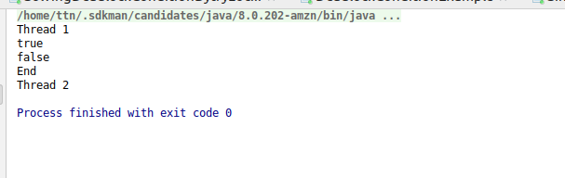

shutdownNow():-
package Question.question4;
import java.util.concurrent.ExecutorService;
import java.util.concurrent.Executors;
public class SinglethreadExecutionShutdownNowEx1 {
public static void main(String[] args) {
ExecutorService executorService = Executors.newSingleThreadExecutor();
try{
executorService.submit(new Runnable() {
@Override
public void run() {
System.out.println("Thread 1");
}
});
executorService.submit(new Runnable() {
@Override
public void run() {
try {
Thread.sleep(1000L);
} catch (InterruptedException e) {
e.printStackTrace();
}
System.out.println("Thread 2");
}
});
}finally{
executorService.shutdownNow();
}
System.out.println("End");
}
}
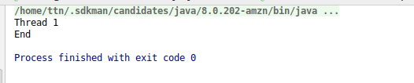

Question 5 :Use isShutDown() and isTerminate() with ExecutorService.
Answer 5 :
package Question.question5;
import java.util.concurrent.ExecutorService;
import java.util.concurrent.Executors;
public class IsShutdownExample {
public static void main(String[] args) {
ExecutorService executorService = Executors.newSingleThreadExecutor();
try {
executorService.submit(new Runnable() {
@Override
public void run() {
System.out.println("Thread 1");
}
});
executorService.submit(new Runnable() {
@Override
public void run() {
System.out.println("Thread 2");
}
});
} finally {
executorService.shutdown();
}
System.out.println(executorService.isShutdown());
System.out.println(executorService.isTerminated());
System.out.println("End");
}
}
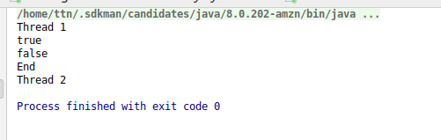

Question 6 :Return a Future from ExecutorService by using callable and use get(), isDone(), isCancelled() with the Future object to know the status of task submitted.
Answer 6 : package Question.question6;
import java.util.concurrent.*;
public class CallableExample {
public static void main(String[] args) throws ExecutionException, InterruptedException {
ExecutorService executorService = Executors.newSingleThreadExecutor();
Future<Integer> future=executorService.submit(new Callable<Integer>() {
@Override
public Integer call() throws Exception {
return 1;
}
});
executorService.shutdown();
if(future.isDone()){
System.out.println(future.get());
}if(future.isCancelled()){
System.out.println("Thread is cancelled");
}
}
}


Question 7 :Submit List of tasks to ExecutorService and wait for the completion of all the tasks.
Answer 7 :package Question.question7;
import java.util.ArrayList;
import java.util.List;
import java.util.concurrent.*;
public class SubmitListExample {
public static void main(String[] args) throws InterruptedException {
List<Callable<Integer>> runnablelist = new ArrayList<>();
runnablelist.add(new Callable<Integer>() {
@Override
public Integer call() throws Exception {
return 1;
}
});
runnablelist.add(new Callable<Integer>() {
@Override
public Integer call() throws Exception {
return 2;
}
});
runnablelist.add(new Callable<Integer>() {
@Override
public Integer call() throws Exception {
return 3;
}
});
runnablelist.add(new Callable<Integer>() {
@Override
public Integer call() throws Exception {
return 4;
}
});
ExecutorService executorService = Executors.newSingleThreadExecutor();
List<Future<Integer>> futureList = executorService.invokeAll(runnablelist);
futureList.forEach((e)->{
if(e.isDone()){
try{
System.out.println(e.get());
} catch (InterruptedException e1) {
e1.printStackTrace();
} catch (ExecutionException e1) {
e1.printStackTrace();
}
}
});
}
}
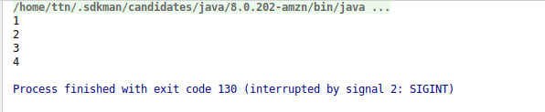

Question 8 :Schedule task using schedule(), scheduleAtFixedRate() and scheduleAtFixedDelay()
Answer 8 : scheduleAtFixedRate() and scheduleAtFixedDelay()
package Question.question8;
import java.util.concurrent.Executors;
import java.util.concurrent.ScheduledExecutorService;
import java.util.concurrent.TimeUnit;
public class TaskScheduleAtFixedRate {
public static void main(String[] args) {
ScheduledExecutorService executorService = Executors.newSingleThreadScheduledExecutor();
executorService.scheduleAtFixedRate(new Runnable() {
@Override
public void run() {
try {
Thread.sleep(2000L);
System.out.println("SceduledAtFixedRate Scheduled task at fixed Interval");
} catch (InterruptedException e) {
e.printStackTrace();
}
}
}, 0, 1, TimeUnit.SECONDS);
executorService.scheduleWithFixedDelay(new Runnable() {
@Override
public void run() {
try {
Thread.sleep(2000L);
System.out.println("SceduleAtFixedDelay scheduled task at fixed Interval");
} catch (InterruptedException e) {
e.printStackTrace();
}
}
}, 0, 1, TimeUnit.SECONDS);
// executorService.shutdown();
}
}

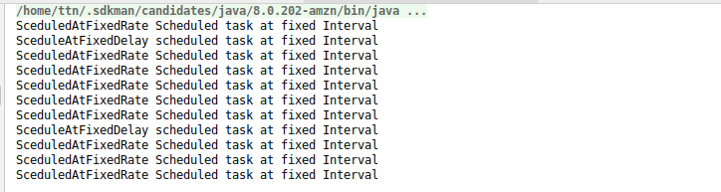

schedule() :-
package Question.question8;
import java.util.concurrent.Executors;
import java.util.concurrent.ScheduledExecutorService;
import java.util.concurrent.TimeUnit;
public class TaskScheduleExample {
public static void main(String[] args) {
ScheduledExecutorService executorService = Executors.newSingleThreadScheduledExecutor();
executorService.schedule(new Runnable() {
@Override
public void run() {
System.out.println("Task exceuted After 1 sec");
}
},1, TimeUnit.SECONDS);
executorService.shutdown();
}
}
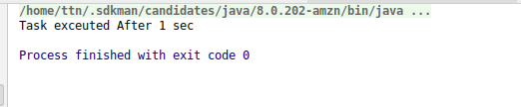

Question 9 : Increase concurrency with Thread pools using newCachedThreadPool() and newFixedThreadPool().
Answer 9 : package Question.question9;
import java.util.concurrent.ExecutorService;
import java.util.concurrent.Executors;
public class NewFixedThreadPoolExample implements Runnable{
int id;
public NewFixedThreadPoolExample(int id){
this.id=id;
}
@Override
public void run() {
System.out.println("Thread Name : "+Thread.currentThread().getName()+" and Start id is : "+id);
try {
Thread.sleep(1000L);
} catch (InterruptedException e) {
e.printStackTrace();
}
System.out.println("Thread Name : "+Thread.currentThread().getName()+" and End id is : "+id);
}
}
class ExecuterServiceDemo{
public static void main(String[] args) {
ExecutorService executorService1=Executors.newCachedThreadPool();
ExecutorService executorService=Executors.newFixedThreadPool(5);
for(int i=0;i<=100;i++){
executorService.submit(new NewFixedThreadPoolExample(i));
}
executorService.shutdown();
}
}
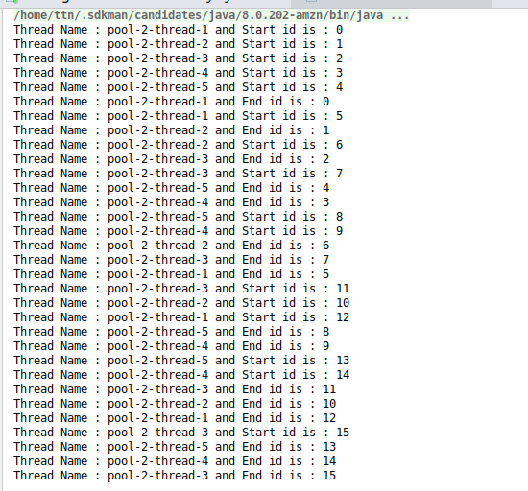
package Question.question9;
import java.util.concurrent.ExecutorService;
import java.util.concurrent.Executors;
public class NewFixedThreadPoolExample implements Runnable{
int id;
public NewFixedThreadPoolExample(int id){
this.id=id;
}
@Override
public void run() {
System.out.println("Thread Name : "+Thread.currentThread().getName()+" and Start id is : "+id);
try {
Thread.sleep(1000L);
} catch (InterruptedException e) {
e.printStackTrace();
}
System.out.println("Thread Name : "+Thread.currentThread().getName()+" and End id is : "+id);
}
}
class ExecuterServiceDemo{
public static void main(String[] args) {
ExecutorService executorService1=Executors.newCachedThreadPool();
ExecutorService executorService=Executors.newFixedThreadPool(5);
for(int i=0;i<=15;i++){
executorService1.submit(new NewFixedThreadPoolExample(i));
}
executorService1.shutdown();
}
}

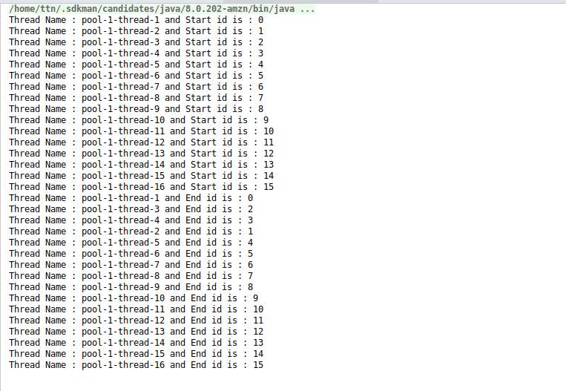

Question 10 :Use Synchronize method to enable synchronization between multiple threads trying to access method at same time.
Answer 10 : package Question.question10;
public class SynchronizeDemo {
int count;
synchronized public void incrementCount() {
count++;
}
public void worker1() {
for (int i = 1; i <= 1000; i++) {
incrementCount();
}
}
public void worker2() {
for (int i = 1; i <= 1000; i++) {
incrementCount();
}
}
public static void main(String[] args) throws InterruptedException {
SynchronizeDemo synchronizeDemo = new SynchronizeDemo();
Thread thread1 = new Thread(new Runnable() {
@Override
public void run() {
synchronizeDemo.worker1();
}
});
Thread thread2 = new Thread(new Runnable() {
@Override
public void run() {
synchronizeDemo.worker2();
}
});
thread1.start();
thread2.start();
thread1.join();
thread2.join();
System.out.println(synchronizeDemo.count);
}
}
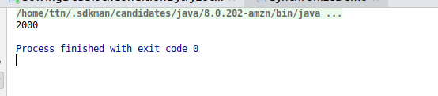

Question 11 :Use Synchronize block to enable synchronization between multiple threads trying to access method at same time.
Answer 11 : package Question.question11;
public class SynchronizedBlockExample {
int count;
public void incrementCount() {
synchronized (this) {
count++;
}
}
public void worker1() {
for (int i = 1; i <= 1000; i++) {
incrementCount();
}
}
public void worker2() {
for (int i = 1; i <= 1000; i++) {
incrementCount();
}
}
public static void main(String[] args) throws InterruptedException {
SynchronizedBlockExample synchronizeDemo = new SynchronizedBlockExample();
Thread thread1 = new Thread(new Runnable() {
@Override
public void run() {
synchronizeDemo.worker1();
}
});
Thread thread2 = new Thread(new Runnable() {
@Override
public void run() {
synchronizeDemo.worker2();
}
});
thread1.start();
thread2.start();
thread1.join();
thread2.join();
System.out.println(synchronizeDemo.count);
}
}
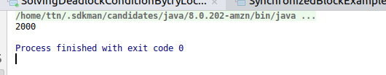

Question 12 :Use Atomic Classes instead of Synchronize method and blocks.
Answer 12 : package Question.question12;
import java.util.concurrent.atomic.AtomicInteger;
public class AtomicClassExample {
AtomicInteger count=new AtomicInteger();
public void worker1(){
for(int i=1;i<1000;i++)
count.incrementAndGet();
}
public void worker2(){
for(int i=1;i<1000;i++)
count.incrementAndGet();
}
public static void main(String[] args) throws InterruptedException {
AtomicClassExample atomicClassExample=new AtomicClassExample();
Thread thread=new Thread(new Runnable() {
@Override
public void run() {
atomicClassExample.worker1();
}
});
Thread thread1=new Thread(new Runnable() {
@Override
public void run() {
atomicClassExample.worker2();
}
});
thread.start();
thread1.start();
thread.join();
thread1.join();
System.out.println(atomicClassExample.count);
}
}
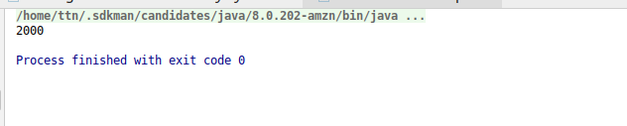

Question 13 :Coordinate 2 threads using wait() and notify().
Answer 13 : package Question.question13;
public class WaitAndNotifyExample {
public void worker1(){
synchronized(this){
System.out.println("this is worker1 started");
try {
wait();
} catch (InterruptedException e) {
e.printStackTrace();
}
System.out.println("worker1 ended");
}
}
public void worker2(){
synchronized (this){
System.out.println("worker2 started");
System.out.println("worker2 ended");
notify();
}
}
public static void main(String[] args) {
WaitAndNotifyExample waitAndNotifyExample=new WaitAndNotifyExample();
Thread thread=new Thread(new Runnable() {
@Override
public void run() {
waitAndNotifyExample.worker1();
}
});
Thread thread1=new Thread(new Runnable() {
@Override
public void run() {
waitAndNotifyExample.worker2();
}
});
thread.start();
thread1.start();
}
}
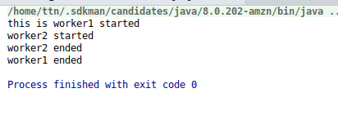

Question 14 :Coordinate mulitple threads using wait() and notifyAll()
Answer 14 : package Question.question14;
public class WaitAndNotifyAllExample {
public void worker1(){
synchronized (this){
System.out.println("thread1 started");
try {
wait();
} catch (InterruptedException e) {
e.printStackTrace();
}
System.out.println("thread1 ended");
}
}
public void worker2(){
synchronized (this){
System.out.println("thread2 started");
try {
wait();
} catch (InterruptedException e) {
e.printStackTrace();
}
System.out.println("thread2 ended");
}
}
public void worker3(){
synchronized (this){
System.out.println("thread3 started");
System.out.println("thread3 ended");
notifyAll();
}
}
public static void main(String[] args) {
WaitAndNotifyAllExample waitAndNotifyExample=new WaitAndNotifyAllExample();
Thread thread=new Thread(new Runnable() {
@Override
public void run() {
waitAndNotifyExample.worker1();
}
});
Thread thread1=new Thread(new Runnable() {
@Override
public void run() {
waitAndNotifyExample.worker2();
}
});
Thread thread2=new Thread(new Runnable() {
@Override
public void run() {
waitAndNotifyExample.worker3();
}
});
thread.start();
thread1.start();
thread2.start();
}
}

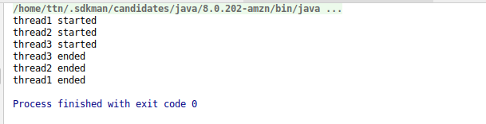

Question 15 :Use Reentract lock for coordinating 2 threads with signal(), signalAll() and wait().
Answer 15 :
package Question.question15;
import java.util.concurrent.locks.Condition;
import java.util.concurrent.locks.Lock;
import java.util.concurrent.locks.ReentrantLock;
public class ReetrantLockExample {
Lock lock=new ReentrantLock(true);
Condition condition=lock.newCondition();
public void worker1(){
lock.lock();
System.out.println("worker1 started");
try {
condition.await();
System.out.println("worker1 ended");
} catch (InterruptedException e) {
e.printStackTrace();
}finally {
lock.unlock();
}
}
public void worker2(){
lock.lock();
System.out.println("worker2 started");
try {
condition.await();
System.out.println("worker2 ended");
} catch (InterruptedException e) {
e.printStackTrace();
}finally {
lock.unlock();
}
}
public void worker3(){
try {
lock.lock();
System.out.println("worekr3 started");
System.out.println("worker3 ended");
condition.signalAll();
}finally{
lock.unlock();
}
}
public static void main(String[] args) {
ReetrantLockExample reetrantLockExample=new ReetrantLockExample();
new Thread(new Runnable() {
@Override
public void run() {
reetrantLockExample.worker1();
}
}).start();
new Thread(new Runnable() {
@Override
public void run() {
reetrantLockExample.worker2();
}
}).start();
new Thread(new Runnable() {
@Override
public void run() {
reetrantLockExample.worker3();
}
}).start();
}
}
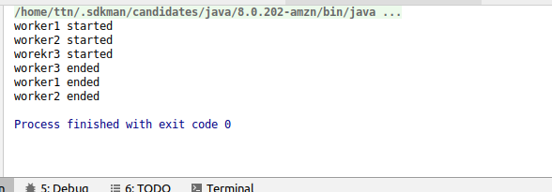

Question 16 :Create a deadlock and Resolve it using tryLock().
Answer 16 : Deadlock Condition
package Question.question16;
import java.util.concurrent.locks.Lock;
import java.util.concurrent.locks.ReentrantLock;
public class DeadlockConditionExample {
Lock lock1=new ReentrantLock(true);
Lock lock2=new ReentrantLock(true);
public void worker1(){
lock1.lock();
System.out.println("lock1 on worker1");
lock2.lock();
System.out.println("lock2 on worker1");
lock2.unlock();
lock1.unlock();
}
public void worker2(){
lock2.lock();
System.out.println("lock2 on worker2");
lock1.lock();
System.out.println("lock1 on worker2");
lock1.unlock();
lock2.unlock();
}
public static void main(String[] args) throws InterruptedException {
DeadlockConditionExample solvingDeadlockConditionBytryLockExample=new DeadlockConditionExample();
Thread thread=new Thread(new Runnable() {
@Override
public void run() {
solvingDeadlockConditionBytryLockExample.worker1();
}
});
Thread thread1=new Thread(new Runnable() {
@Override
public void run() {
solvingDeadlockConditionBytryLockExample.worker2();
}
});
thread.start();
thread1.start();
thread.join();
thread1.join();
}
}

Deadlock Remove using trylock()
package Question.question16;
import java.util.concurrent.locks.Lock;
import java.util.concurrent.locks.ReentrantLock;
public class SolvedDeadlockByTrylockExample {
Lock lock1=new ReentrantLock(true);
Lock lock2=new ReentrantLock(true);
public void acquireLock(Lock lock1,Lock lock2){
boolean acquirelock1=lock1.tryLock();
boolean acquirelock2=lock2.tryLock();
if(acquirelock1 && acquirelock2)
return;
if(acquirelock1){
lock1.unlock();
}if(acquirelock2){
lock2.unlock();
}
}
public void worker1(){
acquireLock(lock1,lock2);
System.out.println("lock1 on worker1");
System.out.println("lock2 on worker1");
lock2.unlock();
lock1.unlock();
}
public void worker2(){
acquireLock(lock2,lock1);
System.out.println("lock2 on worker2");
System.out.println("lock1 on worker2");
lock1.unlock();
lock2.unlock();
}
public static void main(String[] args) throws InterruptedException {
SolvedDeadlockByTrylockExample solvedDeadlockByTrylockExample=new SolvedDeadlockByTrylockExample();
Thread thread=new Thread(new Runnable() {
@Override
public void run() {
solvedDeadlockByTrylockExample.worker1();
}
});
Thread thread1=new Thread(new Runnable() {
@Override
public void run() {
solvedDeadlockByTrylockExample.worker2();
}
});
thread.start();
thread1.start();
thread.join();
thread1.join();
}
}
