Question 1 :Create a Person entity with instance variables Firstname, Lastname, salary, age and Id.
Answer 1 :
Person.java
package entity;
import javax.persistence.Entity;
import javax.persistence.Id;
import javax.persistence.NamedNativeQueries;
@Entity
public class Person {
@Id
private int Id;
private String firstName;
private String lastName;
private int salary;
private int age;
public int getId() {
return Id;
}
public void setId(int id) {
Id = id;
}
public String getFirstName() {
return firstName;
}
public void setFirstName(String firstName) {
this.firstName = firstName;
}
public String getLastName() {
return lastName;
}
public void setLastName(String lastName) {
this.lastName = lastName;
}
public int getSalary() {
return salary;
}
public void setSalary(int salary) {
this.salary = salary;
}
public int getAge() {
return age;
}
public void setAge(int age) {
this.age = age;
}
@Override
public String toString() {
return "Person{" +
"Id=" + Id +
", firstName='" + firstName + '\'' +
", lastName='" + lastName + '\'' +
", salary=" + salary +
", age=" + age +
'}';
}
}
PersistenceContext.java
package config;
import org.springframework.context.annotation.Bean;
import org.springframework.context.annotation.Configuration;
import org.springframework.data.jpa.repository.config.EnableJpaRepositories;
import org.springframework.jdbc.datasource.DriverManagerDataSource;
import org.springframework.orm.jpa.JpaTransactionManager;
import org.springframework.orm.jpa.LocalContainerEntityManagerFactoryBean;
import org.springframework.orm.jpa.vendor.HibernateJpaVendorAdapter;
import javax.persistence.EntityManagerFactory;
import javax.sql.DataSource;
import java.util.Properties;
@Configuration
@EnableJpaRepositories("repositories")
public class PersistenceContext {
@Bean
DataSource dataSource() {
DriverManagerDataSource driverManagerDataSource = new DriverManagerDataSource();
driverManagerDataSource.setDriverClassName("com.mysql.jdbc.Driver");
driverManagerDataSource.setUrl("jdbc:mysql://localhost:3306/JPADemo");
driverManagerDataSource.setUsername("root");
driverManagerDataSource.setPassword("Shivamsaxena@1234.");
return driverManagerDataSource;
}
@Bean
LocalContainerEntityManagerFactoryBean entityManagerFactory(DataSource dataSource) {
LocalContainerEntityManagerFactoryBean entityManagerFactoryBean = new LocalContainerEntityManagerFactoryBean();
entityManagerFactoryBean.setDataSource(dataSource);
entityManagerFactoryBean.setJpaVendorAdapter(new HibernateJpaVendorAdapter());
entityManagerFactoryBean.setPackagesToScan("entity");
Properties jpaProperties = new Properties();
jpaProperties.setProperty("hibernate.dialect", "org.hibernate.dialect.MySQLDialect");
jpaProperties.setProperty("hibernate.show_sql", "true");
jpaProperties.setProperty("hibernate.hbm2ddl.auto", "update");
entityManagerFactoryBean.setJpaProperties(jpaProperties);
return entityManagerFactoryBean;
}
@Bean
JpaTransactionManager transactionManager(EntityManagerFactory entityManagerFactory) {
JpaTransactionManager transactionManager = new JpaTransactionManager();
transactionManager.setEntityManagerFactory(entityManagerFactory);
return transactionManager;
}
}

Question 2 :Implement CrudRepository for it.
Answer 2 :
PersonRepositories.java
package repositories;
import entity.Person;
import org.springframework.data.repository.CrudRepository;
public interface PersonRepository extends CrudRepository<Person, Integer> {
}

Question 3 :Perform all the methods inside CrudRepository for Person Class.
Answer 3 :
Create
PersonRepository.java
package repositories;
import entity.Person;
import org.springframework.data.repository.CrudRepository;
import java.util.List;
public interface PersonRepository extends CrudRepository<Person, Integer> { }
JPAServices.java
package services;
import entity.Person;
import org.springframework.beans.factory.annotation.Autowired;
import org.springframework.stereotype.Service;
import repositories.PersonRepository;
import java.util.Iterator;
import java.util.List;
@Service
public class JPAServices {
@Autowired
PersonRepository personRepository;
public void save() {
Person person = new Person();
person.setId(4);
person.setFirstName("Sanjeev");
person.setLastName("Kumar");
person.setAge(27);
person.setSalary(303020);
personRepository.save(person);
}
}
Main.java
import org.springframework.context.ConfigurableApplicationContext;
import org.springframework.context.annotation.AnnotationConfigApplicationContext;
import services.JPAServices;
public class Main {
public static void main(String[] args) {
ConfigurableApplicationContext ctx = new AnnotationConfigApplicationContext("config", "services");
JPAServices jpaServices = ctx.getBean(JPAServices.class);
/*Question 3*/
jpaServices.save();
}
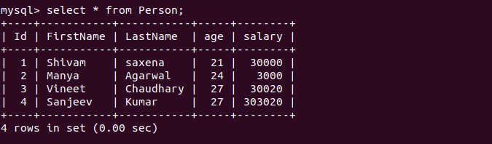
Read
PersonRepository.java
package repositories;
import entity.Person;
import org.springframework.data.repository.CrudRepository;
import java.util.List;
public interface PersonRepository extends CrudRepository<Person, Integer> {
List<Person> findAll();
}
JPAServices.java
package services;
import entity.Person;
import org.springframework.beans.factory.annotation.Autowired;
import org.springframework.stereotype.Service;
import repositories.PersonRepository;
import java.util.Iterator;
import java.util.List;
@Service
public class JPAServices {
@Autowired
PersonRepository personRepository;
public void save() {
Person person = new Person();
person.setId(4);
person.setFirstName("Sanjeev");
person.setLastName("Kumar");
person.setAge(27);
person.setSalary(303020);
personRepository.save(person);
}
public void findAll(){
List<Person> list=personRepository.findAll();
Iterator<Person> iterator=list.iterator();
while (iterator.hasNext()){
System.out.println(iterator.next());
}
}
}

Main.java
import org.springframework.context.ConfigurableApplicationContext;
import org.springframework.context.annotation.AnnotationConfigApplicationContext;
import services.JPAServices;
public class Main {
public static void main(String[] args) {
ConfigurableApplicationContext ctx = new AnnotationConfigApplicationContext("config", "services");
JPAServices jpaServices = ctx.getBean(JPAServices.class);
/*Question 3*/
jpaServices.save();
jpaServices.findAll();
}
}
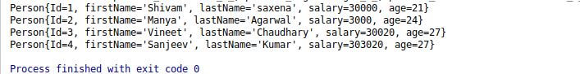
delete
JPAServices.java
package services;
import entity.Person;
import org.springframework.beans.factory.annotation.Autowired;
import org.springframework.stereotype.Service;
import repositories.PersonRepository;
import java.util.Iterator;
import java.util.List;
@Service
public class JPAServices {
@Autowired
PersonRepository personRepository;
public void save() {
Person person = new Person();
person.setId(4);
person.setFirstName("Sanjeev");
person.setLastName("Kumar");
person.setAge(27);
person.setSalary(303020);
personRepository.save(person);
}
public void findAll(){
List<Person> list=personRepository.findAll();
Iterator<Person> iterator=list.iterator();
while (iterator.hasNext()){
System.out.println(iterator.next());
}
}
public void delete(int id){
personRepository.delete(id);
}
}

Main.java
import org.springframework.context.ConfigurableApplicationContext;
import org.springframework.context.annotation.AnnotationConfigApplicationContext;
import services.JPAServices;
public class Main {
public static void main(String[] args) {
ConfigurableApplicationContext ctx = new AnnotationConfigApplicationContext("config", "services");
JPAServices jpaServices = ctx.getBean(JPAServices.class);
/*Question 3*/
jpaServices.save();
jpaServices.findAll();
System.out.println("ID 4 is deleted from Person");
jpaServices.delete(4);
jpaServices.findAll();
}
}
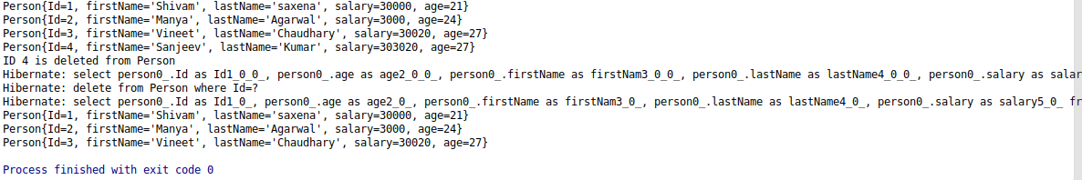
exists
JPASerivces.java
package services;
import entity.Person;
import org.springframework.beans.factory.annotation.Autowired;
import org.springframework.stereotype.Service;
import repositories.PersonRepository;
import java.util.Iterator;
import java.util.List;
@Service
public class JPAServices {
@Autowired
PersonRepository personRepository;
public void save() {
Person person = new Person();
person.setId(4);
person.setFirstName("Sanjeev");
person.setLastName("Kumar");
person.setAge(27);
person.setSalary(303020);
personRepository.save(person);
}
public void findAll() {
List<Person> list = personRepository.findAll();
Iterator<Person> iterator = list.iterator();
while (iterator.hasNext()) {
System.out.println(iterator.next());
}
}
public void delete(int id) {
personRepository.delete(id);
}
public boolean checkPeople(int id){
return personRepository.exists(id);
}
}
Main.java
import org.springframework.context.ConfigurableApplicationContext;
import org.springframework.context.annotation.AnnotationConfigApplicationContext;
import services.JPAServices;
public class Main {
public static void main(String[] args) {
ConfigurableApplicationContext ctx = new AnnotationConfigApplicationContext("config", "services");
JPAServices jpaServices = ctx.getBean(JPAServices.class);
/*Question 3*/
jpaServices.save();
jpaServices.findAll();
System.out.println("ID 4 is deleted from Person");
jpaServices.delete(4);
jpaServices.findAll();
System.out.println("Check Id 3 is present or not");
System.out.println(jpaServices.checkPeople(3));
}
}
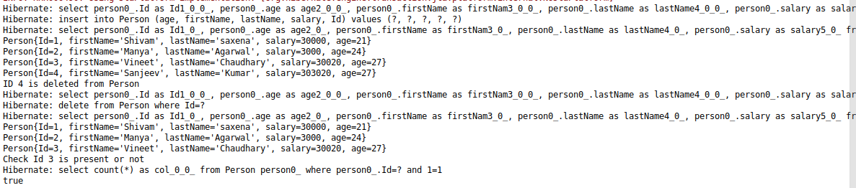
count
package services;
import entity.Person;
import org.springframework.beans.factory.annotation.Autowired;
import org.springframework.stereotype.Service;
import repositories.PersonRepository;
import java.util.Iterator;
import java.util.List;
@Service
public class JPAServices {
@Autowired
PersonRepository personRepository;

public void count(){
System.out.println(personRepository.count());
}
}

Main.java
import org.springframework.context.ConfigurableApplicationContext;
import org.springframework.context.annotation.AnnotationConfigApplicationContext;
import services.JPAServices;
public class Main {
public static void main(String[] args) {
ConfigurableApplicationContext ctx = new AnnotationConfigApplicationContext("config", "services");
JPAServices jpaServices = ctx.getBean(JPAServices.class);
/*Question 3*/
jpaServices.count();
}
}

Question 4 : For class Person find person declare methods in repository to find person by firstname, lastname and Id.
Answer 4 :
PersonRepository:
package repositories;
import entity.Person;
import org.springframework.data.repository.CrudRepository;
import java.util.List;
public interface PersonRepository extends CrudRepository<Person, Integer> {
List<Person> findByFirstName(String name);
List<Person> findByLastName(String name);
List<Person> findById(int id);
}

Question 5 :Use the methods declared above to fetch the person.
Answer 5 :
JPAServices.java
package services;
import entity.Person;
import org.springframework.beans.factory.annotation.Autowired;
import org.springframework.stereotype.Service;
import repositories.PersonRepository;
import javax.persistence.Id;
import java.util.Iterator;
import java.util.List;
@Service
public class JPAServices {
@Autowired
PersonRepository personRepository;
/*Question 4*/
public List<Person> findPersonByFirstName(String name){
return personRepository.findByFirstName(name);
}
public List<Person> findPersonByLastName(String name){
return personRepository.findByLastName(name);
}
public List<Person> findPersonById(int id){
return personRepository.findById(id);
}
}
Main.java
import org.springframework.context.ConfigurableApplicationContext;
import org.springframework.context.annotation.AnnotationConfigApplicationContext;
import services.JPAServices;
public class Main {
public static void main(String[] args) {
ConfigurableApplicationContext ctx = new AnnotationConfigApplicationContext("config", "services");
JPAServices jpaServices = ctx.getBean(JPAServices.class);
System.out.println(jpaServices.findPersonByFirstName("Shivam"));
System.out.println("\n");
System.out.println(jpaServices.findPersonByLastName("Chaudhary"));
System.out.println("\n");
System.out.println(jpaServices.findPersonById(3));
}
}

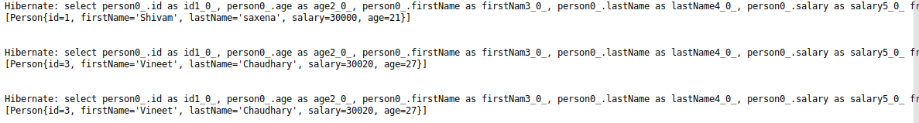

Question 6 :Use @Query to fetch firstname of the Person whose age is 25.
Answer 6 :
PersonRepository.java
package repositories;
import entity.Person;
import org.springframework.data.jpa.repository.Query;
import org.springframework.data.repository.CrudRepository;
import org.springframework.data.repository.query.Param;
import java.util.List;
public interface PersonRepository extends CrudRepository<Person, Integer> {
/*Question 6*/
@Query("select firstName from Person where age=:age")
List<Person> customFindFirstName(@Param("age") Integer age);
}
JPAServices.java
package services;
import entity.Person;
import org.springframework.beans.factory.annotation.Autowired;
import org.springframework.stereotype.Service;
import repositories.PersonRepository;
import java.util.Iterator;
import java.util.List;
@Service
public class JPAServices {
@Autowired
PersonRepository personRepository;

/*Question 6*/
public void findFirstNameCustom(Integer age) {
List<Person> list = personRepository.customFindFirstName(age);
Iterator<Person> iterator = list.iterator();
while (iterator.hasNext()) {
System.out.println(iterator.next());
}
}
}

Main.java
import org.springframework.context.ConfigurableApplicationContext;
import org.springframework.context.annotation.AnnotationConfigApplicationContext;
import services.JPAServices;
public class Main {
public static void main(String[] args) {
ConfigurableApplicationContext ctx = new AnnotationConfigApplicationContext("config", "services");
JPAServices jpaServices = ctx.getBean(JPAServices.class);
jpaServices.findFirstNameCustom(27);
}
}

Question 7 :Use @Query to fetch firstname and lastname of the Person whose age is 25.
Answer 7 :
PersonRepository.java
package repositories;
import entity.Person;
import org.springframework.data.jpa.repository.Query;
import org.springframework.data.repository.CrudRepository;
import org.springframework.data.repository.query.Param;
import java.util.List;
public interface PersonRepository extends CrudRepository<Person, Integer> {
/*Question 7*/
@Query("select firstName,lastName from Person where age=:age")
List<Object[]> customFindFirstNameAndLastName(@Param("age") Integer age);
}
JPAServices.java
package services;
import entity.Person;
import org.springframework.beans.factory.annotation.Autowired;
import org.springframework.stereotype.Service;
import repositories.PersonRepository;
import java.util.Iterator;
import java.util.List;
@Service
public class JPAServices {
@Autowired
PersonRepository personRepository;
public void save() {
Person person = new Person();
person.setId(4);
person.setFirstName("Sanjeev");
person.setLastName("Kumar");
person.setAge(27);
person.setSalary(303020);
personRepository.save(person);
}
public void findAll() {
Iterable<Person> iterable = personRepository.findAll();
Iterator<Person> iterator = iterable.iterator();
while (iterator.hasNext()) {
System.out.println(iterator.next());
}
}
public void delete(int id) {
personRepository.delete(id);
}
public boolean checkPeople(int id) {
return personRepository.exists(id);
}
public void count() {
System.out.println(personRepository.count());
}
/*Question 4*/
public List<Person> findPersonByFirstName(String name) {
return personRepository.findByFirstName(name);
}
public List<Person> findPersonByLastName(String name) {
return personRepository.findByLastName(name);
}
public List<Person> findPersonById(int id) {
return personRepository.findById(id);
}
/*Question 6*/
public void findFirstNameCustom(Integer age) {
List<Person> list = personRepository.customFindFirstName(age);
Iterator<Person> iterator = list.iterator();
while (iterator.hasNext()) {
System.out.println(iterator.next());
}
}
/*Question 7*/
public void findFirstNameAndLastNameCustom(Integer age){
List<Object[]> obj=personRepository.customFindFirstNameAndLastName(age);
Iterator<Object[]> iterator=obj.iterator();
while (iterator.hasNext()){
Object[] objects=iterator.next();
System.out.println(objects[0] +" "+ objects[1]);
}
}
}
Main.java
import org.springframework.context.ConfigurableApplicationContext;
import org.springframework.context.annotation.AnnotationConfigApplicationContext;
import services.JPAServices;
public class Main {
public static void main(String[] args) {
ConfigurableApplicationContext ctx = new AnnotationConfigApplicationContext("config", "services");
JPAServices jpaServices = ctx.getBean(JPAServices.class);
/*Question 7*/
jpaServices.findFirstNameAndLastNameCustom(27);
}
}

Question 8 :Get complete information of the Employee whose age is 25 using @Query.
Answer 8 :
PersonRepository.java
package repositories;
import entity.Person;
import org.springframework.data.jpa.repository.Query;
import org.springframework.data.repository.CrudRepository;
import org.springframework.data.repository.query.Param;
import java.util.List;
import java.util.Objects;
public interface PersonRepository extends CrudRepository<Person, Integer> {
/*Question 8*/
@Query("SELECT e from Person e where age=:age")
List<Person> customFindAll(@Param("age") Integer age);
}
JSPServices.java
package services;
import entity.Person;
import org.springframework.beans.factory.annotation.Autowired;
import org.springframework.stereotype.Service;
import repositories.PersonRepository;
import java.util.Iterator;
import java.util.List;
@Service
public class JPAServices {
@Autowired
PersonRepository personRepository;
/*Question 8*/
public void customFindAllPerson(Integer age){
List<Person> list=personRepository.customFindAll(age);
Iterator<Person> iterator=list.iterator();
while (iterator.hasNext()){
System.out.println(iterator.next());
}
}
}
Main.java
import org.springframework.context.ConfigurableApplicationContext;
import org.springframework.context.annotation.AnnotationConfigApplicationContext;
import services.JPAServices;
public class Main {
public static void main(String[] args) {
ConfigurableApplicationContext ctx = new AnnotationConfigApplicationContext("config", "services");
JPAServices jpaServices = ctx.getBean(JPAServices.class);
/*Question 8*/
jpaServices.customFindAllPerson(27);
}
}
Question 9 :Count Person where name is "Peter" using @Query.
Answer 9 :
PersonRepository.java
package repositories;
import entity.Person;
import org.springframework.data.jpa.repository.Query;
import org.springframework.data.repository.CrudRepository;
import org.springframework.data.repository.query.Param;
import java.util.List;
public interface PersonRepository extends CrudRepository<Person, Integer> {
/*Question 9*/
@Query("SELECT COUNT(e) from Person e where firstName=:firstName")
Integer countByFirstName(@Param("firstName") String firstName);
}
JPAServices.java
package services;
import entity.Person;
import org.springframework.beans.factory.annotation.Autowired;
import org.springframework.stereotype.Service;
import repositories.PersonRepository;
import javax.persistence.criteria.CriteriaBuilder;
import java.util.Iterator;
import java.util.List;
@Service
public class JPAServices {
@Autowired
PersonRepository personRepository;
/*Question 9*/
public Integer countByFirstName(String fName){
Integer integer=personRepository.countByFirstName(fName);
return integer;
}
}
Main.java
import org.springframework.context.ConfigurableApplicationContext;
import org.springframework.context.annotation.AnnotationConfigApplicationContext;
import services.JPAServices;
public class Main {
public static void main(String[] args) {
ConfigurableApplicationContext ctx = new AnnotationConfigApplicationContext("config", "services");
JPAServices jpaServices = ctx.getBean(JPAServices.class);
/*Question 9*/
Integer count=jpaServices.countByFirstName("Peter");
System.out.println("Number of People from Peter Name is : "+count);
}
}

Question 10 : Implement following methods for Person repository:
Answer 10 :
(a). count

PersonRepository.java
package repositories;
import entity.Person;
import org.springframework.data.jpa.repository.Query;
import org.springframework.data.repository.CrudRepository;
import org.springframework.data.repository.query.Param;
import java.util.List;
public interface PersonRepository extends CrudRepository<Person, Integer> {
int countPersonByFirstName(String fName);
}
JPAServices.java
package services;
import entity.Person;
import org.springframework.beans.factory.annotation.Autowired;
import org.springframework.stereotype.Service;
import repositories.PersonRepository;
import javax.persistence.criteria.CriteriaBuilder;
import java.util.Iterator;
import java.util.List;
@Service
public class JPAServices {
@Autowired
PersonRepository personRepository;
/*Question 10*/
public Integer countByMethodOfPersonRepository(String Name){
return personRepository.countPersonByFirstName(Name);
}
}
Main.java
import org.springframework.context.ConfigurableApplicationContext;
import org.springframework.context.annotation.AnnotationConfigApplicationContext;
import services.JPAServices;
public class Main {
public static void main(String[] args) {
ConfigurableApplicationContext ctx = new AnnotationConfigApplicationContext("config", "services");

JPAServices jpaServices = ctx.getBean(JPAServices.class);
Integer count1 = jpaServices.countByMethodOfPersonRepository("Peter");
System.out.println("Number of People From Peter Name is : " + count1);
}
}

(b). distinct

PersonRepository.java
package repositories;
import entity.Person;
import org.springframework.data.jpa.repository.Query;
import org.springframework.data.repository.CrudRepository;
import org.springframework.data.repository.query.Param;
import java.util.List;
public interface PersonRepository extends CrudRepository<Person, Integer> {
Person findDistinctByFirstName(String name);
}
JPAServices.java
package services;
import entity.Person;
import org.springframework.beans.factory.annotation.Autowired;
import org.springframework.stereotype.Service;
import repositories.PersonRepository;
import javax.persistence.criteria.CriteriaBuilder;
import java.util.Iterator;
import java.util.List;
@Service
public class JPAServices {
@Autowired
PersonRepository personRepository;
public Person findDistinctPersonByName(String name){
return personRepository.findDistinctByFirstName(name);
}
}
Main.java
import entity.Person;
import org.springframework.context.ConfigurableApplicationContext;
import org.springframework.context.annotation.AnnotationConfigApplicationContext;
import services.JPAServices;
public class Main {
public static void main(String[] args) {
ConfigurableApplicationContext ctx = new AnnotationConfigApplicationContext("config", "services");
JPAServices jpaServices = ctx.getBean(JPAServices.class);
Person person=jpaServices.findDistinctPersonByName("Shivam");
System.out.println(person);
}
}

(c). or
PersonRepository.java
package repositories;
import entity.Person;
import org.springframework.data.jpa.repository.Query;
import org.springframework.data.repository.CrudRepository;
import org.springframework.data.repository.query.Param;
import java.util.List;
public interface PersonRepository extends CrudRepository<Person, Integer> {
List<Person> findByFirstNameOrAge(String fname,Integer age);
}
JPAServices.java
package services;
import entity.Person;
import org.springframework.beans.factory.annotation.Autowired;
import org.springframework.stereotype.Service;
import repositories.PersonRepository;
import javax.persistence.criteria.CriteriaBuilder;
import java.util.Iterator;
import java.util.List;
@Service
public class JPAServices {
@Autowired
PersonRepository personRepository;

public void findByFirstNameOrAge(String name,Integer age){
List<Person> list=personRepository.findByFirstNameOrAge(name,age);
Iterator<Person> iterator=list.iterator();
while (iterator.hasNext()){
System.out.println(iterator.next());
}
}
}
Main.java
import entity.Person;
import org.springframework.context.ConfigurableApplicationContext;
import org.springframework.context.annotation.AnnotationConfigApplicationContext;
import services.JPAServices;
public class Main {
public static void main(String[] args) {
ConfigurableApplicationContext ctx = new AnnotationConfigApplicationContext("config", "services");
JPAServices jpaServices = ctx.getBean(JPAServices.class);

System.out.println("This is through Name");
jpaServices.findByFirstNameOrAge("Shivam",34);
System.out.println("\n");
System.out.println("This is through Age");
jpaServices.findByFirstNameOrAge("sdfaasd",21);
}
}
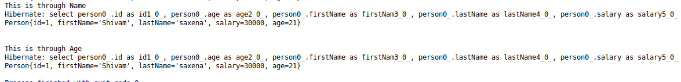

(d). and
PersonRepository.java
package repositories;
import entity.Person;
import org.springframework.data.jpa.repository.Query;
import org.springframework.data.repository.CrudRepository;
import org.springframework.data.repository.query.Param;
import java.util.List;
public interface PersonRepository extends CrudRepository<Person, Integer> {
List<Person> findByFirstNameAndAge(String fname,Integer age);
}
JPAServices.java
package services;
import entity.Person;
import org.springframework.beans.factory.annotation.Autowired;
import org.springframework.stereotype.Service;
import repositories.PersonRepository;
import javax.persistence.criteria.CriteriaBuilder;
import java.util.Iterator;
import java.util.List;
@Service
public class JPAServices {
@Autowired
PersonRepository personRepository;

public void findByFirstNameAndAge(String name,Integer age){
List<Person> list=personRepository.findByFirstNameAndAge(name, age);
Iterator<Person> iterator=list.iterator();
while (iterator.hasNext()){
System.out.println(iterator.next());
}
}
}
Main.java
import entity.Person;
import org.springframework.context.ConfigurableApplicationContext;
import org.springframework.context.annotation.AnnotationConfigApplicationContext;
import services.JPAServices;
public class Main {
public static void main(String[] args) {
ConfigurableApplicationContext ctx = new AnnotationConfigApplicationContext("config", "services");
JPAServices jpaServices = ctx.getBean(JPAServices.class);

System.out.println("This is through And Method of Person");
jpaServices.findByFirstNameAndAge("Shivam",21);
}
}

(e). between

PersonRepository.java
package repositories;
import entity.Person;
import org.springframework.data.jpa.repository.Query;
import org.springframework.data.repository.CrudRepository;
import org.springframework.data.repository.query.Param;
import java.util.List;
public interface PersonRepository extends CrudRepository<Person, Integer> {
List<Person> findByAgeBetween(int min,int max);
}
JPAServices.java
package services;
import entity.Person;
import org.springframework.beans.factory.annotation.Autowired;
import org.springframework.stereotype.Service;
import repositories.PersonRepository;
import javax.persistence.criteria.CriteriaBuilder;
import java.util.Iterator;
import java.util.List;
@Service
public class JPAServices {
@Autowired
PersonRepository personRepository;

public void findByAgeBetween(int min,int max){
List<Person> list=personRepository.findByAgeBetween(min, max);
Iterator<Person> iterator=list.iterator();
while (iterator.hasNext()){
System.out.println(iterator.next());
}
}
}
Main.java
import entity.Person;
import org.springframework.context.ConfigurableApplicationContext;
import org.springframework.context.annotation.AnnotationConfigApplicationContext;
import services.JPAServices;
public class Main {
public static void main(String[] args) {
ConfigurableApplicationContext ctx = new AnnotationConfigApplicationContext("config", "services");
JPAServices jpaServices = ctx.getBean(JPAServices.class);
System.out.println("This is example of between");
jpaServices.findByAgeBetween(20,30);
}
}

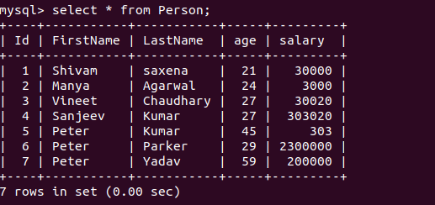
Data present in database

Output
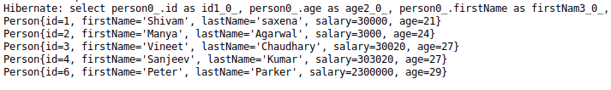

(f). LessThan
PersonRespository.java
package repositories;
import entity.Person;
import org.springframework.data.jpa.repository.Query;
import org.springframework.data.repository.CrudRepository;
import org.springframework.data.repository.query.Param;
import java.util.List;
public interface PersonRepository extends CrudRepository<Person, Integer> {
List<Person> findByAgeLessThan(int number);
}

package services;
import entity.Person;
import org.springframework.beans.factory.annotation.Autowired;
import org.springframework.stereotype.Service;
import repositories.PersonRepository;
import javax.persistence.criteria.CriteriaBuilder;
import java.util.Iterator;
import java.util.List;
@Service
public class JPAServices {
@Autowired
PersonRepository personRepository;
public void findByAgeLessThan(int number){
List<Person> list=personRepository.findByAgeLessThan(number);
Iterator<Person> iterator=list.iterator();
while (iterator.hasNext()){
System.out.println(iterator.next());
}
}
}
Main.java
import entity.Person;
import org.springframework.context.ConfigurableApplicationContext;
import org.springframework.context.annotation.AnnotationConfigApplicationContext;
import services.JPAServices;
public class Main {
public static void main(String[] args) {
ConfigurableApplicationContext ctx = new AnnotationConfigApplicationContext("config", "services");
JPAServices jpaServices = ctx.getBean(JPAServices.class);
System.out.println("This is example of Less Than");
jpaServices.findByAgeLessThan(27);
}
}

(g). GreaterThan
PersonRespository.java
package repositories;
import entity.Person;
import org.springframework.data.jpa.repository.Query;
import org.springframework.data.repository.CrudRepository;
import org.springframework.data.repository.query.Param;
import java.util.List;
public interface PersonRepository extends CrudRepository<Person, Integer> {
List<Person> findByAgeGreaterThan(int number);
}
JPAServices.java
package services;
import entity.Person;
import org.springframework.beans.factory.annotation.Autowired;
import org.springframework.stereotype.Service;
import repositories.PersonRepository;
import javax.persistence.criteria.CriteriaBuilder;
import java.util.Iterator;
import java.util.List;
@Service
public class JPAServices {
@Autowired
PersonRepository personRepository;
public void findByAgeGreaterThan(int number){
List<Person> list=personRepository.findByAgeGreaterThan(number);
Iterator<Person> iterator=list.iterator();
while (iterator.hasNext()){
System.out.println(iterator.next());
}
}
}
Main.java
import entity.Person;
import org.springframework.context.ConfigurableApplicationContext;
import org.springframework.context.annotation.AnnotationConfigApplicationContext;
import services.JPAServices;
public class Main {
public static void main(String[] args) {
ConfigurableApplicationContext ctx = new AnnotationConfigApplicationContext("config", "services");
JPAServices jpaServices = ctx.getBean(JPAServices.class);
System.out.println("This is example of Greater Than");
jpaServices.findByAgeGreaterThan(27);
}
}
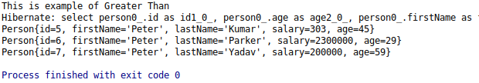

(h). Like
PersonRespository.java
package repositories;
import entity.Person;
import org.springframework.data.jpa.repository.Query;
import org.springframework.data.repository.CrudRepository;
import org.springframework.data.repository.query.Param;
import java.util.List;
public interface PersonRepository extends CrudRepository<Person, Integer> {
List<Person> findByFirstNameLike(String name);
}
JPAServices.java
package services;
import entity.Person;
import org.springframework.beans.factory.annotation.Autowired;
import org.springframework.stereotype.Service;
import repositories.PersonRepository;
import javax.persistence.criteria.CriteriaBuilder;
import java.util.Iterator;
import java.util.List;
@Service
public class JPAServices {
@Autowired
PersonRepository personRepository;
public void findByFirstNameLike(String name){
List<Person> list=personRepository.findByFirstNameLike(name);
Iterator<Person> iterator=list.iterator();
while (iterator.hasNext()){
System.out.println(iterator.next());
}
}
}
Main.java
import entity.Person;
import org.springframework.context.ConfigurableApplicationContext;
import org.springframework.context.annotation.AnnotationConfigApplicationContext;
import services.JPAServices;
public class Main {
public static void main(String[] args) {
ConfigurableApplicationContext ctx = new AnnotationConfigApplicationContext("config", "services");
JPAServices jpaServices = ctx.getBean(JPAServices.class);
System.out.println("This is example of Like Method");
jpaServices.findByFirstNameLike("%S%");
}

}
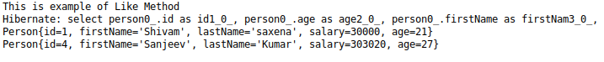

(i). Not
PersonRespository.java
package repositories;
import entity.Person;
import org.springframework.data.jpa.repository.Query;
import org.springframework.data.repository.CrudRepository;
import org.springframework.data.repository.query.Param;
import java.util.List;
public interface PersonRepository extends CrudRepository<Person, Integer> {
List<Person> findByFirstNameNot(String name);
}
JPAServices.java
package services;
import entity.Person;
import org.springframework.beans.factory.annotation.Autowired;
import org.springframework.stereotype.Service;
import repositories.PersonRepository;
import javax.persistence.criteria.CriteriaBuilder;
import java.util.Iterator;
import java.util.List;
@Service
public class JPAServices {
@Autowired
PersonRepository personRepository;
public void findByFirstNameNot(String name){
List<Person> list=personRepository.findByFirstNameNot(name);
Iterator<Person> iterator=list.iterator();
while (iterator.hasNext()){
System.out.println(iterator.next());
}
}
}
Main.java
import entity.Person;
import org.springframework.context.ConfigurableApplicationContext;
import org.springframework.context.annotation.AnnotationConfigApplicationContext;
import services.JPAServices;
public class Main {
public static void main(String[] args) {
ConfigurableApplicationContext ctx = new AnnotationConfigApplicationContext("config", "services");
JPAServices jpaServices = ctx.getBean(JPAServices.class);
System.out.println("This is example of Not Method");
jpaServices.findByFirstNameNot("Peter");
}
}
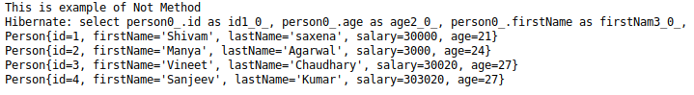

(j). In

PersonRespository.java
package repositories;
import entity.Person;
import org.springframework.data.jpa.repository.Query;
import org.springframework.data.repository.CrudRepository;
import org.springframework.data.repository.query.Param;
import java.util.List;
public interface PersonRepository extends CrudRepository<Person, Integer> {
List<Person> findByFirstNameIgnoreCase(String name);
}
JPAServices.java
package services;
import entity.Person;
import org.springframework.beans.factory.annotation.Autowired;
import org.springframework.stereotype.Service;
import repositories.PersonRepository;
import javax.persistence.criteria.CriteriaBuilder;
import java.util.Iterator;
import java.util.List;
@Service
public class JPAServices {
@Autowired
PersonRepository personRepository;
public void findByAgeIn(List<Integer> agelist){
List<Person> list=personRepository.findByAgeIn(agelist);
Iterator<Person> iterator=list.iterator();
while (iterator.hasNext()){
System.out.println(iterator.next());
}
}
}
Main.java
import entity.Person;
import org.springframework.context.ConfigurableApplicationContext;
import org.springframework.context.annotation.AnnotationConfigApplicationContext;
import services.JPAServices;
import java.util.Arrays;
public class Main {
public static void main(String[] args) {
ConfigurableApplicationContext ctx = new AnnotationConfigApplicationContext("config", "services");
JPAServices jpaServices = ctx.getBean(JPAServices.class);
System.out.println("This is example of In Method");
jpaServices.findByAgeIn(Arrays.asList(23,25,27));
}
}

(k). IgnoreCase
PersonRespository.java
package repositories;
import entity.Person;
import org.springframework.data.jpa.repository.Query;
import org.springframework.data.repository.CrudRepository;
import org.springframework.data.repository.query.Param;
import java.util.List;
public interface PersonRepository extends CrudRepository<Person, Integer> {
List<Person> findByFirstNameIgnoreCase(String name);
}
JPAServices.java
package services;
import entity.Person;
import org.springframework.beans.factory.annotation.Autowired;
import org.springframework.stereotype.Service;
import repositories.PersonRepository;
import javax.persistence.criteria.CriteriaBuilder;
import java.util.Iterator;
import java.util.List;
@Service
public class JPAServices {
@Autowired
PersonRepository personRepository;
public void save() {
public void findByFirstNameIgnoreCase(String string){
List<Person> list=personRepository.findByFirstNameIgnoreCase(string);
Iterator<Person> iterator=list.iterator();
while (iterator.hasNext()){
System.out.println(iterator.next());
}
}

}
Main.java
import entity.Person;
import org.springframework.context.ConfigurableApplicationContext;
import org.springframework.context.annotation.AnnotationConfigApplicationContext;
import services.JPAServices;
import java.util.Arrays;
public class Main {
public static void main(String[] args) {
ConfigurableApplicationContext ctx = new AnnotationConfigApplicationContext("config", "services");
JPAServices jpaServices = ctx.getBean(JPAServices.class);
System.out.println("This is example of Ignore Method");
jpaServices.findByFirstNameIgnoreCase("shivam");
}
}

Question 11 :Get the persons greater than age 25 and sort them in descending order according to id by method query.
Answer 11 :
PersonRepository.java
package repositories;
import entity.Person;
import org.springframework.data.jpa.repository.Query;
import org.springframework.data.repository.CrudRepository;
import org.springframework.data.repository.query.Param;
import java.util.List;
public interface PersonRepository extends CrudRepository<Person, Integer> {
/*Question 11*/
List<Person> findByAgeGreaterThanOrderByIdDesc(Integer age);
}
JPAServices.java
package services;
import entity.Person;
import org.springframework.beans.factory.annotation.Autowired;
import org.springframework.stereotype.Service;
import repositories.PersonRepository;
import javax.persistence.criteria.CriteriaBuilder;
import java.util.Iterator;
import java.util.List;
@Service
public class JPAServices {
@Autowired
PersonRepository personRepository;
/*Question 11*/
public void findByAgeGreaterThanAndOrderByIdDesc(Integer age){
List<Person> list=personRepository.findByAgeGreaterThanOrderByIdDesc(age);
Iterator<Person> iterator=list.iterator();
while (iterator.hasNext()){
System.out.println(iterator.next());
}
}
}
Main.java
import entity.Person;
import org.springframework.context.ConfigurableApplicationContext;
import org.springframework.context.annotation.AnnotationConfigApplicationContext;
import services.JPAServices;
import java.util.Arrays;
public class Main {
public static void main(String[] args) {
ConfigurableApplicationContext ctx = new AnnotationConfigApplicationContext("config", "services");
JPAServices jpaServices = ctx.getBean(JPAServices.class);
/*Question 11 */
System.out.println("This function print person greater than 25 and order by id in Descending order");
jpaServices.findByAgeGreaterThanAndOrderByIdDesc(25);
}
}
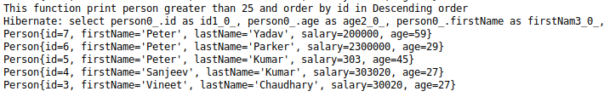

Question 12 :Do the question above using the Sort class.
Answer 12 :
PersonRepository.java
package repositories;
import entity.Person;
import org.springframework.data.domain.Sort;
import org.springframework.data.jpa.repository.Query;
import org.springframework.data.repository.CrudRepository;
import org.springframework.data.repository.query.Param;
import java.util.List;
public interface PersonRepository extends CrudRepository<Person, Integer> {
/*Queston 12*/
@Query("select e from Person e where age>:age")
List<Person> findAll(@Param("age")Integer age , Sort sort);
}
JPAServices.java
package services;
import entity.Person;
import org.springframework.beans.factory.annotation.Autowired;
import org.springframework.data.domain.Sort;
import org.springframework.stereotype.Service;
import repositories.PersonRepository;
import javax.persistence.criteria.CriteriaBuilder;
import java.util.Iterator;
import java.util.List;
@Service
public class JPAServices {
@Autowired
PersonRepository personRepository;
/*Question 12*/
public void findAll(Integer age,Sort sort){
List<Person> list=personRepository.findAll(age,sort);
Iterator<Person> iterator=list.iterator();
while (iterator.hasNext()){
System.out.println(iterator.next());
}
}
}
Main.java
import entity.Person;
import org.springframework.context.ConfigurableApplicationContext;
import org.springframework.context.annotation.AnnotationConfigApplicationContext;
import org.springframework.data.domain.Sort;
import services.JPAServices;
import java.util.Arrays;
public class Main {
public static void main(String[] args) {
ConfigurableApplicationContext ctx = new AnnotationConfigApplicationContext("config", "services");
JPAServices jpaServices = ctx.getBean(JPAServices.class);
/*Question 12*/
System.out.println("This is through Sort Class");
jpaServices.findAll(25,new Sort(Sort.Direction.DESC,"id"));
}
}
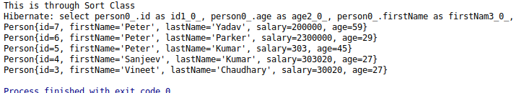

Question 13 : Apply Pagination on Person entities.
Answer 13 :
PersonRepository.java
package repositories;
import entity.Person;
import org.springframework.data.domain.Page;
import org.springframework.data.domain.Pageable;
import org.springframework.data.domain.Sort;
import org.springframework.data.jpa.repository.Query;
import org.springframework.data.repository.CrudRepository;
import org.springframework.data.repository.query.Param;
import java.util.List;
public interface PersonRepository extends CrudRepository<Person, Integer> {
Page<Person> findAll(Pageable pageable);
}
JPAServices.java
package services;
import entity.Person;
import org.springframework.beans.factory.annotation.Autowired;
import org.springframework.data.domain.Page;
import org.springframework.data.domain.Pageable;
import org.springframework.data.domain.Sort;
import org.springframework.stereotype.Service;
import repositories.PersonRepository;
import javax.persistence.criteria.CriteriaBuilder;
import java.util.Iterator;
import java.util.List;
@Service
public class JPAServices {
@Autowired
PersonRepository personRepository;
/*Question 13*/
public void findAll(Pageable pageable){
Page<Person> page=personRepository.findAll(pageable);
System.out.println(page.getContent());
}
}
Main.java
import entity.Person;import org.springframework.context.ConfigurableApplicationContext;
import org.springframework.context.annotation.AnnotationConfigApplicationContext;
import org.springframework.data.domain.PageRequest;
import org.springframework.data.domain.Sort;
import services.JPAServices;
import java.util.Arrays;
public class Main {
public static void main(String[] args) {
ConfigurableApplicationContext ctx = new AnnotationConfigApplicationContext("config", "services");
JPAServices jpaServices = ctx.getBean(JPAServices.class);
/*Question 13*/
System.out.println("This is of Pageable type");
jpaServices.findAll(new PageRequest(2,3));
}
}

