Question 1: Create a class Author with instance variables firstName, lastName and age.
Answer 1 :
hibernate.cfg.xml
<?xml version="1.0" encoding="UTF-8"?>
<!DOCTYPE hibernate-configuration PUBLIC "-//Hibernate/Hibernate Configuration DTD 3.0//EN"
"http://hibernate.sourceforge.net/hibernate-configuration-3.0.dtd">
<hibernate-configuration>
<session-factory>
<property name="hibernate.connection.driver_class">com.mysql.jdbc.Driver</property>
<property name="hibernate.connection.url">jdbc:mysql://localhost:3306/hibernateDemo</property>
<property name="hibernate.connection.username">root</property>
<property name="hibernate.connection.password">Shivamsaxena@1234.</property>
<property name="connection.pool_size">10</property>

<property name="hibernate.dialect">org.hibernate.dialect.MySQLDialect</property>

<property name="show_sql">true</property>
<property name="hbm2ddl.auto">create</property>
<mapping class="com.hibernate.demo.Author"/>
</session-factory>
</hibernate-configuration>
Author.java
package com.hibernate.demo;
import javax.persistence.Entity;
import javax.persistence.Id;
@Entity
public class Author {
@Id
private int id;
private String firstName;
private String lastName;
private int age;
public int getId() {
return id;
}
public void setId(int id) {
this.id = id;
}
public String getFirstName() {
return firstName;
}
public void setFirstName(String firstName) {
this.firstName = firstName;
}
public String getLastName() {
return lastName;
}
public void setLastName(String lastName) {
this.lastName = lastName;
}
public int getAge() {
return age;
}
public void setAge(int age) {
this.age = age;
}
@Override
public String toString() {
return "Author{" +
"id=" + id +
", firstName='" + firstName + '\'' +
", lastName='" + lastName + '\'' +
", age=" + age +
'}';
}
}
Main.java
package com.hibernate.demo;
import org.hibernate.Session;
import org.hibernate.SessionFactory;
import org.hibernate.cfg.Configuration;
public class Main {
public static void main(String[] args) {
Author author=new Author();
author.setId(1);
author.setFirstName("Shivam");
author.setLastName("Saxena");
author.setAge(20);
SessionFactory sessionFactory=new Configuration().configure().buildSessionFactory();
Session session=sessionFactory.openSession();
session.beginTransaction();
session.save(author);
session.getTransaction().commit();
}
}
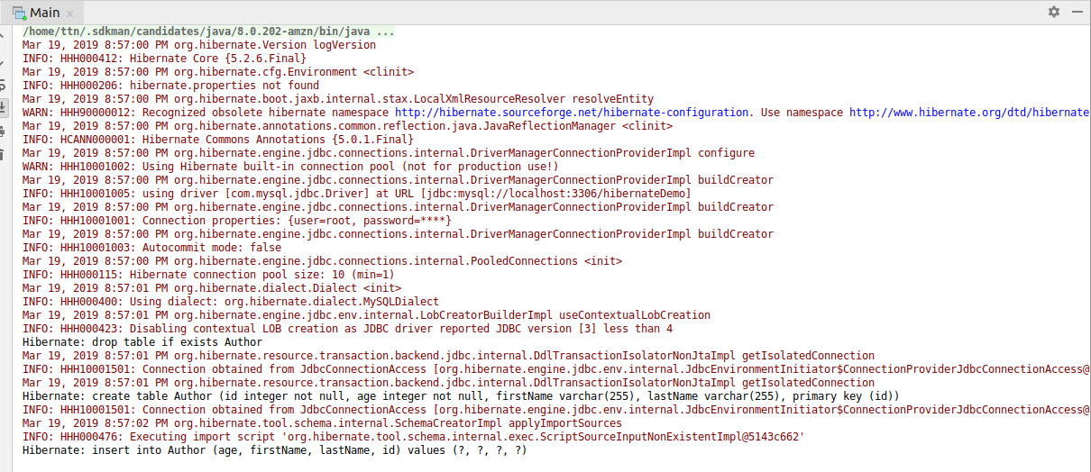

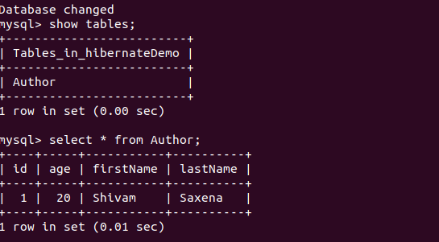

Question 2 :Perform CRUD operation for Author class.
Answer 2 :
Create:
hibernate.cfg.xml
<?xml version="1.0" encoding="UTF-8"?>
<!DOCTYPE hibernate-configuration PUBLIC "-//Hibernate/Hibernate Configuration DTD 3.0//EN"
"http://hibernate.sourceforge.net/hibernate-configuration-3.0.dtd">
<hibernate-configuration>
<session-factory>
<property name="hibernate.connection.driver_class">com.mysql.jdbc.Driver</property>
<property name="hibernate.connection.url">jdbc:mysql://localhost:3306/hibernateDemo</property>
<property name="hibernate.connection.username">root</property>
<property name="hibernate.connection.password">Shivamsaxena@1234.</property>
<property name="connection.pool_size">10</property>

<property name="hibernate.dialect">org.hibernate.dialect.MySQLDialect</property>

<property name="show_sql">true</property>
<property name="hbm2ddl.auto">create</property>
<mapping class="com.hibernate.demo.Author"/>
</session-factory>
</hibernate-configuration>
Main.java
package com.hibernate.demo;
import org.hibernate.Session;
import org.hibernate.SessionFactory;
import org.hibernate.cfg.Configuration;
public class Main {
public static void main(String[] args) {
Author author=new Author();
author.setId(1);
author.setFirstName("Shivam");
author.setLastName("Saxena");
author.setAge(21);
SessionFactory sessionFactory=new Configuration().configure().buildSessionFactory();
Session session=sessionFactory.openSession();
session.beginTransaction();
session.save(author);
session.getTransaction().commit();
}
}
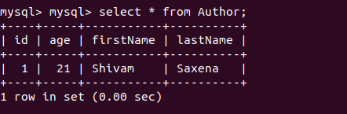

Read:
hibernate.cfg.xml
<?xml version="1.0" encoding="UTF-8"?>
<!DOCTYPE hibernate-configuration PUBLIC "-//Hibernate/Hibernate Configuration DTD 3.0//EN"
"http://hibernate.sourceforge.net/hibernate-configuration-3.0.dtd">
<hibernate-configuration>
<session-factory>
<property name="hibernate.connection.driver_class">com.mysql.jdbc.Driver</property>
<property name="hibernate.connection.url">jdbc:mysql://localhost:3306/hibernateDemo</property>
<property name="hibernate.connection.username">root</property>
<property name="hibernate.connection.password">Shivamsaxena@1234.</property>
<property name="connection.pool_size">10</property>

<property name="hibernate.dialect">org.hibernate.dialect.MySQLDialect</property>

<property name="show_sql">true</property>
<property name="hbm2ddl.auto">update</property>
<mapping class="com.hibernate.demo.Author"/>
</session-factory>
</hibernate-configuration>
Main.java
package com.hibernate.demo;
import org.hibernate.Session;
import org.hibernate.SessionFactory;
import org.hibernate.cfg.Configuration;
public class Main {
public static void main(String[] args) {
Author author=new Author();
author.setId(1);
author.setFirstName("Shivam");
author.setLastName("Saxena");
author.setAge(21);
SessionFactory sessionFactory=new Configuration().configure().buildSessionFactory();
Session session=sessionFactory.openSession();
session.beginTransaction();
Author author1=session.get(Author.class,1);
System.out.println(author1);
session.getTransaction().commit();
}
}
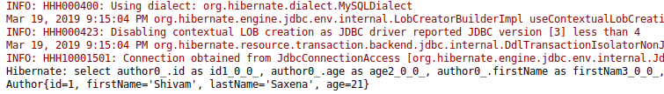

Update:
Main.java
package com.hibernate.demo;
import org.hibernate.Session;
import org.hibernate.SessionFactory;
import org.hibernate.cfg.Configuration;
public class Main {
public static void main(String[] args) {
Author author=new Author();
author.setId(1);
author.setFirstName("Shivam");
author.setLastName("Saxena");
author.setAge(21);
SessionFactory sessionFactory=new Configuration().configure().buildSessionFactory();
Session session=sessionFactory.openSession();
session.beginTransaction();
Author author1=session.get(Author.class,1);
author1.setFirstName("Updated Name");
session.update(author1);
session.getTransaction().commit();
session.close();
System.out.println(author1);
}
}

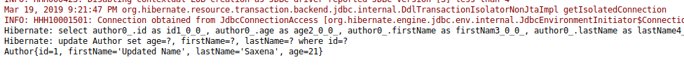
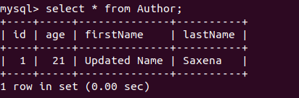

Delete
package com.hibernate.demo;
import org.hibernate.Session;
import org.hibernate.SessionFactory;
import org.hibernate.cfg.Configuration;
public class Main {
public static void main(String[] args) {
Author author=new Author();
author.setId(1);
author.setFirstName("Shivam");
author.setLastName("Saxena");
author.setAge(21);
SessionFactory sessionFactory=new Configuration().configure().buildSessionFactory();
Session session=sessionFactory.openSession();
session.beginTransaction();
Author author1=session.get(Author.class,1);
session.delete(author1);
session.getTransaction().commit();
session.close();
System.out.println(author1);
}
}

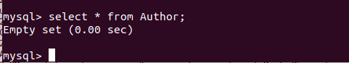

Question 3 :Use hbm2ddl create to introduce Date of Birth for Author.
Answer 3 :
Author.java
package com.hibernate.demo;
import javax.persistence.Entity;
import javax.persistence.Id;
import javax.persistence.Temporal;
import javax.persistence.TemporalType;
import java.util.Date;
@Entity
public class Author {
@Id
private int id;
private String firstName;
private String lastName;
private int age;
@Temporal(TemporalType.DATE)
private Date dob;
public Date getDob() {
return dob;
}
public void setDob(Date dob) {
this.dob = dob;
}
public int getId() {
return id;
}
public void setId(int id) {
this.id = id;
}
public String getFirstName() {
return firstName;
}
public void setFirstName(String firstName) {
this.firstName = firstName;
}
public String getLastName() {
return lastName;
}
public void setLastName(String lastName) {
this.lastName = lastName;
}
public int getAge() {
return age;
}
public void setAge(int age) {
this.age = age;
}
@Override
public String toString() {
return "Author{" +
"id=" + id +
", firstName='" + firstName + '\'' +
", lastName='" + lastName + '\'' +
", age=" + age +
", dob=" + dob +
'}';
}
}
Main.java
package com.hibernate.demo;
import org.hibernate.Session;
import org.hibernate.SessionFactory;
import org.hibernate.cfg.Configuration;
import java.util.Date;
public class Main {
public static void main(String[] args) {
Author author=new Author();
author.setId(1);
author.setFirstName("Shivam");
author.setLastName("Saxena");
author.setAge(21);
author.setDob(new Date());
SessionFactory sessionFactory=new Configuration().configure().buildSessionFactory();
Session session=sessionFactory.openSession();
session.beginTransaction();
session.save(author);
session.getTransaction().commit();
session.close();
}
}

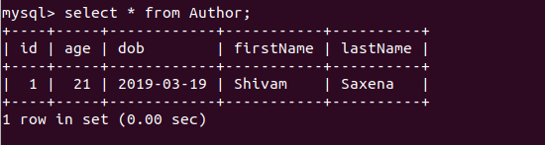

Question 4 : Use hbm2dll update to insert at least 4 records for Author.
Answer 4 :
Main.java
package com.hibernate.demo;
import org.hibernate.Session;
import org.hibernate.SessionFactory;
import org.hibernate.cfg.Configuration;
import java.util.Date;
public class Main {
public static void main(String[] args) {
Author author=new Author();
author.setId(1);
author.setFirstName("Shivam");
author.setLastName("Saxena");
author.setAge(21);
author.setDob(new Date());

Author author1=new Author();
author1.setId(2);
author1.setFirstName("Nitin");
author1.setLastName("Ansal");
author1.setAge(22);
author1.setDob(new Date());

Author author2=new Author();
author2.setId(3);
author2.setFirstName("Vishal");
author2.setLastName("Madheshiya");
author2.setAge(32);
author2.setDob(new Date());

Author author3=new Author();
author3.setId(4);
author3.setFirstName("Saddam");
author3.setLastName("Ansari");
author3.setAge(32);
author3.setDob(new Date());

SessionFactory sessionFactory=new Configuration().configure().buildSessionFactory();
Session session=sessionFactory.openSession();
session.beginTransaction();
//session.save(author);
session.update(author1);
session.update(author2);
session.update(author3);
session.getTransaction().commit();
session.close();
}
}

hibernate.cfg.xml
<?xml version="1.0" encoding="UTF-8"?>
<!DOCTYPE hibernate-configuration PUBLIC "-//Hibernate/Hibernate Configuration DTD 3.0//EN"
"http://hibernate.sourceforge.net/hibernate-configuration-3.0.dtd">
<hibernate-configuration>
<session-factory>
<property name="hibernate.connection.driver_class">com.mysql.jdbc.Driver</property>
<property name="hibernate.connection.url">jdbc:mysql://localhost:3306/hibernateDemo</property>
<property name="hibernate.connection.username">root</property>
<property name="hibernate.connection.password">Shivamsaxena@1234.</property>
<property name="connection.pool_size">10</property>

<property name="hibernate.dialect">org.hibernate.dialect.MySQLDialect</property>

<property name="show_sql">true</property>
<property name="hbm2ddl.auto">update</property>
<mapping class="com.hibernate.demo.Author"/>
</session-factory>
</hibernate-configuration>

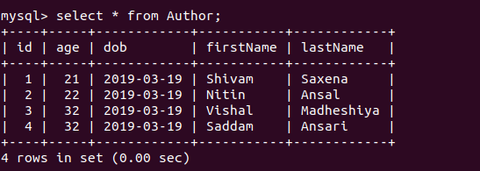

Question 5 :Perform hbm2dll create-drop by closing session factory.
Answer 5 :
hibernate.config.xml
<?xml version="1.0" encoding="UTF-8"?>
<!DOCTYPE hibernate-configuration PUBLIC "-//Hibernate/Hibernate Configuration DTD 3.0//EN"
"http://hibernate.sourceforge.net/hibernate-configuration-3.0.dtd">
<hibernate-configuration>
<session-factory>
<property name="hibernate.connection.driver_class">com.mysql.jdbc.Driver</property>
<property name="hibernate.connection.url">jdbc:mysql://localhost:3306/hibernateDemo</property>
<property name="hibernate.connection.username">root</property>
<property name="hibernate.connection.password">Shivamsaxena@1234.</property>
<property name="connection.pool_size">10</property>

<property name="hibernate.dialect">org.hibernate.dialect.MySQLDialect</property>

<property name="show_sql">true</property>
<property name="hbm2ddl.auto">create-drop</property>
<mapping class="com.hibernate.demo.Author"/>
</session-factory>
</hibernate-configuration>
Main.java
package com.hibernate.demo;
import org.hibernate.Session;
import org.hibernate.SessionFactory;
import org.hibernate.cfg.Configuration;
import java.util.Date;
public class Main {
public static void main(String[] args) {
Author author=new Author();
author.setId(1);
author.setFirstName("Shivam");
author.setLastName("Saxena");
author.setAge(21);
author.setDob(new Date());
SessionFactory sessionFactory=new Configuration().configure().buildSessionFactory();
Session session=sessionFactory.openSession();
session.beginTransaction();
session.save(author);
session.getTransaction().commit();
session.close();
sessionFactory.close();
}
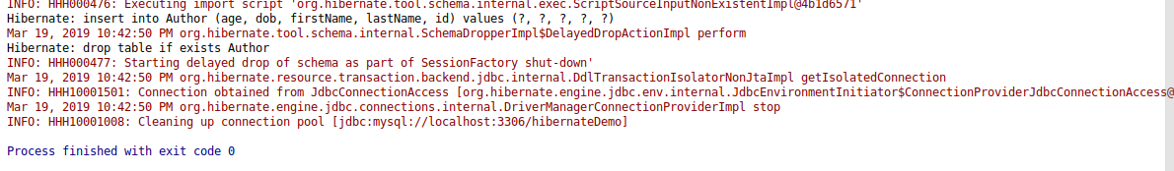
}

Question 6 :Rename all the fields using column annotation.
Mark lastName as @Transient.
Answer 6 :
Author.java
package com.hibernate.demo;
import javax.persistence.*;
import java.util.Date;
@Entity
public class Author {
@Id
@Column(name = "author_id")
private int id;
@Column(name = "author_firstName")
private String firstName;
@Column(name = "author_lastName")
private String lastName;
@Column(name = "author_age")
private int age;
@Column(name = "author_dob")
@Temporal(TemporalType.DATE)
private Date dob;
public Date getDob() {
return dob;
}
public void setDob(Date dob) {
this.dob = dob;
}
public int getId() {
return id;
}
public void setId(int id) {
this.id = id;
}
public String getFirstName() {
return firstName;
}
public void setFirstName(String firstName) {
this.firstName = firstName;
}
public String getLastName() {
return lastName;
}
public void setLastName(String lastName) {
this.lastName = lastName;
}
public int getAge() {
return age;
}
public void setAge(int age) {
this.age = age;
}
@Override
public String toString() {
return "Author{" +
"id=" + id +
", firstName='" + firstName + '\'' +
", lastName='" + lastName + '\'' +
", age=" + age +
", dob=" + dob +
'}';
}
}
Main.java
package com.hibernate.demo;
import org.hibernate.Session;
import org.hibernate.SessionFactory;
import org.hibernate.cfg.Configuration;
import java.util.Date;
public class Main {
public static void main(String[] args) {
Author author=new Author();
author.setId(1);
author.setFirstName("Shivam");
author.setLastName("Saxena");
author.setAge(21);
author.setDob(new Date());
SessionFactory sessionFactory=new Configuration().configure().buildSessionFactory();
Session session=sessionFactory.openSession();
session.beginTransaction();
session.save(author);
session.getTransaction().commit();
session.close();
sessionFactory.close();
}
}
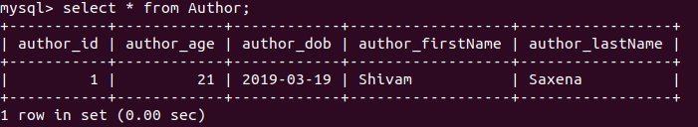

Question 7 :Use @Temporal for date of birth of Author.
Answer 7 :
Author.java
package com.hibernate.demo;
import javax.persistence.*;
import java.util.Date;
@Entity
public class Author {
@Id
@Column(name = "author_id")
private int id;
@Column(name = "author_firstName")
private String firstName;
@Column(name = "author_lastName")
private String lastName;
@Column(name = "author_age")
private int age;
@Column(name = "author_dob")
@Temporal(TemporalType.DATE)
@Transient
private Date dob;
public Date getDob() {
return dob;
}
public void setDob(Date dob) {
this.dob = dob;
}
public int getId() {
return id;
}
public void setId(int id) {
this.id = id;
}
public String getFirstName() {
return firstName;
}
public void setFirstName(String firstName) {
this.firstName = firstName;
}
public String getLastName() {
return lastName;
}
public void setLastName(String lastName) {
this.lastName = lastName;
}
public int getAge() {
return age;
}
public void setAge(int age) {
this.age = age;
}
@Override
public String toString() {
return "Author{" +
"id=" + id +
", firstName='" + firstName + '\'' +
", lastName='" + lastName + '\'' +
", age=" + age +
", dob=" + dob +
'}';
}
}
Main.java
package com.hibernate.demo;
import org.hibernate.Session;
import org.hibernate.SessionFactory;
import org.hibernate.cfg.Configuration;
import java.util.Date;
public class Main {
public static void main(String[] args) {
Author author=new Author();
author.setId(1);
author.setFirstName("Shivam");
author.setLastName("Saxena");
author.setAge(21);
author.setDob(new Date());
SessionFactory sessionFactory=new Configuration().configure().buildSessionFactory();
Session session=sessionFactory.openSession();
session.beginTransaction();
session.save(author);
session.getTransaction().commit();
session.close();
sessionFactory.close();
}
}
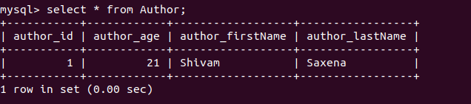

Question 8 :Generate Id for Author Using IDENTITY and TABLE starategy.
Answer 8 :
hibernate.cfg.xml
package com.hibernate.demo;
import javax.persistence.*;
import java.util.Date;
@Entity
public class Author {
@Id
@GeneratedValue(strategy = GenerationType.IDENTITY)
@Column(name = "author_id")
private int id;
@Column(name = "author_firstName")
private String firstName;
@Column(name = "author_lastName")
private String lastName;
@Column(name = "author_age")
private int age;
@Column(name = "author_dob")
@Temporal(TemporalType.DATE)
@Transient
private Date dob;
public Date getDob() {
return dob;
}
public void setDob(Date dob) {
this.dob = dob;
}
public int getId() {
return id;
}
public void setId(int id) {
this.id = id;
}
public String getFirstName() {
return firstName;
}
public void setFirstName(String firstName) {
this.firstName = firstName;
}
public String getLastName() {
return lastName;
}
public void setLastName(String lastName) {
this.lastName = lastName;
}
public int getAge() {
return age;
}
public void setAge(int age) {
this.age = age;
}
@Override
public String toString() {
return "Author{" +
"id=" + id +
", firstName='" + firstName + '\'' +
", lastName='" + lastName + '\'' +
", age=" + age +
", dob=" + dob +
'}';
}
}
Main.java
package com.hibernate.demo;
import org.hibernate.Session;
import org.hibernate.SessionFactory;
import org.hibernate.cfg.Configuration;
import java.util.Date;
public class Main {
public static void main(String[] args) {
Author author=new Author();
author.setFirstName("Shivam");
author.setLastName("Saxena");
author.setAge(21);
author.setDob(new Date());
SessionFactory sessionFactory=new Configuration().configure().buildSessionFactory();
Session session=sessionFactory.openSession();
session.beginTransaction();
session.save(author);
session.getTransaction().commit();
session.close();
sessionFactory.close();
}
}
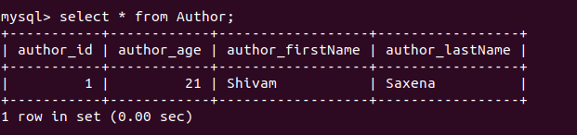
Tables
Author.java
package com.hibernate.demo;
import javax.persistence.*;
import java.util.Date;
@Entity
public class Author {
@Id
@GeneratedValue(strategy = GenerationType.TABLE)
@Column(name = "author_id")
private int id;
@Column(name = "author_firstName")
private String firstName;
@Column(name = "author_lastName")
private String lastName;
@Column(name = "author_age")
private int age;
@Column(name = "author_dob")
@Temporal(TemporalType.DATE)
@Transient
private Date dob;
public Date getDob() {
return dob;
}
public void setDob(Date dob) {
this.dob = dob;
}
public int getId() {
return id;
}
public void setId(int id) {
this.id = id;
}
public String getFirstName() {
return firstName;
}
public void setFirstName(String firstName) {
this.firstName = firstName;
}
public String getLastName() {
return lastName;
}
public void setLastName(String lastName) {
this.lastName = lastName;
}
public int getAge() {
return age;
}
public void setAge(int age) {
this.age = age;
}
@Override
public String toString() {
return "Author{" +
"id=" + id +
", firstName='" + firstName + '\'' +
", lastName='" + lastName + '\'' +
", age=" + age +
", dob=" + dob +
'}';
}
}
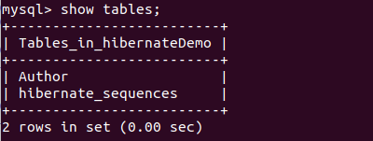

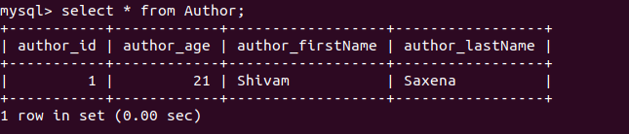
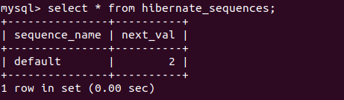

Question 9 :Create a class Address for Author with instance variables streetNumber, location, State.
Answer 9 :
Address.java
package com.hibernate.demo;
import javax.persistence.Embeddable;
@Embeddable
public class Address {
private String streetNumber;
private String location;
private String state;
public String getStreetNumber() {
return streetNumber;
}
public void setStreetNumber(String streetNumber) {
this.streetNumber = streetNumber;
}
public String getLocation() {
return location;
}
public void setLocation(String location) {
this.location = location;
}
public String getState() {
return state;
}
public void setState(String state) {
this.state = state;
}
@Override
public String toString() {
return "Address{" +
"streetNumber='" + streetNumber + '\'' +
", location='" + location + '\'' +
", state='" + state + '\'' +
'}';
}
}

Question 10 :Create instance variable of Address class inside Author class and save it as embedded object.
Answer 10 :
Author.java
package com.hibernate.demo;
import javax.persistence.*;
import java.util.Date;
@Entity
public class Author {
@Id
@GeneratedValue(strategy = GenerationType.TABLE)
@Column(name = "author_id")
private int id;
@Column(name = "author_firstName")
private String firstName;
@Column(name = "author_lastName")
private String lastName;
@Column(name = "author_age")
private int age;
@Column(name = "author_dob")
@Temporal(TemporalType.DATE)
@Transient
private Date dob;
@Embedded
private Address address;
public Address getAddress() {
return address;
}
public void setAddress(Address address) {
this.address = address;
}
public Date getDob() {
return dob;
}
public void setDob(Date dob) {
this.dob = dob;
}
public int getId() {
return id;
}
public void setId(int id) {
this.id = id;
}
public String getFirstName() {
return firstName;
}
public void setFirstName(String firstName) {
this.firstName = firstName;
}
public String getLastName() {
return lastName;
}
public void setLastName(String lastName) {
this.lastName = lastName;
}
public int getAge() {
return age;
}
public void setAge(int age) {
this.age = age;
}
@Override
public String toString() {
return "Author{" +
"id=" + id +
", firstName='" + firstName + '\'' +
", lastName='" + lastName + '\'' +
", age=" + age +
", dob=" + dob +
", address=" + address +
'}';
}
}
Main.java
package com.hibernate.demo;
import org.hibernate.Session;
import org.hibernate.SessionFactory;
import org.hibernate.cfg.Configuration;
import java.util.Date;
public class Main {
public static void main(String[] args) {
Author author=new Author();
author.setFirstName("Shivam");
author.setLastName("Saxena");
author.setAge(21);
author.setDob(new Date());
Address address=new Address();
address.setStreetNumber("C-339");
address.setLocation("Alpha 1");
address.setState("Uttar Pradesh");
author.setAddress(address);
SessionFactory sessionFactory=new Configuration().configure().buildSessionFactory();
Session session=sessionFactory.openSession();
session.beginTransaction();
session.save(author);
session.getTransaction().commit();
session.close();
sessionFactory.close();
}
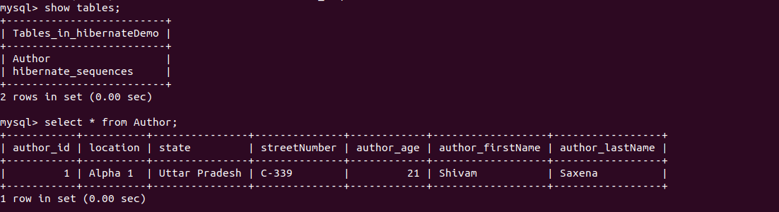
}

Question 11 :Introduce a List of subjects for author.
Answer 11 :
Author.java
package com.hibernate.demo;
import javax.persistence.*;
import java.util.Date;
import java.util.List;
import java.util.Set;
@Entity
public class Author {
@Id
@GeneratedValue(strategy = GenerationType.TABLE)
@Column(name = "author_id")
private int id;
@Column(name = "author_firstName")
private String firstName;
@Column(name = "author_lastName")
private String lastName;
@Column(name = "author_age")
private int age;
@Column(name = "author_dob")
@Temporal(TemporalType.DATE)
@Transient
private Date dob;
@Embedded
private Address address;
@ElementCollection
private Set<String> subjects;
public Set<String> getSubjects() {
return subjects;
}
public void setSubjects(Set<String> subjects) {
this.subjects = subjects;
}
public Address getAddress() {
return address;
}
public void setAddress(Address address) {
this.address = address;
}
public Date getDob() {
return dob;
}
public void setDob(Date dob) {
this.dob = dob;
}
public int getId() {
return id;
}
public void setId(int id) {
this.id = id;
}
public String getFirstName() {
return firstName;
}
public void setFirstName(String firstName) {
this.firstName = firstName;
}
public String getLastName() {
return lastName;
}
public void setLastName(String lastName) {
this.lastName = lastName;
}
public int getAge() {
return age;
}
public void setAge(int age) {
this.age = age;
}
@Override
public String toString() {
return "Author{" +
"id=" + id +
", firstName='" + firstName + '\'' +
", lastName='" + lastName + '\'' +
", age=" + age +
", dob=" + dob +
", address=" + address +
", subjects=" + subjects +
'}';
}
}

Question 12 :Persist 3 subjects for each author.
Answer 12 :
Main.java
Main.java
package com.hibernate.demo;
import org.hibernate.Session;
import org.hibernate.SessionFactory;
import org.hibernate.cfg.Configuration;
import java.util.Date;
import java.util.HashSet;
import java.util.Set;
public class Main {
public static void main(String[] args) {
Author author=new Author();
author.setFirstName("Shivam");
author.setLastName("Saxena");
author.setAge(21);
author.setDob(new Date());
Address address=new Address();
address.setStreetNumber("C-339");
address.setLocation("Alpha 1");
address.setState("Uttar Pradesh");
author.setAddress(address);
Set<String> students=new HashSet<>();
students.add("Maths");
students.add("physics");
students.add("Chemistry");
author.setSubjects(students);
SessionFactory sessionFactory=new Configuration().configure().buildSessionFactory();
Session session=sessionFactory.openSession();
session.beginTransaction();
session.save(author);
session.getTransaction().commit();
session.close();
sessionFactory.close();
}
}
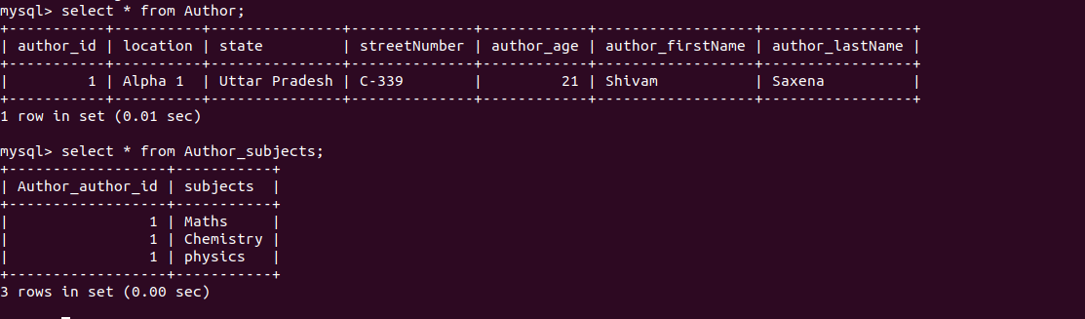

Question 13 : Create an Entity book with an instance variable bookName.
Answer 13 :
Book.java
package com.hibernate.demo;
import javax.persistence.Entity;
import javax.persistence.GeneratedValue;
import javax.persistence.GenerationType;
import javax.persistence.Id;
@Entity
public class Book {
@Id
@GeneratedValue(strategy = GenerationType.AUTO)
private String bookId;
private String bookName;
public String getBookId() {
return bookId;
}
public void setBookId(String bookId) {
this.bookId = bookId;
}
public String getBookName() {
return bookName;
}
public void setBookName(String bookName) {
this.bookName = bookName;
}
@Override
public String toString() {
return "Book{" +
"bookId='" + bookId + '\'' +
", bookName='" + bookName + '\'' +
'}';
}
}

Question 14 : Implement One to One mapping between Author and Book.
Author.java
package com.hibernate.demo;
import javax.persistence.*;
import java.util.Date;
import java.util.List;
import java.util.Set;
@Entity
public class Author {
@Id
@GeneratedValue(strategy = GenerationType.AUTO)
private int id;
@Column(name = "author_firstName")
private String firstName;
@Column(name = "author_lastName")
private String lastName;
@Column(name = "author_age")
private int age;
@Column(name = "author_dob")
@Temporal(TemporalType.DATE)
@Transient
private Date dob;
@Embedded
private Address address;
@ElementCollection
private Set<String> subjects;
@OneToOne
@JoinColumn(name = "join_book_column")
private Book book;
public Book getBook() {
return book;
}
public void setBook(Book book) {
this.book = book;
}
public Set<String> getSubjects() {
return subjects;
}
public void setSubjects(Set<String> subjects) {
this.subjects = subjects;
}
public Address getAddress() {
return address;
}
public void setAddress(Address address) {
this.address = address;
}
public Date getDob() {
return dob;
}
public void setDob(Date dob) {
this.dob = dob;
}
public int getId() {
return id;
}
public void setId(int id) {
this.id = id;
}
public String getFirstName() {
return firstName;
}
public void setFirstName(String firstName) {
this.firstName = firstName;
}
public String getLastName() {
return lastName;
}
public void setLastName(String lastName) {
this.lastName = lastName;
}
public int getAge() {
return age;
}
public void setAge(int age) {
this.age = age;
}
@Override
public String toString() {
return "Author{" +
"id=" + id +
", firstName='" + firstName + '\'' +
", lastName='" + lastName + '\'' +
", age=" + age +
", dob=" + dob +
", address=" + address +
", subjects=" + subjects +
", book=" + book +
'}';
}
}
Main.java
package com.hibernate.demo;
import org.hibernate.Session;
import org.hibernate.SessionFactory;
import org.hibernate.cfg.Configuration;
import java.util.Date;
import java.util.HashSet;
import java.util.Set;
public class Main {
public static void main(String[] args) {
Author author=new Author();
author.setFirstName("Shivam");
author.setLastName("Saxena");
author.setAge(21);
author.setDob(new Date());
Address address=new Address();
address.setStreetNumber("C-339");
address.setLocation("Alpha 1");
address.setState("Uttar Pradesh");
author.setAddress(address);
Set<String> subjects=new HashSet<>();
subjects.add("Maths");
subjects.add("physics");
subjects.add("Chemistry");
author.setSubjects(subjects);

Book book=new Book();
book.setBookName("DAA");
author.setBook(book);
SessionFactory sessionFactory=new Configuration().configure().buildSessionFactory();
Session session=sessionFactory.openSession();
session.beginTransaction();
session.save(author);
session.save(book);
session.getTransaction().commit();
session.close();
sessionFactory.close();
}
}
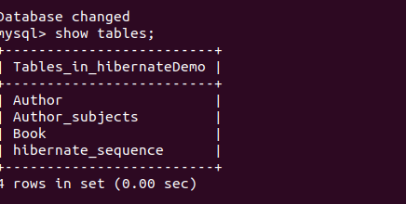

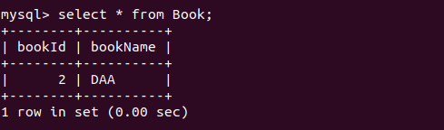

Question 15 : Implement One to Many Mapping between Author and Book(Unidirectional, BiDirectional and without additional table ) and implement cascade save.
Answer 15 :
Book.java
OneToMany(Unidirectional)
package com.hibernate.demo;
import org.hibernate.Session;
import org.hibernate.SessionFactory;
import org.hibernate.cfg.Configuration;
import java.util.Date;
import java.util.HashSet;
import java.util.Set;
public class Main {
public static void main(String[] args) {
Author author=new Author();
author.setFirstName("Shivam");
author.setLastName("Saxena");
author.setAge(21);
author.setDob(new Date());
Address address=new Address();
address.setStreetNumber("C-339");
address.setLocation("Alpha 1");
address.setState("Uttar Pradesh");
author.setAddress(address);
Set<String> subjects=new HashSet<>();
subjects.add("Maths");
subjects.add("physics");
subjects.add("Chemistry");
author.setSubjects(subjects);
Book book=new Book();
book.setBookName("DAA");
Book book1=new Book();
book1.setBookName("Computer Networks");
Book book2=new Book();
book2.setBookName("TAFL");
author.getBookListForAuthor().add(book);
author.getBookListForAuthor().add(book1);
author.getBookListForAuthor().add(book2);
//author.setBook(book);
SessionFactory sessionFactory=new Configuration().configure().buildSessionFactory();
Session session=sessionFactory.openSession();
session.beginTransaction();
session.save(author);
session.save(book);
session.save(book1);
session.save(book2);
session.getTransaction().commit();
session.close();
sessionFactory.close();
}
}

Author.java
package com.hibernate.demo;
import javax.persistence.*;
import java.util.Collection;
import java.util.Date;
import java.util.HashSet;
import java.util.Set;
@Entity
public class Author {
@Id
@GeneratedValue(strategy = GenerationType.AUTO)
private int id;
@Column(name = "author_firstName")
private String firstName;
@Column(name = "author_lastName")
private String lastName;
@Column(name = "author_age")
private int age;
@Column(name = "author_dob")
@Temporal(TemporalType.DATE)
@Transient
private Date dob;
@Embedded
private Address address;
@ElementCollection
private Set<String> subjects;
/*Question 14*/
/*@OneToOne
@JoinColumn(name = "join_book_column")
private Book book;
public Book getBook() {
return book;
}
public void setBook(Book book) {
this.book = book;
}*/
@OneToMany
@JoinTable(joinColumns = @JoinColumn(name = "id"),inverseJoinColumns = @JoinColumn(name = "bookId"))
Collection<Book> bookListForAuthor=new HashSet<>();
public Collection<Book> getBookListForAuthor() {
return bookListForAuthor;
}
public void setBookListForAuthor(Collection<Book> bookListForAuthor) {
this.bookListForAuthor = bookListForAuthor;
}
public Set<String> getSubjects() {
return subjects;
}
public void setSubjects(Set<String> subjects) {
this.subjects = subjects;
}
public Address getAddress() {
return address;
}
public void setAddress(Address address) {
this.address = address;
}
public Date getDob() {
return dob;
}
public void setDob(Date dob) {
this.dob = dob;
}
public int getId() {
return id;
}
public void setId(int id) {
this.id = id;
}
public String getFirstName() {
return firstName;
}
public void setFirstName(String firstName) {
this.firstName = firstName;
}
public String getLastName() {
return lastName;
}
public void setLastName(String lastName) {
this.lastName = lastName;
}
public int getAge() {
return age;
}
public void setAge(int age) {
this.age = age;
}
@Override
public String toString() {
return "Author{" +
"id=" + id +
", firstName='" + firstName + '\'' +
", lastName='" + lastName + '\'' +
", age=" + age +
", dob=" + dob +
", address=" + address +
", subjects=" + subjects +
", bookListForAuthor=" + bookListForAuthor +
'}';
}
}
Main.java
package com.hibernate.demo;
import org.hibernate.Session;
import org.hibernate.SessionFactory;
import org.hibernate.cfg.Configuration;
import java.util.Date;
import java.util.HashSet;
import java.util.Set;
public class Main {
public static void main(String[] args) {
Author author=new Author();
author.setFirstName("Shivam");
author.setLastName("Saxena");
author.setAge(21);
author.setDob(new Date());
Address address=new Address();
address.setStreetNumber("C-339");
address.setLocation("Alpha 1");
address.setState("Uttar Pradesh");
author.setAddress(address);
Set<String> subjects=new HashSet<>();
subjects.add("Maths");
subjects.add("physics");
subjects.add("Chemistry");
author.setSubjects(subjects);
Book book=new Book();
book.setBookName("DAA");
Book book1=new Book();
book1.setBookName("Computer Networks");
Book book2=new Book();
book2.setBookName("TAFL");
author.getBookListForAuthor().add(book);
author.getBookListForAuthor().add(book1);
author.getBookListForAuthor().add(book2);
//author.setBook(book);
SessionFactory sessionFactory=new Configuration().configure().buildSessionFactory();
Session session=sessionFactory.openSession();
session.beginTransaction();
session.save(author);
session.save(book);
session.save(book1);
session.save(book2);
session.getTransaction().commit();
session.close();
sessionFactory.close();
}
}

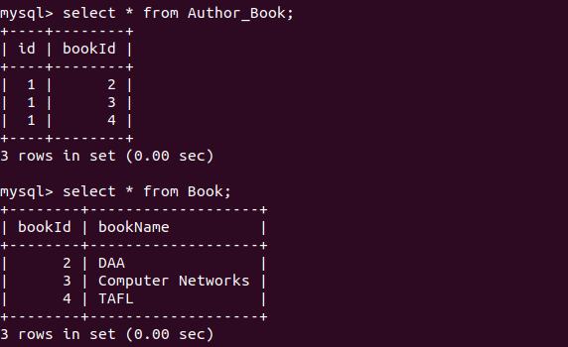

OneToMany(Bidirectional)
Book.java
package com.hibernate.demo;
import javax.persistence.*;
@Entity
public class Book {
@Id
@GeneratedValue(strategy = GenerationType.AUTO)
private int bookId;
private String bookName;
@ManyToOne
private Author author;
public Author getAuthor() {
return author;
}
public void setAuthor(Author author) {
this.author = author;
}
public int getBookId() {
return bookId;
}
public void setBookId(int bookId) {
this.bookId = bookId;
}
public String getBookName() {
return bookName;
}
public void setBookName(String bookName) {
this.bookName = bookName;
}
@Override
public String toString() {
return "Book{" +
"bookId=" + bookId +
", bookName='" + bookName + '\'' +
", author=" + author +
'}';
}
}
Main.java
package com.hibernate.demo;
import org.hibernate.Session;
import org.hibernate.SessionFactory;
import org.hibernate.cfg.Configuration;
import java.util.Date;
import java.util.HashSet;
import java.util.Set;
public class Main {
public static void main(String[] args) {
Author author=new Author();
author.setFirstName("Shivam");
author.setLastName("Saxena");
author.setAge(21);
author.setDob(new Date());
Address address=new Address();
address.setStreetNumber("C-339");
address.setLocation("Alpha 1");
address.setState("Uttar Pradesh");
author.setAddress(address);
Set<String> subjects=new HashSet<>();
subjects.add("Maths");
subjects.add("physics");
subjects.add("Chemistry");
author.setSubjects(subjects);
Book book=new Book();
book.setBookName("DAA");
book.setAuthor(author);
Book book1=new Book();
book1.setBookName("Computer Networks");
book1.setAuthor(author);
Book book2=new Book();
book2.setBookName("TAFL");
book2.setAuthor(author);
author.getBookListForAuthor().add(book);
author.getBookListForAuthor().add(book1);
author.getBookListForAuthor().add(book2);
//author.setBook(book);
SessionFactory sessionFactory=new Configuration().configure().buildSessionFactory();
Session session=sessionFactory.openSession();
session.beginTransaction();
session.save(author);
session.save(book);
session.save(book1);
session.save(book2);
session.getTransaction().commit();
session.close();
sessionFactory.close();
}
}
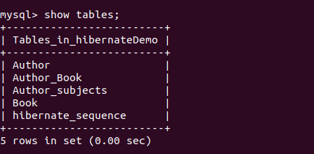

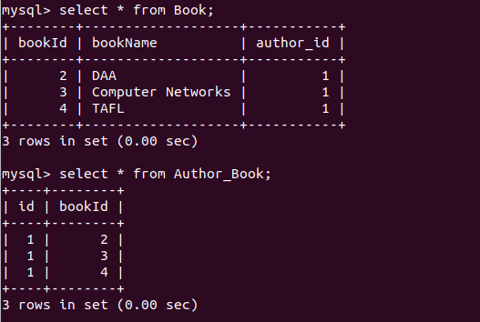
@OneToMany(without Any Additional Tables)
Author.java
package com.hibernate.demo;
import javax.persistence.*;
import java.util.Collection;
import java.util.Date;
import java.util.HashSet;
import java.util.Set;
@Entity
public class Author {
@Id
@GeneratedValue(strategy = GenerationType.AUTO)
private int id;
@Column(name = "author_firstName")
private String firstName;
@Column(name = "author_lastName")
private String lastName;
@Column(name = "author_age")
private int age;
@Column(name = "author_dob")
@Temporal(TemporalType.DATE)
@Transient
private Date dob;
@Embedded
private Address address;
@ElementCollection
private Set<String> subjects;

@OneToMany(mappedBy = "author")
Collection<Book> bookListForAuthor=new HashSet<>();
public Collection<Book> getBookListForAuthor() {
return bookListForAuthor;
}
public void setBookListForAuthor(Collection<Book> bookListForAuthor) {
this.bookListForAuthor = bookListForAuthor;
}
public Set<String> getSubjects() {
return subjects;
}
public void setSubjects(Set<String> subjects) {
this.subjects = subjects;
}
public Address getAddress() {
return address;
}
public void setAddress(Address address) {
this.address = address;
}
public Date getDob() {
return dob;
}
public void setDob(Date dob) {
this.dob = dob;
}
public int getId() {
return id;
}
public void setId(int id) {
this.id = id;
}
public String getFirstName() {
return firstName;
}
public void setFirstName(String firstName) {
this.firstName = firstName;
}
public String getLastName() {
return lastName;
}
public void setLastName(String lastName) {
this.lastName = lastName;
}
public int getAge() {
return age;
}
public void setAge(int age) {
this.age = age;
}
@Override
public String toString() {
return "Author{" +
"id=" + id +
", firstName='" + firstName + '\'' +
", lastName='" + lastName + '\'' +
", age=" + age +
", dob=" + dob +
", address=" + address +
", subjects=" + subjects +
", bookListForAuthor=" + bookListForAuthor +
'}';
}
}

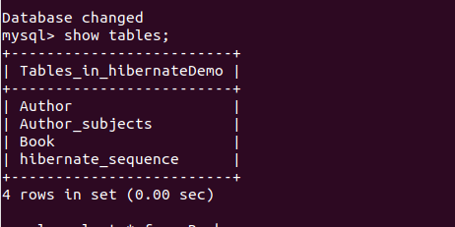

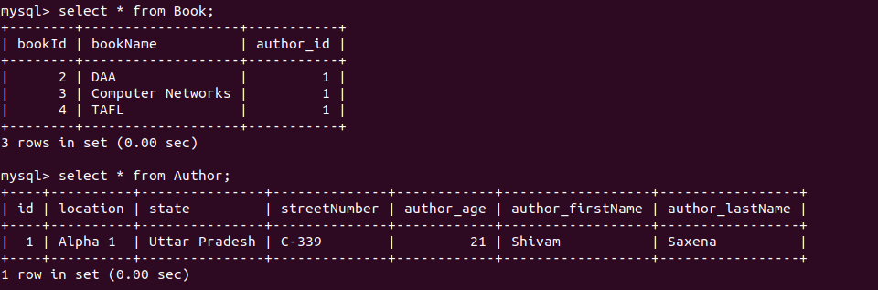
Through Cascade save;
Author.java
package com.hibernate.demo;
import javax.persistence.*;
import java.util.*;
@Entity
public class Author {
@Id
@GeneratedValue(strategy = GenerationType.AUTO)
private int id;
@Column(name = "author_firstName")
private String firstName;
@Column(name = "author_lastName")
private String lastName;
@Column(name = "author_age")
private int age;
@Column(name = "author_dob")
@Temporal(TemporalType.DATE)
@Transient
private Date dob;
@Embedded
private Address address;
@ElementCollection
private Set<String> subjects;
/*Question 14*/
/*@OneToOne
@JoinColumn(name = "join_book_column")
private Book book;
public Book getBook() {
return book;
}
public void setBook(Book book) {
this.book = book;
}*/
@OneToMany(cascade = CascadeType.PERSIST)
List<Book> listOfBook=new ArrayList<>();
public List<Book> getListOfBook() {
return listOfBook;
}
public void setListOfBook(List<Book> listOfBook) {
this.listOfBook = listOfBook;
}
public Set<String> getSubjects() {
return subjects;
}
public void setSubjects(Set<String> subjects) {
this.subjects = subjects;
}
public Address getAddress() {
return address;
}
public void setAddress(Address address) {
this.address = address;
}
public Date getDob() {
return dob;
}
public void setDob(Date dob) {
this.dob = dob;
}
public int getId() {
return id;
}
public void setId(int id) {
this.id = id;
}
public String getFirstName() {
return firstName;
}
public void setFirstName(String firstName) {
this.firstName = firstName;
}
public String getLastName() {
return lastName;
}
public void setLastName(String lastName) {
this.lastName = lastName;
}
public int getAge() {
return age;
}
public void setAge(int age) {
this.age = age;
}
@Override
public String toString() {
return "Author{" +
"id=" + id +
", firstName='" + firstName + '\'' +
", lastName='" + lastName + '\'' +
", age=" + age +
", dob=" + dob +
", address=" + address +
", subjects=" + subjects +
", listOfBook=" + listOfBook +
'}';
}
}
Main.java
package com.hibernate.demo;
import org.hibernate.Session;
import org.hibernate.SessionFactory;
import org.hibernate.cfg.Configuration;
import java.util.Date;
import java.util.HashSet;
import java.util.Set;
public class Main {
public static void main(String[] args) {
Author author=new Author();
author.setFirstName("Shivam");
author.setLastName("Saxena");
author.setAge(21);
author.setDob(new Date());
Address address=new Address();
address.setStreetNumber("C-339");
address.setLocation("Alpha 1");
address.setState("Uttar Pradesh");
author.setAddress(address);
Set<String> subjects=new HashSet<>();
subjects.add("Maths");
subjects.add("physics");
subjects.add("Chemistry");
author.setSubjects(subjects);
Book book=new Book();
book.setBookName("DAA");
book.setAuthor(author);
Book book1=new Book();
book1.setBookName("Computer Networks");
book1.setAuthor(author);
Book book2=new Book();
book2.setBookName("TAFL");
book2.setAuthor(author);
author.getListOfBook().add(book);
author.getListOfBook().add(book1);
author.getListOfBook().add(book2);
//author.setBook(book);
SessionFactory sessionFactory=new Configuration().configure().buildSessionFactory();
Session session=sessionFactory.openSession();
session.beginTransaction();
session.persist(author);
session.getTransaction().commit();
session.close();
sessionFactory.close();
}
}
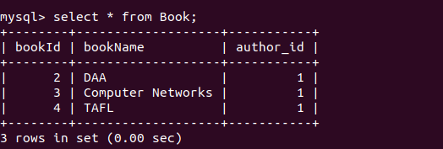

Question 16 : Implement Many to Many Mapping between Author and Book.
Answer 16 :
Author.java
package com.hibernate.demo;
import javax.persistence.*;
import java.util.*;
@Entity
public class Author {
@Id
@GeneratedValue(strategy = GenerationType.AUTO)
private int id;
@Column(name = "author_firstName")
private String firstName;
@Column(name = "author_lastName")
private String lastName;
@Column(name = "author_age")
private int age;
@Column(name = "author_dob")
@Temporal(TemporalType.DATE)
@Transient
private Date dob;
@Embedded
private Address address;
@ElementCollection
private Set<String> subjects;
/*Question 14*/
/*@OneToOne
@JoinColumn(name = "join_book_column")
private Book book;
public Book getBook() {
return book;
}
public void setBook(Book book) {
this.book = book;
}*/
@ManyToMany
List<Book> bookList=new ArrayList<>();
public List<Book> getBookList() {
return bookList;
}
public void setBookList(List<Book> bookList) {
this.bookList = bookList;
}
public Set<String> getSubjects() {
return subjects;
}
public void setSubjects(Set<String> subjects) {
this.subjects = subjects;
}
public Address getAddress() {
return address;
}
public void setAddress(Address address) {
this.address = address;
}
public Date getDob() {
return dob;
}
public void setDob(Date dob) {
this.dob = dob;
}
public int getId() {
return id;
}
public void setId(int id) {
this.id = id;
}
public String getFirstName() {
return firstName;
}
public void setFirstName(String firstName) {
this.firstName = firstName;
}
public String getLastName() {
return lastName;
}
public void setLastName(String lastName) {
this.lastName = lastName;
}
public int getAge() {
return age;
}
public void setAge(int age) {
this.age = age;
}
@Override
public String toString() {
return "Author{" +
"id=" + id +
", firstName='" + firstName + '\'' +
", lastName='" + lastName + '\'' +
", age=" + age +
", dob=" + dob +
", address=" + address +
", subjects=" + subjects +
", bookList=" + bookList +
'}';
}
}
Book.java
package com.hibernate.demo;
import javax.persistence.*;
import java.util.ArrayList;
import java.util.List;
@Entity
public class Book {
@Id
@GeneratedValue(strategy = GenerationType.AUTO)
private int bookId;
private String bookName;
@ManyToMany(mappedBy = "bookList")
List<Author> AuthorList=new ArrayList<>();
public List<Author> getAuthorList() {
return AuthorList;
}
public void setAuthorList(List<Author> authorList) {
AuthorList = authorList;
}
public int getBookId() {
return bookId;
}
public void setBookId(int bookId) {
this.bookId = bookId;
}
public String getBookName() {
return bookName;
}
public void setBookName(String bookName) {
this.bookName = bookName;
}
@Override
public String toString() {
return "Book{" +
"bookId=" + bookId +
", bookName='" + bookName + '\'' +
", AuthorList=" + AuthorList +
'}';
}
}
Main.java
package com.hibernate.demo;
import org.hibernate.Session;
import org.hibernate.SessionFactory;
import org.hibernate.cfg.Configuration;
import sun.swing.BakedArrayList;
import java.util.*;
public class Main {
public static void main(String[] args) {
Author author=new Author();
author.setFirstName("Shivam");
author.setLastName("Saxena");
author.setAge(21);
author.setDob(new Date());
Address address=new Address();
address.setStreetNumber("C-339");
address.setLocation("Alpha 1");
address.setState("Uttar Pradesh");
author.setAddress(address);
Set<String> subjects=new HashSet<>();
subjects.add("Maths");
subjects.add("physics");
subjects.add("Chemistry");
author.setSubjects(subjects);
List<Author> authorList1=new ArrayList<>();
authorList1.add(author);
List<Book> bookList=new ArrayList<>();
Book book=new Book();
book.setBookName("DAA");
book.setAuthorList(authorList1);
bookList.add(book);
author.setBookList(bookList);
//author.setBook(book);
SessionFactory sessionFactory=new Configuration().configure().buildSessionFactory();
Session session=sessionFactory.openSession();
session.beginTransaction();
session.save(author);
session.save(book);
session.getTransaction().commit();
session.close();
sessionFactory.close();
}
}
