Question 1 : Invoke context events start(), stop() and close().
Answer 1 :
MyEventListener.java
import org.springframework.context.ApplicationEvent;
import org.springframework.context.ApplicationListener;
public class MyEventListener implements ApplicationListener {
@Override
public void onApplicationEvent(ApplicationEvent event) {
System.out.println("*********EVENT******** "+event);
}
}
Main.java
import org.springframework.context.ConfigurableApplicationContext;
import org.springframework.context.support.ClassPathXmlApplicationContext;
import java.io.IOException;
public class Main {
public static void main(String[] args) throws IOException {
ConfigurableApplicationContext configurableApplicationContext=new ClassPathXmlApplicationContext("Spring-config.xml");
((ClassPathXmlApplicationContext) configurableApplicationContext).start();
System.out.println(configurableApplicationContext.getBean("database"));
((ClassPathXmlApplicationContext) configurableApplicationContext).stop();
Spring-config.xml
<bean id="database" class="Database">
<property name="port" value="8080"/>
<property name="name" value="mysql"/>
</bean>
<bean class="MyEventListener"/>
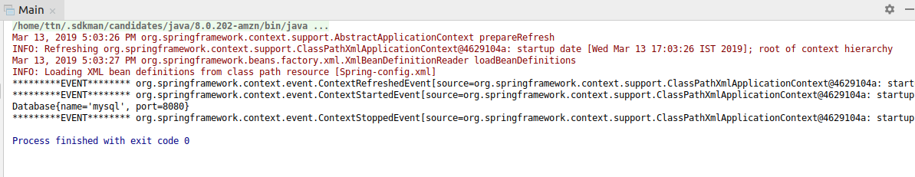

Question 2 : Create listeners for spring events.
Answer 2 :
MyEventListener.java
import org.springframework.context.ApplicationEvent;
import org.springframework.context.ApplicationListener;
import org.springframework.context.event.ContextStartedEvent;
public class MyEventListener implements ApplicationListener<ContextStartedEvent> {
@Override
public void onApplicationEvent(ContextStartedEvent event) {
System.out.println("*******Event*******"+event);
}
}
Main.java
import org.springframework.context.ConfigurableApplicationContext;
import org.springframework.context.support.ClassPathXmlApplicationContext;
import java.io.IOException;
public class Main {
public static void main(String[] args) throws IOException {
ConfigurableApplicationContext ctx=new ClassPathXmlApplicationContext("Spring-config.xml");
ctx.start();
Database database=(Database) ctx.getBean("database");
System.out.println(database);
ctx.stop();

Spring-config.xml
<bean id="database" class="Database">
<property name="port" value="8080"/>
<property name="name" value="mysql"/>
</bean>
<bean class="MyEventListener"/>

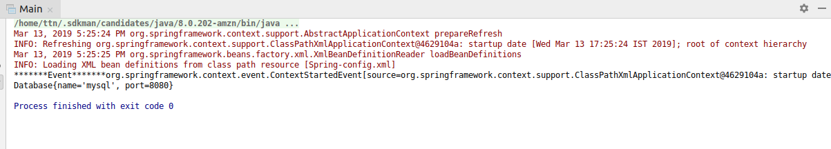

Question 3 : Create a CustomEvent which should get published when you invoke connect method of database bean.
Answer 3 :
Database.java
import org.springframework.context.ApplicationEventPublisher;
import org.springframework.context.ApplicationEventPublisherAware;
import java.io.IOException;
public class Database implements ApplicationEventPublisherAware {
private String name;
private int port;
public String getName() {
return name;
}
public void setName(String name) {
this.name = name;
}
public int getPort() {
return port;
}
public void setPort(int port) {
this.port = port;
}
@Override
public String toString() {
return "Database{" +
"name='" + name + '\'' +
", port=" + port +
'}';
}
ApplicationEventPublisher applicationEventPublisher;
public void connect() {
MyCustomEvent myCustomEvent = new MyCustomEvent(this);
applicationEventPublisher.publishEvent(myCustomEvent);
System.out.println("connecting to Database");
}
@Override
public void setApplicationEventPublisher(ApplicationEventPublisher applicationEventPublisher) {
this.applicationEventPublisher = applicationEventPublisher;
}
}
MyCustomEvent.java
import org.springframework.context.ApplicationEvent;
public class MyCustomEvent extends ApplicationEvent {
/**
* Create a new ApplicationEvent.
*
* @param source the object on which the event initially occurred (never {@code null})
*/
public MyCustomEvent(Object source) {
super(source);
}
}
CustomEventListener.java
import org.springframework.context.ApplicationListener;
public class CustomEventListener implements ApplicationListener<MyCustomEvent> {
@Override
public void onApplicationEvent(MyCustomEvent event) {
System.out.println("This is my Custom Event " + event.getSource());
}
}
Spring-config.xml
<bean class="CustomEventListener"/>

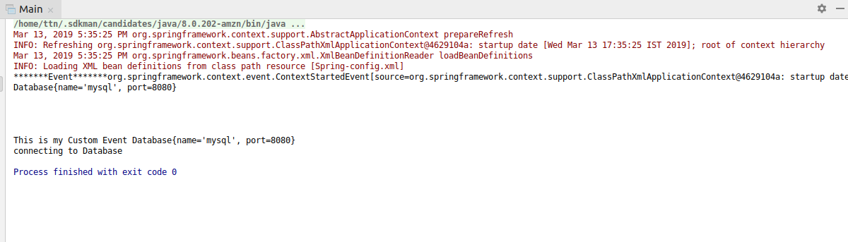

Question 4 :Create a logging aspect. Create a pointcut to log all methods Of services .
Answer 4 :
LoggingAspect.java
package aop;
import org.aspectj.lang.JoinPoint;
import org.aspectj.lang.annotation.*;
@Aspect
public class LoggingAspect {
//Question 4
//Example of PointcutMethods
@Pointcut("execution(* *())")
void pointcutMethods() { }

@Before("aop.LoggingAspect.pointcutMethods()")
void question4(){
System.out.println("This is question4");
}
Spring-config.xml
<aop:aspectj-autoproxy/>

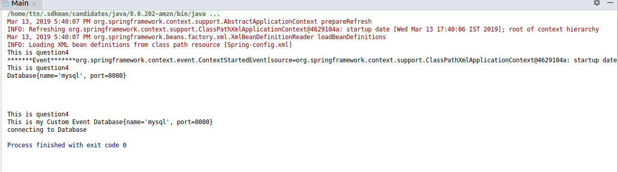

Question 5 :Add a logging statement before and after the method ends
Answer 5 :
Database.java
public void connect() {
MyCustomEvent myCustomEvent = new MyCustomEvent(this);
applicationEventPublisher.publishEvent(myCustomEvent);
System.out.println("connecting to Database");
}

LoggingAspect.java
@Before("execution(void connect())")
void beforeConnect() {
System.out.println("Before Connect");
}
@After("execution(void connect())")
void afterConnect() {
System.out.println("after Connect");
}
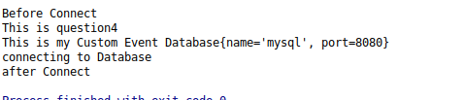

Question 6 : Log all the methods which throw IOException
Answer 6 :
Database.java
public void throwsException() throws IOException {
System.out.println("Throwing IOException ");
throw new IOException();
}
Spring-config.xml
<aop:aspectj-autoproxy/>

LoggingAspect.java
@AfterThrowing(pointcut = "execution(* *())", throwing = "ex")
void afterThrowingAdvice(Exception ex) {
System.out.println("Running AfterThrowing :" + ex);
}
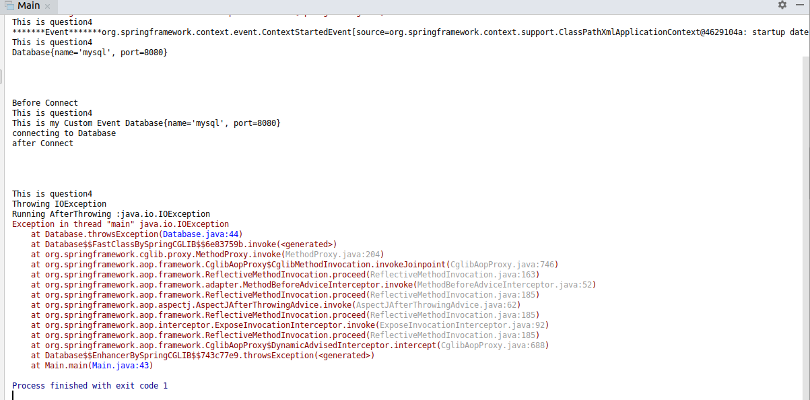

Question 7 :Apply execution, within, args, this and bean expressions on the before and after advice of service bean.
Answer 7 :
Database.java
import org.springframework.context.ApplicationEventPublisher;
import org.springframework.context.ApplicationEventPublisherAware;
import java.io.IOException;
public class Database implements ApplicationEventPublisherAware {

private String name;
private int port;

public String getName() {
return name;
}

public void setName(String name) {
this.name = name;
}

public int getPort() {
return port;
}
public void setPort(int port) {
this.port = port;
}
@Override
public String toString() {
return "Database{" +
"name='" + name + '\'' +
", port=" + port +
'}';
}
ApplicationEventPublisher applicationEventPublisher;
public void connect() {
MyCustomEvent myCustomEvent = new MyCustomEvent(this);
applicationEventPublisher.publishEvent(myCustomEvent);
System.out.println("connecting to Database");
}
public void throwsException() throws IOException {
System.out.println("Throwing IOException ");
throw new IOException();
}
public void checkPointcutTypes() {
System.out.println("This is CheckPointTypes");
}
public void argsMethod(Integer a){
System.out.println(a);
}
@Override
public void setApplicationEventPublisher(ApplicationEventPublisher applicationEventPublisher) {
this.applicationEventPublisher = applicationEventPublisher;
}
}

LoggingAspect.java
package aop;
import org.aspectj.lang.JoinPoint;
import org.aspectj.lang.annotation.*;
@Aspect
public class LoggingAspect {
//Question 7
//Example of pointcut Types
@Pointcut("within(Database)")
void pointCutWithin() { }

@Pointcut("bean(database)")
void pointCutBean() { }

@Before("execution(void checkPointcutTypes())")
void executionType() {
System.out.println("Before---> This is Example of Execution type of PointCut");
}
@After("execution(void checkPointcutTypes())")
void executionType1() {
System.out.println("After---> This is Example of Execution type of PointCut");
}
@Before("pointCutWithin()")
void withInType() {
System.out.println("This is Before With In type");
}
@After("pointCutWithin()")
void withInType1() {
System.out.println("This is After With In type");
}
@Before("pointCutBean()")
void beanType() {
System.out.println("This is Before Bean type");
}
@After("pointCutBean()")
void beanType1() {
System.out.println("This is After Bean type");
}
@Before("args(Integer)")
void argsPointType(JoinPoint joinPoint){
System.out.println("LOG Before is :"+joinPoint.getArgs());
}
@After("args(Integer)")
void argsPointType1(JoinPoint joinPoint){
System.out.println("LOG After is :"+joinPoint.getArgs());
}
@Before("this(Database)")
void thisPointType(){
System.out.println("This is Example of this");
}

Spring-config.xml
<?xml version="1.0" encoding="UTF-8"?>
<beans xmlns="http://www.springframework.org/schema/beans"
xmlns:xsi="http://www.w3.org/2001/XMLSchema-instance"
xmlns:aop="http://www.springframework.org/schema/aop"
xmlns:context="http://www.springframework.org/schema/context"
xsi:schemaLocation="http://www.springframework.org/schema/beans
http://www.springframework.org/schema/beans/spring-beans.xsd
http://www.springframework.org/schema/aop
http://www.springframework.org/schema/aop/spring-aop.xsd
http://www.springframework.org/schema/context
http://www.springframework.org/schema/context/spring-context.xsd">
<bean id="database" class="Database">
<property name="port" value="8080"/>
<property name="name" value="mysql"/>
</bean>
<bean id="database1" class="Database">
<property name="port" value="3036"/>
<property name="name" value="oracle"/>
</bean>
<bean class="MyEventListener"/>
<bean class="CustomEventListener"/>
<aop:aspectj-autoproxy/>
<bean class="aop.LoggingAspect"/>
<context:annotation-config/>
</beans>
Main.java
import org.springframework.context.ApplicationContext;
import org.springframework.context.ConfigurableApplicationContext;
import org.springframework.context.support.ClassPathXmlApplicationContext;
import java.io.IOException;
public class Main {
public static void main(String[] args) throws IOException {
ConfigurableApplicationContext ctx=new ClassPathXmlApplicationContext("Spring-config.xml");
ctx.start();
Database database=(Database) ctx.getBean("database");
System.out.println(database);
ctx.stop();
System.out.println("\n");
System.out.println("\n");
database.connect();
System.out.println("\n");
System.out.println("\n");
database.checkPointcutTypes();
System.out.println("\n");
System.out.println("\n");
database.argsMethod(20);
System.out.println("\n");
System.out.println("\n");
System.out.println(ctx.getBean("database1"));
System.out.println("\n");
System.out.println("\n");
database.throwsException();
ctx.stop();
// ctx.close();
}

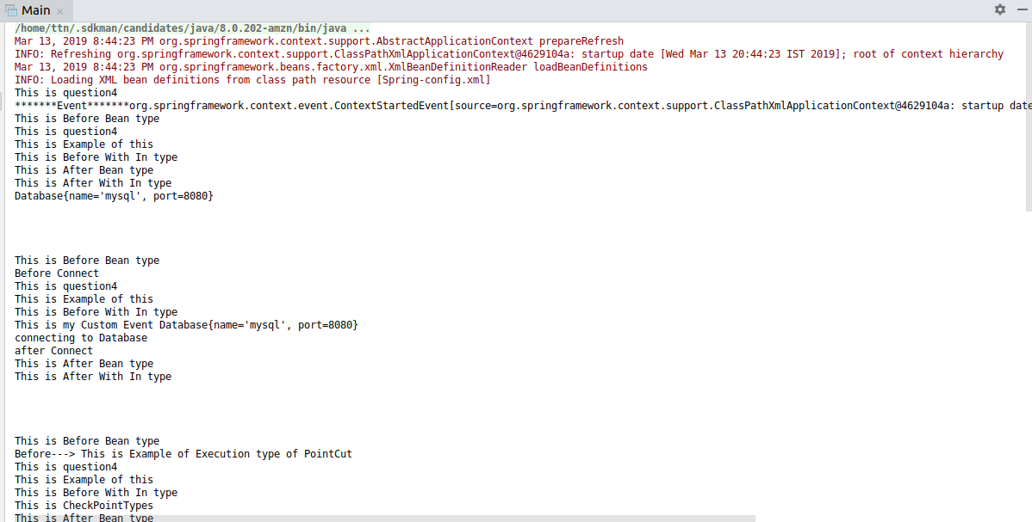
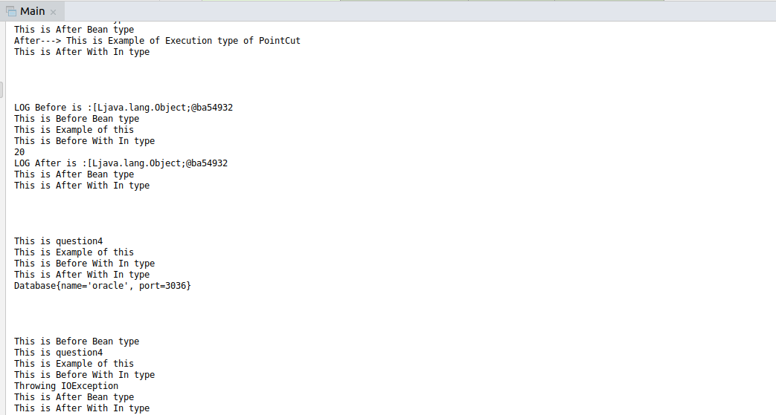
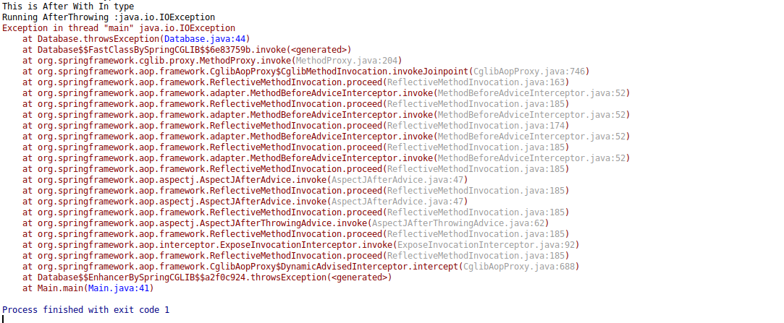

Question 8 : Demonstrate the use of pointCut @Pointcut annotation and Reuse the expression created
Answer 8 :
LoggingAspect.java
@Pointcut("bean(database)")
void pointCutBean() { }
@Before("pointCutBean()")
void beanType() {
System.out.println("This is Before Bean type");
}
@After("pointCutBean()")
void beanType1() {
System.out.println("This is After Bean type");
}
Main.java
import org.springframework.context.ApplicationContext;
import org.springframework.context.ConfigurableApplicationContext;
import org.springframework.context.support.ClassPathXmlApplicationContext;
import java.io.IOException;
public class Main {
public static void main(String[] args) throws IOException {
ConfigurableApplicationContext ctx=new ClassPathXmlApplicationContext("Spring-config.xml");
ctx.start();
Database database=(Database) ctx.getBean("database");
System.out.println(database);
ctx.stop();
System.out.println("\n");
database.connect();
System.out.println("\n");
database.checkPointcutTypes();
System.out.println("\n");
database.argsMethod(20);
System.out.println("\n");
System.out.println(ctx.getBean("database1"));

System.out.println("\n");
database.throwsException();
ctx.stop();
}
}

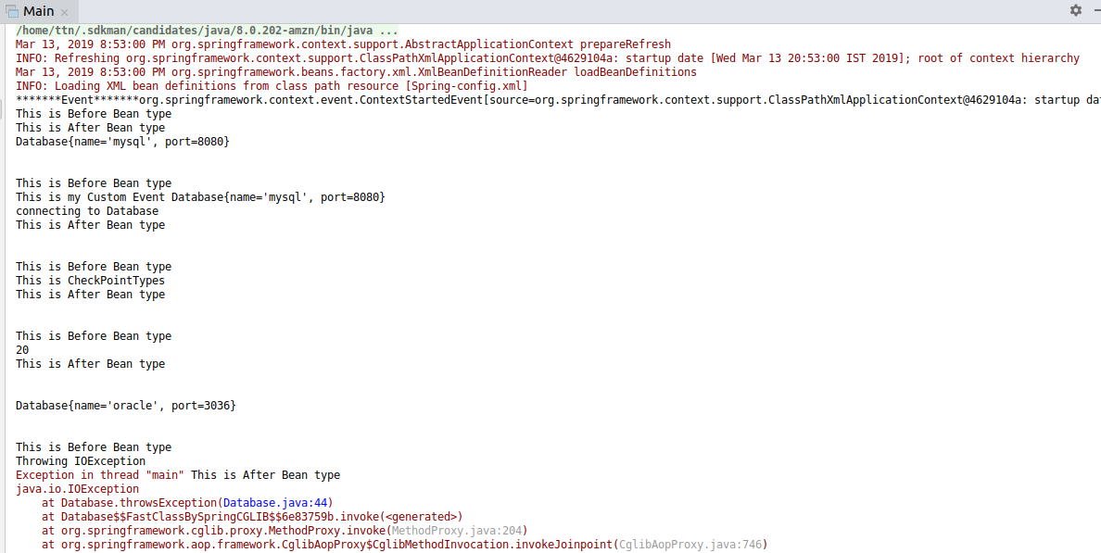

Question 9 : Access the properties of the JoinPoint in before advice. Print Signature of method being called and its arguments
Answer 9 :
LoggingAspect.java
package aop;
import org.aspectj.lang.JoinPoint;
import org.aspectj.lang.annotation.*;
@Aspect
public class LoggingAspect {

@Before("execution(void agsMethod1(Integer,Integer))")
void beforeAdvice(JoinPoint joinPoint){
System.out.println("Running Before");
System.out.println(joinPoint);
System.out.println(joinPoint.getThis());
System.out.println(joinPoint.getSignature());
Object[] object=joinPoint.getArgs();
for(Object o: object){
System.out.println(o);
}
}
}

Main.java

import org.springframework.context.ApplicationContext;
import org.springframework.context.ConfigurableApplicationContext;
import org.springframework.context.support.ClassPathXmlApplicationContext;
import java.io.IOException;
public class Main {
public static void main(String[] args) throws IOException {
ConfigurableApplicationContext ctx=new ClassPathXmlApplicationContext("Spring-config.xml");
ctx.start();
Database database=(Database) ctx.getBean("database");
System.out.println(database);
ctx.stop();
System.out.println("\n");
database.connect();
System.out.println("\n");
database.checkPointcutTypes();
System.out.println("\n");
database.argsMethod(20);
System.out.println("\n");
System.out.println(ctx.getBean("database1"));
System.out.println("\n");
System.out.println("\n");
database.argsMethod1(20,20);
System.out.println("\n");
database.throwsException();
ctx.stop();
// ctx.close();
}
}

Database.java

import org.springframework.context.ApplicationEventPublisher;
import org.springframework.context.ApplicationEventPublisherAware;
import java.io.IOException;
public class Database implements ApplicationEventPublisherAware {
private String name;
private int port;
public String getName() {
return name;
}
public void setName(String name) {
this.name = name;
}
public int getPort() {
return port;
}
public void setPort(int port) {
this.port = port;
}
@Override
public String toString() {
return "Database{" +
"name='" + name + '\'' +
", port=" + port +
'}';
}
ApplicationEventPublisher applicationEventPublisher;
public void connect() {
MyCustomEvent myCustomEvent = new MyCustomEvent(this);
applicationEventPublisher.publishEvent(myCustomEvent);
System.out.println("connecting to Database");
}
public void throwsException() throws IOException {
System.out.println("Throwing IOException ");
throw new IOException();
}
public void checkPointcutTypes() {
System.out.println("This is CheckPointTypes");
}
public void argsMethod(Integer a){
System.out.println(a);
}
public void argsMethod1(Integer a,Integer b){
System.out.println(a);
System.out.println(b);
}
@Override
public void setApplicationEventPublisher(ApplicationEventPublisher applicationEventPublisher) {
this.applicationEventPublisher = applicationEventPublisher;
}
}

