Question 1 : Create a class Database with 2 instance variables port and name. Configure Database class bean in spring container through Spring XML. Initialize instance variables using setter method.
Answer 1 :
Spring-config.xml
<bean id="database" class="Database">
<property name="name" value="Mysql"/>
<property name="port" value="8080"/>
</bean>
Database.class
public class Database {
private int port;
private String name;
public String getName() {
return name;
}
public int getPort() {
return port;
}
public void setPort(int port) {
this.port = port;
}
public void setName(String name) {
this.name = name;
}
@Override
public String toString() {
return "Database{" +
"port=" + port +
", name='" + name + '\'' +
'}';
}
}

Question 2: Get the bean of the class from spring container and print the values of the instance variable.
Answer 2: Spring-Main.class
import org.springframework.context.ApplicationContext;
import org.springframework.context.support.ClassPathXmlApplicationContext;
public class SpringMain {
public static void main(String[] args) {
ApplicationContext ctx=new ClassPathXmlApplicationContext("Spring-config.xml");
System.out.println(ctx.getBean("database"));
}
}
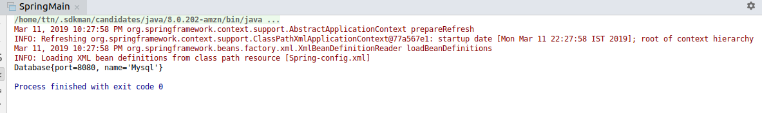

Question 3 : Create a class Restaurant. Create an interface HotDrink with an abstract method prepareHotDrink. Create two classes Tea and ExpressTea which implements HotDrink Class. Create an instance variable of type HotDrink in Restaurant class. Configure Tea and ExpressTea classes beans in Spring XML. create a bean with the name teaRestaurant of type Restaurant which inject Tea object as dependency using setter method.
Answer 3 :
Restaurant.java
package question2;
public class Restaurant {
HotDrink hotDrink;
public Restaurant() {
}
public Restaurant(HotDrink hotDrink) {
this.hotDrink = hotDrink;
}
public HotDrink getHotDrink() {
return hotDrink;
}
public void setHotDrink(HotDrink hotDrink) {
this.hotDrink = hotDrink;
}
@Override
public String toString() {
return "Restaurant{" +
"hotDrink=" + hotDrink.prepareHotDrink() +
'}';
}
}
Tea.java
package question2;
public class Tea implements HotDrink {
@Override
public String prepareHotDrink() {
return "Tea is ready for you";
}
}
ExpressTea.java
package question2;
public class ExpressTea implements HotDrink{
@Override
public String prepareHotDrink() {
return "Express Tea is ready";
}
}
Interface
package question2;
public interface HotDrink {
String prepareHotDrink();
}
Spring-config.xml
<bean id="tea" class="question2.Tea"/>
<bean id="expresstea" class="question2.ExpressTea" primary="true"/>

<bean id="teaRestaurant" class="question2.Restaurant">
<property name="hotDrink" ref="tea"/>
</bean>
Main.java
ApplicationContext ctx = new ClassPathXmlApplicationContext("Spring-config.xml");
Restaurant restaurant=(Restaurant) ctx.getBean("teaRestaurant");
System.out.println(restaurant);
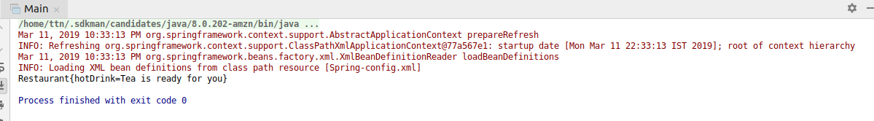

Question 3 :Get both the beans and invoke prepareHotDrink method via hotDrink instance variables. Try inner bean with expressTeaRestaurant.
Answer 3 :
Spring-config.xml
<bean id="teaExpressRestaurant" class="question2.Restaurant">
<property name="hotDrink">
<bean class="question2.ExpressTea"/>
</property>
</bean>
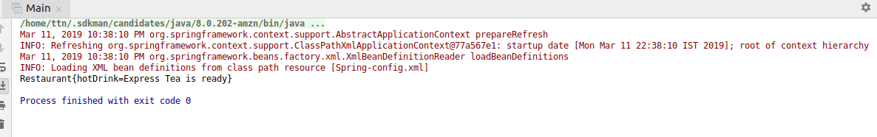
Main.java
Restaurant restaurant1=(Restaurant) ctx.getBean("teaExpressRestaurant");
System.out.println(restaurant1);

Question 5 :Create Class Complex as follows:
class complex {
List list;
Set set;
Map map;
} Initialize all the instance variables of the complex class using Spring XML. Give bean name as complexBean. Get the bean and display the properties.
Answer 5 :
Spring-config.xml
<bean id="complexBean" class="question5.Complex">
<property name="list">
<list>
<value>Value 1</value>
<value>Value 2</value>
<value>Value 3</value>
</list>
</property>
<property name="set">
<set>
<value>A</value>
<value>B</value>
<value>C</value>
<value>A</value>
</set>
</property>
<property name="map">
<map>
<entry key="1" value="Shivam"/>
<entry key="2" value="Sumit"/>
<entry key="3" value="Abhinav"/>
</map>
</property>
</bean>
Main.java
System.out.println(ctx.getBean("complexBean"));
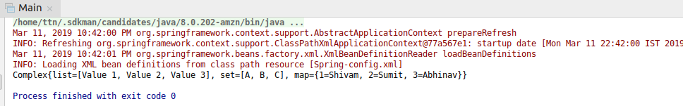

Question 6 : Autowire hotDrink in Restaurant with tea bean byName, byType and constructor.
Answer 6 :
Spring-config.xml
<bean id="hotDrink" class="question2.Tea"/>
<bean id="prepareHotDrink" class="question2.Restaurant" autowire="byName"/>

<bean id="expressTea1" class="question2.ExpressTea"/>
<bean id="prepareHotDrink1" class="question2.Restaurant" autowire="byType"/>

<bean id="expressTea2" class="question2.ExpressTea"/>
<bean id="prepareHotDrink2" class="question2.Restaurant" autowire="constructor"/>
Main.java
Restaurant restaurant2=(Restaurant) ctx.getBean("prepareHotDrink");
System.out.println("This is through ByName "+ restaurant2);
Restaurant restaurant3=(Restaurant) ctx.getBean("prepareHotDrink1");
System.out.println("This is through ByType "+ restaurant3);
Restaurant restaurant4=(Restaurant) ctx.getBean("prepareHotDrink2");
System.out.println("This is through ByConstructor "+ restaurant4);

Question 7 :Set the scope of the teaRestaurant bean as proptotype and check the scope type after accessing the bean.
Answer 7 :
Spring-config.xml
<bean id="expressTea7" class="question2.ExpressTea" scope="prototype"/>
<bean id="ExpressTeaRestaurant" class="question2.Restaurant">
<property name="hotDrink" ref="expressTea7"/>
</bean>
<bean id="ExpressTeaRestaurant1" class="question2.Restaurant">
<property name="hotDrink" ref="expressTea7"/>
</bean>
Main.java
Restaurant restaurant5=(Restaurant)ctx.getBean("ExpressTeaRestaurant");
System.out.println(restaurant5.hotDrink);
Restaurant restaurant6=(Restaurant)ctx.getBean("ExpressTeaRestaurant1");
System.out.println(restaurant6.hotDrink);
Output ----->

Question 8 :Use @Required annotation for hotDrink setter method in Restaurant class.
Answer 8 :
package question2;
import org.springframework.beans.factory.annotation.Autowired;
import org.springframework.beans.factory.annotation.Required;
public class Restaurant {
@Autowired
HotDrink hotDrink;
public Restaurant(){
}
public Restaurant(HotDrink hotDrink) {
this.hotDrink = hotDrink;
}
public HotDrink getHotDrink() {
return hotDrink;
}
@Required
public void setHotDrink(HotDrink hotDrink) {
this.hotDrink = hotDrink;
}
@Override
public String toString() {
return "Restaurant{" +
"hotDrink=" + hotDrink.prepareHotDrink() +
'}';
}
}

Question 9 : Use @Autowired annotation to wire Tea with Restaurant class Using setter method, field and constructor.
Answer 9 :
package question2;
import org.springframework.beans.factory.annotation.Autowired;
import org.springframework.beans.factory.annotation.Required;
import org.springframework.stereotype.Component;
@Component
public class Restaurant {
@Autowired
HotDrink hotDrink;
public Restaurant(){
}
@Autowired
public Restaurant(HotDrink hotDrink) {
this.hotDrink = hotDrink;
}
public HotDrink getHotDrink() {
return hotDrink;
}
@Autowired
public void setHotDrink(HotDrink hotDrink) {
this.hotDrink = hotDrink;
}
@Override
public String toString() {
return "Restaurant{" +
"hotDrink=" + hotDrink.prepareHotDrink() +
'}';
}
}

Question 10 :Use @Component, @Controller, @Repository etc annotation to configure Tea and Restaurant in Spring Container.
Answer 10 :
Restaurant.java
package question2;
import org.springframework.beans.factory.annotation.Autowired;
import org.springframework.beans.factory.annotation.Required;
import org.springframework.stereotype.Component;
@Component
public class Restaurant {
@Autowired
HotDrink hotDrink;
public Restaurant(){
}
@Autowired
public Restaurant(HotDrink hotDrink) {
this.hotDrink = hotDrink;
}
public HotDrink getHotDrink() {
return hotDrink;
}
@Autowired
public void setHotDrink(HotDrink hotDrink) {
this.hotDrink = hotDrink;
}
@Override
public String toString() {
return "Restaurant{" +
"hotDrink=" + hotDrink.prepareHotDrink() +
'}';
}
}
Spring-config.xml
<!--Question 8-->
<context:annotation-config/>
<context:component-scan base-package="question2"/>

