Question 1 :Create an external JS file and use it to show an alert on click of a button.
Answer 1 :
TestController.java
package com.ttn.thymeleaf.SpringThymeleaf.controller;
import org.springframework.stereotype.Controller;
import org.springframework.ui.Model;
import org.springframework.web.bind.annotation.RequestMapping;
import org.springframework.web.bind.annotation.RequestMethod;
import javax.servlet.http.HttpServletRequest;
import javax.servlet.http.HttpServletResponse;
@Controller
public class TestController {
/*Question 1*/
@RequestMapping(value = "/js",method = RequestMethod.GET)
public String showAlert(){
return "showalert";
}
}
showalert.html
<!DOCTYPE html>
<html lang="en" xmlns:th="http://www.thymleaf.org">
<head>
<meta charset="UTF-8">
<title>Title</title>
</head>
<body>
<script th:src="@{'/js/showalert.js'}"></script>
<form>
<input type="button" value="Click Me" onclick="show_alert()">
</form>
</body>
</html>
showalert.js
function show_alert(){
alert("This is alert");
}
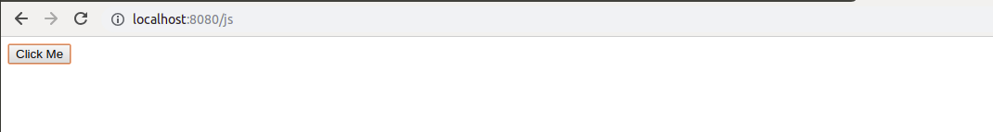
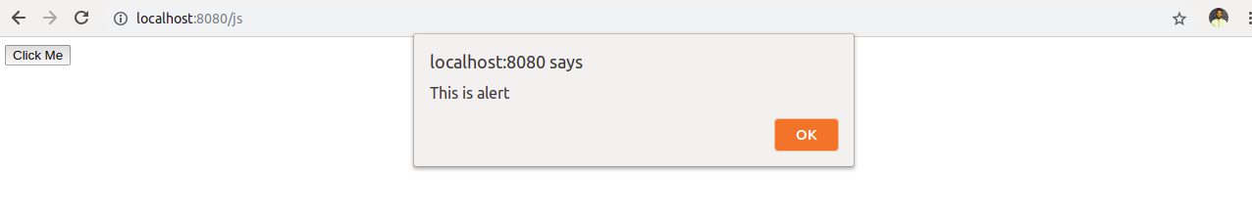
Question 2 :Create an external CSS file and use it to modify hello world page background color to grey.
Answer 2 :
TestController.java
package com.ttn.thymeleaf.SpringThymeleaf.controller;
import org.springframework.stereotype.Controller;
import org.springframework.ui.Model;
import org.springframework.web.bind.annotation.RequestMapping;
import org.springframework.web.bind.annotation.RequestMethod;
import javax.servlet.http.HttpServletRequest;
import javax.servlet.http.HttpServletResponse;
@Controller
public class TestController {
/*Question 2*/
@RequestMapping(value = "/css",method = RequestMethod.GET)
public String showCss(){
return "showcss";
}
}
showcss.html
<!DOCTYPE html>
<html lang="en" xmlns:th="http://www.thymleaf.org">
<head>
<meta charset="UTF-8">
<title>question 2</title>
<link th:href="@{/css/changebackgroundcolor.css}" rel="stylesheet"/>
</head>
<body>
<h1>Hello World</h1>
</body>
</html>
changebackgroundcolor.css
body{
background-color: grey;
}
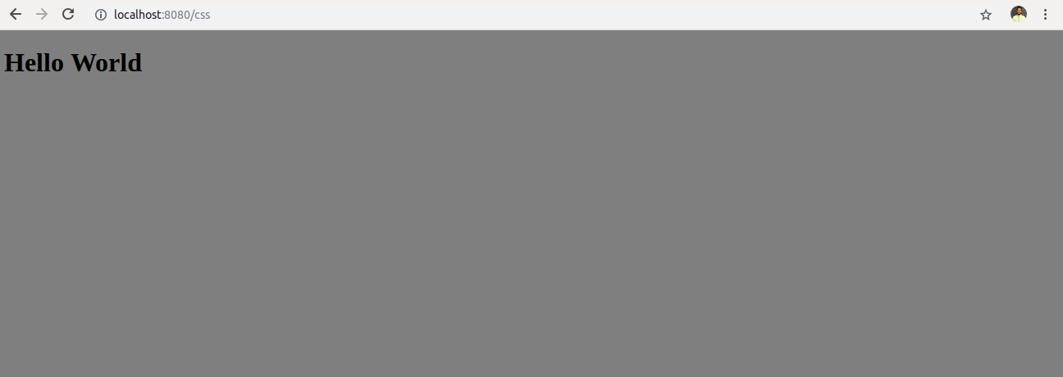
Question 3 :Create an Employee registration form and bind it's requested values on the controller.
Answer 3 :
TestController.java
package com.ttn.thymeleaf.SpringThymeleaf.controller;
import org.springframework.stereotype.Controller;
import org.springframework.ui.Model;
import org.springframework.web.bind.annotation.RequestMapping;
import org.springframework.web.bind.annotation.RequestMethod;
import javax.servlet.http.HttpServletRequest;
@Controller
public class TestController {
/*Question 3*/
@RequestMapping(value = "/showEmployee",method = RequestMethod.POST)
public String showRegisteredData(HttpServletRequest request, Model model){
String name=request.getParameter("name");
int age=Integer.parseInt(request.getParameter("age"));
model.addAttribute("name",name);
model.addAttribute("age",age);
return "showRegisteredEmployee";
}
@RequestMapping(value = "/showEmployee",method = RequestMethod.GET)
public String sayHElloForm(){
return "employeeregistration";
}
}
employeeregistartion.html
<!Doctype html>
<html lang="en" xmlns:th="http://www.thymleaf.org">
<body>
<form method="post">
Name :<input type="text" name="name">
Age :<input type="text" name="age">
<input type="submit" value="Submit">
</form>
</body>
</html>
showRegisteredEmployee.html
<!DOCTYPE html>
<html lang="en" xmlns:th="http://www.thymleaf.org">
<head>
<meta charset="UTF-8">
<title>Title</title>
</head>
<body>
<h1 th:text="${name}"></h1>
<h1 th:text="${age}"></h1>
</body>
</html>
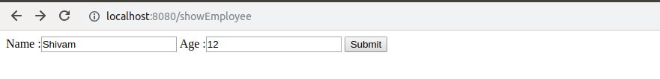
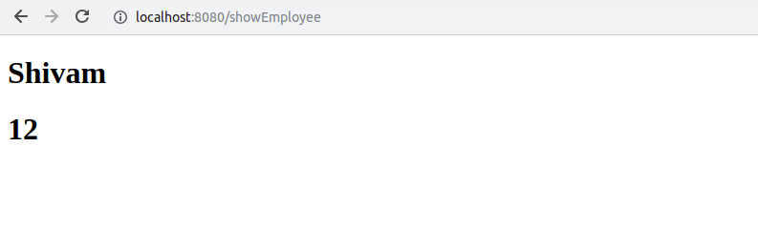

Question 4 :Create a dynamic HTML page and render an Employee table with emp object return from the controller
Answer 4 :
TestController.java
package com.ttn.thymeleaf.SpringThymeleaf.controller;
import com.ttn.thymeleaf.SpringThymeleaf.Employee;
import org.springframework.stereotype.Controller;
import org.springframework.ui.Model;
import org.springframework.web.bind.annotation.RequestMapping;
import org.springframework.web.bind.annotation.RequestMethod;
import javax.servlet.http.HttpServletRequest;
import java.util.Arrays;
import java.util.List;
@Controller
public class TestController {
/*Question 4*/
@RequestMapping(value = "/employee",method = RequestMethod.GET)
public String showEmployee(Model model){
List<Employee> employeeList= Arrays.asList(new Employee("Shivam","Saxena",21),
new Employee("Vineet","Chaudary",23));
model.addAttribute("employee",employeeList);
return "showEmployee";
}
}
Employee.java
package com.ttn.thymeleaf.SpringThymeleaf;
public class Employee {
private String firstName;
private String lastName;
private int age;
public Employee(String firstName, String lastName, int age) {
this.firstName = firstName;
this.lastName = lastName;
this.age = age;
}
public String getFirstName() {
return firstName;
}
public void setFirstName(String firstName) {
this.firstName = firstName;
}
public String getLastName() {
return lastName;
}
public void setLastName(String lastName) {
this.lastName = lastName;
}
public int getAge() {
return age;
}
public void setAge(int age) {
this.age = age;
}
}
showEmployee.html
<!DOCTYPE html>
<html lang="en" xmlns:th="http://www.thymleaf.org">
<head>
<meta charset="UTF-8">
<title>Title</title>
</head>
<body>
<table>
<tr>
<td>FirstName</td>
<td>LastName</td>
<td>age</td>
</tr>
<tr th:each="empl : ${employee}">
<td th:text="${empl.firstName}"></td>
<td th:text="${empl.lastName}"></td>
<td th:text="${empl.age}"></td>
</tr>
</table>
</body>
</html>
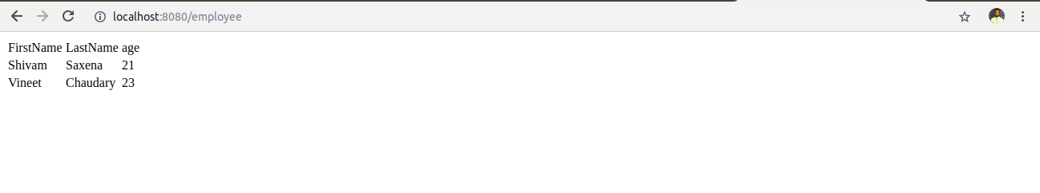

Question 5 :Show different custom greeting message based on the type of user. For example, if the user is of type admin=true then show "Hello Admin" message on Page else show "Hello User" basis on isAdmin attribute value passed in model data.
Answer 5 :
TestController.java
package com.ttn.thymeleaf.SpringThymeleaf.controller;
import com.ttn.thymeleaf.SpringThymeleaf.Employee;
import org.springframework.stereotype.Controller;
import org.springframework.ui.Model;
import org.springframework.web.bind.annotation.RequestMapping;
import org.springframework.web.bind.annotation.RequestMethod;
import javax.servlet.http.HttpServletRequest;
import java.util.Arrays;
import java.util.List;
@Controller
public class TestController {
/*Question 5*/
@RequestMapping(value = "/checkAdmin" ,method = RequestMethod.POST)
public String isAdmin(HttpServletRequest request,Model model){
String value=request.getParameter("admin");
model.addAttribute("isAdmin",value);
return "checkadmin";
}
@RequestMapping(value = "/checkAdmin",method = RequestMethod.GET)
public String passAdminValue(){
return "formToCheckAdmin";
}
}
formToCheckAdmin.html
<!DOCTYPE html>
<html lang="en" xmlns:th="http://www.thymleaf.org">
<head>
<meta charset="UTF-8">
<title>Title</title>
</head>
<body>
<form method="post">
<input type="text" name="admin"><br/>
<input type="submit" value="submit">
</form>
</body>
</html>

checkAdmin.html
<!DOCTYPE html>
<html lang="en" xmlns:th="http://www.thymleaf.org">
<head>
<meta charset="UTF-8">
<title>Title</title>
</head>
<body th:with="var=${isAdmin}">
<div th:if="${var=='admin'}">
Hello Admin
</div>
<div th:if="${var!='admin'}">
Hello User
</div>
</body>
</html>
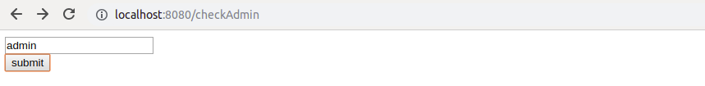
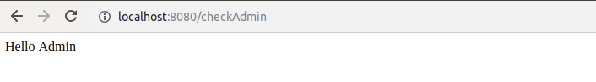

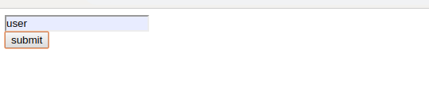
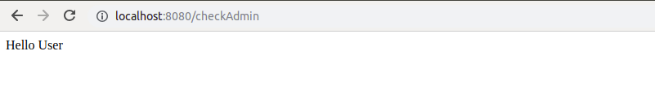

Question 6 :Create and split common header and footer in the above-created listing page.
Answer 6 :
TestController.java
@RequestMapping(value = "/headerandfooter" ,method = RequestMethod.GET)
public String headerAndFooter(){
return "footer";
}
footer.html
<!DOCTYPE html>
<html lang="en" xmlns:th="http://www.thymleaf.org">
<body>
<div th:replace="headerAndFooter :: header"></div>
<div th:replace="headerAndFooter :: footer"></div>
</body>
</html>
headerAndFooter.html
<!DOCTYPE html>
<html lang="en" xmlns:th="http://www.thymleaf.org">
<head>
<title>Header and footer</title>
</head>
<body>
<div th:fragment="header" class="header">
This is header
</div>
<div th:fragment="footer" class="footer">
copyright Shivam: 2019
</div>
</body>
</html>
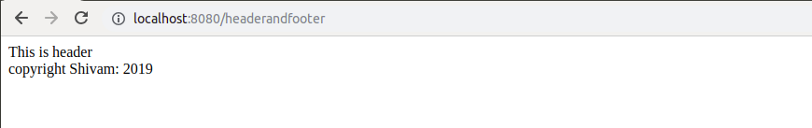

Question 7 :Make a web page to show server time using ajax call.
Answer 7 :
TestController.java
@RequestMapping(value = "/showtime")
public String showTime(){
return "ajaxtime";
}
@RequestMapping(value = "/getTime" ,method = RequestMethod.GET )
@ResponseBody
public String getTime(){
return new Date().toLocaleString();
}
showtime.js
$(document).ready(function () {
var time = $.ajax({
url: "/getTime",
method: "GET"
});
time.done(function (data) {
$('#time').append(data)
});
time.fail(function (jqXHR, textStatus) {
console.log("Error in fetching time");
})
});
ajaxtime.html
<!DOCTYPE html>
<html lang="en" xmlns:th="http://www.thymleaf.org">
<head>
<meta charset="UTF-8">
<title>AJax</title>
<script
src="https://code.jquery.com/jquery-3.3.1.min.js"
integrity="sha256-FgpCb/KJQlLNfOu91ta32o/NMZxltwRo8QtmkMRdAu8="
crossorigin="anonymous"></script>
<script th:src="@{'/js/showtime.js'}"></script>
</head>
<body>
<p id="time"></p>
</body>
</html>
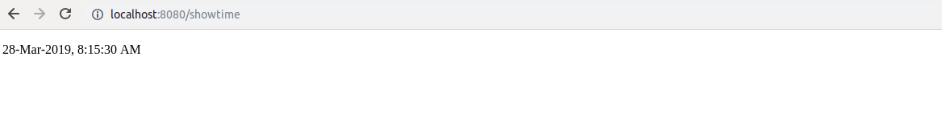
Question 8 :Create a user listing table show alternate row color using a conditional tag.
Answer 8 :
testController.java
/*Question 8*/
@RequestMapping(value = "/condition" ,method = RequestMethod.GET)
public String conditionalTag(){
return "conditionalTag";
}
conditionTag.html
<!DOCTYPE html>
<html lang="en" xmlns:th="http://www.w3.org/1999/xhtml">
<head>
<meta charset="UTF-8">
<title>Conditional Tag</title>
</head>
<body th:with="var=${({1,2,3})}">
<table>
<tr th:each="prod, iterStat : ${var}" class="row" th:classappend="${iterStat.odd}? 'odd':'even'">
<td th:text="${prod}">.</td>
</tr>
</table>
<link rel="stylesheet" th:href="@{/css/changeColumnColor.css}">
</body>
</html>
changeColumnColor.css
tr.row.odd{
background-color: red;
}

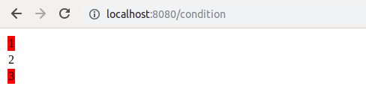

Question 9 :Create an ENUM with values USER, ADMIN, SUPER_ADMIN and iterate it to show a custom message to users basis on the ENUM value
Answer 9 :
TestController.java
@RequestMapping(value = "/showEnums",method = RequestMethod.GET)
public String showEnums(){
return "getEnum";
}
Users.java
package com.ttn.thymeleaf.SpringThymeleaf.enums;
public enum Users {
User("This is user"),
Admin("This is admin"),
Super_Admin("This is super admin");
String value;
Users(String users){
value=users;
}
public String getValue(){
return value;
}
}
getEnum.html
<!DOCTYPE html>
<html lang="en" xmlns:th="http://www.w3.org/1999/xhtml">
<head>
<meta charset="UTF-8">
<title>Enum</title>
</head>
<body>
<label>Users</label>
<select>
<option th:value="None">Select One</option>
<option th:each="users:${T(com.ttn.thymeleaf.SpringThymeleaf.enums.Users).values()}"
th:value="${users.getValue()}" th:text="${users.getValue()}"></option>
</select>
</body>
</html>
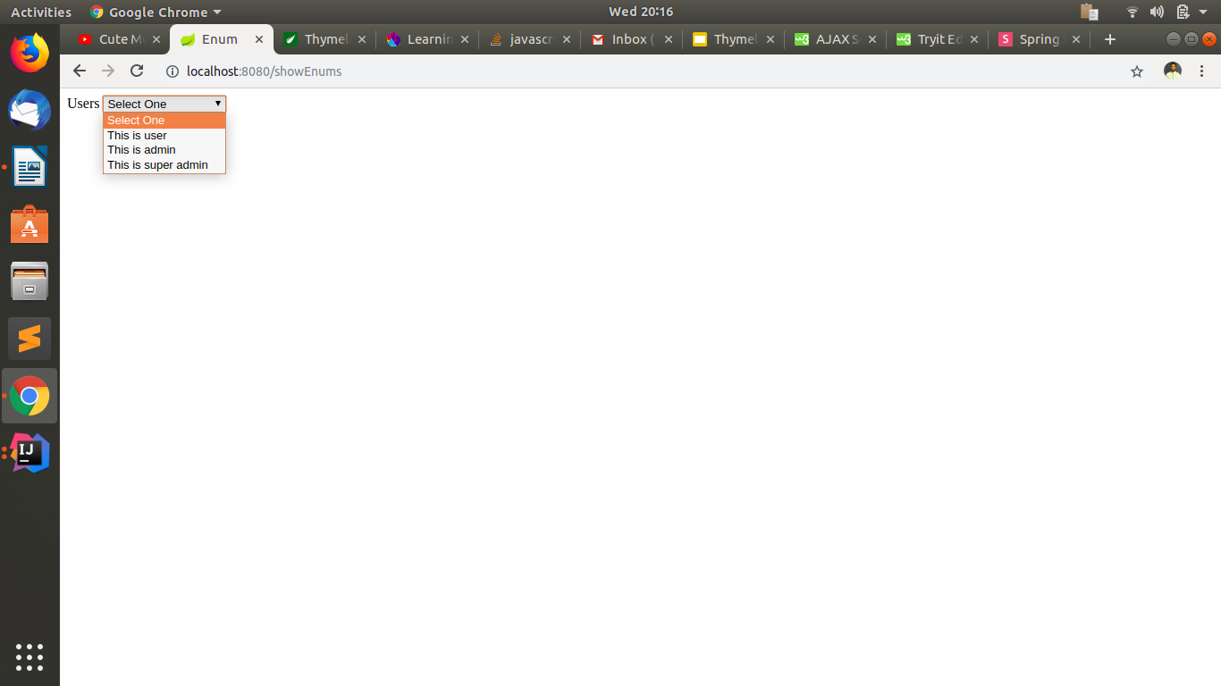

Question 10 :Add loader in registration form submission which renders load till server return success form submission response.
Answer 10 :
TestController.java
@RequestMapping(value = "/showLoader")
public String showLoader(){
return "registration";
}
@PostMapping("/registrationSubmit")
@ResponseBody
public String registerEmployee(@ModelAttribute Employee employee)
{
try {
Thread.sleep(1000);
} catch (InterruptedException e) {
e.printStackTrace();
}
return "Registered: "+employee.getName()+"\n";
}
registration.html
<!DOCTYPE html>
<html lang="en" xmlns:th="http://www.thymeleaf.org">
<head>
<meta charset="UTF-8">
<script
src="https://code.jquery.com/jquery-3.3.1.min.js"
integrity="sha256-FgpCb/KJQlLNfOu91ta32o/NMZxltwRo8QtmkMRdAu8="
crossorigin="anonymous"></script>
<title>Employee Registration Form</title>
<script th:src="@{/js/showLoader.js}"></script>
<script type="text/javascript">
$(function(){
$("#LoadingImage").hide();
$("#employeeRegitsrationForm").on('submit',function(){
var data=$("#employeeRegitsrationForm").serialize();
showImage(data);
return false;
})
$(document).ajaxStart(function () {
$("#LoadingImage").show();
})
})
</script>
</head>
<body>
<form id="employeeRegitsrationForm" method="post">
Name :<input type="text" id="name" name="name">
Age :<input type="text" id="age" name="age">
<input type="submit" value="Submit">
</form>
<p id="response"></p>
<div id="LoadingImage">
<img src="images/loader.gif"/>
</div>
</body>
</html>
showLoader.js
function showImage(formData)
{
var res= $.ajax({
method: "POST",
url: "/registrationSubmit",
data: formData,
success: function (data) {
console.log(data)
$("#LoadingImage").hide();
$("#response").append("Response "+data);
console.log("Successful Registration");
},
error: function (xhr, status) {
$("#LoadingImage").hide();
alert('Unknown error ' + status);
}
});


