Question 1 :Write the following a functional interface and implement it using lambda:
(1) First number is greater than second number or not Parameter (int ,int ) Return boolean
(2) Increment the number by 1 and return incremented value Parameter (int) Return int
(3) Concatination of 2 string Parameter (String , String ) Return (String)
(4) Convert a string to uppercase and return Parameter (String) Return (String)
Answer 1 :
package Questions.question1;
interface CheckNumber{
boolean greatestNumber(int a,int b);
}
interface IncrementNumber{
int incrementedNumberBy1(int a);
}
interface ConcatString{
String concatedString(String str1,String str2);
}
interface ToUppercase{
String stringToUppercase(String str);
}
public class LambdaImplementation {
public static void main(String[] args) {
CheckNumber checkNumber=(a,b)-> (a>b)?true : false;
IncrementNumber incrementNumber=(a)->a+1;
ConcatString concatString=(a,b)->a+b;
ToUppercase toUppercase=(a)->a.toUpperCase();
System.out.println("First Number is greatest Number or not --->"+checkNumber.greatestNumber(3,2));
System.out.println("Increment 4 by 1 "+incrementNumber.incrementedNumberBy1(4));
System.out.println("Concated String is "+concatString.concatedString("Shivam","Saxena"));
System.out.println("Uppercase String is "+toUppercase.stringToUppercase("shivam"));
}
}
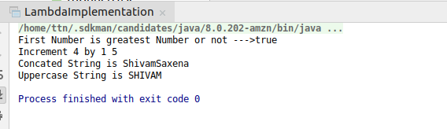

Question 2. Create a functional interface whose method takes 2 integers and return one integer.
Answer 2. package Questions.question2;
@FunctionalInterface
public interface FunctionalInterfaceExample {
int performOperation(int a,int b);
}

Question 3 :Using (instance) Method reference create and apply add and subtract method and using (Static) Method reference create and apply multiplication method for the functional interface created.
Answer 3 :
package Questions.question3;
import Questions.question2.FunctionalInterfaceExample;
public class MethodReferenceExample {
int add(int a,int b){
return(a+b);
}
int sub(int a, int b){
return a-b;
}
static int multiply(int z,int q){
return z*q;
}
public static void main(String[] args) {
FunctionalInterfaceExample myjob=MethodReferenceExample::multiply;
int mul=myjob.performOperation(2,4);
System.out.println("multiply of 2 and 4 is : "+mul);
FunctionalInterfaceExample instancemethod=new MethodReferenceExample()::add;
int addition=instancemethod.performOperation(1,2);
System.out.println("Addition of 1 and 2 is : "+addition);
FunctionalInterfaceExample instancemethodadd=new MethodReferenceExample()::sub;
int substract=instancemethodadd.performOperation(23,2);
System.out.println("Substraction of 23 and 2 is : "+substract);
}
}
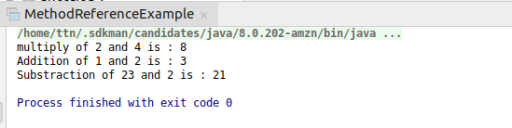

Question 4 :Create an Employee Class with instance variables (String) name, (Integer)age, (String)city and get the instance of the Class using constructor reference
Answer 4 :
package Questions.question4;
@FunctionalInterface
interface GetEmployee{
Employee getEmployeeInfo(String name,Integer age,String city);
}
public class Employee {
String name;
Integer age;
String city;
@Override
public String toString() {
return "Employee{" +
"name='" + name + '\'' +
", age=" + age +
", city='" + city + '\'' +
'}';
}
public Employee(String n, Integer a, String c){
this.name=n;
this.age=a;
this.city=c;
}
public static void main(String[] args) {
GetEmployee getEmployee= Employee::new;
System.out.println(getEmployee.getEmployeeInfo("Shivam",21,"Agra"));
}
}
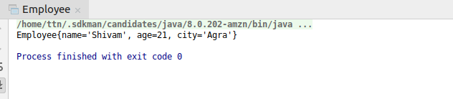

Question 5 : Implement following functional interfaces from java.util.function using lambdas:
(1) Consumer
(2) Supplier
(3) Predicate
(4) Function
Answer 5 :
(1) package Questions.question5;
import java.util.function.Consumer;
public class ConsumerExample {
public static void main(String[] args) {
Consumer consumer=(e)->System.out.println(e);
consumer.accept(2);
}
}
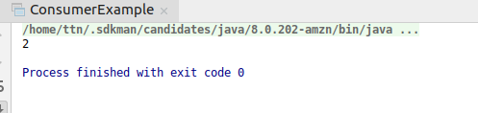
(2)package Questions.question5;
import java.util.function.Supplier;
public class SupplierExample {
public static void main(String[] args) {
Supplier supplier=()->10;
System.out.println(supplier.get());
}
}
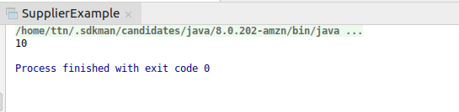

(3)package Questions.question5;
import java.util.function.Predicate;
public class PredicateExample {
public static void main(String[] args) {
Predicate<Integer> predicate=(e)-> e%2==0;
System.out.println(predicate.test(12));
}
}
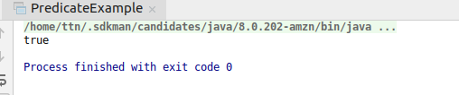
(4)package Questions.question5;
import java.util.Arrays;
import java.util.List;
import java.util.function.Function;
public class FunctionExample {
public static void main(String[] args) {
Function<Integer,Integer> function=e->e+3;
System.out.println(function.apply(1));
}
}
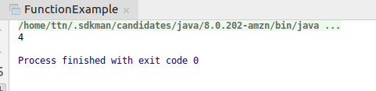

Question 6: Create and access default and static method of an interface.
Answer 6: package Questions.question6;
import Questions.question3.MethodReferenceExample;
interface OperationPerform{
static void staticMember(){
System.out.println("this is a static method");
}
default void defaultMethod(){
System.out.println("Default Method");
}
}
public class MemberAccessOfInterface implements OperationPerform {
public static void main(String[] args) {
OperationPerform.staticMember();
MemberAccessOfInterface memberAccessOfInterface=new MemberAccessOfInterface();
memberAccessOfInterface.defaultMethod();
}
}
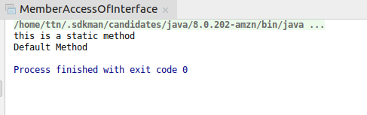

Question 7 : Override the default method of the interface.
Answer 7 :
package Questions.question7;
interface MyJob{
default void defaultMethod(){
System.out.println("this is Default Method");
}
}
public class OverrideDefaultMethod implements MyJob{
public void defaultMethod(){
System.out.println("this is class method");
}
public static void main(String[] args) {
OverrideDefaultMethod overrideDefaultMethod=new OverrideDefaultMethod();
overrideDefaultMethod.defaultMethod();
}
}
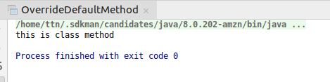

Question 8 :Implement multiple inheritance with default method inside interface.
Answer 8 :
package Questions.question8;
interface Parent {
default void defaultMethod() {
System.out.println("Parent");
}
}
interface child1 extends Parent {
default void defaultMethod() {
System.out.println("child1");
}
}
interface child2 extends Parent{
default void defaultMethod() {
System.out.println("child2");
}
}
public class MultipleInheritanceWithDefaultMethod implements child1, child2 {
@Override
public void defaultMethod() {
child1.super.defaultMethod();
System.out.println("this is class default Method");
}
public static void main(String[] args) {
MultipleInheritanceWithDefaultMethod multipleInheritanceWithDefaultMethod = new MultipleInheritanceWithDefaultMethod();
multipleInheritanceWithDefaultMethod.defaultMethod();
}
}
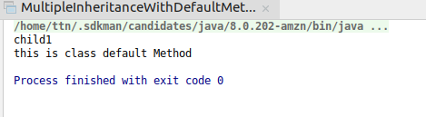

Question 9 : Collect all the even numbers from an integer list.
Answer 9 :
package Questions.question9;
import java.util.ArrayList;
import java.util.Arrays;
import java.util.List;
import java.util.stream.Collectors;
public class CollectEvenNumbers {
public static void main(String[] args) {
List<Integer> list= Arrays.asList(1,2,3,4,5,6,7,8,9,10);
System.out.println(list.stream().filter(e->e%2==0).collect(Collectors.toList()));
}
}
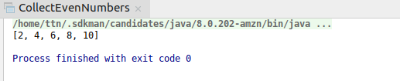

Question 10 :Sum all the numbers greater than 5 in the integer list.
Answer 10 :
package Questions.question10;
import java.util.Arrays;
import java.util.List;
import java.util.stream.Collectors;
public class SumIntegerGreaterThan5 {
public static void main(String[] args) {
List<Integer> list= Arrays.asList(1,2,3,4,5,6,7,8,9,10);
System.out.println(list.stream().filter((e)->e>5).collect(Collectors.summingInt(e->e)));
}
}
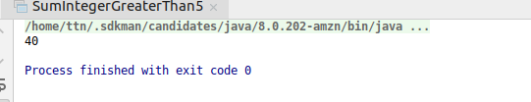

Quetion 11: Find average of the number inside integer list after doubling it.
Answer 11:
package Questions.question11;
import java.util.Arrays;
import java.util.List;
import java.util.stream.Collectors;
public class AverageOfNumber {
public static void main(String[] args) {
List<Integer> list= Arrays.asList(1,2,3,4,5,6,7,8,9,10);
System.out.println(list.stream().collect(Collectors.averagingInt(e->e*2)));
}
}
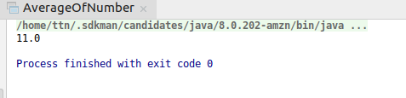

Question 12 : Find the first even number in the integer list which is greater than 3.
Answer 12 : package Questions.question12;
import java.util.Arrays;
import java.util.List;
import java.util.Optional;
import java.util.stream.Collectors;
public class FindEvenNumber {
public static void main(String[] args) {
List<Integer> list= Arrays.asList(1,2,3,4,5,6,7,8,9,10);
Optional optional=list.stream().filter((e)->e>3).filter((e)->e%2==0).findFirst();
if(optional!=null){
System.out.println("Even Value after 3 is : "+optional.get());
}else
System.out.println("value is not Present");
}
}
