Question 1 :Create database springDemo with user table with fields
(a) username
(b) password
(c) name
(d) age
(e) dob
Answer 1 :
for Database
create Database springDemo;
for user Table
create table user (username VARCHAR(100),
password VARCHAR(100), name VARCHAR(100),
age INT, dob DATE);
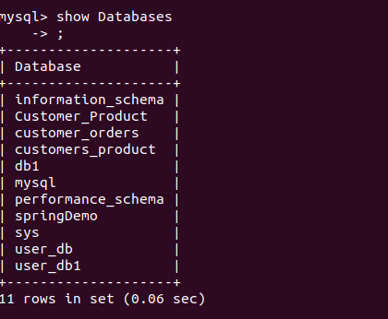

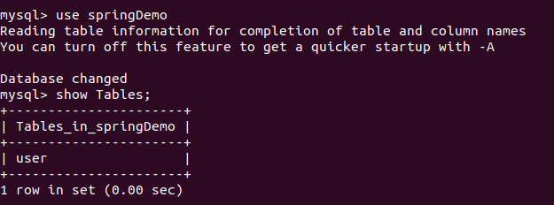

Question 2 :Insert few records inside user Tables
Answer 2 :
insert into user values("shivam","shivam","shivam",20,'1999-09-14');
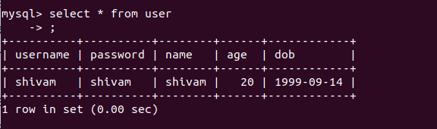

Question 3 :Use datasource with DriverManagerDataSource, dbcp2.BasicDataSource and
Answer 3 :
UserDao.java
package userdao;
import org.springframework.beans.factory.annotation.Autowired;
import org.springframework.stereotype.Service;
import javax.sql.DataSource;
import java.sql.Connection;
import java.sql.PreparedStatement;
import java.sql.ResultSet;
import java.sql.SQLException;

@Service
public class UserDAO {

@Autowired
DataSource dataSource;

@Autowired
DataSource dbcp2datasource;

public void printUserNames() throws SQLException {
Connection connection = dataSource.getConnection();
PreparedStatement preparedStatement = connection.prepareStatement("SELECT * from user");
ResultSet resultSet = preparedStatement.executeQuery();
while (resultSet.next()) {
System.out.println("Name is : " + resultSet.getString("name"));
System.out.println("Password is : " + resultSet.getString("password"));
System.out.println("Age is : " + resultSet.getInt("age"));
System.out.println("DOB is : " + resultSet.getString("dob"));
}
}

public void printUserNamesThroughDbcp2() throws SQLException {
Connection connection=dbcp2datasource.getConnection();
PreparedStatement preparedStatement=connection.prepareStatement("SELECT name,age from user where username='dbcp2'");
ResultSet resultSet=preparedStatement.executeQuery();
while(resultSet.next()){
System.out.println(resultSet.getString("name"));
System.out.println(resultSet.getInt("age"));
}
}
}

Spring-config.xml
<?xml version="1.0" encoding="UTF-8"?>
<beans xmlns="http://www.springframework.org/schema/beans"
xmlns:xsi="http://www.w3.org/2001/XMLSchema-instance"
xmlns:context="http://www.springframework.org/schema/context"
xsi:schemaLocation="http://www.springframework.org/schema/beans http://www.springframework.org/schema/beans/spring-beans.xsd http://www.springframework.org/schema/context http://www.springframework.org/schema/context/spring-context.xsd">

<bean id="dataSource" class="org.springframework.jdbc.datasource.DriverManagerDataSource">
<property name="url" value="jdbc:mysql://localhost:3306/springDemo"/>
<property name="driverClassName" value="com.mysql.jdbc.Driver"/>
<property name="username" value="root"/>
<property name="password" value="Shivamsaxena@1234."/>
</bean>

<bean id="dbcp2datasource" class="org.apache.commons.dbcp2.BasicDataSource">
<property name="url" value="jdbc:mysql://localhost:3306/springDemo"/>
<property name="driverClassName" value="com.mysql.jdbc.Driver"/>
<property name="username" value="root"/>
<property name="password" value="Shivamsaxena@1234."/>
<property name="initialSize" value="2"/>
<property name="maxTotal" value="6"/>
</bean>

<context:annotation-config/>
<context:component-scan base-package="userdao"/>
</beans>
Main.java

import org.springframework.context.ApplicationContext;
import org.springframework.context.support.ClassPathXmlApplicationContext;
import userdao.UserDAO;
import java.sql.*;
public class Main {

public static void main(String[] args) throws SQLException {
ApplicationContext applicationContext= new ClassPathXmlApplicationContext("spring-config.xml");
UserDAO userDAO=applicationContext.getBean(UserDAO.class);
userDAO.printUserNames();
System.out.println("\n");
UserDAO userDAO1=applicationContext.getBean(UserDAO.class);
userDAO1.printUserNamesThroughDbcp2();
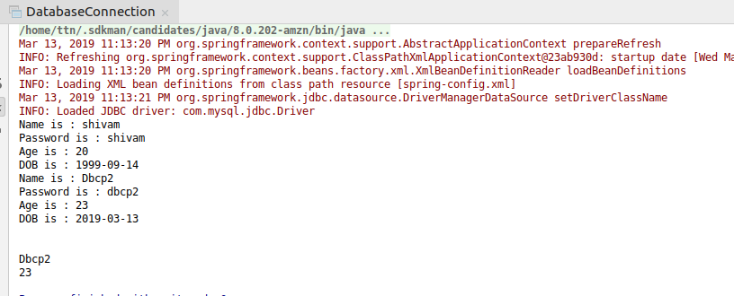
} }
Question 4 : SingleConnectionDataSource to print the records of user tables
Answer 4 :
UserAccessThroughSingleConnectionDatasource.java
package question4;
import org.springframework.beans.factory.annotation.Autowired;
import org.springframework.stereotype.Service;
import javax.sql.DataSource;
import java.sql.*;

@Service
public class UserAccessThroughSingleConnectionDatasource {

@Autowired
DataSource singledataSource;

public void printUserInfoThroughSingleDatasource() throws SQLException {
Connection connection=singledataSource.getConnection();
PreparedStatement preparedStatement= connection.prepareStatement("select * from user");
ResultSet rs=preparedStatement.executeQuery();
while (rs.next()){
System.out.println(rs.getString("name"));
System.out.println(rs.getString("username"));
System.out.println(rs.getInt("age"));
System.out.println(rs.getDate("dob"));
}
}
}
Spring-config.xml
<?xml version="1.0" encoding="UTF-8"?>
<beans xmlns="http://www.springframework.org/schema/beans"
xmlns:xsi="http://www.w3.org/2001/XMLSchema-instance"
xmlns:context="http://www.springframework.org/schema/context"
xsi:schemaLocation="http://www.springframework.org/schema/beans http://www.springframework.org/schema/beans/spring-beans.xsd http://www.springframework.org/schema/context http://www.springframework.org/schema/context/spring-context.xsd">

<!--Question 4-->
<bean id="singledataSource" class="org.springframework.jdbc.datasource.SingleConnectionDataSource">
<property name="url" value="jdbc:mysql://localhost:3306/springDemo"/>
<property name="driverClassName" value="com.mysql.jdbc.Driver"/>
<property name="username" value="root"/>
<property name="password" value="Shivamsaxena@1234."/>
</bean>

<context:annotation-config/>
<context:component-scan base-package="userdao.Question3"/>
<context:component-scan base-package="question4"/>
</beans>

Main.java
import org.springframework.context.ApplicationContext;
import org.springframework.context.support.ClassPathXmlApplicationContext;
import question4.UserAccessThroughSingleConnectionDatasource;
import userdao.Question3.UserDAO;
import java.sql.*;
public class Main {
public static void main(String[] args) throws SQLException {

ApplicationContext applicationContext1=new ClassPathXmlApplicationContext("spring-config.xml");
UserAccessThroughSingleConnectionDatasource userAccessThroughSingleConnectionDatasource=
applicationContext1.getBean(UserAccessThroughSingleConnectionDatasource.class);
userAccessThroughSingleConnectionDatasource.printUserInfoThroughSingleDatasource();
}
}
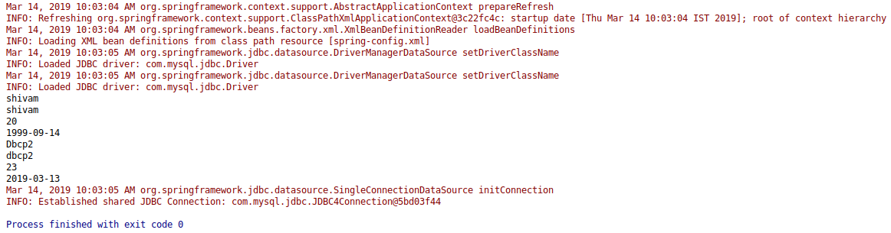

Question 5 : Use JdbcTemplate to get the count of users
Answer 5 :
question5.UserAcsessThroughJdbcTemplate.java
package question5;
import org.springframework.beans.factory.annotation.Autowired;
import org.springframework.jdbc.core.JdbcTemplate;
import org.springframework.stereotype.Repository;
import javax.sql.DataSource;

@Repository
public class UserAccessThroughJdbcTemplate {

@Autowired
DataSource dataSource;

@Autowired
JdbcTemplate jdbcTemplate;

public int UserCount(){
String sql="SELECT COUNT(*) from user";
return (Integer)jdbcTemplate.queryForObject(sql,Integer.class);
}
}
Spring-config.xml
<?xml version="1.0" encoding="UTF-8"?>
<beans xmlns="http://www.springframework.org/schema/beans"
xmlns:xsi="http://www.w3.org/2001/XMLSchema-instance"
xmlns:context="http://www.springframework.org/schema/context"
xsi:schemaLocation="http://www.springframework.org/schema/beans http://www.springframework.org/schema/beans/spring-beans.xsd http://www.springframework.org/schema/context http://www.springframework.org/schema/context/spring-context.xsd">

<!--Question 5-->
<bean id="jdbctemplate" class="org.springframework.jdbc.core.JdbcTemplate">
<property name="dataSource" ref="dataSource"/>
</bean>
<context:annotation-config/>

<context:component-scan base-package="question5"/>
</beans>

Main.java
import org.springframework.context.ApplicationContext;
import org.springframework.context.support.ClassPathXmlApplicationContext;
import question4.UserAccessThroughSingleConnectionDatasource;
import question5.UserAccessThroughJdbcTemplate;
import userdao.Question3.UserDAO;
import java.sql.*;
public class Main {
public static void main(String[] args) throws SQLException {

/*Question 5*/
ApplicationContext applicationContext2=new ClassPathXmlApplicationContext("spring-config.xml");
UserAccessThroughJdbcTemplate userAccessThroughJdbcTemplate=applicationContext2.getBean(UserAccessThroughJdbcTemplate.class);
Integer count=userAccessThroughJdbcTemplate.UserCount();
System.out.println("Count is :"+count);
}
}

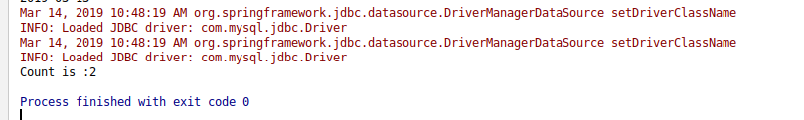

Question 6 :Get name of the user by providing username to the parametrized query
Answer 6 :
question6.GetUserNameThroughParameterizedQuery.java
package question6;
import org.springframework.beans.factory.annotation.Autowired;
import org.springframework.jdbc.core.JdbcTemplate;
import org.springframework.stereotype.Repository;
import javax.sql.DataSource;
@Repository
public class GetUserNameThroughParameterizedQuery {
@Autowired
DataSource dataSource;
@Autowired
JdbcTemplate jdbcTemplate;
public String getName() {
String sql = "SELECT name from user WHERE username=?";
return (String) jdbcTemplate.queryForObject(sql, new Object[]{"shivam"}, String.class);
}
}
Main.java
import org.springframework.context.ApplicationContext;
import org.springframework.context.support.ClassPathXmlApplicationContext;
import question4.UserAccessThroughSingleConnectionDatasource;
import question5.UserAccessThroughJdbcTemplate;
import question6.GetUserNameThroughParameterizedQuery;
import userdao.Question3.UserDAO;
import java.sql.*;
public class Main {
public static void main(String[] args) throws SQLException {

/*Question 6*/
ApplicationContext applicationContext3=new ClassPathXmlApplicationContext("spring-config.xml");
GetUserNameThroughParameterizedQuery getUserNameThroughParameterizedQuery=applicationContext3.getBean(GetUserNameThroughParameterizedQuery.class);
String str=getUserNameThroughParameterizedQuery.getName();
System.out.println("Name is :"+str);
}
}

Spring-config.xml
<?xml version="1.0" encoding="UTF-8"?>
<beans xmlns="http://www.springframework.org/schema/beans"
xmlns:xsi="http://www.w3.org/2001/XMLSchema-instance"
xmlns:context="http://www.springframework.org/schema/context"
xsi:schemaLocation="http://www.springframework.org/schema/beans http://www.springframework.org/schema/beans/spring-beans.xsd http://www.springframework.org/schema/context http://www.springframework.org/schema/context/spring-context.xsd">

<!--Question 5-->
<bean id="jdbctemplate" class="org.springframework.jdbc.core.JdbcTemplate">
<property name="dataSource" ref="dataSource"/>
</bean>
<context:annotation-config/>
<context:component-scan base-package="question6"/>
</beans>

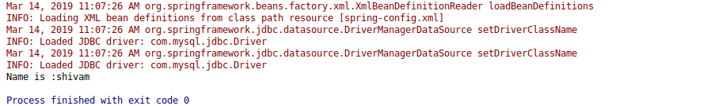

Question 7 :Insert one record using JdbcTemplate
Answer 7 :
InsertUsingJdbcTemplate.java
package question7;
import org.springframework.beans.factory.annotation.Autowired;
import org.springframework.jdbc.core.JdbcTemplate;
import org.springframework.stereotype.Repository;
import javax.sql.DataSource;
@Repository
public class InsertUsingJdbcTemplate {
@Autowired
DataSource dataSource;
@Autowired
JdbcTemplate jdbcTemplate;
public void insertUser(User user){
String sql="INSERT into user (username, password, name, age, dob)VALUES(?,?,?,?,?)";
jdbcTemplate.update(sql,new Object[]{
user.getUsername(),user.getPassword(),user.getName(),user.getAge(),user.getDob()
});
}
public void getUser(){
String sql="SELECT * from user WHERE username=?";
System.out.println(jdbcTemplate.queryForMap(sql,new Object[]{"vineet"}));
}
}
Main.java
import org.springframework.context.ApplicationContext;
import org.springframework.context.support.ClassPathXmlApplicationContext;
import question4.UserAccessThroughSingleConnectionDatasource;
import question5.UserAccessThroughJdbcTemplate;
import question6.GetUserNameThroughParameterizedQuery;
import question7.InsertUsingJdbcTemplate;
import question7.User;
import question8.QueryForMap;
import userdao.Question3.UserDAO;
import java.sql.SQLException;
import java.util.Date;
public class Main {
public static void main(String[] args) throws SQLException {

/*Question 7*/
ApplicationContext applicationContext4=new ClassPathXmlApplicationContext("spring-config.xml");
InsertUsingJdbcTemplate insertUsingJdbcTemplate=applicationContext4.getBean(InsertUsingJdbcTemplate.class);
User user=new User();
user.setUsername("vineet");
user.setPassword("vineet");
user.setName("Vineet");
user.setAge(12);
user.setDob(new Date());
insertUsingJdbcTemplate.getUser();

}
}

User.java
package question7;
import java.util.Date;
public class User {
String name;
String username;
String password;
int age;
Date dob;
public String getName() {
return name;
}
public void setName(String name) {
this.name = name;
}
public String getUsername() {
return username;
}
public void setUsername(String username) {
this.username = username;
}
public String getPassword() {
return password;
}
public void setPassword(String password) {
this.password = password;
}
public int getAge() {
return age;
}
public void setAge(int age) {
this.age = age;
}
public Date getDob() {
return dob;
}
public void setDob(Date dob) {
this.dob = dob;
}
@Override
public String toString() {
return "User{" +
"name='" + name + '\'' +
", username='" + username + '\'' +
", password='" + password + '\'' +
", age=" + age +
", dob=" + dob +
'}';
}
}

Question 8 :Use QueryForMap to fetch the user details of the user
Answer 8 :
QueryForMap.java
package question8;
import org.springframework.beans.factory.annotation.Autowired;
import org.springframework.jdbc.core.JdbcTemplate;
import org.springframework.stereotype.Repository;
@Repository
public class QueryForMap {
@Autowired
JdbcTemplate jdbcTemplate;
public void userDetails(){
String sql="SELECT * from user WHERE username=?";
System.out.println(jdbcTemplate.queryForMap(sql,new Object[]{"vineet"}));
}
}
Main.java

Question 9 : Use QueryForList to fetch records of all users
Answer 9 :
QueryForList.java
package question9;
import org.springframework.beans.factory.annotation.Autowired;
import org.springframework.jdbc.core.JdbcTemplate;
import org.springframework.stereotype.Repository;
@Repository
public class QueryForList {
@Autowired
JdbcTemplate jdbcTemplate;
public void userDetailsThroughQueryForList(){
String sql="SELECT * from user";
System.out.println(jdbcTemplate.queryForList(sql));
}
}
Main.java
ApplicationContext applicationContext6=new ClassPathXmlApplicationContext("spring-config.xml");
QueryForList queryForList=applicationContext6.getBean(QueryForList.class);
queryForList.userDetailsThroughQueryForList();

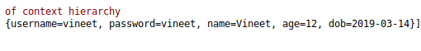

Question 10 :Use a rowmapper to get the User object when you query for a user
Answer 10 :
UserDetailsThroughRowMapper.java
package question10;
import org.springframework.beans.factory.annotation.Autowired;
import org.springframework.jdbc.core.JdbcTemplate;
import org.springframework.stereotype.Repository;
import question7.user;
@Repository
public class UserDetailsThroughRowMapper {
@Autowired
JdbcTemplate jdbcTemplate;
public user getUserDetails(){
String sql="SELECT * from user WHERE username=?";
return jdbcTemplate.queryForObject(sql,new Object[]{"shivam"},new UserMapper());
}
}

UserMapper.java
package question10;
import org.springframework.jdbc.core.RowMapper;
import question7.user;
import java.sql.ResultSet;
import java.sql.SQLException;
public class UserMapper implements RowMapper<user> {
@Override
public user mapRow(ResultSet rs, int rowNum) throws SQLException {
user user=new user();
user.setUsername(rs.getString("username"));
user.setPassword(rs.getString("password"));
user.setName(rs.getString("name"));
user.setAge(rs.getInt("age"));
user.setDob(rs.getDate("dob"));
return user;
}
}
Main.java
ApplicationContext applicationContext7=new ClassPathXmlApplicationContext("spring-config.xml");
UserDetailsThroughRowMapper userDetailsThroughRowMapper=applicationContext7.getBean(UserDetailsThroughRowMapper.class);
user=userDetailsThroughRowMapper.getUserDetails();
System.out.println(user);

Question 11 :Integrate Hibernate with Spring and use hql query to count the number of records in user table.
Answer 11 :
GetUserThroughSpringORM
package question11;
import org.hibernate.SessionFactory;
import org.hibernate.query.Query;
import org.springframework.beans.factory.annotation.Autowired;
import org.springframework.stereotype.Repository;
@Repository
public class GetUserThroughSpringORM {
@Autowired
SessionFactory sessionFactory;
public void getUserDetailsThroughORM(){
String sql="SELECT count(*) from user";
Query query=sessionFactory.openSession().createQuery(sql);
System.out.println(query.uniqueResult());
}
}
User.java
package question11;
import javax.persistence.Entity;
import javax.persistence.Id;
import java.util.Date;
@Entity
public class user {
@Id
String username;
String name;
String password;
int age;
Date dob;
public String getName() {
return name;
}
public void setName(String name) {
this.name = name;
}
public String getUsername() {
return username;
}
public void setUsername(String username) {
this.username = username;
}
public String getPassword() {
return password;
}
public void setPassword(String password) {
this.password = password;
}
public int getAge() {
return age;
}
public void setAge(int age) {
this.age = age;
}
public Date getDob() {
return dob;
}
public void setDob(Date dob) {
this.dob = dob;
}
@Override
public String toString() {
return "user{" +
"name='" + name + '\'' +
", username='" + username + '\'' +
", password='" + password + '\'' +
", age=" + age +
", dob=" + dob +
'}';
}
}
Spring-config.xml
<bean id="txManager" class="org.springframework.jdbc.datasource.DataSourceTransactionManager">
<property name="dataSource" ref="dataSource"/>
</bean>
<tx:annotation-driven transaction-manager="txManager"/>
<context:component-scan base-package="question12"/>

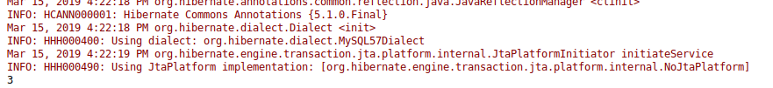

Question 12 :Use @Transactional to save to save 2 records using jdbc template with the following prapogation options
Answer 12 :
REQUIRED

UserDao1.java
package question12;
import org.springframework.beans.factory.annotation.Autowired;
import org.springframework.jdbc.core.JdbcTemplate;
import org.springframework.stereotype.Repository;
import org.springframework.transaction.annotation.Propagation;
import org.springframework.transaction.annotation.Transactional;
@Repository
public class UserDao1 {
@Autowired
JdbcTemplate jdbcTemplate;
@Autowired
UserDao2 userDao2;
@Transactional(propagation = Propagation.REQUIRED)
public void insertUserDao1() {
String sql = "INSERT INTO People(id,name)VALUES(1,'Shivam')";
jdbcTemplate.update(sql);
try{
userDao2.insertUserDao2();
}catch (Exception ex){
}
}
}
UserDao2.java
package question12;
import org.springframework.beans.factory.annotation.Autowired;
import org.springframework.jdbc.core.JdbcTemplate;
import org.springframework.stereotype.Repository;
import org.springframework.transaction.annotation.Propagation;
import org.springframework.transaction.annotation.Transactional;
@Repository
public class UserDao2 {
@Autowired
JdbcTemplate jdbcTemplate;
@Transactional(propagation = Propagation.REQUIRED)
public void insertUserDao2() {
String sql = "INSERT INTO People(id,name)VALUES(2,'Saxena')";
jdbcTemplate.update(sql);
throw new RuntimeException();
}
}
Main.java
ApplicationContext applicationContext9=new ClassPathXmlApplicationContext("spring-config.xml");
UserDao1 userDao1=applicationContext9.getBean(UserDao1.class);
userDao1.insertUserDao1();
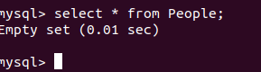
REQUIRES_NEW
UserDao1.java
package question12;
import org.springframework.beans.factory.annotation.Autowired;
import org.springframework.jdbc.core.JdbcTemplate;
import org.springframework.stereotype.Repository;
import org.springframework.transaction.annotation.Propagation;
import org.springframework.transaction.annotation.Transactional;
@Repository
public class UserDao1 {
@Autowired
JdbcTemplate jdbcTemplate;
@Autowired
UserDao2 userDao2;
@Transactional(propagation = Propagation.REQUIRED)
public void insertUserDao1() {
String sql = "INSERT INTO People(id,name)VALUES(1,'Shivam')";
jdbcTemplate.update(sql);
try{
userDao2.insertUserDao2();
}catch (Exception ex){
}
}
}
UserDao2.java

package question12;
import org.springframework.beans.factory.annotation.Autowired;
import org.springframework.jdbc.core.JdbcTemplate;
import org.springframework.stereotype.Repository;
import org.springframework.transaction.annotation.Propagation;
import org.springframework.transaction.annotation.Transactional;
@Repository
public class UserDao2 {
@Autowired
JdbcTemplate jdbcTemplate;
@Transactional(propagation = Propagation.REQUIRES_NEW)
public void insertUserDao2() {
String sql = "INSERT INTO People(id,name)VALUES(2,'Saxena')";
jdbcTemplate.update(sql);
throw new RuntimeException();
}
}
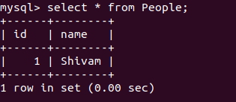

NESTED
UserDao1.java
package question12;
import org.springframework.beans.factory.annotation.Autowired;
import org.springframework.jdbc.core.JdbcTemplate;
import org.springframework.stereotype.Repository;
import org.springframework.transaction.annotation.Propagation;
import org.springframework.transaction.annotation.Transactional;
@Repository
public class UserDao1 {
@Autowired
JdbcTemplate jdbcTemplate;
@Autowired
UserDao2 userDao2;
@Transactional(propagation = Propagation.REQUIRED)
public void insertUserDao1() {
String sql = "INSERT INTO People(id,name)VALUES(1,'Shivam')";
jdbcTemplate.update(sql);
try{
userDao2.insertUserDao2();
}catch (Exception ex){
}
}
}
UserDao2.java
package question12;
import org.springframework.beans.factory.annotation.Autowired;
import org.springframework.jdbc.core.JdbcTemplate;
import org.springframework.stereotype.Repository;
import org.springframework.transaction.annotation.Propagation;
import org.springframework.transaction.annotation.Transactional;
@Repository
public class UserDao2 {
@Autowired
JdbcTemplate jdbcTemplate;
@Autowired
UserDao3 userDao3;
@Transactional(propagation = Propagation.REQUIRES_NEW)
public void insertUserDao2() {
String sql = "INSERT INTO People(id,name)VALUES(2,'Saxena')";
jdbcTemplate.update(sql);
try{
userDao3.insertUserDao3();
}catch(Exception ex){
}
}
}

UserDao3.java
package question12;
import org.springframework.beans.factory.annotation.Autowired;
import org.springframework.jdbc.core.JdbcTemplate;
import org.springframework.stereotype.Repository;
import org.springframework.transaction.annotation.Propagation;
import org.springframework.transaction.annotation.Transactional;
@Repository
public class UserDao3 {
@Autowired
JdbcTemplate jdbcTemplate;
@Transactional(propagation = Propagation.NESTED)
public void insertUserDao3() {
String sql = "INSERT INTO People(id,name)VALUES(3,'Vineet')";
jdbcTemplate.update(sql);
throw new RuntimeException();
}
}
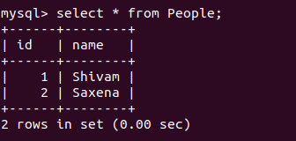

MANDATORY

UserDao1.java
package question12;
import org.springframework.beans.factory.annotation.Autowired;
import org.springframework.jdbc.core.JdbcTemplate;
import org.springframework.stereotype.Repository;
import org.springframework.transaction.annotation.Propagation;
import org.springframework.transaction.annotation.Transactional;
@Repository
public class UserDao1 {
@Autowired
JdbcTemplate jdbcTemplate;
@Autowired
UserDao2 userDao2;
@Transactional(propagation = Propagation.REQUIRED)
public void insertUserDao1() {
String sql = "INSERT INTO People(id,name)VALUES(1,'Shivam')";
jdbcTemplate.update(sql);
try{
userDao2.insertUserDao2();
}catch (Exception ex){
}
}
}
UserDao2.java
package question12;
import org.springframework.beans.factory.annotation.Autowired;
import org.springframework.jdbc.core.JdbcTemplate;
import org.springframework.stereotype.Repository;
import org.springframework.transaction.annotation.Propagation;
import org.springframework.transaction.annotation.Transactional;
@Repository
public class UserDao2 {
@Autowired
JdbcTemplate jdbcTemplate;
@Transactional(propagation = Propagation.MANDATORY)
public void insertUserDao2() {
String sql = "INSERT INTO People(id,name)VALUES(2,'Saxena')";
jdbcTemplate.update(sql);

}
}
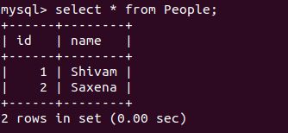

NEVER
UserDao1.java
package question12;
import org.springframework.beans.factory.annotation.Autowired;
import org.springframework.jdbc.core.JdbcTemplate;
import org.springframework.stereotype.Repository;
import org.springframework.transaction.annotation.Propagation;
import org.springframework.transaction.annotation.Transactional;
@Repository
public class UserDao1 {
@Autowired
JdbcTemplate jdbcTemplate;
@Autowired
UserDao2 userDao2;
// @Transactional(propagation = Propagation.REQUIRED)
public void insertUserDao1() {
String sql = "INSERT INTO People(id,name)VALUES(1,'Shivam')";
jdbcTemplate.update(sql);
try{
userDao2.insertUserDao2();
}catch (Exception ex){
}
}
}
UserDao2.java
package question12;
import org.springframework.beans.factory.annotation.Autowired;
import org.springframework.jdbc.core.JdbcTemplate;
import org.springframework.stereotype.Repository;
import org.springframework.transaction.annotation.Propagation;
import org.springframework.transaction.annotation.Transactional;
@Repository
public class UserDao2 {
@Autowired
JdbcTemplate jdbcTemplate;
@Transactional(propagation = Propagation.NEVER)
public void insertUserDao2() {
String sql = "INSERT INTO People(id,name)VALUES(2,'Saxena')";
jdbcTemplate.update(sql);
//throw new RuntimeException();
}
}
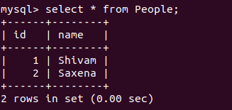

NOT_SUPPORTED

UserDao1.java
package question12;
import org.springframework.beans.factory.annotation.Autowired;
import org.springframework.jdbc.core.JdbcTemplate;
import org.springframework.stereotype.Repository;
import org.springframework.transaction.annotation.Propagation;
import org.springframework.transaction.annotation.Transactional;
@Repository
public class UserDao1 {
@Autowired
JdbcTemplate jdbcTemplate;
@Autowired
UserDao2 userDao2;
@Transactional(propagation = Propagation.REQUIRED)
public void insertUserDao1() {
String sql = "INSERT INTO People(id,name)VALUES(1,'Shivam')";
jdbcTemplate.update(sql);
try{
userDao2.insertUserDao2();
}catch (Exception ex){
}
}
}

UserDao2.java
package question12;
import org.springframework.beans.factory.annotation.Autowired;
import org.springframework.jdbc.core.JdbcTemplate;
import org.springframework.stereotype.Repository;
import org.springframework.transaction.annotation.Propagation;
import org.springframework.transaction.annotation.Transactional;
@Repository
public class UserDao2 {
@Autowired
JdbcTemplate jdbcTemplate;
@Transactional(propagation = Propagation.NOT_SUPPORTED)
public void insertUserDao2() {
String sql = "INSERT INTO People(id,name)VALUES(2,'Saxena')";
jdbcTemplate.update(sql);
throw new RuntimeException();
}
}

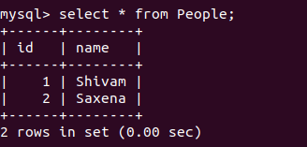

SUPPORTS

UserDao1.java
package question12;
import org.springframework.beans.factory.annotation.Autowired;
import org.springframework.jdbc.core.JdbcTemplate;
import org.springframework.stereotype.Repository;
import org.springframework.transaction.annotation.Propagation;
import org.springframework.transaction.annotation.Transactional;
@Repository
public class UserDao1 {
@Autowired
JdbcTemplate jdbcTemplate;
@Autowired
UserDao2 userDao2;
// @Transactional(propagation = Propagation.REQUIRED)
public void insertUserDao1() {
String sql = "INSERT INTO People(id,name)VALUES(1,'Shivam')";
jdbcTemplate.update(sql);
try{
userDao2.insertUserDao2();
}catch (Exception ex){
}
}
}
UserDao2.java
package question12;
import org.springframework.beans.factory.annotation.Autowired;
import org.springframework.jdbc.core.JdbcTemplate;
import org.springframework.stereotype.Repository;
import org.springframework.transaction.annotation.Propagation;
import org.springframework.transaction.annotation.Transactional;
@Repository
public class UserDao2 {
@Autowired
JdbcTemplate jdbcTemplate;
@Transactional(propagation = Propagation.SUPPORTS)
public void insertUserDao2() {
String sql = "INSERT INTO People(id,name)VALUES(2,'Saxena')";
jdbcTemplate.update(sql);
throw new RuntimeException();
}
}
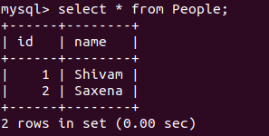

Question 13 :Demonstrate the use of following options of @Transactional annotation
read-only
UserDao3.java
package question12;
import org.springframework.beans.factory.annotation.Autowired;
import org.springframework.jdbc.core.JdbcTemplate;
import org.springframework.stereotype.Repository;
import org.springframework.transaction.annotation.Propagation;
import org.springframework.transaction.annotation.Transactional;
@Repository
public class UserDao3 {
@Autowired
JdbcTemplate jdbcTemplate;
@Transactional(propagation = Propagation.REQUIRED,readOnly = true)
public void insertUserDao3() {
String sql = "INSERT INTO People(id,name)VALUES(3,'Vineet')";
jdbcTemplate.update(sql);
throw new RuntimeException();
}
}
Main.java
ApplicationContext applicationContext9=new ClassPathXmlApplicationContext("spring-config.xml");
UserDao3 userDao3=applicationContext9.getBean(UserDao3.class);
userDao3.insertUserDao3();

timeout
UserDao3.java

package question12;
import org.springframework.beans.factory.annotation.Autowired;
import org.springframework.jdbc.core.JdbcTemplate;
import org.springframework.stereotype.Repository;
import org.springframework.transaction.annotation.Propagation;
import org.springframework.transaction.annotation.Transactional;
@Repository
public class UserDao3 {
@Autowired
JdbcTemplate jdbcTemplate;
@Transactional(propagation = Propagation.REQUIRED,timeout = 2)
public void insertUserDao3() {
try {
Thread.sleep(2000L);
} catch (InterruptedException e) {
e.printStackTrace();
}
String sql = "INSERT INTO People(id,name)VALUES(3,'Vineet')";
jdbcTemplate.update(sql);
throw new RuntimeException();
}
}
Main.java
ApplicationContext applicationContext9=new ClassPathXmlApplicationContext("spring-config.xml");
UserDao3 userDao3=applicationContext9.getBean(UserDao3.class);
userDao3.insertUserDao3();
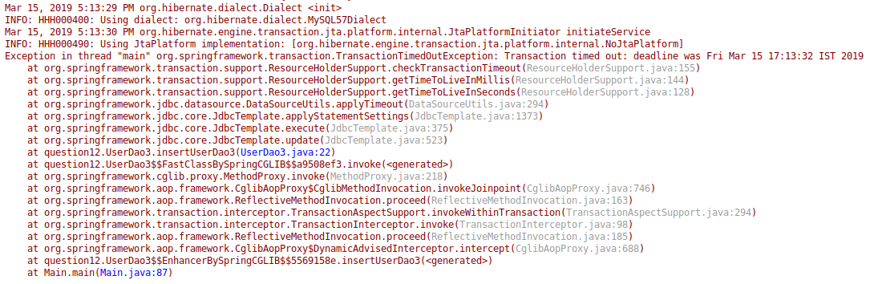

rollback-for
UserDao3.java
package question12;
import org.springframework.beans.factory.annotation.Autowired;
import org.springframework.jdbc.core.JdbcTemplate;
import org.springframework.stereotype.Repository;
import org.springframework.transaction.annotation.Propagation;
import org.springframework.transaction.annotation.Transactional;
@Repository
public class UserDao3 {
@Autowired
JdbcTemplate jdbcTemplate;
@Transactional(rollbackFor = ArithmeticException.class)
public void insertUserDao3() {
String sql = "INSERT INTO People(id,name)VALUES(3,'Vineet')";
jdbcTemplate.update(sql);
int i=1/0;
System.out.println(i);
//throw new RuntimeException();
}
}
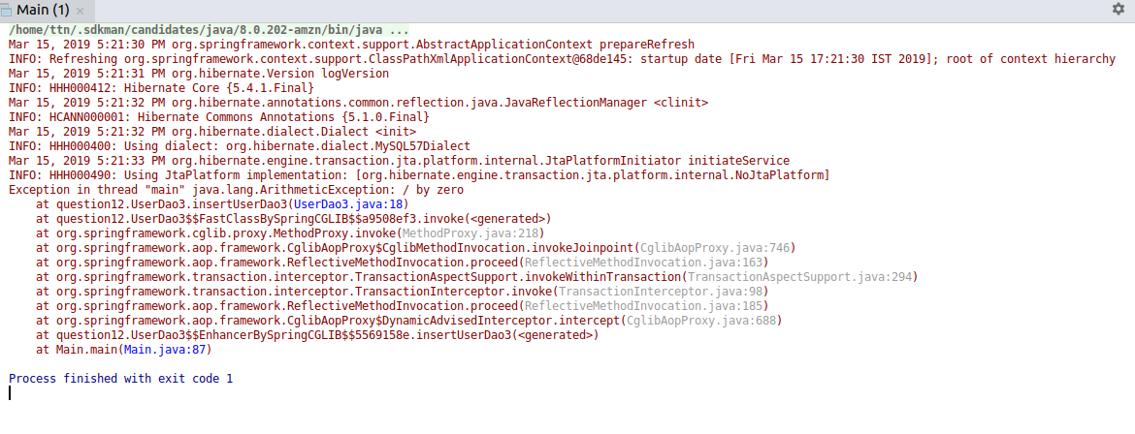

no-rollback-for
UserDao3.java
package question12;
import org.springframework.beans.factory.annotation.Autowired;
import org.springframework.jdbc.core.JdbcTemplate;
import org.springframework.stereotype.Repository;
import org.springframework.transaction.annotation.Propagation;
import org.springframework.transaction.annotation.Transactional;
@Repository
public class UserDao3 {
@Autowired
JdbcTemplate jdbcTemplate;
@Transactional(noRollbackFor = ArithmeticException.class)
public void insertUserDao3() {
String sql = "INSERT INTO People(id,name)VALUES(3,'Vineet')";
jdbcTemplate.update(sql);
int i=1/0;
System.out.println(i);
//throw new RuntimeException();
}
}
Main.java
ApplicationContext applicationContext9=new ClassPathXmlApplicationContext("spring-config.xml");
UserDao3 userDao3=applicationContext9.getBean(UserDao3.class);
userDao3.insertUserDao3();
