Question 1 : Implement AbstractController in StudentController. create a mapping index.html for it and render index.jsp view from it which displays messages "Hello from index.gsp"
Answer 1 :
Web.xml
<?xml version="1.0" encoding="UTF-8"?>
<web-app version="2.5"
xmlns="http://java.sun.com/xml/ns/j2ee"
xmlns:xsi="http://www.w3.org/2001/XMLSchema-instance"
xsi:schemaLocation="http://java.sun.com/xml/ns/j2ee
http://java.sun.com/xml/ns/j2ee/web-app_2_5.xsd">
<servlet>
<servlet-name>dispatcherServlet</servlet-name>
<servlet-class>
org.springframework.web.servlet.DispatcherServlet
</servlet-class>
<init-param>
<param-name>contextConfigLocation</param-name>
<param-value>/WEB-INF/spring-dispatcher-servlet.xml</param-value>
</init-param>
</servlet>
<servlet-mapping>
<servlet-name>dispatcherServlet</servlet-name>
<url-pattern>/</url-pattern>
</servlet-mapping>
</web-app>
spring-dispatcher-servlet.xml
<?xml version="1.0" encoding="UTF-8"?>
<beans xmlns="http://www.springframework.org/schema/beans"
xmlns:mvc="http://www.springframework.org/schema/mvc"
xmlns:xsi="http://www.w3.org/2001/XMLSchema-instance"
xmlns:context="http://www.springframework.org/schema/context"
xsi:schemaLocation="http://www.springframework.org/schema/beans
http://www.springframework.org/schema/beans/spring-beans.xsd
http://www.springframework.org/schema/mvc
http://www.springframework.org/schema/mvc/spring-mvc.xsd
http://www.springframework.org/schema/context
http://www.springframework.org/schema/context/spring-context.xsd">
<bean class="org.springframework.web.servlet.handler.BeanNameUrlHandlerMapping"/>
<bean name="/student" class="com.ttn.bootcamp.StudentController"/>

<bean id="viewResolver"
class="org.springframework.web.servlet.view.InternalResourceViewResolver">
<property name="prefix">
<value>/WEB-INF/</value>
</property>
<property name="suffix">
<value>.jsp</value>
</property>
</bean>
<context:annotation-config/>
<mvc:annotation-driven/>
</beans>
StudentController.java
package com.ttn.bootcamp;
import org.springframework.web.servlet.ModelAndView;
import org.springframework.web.servlet.mvc.AbstractController;
import javax.servlet.http.HttpServletRequest;
import javax.servlet.http.HttpServletResponse;
public class StudentController extends AbstractController {
@Override
protected ModelAndView handleRequestInternal(HttpServletRequest request, HttpServletResponse response) throws Exception {
System.out.println("Shivam");
ModelAndView modelAndView=new ModelAndView("index");
return modelAndView;
}
}
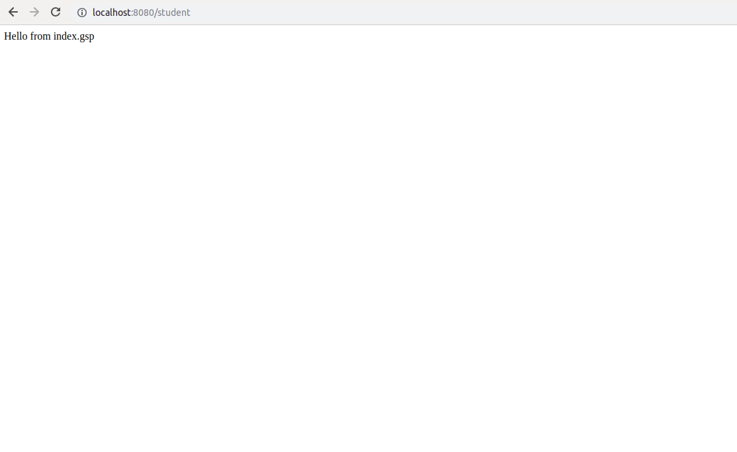

Question 2 :Now remove AbstractController and useMultiActionController for StudentController which contains 2 actions one action renders a jsp view and another action uses HttpServletResponse to show the output on the Web browser.
Answer 2 :
spring-dispatcher-servlet.xml
<?xml version="1.0" encoding="UTF-8"?>
<beans xmlns="http://www.springframework.org/schema/beans"
xmlns:mvc="http://www.springframework.org/schema/mvc"
xmlns:xsi="http://www.w3.org/2001/XMLSchema-instance"
xmlns:context="http://www.springframework.org/schema/context"
xsi:schemaLocation="http://www.springframework.org/schema/beans
http://www.springframework.org/schema/beans/spring-beans.xsd
http://www.springframework.org/schema/mvc
http://www.springframework.org/schema/mvc/spring-mvc.xsd
http://www.springframework.org/schema/context
http://www.springframework.org/schema/context/spring-context.xsd">

<bean class="org.springframework.web.servlet.mvc.support.ControllerClassNameHandlerMapping"/>
<bean name="/student" class="com.ttn.bootcamp.StudentController"/>
<bean id="viewResolver"
class="org.springframework.web.servlet.view.InternalResourceViewResolver">
<property name="prefix">
<value>/WEB-INF/</value>
</property>
<property name="suffix">
<value>.jsp</value>
</property>
</bean>

<context:annotation-config/>
<mvc:annotation-driven/>
</beans>
StudentController.java
package com.ttn.bootcamp;
import org.springframework.web.servlet.ModelAndView;
import org.springframework.web.servlet.mvc.multiaction.MultiActionController;
import javax.servlet.http.HttpServletRequest;
import javax.servlet.http.HttpServletResponse;
import java.io.IOException;
public class StudentController extends MultiActionController {
public void dummy(HttpServletRequest request, HttpServletResponse response) throws IOException {
response.setContentType("text/html");
response.getWriter().print("Hello HTMl");
}
public ModelAndView dummy1(HttpServletRequest request, HttpServletResponse response) {
ModelAndView modelAndView = new ModelAndView("index");
return modelAndView;
}
}
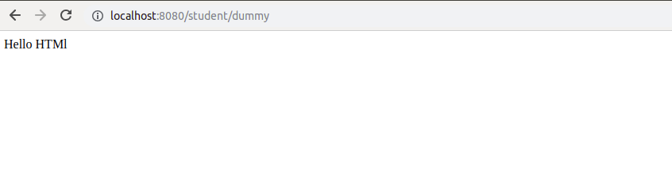
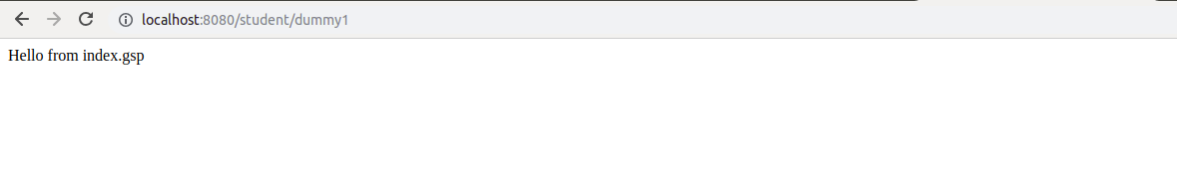

Question 3 :Use annotation in StudentController to define a default action index which renders a jsp page.
Answer 3 :
StudentController.java
package com.ttn.bootcamp;
import org.springframework.stereotype.Controller;
import org.springframework.web.bind.annotation.RequestMapping;
import org.springframework.web.servlet.ModelAndView;
@Controller
public class StudentController {
@RequestMapping("/")
public ModelAndView renderPage(){
ModelAndView modelAndView=new ModelAndView("index");
return modelAndView;
}
}
spring-dispatcher-servlet.xml
<?xml version="1.0" encoding="UTF-8"?>
<beans xmlns="http://www.springframework.org/schema/beans"
xmlns:mvc="http://www.springframework.org/schema/mvc"
xmlns:xsi="http://www.w3.org/2001/XMLSchema-instance"
xmlns:context="http://www.springframework.org/schema/context"
xsi:schemaLocation="http://www.springframework.org/schema/beans
http://www.springframework.org/schema/beans/spring-beans.xsd
http://www.springframework.org/schema/mvc
http://www.springframework.org/schema/mvc/spring-mvc.xsd
http://www.springframework.org/schema/context
http://www.springframework.org/schema/context/spring-context.xsd">
<bean id="viewResolver"
class="org.springframework.web.servlet.view.InternalResourceViewResolver">
<property name="prefix">
<value>/WEB-INF/</value>
</property>
<property name="suffix">
<value>.jsp</value>
</property>
</bean>
<context:component-scan base-package="com.ttn.bootcamp"/>
<mvc:annotation-driven/>
</beans>
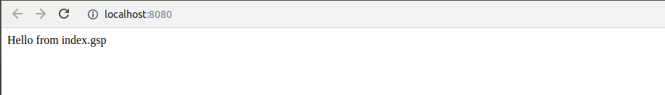

Question 4 :Create one more annotation based action hello inside the StudentController which and use @ResponseBody annotation from it to display Hello world.
Answer 4 :
StudentController.java
package com.ttn.bootcamp;
import org.springframework.stereotype.Controller;
import org.springframework.web.bind.annotation.RequestMapping;
import org.springframework.web.bind.annotation.ResponseBody;
import org.springframework.web.servlet.ModelAndView;
@Controller
public class StudentController {
@RequestMapping("/")
public ModelAndView renderPage(){
ModelAndView modelAndView=new ModelAndView("index");
return modelAndView;
}
@RequestMapping("/hello")
@ResponseBody
public String hello(){
return "Hello World";
}
}
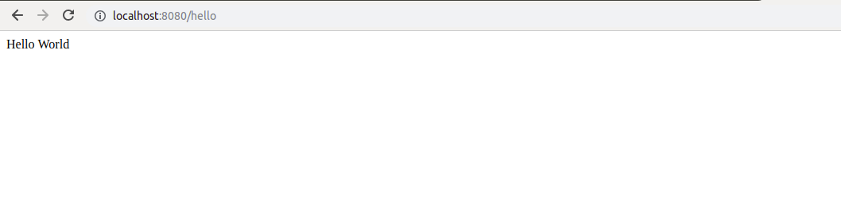

Question 5 :Create one more action which sends Model HelloWorld to the jsp file.
Answer 5 :
StudentController.java
package com.ttn.bootcamp;
import org.springframework.stereotype.Controller;
import org.springframework.web.bind.annotation.RequestMapping;
import org.springframework.web.bind.annotation.ResponseBody;
import org.springframework.web.servlet.ModelAndView;
@Controller
public class StudentController {

/*Question 5*/
@RequestMapping("/send")
public ModelAndView printHelloWorld(){
ModelAndView modelAndView=new ModelAndView("index");
modelAndView.addObject("helloworld","Hello World");
return modelAndView;
}
@RequestMapping("/send1")
public ModelAndView printHelloWorld1(){
ModelAndView modelAndView=new ModelAndView("index");
modelAndView.addObject("helloworld","Hello World!!!!");
return modelAndView;
}
}
Without any method call
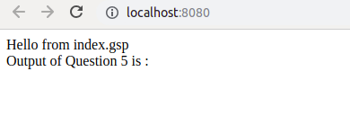

with /send method output is :
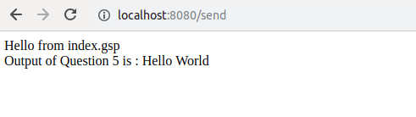

with /send1 method output is :

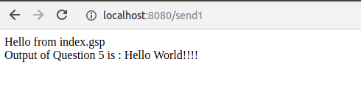

Question 6 :Use @PathVariable annotation to access firstname and lastname in an action inside StudentController place both the parameters in different arguments and access them.
Answer 6 :
StudentController.java
package com.ttn.bootcamp;
import org.springframework.stereotype.Controller;
import org.springframework.web.bind.annotation.PathVariable;
import org.springframework.web.bind.annotation.RequestMapping;
import org.springframework.web.bind.annotation.ResponseBody;
import org.springframework.web.servlet.ModelAndView;
@Controller
public class StudentController {

@RequestMapping("/fetchStudent/{firstName}/{lastName}")
@ResponseBody
public String fetchData(@PathVariable("firstName") String firstName,@PathVariable("lastName") String lastName){
return firstName + " " + lastName;
}
}
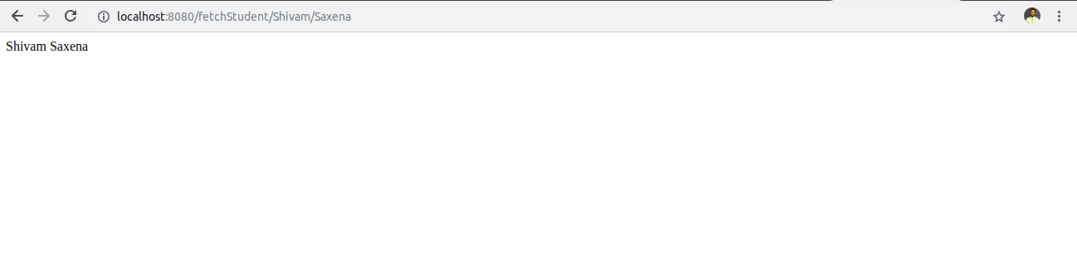

Question 7 :Now place both the arguments inside a Map and access the Map instead.(Hint : check the slide for @PathVariable action returnCountryAndState shows how to do it with map)
Answer 7 :
StudentController.java
package com.ttn.bootcamp;
import org.springframework.stereotype.Controller;
import org.springframework.web.bind.annotation.PathVariable;
import org.springframework.web.bind.annotation.RequestMapping;
import org.springframework.web.bind.annotation.ResponseBody;
import org.springframework.web.servlet.ModelAndView;
import java.util.Map;
@Controller
public class StudentController {

/*Question 7*/
@RequestMapping("/fetchThroughMap/{firstName}/{lastName}")
@ResponseBody
public String fetchThroughMap(@PathVariable Map<String , String> stringMap){
return stringMap.get("firstName") + " "+stringMap.get("lastName");
}
}
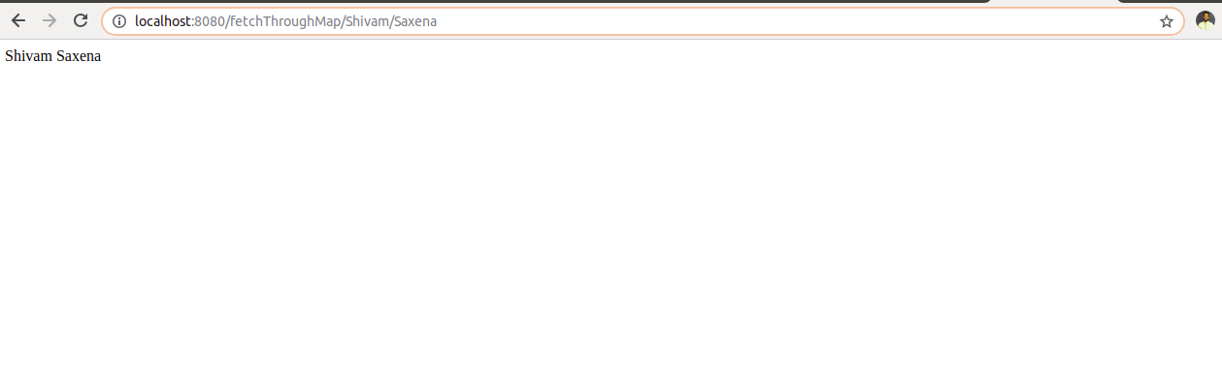

Question 8 :Use @RequestParam annotation to access the firstname and lastname in formData action of StudentController.
Answer 8 :
Index.jsp
<%--
Created by IntelliJ IDEA.
User: ttn
Date: 17/3/19
Time: 1:29 PM
To change this template use File | Settings | File Templates.
--%>
<%@ page contentType="text/html;charset=UTF-8" language="java" %>
<html>
<head>
<title>Title</title>
</head>
<body>
<form action="/fetchData">
FirstName :<input type="text" name="firstName">
LastName. :<input type="text" name="lastName">
<input type="submit">
</form>
</body>
</html>

StudentController.java
package com.ttn.bootcamp;
import org.springframework.stereotype.Controller;
import org.springframework.web.bind.annotation.PathVariable;
import org.springframework.web.bind.annotation.RequestMapping;
import org.springframework.web.bind.annotation.RequestParam;
import org.springframework.web.bind.annotation.ResponseBody;
import org.springframework.web.servlet.ModelAndView;
import java.util.Map;
@Controller
public class StudentController {

/*Question 8*/
@RequestMapping("/fetchData")
public ModelAndView fetching(@RequestParam("firstName") String fName,@RequestParam("lastName") String lName){
ModelAndView modelAndView=new ModelAndView("display");
modelAndView.addObject("fName",fName);
modelAndView.addObject("lName",lName);
return modelAndView;
}
}

display.jsp
<%--
Created by IntelliJ IDEA.
User: ttn
Date: 17/3/19
Time: 9:14 PM
To change this template use File | Settings | File Templates.
--%>
<%@ page contentType="text/html;charset=UTF-8" language="java" %>
<html>
<head>
<title>Title</title>
</head>
<body>
First Name is : ${fName}<br>
Last Name is : ${lName}
</body>
</html>
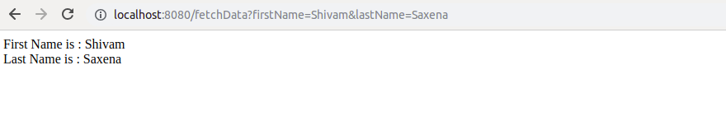

Question 9 :Create a StudentCO and bind firstname and lastname with instance variable of StudentCO.
Answer 9 :
StudentController.java
package com.ttn.bootcamp;
import Model.StudentCO;
import org.springframework.stereotype.Controller;
import org.springframework.web.bind.annotation.PathVariable;
import org.springframework.web.bind.annotation.RequestMapping;
import org.springframework.web.bind.annotation.RequestParam;
import org.springframework.web.bind.annotation.ResponseBody;
import org.springframework.web.servlet.ModelAndView;
import java.util.Map;
@Controller
public class StudentController {

/*Question 9*/
@RequestMapping("/StudentForm")
public ModelAndView getStudentForm(){
ModelAndView modelAndView=new ModelAndView("StudentForm");
return modelAndView;
}
@RequestMapping("/submitform")
public ModelAndView SubmitStudentData(@RequestParam("studentFirstName") String fName,
@RequestParam("studentLastName") String lName)
{
StudentCO studentCO=new StudentCO();
studentCO.setStudentFirstName(fName);
studentCO.setStudentLastName(lName);
ModelAndView modelAndView=new ModelAndView("DisplayStudentData");
modelAndView.addObject("studentCO",studentCO);
return modelAndView;
}
}
StudentCO.java
package Model;
public class StudentCO {
private String studentFirstName;
private String studentLastName;
public String getStudentFirstName() {
return studentFirstName;
}
public void setStudentFirstName(String studentFirstName) {
this.studentFirstName = studentFirstName;
}
public String getStudentLastName() {
return studentLastName;
}
public void setStudentLastName(String studentLastName) {
this.studentLastName = studentLastName;
}
}

StudentForm.jsp
<%--
Created by IntelliJ IDEA.
User: ttn
Date: 18/3/19
Time: 12:06 AM
To change this template use File | Settings | File Templates.
--%>
<%@ page contentType="text/html;charset=UTF-8" language="java" %>
<html>
<head>
<title>Student Registration</title>
</head>
<body>
<form action="/submitform">
First Name :<input type="text" name="studentFirstName"><br>
Last Name : <input type="text" name="studentLastName"><br>
<input type="submit">
</form>
</body>
</html>
DisplayStudentData.jsp
<%--
Created by IntelliJ IDEA.
User: ttn
Date: 18/3/19
Time: 12:13 AM
To change this template use File | Settings | File Templates.
--%>
<%@ page contentType="text/html;charset=UTF-8" language="java" %>
<html>
<head>
<title>Student</title>
</head>
<body>
<h1>First Name is : ${studentCO.studentFirstName}</h1>
<h1>Last Name is : ${studentCO.studentLastName}</h1>
</body>
</html>
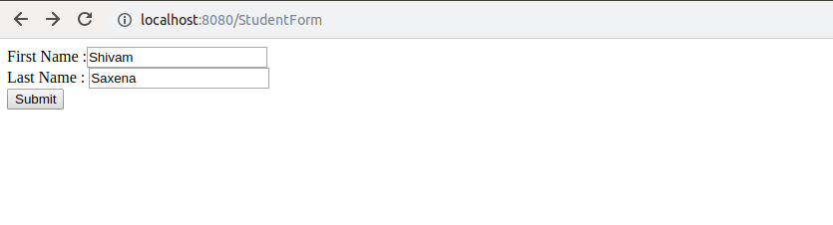

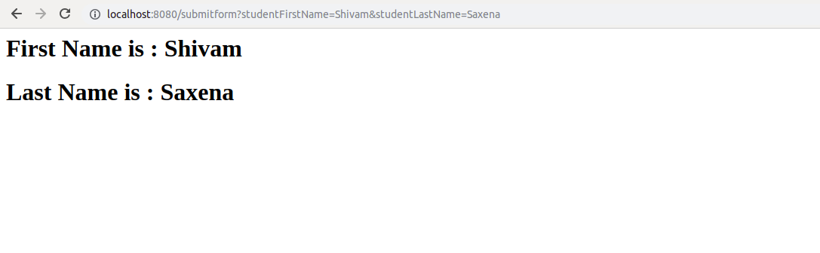

Question 10 :Use @ModelAttribute annotation to add Heading "Spring MVC Demo" in every model.
Answer 10 :
StudentController.java
package com.ttn.bootcamp;
import Model.StudentCO;
import org.springframework.stereotype.Controller;
import org.springframework.ui.Model;
import org.springframework.web.bind.annotation.*;
import org.springframework.web.servlet.ModelAndView;
import java.util.Map;
@Controller
public class StudentController {
@ModelAttribute
void addingHeading(Model model){
model.addAttribute("heading","Spring MVC Demo");
}

@RequestMapping("/submitform1")
public ModelAndView SubmitStudentData1(@ModelAttribute("studentCO") StudentCO studentCO)
{
ModelAndView modelAndView=new ModelAndView("DisplayStudentData");
modelAndView.addObject("studentCO",studentCO);
return modelAndView;
}
DisplayStudentData.jsp
<%--
Created by IntelliJ IDEA.
User: ttn
Date: 18/3/19
Time: 12:13 AM
To change this template use File | Settings | File Templates.
--%>
<%@ page contentType="text/html;charset=UTF-8" language="java" %>
<html>
<head>
<title>Student</title>
</head>
<body>
<h1>${heading}</h1>
<h2>First Name is : ${studentCO.studentFirstName}</h2>
<h2>Last Name is : ${studentCO.studentLastName}</h2>
</body>
</html>
