Question 1 :Create a Restful API using Spring Boot for Student.(1 Mark)
Answer 1 :
StudentService.java
package com.spring.spring.boot.demo.service;
import com.spring.spring.boot.demo.entity.Student;
import org.springframework.stereotype.Service;
import java.util.Arrays;
import java.util.List;
@Service
public class StudentService {
public List<Student> getStudents(){
return Arrays.asList(new Student(1,"Shivam","Saxena"),new Student(2,"Vineet","Chaudhary"));
}
}
Student.java
package com.spring.spring.boot.demo.entity;
public class Student {
private int id;
private String FirstName;
private String LastName;
public Student(int id, String firstName, String lastName) {
this.id = id;
FirstName = firstName;
LastName = lastName;
}
public int getId() {
return id;
}
public void setId(int id) {
this.id = id;
}
public String getFirstName() {
return FirstName;
}
public void setFirstName(String firstName) {
FirstName = firstName;
}
public String getLastName() {
return LastName;
}
public void setLastName(String lastName) {
LastName = lastName;
}
public Student() {
}
}

StudentController.java
package com.spring.spring.boot.demo.controller;
import com.spring.spring.boot.demo.entity.Student;
import com.spring.spring.boot.demo.service.StudentService;
import org.springframework.beans.factory.annotation.Autowired;
import org.springframework.web.bind.annotation.GetMapping;
import org.springframework.web.bind.annotation.RestController;
import java.util.List;
@RestController
public class StudentController {
@Autowired
StudentService studentService;
@GetMapping("/")
public List<Student> getStudent() {
return studentService.getStudents();
}
}
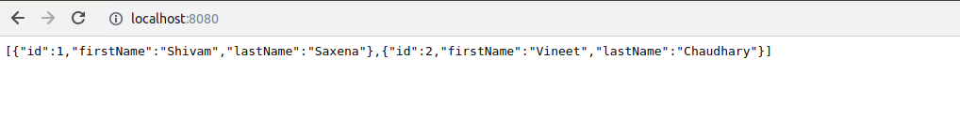

Question 2 :Run Spring Boot Application with all the three ways (1 Mark)
Answer 2 :
First Method is through Main.class
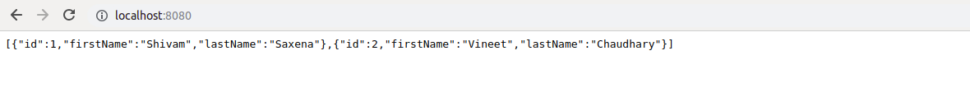
Second Method through bootRun
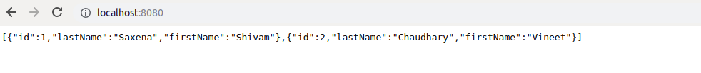
Third Method is through jar
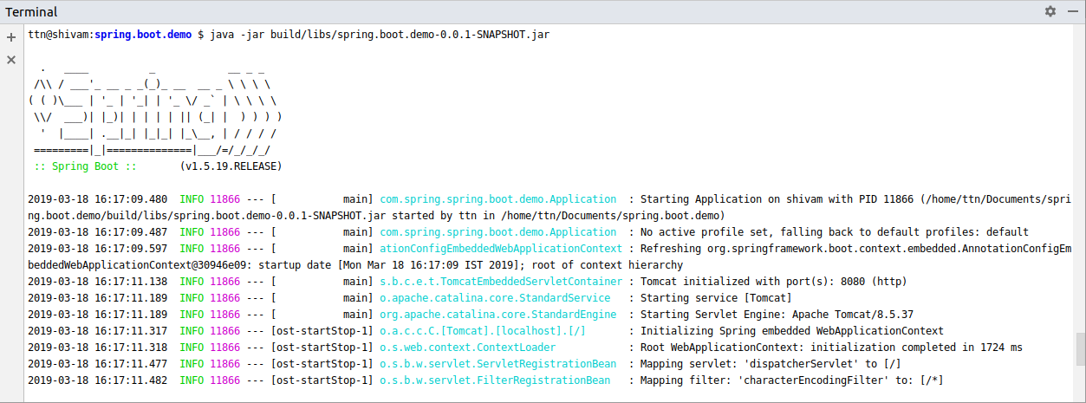
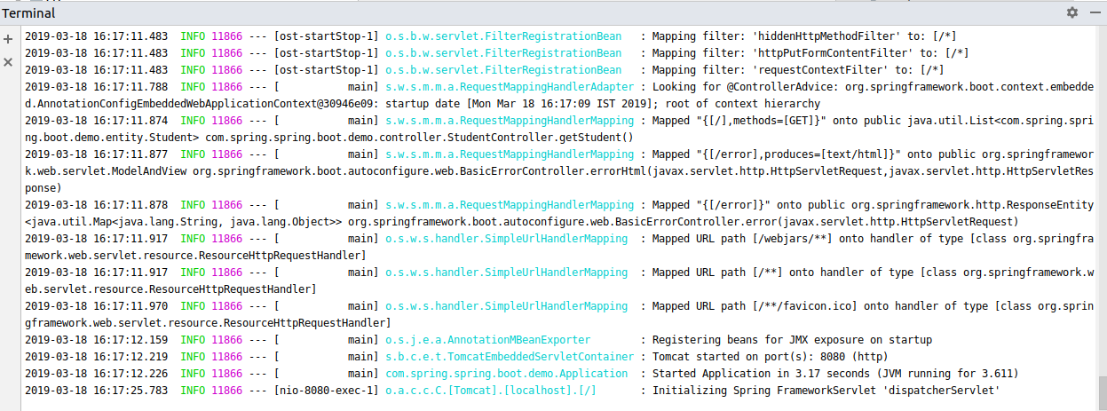
Question 3 :Create Bean User containing two field username and password with Spring Context File (1 Mark)
Answer 3 :
User.java
package com.spring.spring.boot.demo.entity;
import org.springframework.stereotype.Component;
public class User {
private String username;
private String password;
public User() {
}
public User(String username, String password) {
this.username = username;
this.password = password;
}
public String getUsername() {
return username;
}
public void setUsername(String username) {
this.username = username;
}
public String getPassword() {
return password;
}
public void setPassword(String password) {
this.password = password;
}
}
UserController.java
package com.spring.spring.boot.demo.controller;
import com.spring.spring.boot.demo.entity.User;
import org.springframework.beans.factory.annotation.Autowired;
import org.springframework.stereotype.Controller;
import org.springframework.web.bind.annotation.GetMapping;
import org.springframework.web.bind.annotation.ResponseBody;
@Controller
public class UserController {
@Autowired
User user;
@GetMapping("/user")
@ResponseBody
public String getUser(){
return "UserName is :" + user.getUsername() +" "+"Password "+ user.getPassword();
}
}

Application.java
package com.spring.spring.boot.demo;
import com.spring.spring.boot.demo.entity.User;
import org.springframework.boot.SpringApplication;
import org.springframework.boot.autoconfigure.SpringBootApplication;
import org.springframework.context.annotation.Bean;
@SpringBootApplication
public class Application {
@Bean
User user(){
return new User("Shivam@abc.com","Shivam");
}
public static void main(String[] args) {
SpringApplication.run(Application.class, args);
}
}

Question 4 :Create a Bean Database with two fields port and name and Access its values using application.properties (1 Mark)
Answer 4 :
Database.java
package com.spring.spring.boot.demo.entity;
import org.springframework.beans.factory.annotation.Value;
public class Database {
@Value("${server.port}")
private int port;
@Value("${server.name}")
private String name;
public int getPort() {
return port;
}
public void setPort(int port) {
this.port = port;
}
public String getName() {
return name;
}
public void setName(String name) {
this.name = name;
}
@Override
public String toString() {
return "Database{" +
"port=" + port +
", name='" + name + '\'' +
'}';
}
}
Application.java
package com.spring.spring.boot.demo;
import com.spring.spring.boot.demo.entity.Database;
import com.spring.spring.boot.demo.entity.User;
import org.springframework.boot.SpringApplication;
import org.springframework.boot.autoconfigure.SpringBootApplication;
import org.springframework.context.annotation.Bean;
@SpringBootApplication
public class Application {
@Bean
User user(){
return new User("Shivam@abc.com","Shivam");
}
@Bean
Database database(){
return new Database();
}
public static void main(String[] args) {
SpringApplication.run(Application.class, args);
}
}

DatabaseController.java
package com.spring.spring.boot.demo.controller;
import com.spring.spring.boot.demo.entity.Database;
import org.springframework.beans.factory.annotation.Autowired;
import org.springframework.stereotype.Controller;
import org.springframework.web.bind.annotation.GetMapping;
import org.springframework.web.bind.annotation.RestController;
@RestController
public class DatabaseController {
@Autowired
Database database;
@GetMapping("/database")
public String getDatabase(){
return database.toString();
}
}
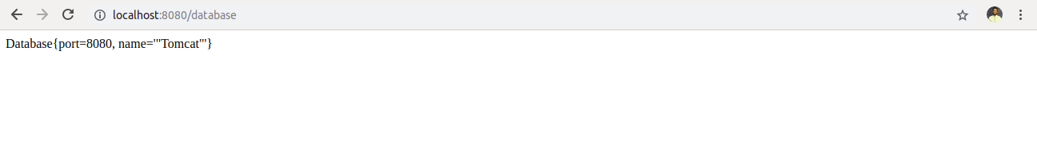

Question 5 :Configure environment specfic values form Database Bean (2 Marks)
Answer 5 :
application-prod.properties
server.port=7070
server.name=Apache Tomcat
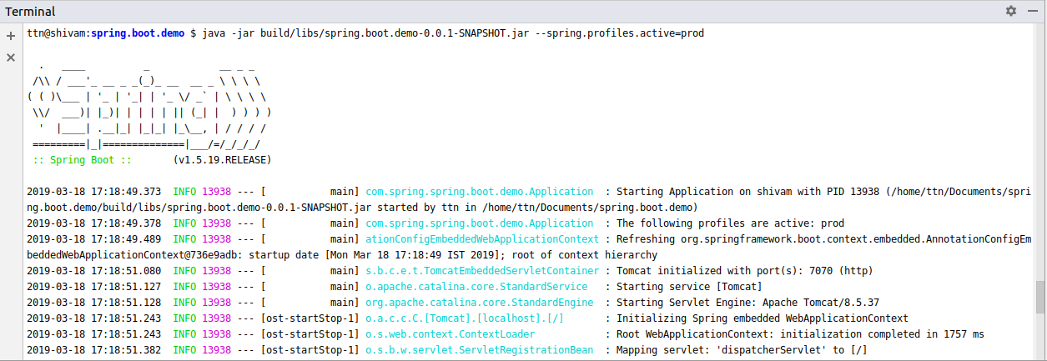
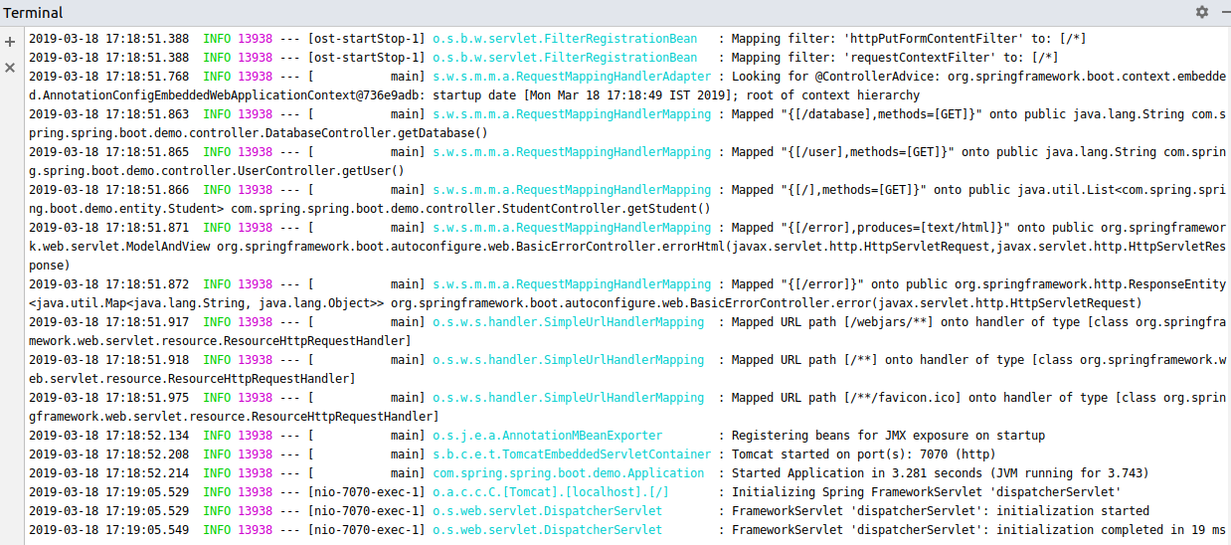
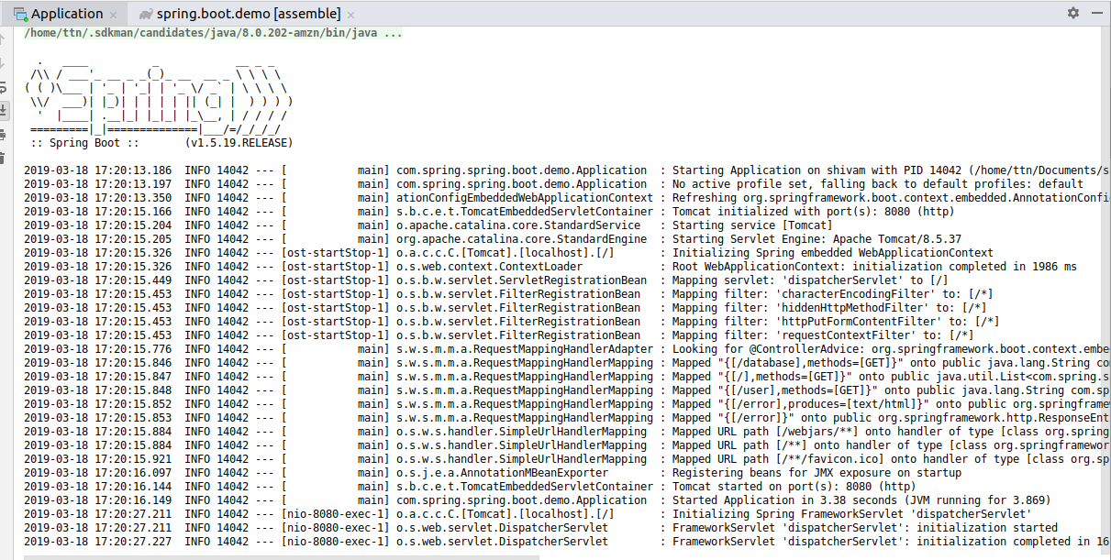
Output

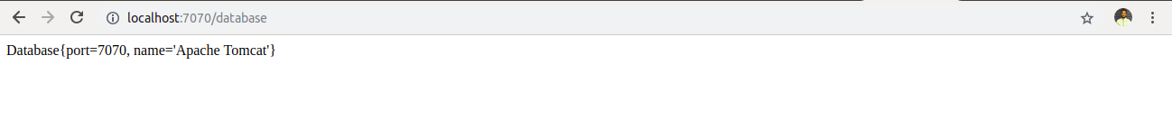

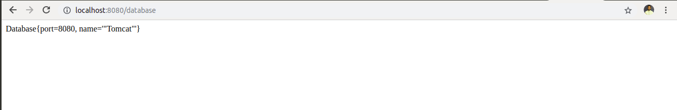

Question 6 :Apply Logging whereever you feel is necessity (1 Mark)
Answer 6 :
StudentController.java
package com.spring.spring.boot.demo.controller;
import com.spring.spring.boot.demo.entity.Student;
import com.spring.spring.boot.demo.service.StudentService;
import org.slf4j.Logger;
import org.slf4j.LoggerFactory;
import org.springframework.beans.factory.annotation.Autowired;
import org.springframework.web.bind.annotation.GetMapping;
import org.springframework.web.bind.annotation.RestController;
import java.util.List;
@RestController
public class StudentController {
@Autowired
StudentService studentService;
Logger logger= LoggerFactory.getLogger(StudentController.class);
@GetMapping("/")
public List<Student> getStudent() {
logger.info("......Enter get Students......");
return studentService.getStudents();
}
}
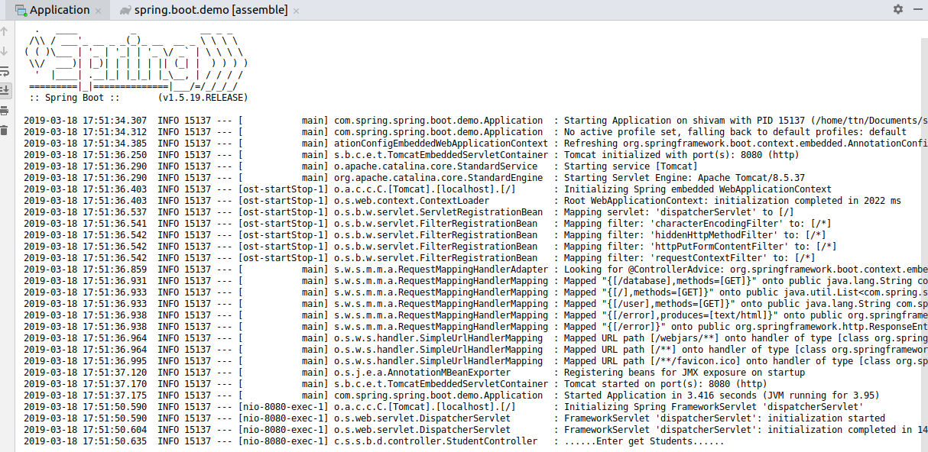

Question 7 :Bootstrap Data for Student Domain (3 Marks)
Answer 7 :
Bootstrap.java
package com.spring.spring.boot.demo.event;
import com.spring.spring.boot.demo.entity.Student;
import org.springframework.context.event.ContextRefreshedEvent;
import org.springframework.context.event.EventListener;
import org.springframework.stereotype.Component;
@Component
public class Bootstrap {
@EventListener(Student.class)
public void init(){
System.out.println("Application is up for student and running");
}
}
StudentController.java
package com.spring.spring.boot.demo.controller;
import com.spring.spring.boot.demo.entity.Student;
import com.spring.spring.boot.demo.event.Bootstrap;
import com.spring.spring.boot.demo.service.StudentService;
import org.slf4j.Logger;
import org.slf4j.LoggerFactory;
import org.springframework.beans.factory.annotation.Autowired;
import org.springframework.web.bind.annotation.GetMapping;
import org.springframework.web.bind.annotation.RestController;
import java.util.List;
@RestController
public class StudentController {
@Autowired
StudentService studentService;
@Autowired
Bootstrap bootstrap;
Logger logger= LoggerFactory.getLogger(StudentController.class);
@GetMapping("/")
public List<Student> getStudent() {
bootstrap.init();
logger.info("......Enter get Students......");
return studentService.getStudents();
}
}
