Fivetran

**Destination setup**

AWS Redshift

1. Account on AWS

2. Login into Redshift (serverless)

3. In fivetran, add Destination -> name it -> Select Redshift.

4. Start Redshift serverless, keep default settings. Click Save configuraton. Default project and workspace will be created.

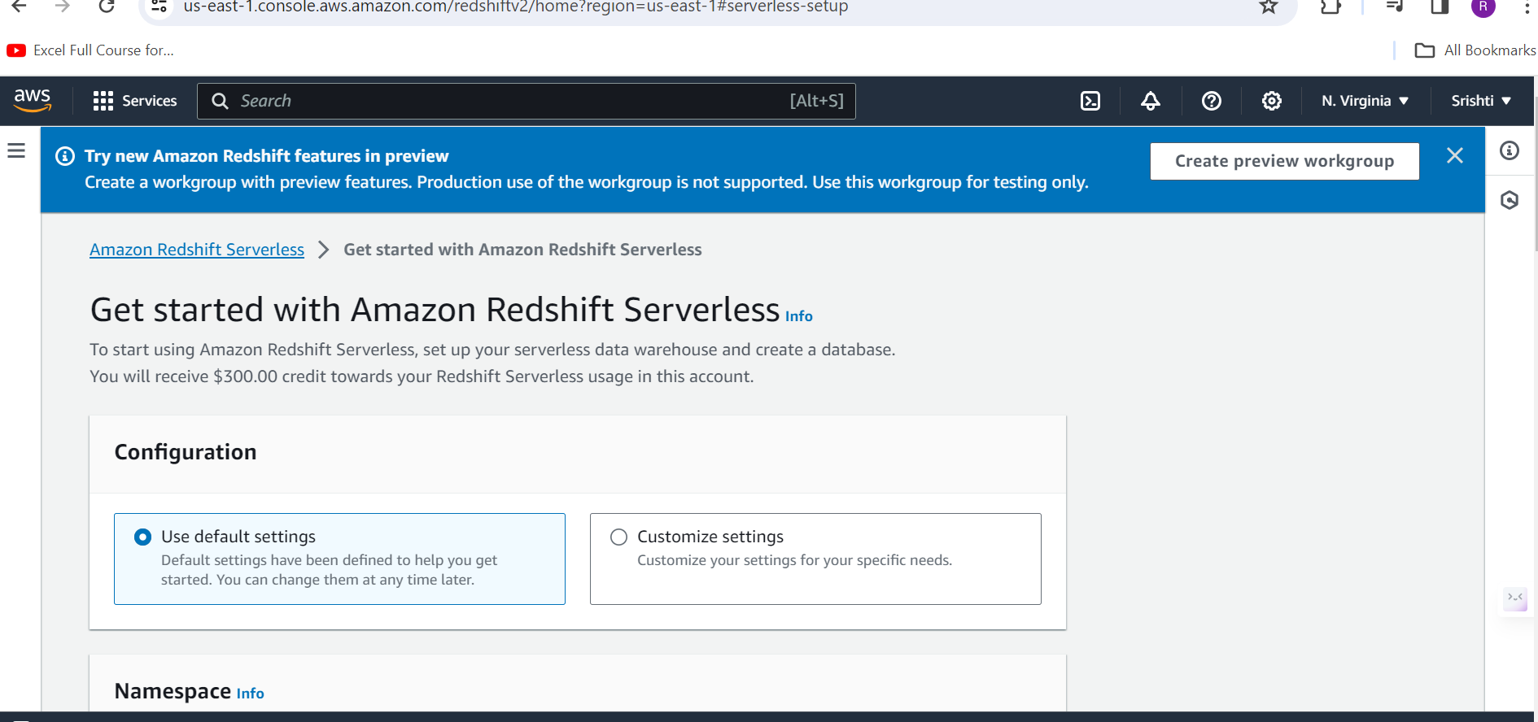

5. go to Provisioned Cluster dashboard

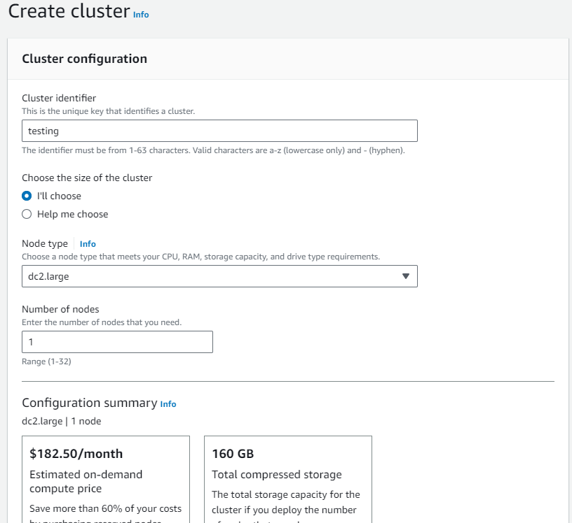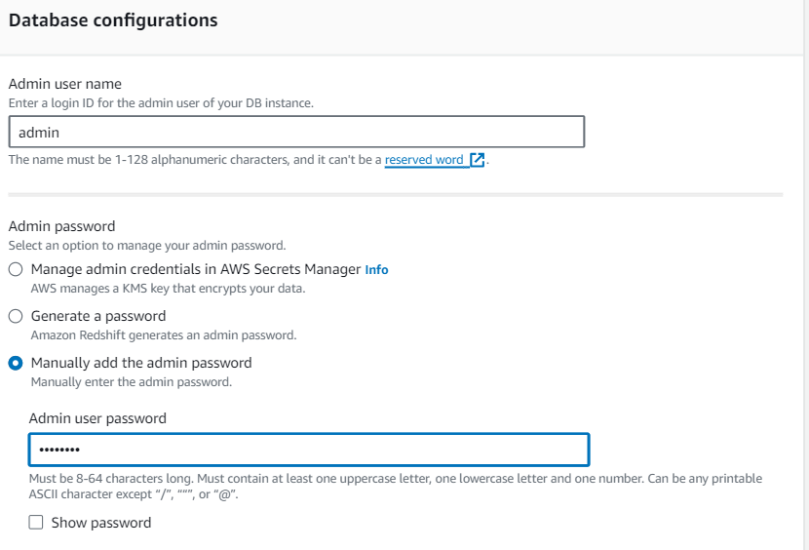

6. Select the cluster name -> Copy the endpoint before the colon string for host string

(test.c52anukjly3j.eu-north-1.redshift.amazonaws.com:5439/dev test.c52anukjly3j.eu-north-1.redshift.amazonaws.com:5439/dev)

7. Select cluster name -> properties -> Edit network and security settings -> Turn on public access

8. Select cluster name -> Go on VPC security group. Click on security group id -> edit inbound rules ->

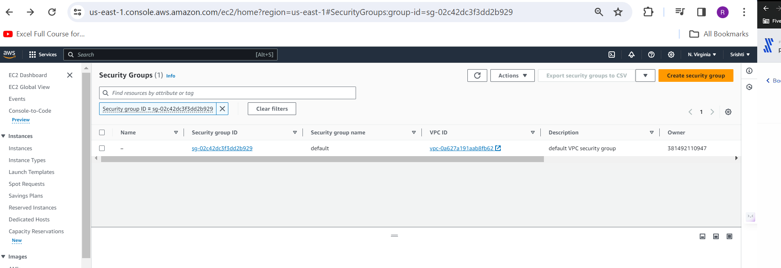

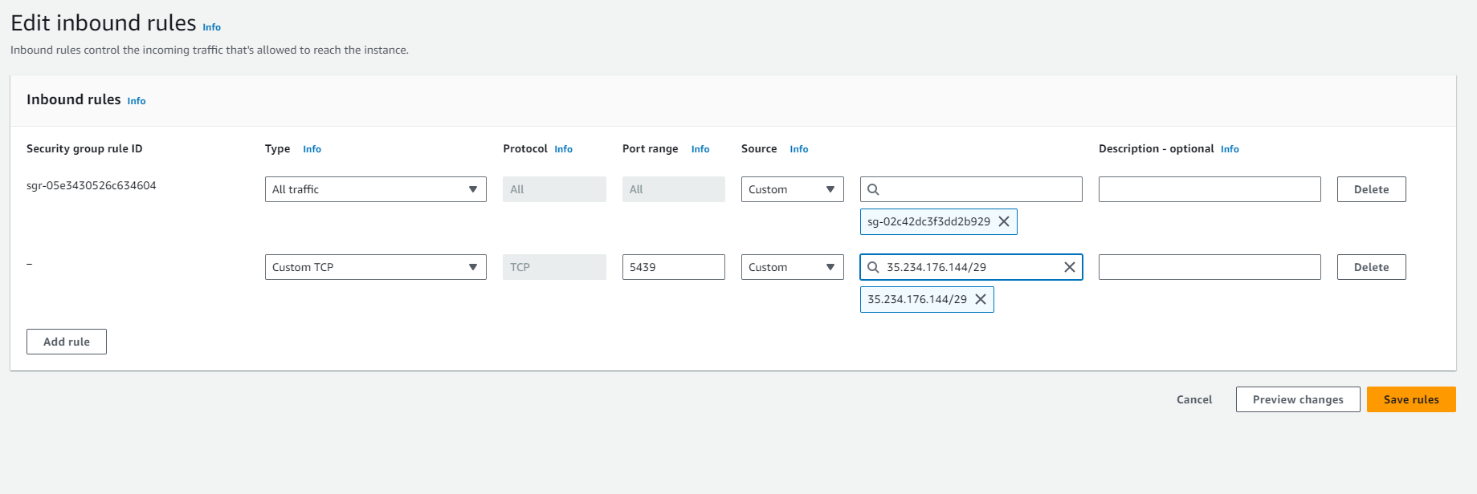

Save rules

9. 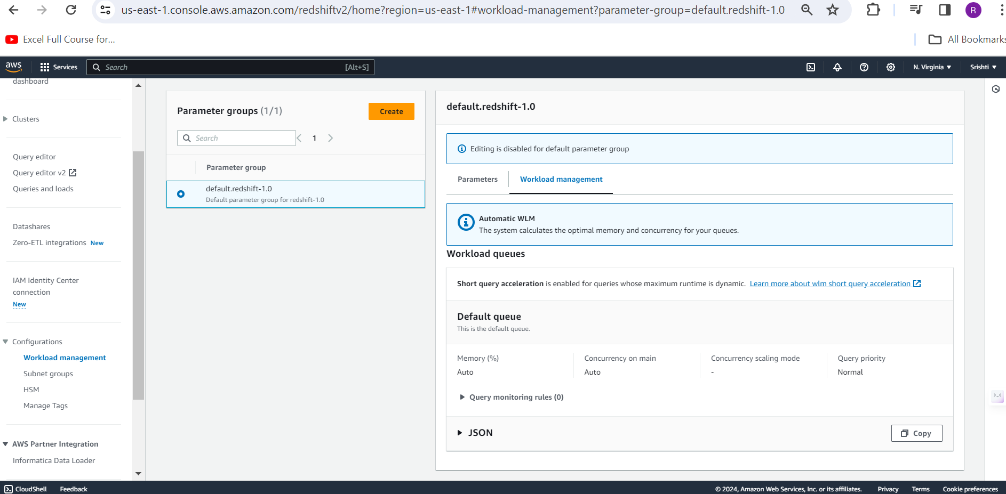

POSTGRES

1. Add destination -> name it -> setup postgres .
2. Run the commands given in setup guide. Need to create database with CREATE DATABASE <DB> .
3. Fill info in form.

Databricks AWS

1. Account on databricks(free trial) -> AWS console->create stack
2. On databricks console, go to data -> metastore_aws_ap_south_1-> workspaces -> open .
3. SQl warehouses -> create warehouse

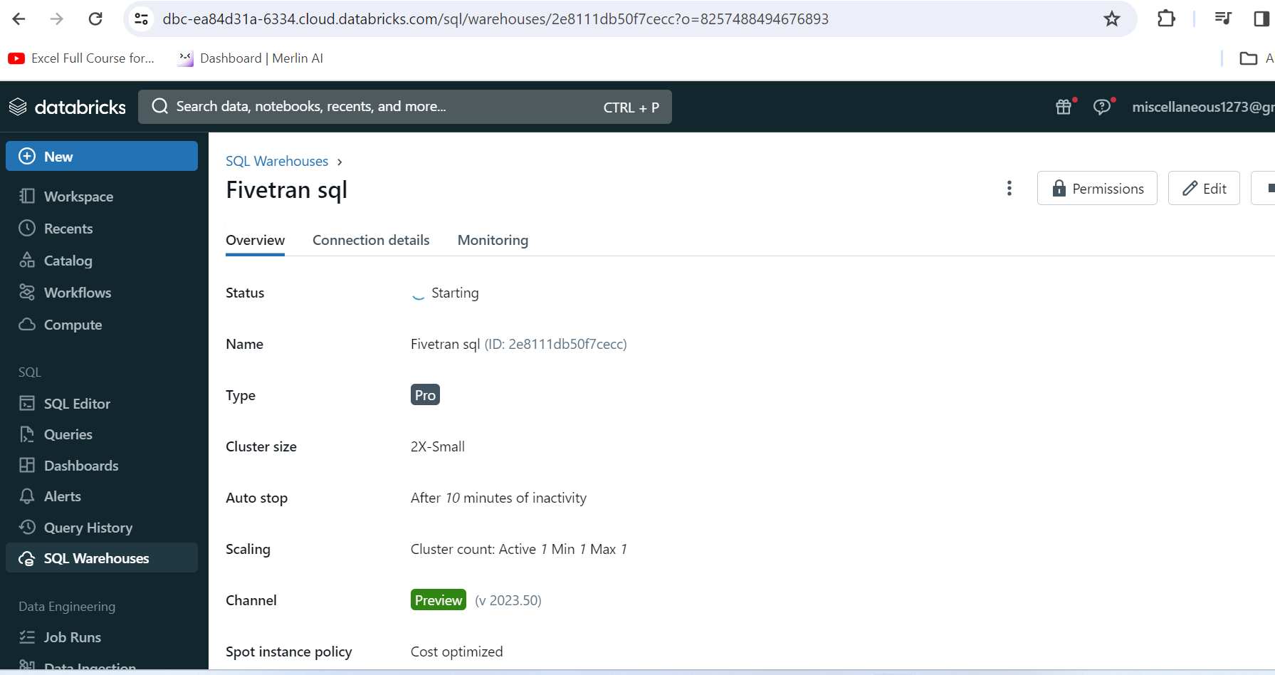

1. Note the values

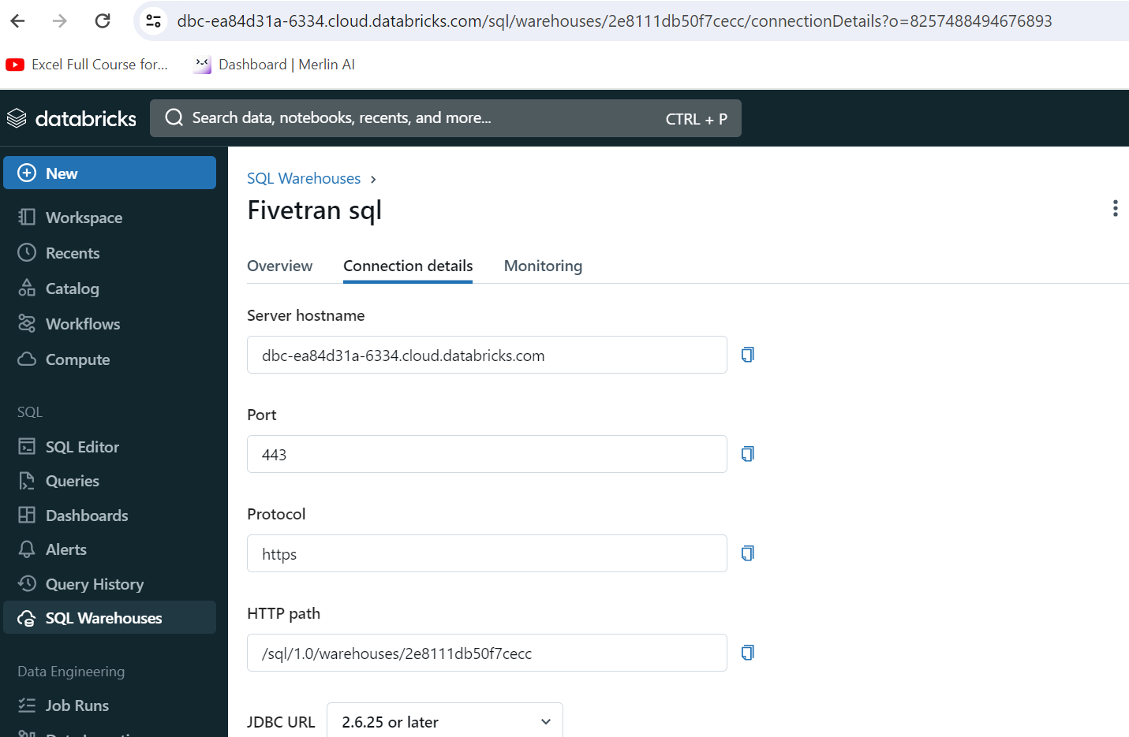

1. In the same tab, click on generate acecss token. The new window appears name it and generate the token.
2. Paste the token key in the fivetran dashboard.
3. Fill ther details ffrom above window(connection details).

SNOWFLAKE

1. Account in snowflakes.
2. Craete a new worksheet.
3. Copy the script provided in setup guide, change the details appropriately, then run the script.
4. Copy the link without https:// and fill in the host field.
5. Fill other details in the setup form.

**Source setup**

GDrive

1. New folder in drive.
2. In fivetran dashboard, go to connectors tab and click Add connector.
3. Select google drive then choose the destination.
4. On the Fivetran setup form, copy the Fivetran email and in the drive, share the folder(three dots) to that link.
5. Copy the link of the folder(three dots) and paste in the form and click the button to add the connector.
6. Try out the initial sync.

Shopify

1. On shopify website, make an account and log into the shopify to make your own store.
2. On fivetran dashboard, Add connector-> select the destination -> choose Shopify -> add connector
3. Install the shopify app from the link given.

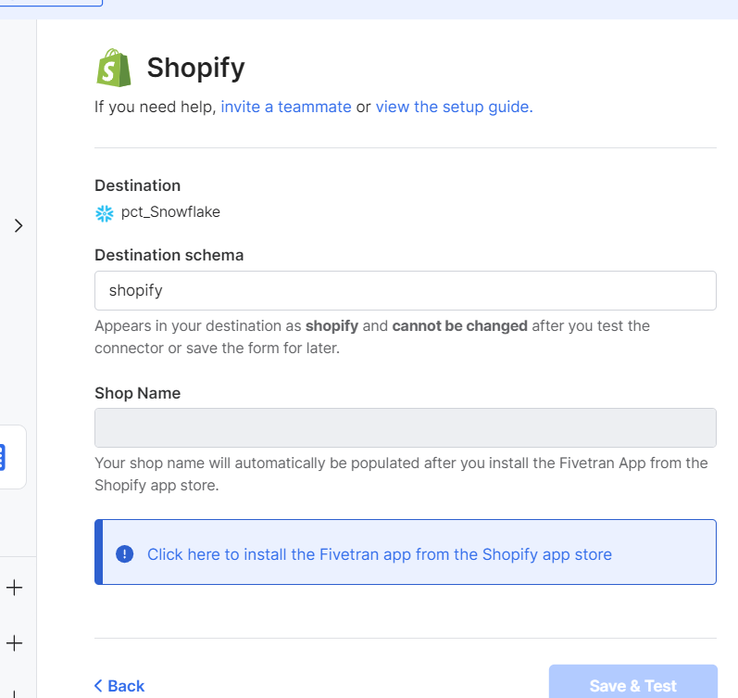

1. Once again choose the destination.
2. It will automatically take in the store id. Just authorize it.
3. Setup the connection.