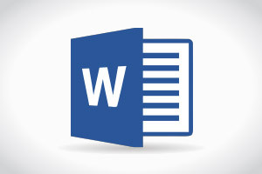

1. Os is an operating system
2. It is an interface between user and hardware
3. It provides any services
4. It manages both hardware ad software parts of a system