Answer-4

521651

Register No.-22BTCS109

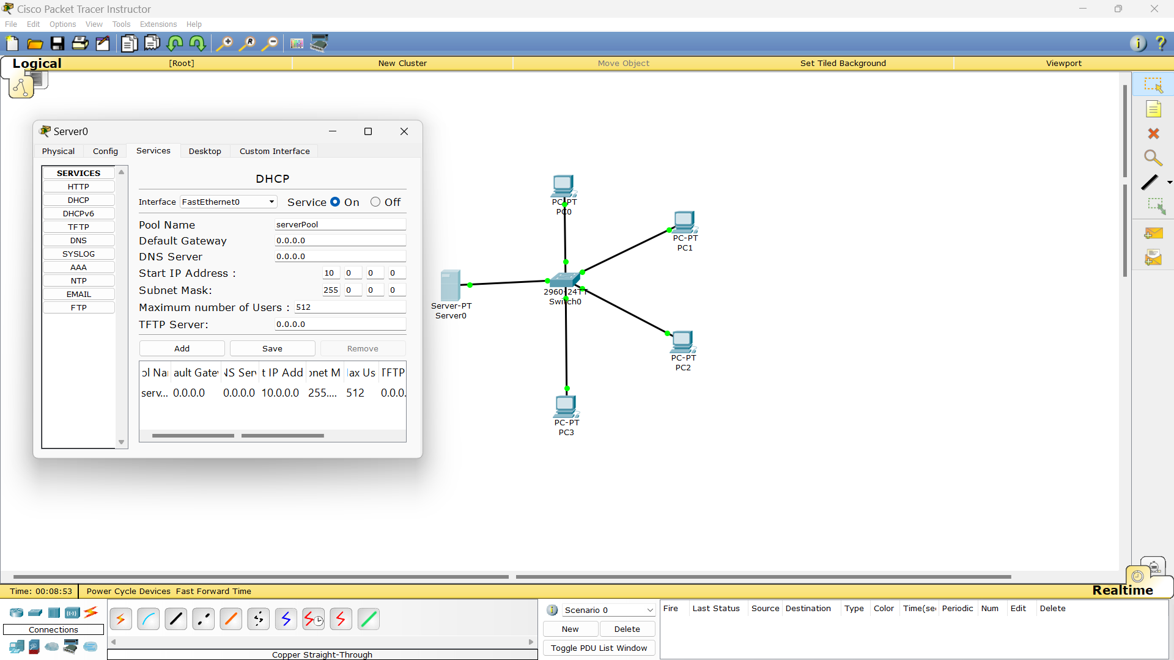

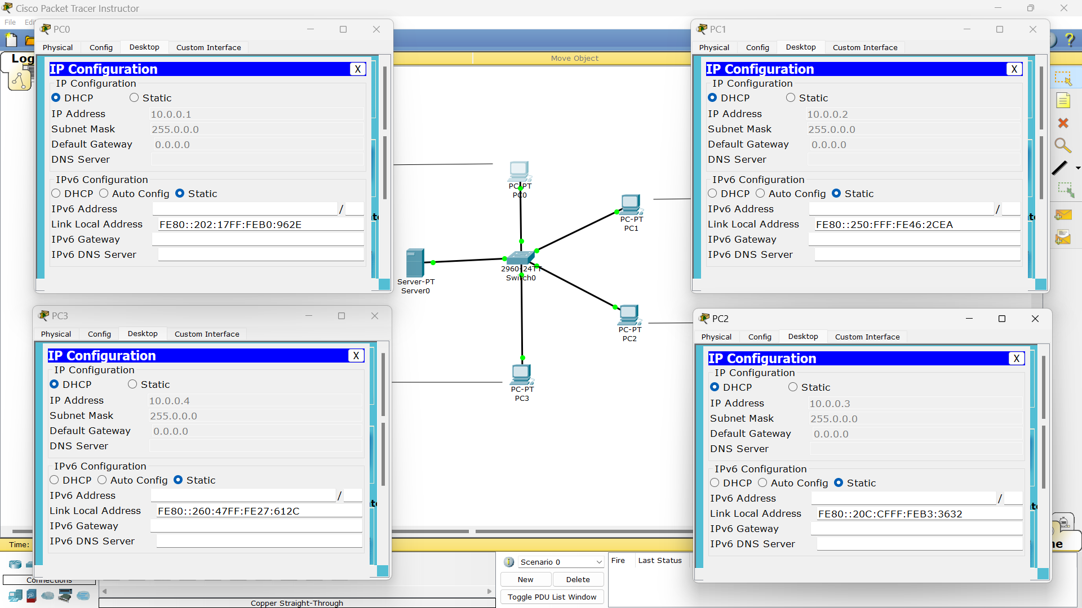

Answer-6

521651

Register No.-22BTCS109

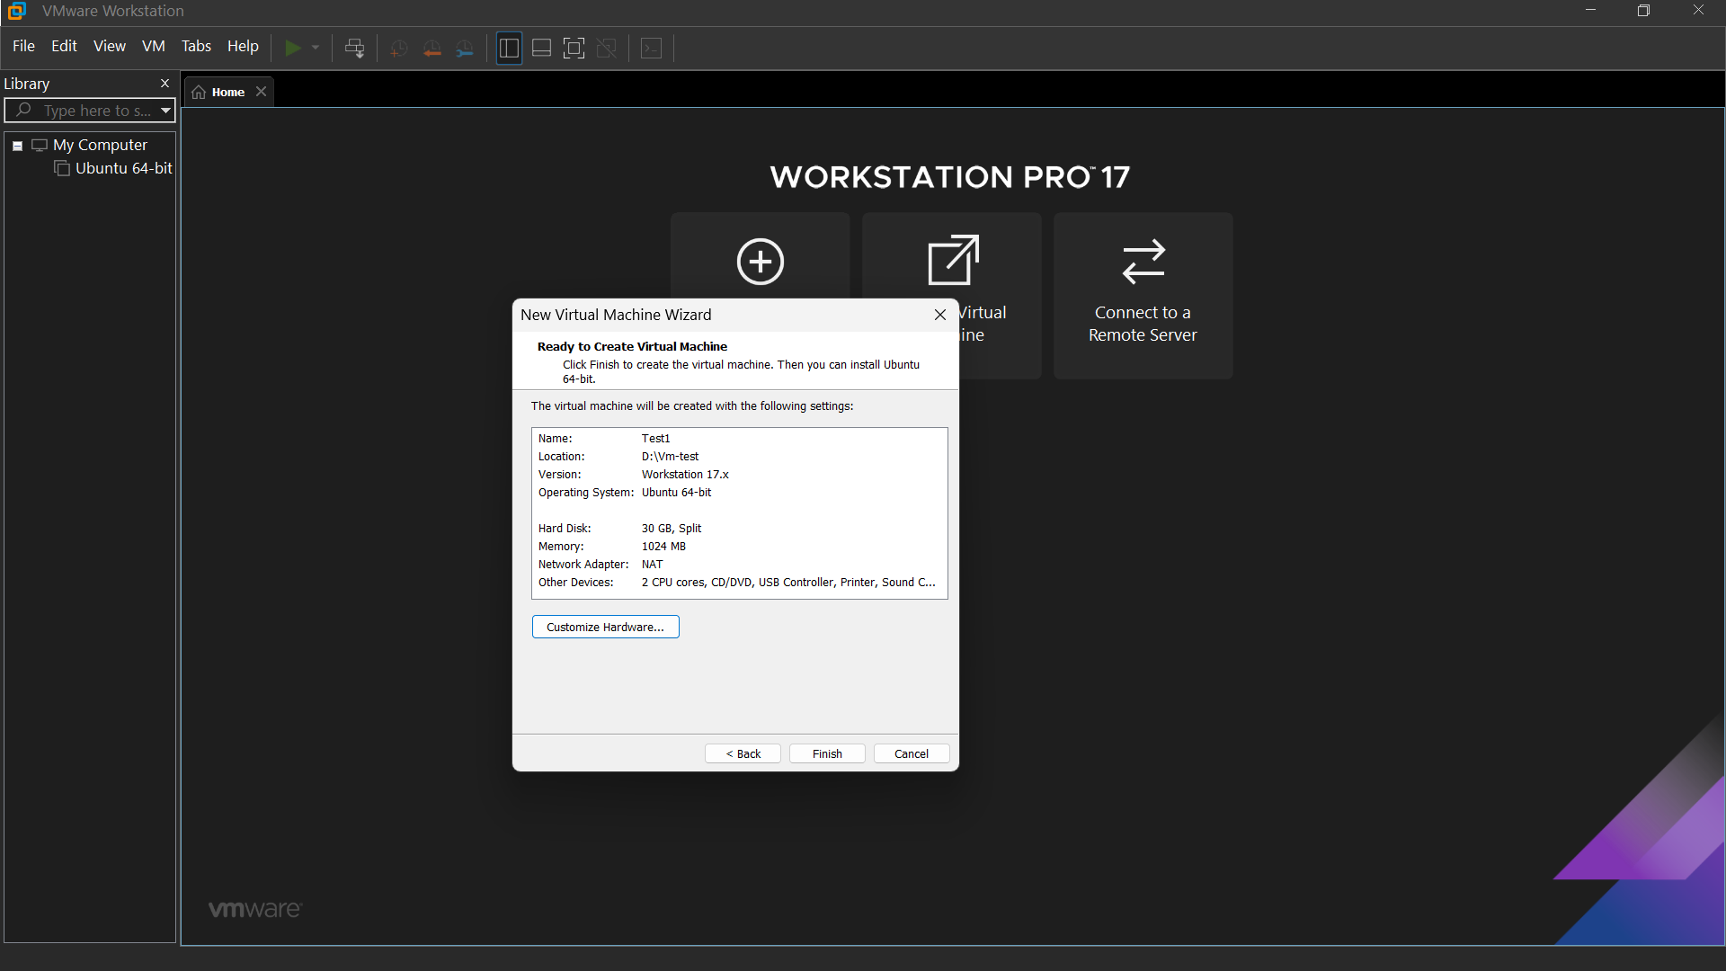

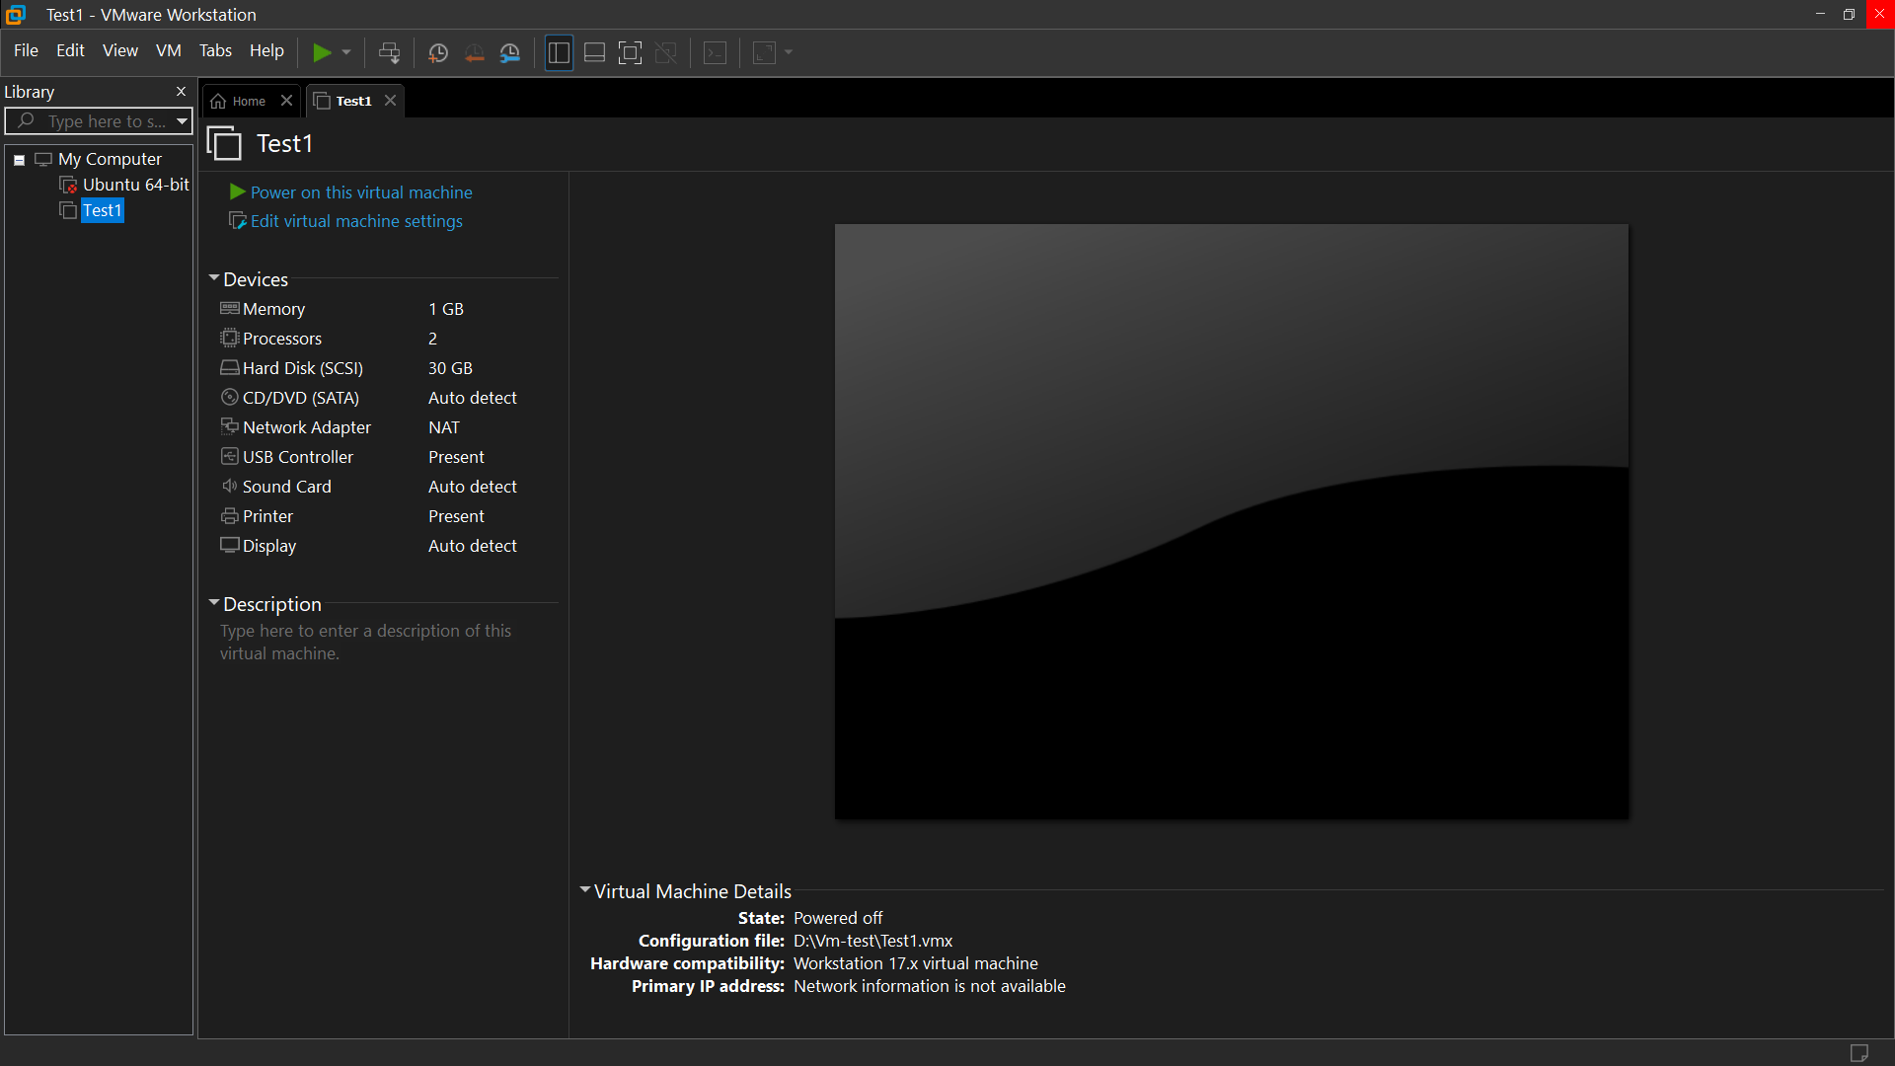

ANSWER-8

521651

Register No.-22BTCS109

ANSWER-9

521651

Register No.-22BTCS109

