|  |
| --- |
| GCU – Alumni]=]  r |
| **Dr. A P J Abdul Kalam School of Engineering**  **I Semester, B.Tech in Computer Science and Engineering**  **(AL&ML, CS and DS)** |
| LAC SOFTWARE BASED LEARNING |
|  |

|  |  |
| --- | --- |
| Name of the Student | Dhanaraj Dattanakree |
| Section | B |
| Roll No | 22BTDS |
| Course Instructor | MRS.INDIRA.DEVI |

MODULE-1

1. Create A=3*3, B=4*4 and C=3*4 and D=4*3 matrices in matlab

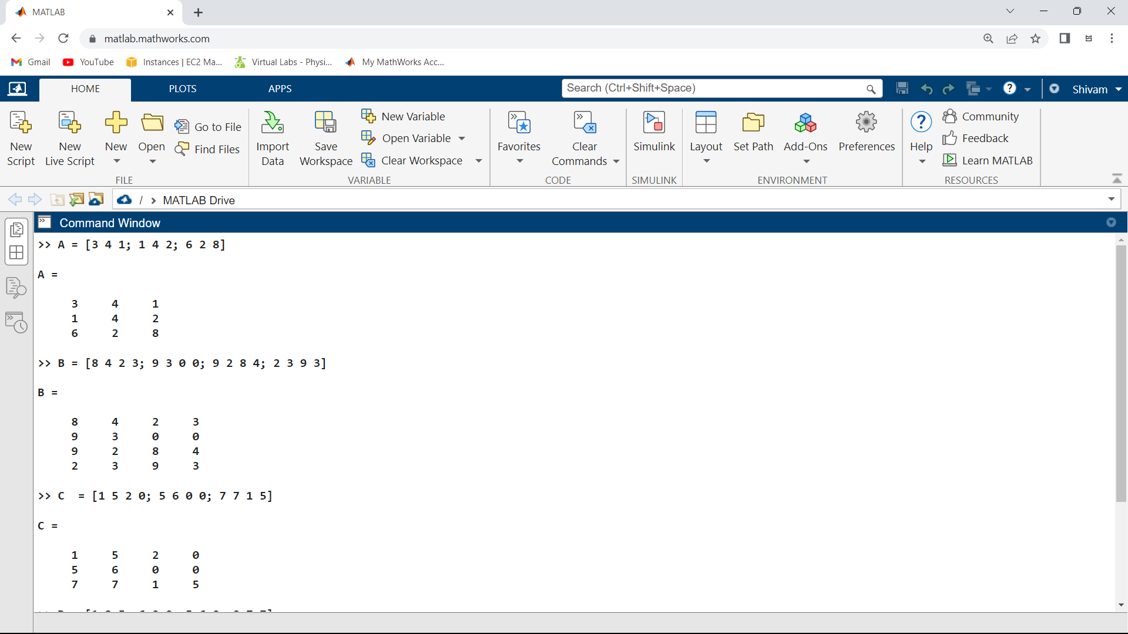

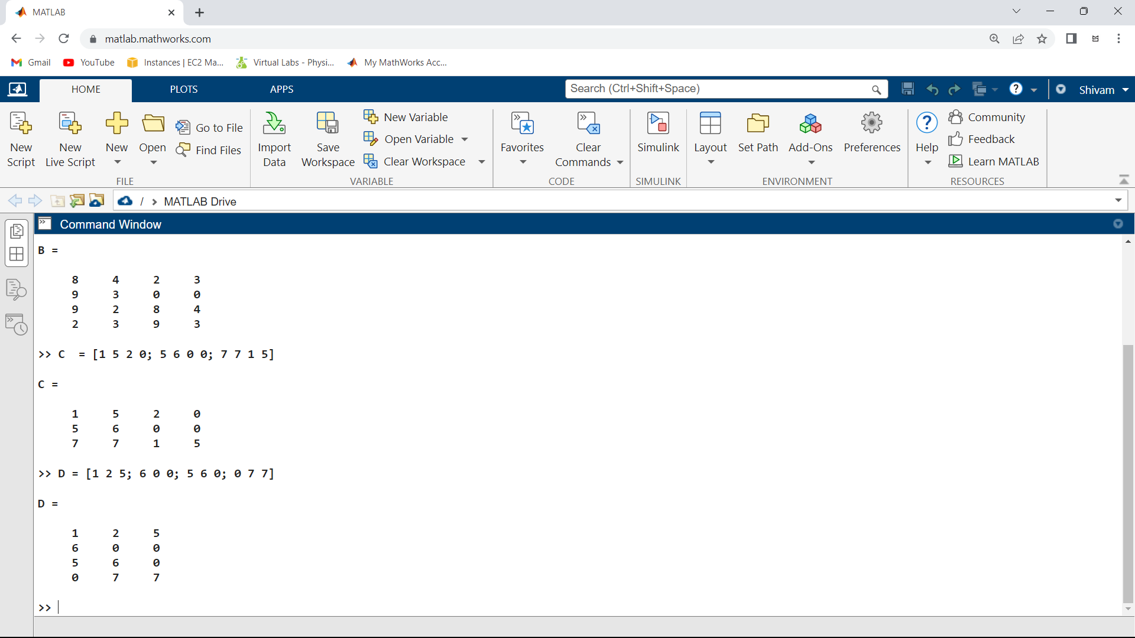

2. A+B and B*D operations in matlab

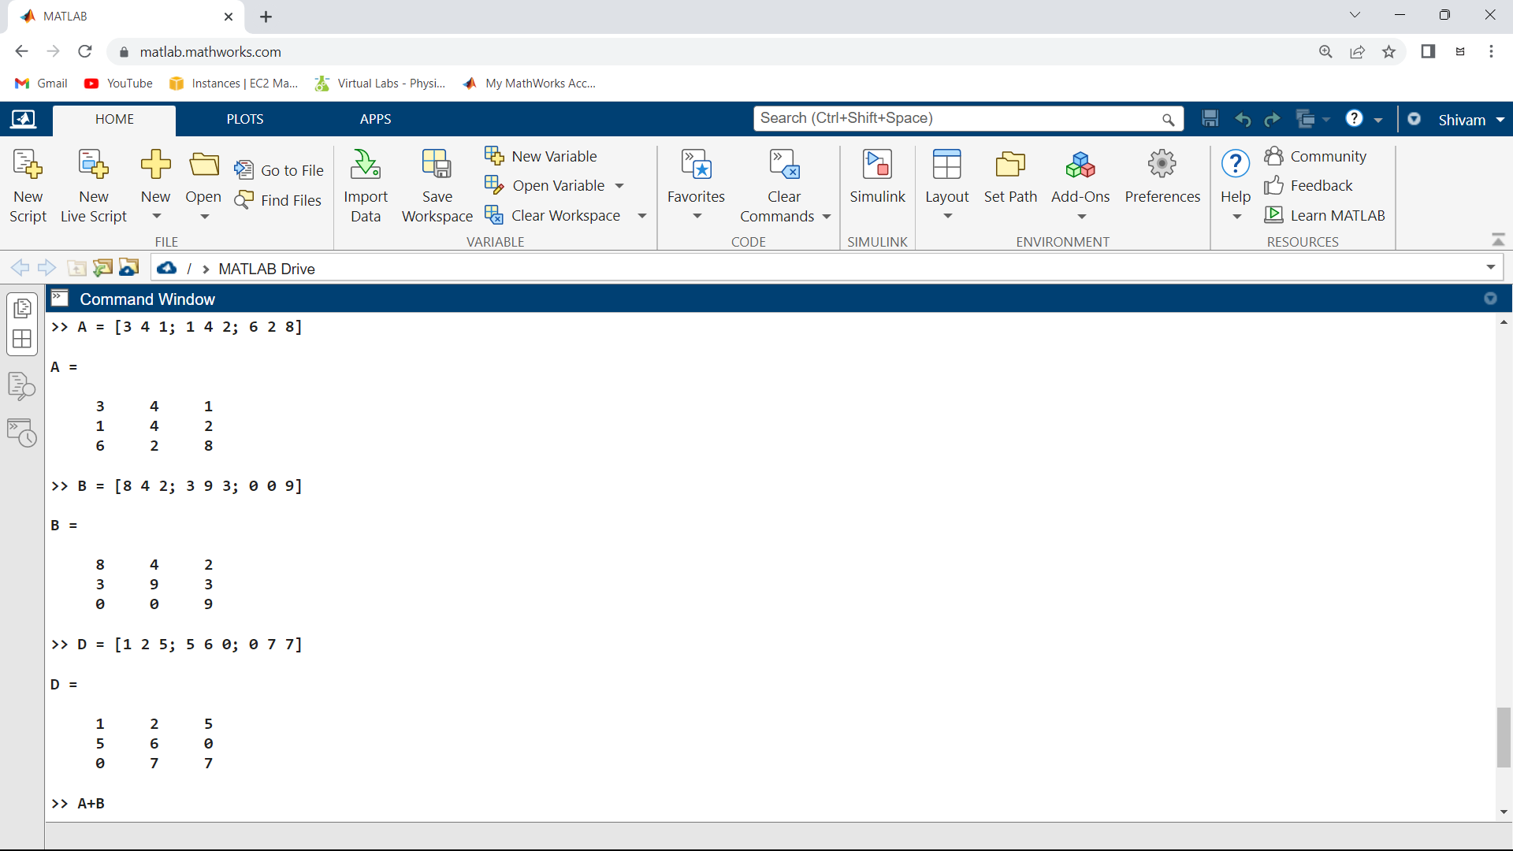

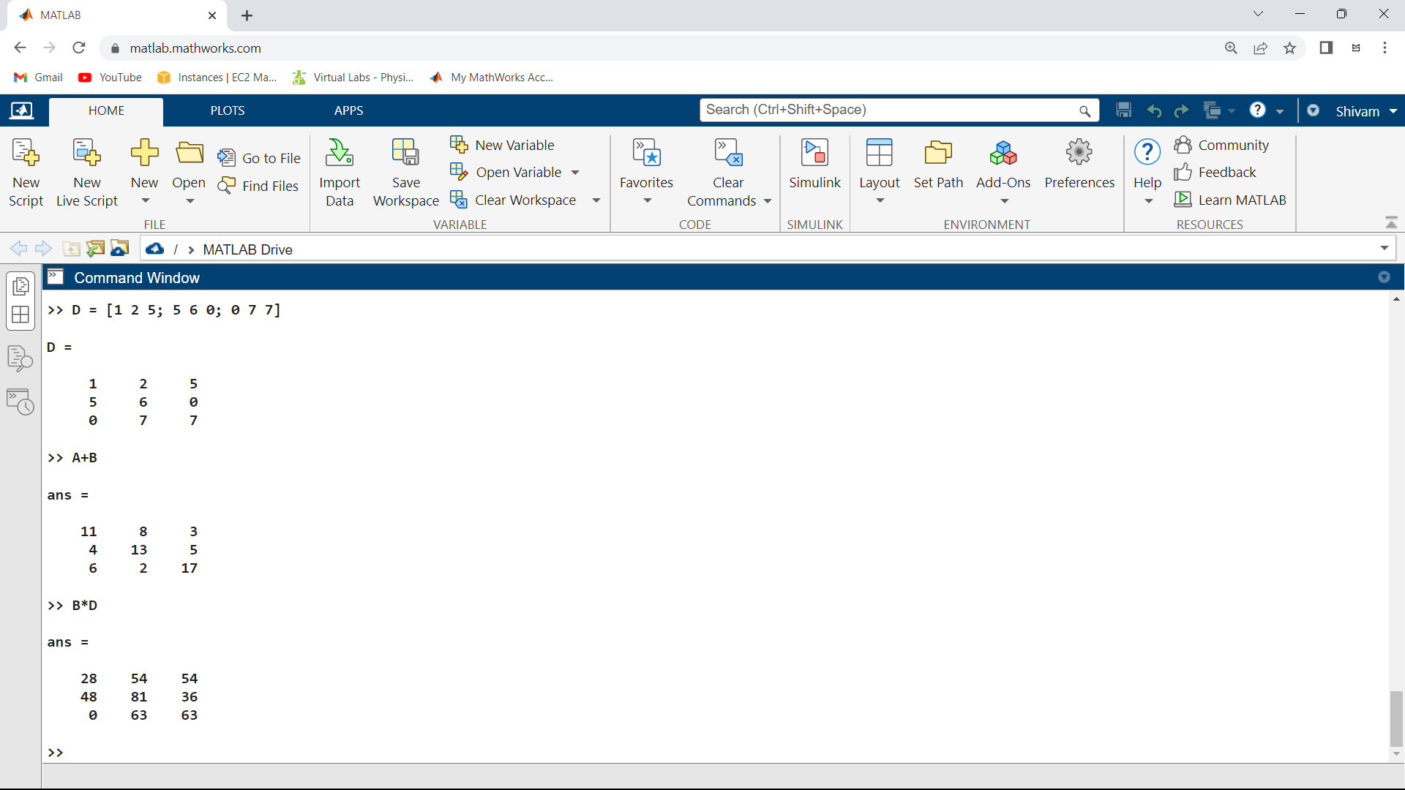

3. Determinant of all matrices

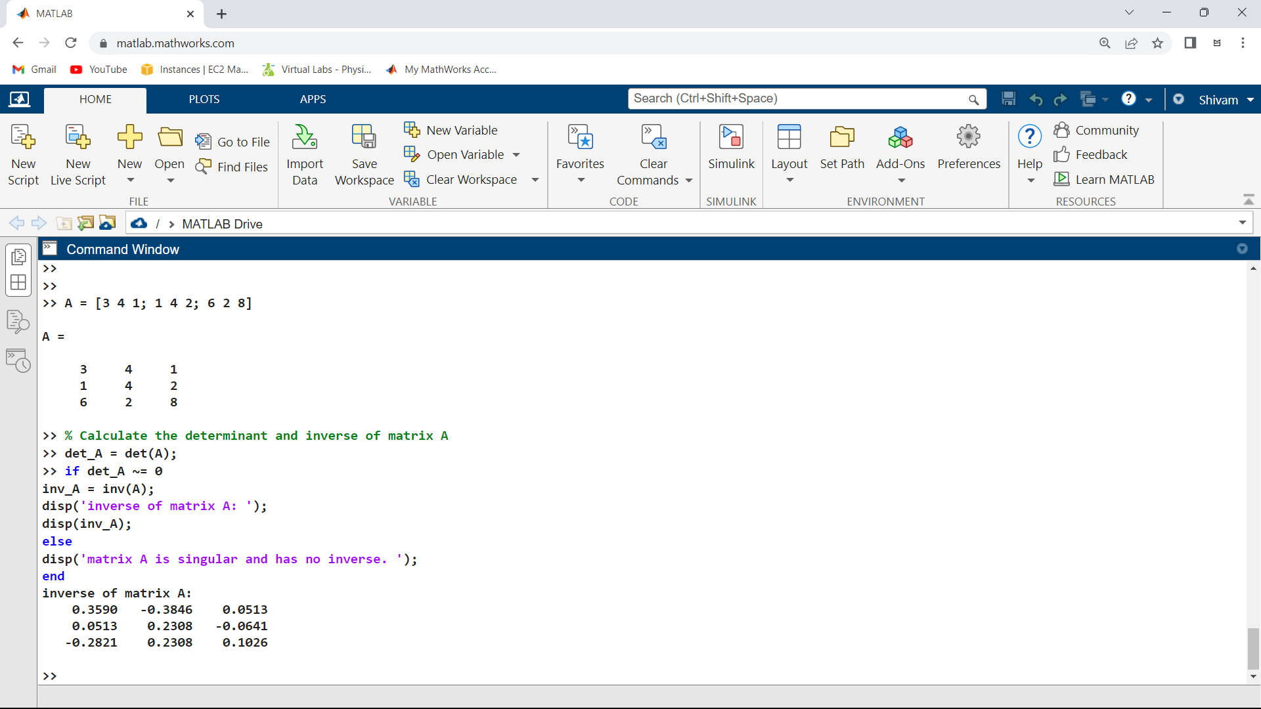

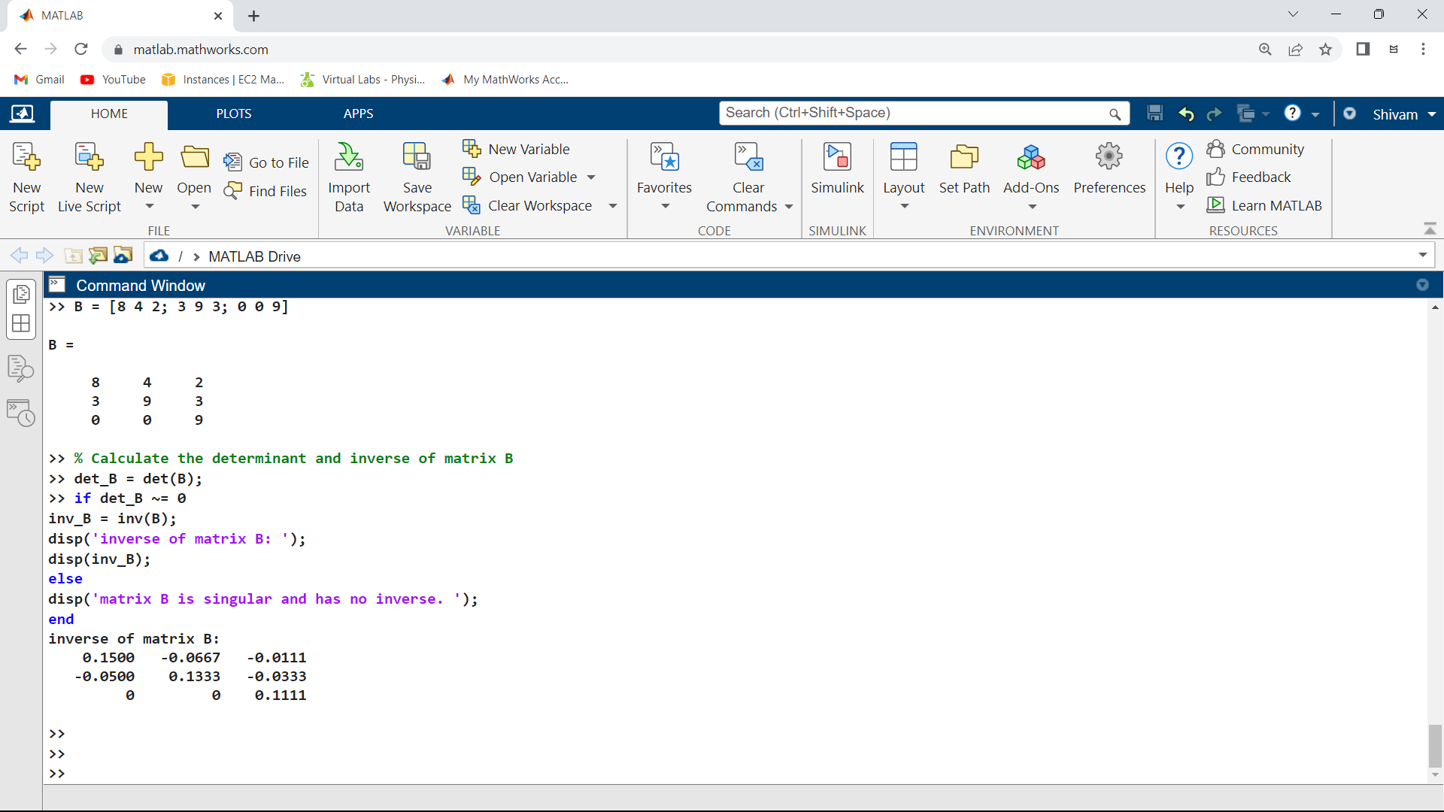

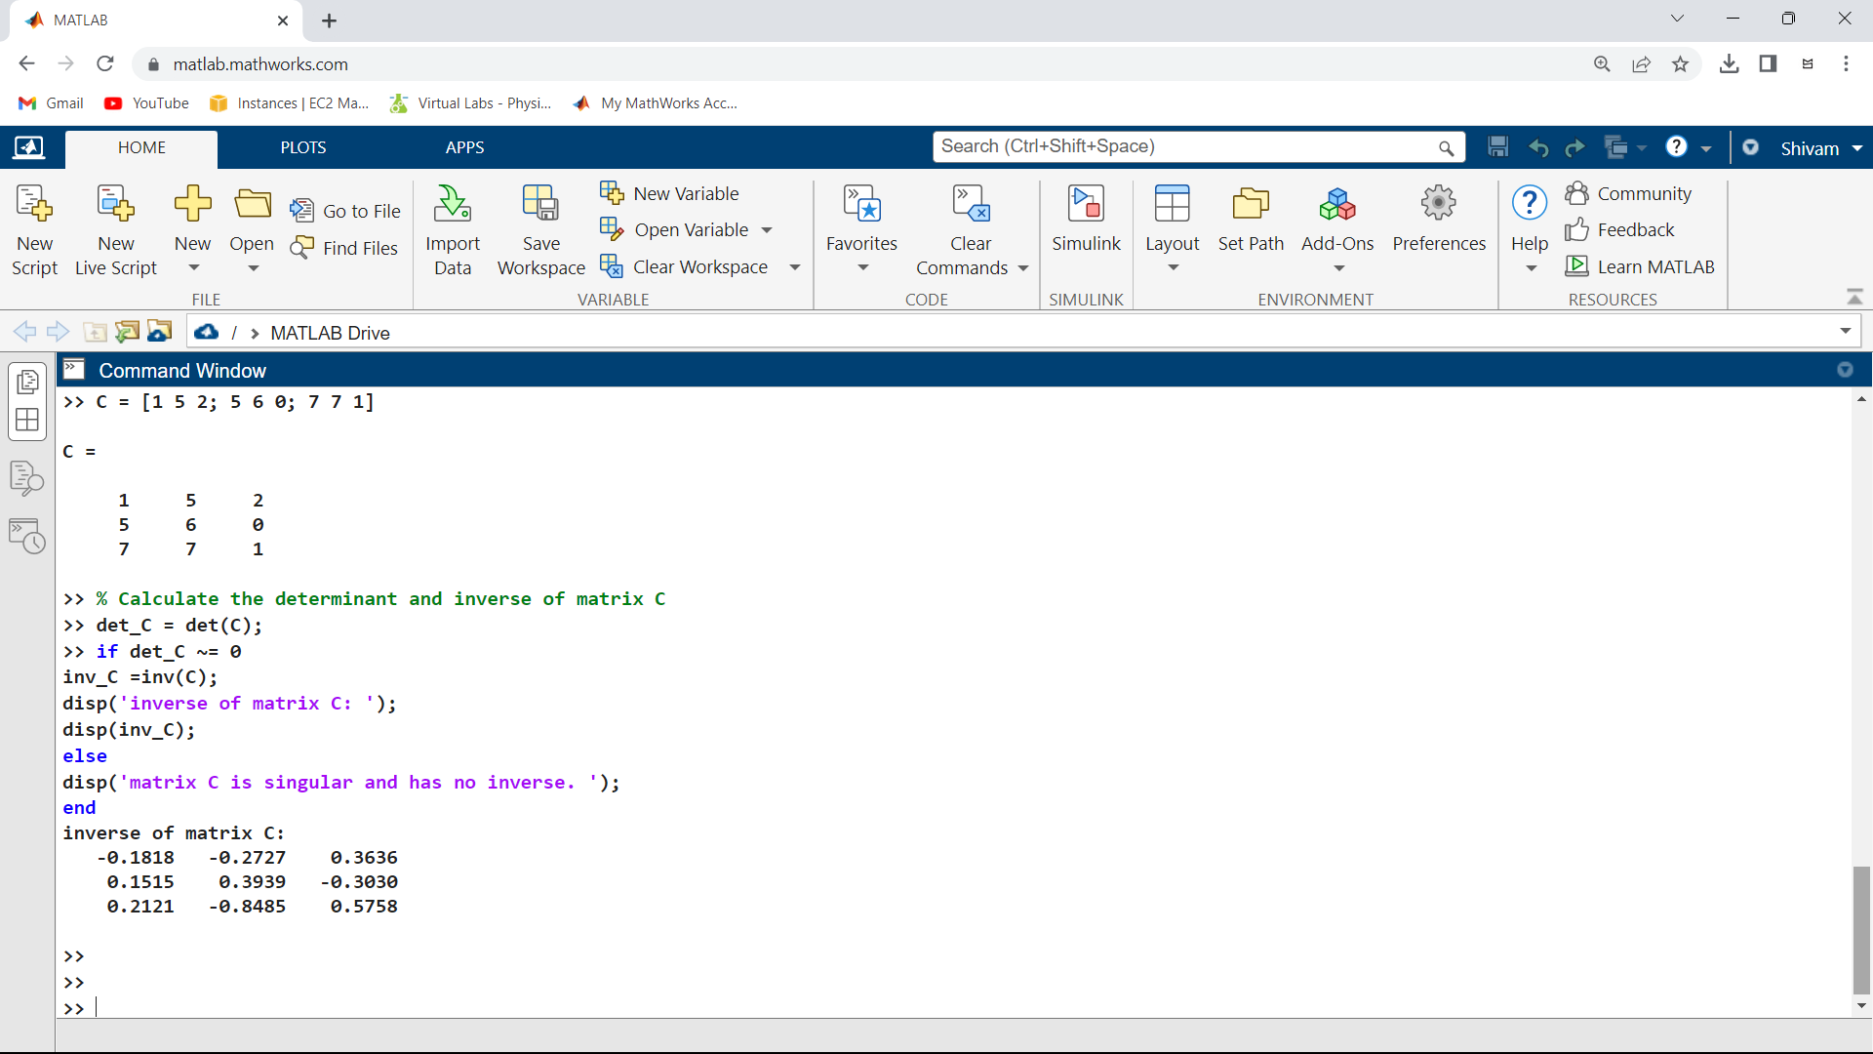

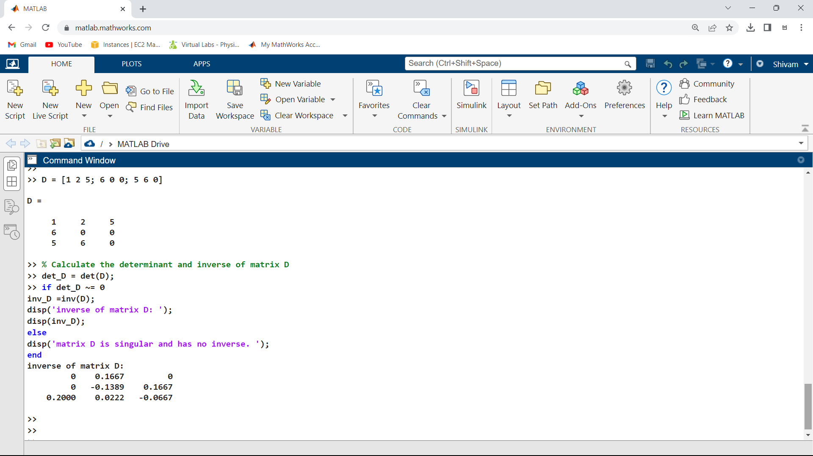

4. Eigenvalues and Eigenvectors of all the matrices

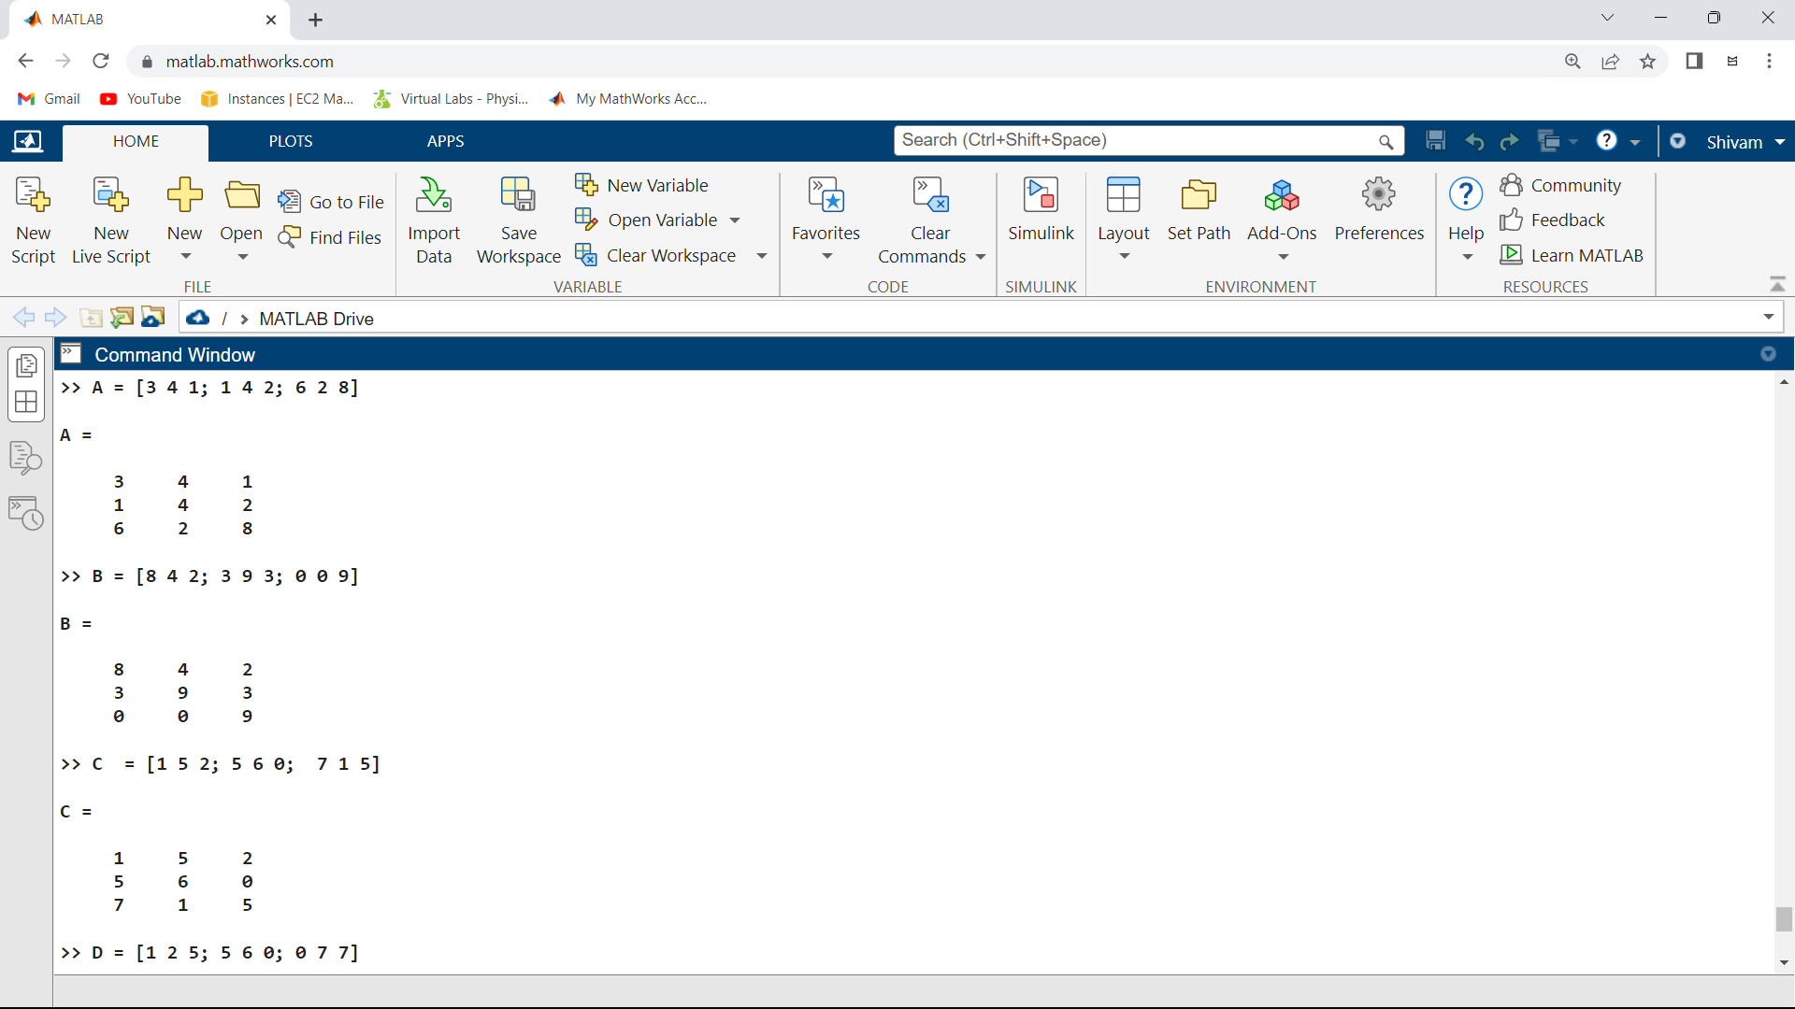

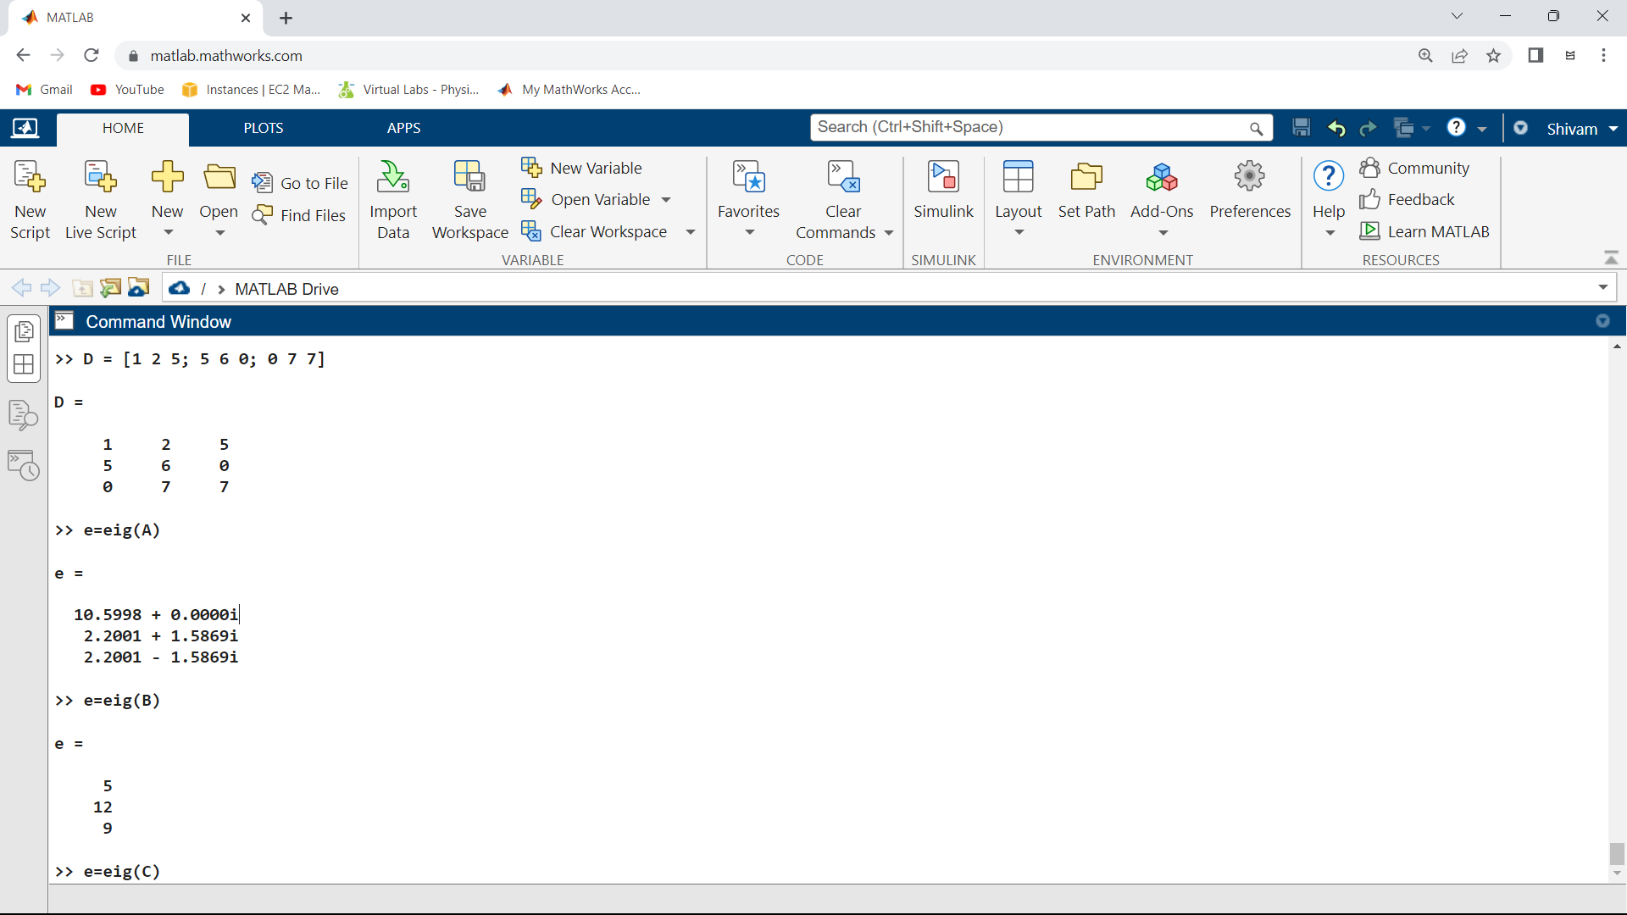

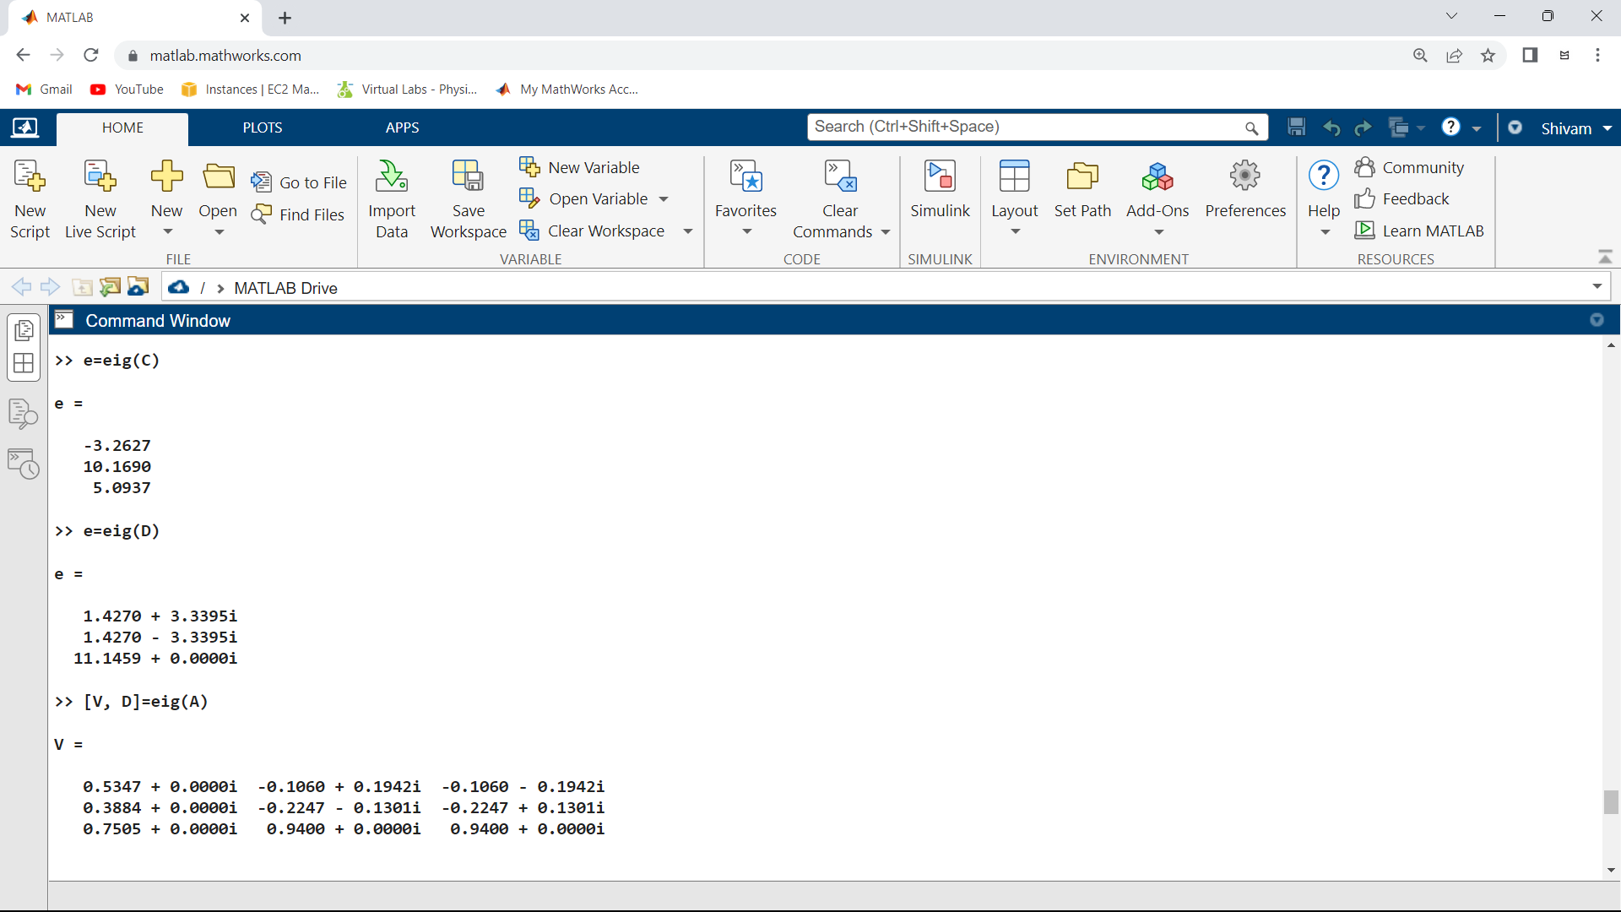

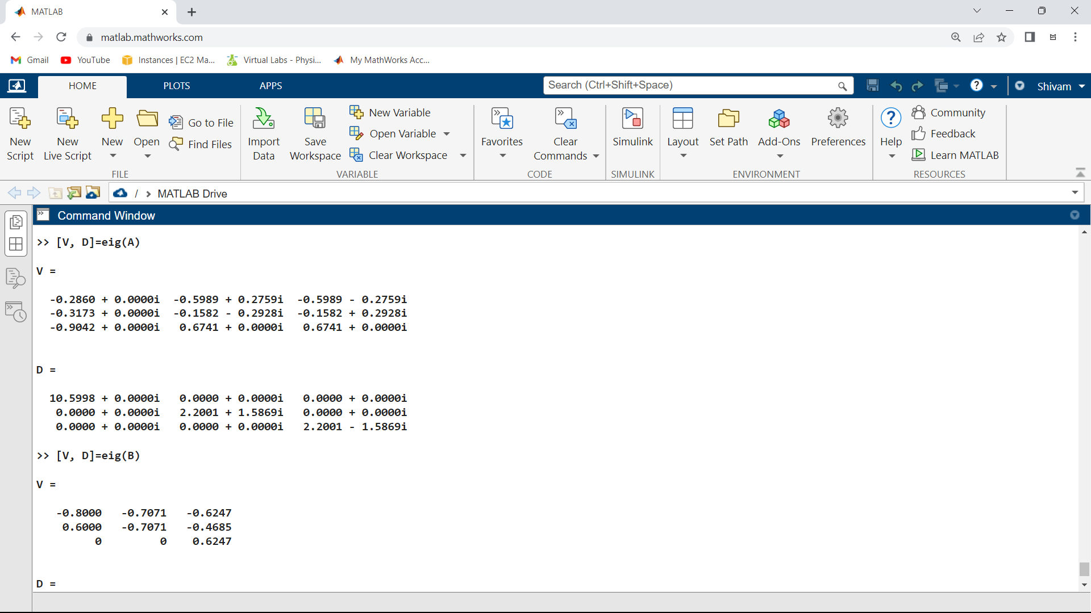

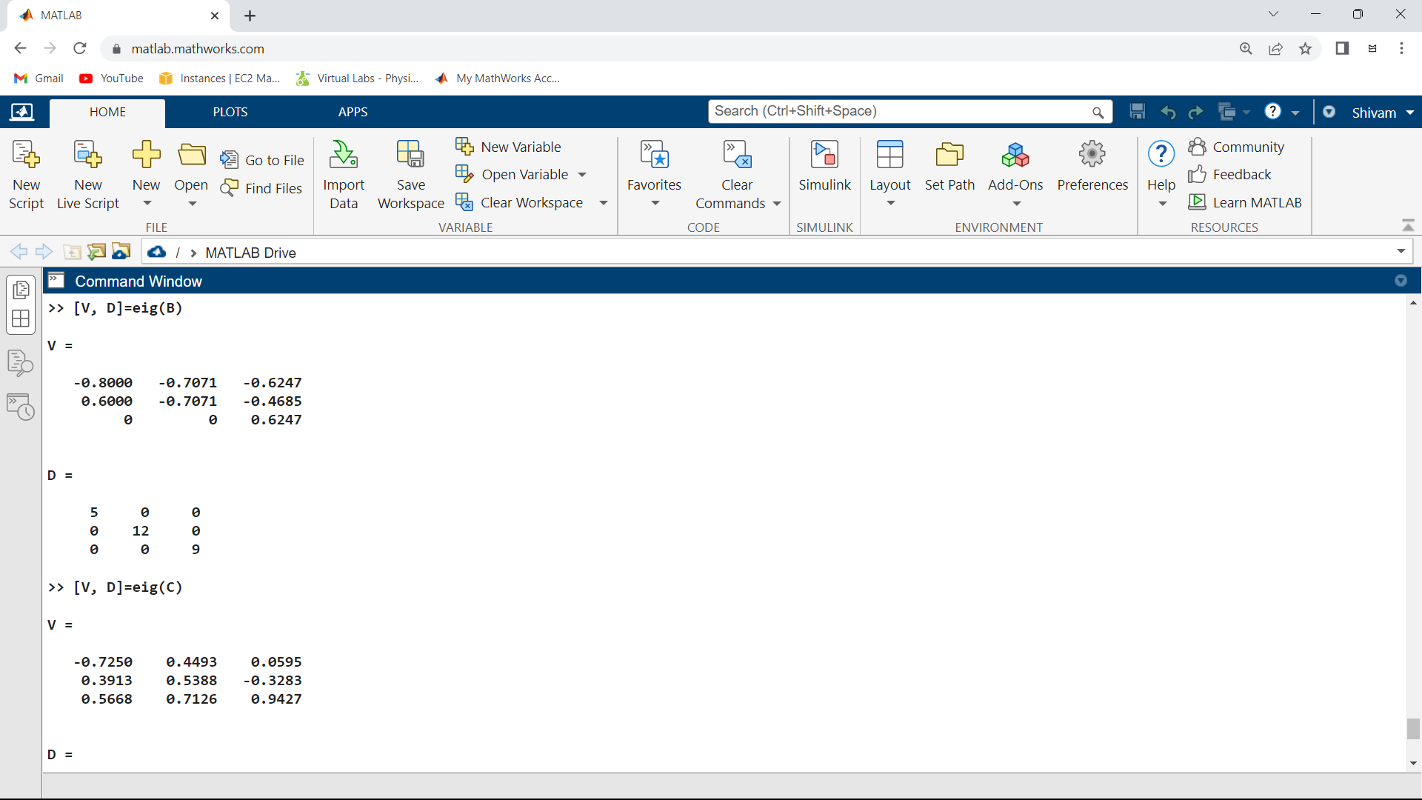

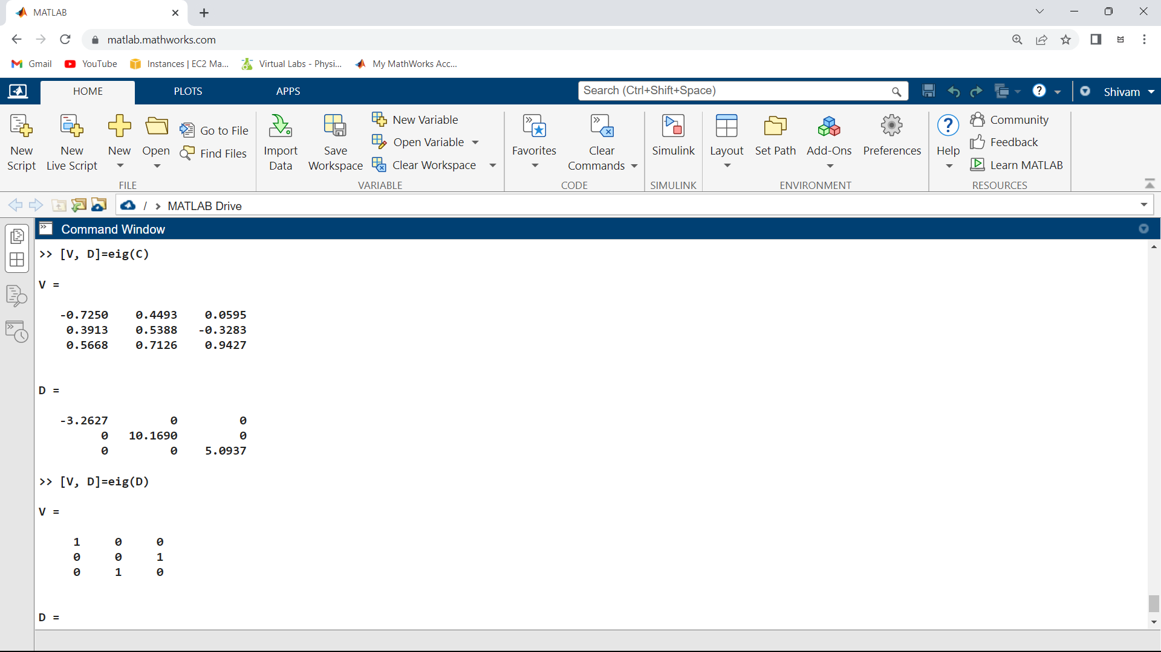

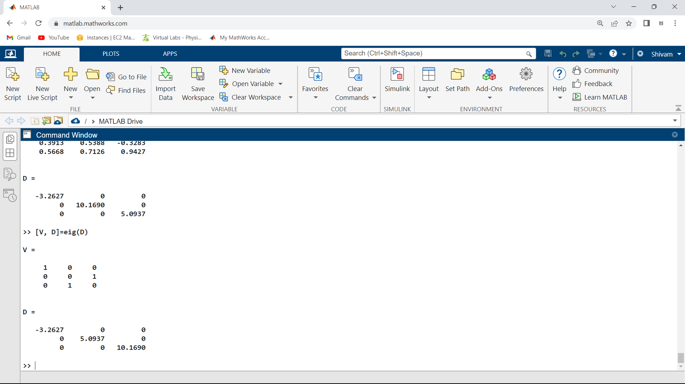

MODULE – 2

1.Plot the polar curve in Python

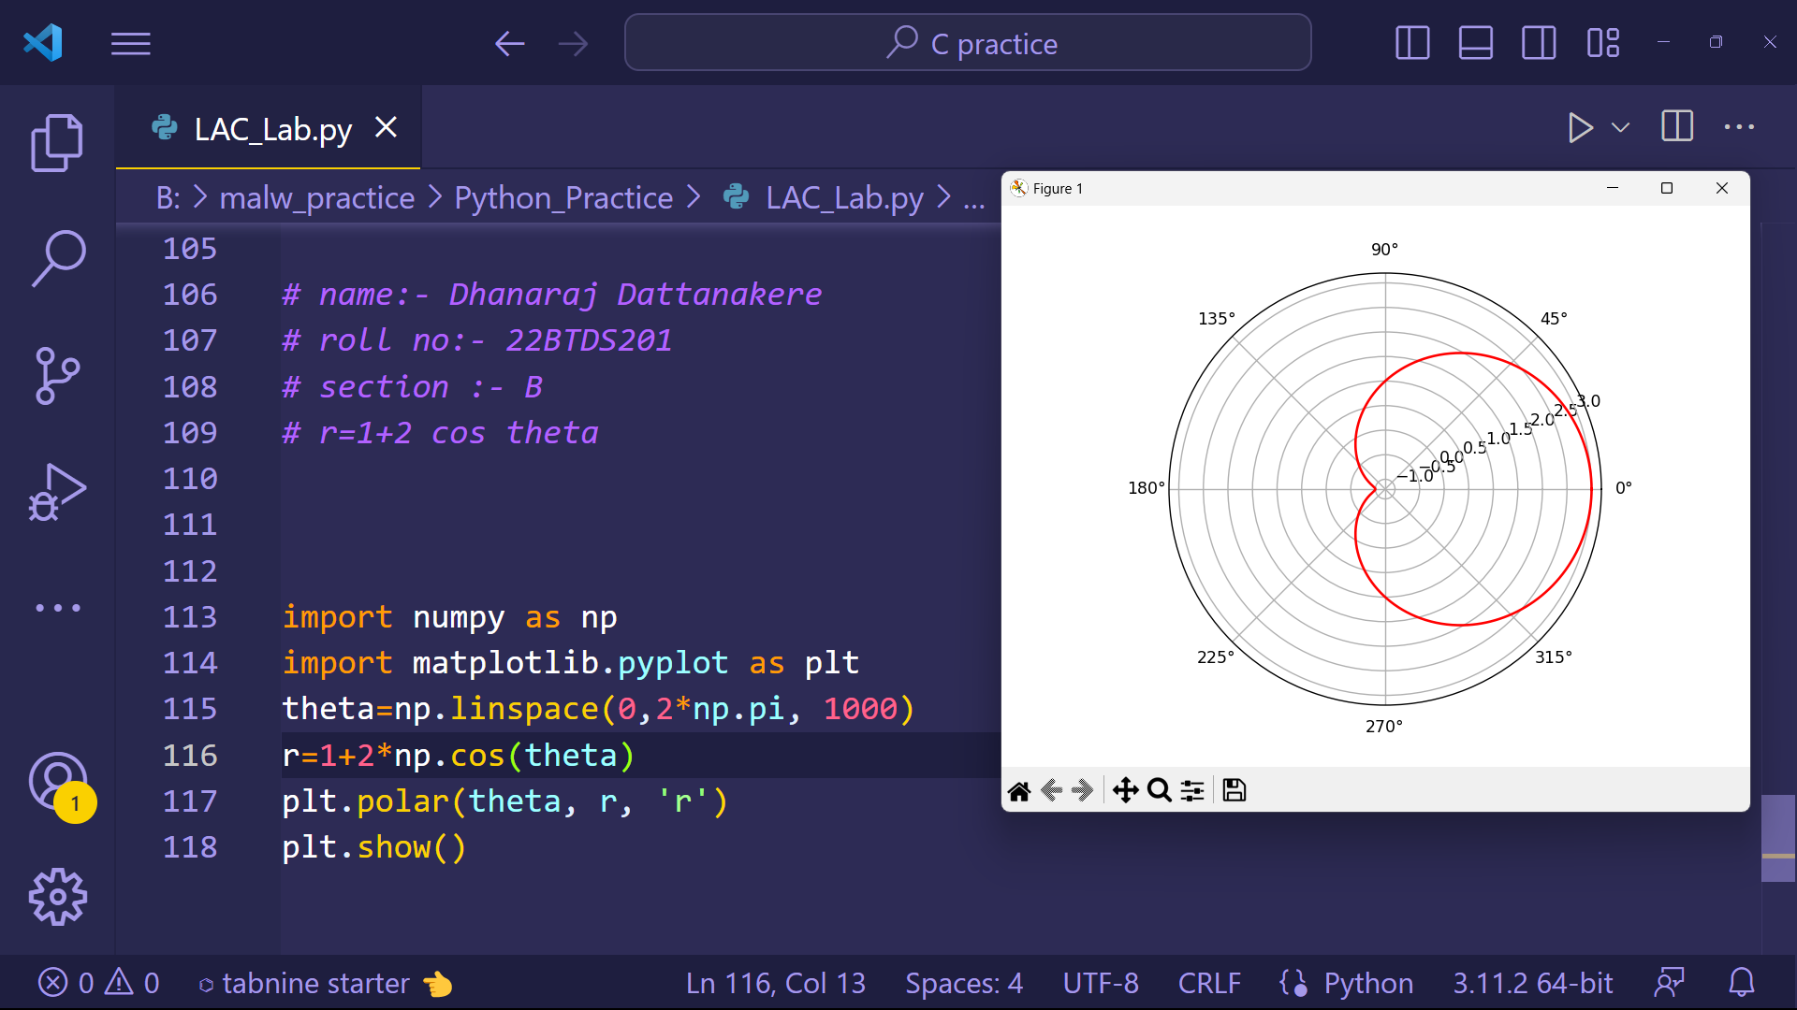

MODULE – 3

1.Declare 2 variables and find the partial differentiation of a function of two variables.

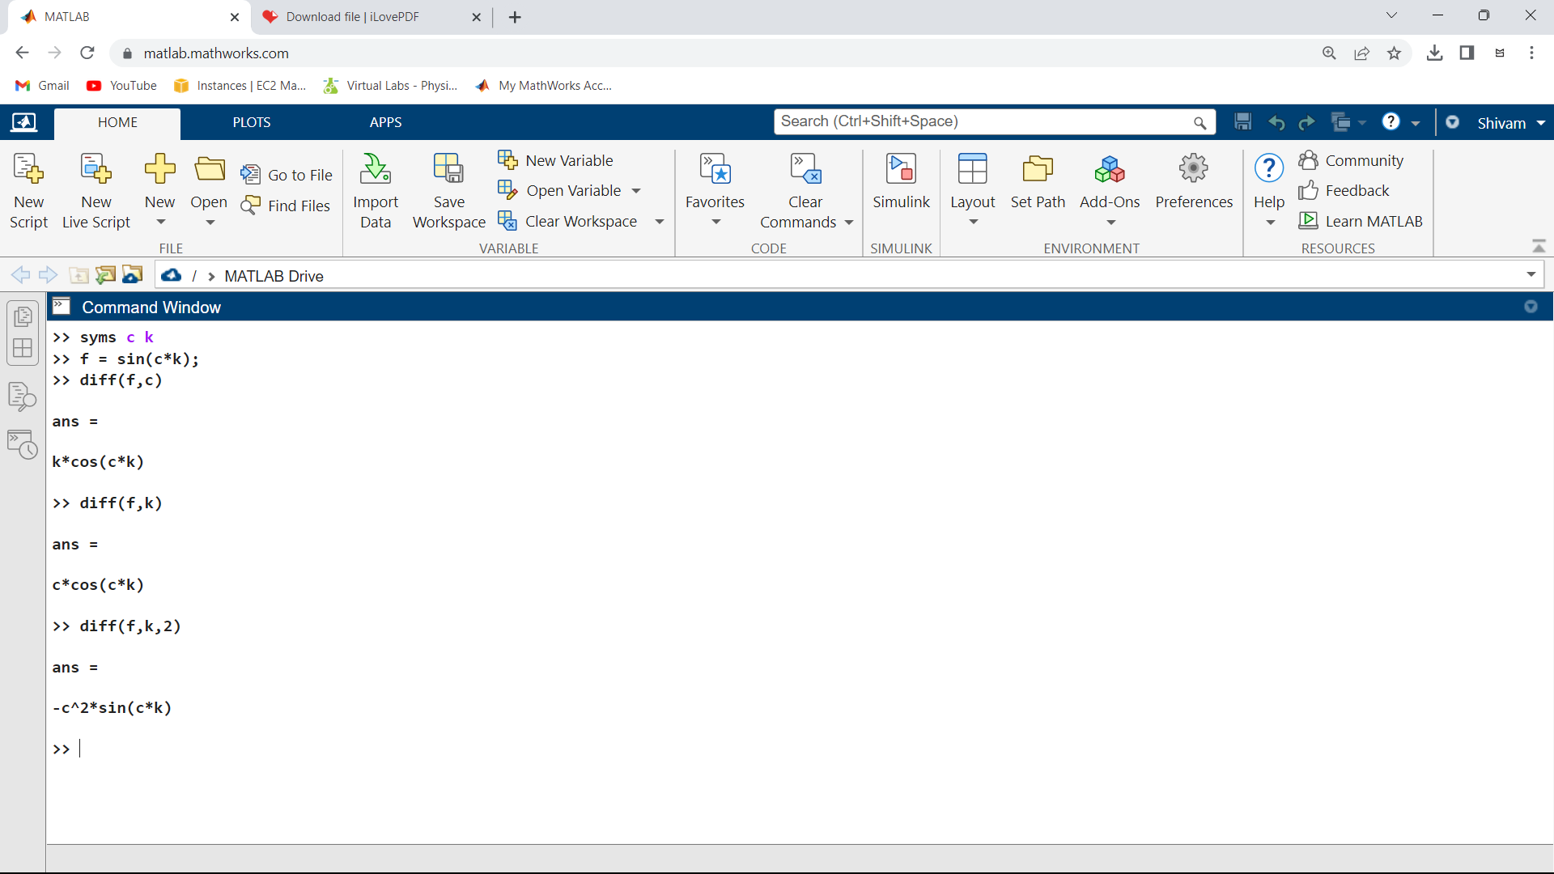

2.Find the differentiation using Jacobian method

