# Question - 1:

**MA 323 - Monte Carlo Simulation Assignment - 12**

## Vishisht Priyadarshi

**180123053**

The first 25 values of the Van der Corput sequences using the radical function xi = 2(i) are:

|  |  |  |  |
| --- | --- | --- | --- |
| **SI No.** | **Van der Corput Sequence** | **SI No** | **Van der Corput Sequence** |
| **1** | 0 | **14** | 0.6875 |
| **2** | 0.5 | **15** | 0.4375 |
| **3** | 0.25 | **16** | 0.9375 |
| **4** | 0.75 | **17** | 0.03125 |
| **5** | 0.125 | **18** | 0.53125 |
| **6** | 0.625 | **19** | 0.28125 |
| **7** | 0.375 | **20** | 0.78125 |
| **8** | 0.875 | **21** | 0.15625 |
| **9** | 0.0625 | **22** | 0.65625 |
| **10** | 0.5625 | **23** | 0.40625 |
| **11** | 0.3125 | **24** | 0.90625 |
| **12** | 0.8125 | **25** | 0.09375 |
| **13** | 0.1875 |  |  |

The plot for the first 1000 values in the form of (xi, xi+1) is:

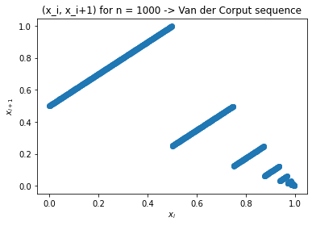

**Observations:**

1. As we can observe the points are forming a set of lines parallel to the line y = x, it shows that the points are not uniformally distributed. Similar plots in previous labs was shown to cover the whole area (which is not the case here).
2. I found that this plot helps in what is known as “Spectral Test”. LCGs have a property that when plotted in 2 dimensions, lines will form, on which all possible outputs can be found. The spectral test compares the distance between these planes; the further apart they are, the worse the generator is.

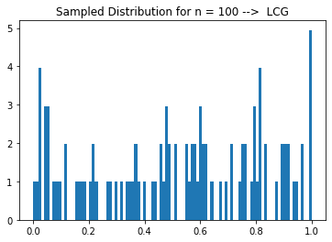**Sampled Distributions:**

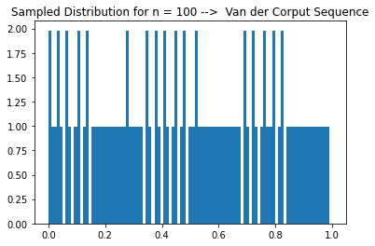

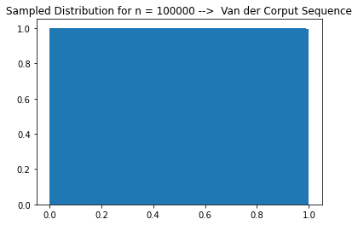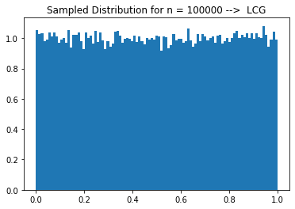

**LCG Used:** Lagged Fibonacci Generator

Ui = (Ui – 17 – Ui – 5)

If Ui  < 0, set Ui  = Ui  + 1

The first 17 values were generated using following General Linear Congruence Generator:

xi + 1  = (a.xi + b) mod m

ui + 1 = xi + 1 / m , with a = 1229, b = 1, m = 2048 and seed (x0) = 1

**Observations:**

1. We can observe that the plot for the Van der Corput sequence is more uniformally distributed, than the LCG used – Lagged Fibonacci Generator.
2. In both the plots of Van der Corput sequence, the proportional of points belonging to a fixed interval is almost proportional to the length of the interval – a very important property of the random numbers. But this property is not fully satisfied by the Lagged Fibonacci Generator.

# Question - 2:

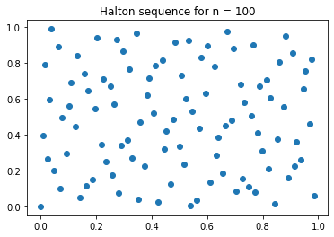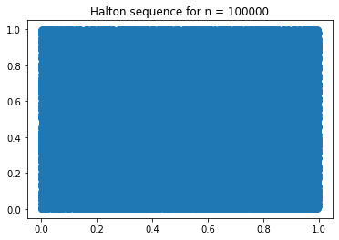

**Observations:**

1. We can observe that the points are more uniformally and equi-distantly located in the R2 plane. They completely cover the whole region.

2. So, this sequence generates the required set of points which are used in the Quasi-Monte Carlo simulation, and achieves our end goal.