# Question - 1:

**MA 323 - Monte Carlo Simulation Assignment - 2**

## Vishisht Priyadarshi

**180123053**

a) The Linear Congruence Generator used to generate first 17 values of Ui is of the form:

xi+1 = (axi + b) mod m

ui+1 = xi+1/m

with a = 1229, b = 1, m = 2048.

c)

* **Plots for 1000 values:**

**i) Scatter Plot (Ui, Ui+1) ii) Bar Plot (Ui vs i)**

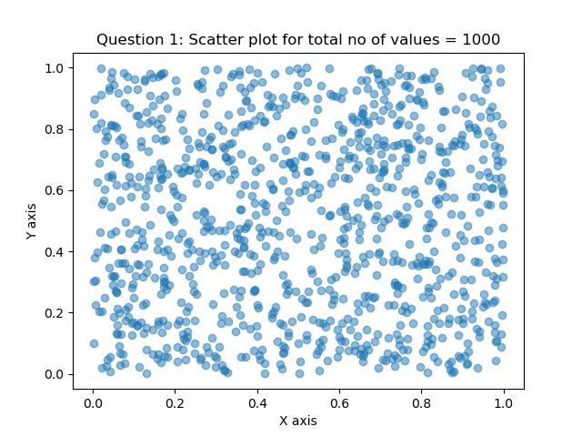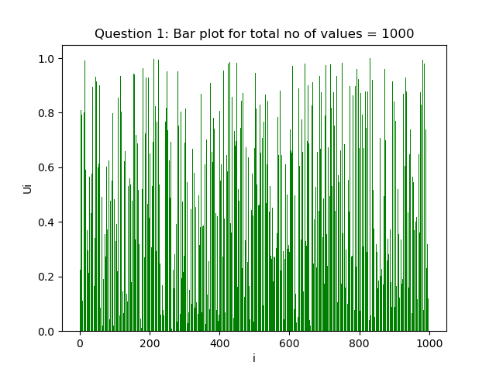

**iii) Frequency Distribution of Ui**

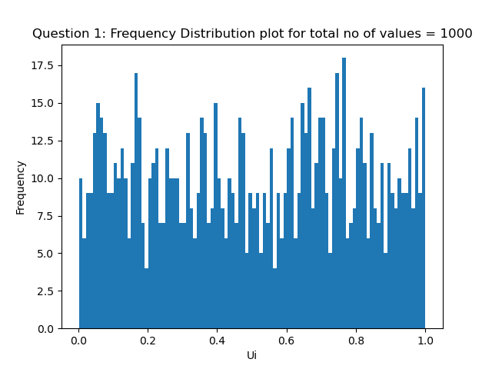

* **Plots for 10000 values:**

**i) Scatter Plot (Ui, Ui+1) ii) Bar Plot (Ui vs i)**

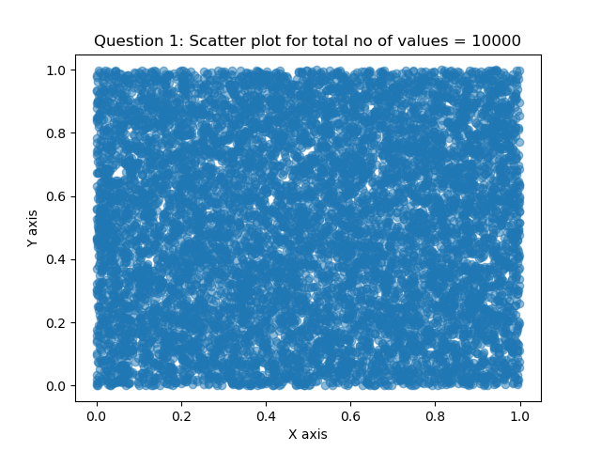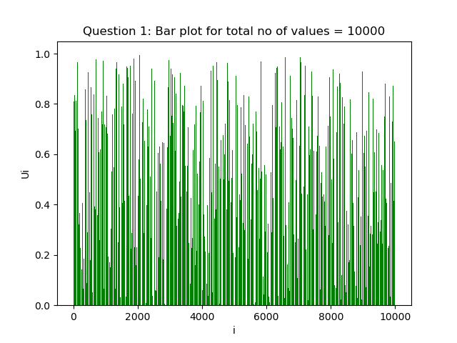

**iii) Frequency Distribution of Ui**

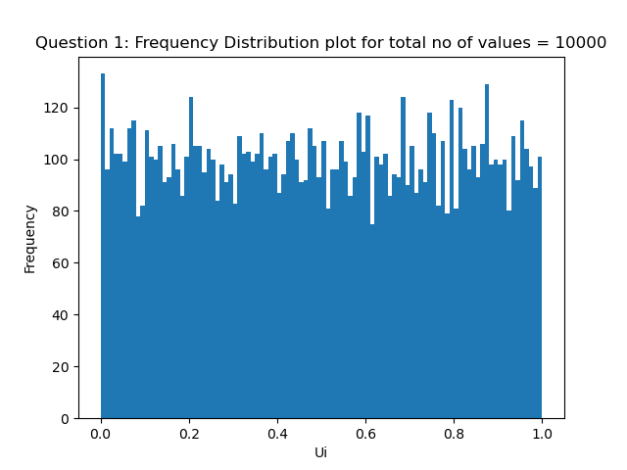

* **Plots for 100000 values:**

**i) Scatter Plot (Ui, Ui+1) ii) Bar Plot (Ui vs i)**

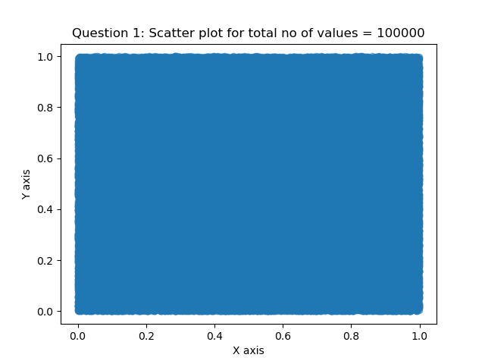 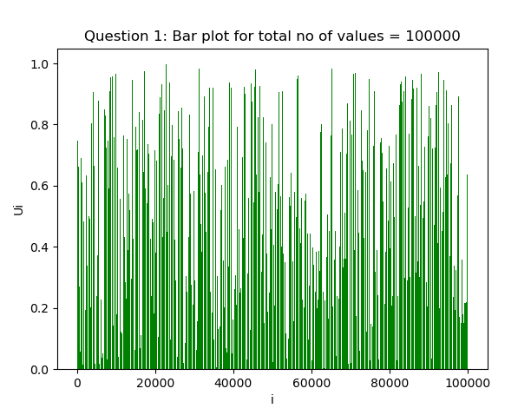

**iii) Frequency Distribution of Ui**

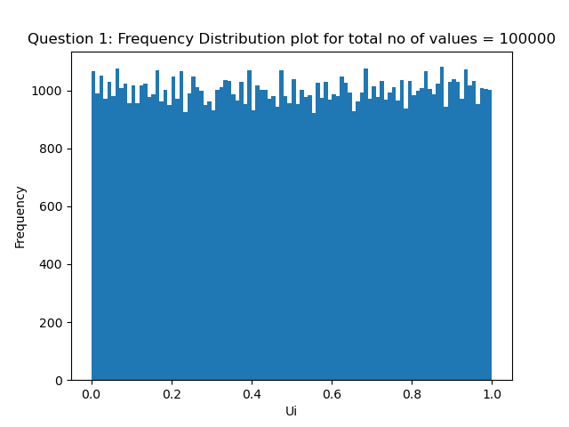

* **Observations:**

1. The scatter plot suggests that the Ui ‘s do not follow any particular pattern, so, they are almost completely random.
2. The frequency distribution plots suggest that the random generator follows the 2 properties of the ideal random generator:

a) Each Ui is uniformly distributed between 0 and 1.

b) The Ui are mutually independent.

The frequency of different numbers lying in same length intervals are almost same. So, the given random generator behaves like a good random generator.

# Question - 2:

Mean (ɵ) = π / 2 *(assumed)*

I have plotted the graphs for 5 different cases in which the number of values generated are 1000, 10000, 100000, 1000000, 10000000.

**Case i): Total number of values generated = 1000**

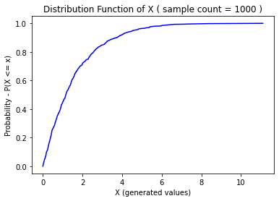 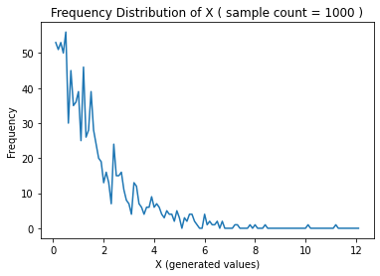

**Case ii): Total number of values generated = 10000**

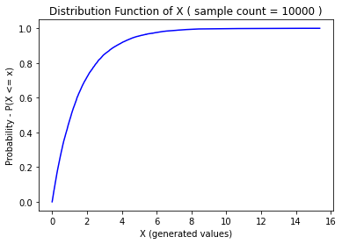 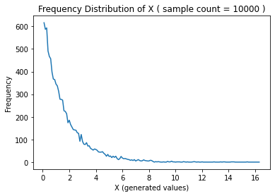

**Case iii): Total number of values generated = 100000**

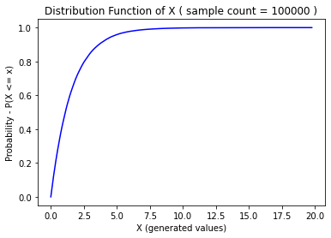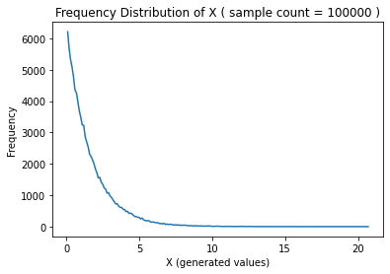

**Case iv): Total number of values generated = 1000000**

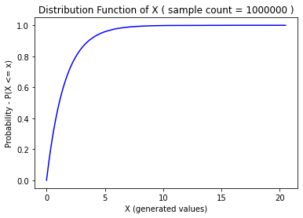 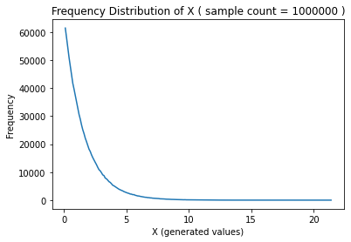

**Case v): Total number of values generated = 10000000**

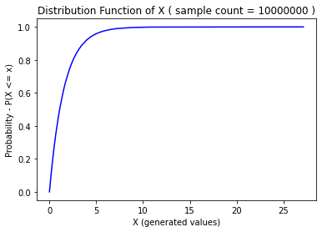 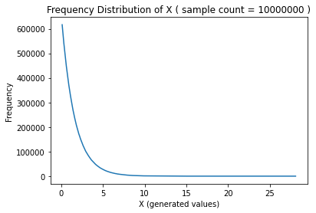

**Actual Distribution Function:**

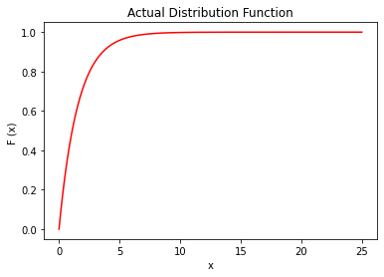

* Actual Mean = 1.5707963267948966

Actual Variance = 2.4674011002723395 (here, Variance = ɵ2 )

|  |  |  |  |
| --- | --- | --- | --- |
| **Case** | **Sample Count** | **Sample Mean** | **Sample Variance** |
| i) | 1000 | 1.527608770849963 | 2.3312738492502976 |
| ii) | 10000 | 1.5354517674732717 | 2.342475561946338 |
| iii) | 100000 | 1.5644662674427838 | 2.4328267137230175 |
| iv) | 1000000 | 1.5725458646556747 | 2.472518537123785 |
| v) | 10000000 | 1.570628987472085 | 2.465969544567569 |

* **Observations:**

1. As we increase the number of values generated (Sample Count), the mean and the variance of the generated values (X) converge to the actual mean and variance. It is also evident from the distribution function of the X for different values of sample count which approaches to the plot of F(x) as sample count increases. It follows from the Law of Large Numbers.
2. The distribution function of X is identical to the cdf F(x) from which random variable X was generated. This is because F(x) is a continuous strictly increasing function and U is a uniform distribution function on [0, 1], so, F-1(U) will be a sample from F. This clearly shows the Inverse Transform Method and the following theorem given in Lecture – 2.

# Question – 3 :

I have plotted the graphs for 5 different cases in which the number of values generated are 1000, 10000, 100000, 1000000, 10000000.

**Case i): Total number of values generated = 1000**

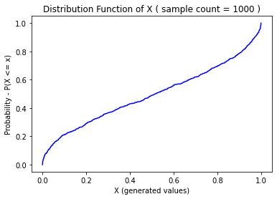 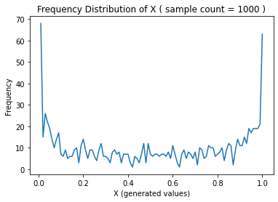

**Case ii): Total number of values generated = 10000**

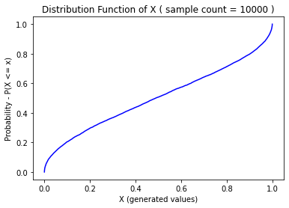 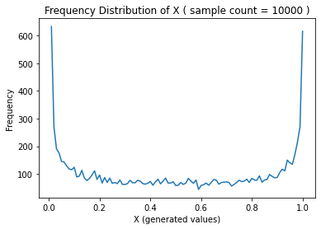

**Case iii): Total number of values generated = 100000**

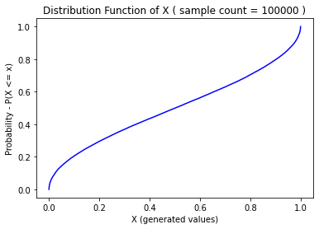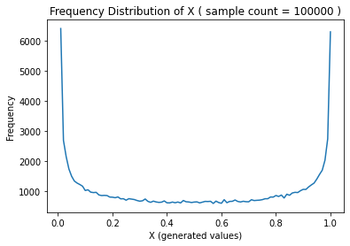

**Case iv): Total number of values generated = 1000000**

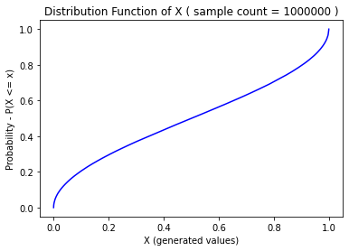 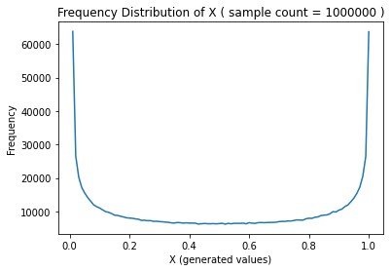

**Case v): Total number of values generated = 10000000**

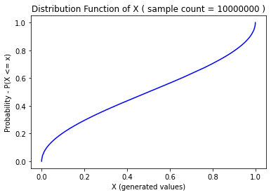 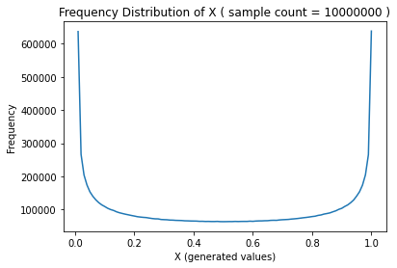

**Actual Distribution Function:**

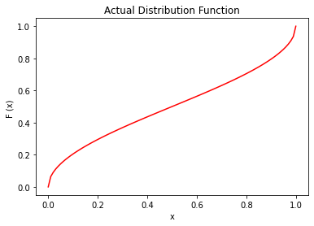

* **Sample Mean & Variance**

|  |  |  |  |
| --- | --- | --- | --- |
| **Case** | **Sample Count** | **Sample Mean** | **Sample Variance** |
| i) | 1000 | 0.48833044199671294 | 0.12727982689751888 |
| ii) | 10000 | 0.49285879887658973 | 0.12416196616477684 |
| iii) | 100000 | 0.49954063843320945 | 0.12488154453701807 |
| iv) | 1000000 | 0.5003726470843849 | 0.12494976854973477 |
| v) | 10000000 | 0.5000121854366314 | 0.12499836920736974 |

* **Observations:**

1. The distribution function of X is identical to the cdf F(x) from which random variable X was generated. This is because F(x) is a continuous strictly increasing function and U is a uniform distribution function on [0, 1], so, F-1(U) will be a sample from F. This clearly shows the Inverse Transform Method and the following theorem given in Lecture – 2.
2. The distribution functions of X approaches the plot of F(x) as the sample count increases.